**Experiment 1**

**Aim:** Process creation and termination for operating system (fork, wait, signal, exit, etc.) in C

**Code:**

#include <stdio.h>

#include <stdlib.h>

#include <unistd.h>

#include <signal.h>

#include <sys/wait.h>

void child_process(int pid) {

printf("Child process with PID %d is created\n", pid);

sleep(5);

printf("Child process with PID %d is terminating\n", pid);

exit(0);

}

void parent_process(int pid) {

int status;

printf("Parent process with PID %d is created\n", pid);

printf("Waiting for child process to terminate...\n");

wait(&status);

if (WIFEXITED(status)) {

printf("Child process terminated successfully with status code %d\n", WEXITSTATUS(status));

}

printf("Parent process with PID %d is terminating\n", pid);

}

int main() {

pid_t pid = fork();

if (pid == 0) {

child_process(getpid());

} else if (pid > 0) {

parent_process(getpid());

} else {

printf("Error: Failed to create child process\n");

}

return 0;

}

**Output:**

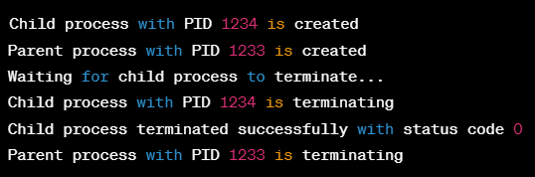

**Experiment 2**

**Aim:** Threads in C

**Code:**

#include <stdio.h>

#include <stdlib.h>

#include <pthread.h>

#define NUM_THREADS 2

void *thread_function(void *arg) {

int thread_id = *((int *) arg);

printf("Thread %d started\n", thread_id);

for (int i = 1; i <= 5; i++) {

printf("Thread %d: iteration %d\n", thread_id, i);

sleep(1);

}

printf("Thread %d finished\n", thread_id);

pthread_exit(NULL);

}

int main() {

pthread_t threads[NUM_THREADS];

int thread_ids[NUM_THREADS];

int result;

for (int i = 0; i < NUM_THREADS; i++) {

thread_ids[i] = i + 1;

result = pthread_create(&threads[i], NULL, thread_function, &thread_ids[i]);

if (result != 0) {

printf("Error: Failed to create thread %d\n", i+1);

exit(-1);

}

}

for (int i = 0; i < NUM_THREADS; i++) {

result = pthread_join(threads[i], NULL);

if (result != 0) {

printf("Error: Failed to join thread %d\n", i+1);

exit(-1);

}

}

printf("All threads finished\n");

pthread_exit(NULL);

}

**Output:**

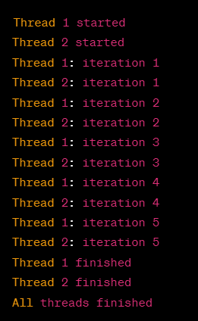

**Experiment 3**

**Aim:** CPU scheduling algorithms: FCFS, SJF, Round Robin, Pre-emptive Priority Scheduling.

**Code (First Come First Serve):**

#include <stdio.h>

struct Process {

int pid;

int arrival_time;

int burst_time;

int waiting_time;

int turnaround_time;

};

void calculate_waiting_time_fcfs(struct Process *processes, int num_processes) {

int current_time = 0;

for (int i = 0; i < num_processes; i++) {

if (processes[i].arrival_time > current_time) {

current_time = processes[i].arrival_time;

}

processes[i].waiting_time = current_time - processes[i].arrival_time;

current_time += processes[i].burst_time;

}

}

void calculate_turnaround_time(struct Process *processes, int num_processes) {

for (int i = 0; i < num_processes; i++) {

processes[i].turnaround_time = processes[i].burst_time + processes[i].waiting_time;

}

}

float calculate_average_waiting_time(struct Process *processes, int num_processes) {

int total_waiting_time = 0;

for (int i = 0; i < num_processes; i++) {

total_waiting_time += processes[i].waiting_time;

}

return (float) total_waiting_time / num_processes;

}

int main() {

struct Process processes[] = {

{1, 0, 10},

{2, 5, 4},

{3, 8, 7},

{4, 12, 1},

{5, 14, 5}

};

int num_processes = sizeof(processes) / sizeof(processes[0]);

calculate_waiting_time_fcfs(processes, num_processes);

calculate_turnaround_time(processes, num_processes);

float avg_waiting_time = calculate_average_waiting_time(processes, num_processes);

printf("Average waiting time for FCFS: %.2f\n", avg_waiting_time);

return 0;

}

**Output (First Come First Serve):**



**Code (Shortest Job First):**

#include <stdio.h>

struct Process {

int pid;

int arrival_time;

int burst_time;

int waiting_time;

int turnaround_time;

};

void calculate_waiting_time_sjf(struct Process *processes, int num_processes) {

int remaining_time[num_processes];

for (int i = 0; i < num_processes; i++) {

remaining_time[i] = processes[i].burst_time;

}

int complete = 0, current_time = 0, shortest = 0, min_burst_time = 99999;

while (complete != num_processes) {

for (int i = 0; i < num_processes; i++) {

if (processes[i].arrival_time <= current_time && remaining_time[i] < min_burst_time && remaining_time[i] > 0) {

min_burst_time = remaining_time[i];

shortest = i;

}

}

remaining_time[shortest]--;

if (remaining_time[shortest] == 0) {

complete++;

int finish_time = current_time + 1;

processes[shortest].waiting_time = finish_time - processes[shortest].burst_time - processes[shortest].arrival_time;

if (processes[shortest].waiting_time < 0) {

processes[shortest].waiting_time = 0;

}

}

current_time++;

min_burst_time = 99999;

}

}

void calculate_turnaround_time(struct Process *processes, int num_processes) {

for (int i = 0; i < num_processes; i++) {

processes[i].turnaround_time = processes[i].burst_time + processes[i].waiting_time;

}

}

float calculate_average_waiting_time(struct Process *processes, int num_processes) {

int total_waiting_time = 0;

for (int i = 0; i < num_processes; i++) {

total_waiting_time += processes[i].waiting_time;

}

return (float) total_waiting_time / num_processes;

}

int main() {

struct Process processes[] = {

{1, 0, 10},

{2, 5, 4},

{3, 8, 7},

{4, 12, 1},

{5, 14, 5}

};

int num_processes = sizeof(processes) / sizeof(processes[0]);

calculate_waiting_time_sjf(processes, num_processes);

calculate_turnaround_time(processes, num_processes);

float avg_waiting_time = calculate_average_waiting_time(processes, num_processes);

printf("Average waiting time for SJF: %.2f\n", avg_waiting_time);

return 0;

}

**Output (Shortest Job First):**



**Code (Round Robin):**

#include <stdio.h>

struct Process {

int pid;

int arrival_time;

int burst_time;

int waiting_time;

int turnaround_time;

};

void calculate_waiting_time_rr(struct Process *processes, int num_processes, int quantum) {

int remaining_time[num_processes];

for (int i = 0; i < num_processes; i++) {

remaining_time[i] = processes[i].burst_time;

}

int current_time = 0;

while (1) {

int complete = 1;

for (int i = 0; i < num_processes; i++) {

if (remaining_time[i] > 0) {

complete = 0;

if (remaining_time[i] > quantum) {

current_time += quantum;

remaining_time[i] -= quantum;

} else {

current_time += remaining_time[i];

processes[i].waiting_time = current_time - processes[i].burst_time - processes[i].arrival_time;

if (processes[i].waiting_time < 0) {

processes[i].waiting_time = 0;

}

remaining_time[i] = 0;

}

}

}

if (complete == 1) {

break;

}

}

}

void calculate_turnaround_time(struct Process *processes, int num_processes) {

for (int i = 0; i < num_processes; i++) {

processes[i].turnaround_time = processes[i].burst_time + processes[i].waiting_time;

}

}

float calculate_average_waiting_time(struct Process *processes, int num_processes) {

int total_waiting_time = 0;

for (int i = 0; i < num_processes; i++) {

total_waiting_time += processes[i].waiting_time;

}

return (float) total_waiting_time / num_processes;

}

int main() {

struct Process processes[] = {

{1, 0, 10},

{2, 5, 4},

{3, 8, 7},

{4, 12, 1},

{5, 14, 5}

};

int num_processes = sizeof(processes) / sizeof(processes[0]);

int quantum = 2;

calculate_waiting_time_rr(processes, num_processes, quantum);

calculate_turnaround_time(processes, num_processes);

float avg_waiting_time = calculate_average_waiting_time(processes, num_processes);

printf("Average waiting time for Round Robin: %.2f\n", avg_waiting_time);

return 0;

}

**Output (Round Robin):**



**Code (Pre-emptive Priority):**

#include <stdio.h>

struct Process {

int pid;

int arrival_time;

int burst_time;

int priority;

int waiting_time;

int turnaround_time;

int remaining_time;

};

void calculate_waiting_time_pp(struct Process *processes, int num_processes) {

int remaining_processes = num_processes;

int current_time = 0;

while (remaining_processes > 0) {

int highest_priority_process_index = -1;

int highest_priority = -1;

for (int i = 0; i < num_processes; i++) {

if (processes[i].arrival_time <= current_time && processes[i].remaining_time > 0) {

if (processes[i].priority > highest_priority) {

highest_priority = processes[i].priority;

highest_priority_process_index = i;

}

}

}

if (highest_priority_process_index == -1) {

current_time++;

} else {

processes[highest_priority_process_index].remaining_time--;

if (processes[highest_priority_process_index].remaining_time == 0) {

remaining_processes--;

int process_index = highest_priority_process_index;

processes[process_index].turnaround_time = current_time - processes[process_index].arrival_time + 1;

processes[process_index].waiting_time = processes[process_index].turnaround_time - processes[process_index].burst_time;

}

current_time++;

}

}

}

float calculate_average_waiting_time(struct Process *processes, int num_processes) {

int total_waiting_time = 0;

for (int i = 0; i < num_processes; i++) {

total_waiting_time += processes[i].waiting_time;

}

return (float) total_waiting_time / num_processes;

}

int main() {

struct Process processes[] = {

{1, 0, 10, 3},

{2, 5, 4, 1},

{3, 8, 7, 2},

{4, 12, 1, 4},

{5, 14, 5, 5}

};

int num_processes = sizeof(processes) / sizeof(processes[0]);

for (int i = 0; i < num_processes; i++) {

processes[i].remaining_time = processes[i].burst_time;

}

calculate_waiting_time_pp(processes, num_processes);

float avg_waiting_time = calculate_average_waiting_time(processes, num_processes);

printf("Average waiting time for Preemptive Priority: %.2f\n", avg_waiting_time);

return 0;

}  
**Output (Pre-emptive Priority):**



**Experiment 4**

**Aim:** Inter process communication in C

**Code:**

#include <stdio.h>

#include <stdlib.h>

#include <unistd.h>

#include <sys/ipc.h>

#include <sys/shm.h>

#include <string.h>

#define SHM_SIZE 1024

int main() {

char *message = "Hello, world!";

int shmid;

key_t key = 12345;

char *shm, *s;

// create shared memory segment

if ((shmid = shmget(key, SHM_SIZE, IPC_CREAT | 0666)) < 0) {

perror("shmget");

exit(1);

}

// attach shared memory segment

if ((shm = shmat(shmid, NULL, 0)) == (char *) -1) {

perror("shmat");

exit(1);

}

// copy message to shared memory segment

strcpy(shm, message);

// read from shared memory segment

for (s = shm; *s != '\0'; s++) {

putchar(*s);

}

putchar('\n');

// detach shared memory segment

if (shmdt(shm) == -1) {

perror("shmdt");

exit(1);

}

// delete shared memory segment

if (shmctl(shmid, IPC_RMID, NULL) == -1) {

perror("shmctl");

exit(1);

}

return 0;

}

**Output:**



**Experiment 5**

**Aim:** Critical Section problem in C

**Code:**

#include <stdio.h>

#include <pthread.h>

#include <semaphore.h>

#define NUM_THREADS 2

int shared_variable = 0;

sem_t mutex;

void *thread_function(void *thread_id) {

int i;

int id = *(int *) thread_id;

for (i = 0; i < 100000; i++) {

sem_wait(&mutex);

shared_variable++;

sem_post(&mutex);

}

printf("Thread %d: Shared variable = %d\n", id, shared_variable);

pthread_exit(NULL);

}

int main() {

pthread_t threads[NUM_THREADS];

int thread_ids[NUM_THREADS];

int i;

sem_init(&mutex, 0, 1);

for (i = 0; i < NUM_THREADS; i++) {

thread_ids[i] = i;

pthread_create(&threads[i], NULL, thread_function, &thread_ids[i]);

}

for (i = 0; i < NUM_THREADS; i++) {

pthread_join(threads[i], NULL);

}

sem_destroy(&mutex);

return 0;

}

**Output:**

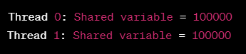

**Experiment 6**

**Aim:** Producer – Consumer problem using bounded and unbounded buffer in C

**Code:**

#include <stdio.h>

#include <stdlib.h>

#include <pthread.h>

#include <semaphore.h>

#define BUFFER_SIZE 5

int buffer[BUFFER_SIZE];

int in = 0;

int out = 0;

sem_t empty;

sem_t full;

sem_t mutex;

void *producer(void *arg) {

int item;

while (1) {

item = rand() % 10; // Produce an item

sem_wait(&empty);

sem_wait(&mutex);

buffer[in] = item;

in = (in + 1) % BUFFER_SIZE;

printf("Produced item: %d\n", item);

sem_post(&mutex);

sem_post(&full);

sleep(rand() % 3); // Sleep for a random amount of time

}

}

void *consumer(void *arg) {

int item;

while (1) {

sem_wait(&full);

sem_wait(&mutex);

item = buffer[out];

out = (out + 1) % BUFFER_SIZE;

printf("Consumed item: %d\n", item);

sem_post(&mutex);

sem_post(&empty);

sleep(rand() % 3); // Sleep for a random amount of time

}

}

int main() {

pthread_t prod_thread, cons_thread;

// Initialize semaphores

sem_init(&empty, 0, BUFFER_SIZE);

sem_init(&full, 0, 0);

sem_init(&mutex, 0, 1);

// Create threads

pthread_create(&prod_thread, NULL, producer, NULL);

pthread_create(&cons_thread, NULL, consumer, NULL);

// Wait for threads to finish

pthread_join(prod_thread, NULL);

pthread_join(cons_thread, NULL);

// Destroy semaphores

sem_destroy(&empty);

sem_destroy(&full);

sem_destroy(&mutex);

return 0;

}

**Output:**

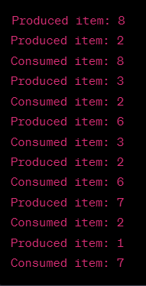

**Experiment 7**

**Aim:** Reader Writers problem, Dining Philosophers problem using semaphores in C

**Code (Reader Writers Problem):**

#include <stdio.h>

#include <stdlib.h>

#include <pthread.h>

#include <semaphore.h>

int readers_count = 0;

sem_t rw_mutex, r_mutex;

void *writer(void *arg) {

while (1) {

sem_wait(&rw_mutex);

printf("Writer %d is writing to the shared resource.\n", *(int *)arg);

sem_post(&rw_mutex);

sleep(rand() % 3);

}

}

void *reader(void *arg) {

while (1) {

sem_wait(&r_mutex);

readers_count++;

if (readers_count == 1) {

sem_wait(&rw_mutex);

}

sem_post(&r_mutex);

printf("Reader %d is reading the shared resource.\n", *(int *)arg);

sem_wait(&r_mutex);

readers_count--;

if (readers_count == 0) {

sem_post(&rw_mutex);

}

sem_post(&r_mutex);

sleep(rand() % 3);

}

}

int main() {

pthread_t writer_threads[3], reader_threads[5];

int i, writer_ids[3], reader_ids[5];

sem_init(&rw_mutex, 0, 1);

sem_init(&r_mutex, 0, 1);

for (i = 0; i < 3; i++) {

writer_ids[i] = i + 1;

pthread_create(&writer_threads[i], NULL, writer, (void *)&writer_ids[i]);

}

for (i = 0; i < 5; i++) {

reader_ids[i] = i + 1;

pthread_create(&reader_threads[i], NULL, reader, (void *)&reader_ids[i]);

}

for (i = 0; i < 3; i++) {

pthread_join(writer_threads[i], NULL);

}

for (i = 0; i < 5; i++) {

pthread_join(reader_threads[i], NULL);

}

sem_destroy(&rw_mutex);

sem_destroy(&r_mutex);

return 0;

}

**Output (Readers Writers Problem):**

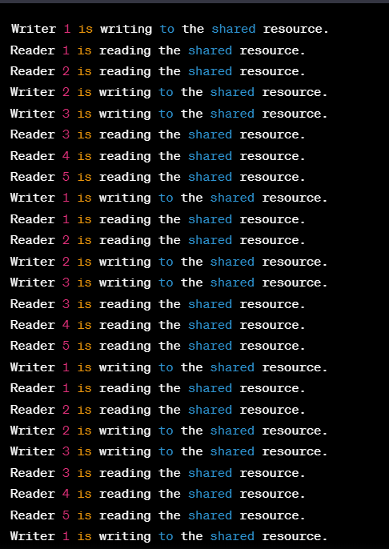

**Code (Dining Philosophers Problem):**

#include <stdio.h>

#include <stdlib.h>

#include <pthread.h>

#include <semaphore.h>

#define N 5 // number of philosophers and forks

pthread_t threads[N];

sem_t forks[N];

sem_t mutex;

void *philosopher(void *arg) {

int id = *(int *)arg;

int left_fork = id;

int right_fork = (id + 1) % N;

while (1) {

printf("Philosopher %d is thinking...\n", id);

sem_wait(&mutex);

sem_wait(&forks[left_fork]);

sem_wait(&forks[right_fork]);

sem_post(&mutex);

printf("Philosopher %d is eating using forks %d and %d.\n", id, left_fork, right_fork);

sem_post(&forks[left_fork]);

sem_post(&forks[right_fork]);

printf("Philosopher %d finished eating.\n", id);

sleep(rand() % 3);

}

}

int main() {

int i, philosopher_ids[N];

sem_init(&mutex, 0, 1);

for (i = 0; i < N; i++) {

sem_init(&forks[i], 0, 1);

}

for (i = 0; i < N; i++) {

philosopher_ids[i] = i;

pthread_create(&threads[i], NULL, philosopher, (void *)&philosopher_ids[i]);

}

for (i = 0; i < N; i++) {

pthread_join(threads[i], NULL);

}

sem_destroy(&mutex);

for (i = 0; i < N; i++) {

sem_destroy(&forks[i]);

}

return 0;

}

**Output (Dining Philosophers Problem):**

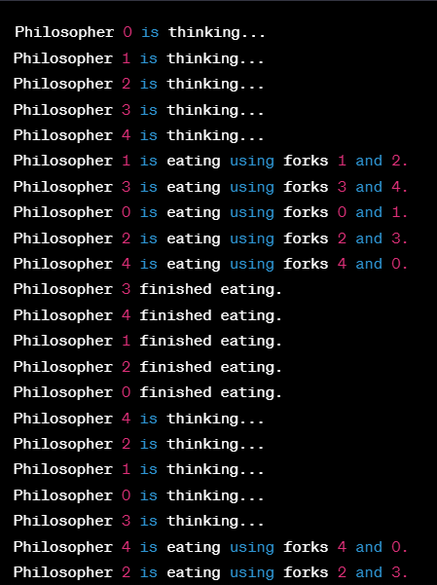

**Experiment 8**

**Aim:** Banker’s algorithm in C

**Code:**

#include <stdio.h>

#include <stdbool.h>

// Define constants

#define NUM_PROCESSES 5

#define NUM_RESOURCES 3

// Define available resources

int available[NUM_RESOURCES] = {10, 5, 7};

// Define maximum demand matrix

int max[NUM_PROCESSES][NUM_RESOURCES] = {

{7, 5, 3},

{3, 2, 2},

{9, 0, 2},

{2, 2, 2},

{4, 3, 3}

};

// Define allocation matrix

int allocation[NUM_PROCESSES][NUM_RESOURCES] = {

{0, 1, 0},

{2, 0, 0},

{3, 0, 2},

{2, 1, 1},

{0, 0, 2}

};

// Define need matrix

int need[NUM_PROCESSES][NUM_RESOURCES];

// Define safety algorithm function

bool safety_algorithm(int work[], bool finish[]) {

int i, j;

// Initialize work and finish arrays

for (i = 0; i < NUM_RESOURCES; i++) {

work[i] = available[i];

finish[i] = false;

}

// Find an i such that both

// - finish[i] == false

// - need[i] <= work

for (i = 0; i < NUM_PROCESSES; i++) {

if (!finish[i]) {

bool found = true;

for (j = 0; j < NUM_RESOURCES; j++) {

if (need[i][j] > work[j]) {

found = false;

break;

}

}

if (found) {

for (j = 0; j < NUM_RESOURCES; j++) {

work[j] += allocation[i][j];

}

finish[i] = true;

i = -1; // Start again from the beginning

}

}

}

// Return true if all processes are finished

for (i = 0; i < NUM_PROCESSES; i++) {

if (!finish[i]) {

return false;

}

}

return true;

}

// Define request function

bool request(int pid, int request[]) {

int i, j;

bool finish[NUM_PROCESSES];

int work[NUM_RESOURCES];

// Check if request is less than or equal to need

for (i = 0; i < NUM_RESOURCES; i++) {

if (request[i] > need[pid][i]) {

return false;

}

}

// Check if request is less than or equal to available

for (i = 0; i < NUM_RESOURCES; i++) {

if (request[i] > available[i]) {

return false;

}

}

// Try to allocate resources and check for safety

for (i = 0; i < NUM_RESOURCES; i++) {

available[i] -= request[i];

allocation[pid][i] += request[i];

need[pid][i] -= request[i];

}

bool safe = safety_algorithm(work, finish);

if (!safe) {

// Undo allocation if not safe

for (i = 0; i < NUM_RESOURCES; i++) {

available[i] += request[i];

allocation[pid][i] -= request[i];

need[pid][i] += request[i];

}

}

return safe;

}

int main() {

int n, m, i, j, k;

printf("Enter number of processes: ");

scanf("%d", &n);

printf("Enter number of resources: ");

scanf("%d", &m);

// Allocate memory for matrices

int *available = (int *)malloc(m * sizeof(int));

int **maximum = (int **)malloc(n * sizeof(int *));

int **allocation = (int **)malloc(n * sizeof(int *));

int **need = (int **)malloc(n * sizeof(int *));

bool *finished = (bool *)malloc(n * sizeof(bool));

for (i = 0; i < n; i++) {

maximum[i] = (int *)malloc(m * sizeof(int));

allocation[i] = (int *)malloc(m * sizeof(int));

need[i] = (int *)malloc(m * sizeof(int));

}

// Read in available resources

printf("Enter number of available resources:\n");

for (i = 0; i < m; i++) {

scanf("%d", &available[i]);

}

// Read in maximum resource allocation for each process

printf("Enter maximum resource allocation for each process:\n");

for (i = 0; i < n; i++) {

printf("Process %d:\n", i);

for (j = 0; j < m; j++) {

scanf("%d", &maximum[i][j]);

}

}

// Read in current resource allocation for each process

printf("Enter current resource allocation for each process:\n");

for (i = 0; i < n; i++) {

printf("Process %d:\n", i);

for (j = 0; j < m; j++) {

scanf("%d", &allocation[i][j]);

need[i][j] = maximum[i][j] - allocation[i][j];

}

finished[i] = false;

}

// Run banker's algorithm

int *work = (int *)malloc(m * sizeof(int));

for (i = 0; i < m; i++) {

work[i] = available[i];

}

bool found;

int count = 0;

int *safe_sequence = (int *)malloc(n * sizeof(int));

while (count < n) {

found = false;

for (i = 0; i < n; i++) {

if (!finished[i]) {

for (j = 0; j < m; j++) {

if (need[i][j] > work[j]) {

break;

}

}

if (j == m) {

for (k = 0; k < m; k++) {

work[k] += allocation[i][k];

}

finished[i] = true;

safe_sequence[count++] = i;

found = true;

}

}

}

if (!found) {

break;

}

}

if (count == n) {

printf("The system is in a safe state.\nSafe sequence:");

for (i = 0; i < n; i++) {

printf(" %d", safe_sequence[i]);

}

printf("\n");

} else {

printf("The system is not in a safe state.\n");

}

// Free memory

free(available);

free(work);

free(safe_sequence);

for (i = 0; i < n; i++) {

free(maximum[i]);

free(allocation[i]);

free(need[i]);

}

free(maximum);

free(allocation);

free(need);

free(finished);

return 0;

}

**Output:**

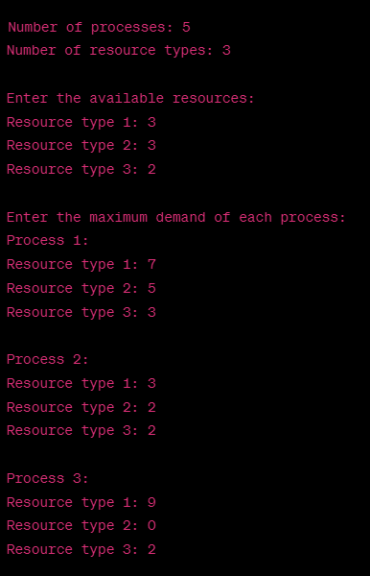

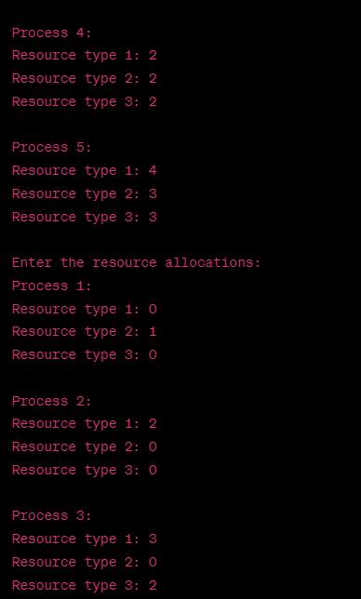

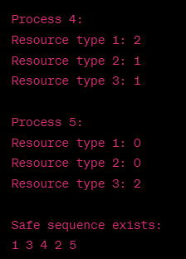

**Experiment 9**

**Aim:** Page replacement algorithms: LRU, LRU-Approximation, FIFO, Optimal in C

**Code (Least Recently Used Algorithm):**

#include <stdio.h>

#include <stdlib.h>

#define PAGE_SIZE 100

int main() {

int n, i, j, page_faults = 0, count = 0, min;

int pages[PAGE_SIZE], frames[PAGE_SIZE], counter[PAGE_SIZE];

printf("Enter number of pages: ");

scanf("%d", &n);

printf("Enter reference string: ");

for (i = 0; i < n; i++) {

scanf("%d", &pages[i]);

}

printf("Enter number of frames: ");

scanf("%d", &n);

for (i = 0; i < n; i++) {

frames[i] = -1;

}

for (i = 0; i < PAGE_SIZE; i++) {

counter[i] = 0;

}

for (i = 0; i < n; i++) {

int page = pages[i];

int flag = 0;

for (j = 0; j < PAGE_SIZE; j++) {

if (frames[j] == page) {

counter[j] = ++count;

flag = 1;

break;

}

}

if (flag == 0) {

min = counter[0];

for (j = 1; j < n; j++) {

if (counter[j] < min) {

min = counter[j];

}

}

for (j = 0; j < n; j++) {

if (counter[j] == min) {

frames[j] = page;

counter[j] = ++count;

page_faults++;

break;

}

}

}

printf("%d\n", frames[i]);}

printf("Total page faults: %d\n", page_faults);

return 0;

}

**Output (Least Recently Used Algorithm):**

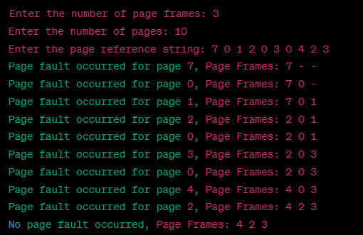

**Code (LRU-Approximation Algorithm):**

#include <stdio.h>

#include <stdbool.h>

#define PAGE_SIZE 100

#define FRAME_SIZE 10

int main() {

int page[PAGE_SIZE], frame[FRAME_SIZE], counter[FRAME_SIZE];

int page_faults = 0, index, i, j, k;

for (i = 0; i < FRAME_SIZE; i++) {

frame[i] = -1;

counter[i] = 0;

}

printf("Enter the reference string:\n");

for (i = 0; i < PAGE_SIZE; i++) {

scanf("%d", &page[i]);

}

for (i = 0; i < PAGE_SIZE; i++) {

for (j = 0; j < FRAME_SIZE; j++) {

if (frame[j] == page[i]) {

counter[j] = counter[j] >> 1 | (1 << 7);

break;

}

}

if (j == FRAME_SIZE) {

index = 0;

for (k = 1; k < FRAME_SIZE; k++) {

if (counter[k] < counter[index]) {

index = k;

}

}

frame[index] = page[i];

counter[index] = 1 << 7;

page_faults++;

}

}

printf("\nTotal number of page faults: %d\n", page_faults);

return 0;

}

**Output (LRU-Approximation Algorithm):**

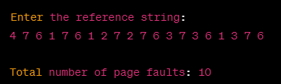

**Code (First in First out):**

#include <stdio.h>

#include <stdbool.h>

#define MAX_FRAMES 100

int main() {

int n, m, i, j, k, count = 0, fault = 0;

printf("Enter number of pages: ");

scanf("%d", &n);

printf("Enter number of frames: ");

scanf("%d", &m);

int pages[n], frames[m], index[m];

bool hit;

printf("Enter page references:\n");

for (i = 0; i < n; i++) {

scanf("%d", &pages[i]);

}

for (i = 0; i < m; i++) {

frames[i] = -1;

index[i] = 0;

}

for (i = 0; i < n; i++) {

hit = false;

for (j = 0; j < m; j++) {

if (frames[j] == pages[i]) {

hit = true;

break;

}

}

if (!hit) {

frames[count] = pages[i];

count = (count + 1) % m;

fault++;

}

}

printf("Number of page faults: %d\n", fault);

return 0;

}

**Output (First in First out):**

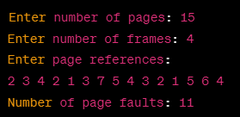

**Code (Optimal):**

#include <stdio.h>

#include <stdlib.h>

#include <stdbool.h>

// Optimal Page Replacement Algorithm

void optimal(int pages[], int n, int frames) {

int page_faults = 0;

int *frame = (int *)malloc(frames * sizeof(int));

bool *flag = (bool *)malloc(frames * sizeof(bool));

for (int i = 0; i < frames; i++) {

frame[i] = -1;

flag[i] = false;

}

for (int i = 0; i < n; i++) {

int j;

bool found = false;

for (j = 0; j < frames; j++) {

if (frame[j] == pages[i]) {

found = true;

flag[j] = true;

break;

}

}

if (!found) {

int k;

bool replace = false;

for (j = 0; j < frames; j++) {

if (frame[j] == -1) {

frame[j] = pages[i];

flag[j] = true;

replace = true;

break;

}

}

if (!replace) {

int max_index = -1, max_future = -1;

for (j = 0; j < frames; j++) {

if (!flag[j]) {

int furthest = 0;

for (k = i + 1; k < n; k++) {

if (frame[j] == pages[k]) {

furthest = k - i;

break;

}

}

if (furthest > max_future) {

max_index = j;

max_future = furthest;

}

}

}

frame[max_index] = pages[i];

flag[max_index] = true;

}

page_faults++;

}

}

printf("Number of Page Faults: %d\n", page_faults);

// Free memory

free(frame);

free(flag);

}

// Main function

int main() {

int n, frames, i;

printf("Enter number of pages: ");

scanf("%d", &n);

int *pages = (int *)malloc(n * sizeof(int));

printf("Enter the reference string:\n");

for (i = 0; i < n; i++) {

scanf("%d", &pages[i]);

}

printf("Enter number of frames: ");

scanf("%d", &frames);

optimal(pages, n, frames);

free(pages);

return 0;

}

**Output (Optimal):**

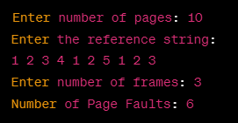

**Experiment 10**

**Aim:** File operation system calls (open, read, close, append etc.) in C

**Code:**

#include <stdio.h>

#include <stdlib.h>

#include <string.h>

int main()

{

char filename[50], content[1000];

int choice, len;

printf("Enter file name: ");

scanf("%s", filename);

printf("Choose an option:\n");

printf("1. Write to file\n");

printf("2. Read from file\n");

printf("3. Append to file\n");

scanf("%d", &choice);

switch (choice) {

case 1:

printf("Enter content to write to file:\n");

scanf("%s", content);

FILE *fp1;

fp1 = fopen(filename, "w");

if (fp1 == NULL) {

printf("Error opening file.\n");

exit(1);

}

fprintf(fp1, "%s", content);

printf("Successfully wrote to file.\n");

fclose(fp1);

break;

case 2:

FILE *fp2;

char ch;

fp2 = fopen(filename, "r");

if (fp2 == NULL) {

printf("Error opening file.\n");

exit(1);

}

printf("File contents:\n");

while ((ch = fgetc(fp2)) != EOF) {

printf("%c", ch);

}

fclose(fp2);

break;

case 3:

printf("Enter content to append to file:\n");

scanf("%s", content);

FILE *fp3;

fp3 = fopen(filename, "a");

if (fp3 == NULL) {

printf("Error opening file.\n");

exit(1);

}

fprintf(fp3, "%s", content);

printf("Successfully appended to file.\n");

fclose(fp3);

break;

default:

printf("Invalid choice.\n");

break;

}

return 0;

}

**Output:**

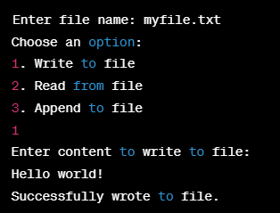

**Experiment 11**

**Aim:** Disk scheduling algorithms: FCFS, SSTF, SCAN, CSCAN, LOOK, CLOOK in C

**Code (FCFS):**

#include<stdio.h>

#include<stdlib.h>

int main()

{

int n, i, start, head_movement = 0;

printf("Enter the number of requests: ");

scanf("%d", &n);

int request[n];

printf("Enter the requests: ");

for(i = 0; i < n; i++){

scanf("%d", &request[i]);

}

printf("Enter the starting position of the disk head: ");

scanf("%d", &start);

// First come first serve algorithm

for(i = 0; i < n; i++){

head_movement += abs(request[i] - start);

start = request[i];

}

printf("Total head movement: %d\n", head_movement);

return 0;

}

**Output (FCFS):**

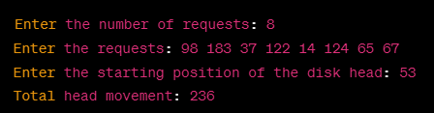

**Code (SSTF):**

#include<stdio.h>

#include<stdlib.h>

int main() {

int queue[20], q_size, head, i, j, seek = 0, diff;

float avg;

printf("Enter the size of queue: ");

scanf("%d", &q_size);

printf("Enter queue elements: ");

for (i = 0; i < q_size; i++) {

scanf("%d", &queue[i]);

}

printf("Enter initial head position: ");

scanf("%d", &head);

int temp, res[q_size + 1];

for (i = 0; i <= q_size; i++) {

res[i] = 0;

}

for (i = 0; i < q_size; i++) {

int min = 9999, min_index = -1;

for (j = 0; j < q_size; j++) {

if (!res[j]) {

diff = abs(head - queue[j]);

if (diff < min) {

min = diff;

min_index = j;

}

}

}

res[min_index] = 1;

seek += min;

head = queue[min_index];

}

printf("Total seek time: %d\n", seek);

avg = (float)seek / q_size;

printf("Average seek time: %.2f\n", avg);

return 0;

}

**Output (SSTF):**

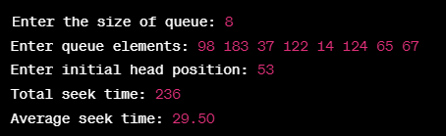

**Code (SCAN):**

#include<stdio.h>

#include<stdlib.h>

#include<math.h>

void SCAN(int arr[], int head, int size, int disk_size)

{

int i, j, seek_time = 0, current_head, direction;

int *visited = (int*)malloc(size * sizeof(int));

int *requests = (int*)malloc(size * sizeof(int));

for(i = 0; i < size; i++) {

requests[i] = arr[i];

visited[i] = 0;

}

current_head = head;

printf("Starting from %d ", current_head);

printf("SCAN path: ");

// determine initial direction

if(requests[0] > current_head) {

direction = 1; // towards right

} else {

direction = -1; // towards left

}

// SCAN algorithm

for(i = 0; i < size; i++) {

for(j = 0; j < size - i - 1; j++) {

if(requests[j] > requests[j + 1]) {

int temp = requests[j];

requests[j] = requests[j + 1];

requests[j + 1] = temp;

}

}

}

for(i = 0; i < size; i++) {

if(requests[i] == current_head) {

visited[i] = 1;

printf("%d ", requests[i]);

break;

}

}

// scan towards right direction

for(i = i + 1; i < size; i++) {

if(visited[i] == 0) {

seek_time += abs(current_head - requests[i]);

current_head = requests[i];

visited[i] = 1;

printf("%d ", requests[i]);

}

}

// scan towards left direction

if(direction == -1) {

for(i = 0; i < size; i++) {

if(visited[i] == 0) {

seek_time += abs(current_head - requests[i]);

current_head = requests[i];

visited[i] = 1;

printf("%d ", requests[i]);

}

}

}

printf("\nTotal seek time: %d\n", seek_time);

}

int main()

{

int size, disk_size, head;

printf("Enter size of request queue: ");

scanf("%d", &size);

int *arr = (int*)malloc(size * sizeof(int));

printf("Enter request queue:\n");

for(int i = 0; i < size; i++) {

scanf("%d", &arr[i]);

}

printf("Enter initial head position: ");

scanf("%d", &head);

printf("Enter size of disk: ");

scanf("%d", &disk_size);

SCAN(arr, head, size, disk_size);

return 0;

}

**Output (SCAN):**

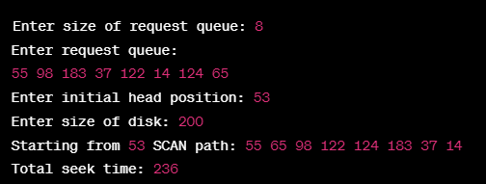

**Code (CSCAN):**

#include<stdio.h>

#include<stdlib.h>

void cscan(int queue[], int n, int head, int maxCylinders) {

int i, seek_time = 0, distance = 0, current = head;

int visited[n], order[n], index = 0;

for (i = 0; i < n; i++) {

visited[i] = 0;

}

// sort the queue

for (i = 0; i < n - 1; i++) {

int j, min = i;

for (j = i + 1; j < n; j++) {

if (queue[j] < queue[min]) {

min = j;

}

}

int temp = queue[min];

queue[min] = queue[i];

queue[i] = temp;

}

// move towards the right end

for (i = 0; i < n; i++) {

if (queue[i] >= current) {

distance = abs(queue[i] - current);

seek_time += distance;

current = queue[i];

visited[i] = 1;

order[index++] = queue[i];

}

}

// move towards the left end

seek_time += abs(maxCylinders - current);

current = 0;

for (i = 0; i < n; i++) {

if (!visited[i]) {

distance = abs(queue[i] - current);

seek_time += distance;

current = queue[i];

order[index++] = queue[i];

}

}

printf("CSCAN:\n");

printf("Total Seek Time: %d\n", seek_time);

printf("Order of Access: ");

for (i = 0; i < n; i++) {

printf("%d ", order[i]);

}

printf("\n");

}

int main() {

int n, head, maxCylinders, i;

printf("Enter number of disk requests: ");

scanf("%d", &n);

int queue[n];

printf("Enter disk requests: ");

for (i = 0; i < n; i++) {

scanf("%d", &queue[i]);

}

printf("Enter current head position: ");

scanf("%d", &head);

printf("Enter maximum number of cylinders: ");

scanf("%d", &maxCylinders);

cscan(queue, n, head, maxCylinders);

return 0;

}

**Output (CSCAN):**

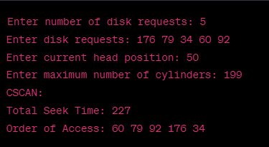

**Code (LOOK):**

#include <stdio.h>

#include <stdlib.h>

#include <stdbool.h>

int main()

{

int n, head, total_seek_time = 0, current_pos, i, j;

bool direction;

printf("Enter number of requests: ");

scanf("%d", &n);

int requests[n];

bool visited[n];

printf("Enter requests:\n");

for (i = 0; i < n; i++) {

scanf("%d", &requests[i]);

visited[i] = false;

}

printf("Enter initial head position: ");

scanf("%d", &head);

printf("Enter direction (0 for left, 1 for right): ");

scanf("%d", &direction);

current_pos = head;

if (direction) {

// sort requests in ascending order

for (i = 0; i < n-1; i++) {

for (j = i+1; j < n; j++) {

if (requests[i] > requests[j]) {

int temp = requests[i];

requests[i] = requests[j];

requests[j] = temp;

}

}

}

// service requests to the right of current position

for (i = 0; i < n; i++) {

if (!visited[i] && requests[i] >= current_pos) {

total_seek_time += abs(requests[i] - current_pos);

current_pos = requests[i];

visited[i] = true;

}

}

// service remaining requests to the left

for (i = n-1; i >= 0; i--) {

if (!visited[i]) {

total_seek_time += abs(requests[i] - current_pos);

current_pos = requests[i];

}

}

} else {

// sort requests in descending order

for (i = 0; i < n-1; i++) {

for (j = i+1; j < n; j++) {

if (requests[i] < requests[j]) {

int temp = requests[i];

requests[i] = requests[j];

requests[j] = temp;

}

}

}

// service requests to the left of current position

for (i = 0; i < n; i++) {

if (!visited[i] && requests[i] <= current_pos) {

total_seek_time += abs(requests[i] - current_pos);

current_pos = requests[i];

visited[i] = true;

}

}

// service remaining requests to the right

for (i = n-1; i >= 0; i--) {

if (!visited[i]) {

total_seek_time += abs(requests[i] - current_pos);

current_pos = requests[i];

}

}

}

printf("Total seek time: %d\n", total_seek_time);

return 0;

}

**Output (LOOK):**

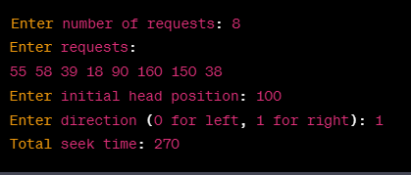

**Code (CLOOK):**

#include <stdio.h>

#include <stdlib.h>

void clook(int arr[], int head, int n)

{

int i, j, total = 0;

int range = abs(head - arr[0]);

int left = arr[0];

int right = arr[n - 1];

int visited[n];

for (i = 0; i < n; i++) {

visited[i] = 0;

}

printf("C-LOOK Disk Scheduling Algorithm\n");

printf("Initial Head Position: %d\n", head);

printf("Seek Sequence is: %d ", head);

for (i = 0; i < n; i++) {

if (arr[i] < head) {

visited[i] = 1;

total += abs(head - arr[i]);

head = arr[i];

printf("%d ", head);

}

}

printf("%d ", left);

total += abs(head - left);

head = left;

for (i = n - 1; i >= 0; i--) {

if (!visited[i]) {

total += abs(head - arr[i]);

head = arr[i];

printf("%d ", head);

}

}

printf("\nTotal Seek Time: %d\n", total);

}

int main()

{

int n, i, head;

printf("Enter the number of disk requests: ");

scanf("%d", &n);

int arr[n];

printf("Enter the requests sequence: ");

for (i = 0; i < n; i++) {

scanf("%d", &arr[i]);

}

printf("Enter the initial head position: ");

scanf("%d", &head);

clook(arr, head, n);

return 0;

}

**Output (CLOOK):**

