Synopsis

On
AI-Enabled Smart Campus With Wireless Sensor Network.



Group ID: BCAIAA22
Team Details

Enrolment No. | Name of Student | Class
ADT23SOCB0201 | Aryan Dhondage | LYAIA02
ADT23SOCB0671 | Om Teke | LYCSF 3
ADT23SOCB0058 | Aditya Bade | LYAIA02
ADT23SOCB0080 | Aditya Nalge | LYAIA02

Under the Guidance of Dr. Tushar Mote Sir

Department of Computer Science & Engineering

MIT School of Computing

Title of the Project
AI-Enabled Smart Campus With Wireless Sensor Network.

Abstract
This project proposes an AI-enabled Smart Campus Wireless Sensor Network (WSN) for intelligent campus energy management. Multiple ESP32-based sensor nodes equipped with current and voltage sensors continuously monitor electricity consumption across classrooms, laboratories, and other campus facilities. Sensor data is transmitted using MQTT to a FastAPI backend, stored in a centralized database, analyzed using machine learning algorithms for energy demand forecasting and anomaly detection, and visualized on a Streamlit dashboard. The proposed solution detects abnormal energy consumption patterns, predicts future electricity demand, and provides actionable insights for optimizing campus energy usage, resulting in measurable cost savings and a scalable architecture for smart-campus deployments.

Introduction / Background
Educational institutions such as engineering colleges operate numerous classrooms, computer laboratories, libraries, seminar halls, and server rooms that consume significant amounts of electricity. Electricity bills represent one of the largest recurring operational expenses for a campus, yet most institutions have no real-time visibility into where, when, and how that energy is being consumed. Traditional approaches rely on monthly utility bills or manual meter readings, which provide no actionable data about consumption patterns, wasteful usage, or equipment anomalies. The proposed system integrates IoT sensor networks, AI/ML-based analytics, and a cloud-ready software stack to provide real-time energy monitoring, intelligent anomaly detection, and demand forecasting across campus facilities.

Problem Definition
Design and implement a scalable wireless sensor network capable of monitoring real-time electricity consumption across multiple campus locations, transmitting energy data wirelessly, storing readings centrally, applying machine learning for anomaly detection and energy demand forecasting, and presenting actionable insights through a real-time dashboard. The core problem is to detect abnormal energy consumption and predict future campus electricity demand before excessive usage or equipment faults translate into avoidable costs.

Objectives
  - Design wireless energy sensor nodes using ESP32 with current and voltage sensing modules.
  - Monitor real-time electricity consumption (voltage, current, power, energy) across multiple campus locations.
  - Implement MQTT-based communication between sensor nodes and the backend server.
  - Develop a FastAPI backend and centralized database for energy data storage and retrieval.
  - Build a real-time Streamlit dashboard with building-wise consumption visualization and alerting.
  - Implement AI-based anomaly detection to identify abnormal energy consumption patterns.
  - Develop energy demand forecasting models to predict future campus electricity requirements.
  - Create a scalable and extensible smart-campus architecture for future multi-domain deployment.

Scope of the Project
The project focuses on developing an AI-enabled smart campus energy management system that collects real-time electricity consumption data using ESP32-based sensor nodes with current and voltage sensors, transmits it wirelessly via MQTT, analyzes it using AI/ML for anomaly detection and demand forecasting, and displays actionable insights on a Streamlit dashboard. The system is designed to cover classrooms, laboratories, the library, and server rooms across the campus. It is scalable and can be extended to water management, occupancy monitoring, smart buildings, and other IoT-based energy optimization environments.

Proposed System
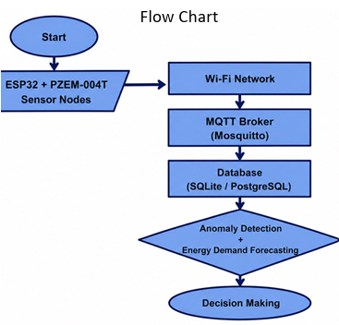

- System Requirements
  - Arduino IDE
  - Python
  - FastAPI
  - Mosquitto MQTT Broker
  - SQLite/PostgreSQL
  - Streamlit
  - Git & GitHub

Hardware Requirements :

Component | Qty | Purpose | Approx.
ESP32 Dev Board | 4 | Sensor Node Controller | ₹2,000
PZEM-004T Energy Sensor | 4 | Voltage, Current, Power & Energy Measurement | ₹1,600
Breadboard | 4 | Prototype Circuit | ₹500
Jumper Wires | 1 Pack | Connections | ₹250
USB Cables | 4 | Programming & Power | ₹500
USB Hub/Power | 1 | Power Supply | ₹800
Miscellaneous | - | Connectors etc. | ₹500

AI Module
The AI module uses historical energy consumption data to detect abnormal electricity usage patterns, forecast future demand, and generate optimization recommendations for campus facility managers.
  - Isolation Forest for real-time anomaly detection in energy consumption data
  - Random Forest / LSTM for energy demand forecasting and peak-load prediction
  - K-Means Clustering for building-wise consumption profiling and usage pattern analysis
  - Energy wastage detection and automated alert generation for abnormal consumption events
  - TinyML-based Edge AI on ESP32 for on-device anomaly detection (future enhancement)

- Estimated Budget:
The estimated implementation cost is between ₹9,000 and ₹11,000, making the project affordable for a student team while demonstrating industry-relevant technologies. The primary hardware components are the ESP32 development boards and PZEM-004T energy monitoring modules, with the remainder covering breadboards, jumper wires, USB cables, and miscellaneous connectors.

Applications
  - Smart Buildings and Commercial Offices
  - Hospitals and Healthcare Facilities
  - Industrial Facilities and Manufacturing Plants
  - Data Centres and Server Room Monitoring
  - Residential Societies and Apartment Complexes

Future Scope
  - Integration with campus water management and occupancy monitoring modules to build a comprehensive smart campus platform.
  - LoRa-based long-range wireless communication to support large-scale campus deployments.
  - Mobile application support for facility managers to monitor energy usage on the go.
  - Solar energy monitoring integration to support campus renewable energy tracking.

Expected Outcomes
The project demonstrates an end-to-end AI-enabled IoT system capable of real-time campus energy monitoring, intelligent anomaly detection, energy demand forecasting, and building-wise consumption profiling. The system will provide facility managers with actionable insights to reduce electricity waste, detect equipment faults early, and optimize energy scheduling, demonstrating a measurable and practical application of wireless sensor networks combined with machine learning in a real campus environment.

Conclusion
The proposed AI-Enabled Smart Campus Wireless Sensor Network for Intelligent Campus Energy Management integrates embedded systems, wireless communication, backend development, databases, machine learning, and data analytics into a single practical and impactful solution. By focusing on energy management as the core campus problem, the project addresses a real and measurable challenge faced by educational institutions while demonstrating strong AI and analytics capability. The project is technically feasible, cost effective, and directly aligned with the learning outcomes of a final-year B.Tech (AI & ML) program.

References
  - A. Kumar and S. Sharma, "IoT based energy monitoring and management system for smart buildings," International Journal of Advanced Research in Computer Science, vol. 9, no. 2, 2018.
  - OASIS Standard, "MQTT Version 5.0," MQTT.org, 2019.
  - F. T. Liu, K. M. Ting, and Z.-H. Zhou, "Isolation Forest," in Proc. IEEE International Conference on Data Mining (ICDM), 2008, pp. 413-422.
  - Espressif Systems, "ESP32 Series Datasheet," 2023.
  - FastAPI Documentation, Sebastian Ramirez, https://fastapi.tiangolo.com/, accessed 2025.
  - Streamlit Inc., "Streamlit Documentation," https://docs.streamlit.io/, accessed 2025.

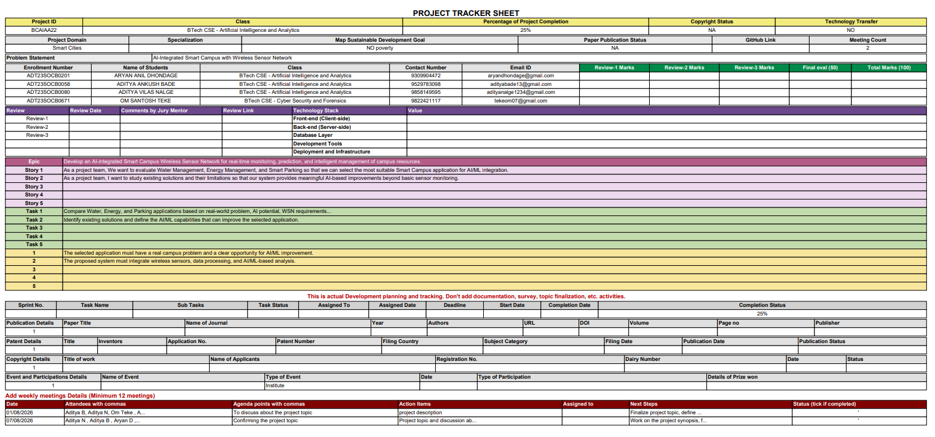
16.Project Tracker Sheet

