StockAnalyser

How-to-use guidebook and instructions

1. This stock analysis data-driven web app combines multiple technical analysis indicators and conversational data analysis using Retrieval Augmented Generation1 libraries like llama-index2 and OpenAI LLM Wrappers.
2. It pulls historical and real-time data from yahoo finance and National Stock Exchange3 and uses analysis parameters like Exponential Moving Averages4 coupled with Simple Moving Averages5 which is further supported by Bollinger Bands and Support Resistance Levels.
3. It uses TradingView API to perform market sentiment analysis and adds extra supporting indicators like the stochastic oscillators and RSI levels.
4. The user is required to combine these analyses using the visual indicators that are plotted along the dynamic and interactive stock graphs generated using plotly.
5. These analyses coupled with the ‘past 7 days trending stock watchlist’ will help make users take accurate financial decisions.
6. In case the user(s) are not able to understand any particular graph(s), in that case our Google-Gemini-Vision-Pro wrapper helps the user(s) to generate visual chart analysis.
7. Integrating Llama-index enables us to build and additional RAG app that enables conversation to be held between the user(s) and the retrieved data(s)

[1]

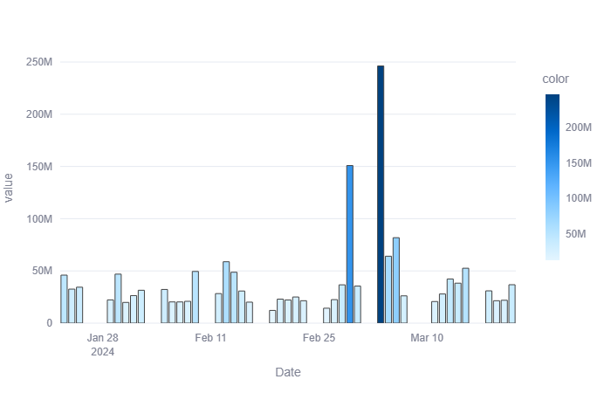

Stock volume refers to the number of shares of a particular stock that are traded during a given period of time, typically within a trading day. Volume can provide insight into market sentiment. Higher volume typically indicates higher interest and activity in a stock, suggesting greater investor confidence or volatility. Conversely, lower volume may suggest lacklustre interest or uncertainty.

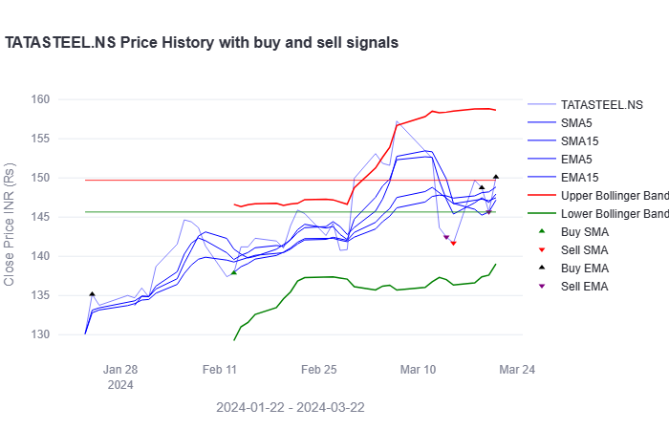

This is an example technical analysis chart, which shows a combination of multiple stock analysis indicators. It shows the Bollinger Bands, Buy and Sell Signals and Support-Resistance levels altogether. All of the charts are dynamic and interactive (i.e you can interact with the charts by hovering over them)

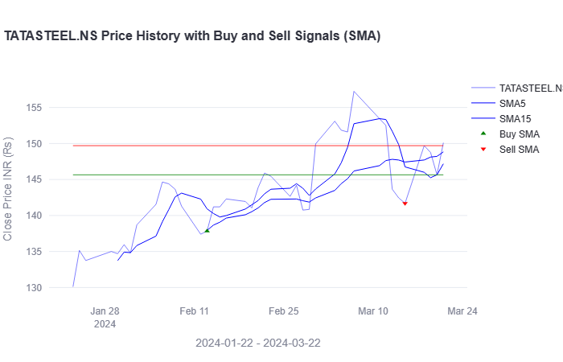

This chart shows the Buy/Sell signals w.r.t to SMA (Simple Moving Average indicators). The Green Up Triangle shows possible buy points and the Red Down Triangle shows probable sell points. We suggest considering only the SMA Buy Points (they are more accurate)

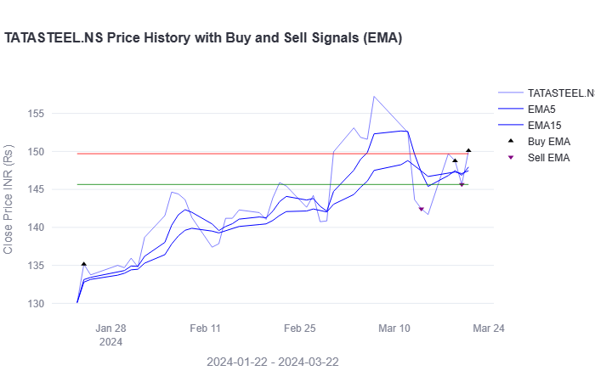

This chart shows the Buy/Sell signals w.r.t to the EMA (Exponential Moving Averages) indicators. The Black Up Triangle gives a probable buy position and the Purple Down Triangle gives the probable sell positions. (Again, Buy signals should be considered due to more accuracy)

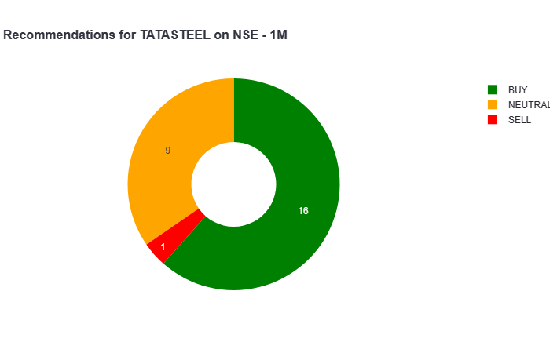

This Donut Chart shows the overall Buy/Sell probability of the stock based on multiple market parameters and technical analytical indicators combined. It gives the overall Market Mood and Analysis.

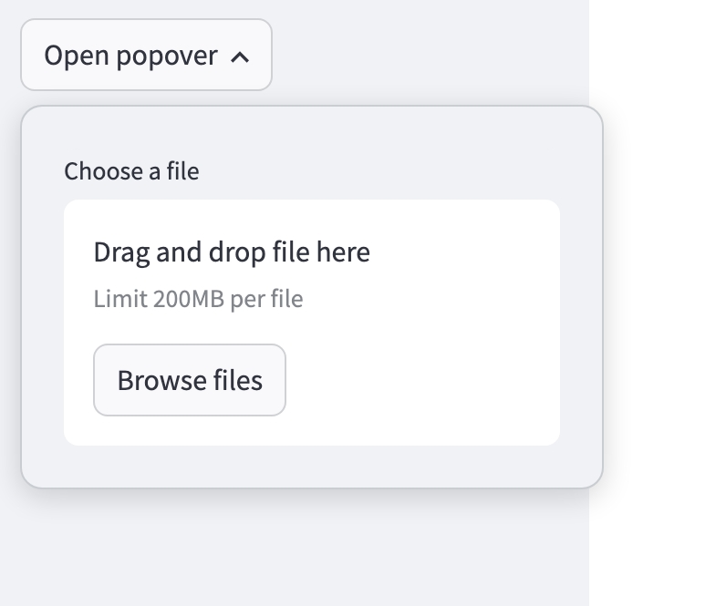

The user can upload the chart and get an explanation

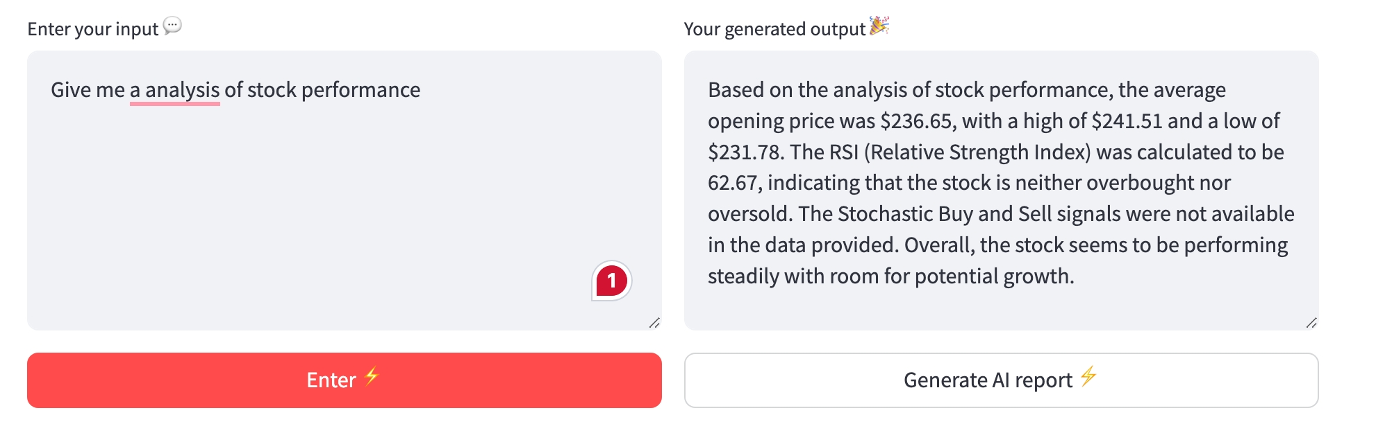

The RAG System enables conversational data analysis and Q&A session(s) between the data and the user

## How to use the app?

1. The Stock Volume Chart is compared with the Stock Price chart to find out possible patterns
2. The SMA Green Buy Indicators indicates that the stock prices might go up. They are comparatively less accurate but coupled with the EMA Buy signals can prove to be great accurate indicators.
3. The EMA Black Buy Indicators indicates that the stock prices might go up. They are comparatively more accurate and efficient. If there is a cluster of EMA Buy Signals and SMA Buy Signals near or at the same location at the stock price chart, than it is recommended to strongly go for the Buying option (The Stock Price will rise rapidly)
4. The Bollinger Bands can be used for risk assessment, to check if the stock prices have probability of a sudden down or up bounce after the SMA and EMA signals.
5. The Support-Resistance bands can be used to further strengthen the probability to check if prices will go up or below.
6. At the end, the overall market analysis donut chart can be used to solidify the buy/sell positions.

NOTE:

This app is best suited for short to medium-term investments, typically spanning around one month. It is not optimised for day-trading strategies. The current iteration of Veracity is intended primarily as a supplementary tool for assessing potential Buy Positions.

1. Retrieval Augmented Generation: Retrieval-Augmented Generation (RAG) is the process of optimising the output of a large language model, so it references an authoritative knowledge base outside of its training data sources before generating a response. Large Language Models (LLMs) are trained on vast volumes of data and use billions of parameters to generate original output for tasks like answering questions, translating languages, and completing sentences.

   2 llama-index: **LlamaIndex** bridges custom data sources with large language models (LLMs) like GPT-4. It simplifies connecting data to LLMs for powerful applications.

   3 National Stock Exchange (NSE): The **National Stock Exchange of India Limited (NSE)** is one of the leading stock exchanges in India, based in Mumbai. It has been a pioneer in Indian financial markets, providing modern, fully automated electronic trading.

   4,5 EMA (Exponential Moving Average) and SMA (Simple Moving Average): Certainly! **EMA (Exponential Moving Average)** and **SMA (Simple Moving Average)** crossovers are popular trading strategies.

   1. **EMA Crossover**: This occurs when a short-term EMA (e.g., 12-day) crosses the long-term EMA (e.g., 50-day). A bullish crossover happens when the short-term EMA crosses above the long-term EMA, indicating an uptrend
   2. **SMA Crossover**: In this strategy, the SMA identifies the longer-term trend and potential support/resistance areas.

  