Project Requirements Document
SitePulse AI
SEO + AEO Website Advisor that audits any URL, generates prioritized recommendations, and produces improved drafts for simple sites.

Version | v1 (MVP)
Owner | Aryan Garg
Document Date | March 06, 2026
Product Type | Web application
Primary Outcome | Turn a URL into actionable SEO + AEO improvements, with deployable outputs for easy sites and blueprints for complex sites.

1. Executive Summary
SitePulse AI is a web platform that analyzes a user-provided website URL and generates clear, prioritized recommendations to improve SEO (search ranking) and AEO (being referenced correctly in AI answer engines).
- Input: a website URL (and optional page selection).
- Outputs: SEO score, AEO score, prioritized fixes with copy-ready examples, and exportable reports.
- Easy sites: generate an improved page (or small-site starter) that can be deployed.
- Complex sites: generate a sample upgraded page plus a rollout blueprint that can be applied across templates.

2. Problem Statement
Most SEO tools either overwhelm users with technical audits or provide generic advice without showing what to do next. At the same time, discovery is shifting toward AI answer engines where content must be structured and quotable to be cited.
- Users need ranked, actionable fixes instead of long checklists.
- Users need AEO-ready content blocks (definitions, steps, FAQs) that AI systems can quote.
- Users need concrete examples (before/after) to implement improvements quickly.

3. Goals and Success Criteria

3.1 Goals (MVP)
- Return SEO + AEO recommendations from a URL in under 3 minutes for typical sites.
- Provide copy-ready modules: titles, meta descriptions, outlines, answer blocks, FAQs, and JSON-LD.
- For easy sites, generate an improved page draft the user can publish with minimal edits.
- For complex sites, generate a high-quality sample plus a reusable pattern and rollout plan.

3.2 Success Metrics (MVP)
- Time to first meaningful output (TTFMO): < 60 seconds (show partial results progressively if needed).
- Completion rate: % of users who submit a URL and reach the results dashboard.
- Export/copy rate: % of users who copy at least one module or download an export.
- User satisfaction: users report the recommendations are specific, clear, and implementable.

4. Target Users
- Founders / small business owners who want organic growth without hiring an agency.
- Growth / marketing teams who want a repeatable SEO + AEO workflow.
- Agencies who want fast, client-ready audits and modular deliverables.

5. User Stories
- As a founder, I want a top 10 list of fixes ranked by impact so I know what to do first.
- As a marketer, I want an AEO question bank and quotable answer blocks for key pages.
- As an agency, I want a clean export (HTML/PDF) I can send to clients.
- As a user with a simple site, I want an improved page draft I can deploy.
- As a user with a complex site, I want a blueprint and a sample implementation to scale across templates.

6. Scope

6.1 In Scope (MVP)
- Analyze a single URL (plus user-selected pages).
- Generate SEO audit + AEO audit scores.
- Return prioritized recommendations with examples.
- Generate AEO Pack: definition, steps (if applicable), risks/tradeoffs, FAQs, FAQ JSON-LD, snippet library.
- Generate improved draft for one page when site is classified as easy.
- Exports: copy-to-clipboard + downloadable HTML report.

6.2 Out of Scope (MVP)
- Backlink outreach automation.
- Full-site rebuild for large, multi-template sites.
- Guaranteed ranking outcomes.
- Deep JS rendering of complex SPAs (supported later via headless rendering).

7. User Experience Requirements

7.1 Primary User Flow
- User enters URL on landing page.
- System detects key pages (homepage, conversion page, optional blog/docs) and allows selection.
- User clicks Analyze and sees progress UI.
- Results dashboard shows SEO score, AEO score, and Top 10 actions.
- User explores tabs: SEO Fixes, AEO Pack, Improved Draft/Blueprint, Export.
- User copies modules or exports report / improved draft.

7.2 UI Requirements
- Attractive, modular card-based UI.
- Clear progress indicators; partial results appear as soon as ready.
- Recommendation cards include: Issue, Why it matters, Fix, Copy-ready example, Impact/Effort tag.
- Draft preview supports side-by-side: Current vs Proposed (optional in v1.1).

8. Functional Requirements (MVP)

8.1 URL Ingestion and Parsing
- Accept input URL and validate it.
- Fetch HTML and parse: title, meta description, canonical, headings (H1/H2/H3).
- Extract main content text and detect thin/duplicative sections.
- Extract internal links and anchors (basic).
- Detect images and whether alt text exists.
- Detect structured data (JSON-LD) presence and types.
- Basic checks: robots.txt reachable; sitemap link discovery if present.

8.2 SEO Audit Engine
- Generate SEO score (0–100) based on rule-based checks + AI interpretation.
- Detect issues: weak/missing title/meta, H1 problems, intent mismatch, thin coverage, weak internal linking, unclear CTA on conversion pages.
- For each issue, return: description, impact rationale, and a concrete fix.

8.3 AEO Audit + AEO Pack
- Generate AEO score (0–100) based on answerability and quotability.
- Return: definition block, steps block (if relevant), risks/tradeoffs block, FAQ list (8–12), FAQ JSON-LD, snippet library (5–10).
- Ensure AEO output avoids hallucinating claims and uses cautious language for sensitive topics.

8.4 Recommendations (Prioritized)
- Return Top 10 recommendations ranked by Impact × Effort.
- Each recommendation includes: What to change, Why, Where (page section), and a copy-ready example.
- Provide 'Quick Wins' group (high impact, low effort).

8.5 Easy vs Complex Classification
- Heuristic classifier labels site/page as Easy or Complex.
- Easy signals: ≤5 pages, single purpose, mostly static content, simple navigation.
- Complex signals: docs/help center, multi-product, many templates, heavy JS rendering.
- User can override classification.

8.6 Content Generation Outputs

Easy Mode
- Generate improved draft for selected page: new structure, rewritten copy, updated title/meta, embedded AEO modules.
- Output formats: markdown + HTML template.

Blueprint Mode (Complex)
- Generate sample upgraded page (or key section) demonstrating the pattern.
- Provide module library: definition, steps, risks, FAQ, comparison, checklist.
- Provide rollout plan: apply modules to top pages, suggested internal links, topic clusters.

8.7 Export and Sharing
- Copy-to-clipboard per module (titles, meta, blocks, FAQ JSON-LD).
- Download an HTML report export.
- Download improved page as a zip (easy mode) in v1.1 (optional).

9. Non-Functional Requirements
- Performance: typical analysis completes in 1–3 minutes; partial results stream as available.
- Reliability: handle errors gracefully; show 'limited analysis' when parsing is restricted.
- Security: avoid storing site content by default; if saved, store minimally and securely.
- Safety: prevent fabricated claims; recommendations must be grounded in extracted content.
- Privacy: do not crawl gated/private pages unless user explicitly provides access.

10. High-Level Architecture

10.1 Frontend
- Next.js (or equivalent) web UI.
- Pages: Home (URL input), Results Dashboard, Project History (optional), Export View.
- Components: Score cards, Recommendation cards, AEO Pack modules, Draft preview, Export controls.

10.2 Backend
- API: /analyze, /generate_draft, /export.
- Parser service: fetch + extract page structure and content.
- LLM orchestrator: prompt templates for scoring, recommendations, AEO pack, rewrite.
- Optional job queue for long runs (v1.1+).

11. Agentic Workflow
The system runs as a controlled agent loop with human approval gates:
- Fetch and parse page(s).
- Extract signals (entities, key phrases, headings, missing modules).
- Infer intent (informational, transactional, comparative).
- Generate prioritized recommendations plan.
- Generate artifacts (SEO fixes, AEO pack, draft or blueprint).
- Run quality + safety pass (no hallucinated claims, cautious language).
- Human review and edits (user approves).
- Export / publish guidance.
- Measure outcomes and iterate (CTR, clicks, conversions).

Appendix A: Workflow Diagram
High-level agent workflow for SitePulse AI:
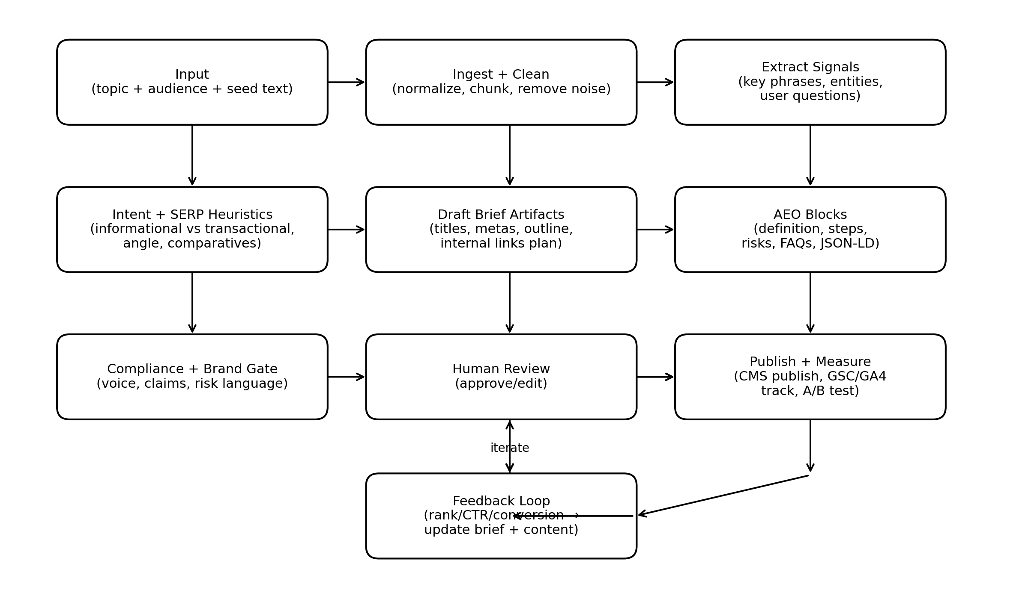

12. Milestones (Suggested)
Milestone | Scope | Target
M1: Analyzer MVP | URL fetch + parse + basic scores + Top 10 recommendations + AEO pack | Week 1–2
M2: Results UI | Dashboard with tabs, copy-to-clipboard, HTML export | Week 2–3
M3: Easy-mode Draft | Generate improved draft for one page (markdown + HTML) | Week 3–4
M4: Blueprint Mode | Sample rewrite + module library + rollout plan | Week 4–5
M5: Polish | Better scoring, templates, error handling, nicer UI | Week 5–6

