UI/UX INTERFACE ANALYSIS

DOMAIN: JOB PORTALS (LINKEDIN, NAUKRI.COM, INDEED)
STUDENT NAME: | Aryan Naik
PRN: | 1262242637
ROLL NO: | 15
PANEL: | F
REPORT DATE: | August 8, 2026

1. PROBLEM STATEMENT
Critical Analysis of Interfaces: Analyse any one interface (website or mobile app) that you have interacted with that could be designed better. Focus on the interface design problems, rather than their engineering faults or business problems. Comment on its learnability, usability, consistency and metaphors.
Modern job portals act as critical bridges between career development, recruiter discovery, and talent acquisition. While their functional purpose is identical—allowing candidates to apply for jobs and recruiters to post roles—the UI/UX choices defining these platforms lead to completely different interactive experiences. This report presents a critical, multi-dimensional interface analysis of three leading global job portals: LinkedIn, Naukri.com, and Indeed. This analysis explores how these platforms implement usability, learnability, error recovery, and the 8 Golden Rules of Interface Design, contrasting LinkedIn's social-networking approach, Naukri's resume-heavy database architecture, and Indeed's minimalist search engine interface.

2. PLATFORM OVERVIEWS

LinkedIn: Social Feed and Professional Network Hub
LinkedIn has transitioned from a traditional job board into a feed-driven social networking ecosystem. Its UI utilizes a clean, card-based interface centered around a scrolling feed, profile highlights, and messaging blocks. While highly effective for passive job discovery, peer validation, and recruiter outreach, the job application sub-pages and filters can feel crowded and secondary to sponsored community posts, occasionally driving up cognitive load.
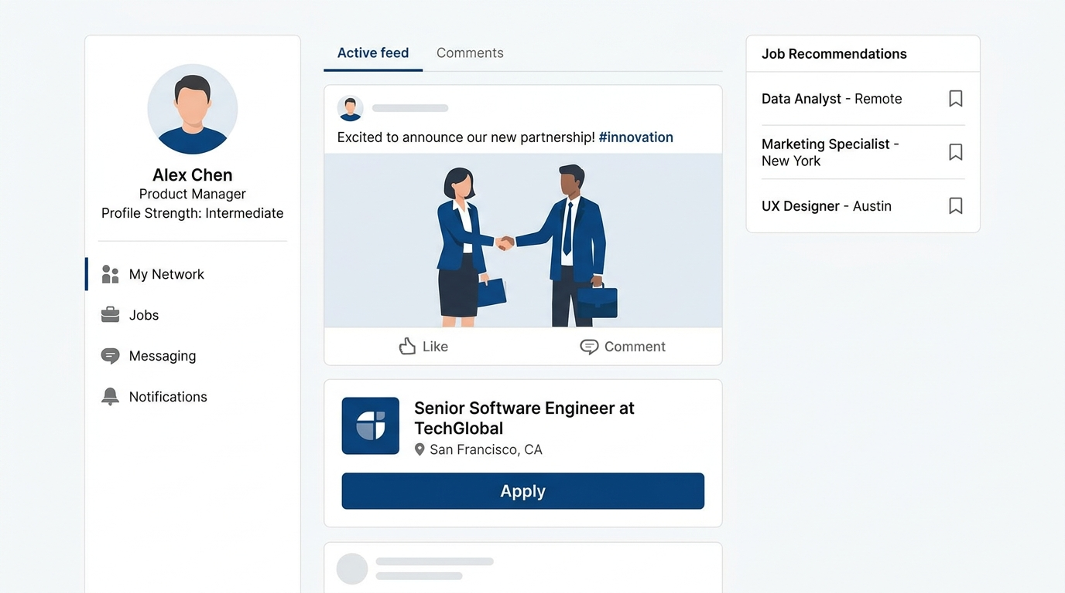
Figure 1: High-Fidelity UI Mockup of LinkedIn's Social Feed & Job Card Split View

Naukri.com: Content-Rich Database & Recruiter Portal
Naukri.com is a traditional job repository that prioritizes high-volume database matching. Its interface is extremely content-dense, highlighting extensive search query filter matrices (Experience, Location, Salary, Skills) and detailed recruiter dashboard portals. Naukri's design ensures highly targeted results but can feel visually overwhelming for freshers due to promotional advertisements, premium upsells, and crowded cards.
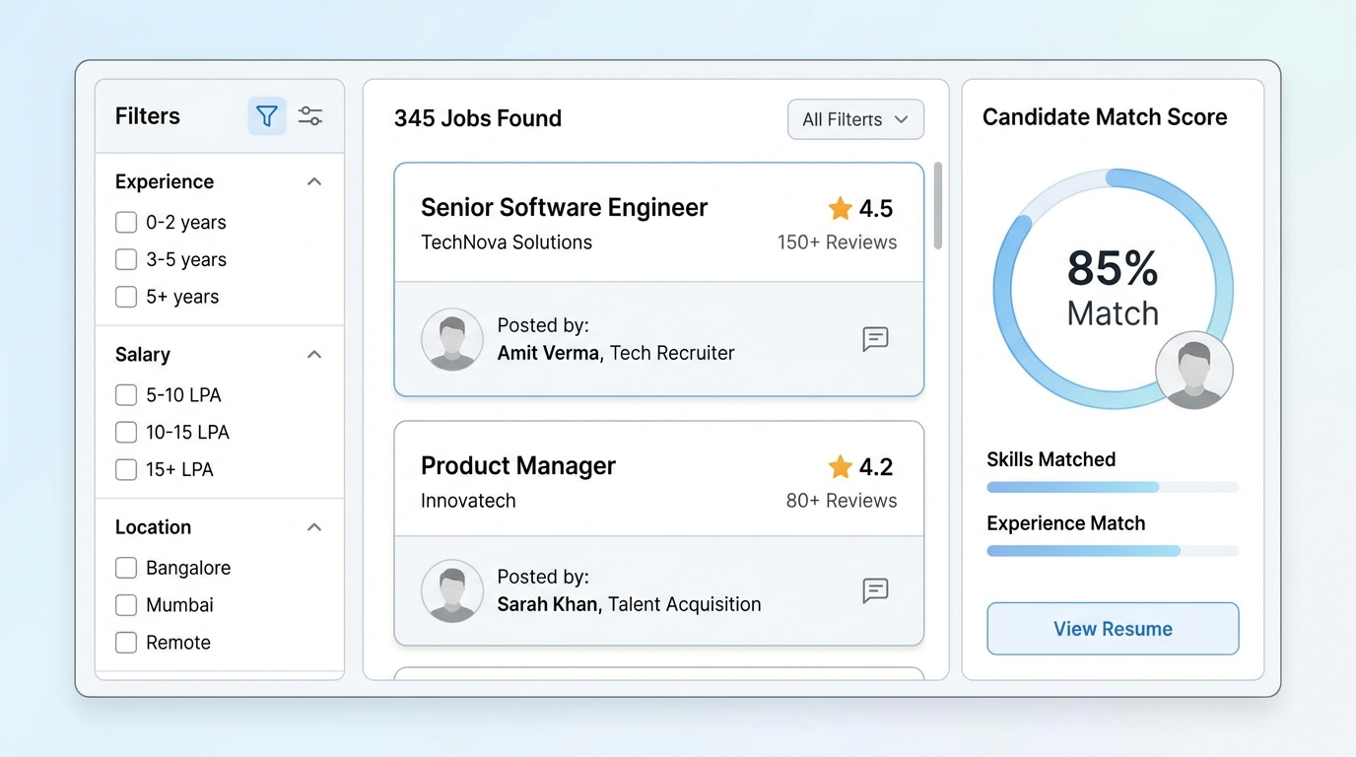
Figure 2: Content-Dense Search Interface Mockup of Naukri.com's Recruiter-Matcher Design

Indeed: Minimalist Search-First Engine
Indeed leverages a highly focused, search-engine-style aesthetic resembling Google's home page. Its primary interaction loop centers on a simple 'What' and 'Where' dual search field. Results are presented in a clean, split-screen layout—with a list of summary cards on the left and an active, scrollable detail view on the right. This design prioritizes high interaction efficiency and accessibility, minimizing distractions to support fast applications.
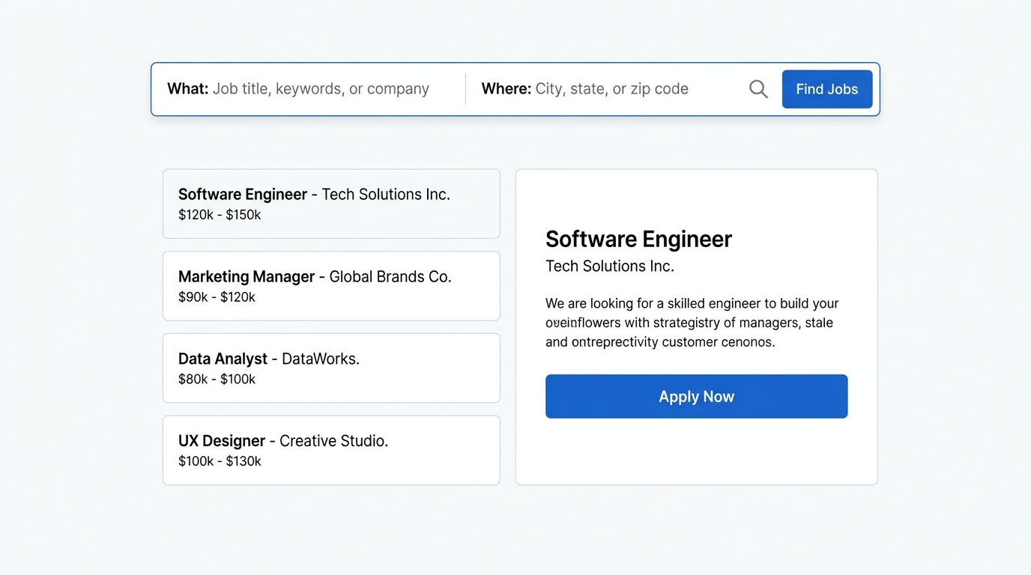
Figure 3: Minimalist Dual-Search Interface & Active Preview Deck of Indeed.com

3. COMPREHENSIVE INTERFACE COMPARISON MATRIX
The following multi-dimensional grid compares the three platforms across 18 distinct UX usability criteria, illustrating how their core interaction patterns support the job application and recruitment lifecycles.
Parameter | LinkedIn | Naukri.com | Indeed
Learnability | High. Social media-style scrolling feed makes learning instantaneous, though job filter mechanics require brief exploration. | Medium-Low. Highly technical, form-heavy registration and complex dashboard layers can confuse freshers. | Very High. Simple dual-field 'What' and 'Where' layout ensures immediately obvious onboarding.
Usability | Excellent for professional branding, networking, and message-driven job applications. | High utility for direct job matchmaking and salary searches, but suffers from informational noise. | Superb for direct, high-frequency job hunts. Focused split-screen speeds application loops.
Consistency | Strong visual design systems (LinkedIn 'Art Deco') maintain highly consistent iconographies, buttons, and layouts. | Moderate. Older modules and recruiter portals occasionally mismatch newer visual patterns. | High. Extremely uniform design language across standard lists, text hierarchies, and menus.
Use of Metaphors | Excellent. Uses 'Connections' (networking), 'Briefcase' (jobs), and 'Bookmarks' (shortlists). | Good. Employs familiar 'Resume Meter', 'Briefcase', and 'Shortlists' metaphors. | Moderate. Clean and highly literal search-engine metaphors (magnifying glass, tags), with few graphics.
Navigation Structure | Flat, feed-based hub, but job sub-screens involve nested, multi-tier navigation tracks. | Highly complex. Extensive hierarchical categories, drop-down headers, and recruiter settings. | Shallow and direct. Horizontal primary tabs (Find Jobs, Company Reviews, Salary Guide) prevent nesting.
Visual Hierarchy | Feed content, profile panels, and blue primary CTA buttons enjoy strong visual priority. | Extremely busy. Competing banners, ads, recruiter badges, and search cards require selective scanning. | Clear and clean. Highly prioritized job titles (blue) and recruiter names stand out over blank spacing.
Accessibility | Robust. Features detailed alt-text options, contrast compliance, and screen-reader optimizations. | Average. High content density, busy grids, and smaller text can create barriers for visually impaired users. | Excellent. Exceptional readability with high-contrast text, simple font hierarchies, and zero background clutter.
Responsiveness | Highly optimized mobile application with a fluid, adaptive mobile web layout. | Responsive listings, but dense filtering sidebars and tables are constrained on smaller screens. | Perfectly fluid. Adapts into a simple, single-column scrollable card stack on mobile screens.
Efficiency of Interaction | Moderate. Quick application buttons ('Easy Apply') are highly efficient, but networking requires effort. | Good. Highly granular advanced filters quickly slice thousands of matching jobs. | Exceptional. Split-screen layout allows reviewing and applying to dozens of jobs without loading new pages.
Feedback & System Status | Excellent. Dynamic real-time statuses like 'Application Viewed', 'Active', and instant message receipts. | Adequate. Form validations and profile completeness percentages give helpful system status. | Clear. Instant confirmation banners and persistent badges ('Applied', 'Seen by employer').
Error Prevention & Recovery | Inline form checks prevent missing contact info; easy single-click application withdrawal. | Strong validations on resume uploads, though excessive filters can sometimes result in zero-match states. | Minimalist validation ensures fewer errors. Easy back-buttons allow immediate query modification.
Aesthetic & Minimalist Design | Modern, visually engaging professional feed with neat card frames and solid margins. | Busy, cluttered, and advertisement-heavy, resulting in increased cognitive load. | Highly minimalist, focusing exclusively on core search content and readable job cards.
Content Readability | Highly scannable profiles and posts, but job description side-panels can have compressed spacing. | Dense typography and high table counts require focused scanning of text blocks. | Exceptional readability with spacious line heights, clean dark charcoal text, and crisp backgrounds.
Search & Discoverability | Excellent semantic recommendations based on user profiles, alongside highly specific boolean filters. | Unmatched filtering parameters (experience, functional area, salary) let power users find exact fits. | Superb key-phrase search. Highly discoverable search boxes require zero setup.
Performance Perception | Feels smooth, though media-heavy feeds can occasionally stutter on slower networks. | Can feel heavy and slower to populate due to numerous advertisement trackers and trackers. | Blazing fast. Loads search results instantly and moves between items with zero lag.
Trust & Credibility | High. Network validation, verified corporate profile badges, and employee links ensure credibility. | Strong. Established reputation in the domestic market, though sponsored profiles can raise skepticism. | High. Transparent salary ranges, employee reviews, and official employer verifications support reliability.
Personalization | Deeply tailored content feed, personalized job recommendations, and bespoke skills match indicators. | Highly personalized job alerts and custom profile matches based on resume keywords. | Subtle, effective recommendations based on search history and location tags.
User Satisfaction | High for passive networking and career building, but job hunt pages can feel exhausting. | Highly functional for active job search, though visual clutter can detract from the experience. | Very high for rapid, direct applications due to its frictionless, utilitarian flow.

4. DETAILED PARAMETER EVALUATIONS
To provide a deeper analysis, the following sections evaluate four critical UI/UX pillars: Learnability, Usability, Error Prevention/Recovery, and Use of Metaphors, rating each platform out of 10.

LEARNABILITY
Learnability represents the ease with which new users can navigate the system and accomplish tasks upon their first exposure.
Website | Rating | Key Usability Analysis & Points
Indeed | 9/10 | The layout mimics a standard web search engine. Simple query inputs mean new users do not need to learn custom interaction models to get immediate feedback.
LinkedIn | 9/10 | Relies heavily on social media scroll-and-interact design models that are deeply familiar to users, creating low friction for general navigation.
Naukri.com | 7/10 | The dense initial landing page, accompanied by intensive profile builder popups and promotional widgets, presents a steep learning curve for entry-level candidates.

USABILITY
Usability measures how effectively and efficiently users can achieve their target goals (e.g., finding relevant jobs, applying, and tracking responses).
Website | Rating | Key Usability Analysis & Points
Indeed | 9/10 | The split-screen layout presents listings and active descriptions side-by-side, maximizing interaction speed and reducing page navigation clicks.
LinkedIn | 8/10 | Highly optimized for passive job hunting and personal branding, but job matching relies heavily on sponsored algorithms, creating noise in candidate searches.
Naukri.com | 8/10 | Offers robust advanced query capabilities specifically tailored to domestic markets (salary, location, key skills), making it highly functional despite visual complexity.

ERROR PREVENTION AND RECOVERY
This parameter evaluates how effectively the platform prevents catastrophic errors and assists users in recovering from incorrect actions.
Website | Rating | Key Usability Analysis & Points
Indeed | 9/10 | Its minimalistic, streamlined data fields minimize entry mistakes. Form-field defaults are optimized, and deleting or modifying searches is straightforward.
LinkedIn | 8/10 | Warning states prevent submitting incomplete application forms, and users can quickly withdraw accidentally submitted resumes with a single tap.
Naukri.com | 7/10 | The form-heavy interface occasionally generates empty search results due to over-filtering. Advanced settings can confuse users, though form field validators are highly structured.

USE OF METAPHORS
Metaphors leverage existing real-world mental models to make digital interfaces more intuitive and comfortable to use.
Website | Rating | Key Usability Analysis & Points
LinkedIn | 9/10 | Utilizes clear, professional metaphors: 'Connections' for professional relationships, 'Briefcase' for career opportunities, and 'Feed' for community bulletin boards.
Naukri.com | 8/10 | Employs an intuitive 'Resume Score Meter' that acts as a dial of completeness, immediately conveying professional readiness and profile strength.
Indeed | 8/10 | Utilizes highly literal search and briefcase symbols. While highly recognizable, the platform relies less on visual metaphors in favor of highly direct textual interfaces.

5. APPLICATION OF THE 8 GOLDEN RULES OF INTERFACE DESIGN
Shneiderman's Eight Golden Rules are foundational guidelines for designing intuitive user interfaces. The matrix below outlines how each platform addresses or struggles with these principles.
Golden Rule | LinkedIn | Naukri.com | Indeed
1. Strive for consistency | Consistent application of primary button styles, font systems, and standardized job card elements throughout the application. | Maintains styling rules across core pages, but older recruiter management portals occasionally show structural discrepancies. | Very high consistency. The minimalist layouts utilize matching search boxes, filters, and standard font hierarchies across pages.
2. Seek universal usability | Highly usable for various skill levels, offering accessibility overlays and fluid mobile responsive scaling. | Highly specialized for intensive domestic job searches, which can be overwhelming for entry-level candidates due to high data density. | Designed for maximum universal usability, offering extreme interface clarity that benefits first-time and advanced users alike.
3. Offer informative feedback | Excellent feedback, including messaging statuses, real-time push alerts, and direct visual indications of 'Applied' statuses. | Provides systematic form validation feedback, checklist tracking, and profile completeness score updates. | Simple but highly effective. Delivers immediate status text overlays and confirmation popups upon submission.
4. Design dialogs to yield closure | Clear, structured stages for 'Easy Apply' flows culminate in a final success animation screen and tracking status. | Multi-stage resume submission screens provide clear final confirmation alerts, though transition delays can feel clunky. | Very direct. Simple step-by-step modal application screens end with a clear green completion checkmark.
5. Prevent errors | Prevents errors by auto-extracting profile details into application fields and highlighting missing required attachments. | Form field validation checks check for missing contact info, though over-filtering can lead to empty results. | Simple, non-restrictive filtering prevents complex state errors, and clear auto-fill reduces keyboard mistakes.
6. Permit easy reversal of actions | Allows immediate withdrawal of direct job applications and provides instant edits for posted comments or profile changes. | Profile edits are easily modified, though withdrawing applications through client company sites is more difficult. | Highly responsive back navigation. Modifying or clearing selected filters is an instantaneous single-click action.
7. Keep users in control | Users retain granular control over their feed visibility, messaging settings, profile views, and active job alerts. | Provides robust control over search filters, recruiter visibility states, and database profile updates. | Highly user-controlled. Users can directly modify their query, jump between tabs, and alter profile info seamlessly.
8. Reduce short-term memory load | Card-based feed and saved job side-panels allow users to quickly resume tasks without manual recall. | The extensive filters and multiple active pages can tax short-term memory during high-volume sessions. | Split-screen layout keeps active lists and full details visible at once, completely eliminating information recall effort.

6. SUMMARY & CONCLUSION
Each job portal utilizes a distinct user interface architecture that dictates how candidates search for and apply to jobs. LinkedIn represents the pinnacle of social networking integration, making job searches highly organic and relationship-driven, though introducing noise. Indeed represents the standard for interaction efficiency and clean, minimalist search-first patterns, reducing onboarding friction. Naukri.com, while visually dense and demanding to navigate, remains an essential high-volume recruiter tool in specific global markets. By applying proper usability rules, reducing cognitive load, and maintaining strong consistency, modern platforms can balance rich utility with clean, accessible design.

THANK YOU

