**SNIPS:**

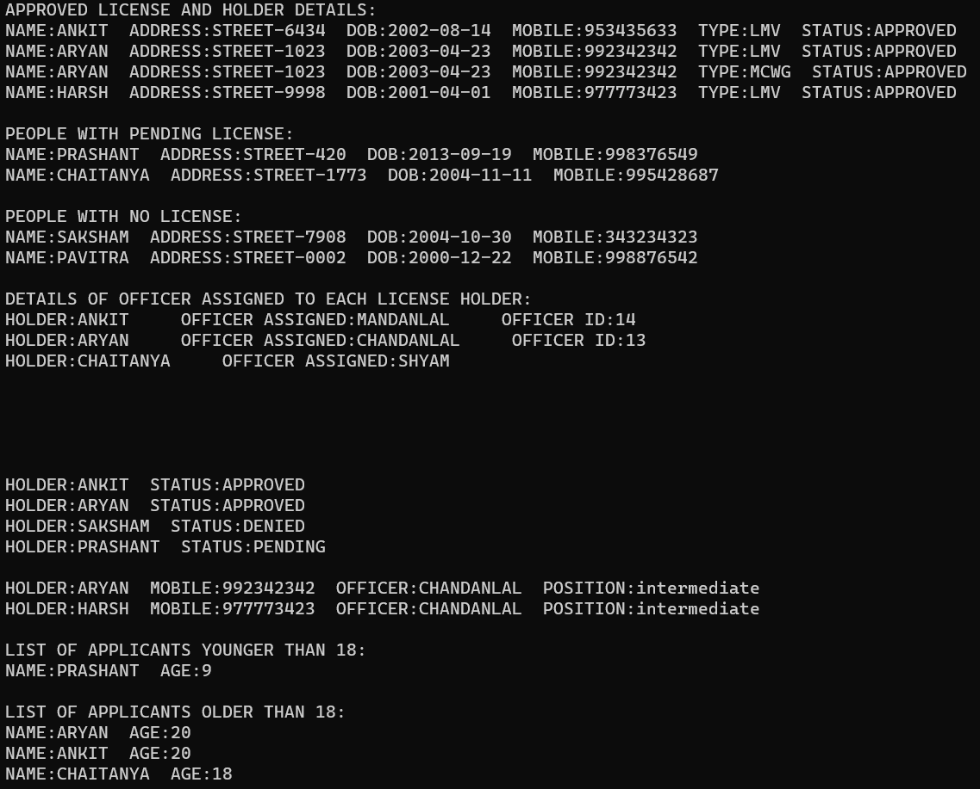

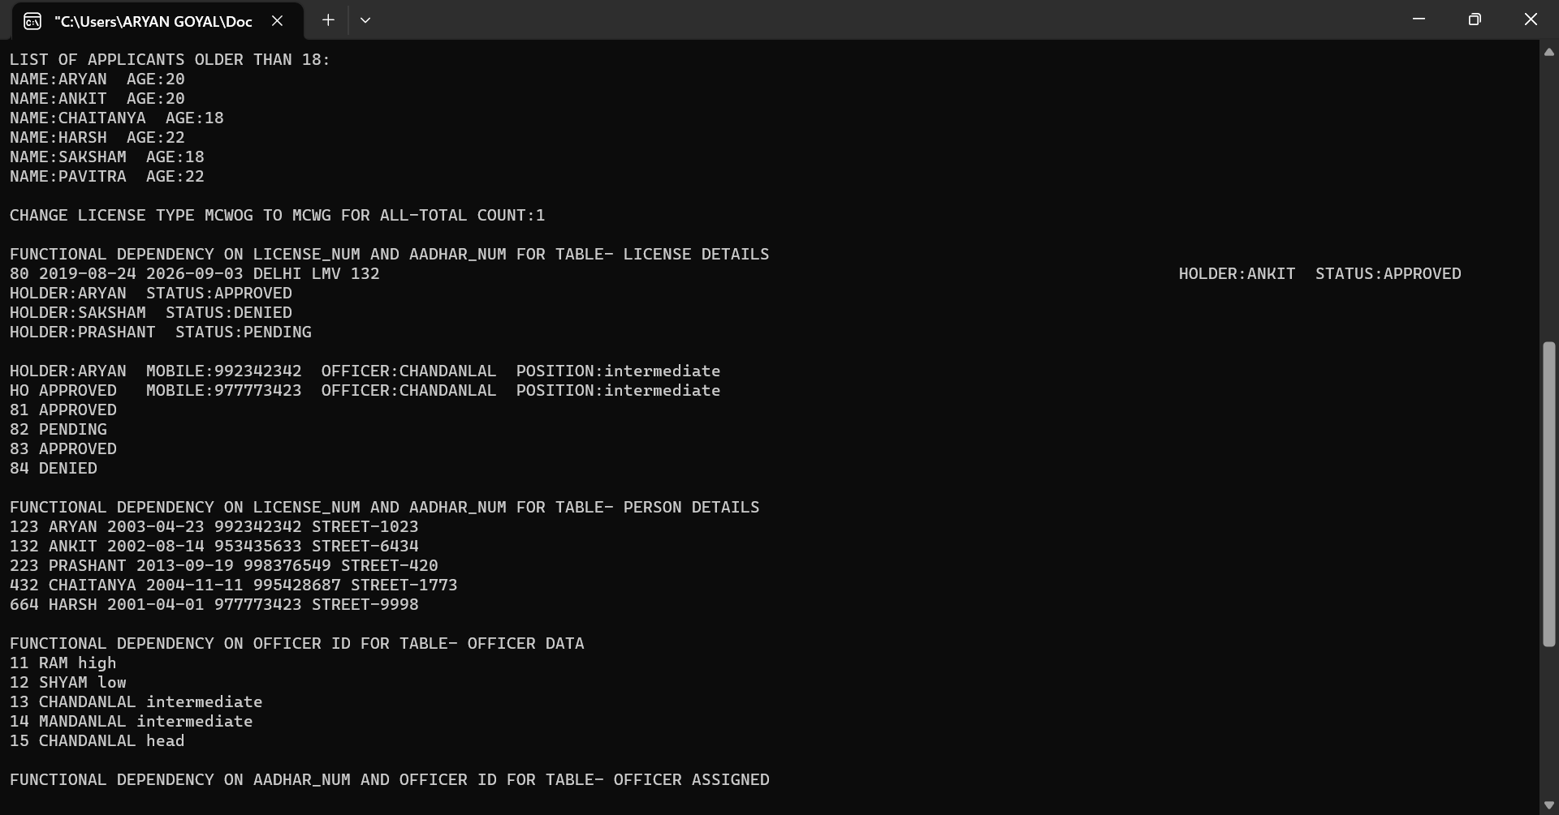

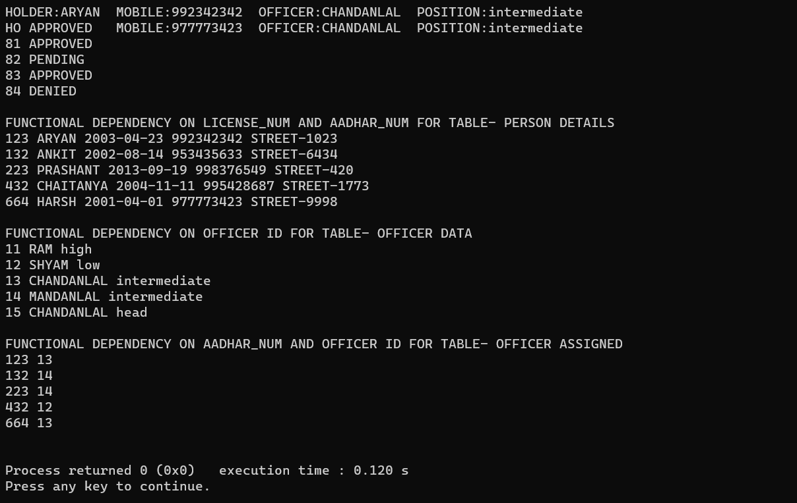

**OUTPUT TRANSCRIPT:**

APPROVED LICENSE AND HOLDER DETAILS:

NAME:ANKIT ADDRESS:STREET-6434 DOB:2002-08-14 MOBILE:953435633 TYPE:LMV STATUS:APPROVED

NAME:ARYAN ADDRESS:STREET-1023 DOB:2003-04-23 MOBILE:992342342 TYPE:LMV STATUS:APPROVED

NAME:ARYAN ADDRESS:STREET-1023 DOB:2003-04-23 MOBILE:992342342 TYPE:MCWG STATUS:APPROVED

NAME:HARSH ADDRESS:STREET-9998 DOB:2001-04-01 MOBILE:977773423 TYPE:LMV STATUS:APPROVED

PEOPLE WITH PENDING LICENSE:

NAME:PRASHANT ADDRESS:STREET-420 DOB:2013-09-19 MOBILE:998376549

NAME:CHAITANYA ADDRESS:STREET-1773 DOB:2004-11-11 MOBILE:995428687

PEOPLE WITH NO LICENSE:

NAME:SAKSHAM ADDRESS:STREET-7908 DOB:2004-10-30 MOBILE:343234323

NAME:PAVITRA ADDRESS:STREET-0002 DOB:2000-12-22 MOBILE:998876542

DETAILS OF OFFICER ASSIGNED TO EACH LICENSE HOLDER:

HOLDER:ANKIT OFFICER ASSIGNED:MANDANLAL OFFICER ID:14

HOLDER:ARYAN OFFICER ASSIGNED:CHANDANLAL OFFICER ID:13

HOLDER:CHAITANYA OFFICER ASSIGNED:SHYAM

HOLDER:ANKIT STATUS:APPROVED

HOLDER:ARYAN STATUS:APPROVED

HOLDER:SAKSHAM STATUS:DENIED

HOLDER:PRASHANT STATUS:PENDING

HOLDER:ARYAN MOBILE:992342342 OFFICER:CHANDANLAL POSITION:intermediate

HOLDER:HARSH MOBILE:977773423 OFFICER:CHANDANLAL POSITION:intermediate

LIST OF APPLICANTS YOUNGER THAN 18:

NAME:PRASHANT AGE:9

LIST OF APPLICANTS OLDER THAN 18:

NAME:ARYAN AGE:20

NAME:ANKIT AGE:20

NAME:CHAITANYA AGE:18

NAME:HARSH AGE:22

NAME:SAKSHAM AGE:18

NAME:PAVITRA AGE:22

CHANGE LICENSE TYPE MCWOG TO MCWG FOR ALL-TOTAL COUNT:1

FUNCTIONAL DEPENDENCY ON LICENSE_NUM AND AADHAR_NUM FOR TABLE- LICENSE DETAILS

80 2019-08-24 2026-09-03 DELHI LMV 132

HOLDER:ANKIT STATUS:APPROVED

HOLDER:ARYAN STATUS:APPROVED

HOLDER:SAKSHAM STATUS:DENIED

HOLDER:PRASHANT STATUS:PENDING

HOLDER:ARYAN MOBILE:992342342 OFFICER:CHANDANLAL POSITION:intermediate

HO APPROVED MOBILE:977773423 OFFICER:CHANDANLAL POSITION:intermediate

81 APPROVED

82 PENDING

83 APPROVED

84 DENIED

FUNCTIONAL DEPENDENCY ON LICENSE_NUM AND AADHAR_NUM FOR TABLE- PERSON DETAILS

123 ARYAN 2003-04-23 992342342 STREET-1023

132 ANKIT 2002-08-14 953435633 STREET-6434

223 PRASHANT 2013-09-19 998376549 STREET-420

432 CHAITANYA 2004-11-11 995428687 STREET-1773

664 HARSH 2001-04-01 977773423 STREET-9998

FUNCTIONAL DEPENDENCY ON OFFICER ID FOR TABLE- OFFICER DATA

11 RAM high

12 SHYAM low

13 CHANDANLAL intermediate

14 MANDANLAL intermediate

15 CHANDANLAL head

FUNCTIONAL DEPENDENCY ON AADHAR_NUM AND OFFICER ID FOR TABLE- OFFICER ASSIGNED

123 13

132 14

223 14

432 12

664 13

Process returned 0 (0x0) execution time : 0.120 s

Press any key to continue.