ATAL COMMUNITY DAY
HANDOUT
Online repository for the content
github.com/adiagr/atl

Breadboard connections
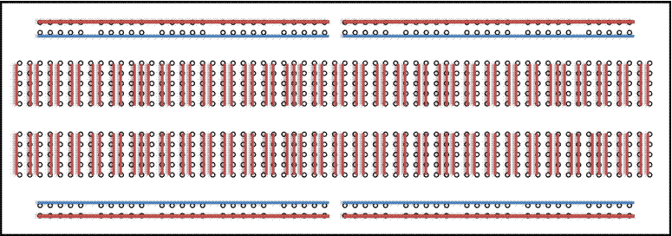

Circuit Diagrams
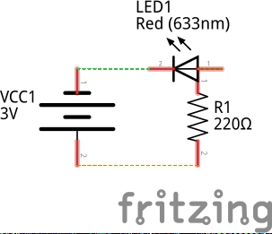
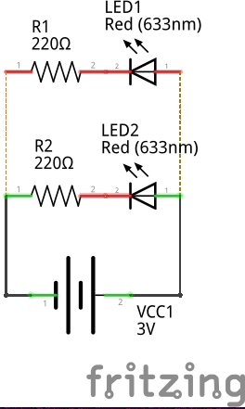
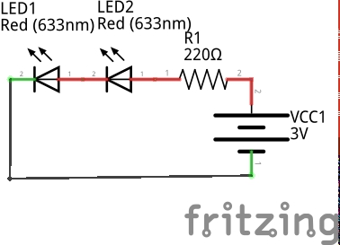
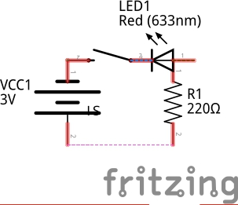

Normal LED Parallel LED Series LED LED with Switch

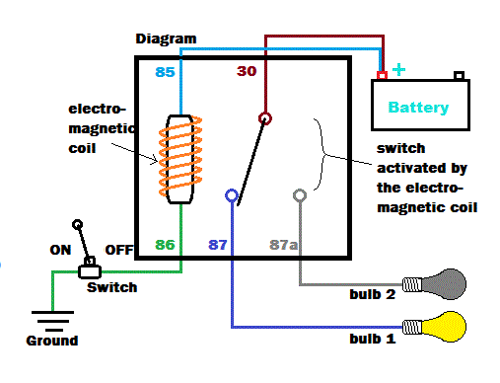

Relay

Common Sensors

Sensor Name | Means of operation | Uses
HCSR-04 Ultrasonic Sensor | Ultrasonic waves | Finding distance
IR sensor | Infrared Light | Distance, Gesture, Color
Light Dependent resistance | Visible Light | Color, ambient light intensity
DHT-11 Temprature humidity | Temprature and moisture | To measure temprature, humidity
MQ-2 Smoke Sensor | Coil | Detect Smoke, LPG, etc

Arduino Cheat Sheet
Remember!!

First set the input mode of the pin
USE:
pinMode(pinNumber, Mode[INPUT/OUTPUT])

Arduino is Case-Sensitive

void setup() executes only once before void loop(), do all your initializing in void setup()

Put your main code in void loop()
that will loop over and over

Output Functions:

digitalWrite(PinNumber, Mode[HIGH/LOW])

analogWrite(PinNumber, Value[0-255])

Input Functions

digitalRead(pinNumber)

analogRead(pinNumber)

pulseIn(pinNumber, type[HIGH/LOW])

Time

delay(Time-in-milliseconds)

delayMicroseconds(Time-in-microseconds)

Serial Functions

Serial.begin(Baud-Rate[9600])

Serial.println(“Message”) //This prints a new line

Serial.print(“This outputs in the same line”)

