Object Oriented Programming Lab

Name: Aryan Gupta
Scholar Number: 25P03F0033

Aim: Find whether you can declare a reference variable.
Observation: It will throw an error saying that a reference variable is not initialized.
Program:
Output:
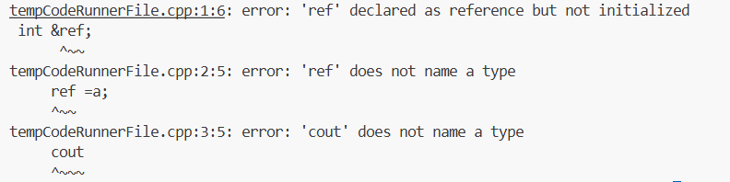

Aim: Write a function to calculate quotient and remainder and return both.
Program:
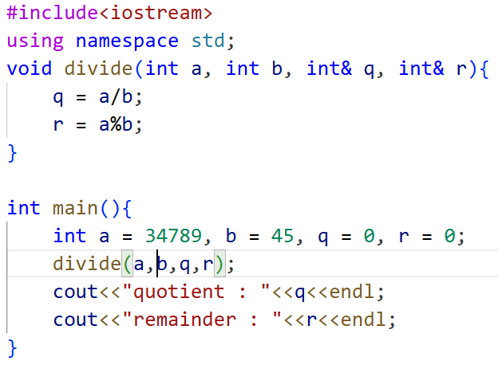
Output:
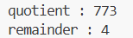

Aim: What if we change the values of a and b inside the function. How can we prevent that.
Observation: We can make use of const keyword in order to prevent changes to the original values that we are passing to the function while also making them reference variables in the function.
Program:
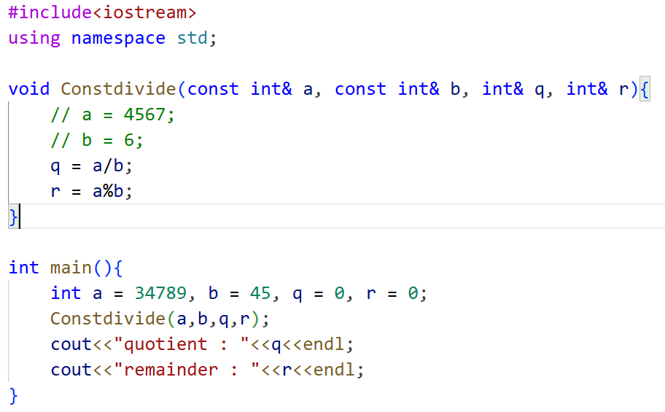
Output:
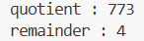

Aim: To understand how default arguments work in a function.
Observation: If an argument is not passed, the default value is used automatically.
Program:
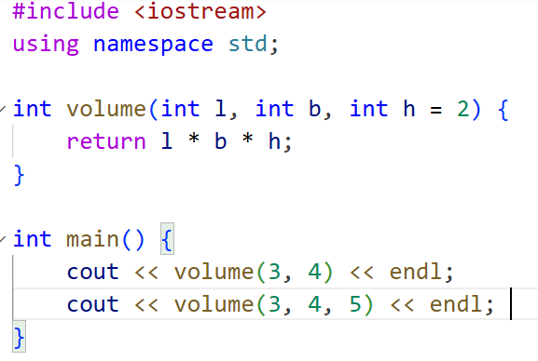
Output:
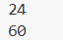

Aim: To show that default parameters can be skipped only from the rightmost side.
Observation: Arguments must be skipped from right to left, not from the middle.
Program:
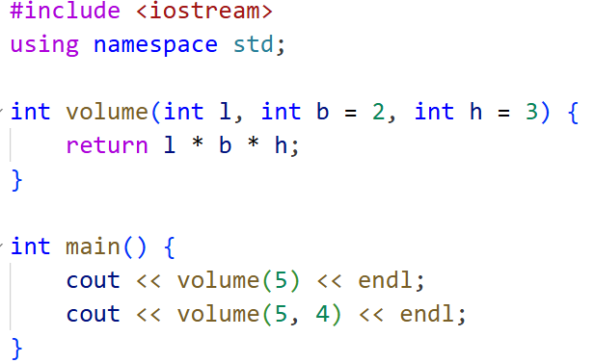
Output:
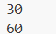

Aim: To observe how function call changes with different number of arguments.
Observation: Provided values replace defaults from left to right.
Program:
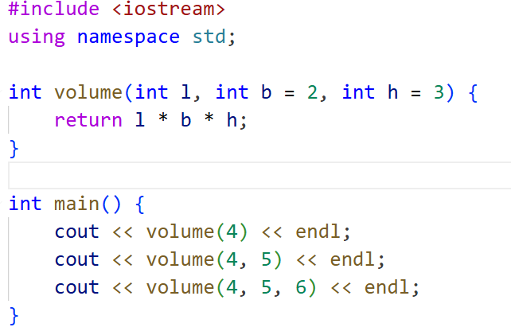
Output:
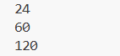
Aim: To verify whether middle arguments can be skipped.
Observation: Middle parameters cannot be skipped; only trailing ones can.
Program:
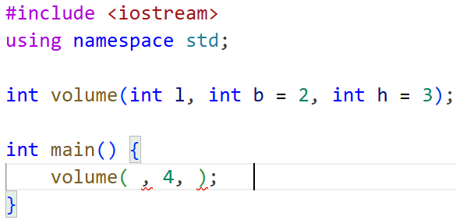
Output:
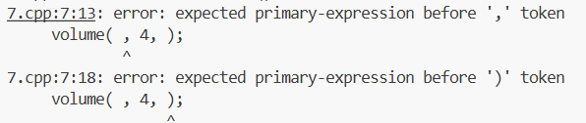

Aim: To find which default value is used when prototype and definition differ.
Observation: Default value from the prototype is used. The definition’s default is ignored.
Program:
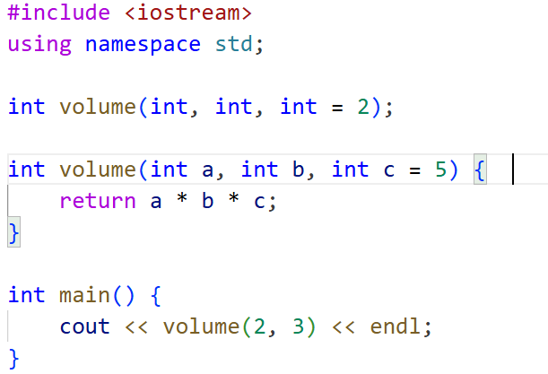
Output:
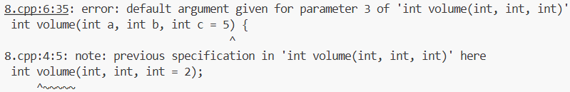

Aim: To show overloading using same function name with different parameter types but same return type.
Observation: Functions are overloaded based on parameter type, not return type.
Program:
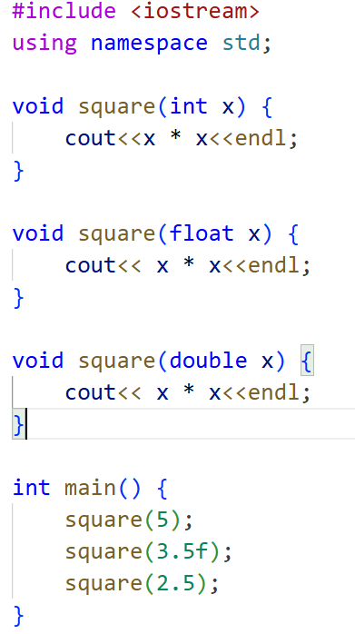
Output:
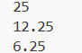

Aim: To check if functions can be overloaded only by changing return type.
Observation: Overloading is not allowed if only return type is different, it causes error.
Program:
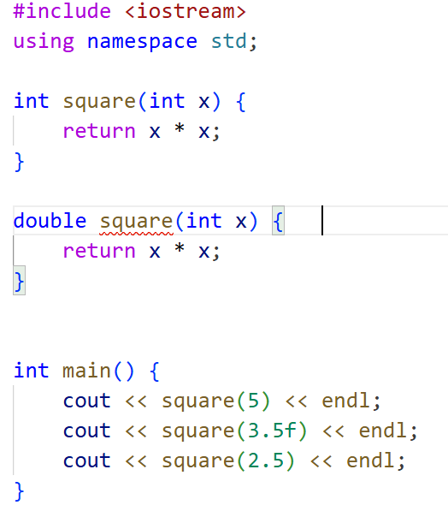
Output:
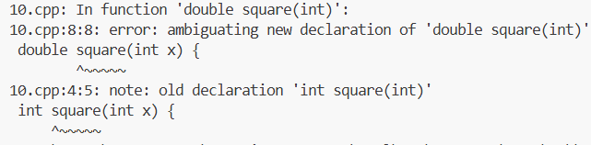

Aim: To see conflict between overloaded functions and default arguments.
Observation: Compiler gets confused because both functions match the call.
Program:
Example 1:
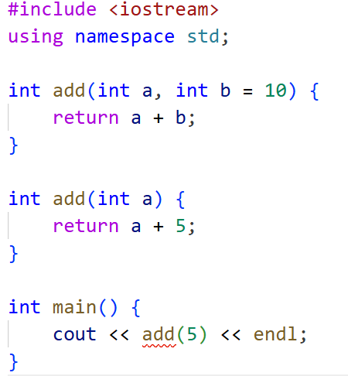

Example 2:
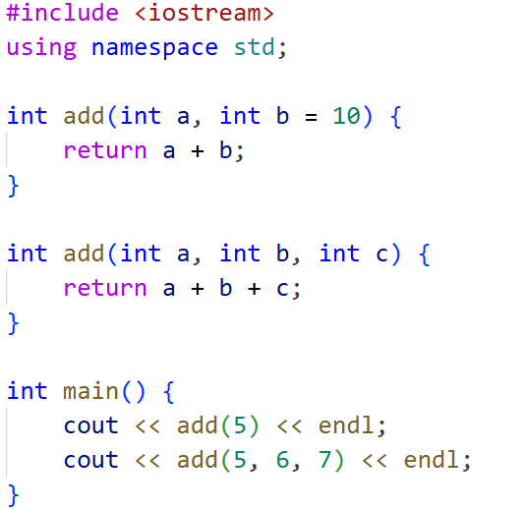
Output:
Example 1:
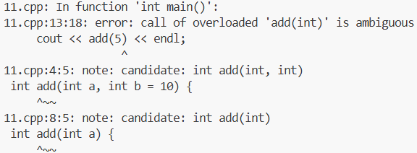
Example 2:
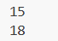
Aim:
Observation:
Program:
Output:

