Object Oriented Programming Lab

Name: Aryan Gupta
Scholar Number: 25P03F0033

Aim: Design a simple C++ program to print a statement.
Program:
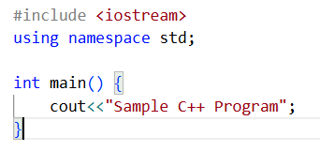
Output:

Aim: Write a C++ program to demonstrate the use of endl.
Program:
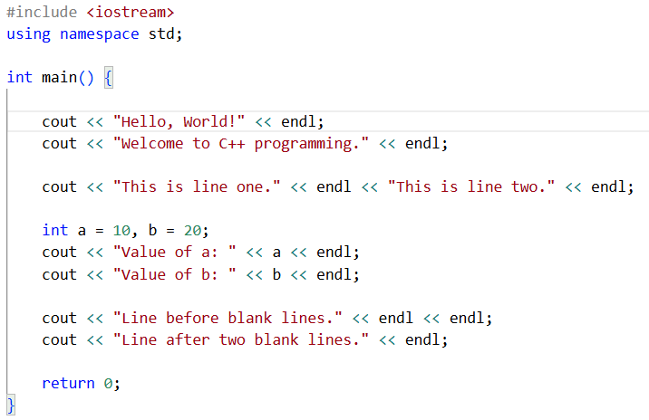
Output:
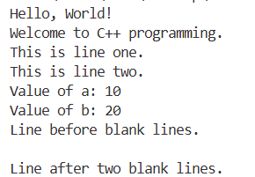

Aim: Write a C++ program to demonstrate how to input different types of data, store them into variables, and display them.
Program:
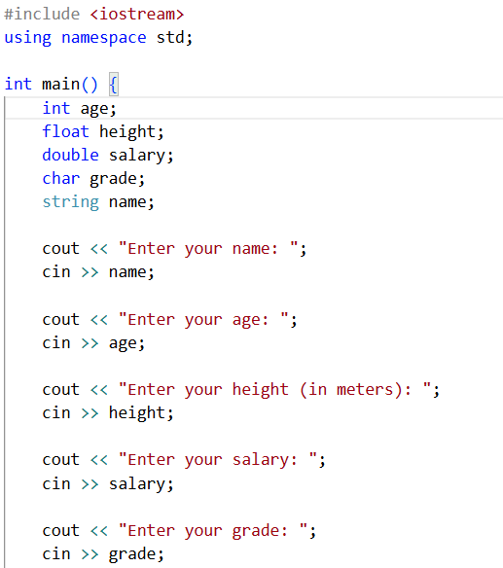
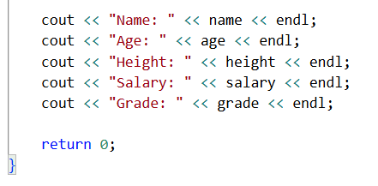
Output:
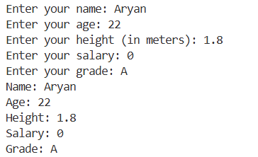

Aim: Demonstrate the working of different operators in C++.
Program:
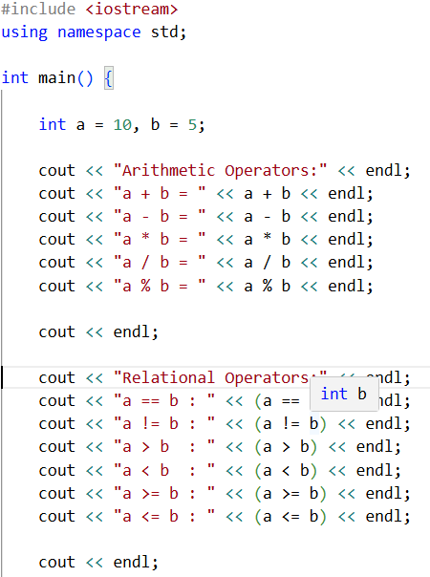

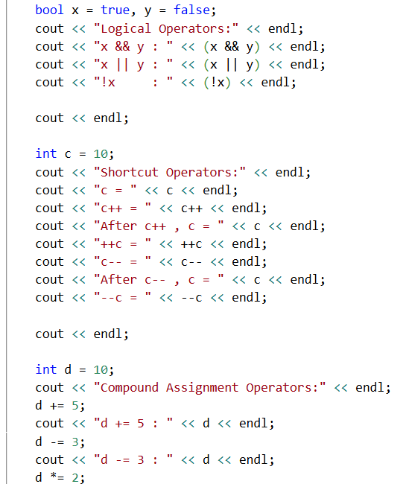
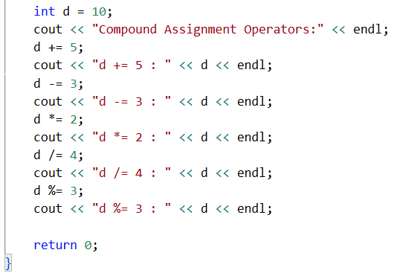
Output:
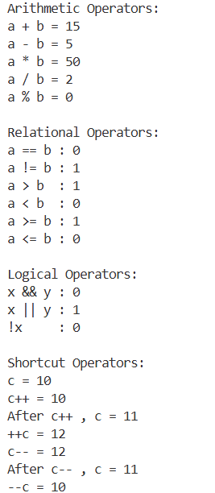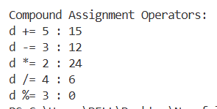

Aim: Identify what happens when you try storing the result of 18/4 into a variable.
Program:
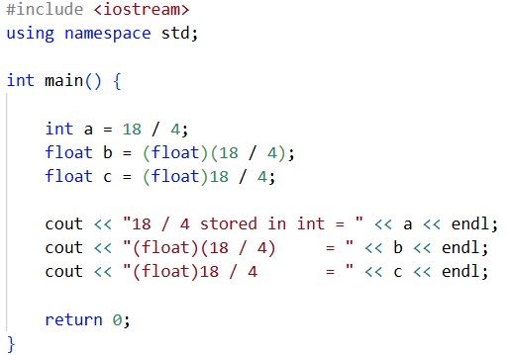
Output:
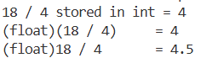
Aim: Demonstrate the difference between x++ and ++x.
Program:
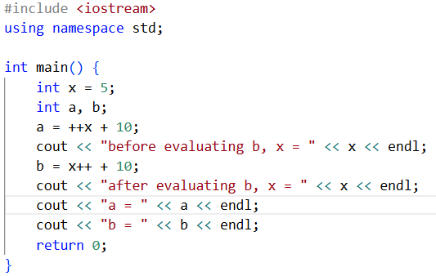
Output:
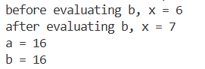

Aim:
Program:
Output:

