Certificate
This is to certify that the project report entitled “SignSpeak India: Real Time Indian Sign Language Accessibility Tool” has been prepared and submitted by [Student Name(s)], [Class/Division], Roll Number(s) [Numbers], for the subject Innovation during the academic year 2026-2027. The work has been carried out under the guidance of [Faculty Guide Name].
Guide Signature: ____________________ Course Coordinator: ____________________
Director / Head of Institute: ____________________ Date: ______________

Student Declaration
I/We declare that the project entitled “SignSpeak India: Real Time Indian Sign Language Accessibility Tool” is our own work prepared for the subject Innovation. Sources, third-party code, data, images, tools and materials used in the project are identified appropriately. The project status and limitations described in this report reflect the available implementation evidence.
Student Signature(s): ____________________ Date: ______________

Acknowledgement
I/We would like to thank [Faculty Guide Name] for guidance, [Department Name] and [Institute Name] for academic support, and the project team members and other contributors who assisted with the development of SignSpeak India. Please revise this acknowledgement to name only people and organisations that genuinely supported the project.

SignSpeak India
Project Report
Real time Indian Sign Language accessibility tool
Project overview, system design, implementation, and next steps
Purpose Translate webcam-captured sign gestures into readable text and optional spoken output, with a browser-based workflow and a Python inference service.

Executive summary
SignSpeak India is a prototype accessibility application for recognizing Indian Sign Language gestures from webcam video. The visible dashboard pairs a camera and live recognition experience with a sentence panel and text-to-speech control. The backend in this project provides a FastAPI service that accepts landmark sequences, validates their shape, runs model inference, and returns the predicted sign with confidence values.
The backend also includes tools for obtaining a targeted ISL500 landmark subset, converting variable-length hand sequences into fixed-length training examples, and collecting labeled examples from the browser. Successful end-to-end recognition depends on compatible inference artifacts in the sibling AI/ML project and a running browser frontend; those model files and frontend source are not included in this backend folder.

Project at a glance
Project | SignSpeak India
Primary use | Webcam-based sign recognition and text output
Frontend input | MediaPipe pose and two-hand landmarks in the browser
Sequence window | 30 frames
Backend | FastAPI with WebSocket prediction stream
Model input layouts | 225 pose-and-hand values or 126 hand-only values per frame

1 Problem and objectives
Communication barriers can make everyday interactions difficult for people who use sign language, especially when a conversation partner does not understand the signs. SignSpeak aims to provide an assistive bridge by interpreting a sequence of visual hand and body landmarks and presenting the recognized sign as text. The dashboard design also includes speech playback so generated text can be voiced aloud.
- Capture webcam frames and extract pose and hand landmarks in the browser.
- Send landmark data to a backend that can stream predictions as frames arrive.
- Present recognized signs and assemble them into a readable sentence.
- Support collecting labeled browser samples to help improve or adapt the recognition model.

2 User experience shown in the supplied image
The screenshot shows the SignSpeak India dashboard in an idle state. The camera preview is offline and the interface is waiting for a sign. A language selector is set to English (India); the right side contains a detected-sign status card and a sentence panel with controls to speak, clear, or copy text. A lower panel, labeled Browser Sample Recording Studio, lets a developer choose a target gesture and signer ID, record a 30-frame sample, or capture idle examples. The image shows zero samples recorded and an inventory that is still loading.
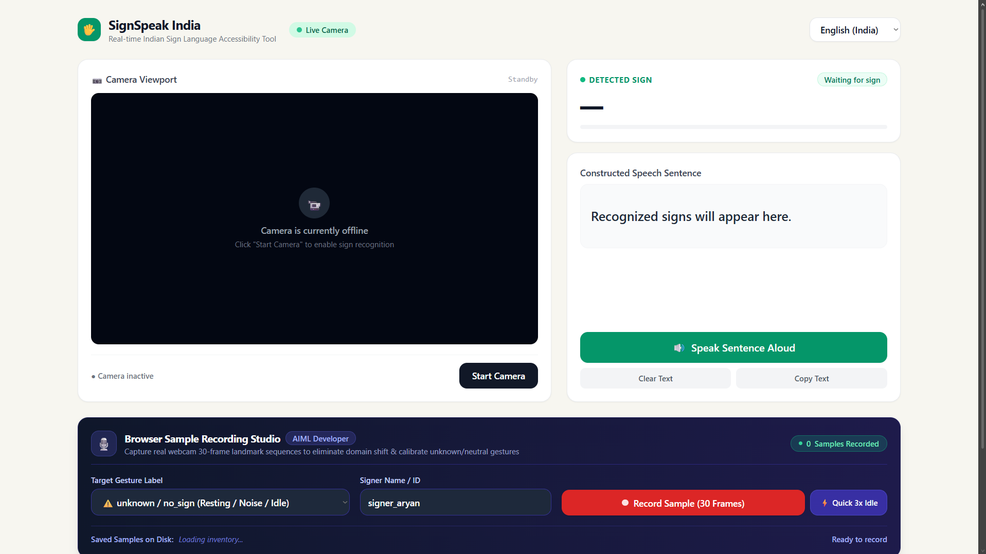
Figure 1. SignSpeak India dashboard and browser sample recording interface (provided project screenshot).

3 System design and data flow
The browser performs camera access and MediaPipe landmark extraction, then sends numeric frames to the backend. The backend keeps a rolling sequence buffer, waits until it contains 30 frames, and passes the sequence to the predictor. Prediction results include the winning label, confidence, and up to three ranked candidates. The dashboard can use those results to update detected-sign and sentence displays.
- Camera and landmark extraction: browser-side MediaPipe generates 225 values per frame: 99 pose values followed by 63 values for each of two hand slots.
- Transport: the browser sends one frame or a batch to the WebSocket endpoint at /ws.
- Validation and adaptation: the service rejects non-numeric, non-finite, or incorrectly sized frames. For a 126-feature hand-only model, it strips the first 99 pose values from browser frames.
- Inference: after the first 30 frames, a rolling 30-frame window is evaluated on each new frame.
- Presentation: prediction messages expose the sign, confidence percentage, ranked alternatives, and buffer size.

Backend endpoints
Endpoint | Purpose | Key behavior
/health | Readiness and model diagnostics | Returns ready/degraded status, sequence and feature dimensions, and model error when unavailable.
WebSocket /ws | Stream landmark frames and predictions | Buffers 30 frames, validates inputs, and returns prediction/status/error messages.
POST /api/save_sample | Save browser-recorded labeled samples | Accepts 225-feature frames, resamples sequences to 30 frames, and stores JSON by label.
GET /api/samples_summary | Summarize saved browser samples | Returns counts per class and total samples.

4 Data and model compatibility
The repository includes a dataset downloader that lists matching MediaPipe HDF5 files for 13 configured labels (actor, adult, afternoon, alive, alright, animal, bad, bag, ball, bank, bathroom, beautiful, and doctor). Download is opt-in through a command-line flag. A separate preparation script reads the HDF5 intermediate landmark arrays, checks for two hands with 21 landmarks and three coordinates each, resamples valid sequences to 30 frames, and writes a compressed NumPy archive with labels, signer IDs, source filenames, and metadata.
The checked-in dataset archive is about 5.1 MB. Its presence alone does not establish the number or quality of its samples; those details are stored in its metadata and were not used to claim training or recognition accuracy in this report. The preparation script notes that the converted data has 126 hand features per frame, while the browser emits 225 pose-plus-hand values. The backend bridges these formats for inference, but model training must use a feature layout consistent with its metadata.

5 Setup and operational requirements
- Install the backend requirements in an environment that can also access the sibling Aiml developer model directory.
- Run the API with Uvicorn from the dashboard project root; the README documents port 8000 and local development frontend ports 5500 and 5173.
- Provide inference.py, model_metadata.json, and a compatible .keras or .h5 model. Startup checks class mappings, model input and output dimensions, and the 30-frame sequence length.
- Open /health to verify readiness. Without model artifacts the HTTP service starts in degraded mode, and WebSocket clients receive a model-unavailable error.
- Configure SIGNSPEAK_ALLOWED_ORIGINS when serving the frontend from a non-default origin.

6 Current scope and constraints
This backend project supplies the prediction API and supporting data utilities; it does not contain the browser application source or the sibling predictor/model artifacts described in the README. Therefore, code inspection can confirm the API contract and data-processing behavior, but cannot establish live camera operation, deployed availability, recognition accuracy, or the quality of the model. The supplied screenshot represents the interface appearance at capture time and visibly shows an offline camera and waiting state.

7 Recommended next steps
- Integrate and document the frontend and backend together, including camera permissions, WebSocket connection handling, and user-facing error states.
- Confirm that the production model expects 225 or 126 features per frame, and verify its class labels and metadata against the training pipeline.
- Evaluate recognition with signer-separated validation data and report per-class results, confusion patterns, and confidence calibration before presenting accuracy claims.
- Test sample capture and inference with representative lighting, camera positions, signing speeds, and signer variation.
- Document consent, retention, access controls, and deletion procedures for webcam-derived landmark samples.

Conclusion
SignSpeak combines a browser-based sign-recognition interface with a backend designed for streaming landmark inference and sample collection. The repository demonstrates a clear processing contract and handles two model feature layouts. Completing and evaluating the model/frontend integration is the key step before the interface can be described as a validated real-time accessibility tool.

