Chapter 1

Data Communications (1.1)
Data communications refers to the exchange of data between two devices via a transmission medium (like a wire cable). For this to work, the devices must be part of a system made of hardware (equipment) and software (programs).
The effectiveness of this system depends on four fundamental characteristics:
- Delivery: The system must deliver data to the correct destination. It must be received only by the intended device or user.
- Accuracy: The data must be delivered exactly as sent. If data is corrupted during transmission and not fixed, it is useless.
- Timeliness: Data must arrive on time.
  - Real-time transmission: Delivering data as it is produced (essential for video/audio) without significant delay.
- Jitter: This refers to the variation in packet arrival time.
  - Example: If video packets are sent every 30ms, but some arrive in 30ms and others in 40ms, the video quality will be uneven.

Components (1.1.1)
A data communications system is made up of five distinct parts.
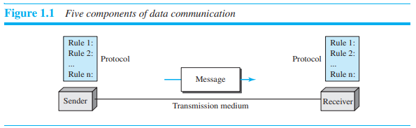
⚙️ Diagram Breakdown: The 5 Components
- Message: The information to be communicated (Text, numbers, pictures, audio, video).
- Sender: The device sending the data (Computer, phone, camera).
- Receiver: The device receiving the message.
- Transmission Medium: The physical path the message travels on.
  - Examples: Twisted-pair wire, fiber-optic cable, radio waves.
- Protocol: A set of rules that govern the communication.
  - The Analogy: A protocol is like a language agreement. If two devices are connected but have no protocol, it is like a person speaking French trying to talk to a person who only speaks Japanese—they can hear each other, but they cannot communicate.

Data Representation (1.1.2)
Information comes in different forms, and computers represent them differently:
- Text: Represented as a bit pattern (sequence of 0s and 1s).
  - Unicode: The prevalent coding system today, using 32 bits to represent symbols from any language.
  - ASCII: An older system that now makes up the first 127 characters of Unicode.
- Numbers: Directly converted to binary numbers to make mathematical operations simpler (unlike text, which uses codes like ASCII).
- Images: Composed of a matrix of pixels (picture elements).
  - Resolution: More pixels = better resolution but higher memory usage.
  - Pixel Depth: A black-and-white image uses 1 bit per pixel. Grayscale or color uses more bits.
  - RGB: Color method combining Red, Green, and Blue.
- Audio: Recording of sound. It is continuous (analog), unlike text or numbers which are discrete.
- Video: Recording of pictures/movies. Can be continuous (TV camera) or a combination of discrete images arranged to show motion.

Data Flow (1.1.3)
Communication between devices can happen in three different modes.
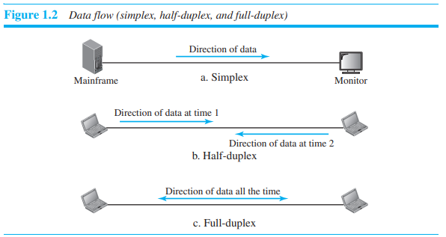
⚙️ Diagram Breakdown: Modes of Transmission
1. Simplex
- Concept: Communication is unidirectional. Only one device can transmit; the other can only receive.
- The Analogy: A one-way street. Traffic can only ever go one way.
- Example: A keyboard (only sends input) and a monitor (only accepts output).
2. Half-Duplex
- Concept: Both stations can transmit and receive, but not at the same time.
- The Analogy: A one-lane road where traffic is allowed in both directions. When cars are going one way, the other side must wait.
- Example: Walkie-talkies. You have to say "Over" to let the other person speak.
3. Full-Duplex
- Concept: Both stations can transmit and receive simultaneously.
- The Analogy: A two-way street where traffic flows in both directions at the same time.
- Example: A telephone network. You can hear the other person talk while you are talking.

Networks (1.2)
A network is the interconnection of a set of devices capable of communication.
- Host (End System): Devices like a large computer, desktop, laptop, phone, or security system.
- Connecting Device: Hardware that links the network together, such as:
  - Router: Connects the network to other networks.
  - Switch: Connects devices together.
  - Modem: Changes the form of data (Modulator-Demodulator).

Network Criteria (1.2.1)
For a network to be effective, it must meet three key criteria:
- Performance: Measured by transit time (time to travel from A to B) and response time (time elapsed between inquiry and response).
  - Throughput vs. Delay: These are often contradictory. Sending more data increases throughput but may cause congestion, which increases delay.
- Reliability: Measured by the frequency of failure, the time it takes to recover, and robustness during a catastrophe.
- Security: Protecting data from unauthorized access, damage, and data loss.

Physical Structures (1.2.2)

Type of Connection
A link is the communications pathway that transfers data. Devices can be connected to these links in two ways.

⚙️ Diagram Breakdown: Connection Types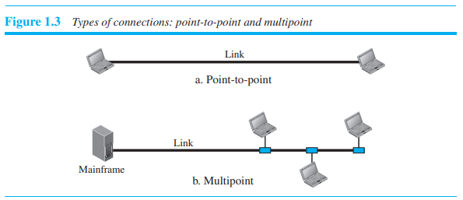
1. Point-to-Point
- Concept: A dedicated link between exactly two devices. The entire capacity is reserved for them.
- The Analogy: A television remote. When you change the channel, you establish a direct line between the remote and the TV. No one else shares that connection.
2. Multipoint (Multidrop)
- Concept: More than two specific devices share a single link.
- The Analogy: A conference call. The capacity of the "line" is shared among multiple people, either by everyone talking at once (spatially shared) or taking turns (time-shared).

Physical Topology
The topology is the geometric representation of how devices (nodes) are connected. There are four basic layouts.
⚙️ Diagram Breakdown: The 4 Topologies

1. Mesh Topology

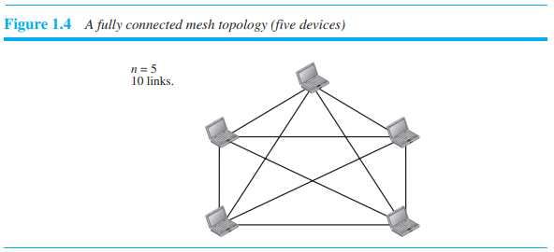
- Concept: Every device has a dedicated point-to-point link to every other device.
- The Formula: For n nodes, you need n(n - 1) / 2 duplex links.
- Pros:
  - No Traffic Problems: Dedicated links mean no sharing load.
  - Robust: If one link breaks, the others still work.
  - Privacy: Only the intended recipient sees the message.
- Cons:
  - Expensive & Bulky: Requires a massive amount of cabling and I/O ports.
  - Installation: Difficult to wire every device to every other device.
- Use Case: Regional telephone offices.

2. Star Topology

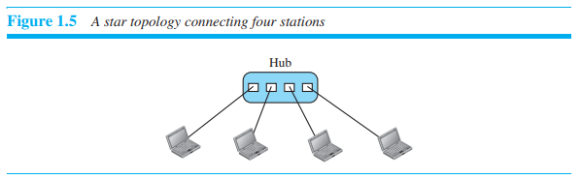
- Concept: Each device connects only to a central controller (called a Hub). Devices do not link directly to each other.
- The Analogy: A bicycle wheel. All the spokes (devices) connect to the center hub.
- Pros:
  - Cheaper: Less cable than Mesh.
  - Robust: If one link fails, only that device is affected.
- Cons:
  - Single Point of Failure: If the Hub goes down, the entire network is dead.
- Use Case: Local-Area Networks (LANs).

3. Bus Topology

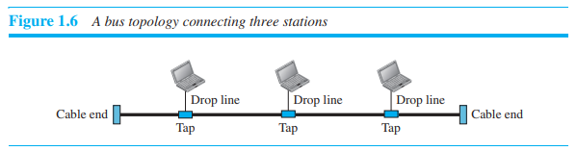
- Concept: A multipoint configuration where one long cable (backbone) links all devices.
- Key Parts:
  - Drop Line: Connection between device and main cable.
  - Tap: Connector that punctures the cable core to create contact.
- Pros: Easiest to install; uses the least amount of cable.
- Cons:
  - Signal Reflection: Signals can reflect at taps, causing degradation.
  - Fragile: A break in the bus cable stops all transmission, even for devices on the same side of the break.

4. Ring Topology
- Concept: Each device connects only to its two immediate neighbors. Signal travels in one direction.
- The "Repeater": Every device acts as a repeater—it receives the signal, regenerates the bits, and passes them along.
- Pros: Easy to install; fault isolation is simple (if a device doesn't receive a signal, it sounds an alarm).
- Cons:
  - Unidirectional: A break in the ring can disable the entire network (unless a dual ring is used).
- Use Case: IBM Token Ring (older technology).

Network Types (1.3)
Distinguishing network types can be tricky, but we generally categorize them by size, geographical coverage, and ownership.

Local Area Network (LAN) (1.3.1)

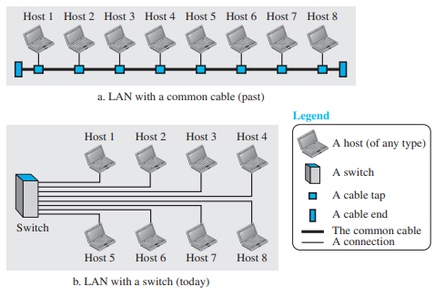
- Definition: A privately owned network connecting hosts in a single office, building, or campus.
- The Identifier: Each host has a unique address.
- The Evolution:
  - Past: All hosts shared a common cable. If Host A sent a message to Host B, everyone received it, but only Host B kept it.
  - Present: Most LANs use a Switch. The switch is "smart"—it recognizes the destination and guides the packet only to that specific host. This reduces traffic and allows simultaneous conversations.

Wide Area Network (WAN) (1.3.2)
- Definition: A network with a wider geographical span (town, state, country, world).
- Key Differences from LAN:
  - Scope: LAN is a building; WAN is the world.
  - Connectivity: LAN connects hosts; WAN connects connecting devices (switches, routers).
  - Ownership: LAN is private; WAN is leased from communication companies.
Types of WANs:
- Point-to-Point WAN: Connects two devices through a transmission medium (cable/air).
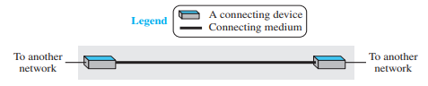
- Switched WAN: A network with more than two ends, used in the global communication backbone. It is a combination of several point-to-point WANs connected by switches.
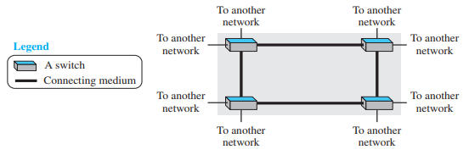

Internetwork (1.3.2)

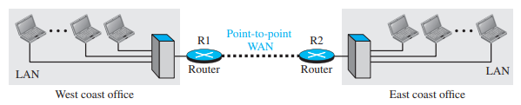
- Concept: Rare to see a LAN or WAN in isolation. When two or more networks connect, they form an internetwork (or internet—lowercase 'i').
- Example: An office in the East Coast (LAN) connects to an office in the West Coast (LAN) using a leased service (WAN).
  - Router vs. Switch: If you send a message to a colleague in the same office, the router blocks it (keeps it local). If you send it to the other office, the router passes it to the WAN.
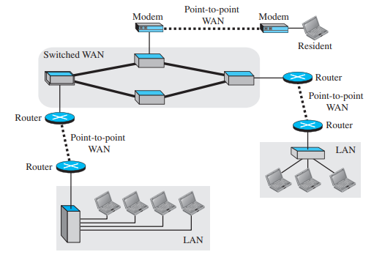

Switching (1.3.3)
An internet is a switched network. A switch's job is to forward data from one network to another.
⚙️ Diagram Breakdown: Circuit vs. Packet
1. Circuit-Switched Network
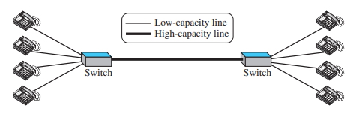
- Concept: A dedicated connection (circuit) is established between two ends and remains theirs for the duration.
- The Analogy: A traditional telephone call. When you call someone, a specific line is reserved for you. Even if you stop talking and just breathe, that line is yours and no one else can use it.
- Pros/Cons: Guarantees connection but is inefficient. If you aren't using the line's full capacity (e.g., silence), that capacity is wasted.
2. Packet-Switched Network
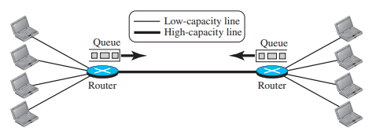
- Concept: Communication is done in independent blocks of data called packets.
- The Analogy: Postal Mail. You don't reserve the road to send a letter. You drop a letter (packet) in the box, and it travels independently along with everyone else's mail.
- Mechanism: Routers use Store and Forward. They hold the packet in a queue and send it when the line is free.
- Pros/Cons: More efficient (lines are shared), but packets may encounter delays (waiting in the queue).

The Internet (1.3.4)
- internet (lowercase): Two or more networks communicating.
- Internet (uppercase): The specific, global collaboration of thousands of interconnected networks.
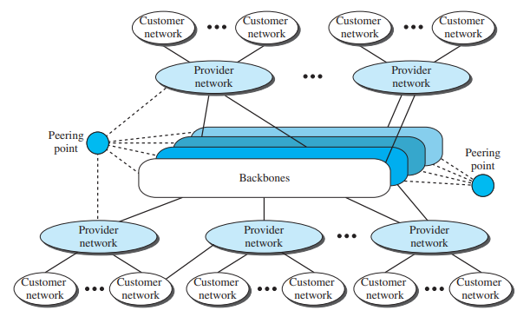
The Hierarchy:
- Backbones (International ISPs): Large networks owned by major companies (Sprint, AT&T). Connected by complex switching systems called peering points.
- Provider Networks (National/Regional ISPs): Smaller networks that pay to use the backbone services.
- Customer Networks: The edge of the Internet (you, me, universities) that pays provider networks for service.

Accessing the Internet (1.3.5)
Users must physically connect to an ISP, usually via a Point-to-Point WAN.
- Telephone Networks:
  - Dial-up: Adds a modem to convert data to voice. Slow; blocks the phone line.
  - DSL (Digital Subscriber Line): Upgraded phone lines allowing simultaneous voice and data.
- Cable Networks: Uses cable TV infrastructure. Speed varies based on how many neighbors are using it.
- Wireless Networks: Access via wireless WANs.
- Direct Connection: Large organizations lease high-speed WANs directly from carrier providers, effectively becoming their own local ISP.

Chapter 2: Network Models

Protocol Layering (2.1)
In Chapter 1, we defined a protocol as a set of rules.
- Simple Communication: Requires only one simple protocol.
- Complex Communication: Requires dividing the task into different layers. This is called Protocol Layering.

Scenarios (2.1.1)
To understand why we need layers, let's look at two analogies involving two friends, Maria and Ann.
Scenario 1: Simple Communication (Face-to-Face)
In this case, communication happens in one layer.
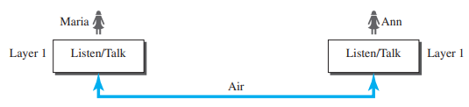
- The Context: Maria and Ann are neighbors talking directly.
- The Protocol: Even here, rules exist:
  - Greet when meeting.
  - Use common vocabulary.
  - Take turns speaking (dialogue, not monologue).
  - Exchange parting words.
Scenario 2: Complex Communication (Remote + Secret)
Now, Ann moves to a distant city. They must communicate via mail, but they want to keep their ideas secret (Encryption). This requires three layers.

⚙️ Diagram Breakdown: The 3 Layers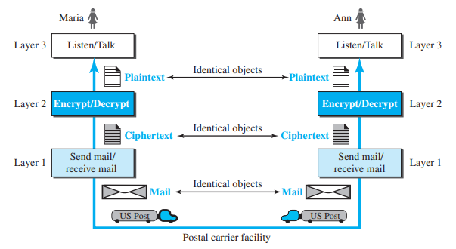
- Layer 3 (High Level): Maria talks to a machine/robot. The machine listens and writes the Plaintext (English letter).
- Layer 2 (Security): The machine takes the plaintext and Encrypts it into Ciphertext.
- Layer 1 (Transmission): The machine takes the ciphertext, puts it in an envelope, stamps it, and drops it in the mailbox.
At the receiving end (Ann's side), the process happens in reverse (Receive Mail -> Decrypt -> Read).

Why use Layering?
1. Modularity (Independent Layers)
- Concept: A layer is a "Black Box." We care about inputs and outputs, not how the work is done inside.
- Benefit: If Maria and Ann want to change their encryption method (Layer 2), they only replace the Layer 2 machine. Layer 1 (Mail) and Layer 3 (Writing) remain untouched.
- Separation of Service vs. Implementation: You can change how a layer works (implementation) without breaking the system, as long as the service provided remains the same.
2. Intermediate Systems
- In complex networks (like the Internet), intermediate devices (routers) don't need to understand all layers (like the content of the message). They only need the lower layers to pass the data along. This makes the system cheaper and more efficient.
Disadvantage:
- Ideally, one single super-machine is faster/easier than three interacting machines. However, if that super-machine breaks or needs an update, you have to replace the entire system, which is costly.

Principles of Protocol Layering (2.1.2)
When designing layered protocols, two golden rules must be followed:
First Principle: Bidirectional Capability
- If communication is two-way, every layer must be able to perform opposite tasks.
- Example:
  - Layer 3: Must be able to Listen AND Talk.
  - Layer 2: Must be able to Encrypt AND Decrypt.
  - Layer 1: Must be able to Send AND Receive.
Second Principle: Identical Objects
- The object passing between Layer X at the sender and Layer X at the receiver must be identical.
- Example:
  - Layer 3 at both sites handles Plaintext.
  - Layer 2 at both sites handles Ciphertext.
  - Layer 1 at both sites handles Mail.

Logical Connections (2.1.3)

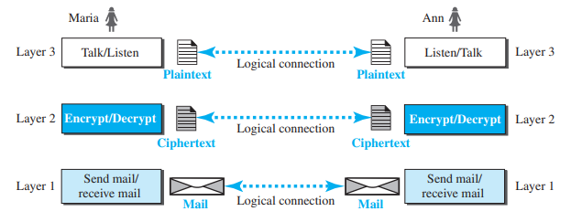
Because of the principles above, we can imagine a Logical Connection directly between layers.
- Physical Flow: The actual data moves vertically (Down from Layer 3 → 1 at the sender, across the wire, then Up from Layer 1 → 3 at the receiver).
- Logical Flow: We pretend there is a direct horizontal line between Layer 2 (Sender) and Layer 2 (Receiver).
  - Why? The Encryption layer doesn't care about the envelope or the mailman. It effectively "talks" directly to the Decryption layer at the other end.

TCP/IP Protocol Suite (2.2)
The TCP/IP (Transmission Control Protocol/Internet Protocol) is the standard protocol suite used for the Internet today. It is hierarchical, meaning each upper-level protocol relies on services provided by lower-level protocols.
- Evolution: Originally defined as 4 layers, but today it is viewed as a 5-layer model.

Layered Architecture (2.2.1)
In a network, different devices operate at different "depths" of the layer stack.
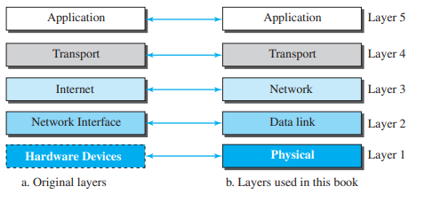
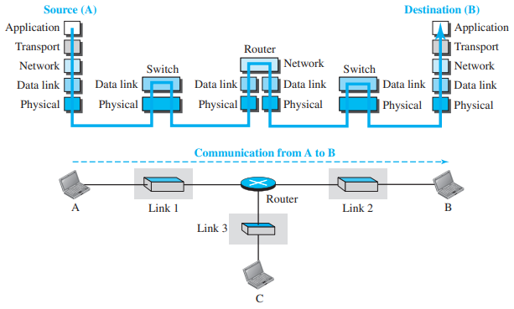

⚙️ Diagram Breakdown: Who uses which layers?
- Hosts (Source & Destination): Involved in all 5 layers.
  - The source creates the message at the top (Application) and sends it down.
  - The destination receives bits at the bottom (Physical) and sends them up.
- Router: Involved in the bottom 3 layers (Network, Data-link, Physical).
  - Routers do not need Transport or Application layers because they only route data; they don't process the message content.
  - Note: A router connects to multiple links (LANs/WANs), so it may use different Data-link/Physical protocols for each side (e.g., receiving from Wi-Fi, sending to Fiber).
- Link-Layer Switch: Involved in the bottom 2 layers (Data-link, Physical).
  - It operates within a single link (LAN).

Layers in the TCP/IP Protocol Suite (2.2.3)
We discuss the layers from bottom (hardware) to top (user).
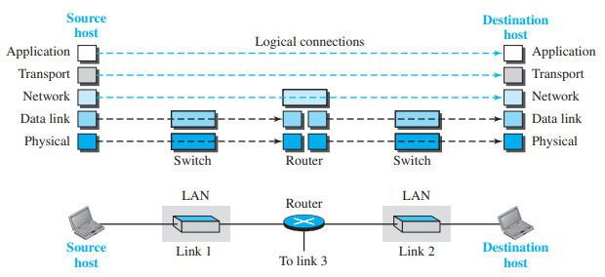
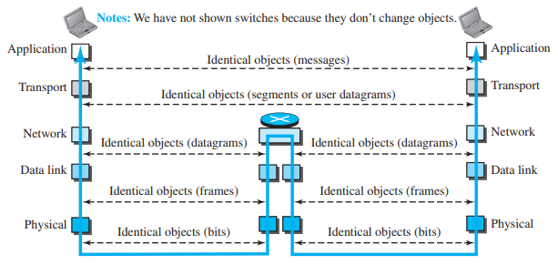

1. Physical Layer
- Duty: Responsible for carrying individual bits across the link.
- The Medium: It connects devices via a transmission medium (cable or air). The medium doesn't carry bits; it carries signals (electrical/optical). The Physical layer converts bits into these signals.
- Logical Unit: A Bit.

2. Data-Link Layer
- Duty: Responsible for moving the packet (called a Frame) across a specific link.
- Hop-to-Hop: It ensures delivery from one node to the very next node (e.g., from your laptop to the Wi-Fi router).
- Flexibility: TCP/IP doesn't define a specific protocol here; it supports all standard protocols (Ethernet, Wi-Fi, etc.).

3. Network Layer
- Duty: Responsible for Host-to-Host communication and Routing.
- Packet Name: Datagram.
- Key Protocol: IP (Internet Protocol).
  - IP is Connectionless: It provides no flow or error control. It relies on higher layers (Transport) for reliability.
- Auxiliary Protocols:
  - ICMP: Reports routing problems.
  - DHCP: Assigns IP addresses.
  - ARP: Finds the link-layer address (MAC) when given a network-layer address (IP).
- The Analogy: The Postal Sorting Center. It looks at the destination address (IP) and decides which truck (route) the package should go on next.

4. Transport Layer
- Duty: Responsible for Process-to-Process delivery. It separates the network duties from the application duties.
- Logical Connection: End-to-End. The Transport layer at the source "talks" directly to the Transport layer at the destination.
- Key Protocols:
  - TCP (Transmission Control Protocol): Connection-oriented. Reliable. Provides flow control (don't overwhelm the receiver) and error control (fix corrupted packets).
  - UDP (User Datagram Protocol): Connectionless. Unreliable but fast. Good for small messages where re-sending data is too slow.
  - SCTP: New protocol for multimedia.
- The Analogy: Certified Mail vs. Regular Mail.
  - TCP is Certified Mail: You get a receipt, and they guarantee delivery.
  - UDP is Regular Mail: You drop it in the box and hope it gets there; it's faster and cheaper, but less secure.

5. Application Layer
- Duty: Enabling the user (human or software) to access the network.
- Communication: Happens between two processes (programs running).
- Common Protocols:
  - HTTP: World Wide Web.
  - SMTP: Email.
  - FTP: File Transfer.
  - DNS: Translates names (www.google.com) into IP addresses.

Summary of Logical Connections
- Top 3 Layers (App, Transport, Network): The data unit should not be changed by switches or routers (mostly). Their duty is effectively End-to-End (or Host-to-Host).
- Bottom 2 Layers (Data-link, Physical): The duty is Hop-to-Hop. The frame is changed at every hop (e.g., a router strips off the "Wi-Fi" frame and puts the packet into an "Ethernet" frame).

Encapsulation and Decapsulation (2.2.4)
This concept describes how data is packaged (wrapped) and unpackaged (unwrapped) as it moves vertically through the layers.
1. Encapsulation at the Source Host
The data moves DOWN the layers. At each step, a layer treats the data from the layer above as "payload" and adds its own header.

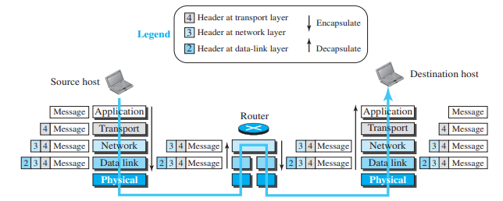
- Step 1 (Application Layer): Creates the Message.
- Step 2 (Transport Layer): Takes the message as Payload.
  - Adds: Transport header (Source/Dest Port numbers, flow control info).
  - Result: Segment (TCP) or User Datagram (UDP).
- Step 3 (Network Layer): Takes the segment/datagram as Payload.
  - Adds: Network header (Source/Dest IP addresses).
  - Result: Datagram.
- Step 4 (Data-Link Layer): Takes the datagram as Payload.
  - Adds: Link-layer header (Source/Dest MAC addresses).
  - Result: Frame.
2. Decapsulation and Encapsulation at the Router
A router acts as a bridge between links, so it must unwrap and re-wrap the data.
- Decapsulate: The router receives the Frame and removes the header to read the Datagram.
- Process: It checks the IP address to find the best path (Routing). Crucially, it generally does not change the datagram content.
- Encapsulate: It wraps the datagram into a new Frame suitable for the next link and sends it out.
3. Decapsulation at the Destination Host
The data moves UP the layers.
- Each layer removes its specific header, checks for errors, and hands the pure payload to the layer above.
- This continues until the Application Layer receives the original message.
⚙️ Diagram Breakdown: The Wrapping Process
- Think of it like a Russian nesting doll:
  - Inner Doll: The letter (Message).
  - Middle Doll: Envelope with apartment numbers (Port Numbers).
  - Outer Doll: Mailbag with the building address (IP Address).
  - Box: Delivery truck container (MAC Address).

Addressing (2.2.5)
Communication requires identifying who is talking to whom. Different layers use different types of addresses.
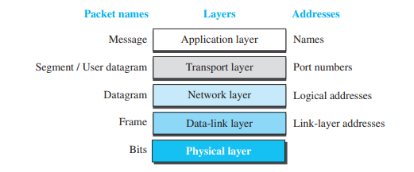
Layer | Packet Name | Address Type | Scope | Example
Application | Message | Names | User-specific | email@domain.com, google.com
Transport | Segment/Datagram | Port Numbers | Local (identifies the program) | Port 80 (Web), Port 25 (Email)
Network | Datagram | Logical Addresses (IP) | Global (identifies the connection) | 192.168.1.1
Data-Link | Frame | Physical Addresses (MAC) | Local (identifies the device on the link) | 00:1A:2B:3C:4D:5E
Physical | Bits | None | N/A | Bits do not need addresses.

Multiplexing and Demultiplexing (2.2.6)
Because the TCP/IP suite allows multiple protocols to run simultaneously, we need a way to mix and un-mix the data traffic.
- Multiplexing (at Source): A protocol at a lower layer accepts packets from several higher-layer protocols.
  - Example: The IP protocol (Network Layer) can carry a TCP packet AND a UDP packet at the same time.
- Demultiplexing (at Destination): A protocol decapsulates a packet and delivers it to the correct higher-layer protocol.
  - Example: When IP receives a packet, it looks at a "Protocol Field" in the header to decide: "Does this go to TCP or UDP?"
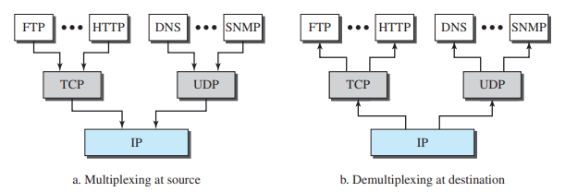
⚙️ Diagram Breakdown: The Funnel Effect
- Sender Side (Multiplexing): Many apps funnel into TCP/UDP → which funnel into IP.
- Receiver Side (Demultiplexing): IP receives the mix and distributes (demultiplexes) it back to the correct transport protocol.

The OSI Model (2.3)

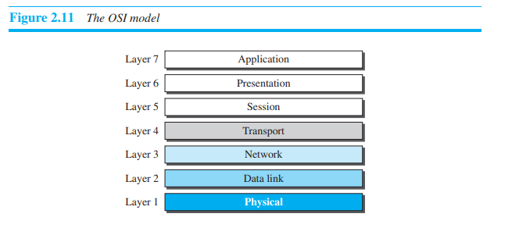
While TCP/IP is the standard for the Internet, the ISO (International Organization for Standardization) established the OSI (Open Systems Interconnection) model in the late 1970s as a comprehensive standard.
- Open System: A set of protocols that allows any two different systems to communicate regardless of their underlying architecture (hardware/software).
- Model vs. Protocol: The OSI model is not a protocol itself. It is a model (a blueprint) for understanding and designing network architectures that are flexible and interoperable. It was intended to be the basis for creating specific protocols.
- Structure: It consists of seven separate but related layers.

OSI versus TCP/IP (2.3.1)
When comparing the two models, there is a distinct difference in how they organize layers.
⚙️ Diagram Breakdown: The Missing Layers
- Missing Layers: The TCP/IP suite does not have a distinct Session or Presentation layer.
- Combination: In TCP/IP, the duties of the Session, Presentation, and Application layers are all combined into the single Application Layer.
Why did TCP/IP combine them?
- Redundancy: Some functions of the Session layer (like tracking connections) are already handled by the Transport Layer (e.g., TCP).
- Flexibility: The Application layer isn't just one piece of software. If a specific app needs session or presentation features (like encryption or dialogue control), those features can be built directly into that specific application's software rather than requiring a separate strict layer.
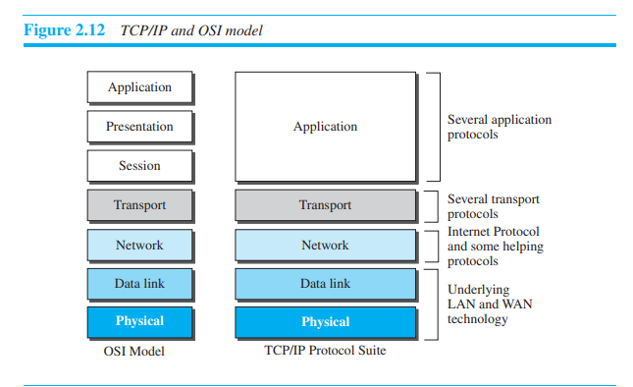

Lack of OSI Model’s Success (2.3.2)
Originally, experts thought OSI would replace TCP/IP. It didn't. There are three main reasons why OSI failed to take over:
- Timing & Cost: TCP/IP was already fully in place. Changing everything to OSI would have been too expensive and time-consuming.
- Undefined Layers: The Session and Presentation layers were never fully defined. Their services were listed, but the actual protocols and software to run them were not fully developed.
- Performance: Initial implementations of OSI did not show high enough performance to convince the Internet authorities to abandon the working TCP/IP suite.

Chapter 3: Data and Signals

Data and Signals (3.1)
In previous chapters, we discussed "logical" communication (sending a message from App to App). However, strictly speaking, logical communication happens at the upper layers (Application, Transport, Network, Data-link).
At the Physical Layer, communication is physical.

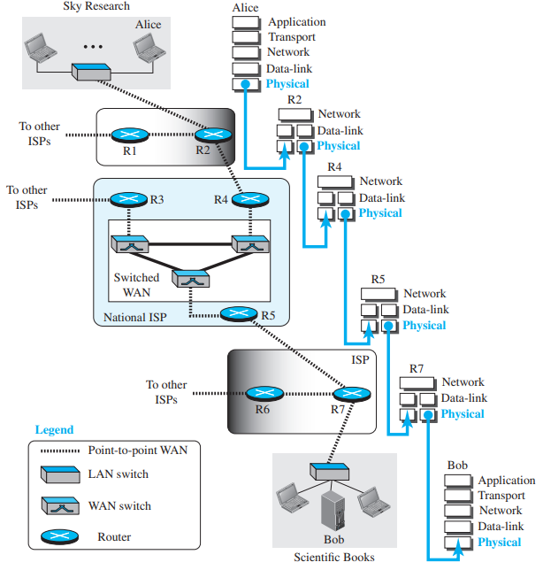
- The Reality: We are not sending "files" or "pictures" through the wire; we are sending signals.
- The Transformation: The transmission media (cable/air) works with signals. Therefore, data must be transformed into electromagnetic signals to be transmitted.

Analog vs. Digital (3.1.1 & 3.1.2)
Both data (the information) and signals (the transmission) can be either analog or digital.

⚙️ Diagram Breakdown: Analog vs. Digital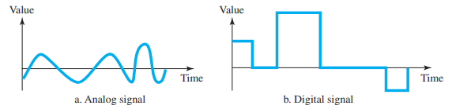
1. Analog (Continuous)
- Concept: Information is continuous. It takes on infinite values within a range.
- The Analogy: An Analog Clock. The hands move continuously; the time flows smoothly from 8:05 to 8:06, passing through every infinite microsecond in between.
- Examples: Human voice, temperature readings.
- Signal Shape: A smooth curve.
2. Digital (Discrete)
- Concept: Information has discrete states. It is limited to a defined set of values.
- The Analogy: A Digital Clock. The display jumps suddenly from 8:05 to 8:06. There is no "in-between" state shown.
- Examples: Computer memory (0s and 1s).
- Signal Shape: Vertical lines/steps (sudden jumps from one value to another).

Periodic and Nonperiodic (3.1.3)
Signals can change over time in two ways:
- Periodic:
  - Completes a specific pattern within a measurable time frame (called a Period).
  - Repeats that pattern over identical subsequent periods.
  - Cycle: One full completion of the pattern.
- Nonperiodic (Aperiodic):
  - Changes without exhibiting a repeating pattern.
Key Note: In data communications, we typically use Periodic Analog Signals and Nonperiodic Digital Signals.

Periodic Analog Signals (3.2)
Periodic analog signals are classified into two types:
- Simple: A Sine Wave. It cannot be broken down into simpler signals.
- Composite: Made of multiple sine waves combined.

Sine Wave (3.2.1)

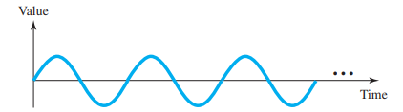
The sine wave is the most fundamental form of a periodic analog signal. It looks like a simple, smooth, oscillating curve. A sine wave is fully described by three parameters:
- Peak Amplitude
- Frequency
- Phase

1. Peak Amplitude
- Definition: The absolute value of the signal's highest intensity.
- Significance: It is proportional to the energy the signal carries.
- Measurement: For electric signals, it is measured in Volts.
Examples:
- House Power: The voltage in US homes is stated as 110–120 V, but this is the RMS (Root Mean Square) value. The actual peak amplitude is higher (approx 155–170 V).
  - Formula: Peak = \sqrt{2} \times RMS
- Battery: A battery provides a constant voltage (e.g., 1.5 V). This is technically a sine wave with a frequency of zero and a constant amplitude.

Period and Frequency (3.2.1 continued)
Period and frequency are two sides of the same coin. They describe the same characteristic of a signal but from different perspectives.
- Period (T): The amount of time, in seconds, a signal needs to complete 1 cycle.
- Frequency (f): The number of periods (cycles) in 1 second.
The Relationship:
They are inverses of each other.
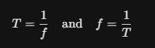
Units:
- Period: Formally expressed in seconds (s).
- Frequency: Formally expressed in Hertz (Hz), which means "cycles per second."

📝 Examples
1. House Power
- Scenario: The power used in US homes has a frequency of 60 Hz.
- Calculation:
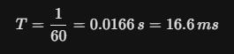
- Observation: The period is 16.6 ms. Our eyes are not fast enough to see the light bulb flickering at this speed, so it looks constant to us.
2. Conversions (Time)
- Task: Express a period of 100 ms in microseconds (\mu s).
- Solution:
3. Conversions (Frequency)
- Task: The period is 100 ms. Find the frequency in kilohertz (kHz).
- Solution:
  - Convert T to seconds: 100 ms = 10⁻¹ s.
  - Calculate Hz: f = 1/10⁻¹ = 10 Hz.
  - Convert to kHz: 10 * 10⁻³ kHz = 10⁻² kHz.

More About Frequency
We usually think of frequency as just "cycles per second," but it is also a measurement of the rate of change.
- Rate of Change: Electromagnetic signals oscillate (fluctuate). Frequency describes how fast this fluctuation happens.
- The Rule:
  - High Frequency: Change happens over a short span of time.
  - Low Frequency: Change happens over a long span of time.

Two Extremes
What happens at the absolute limits of change?
1. Zero Frequency (0 Hz)
- Condition: The signal does not change at all. It maintains a constant voltage level forever.
- Result: It never completes a cycle.
- Example: A battery (Direct Current).
2. Infinite Frequency ( Infinity Hz)
- Condition: The signal changes instantaneously. It jumps from one level to another in no time (Period = 0).
- Result: Since f = 1/T, if T is 0, then f is infinite.
- Note: This is a theoretical concept, as nothing physical changes instantly, but it helps describe sudden spikes or digital transitions.

Phase (3.2.2)
The Phase (or phase shift) describes the position of the waveform relative to time zero (t=0). It indicates the status of the first cycle—essentially, "where" in the cycle the wave is when the clock starts.
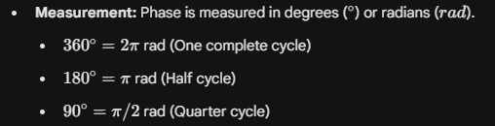

⚙️ Diagram Breakdown: Visualizing Phase Shift
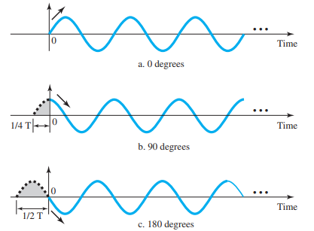
- 0° Phase: Starts at 0 amplitude and increases. The wave is "normal" and unshifted.
- 90° Phase: Starts at Peak amplitude and decreases. It looks like it was shifted to the left by 1/4 of a cycle.
- 180° Phase: Starts at 0 amplitude and decreases (goes negative). It looks like it was shifted to the left by 1/2 a cycle.
Note: We describe the shift as moving "backward" or to the "left," but technically the signal does not exist before time 0.
📝 Example 3.6
- Problem: A sine wave is offset 1/6 cycle with respect to time 0. What is the phase?
- Solution:
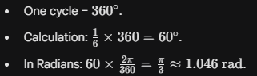

Wavelength (3.2.3)
Wavelength (lambda) is a characteristic of a signal traveling through a transmission medium. It binds the period (T) or frequency (f) to the propagation speed (c) of the medium.
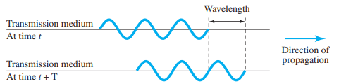
- Definition: The distance a simple signal can travel in one period.
- Dependency:
  - Frequency is independent of the medium (a 60Hz signal is 60Hz in copper or air).
  - Wavelength depends on both the frequency and the medium (because speed changes in different media).
The Formula:
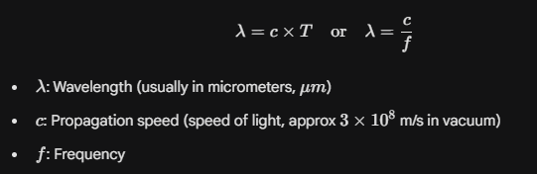
Key Observation:
- In a vacuum, light travels at 3 \times 10⁸ m/s.
- In a cable (coaxial or fiber-optic), the speed is slower, so the wavelength is shorter.

Time and Frequency Domains (3.2.4)
To fully understand a signal, we can view it from two different "angles" or domains.
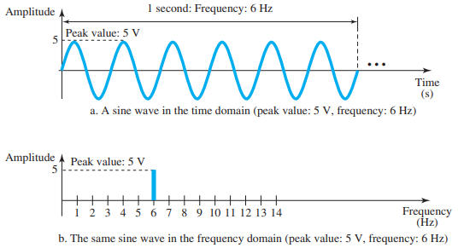
1. Time-Domain Plot
- Axes: Amplitude vs. Time.
- Shows: How the signal changes moment-by-moment.
- Limitation: Phase is not explicitly shown, and it's hard to read frequency instantly just by looking at a wiggly line.
2. Frequency-Domain Plot
- Axes: Peak Amplitude vs. Frequency.
- Shows: The "ingredients" of the signal.
- The Spike: A complete sine wave is represented by a single vertical spike.
  - Position of spike = Frequency.
  - Height of spike = Peak Amplitude.
- Advantage: It is compact. We can immediately see the values without tracing a curve.

📝 Example 3.7 (Multiple Signals)
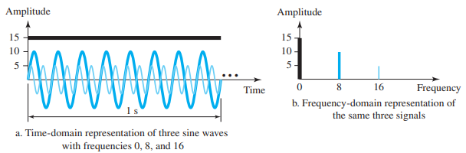
- If you have three different sine waves mixed together, the Time Domain looks like a messy scribble.
- In the Frequency Domain, it is simply three clean spikes. This makes it much easier to analyze complex signals.

Composite Signals (3.2.5)
So far, we discussed simple sine waves. While useful for power (carrying energy at 60Hz) or simple alarms (danger signal), they are useless for data communications.
- Why? If you sent a single sine wave over a phone line, you would just hear a continuous buzz. To convey a conversation (data), we need variety.
- The Solution: We use a Composite Signal—a signal made of many simple sine waves combined.
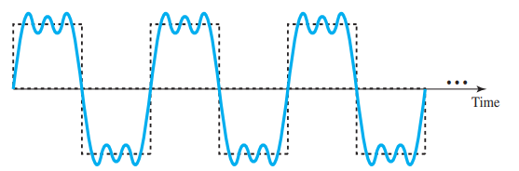
Fourier Analysis In the 1900s, Jean-Baptiste Fourier proved a critical concept:
Any composite signal is actually a combination of simple sine waves with different frequencies, amplitudes, and phases.
Periodic vs. Nonperiodic Decomposition
Depending on the signal type, the "ingredients" (simple sine waves) look different:
Signal Type | Decomposition Result | Frequency Domain Look
Periodic Composite | A series of discrete frequencies (integer values like 1, 2, 3). | Distinct Spikes (Harmonics)
Nonperiodic Composite | A combination of continuous frequencies (real values). | A Continuous Curve

⚙️ Diagram Breakdown: Decomposing a Signal (Example 3.8) 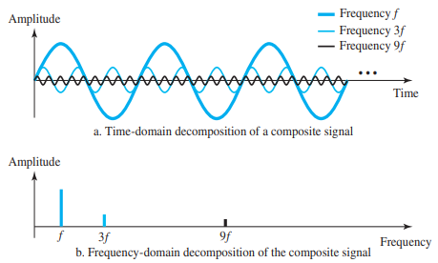
Imagine a periodic signal that looks like a blocky square wave. If we use tools to break it apart, we find it is made of three specific sine waves added together:
- Fundamental Frequency (f): Same frequency as the composite signal. High amplitude.
- Third Harmonic (3f): Frequency is 3 times the fundamental. Lower amplitude (1/3).
- Ninth Harmonic (9f): Frequency is 9 times the fundamental. Even lower amplitude (1/9).
- Observation: In the frequency domain, this looks like three separate spikes.

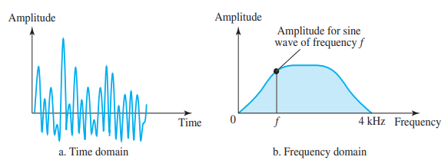
The Human Voice (Example 3.9)
A word pronounced by a human is a Nonperiodic composite signal (because we rarely repeat a word with the exact same tone/speed).
- Result: It contains an infinite number of frequencies.
- Range: A normal human voice creates a continuous range of frequencies between 0 and 4 kHz.
- Observation: In the frequency domain, this looks like a continuous curve, not spikes.

Bandwidth (3.2.6)
The Bandwidth is the range of frequencies contained in a composite signal. It is the difference between the highest and lowest frequencies.
The Formula:


⚙️ Diagram Breakdown: Bandwidth
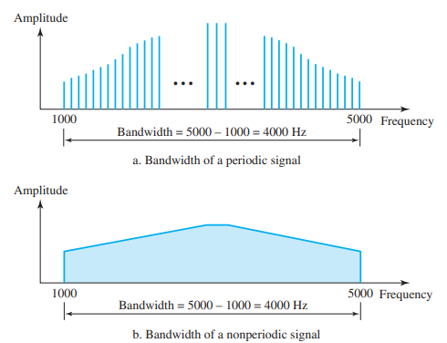
- Periodic Signal: The bandwidth includes all the discrete integer frequencies (spikes) between the min and max.
- Nonperiodic Signal: The bandwidth includes the entire continuous range (curve) between the min and max.

📝 Bandwidth Calculation Examples
Example 3.10 (Discrete Spikes)
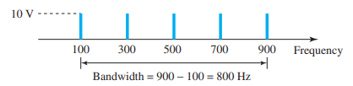
- Scenario: A periodic signal has sine waves at frequencies: 100, 300, 500, 700, and 900 Hz.
- Calculation:
B = 900 - 100 = 800 Hz
- Visual: The spectrum shows exactly 5 spikes.

Example 3.11 (Finding the Low)
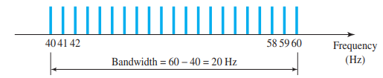
- Scenario: Bandwidth is 20 Hz. Highest frequency is 60 Hz. What is the lowest?
- Calculation:
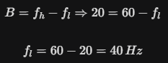

Example 3.12 (Nonperiodic/Continuous)
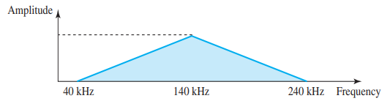
- Scenario: Bandwidth = 200 kHz. Middle frequency = 140 kHz.
- Logic: The bandwidth extends 100 kHz above and 100 kHz below the middle.
  - Low = 140 - 100 = 40 kHz
  - High = 140 + 100 = 240 kHz

🌍 Real-World Bandwidth Examples
- AM Radio:
  - Assigned Bandwidth: 10 kHz per station.
  - Total Range: 530 to 1700 kHz.
- FM Radio:
  - Assigned Bandwidth: 200 kHz per station. (Much higher quality than AM).
  - Total Range: 88 to 108 MHz.
- Old Analog TV (Black & White):
  - The Math: A screen has ~367,500 pixels. Scanned 30 times a second = ~11 million pixels/sec.
  - Worst Case: Alternating black/white pixels requires ~5.5 MHz.
  - Reality: We don't always hit the worst case, so 70% is enough (~3.85 MHz).
  - Standard: A 4 MHz bandwidth is set aside for video.

Digital Signals (3.3)
Information can be represented by a digital signal (discrete values) instead of an analog one.
- Basic Form: Two levels. A 1 is a positive voltage; a 0 is zero voltage.
- Multi-Level: A digital signal can have more than two levels. This allows us to send more than 1 bit per level.
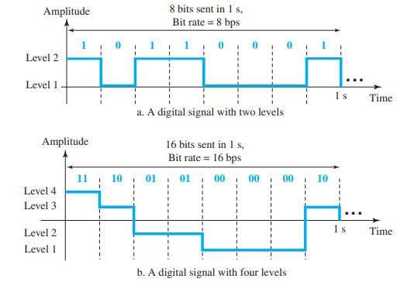
Formula: Bits per Level
If a signal has L levels, the number of bits needed per level is:
Bits per level = log₂₍L)
📝 Examples
- 4 Levels: log₂ 4 = 2 bits per level.
- 8 Levels: log₂ 8 = 3 bits per level.
- 9 Levels: log₂ 9 approx 3.17. Since bits must be integers, we need 4 bits to represent 9 levels (which can actually support up to 16 levels).

Bit Rate (3.3.1)
Since digital signals are rarely periodic, we don't use frequency. We use Bit Rate.
- Definition: The number of bits sent in 1 second.
- Unit: bits per second (bps).
📝 Real-World Calculation Examples
1. Downloading Text
- Scenario: 100 pages/sec. (Page = 24 lines \times 80 chars. Char = 8 bits).
- Calculation: 100 * 24 * 80 * 8 = 1,536,000 bps = 1.536 Mbps
2. Digitized Voice
- Scenario: 4 kHz analog voice, sampled at 2 * frequency (2 * 4000), using 8 bits per sample.
- Calculation: 2 * 4000 * 8 = 64,000 bps = 64 kbps
3. HDTV (High-Def TV)
- Scenario: 1920 \times 1080 pixels, renewed 30 times/sec, 24 bits per color pixel.
- Calculation: 1920 * 1080 * 30 * 24 \approx 1.5 Gbps
- Note: This is huge! TV stations use compression to reduce this to 20–40 Mbps.

Bit Length (3.3.2)
Just as analog signals have wavelength (distance of one cycle), digital signals have Bit Length.
- Definition: The distance one bit occupies on the transmission medium.
- Formula:
\text{Bit Length} = \text{Propagation Speed} \times \text{Bit Duration}

Digital Signal as a Composite Analog Signal (3.3.3)
According to Fourier analysis, a digital signal is actually a composite analog signal with an infinite bandwidth.
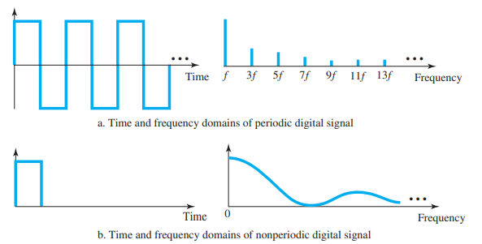
- Why Infinite?
  - A digital signal has vertical lines (instant jumps).
  - Vertical line = Frequency of Infinity.
  - Horizontal line = Frequency of Zero.
  - To create this shape, you theoretically need all frequencies between 0 and Infinity.

Transmission of Digital Signals (3.3.4)
How do we send this "infinite bandwidth" signal? We have two approaches: Baseband and Broadband.

1. Baseband Transmission

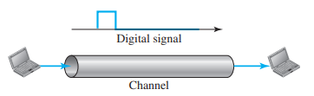
Definition: Sending the digital signal over a channel without changing it to an analog signal (no modulation).
- Requirement: A Low-Pass Channel (a channel where bandwidth starts from 0 Hz).

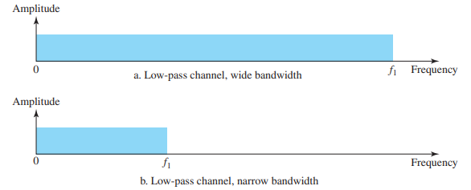

Case A: Low-Pass Channel with Wide Bandwidth
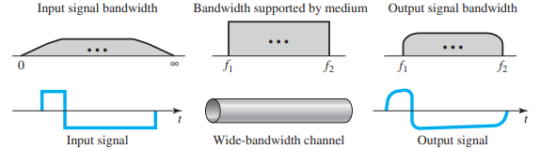
- Scenario: We have a dedicated medium (like a Coaxial cable or Fiber in a LAN).
- Result: The medium has a very wide bandwidth (f₁ is 0, f₂ is very high).
- Outcome: The signal shape is preserved with very good accuracy.
Case B: Low-Pass Channel with Limited Bandwidth
- Scenario: The bandwidth is restricted. We cannot send the "infinite" frequencies required for a perfect square wave.
- Result: We must approximate. The signal will look curved, not square.
- The Harmonics Rule:
  - Rough Approximation: Use Bandwidth = N/2 (First harmonic). The signal looks like a sine wave.
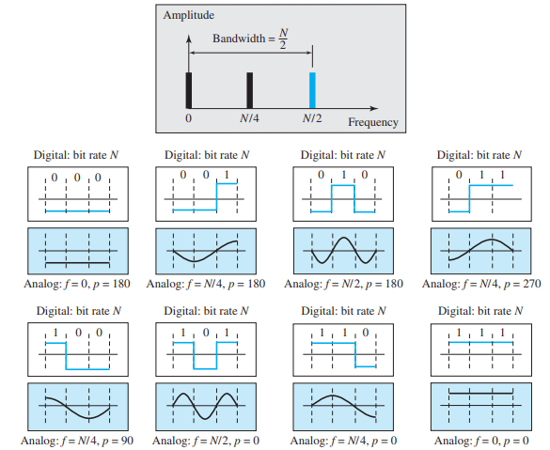

  - Better Approximation: Use Bandwidth = 3N/2 or 5N/2 (Third or Fifth harmonics). The signal starts to look squarer.

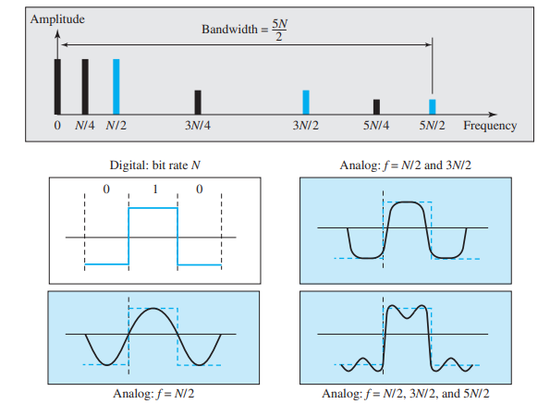

Key Takeaway for Baseband:
The required bandwidth is proportional to the bit rate. If you want to send bits faster (higher N), you need more bandwidth.
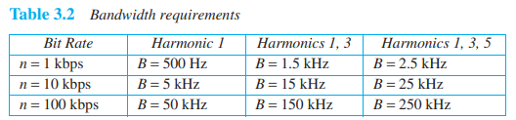

Baseband Calculations (Examples 3.22 & 3.23)
We previously established that for baseband transmission (Digital → Digital), the bandwidth required depends on the bit rate (N) and the accuracy (harmonics) desired.
- Rough Approximation (Min Bandwidth): B = N / 2
- Better Accuracy (1st & 3rd Harmonics): B = 3N / 2
- High Accuracy (1st, 3rd, & 5th Harmonics): B = 5N / 2
📝 Example 3.22: Required Bandwidth
- Goal: Send 1 Mbps (1,000,000 bps).
- Solutions:
  - Minimum (Rough): B = 1 Mbps / 2 = 500 kHz.
  - Better: B = 3 * 500 kHz = 1.5 MHz.
  - Best: B = 5 * 500 kHz = 2.5 MHz.
📝 Example 3.23: Max Bit Rate
- Scenario: You have a low-pass channel with a bandwidth of 100 kHz. What is the max speed?
- Solution: Using the rough approximation (B = N/2):
  - 100 kHz = N / 2
  - N = 200 kbps.

Broadband Transmission (Modulation)
If we do not have a low-pass channel (one that starts at 0 Hz), we cannot use Baseband transmission. We must use Broadband Transmission.
- Definition: Changing the digital signal to an analog signal for transmission. This process is called Modulation.
- The Channel: Allows us to use a Bandpass Channel—a channel where the bandwidth does not start from zero.

⚙️ Diagram Breakdown: Bandpass Channel
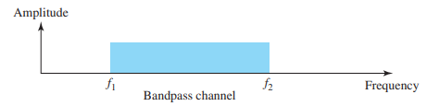
- Low-Pass: Starts at 0 Hz (e.g., 0 to 100 kHz). Used for Baseband.
- Bandpass: Starts at a higher frequency (e.g., 100 kHz to 200 kHz). Used for Broadband.

The Modulation Process

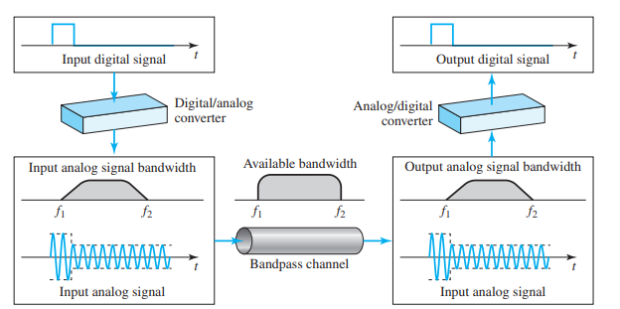
- Digital Signal: The source data (0s and 1s).
- Conversion: We use a single-frequency analog signal called a Carrier. We modify the carrier (change its amplitude, frequency, or phase) to look like the digital signal.
- Transmission: The result is a composite analog signal sent over the bandpass channel.
- Reception: The receiver converts the analog signal back into digital (Demodulation).

📝 Real-World Examples
1. Telephone Lines (The "Modem")
- The Problem: Telephone lines were built for voice (analog) and have a very narrow bandwidth (0 to 4 kHz).
- Baseband Limit: If we treated this as a low-pass channel for digital data, the max speed would only be 8 kbps (very slow).
- Broadband Solution: We treat it as a Bandpass channel. We use a Modem (Modulator/Demodulator) to convert the computer's digital signal into an analog signal that fits the phone line's frequency range.
2. Digital Cellular Phones
- The Process:
  - Voice (Analog) → Converted to Digital (for better processing/compression).
  - Digital Signal → Converted back to Analog (Modulated) to fly through the air.
- Why? The airwaves are a shared resource. Each company gets a specific slice of bandwidth (e.g., 800 MHz to 900 MHz). This is a Bandpass channel because it doesn't start at 0. You cannot send raw digital pulses through it; you must modulate them onto a carrier wave that fits that frequency slice.

Transmission Impairment (3.4)
Transmission media are not perfect. As signals travel through them, they suffer from impairment.
- The Reality: The signal received at the end is rarely identical to the signal sent at the beginning.
- The Causes: There are three primary causes of impairment: Attenuation, Distortion, and Noise.

1. Attenuation (3.4.1)
Attenuation refers to a loss of energy.
- The Cause: When a signal travels through a medium, it must overcome resistance. Some of the signal's electrical energy is converted into heat (just as a wire gets warm when current passes through it).
- The Result: The signal becomes weaker.
- The Fix: We use Amplifiers to boost the signal strength back up.

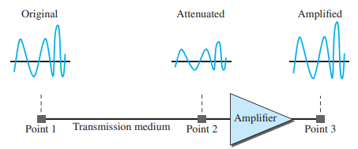

Decibel (dB)
To measure if a signal has lost or gained strength, engineers use the decibel (dB). It measures relative strength between two points.
The Formulas:
- For Power (P):
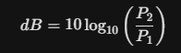
- For Voltage (V): (Since power is proportional to voltage squared)
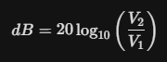
- Key Rules:
  - Negative dB: The signal is Attenuated (weaker).
  - Positive dB: The signal is Amplified (stronger).

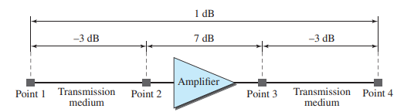
dB = - 3 + 7 - 3 = +1 ( The signal has gained in power. )

2. Distortion (3.4.2)
Distortion means the signal changes its form or shape.
- Where it happens: Usually in composite signals made of different frequencies.
- The Mechanism:
  - Each frequency component has its own propagation speed through the medium.
  - This means they arrive at the destination with different delays.
  - These delays cause phase shifts. If the parts of the signal arrive "out of sync" compared to how they started, the combined shape looks deformed.

⚙️ Diagram Breakdown: Distortion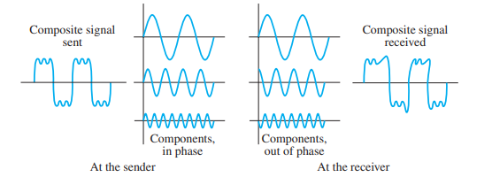
- Sender: Sends a nice, clean composite wave (sum of frequencies A, B, and C).
- Medium: Frequency B travels slightly slower than A.
- Receiver: When re-combined, the wave looks lumpy or flattened because B arrived late.

3. Noise (3.4.3)
Noise is external energy that corrupts the signal. It adds extra, unwanted information.
Types of Noise:
- Thermal Noise: Caused by the random motion of electrons in the wire. It creates a background hum/static.
- Induced Noise: Comes from external sources like motors or appliances. The motor acts as a sending antenna, and your wire acts as a receiving antenna.
- Crosstalk: The effect of one wire on another. Like hearing a faint conversation on an old telephone line because the wires are touching or too close.
- Impulse Noise: A spike with high energy in a very short time.
  - Examples: Lightning strikes, power surges.

Signal-to-Noise Ratio (SNR)
To understand the theoretical limit of how fast we can send data (Bit Rate), we first need to measure the quality of the channel. We do this using SNR.
- Definition: The ratio of the average signal power to the average noise power.
- The Concept: It is the ratio of what is wanted (signal) to what is not wanted (noise).

⚙️ Diagram Breakdown: High vs. Low SNR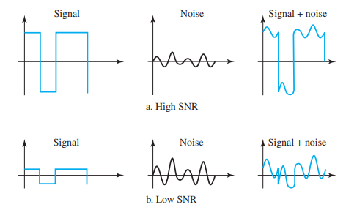
- High SNR: The signal power is much stronger than the noise. The signal is clear and easily separated.
  - Analogy: Talking to a friend in a quiet library. Your voice (Signal) is clear; the background sound (Noise) is near zero.
- Low SNR: The noise power is strong compared to the signal. The signal is corrupted and hard to distinguish.
  - Analogy: Talking to a friend at a loud rock concert. The music (Noise) is so loud that it drowns out your voice (Signal).
The Formulas
- Standard SNR (Ratio):

- SNR in Decibels (SNR_{dB}):
Because SNR ratios can be very large numbers, engineers often express them in decibels.
SNR_{dB} = 10log₁₀(SNR)
Important Note: Do not confuse SNR with SNR_{dB}.
- If SNR = 10,000, then SNR_{dB} = 40.
- Calculations for data limits often require you to convert dB back to the standard ratio first.

Data Rate Limits (3.5)
A critical question in data communications is: "How fast can we send data?"
The Data Rate (in bps) depends on three major factors:
- The Bandwidth available.
- The Level of the signals we use.
- The Quality of the channel (Noise level).
Two theoretical formulas help us calculate this limit: Nyquist (for ideal/noiseless channels) and Shannon (for real/noisy channels).

1. Noiseless Channel: Nyquist Bit Rate (3.5.1)
If we assume the channel is perfectly noiseless (no interference), the limit is defined by the bandwidth and the number of signal levels used.
The Formula:

- BitRate: Speed in bits per second (bps).
- Bandwidth: Bandwidth of the channel.
- L: Number of signal levels used to represent data.
The Trade-off:
- Theory: According to the math, we could get any bit rate we want just by increasing L (the number of levels).
- Reality: Increasing levels imposes a burden on the receiver.
  - 2 Levels: Easy to distinguish (Voltage is either 0 or 5).
  - 64 Levels: Very hard to distinguish. The receiver must be incredibly sophisticated to tell the difference between Level 32 and Level 33.
- Conclusion: Increasing levels reduces the reliability of the system.

2. Noisy Channel: Shannon Capacity (3.5.2)
In reality, noiseless channels don't exist. All channels have some noise. Claude Shannon (1944) introduced a formula to find the absolute maximum data rate (Capacity) for a noisy channel.
The Formula:

- Capacity: The theoretical highest data rate (in bps).
- Bandwidth: Bandwidth of the channel.
- SNR: Signal-to-Noise Ratio (not in dB, use the raw ratio).
Key Observation:
- No Signal Levels: Notice that L (signal levels) is missing from this formula.
- Meaning: No matter how many levels you use or how clever your encoding is, you cannot achieve a data rate higher than the Shannon Capacity. This formula defines the characteristic of the channel, not the transmission method.

3. Using Both Limits (3.5.3)
In practice, we use both methods to design a system.
- Use Shannon to find the upper limit (the "speed limit" of the road).
- Use Nyquist to figure out how many signal levels (L) we need to achieve that speed.

Chapter 6: Bandwidth Utilization: Multiplexing

Multiplexing (6.1)
Bandwidth is one of the most precious resources in data communications. Instead of adding a new physical wire every time we need a new channel, we use Multiplexing.
- Definition: A set of techniques that allows the simultaneous transmission of multiple signals across a single data link.
- The Condition: This works whenever the bandwidth of the medium (the pipe) is greater than the bandwidth needs of the devices connected to it.
- Goal: Efficiency. To maximize the use of high-bandwidth media (like fiber optics or microwaves) by sharing them among many lower-speed users.

⚙️ Diagram Breakdown: The System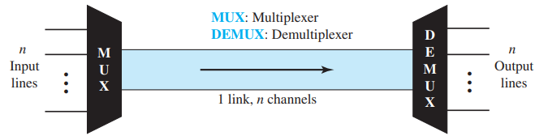
- n Lines: The input sources on the left.
- MUX (Multiplexer): Combines the inputs into a single stream (Many-to-One).
- Link: The physical path (the wire).
- DEMUX (Demultiplexer): Separates the stream back into component transmissions (One-to-Many).
Link vs. Channel:
It is important to distinguish between these two terms:
- Link: The physical path (the cable itself).
- Channel: The portion of a link that carries a specific transmission.
- Math: One link can carry n channels.

The Three Basic Techniques
- FDM (Frequency-Division Multiplexing): Designed for Analog signals.
- WDM (Wavelength-Division Multiplexing): Designed for Analog signals (specifically light).
- TDM (Time-Division Multiplexing): Designed for Digital signals.

Frequency-Division Multiplexing (FDM) (6.1.1)
FDM is an analog technique. It is used when the bandwidth of the link (in Hz) is wider than the combined bandwidths of the signals to be transmitted.
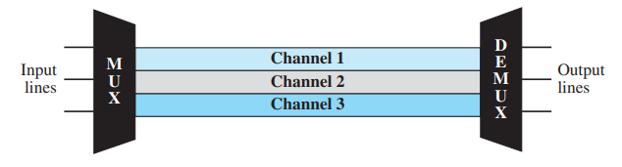
- The Concept: Signals generated by each sender modulate different Carrier Frequencies.
- The Analogy: FM Radio Stations. All radio stations transmit signals through the air (the link) simultaneously. They don't interfere because Station A is at 98.5 MHz and Station B is at 101.5 MHz. They are on different "channels" within the same medium.
- Guard Bands: Strips of unused bandwidth left between channels to prevent signals from overlapping or interfering with each other.

The FDM Process
1. Multiplexing (Sender Side) 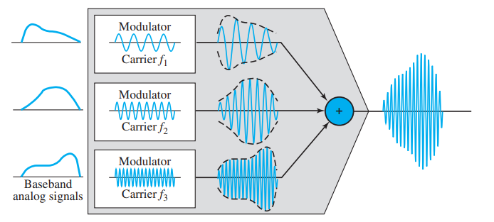
- Step 1: Each source generates a signal.
- Step 2: Each signal modulates a different carrier frequency (f₁, f₂, f₃).
- Step 3: These modulated signals are combined into one single composite signal.
- Step 4: The composite signal is sent across the link.
2. Demultiplexing (Receiver Side)
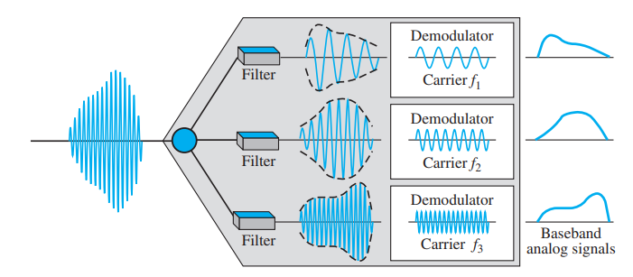
- Step 1: The Demux receives the composite signal.
- Step 2: It uses Filters to decompose the signal into its component parts.
- Step 3: A Demodulator separates the signal from the carrier frequency.
- Step 4: The original signal is sent to the output line.
Note: Although FDM is an analog technique, we can use it for digital signals if we convert them to analog first (using the techniques from Chapter 5).

📝 Example 6.1: Voice Channels
Scenario:
- We have 3 voice channels. Each occupies 4 kHz.
- We need to combine them onto one link with a bandwidth of 12 kHz (ranging from 20 to 32 kHz).
- Assumption: No guard bands.
Solution (The Frequency Shift):
We shift (modulate) each voice channel to a specific slot in the link's range:
- Channel 1: Shifted to 20–24 kHz.
- Channel 2: Shifted to 24–28 kHz.
- Channel 3: Shifted to 28–32 kHz.
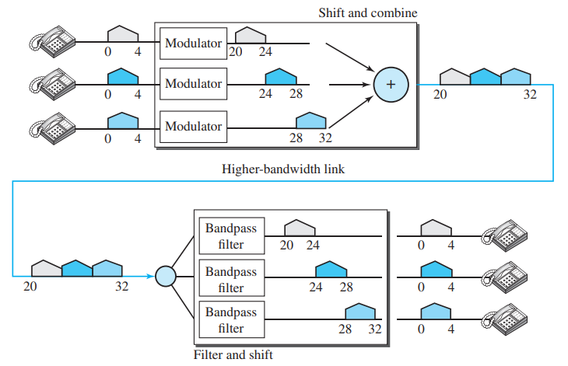
Result:
The single link carries all frequencies from 20 to 32 kHz simultaneously.
- At Receiver:
  - Filter 1 listens only to 20–24 kHz.
  - Filter 2 listens only to 24–28 kHz.
  - Filter 3 listens only to 28–32 kHz.

The Analog Carrier System (6.1.1 continued)
To maximize efficiency, telephone companies use a hierarchical system to multiplex many low-bandwidth voice lines onto fewer, high-bandwidth channels.
- The Method: FDM (Frequency-Division Multiplexing) is used.
- The Hierarchy: It builds up from individual voice channels into massive "Jumbo Groups."

⚙️ Diagram Breakdown: The Hierarchy Levels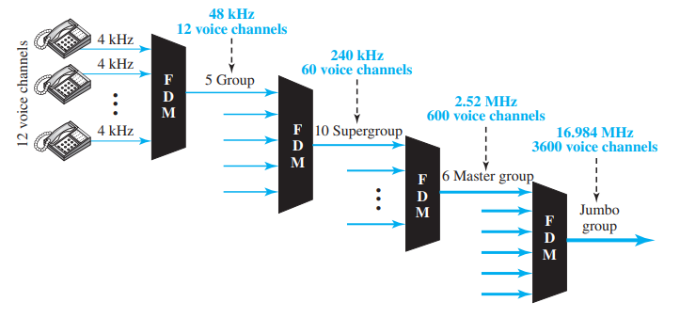
- Group:
  - Composition: 12 Voice Channels.
  - Bandwidth: 48 kHz.
- Supergroup:
  - Composition: 5 Groups (which equals 60 Voice Channels).
  - Bandwidth: 240 kHz.
- Master Group:
  - Composition: 10 Supergroups (600 Voice Channels).
  - Bandwidth: 2.52 MHz.
  - Note: The bandwidth jumps slightly more than the math suggests (2.40 MHz) because Guard Bands are added between supergroups to prevent interference.
- Jumbo Group:
  - Composition: 6 Master Groups (3600 Voice Channels).
  - Bandwidth: 16.984 MHz.

Other Applications of FDM
FDM is not just for telephone lines; it is the backbone of broadcasting.
1. AM Radio Broadcasting
- Medium: Air.
- Total Band: 530 to 1700 kHz.
- Channel Size: Each station is assigned 10 kHz.
- Mechanism: Every station shifts its signal to a different carrier frequency. The receiver filters (tunes) to listen to just one.
2. FM Radio Broadcasting
- Total Band: 88 to 108 MHz.
- Channel Size: Each station is assigned 200 kHz (much wider than AM, allowing for higher quality audio).
3. Television Broadcasting
- Channel Size: Each TV channel receives a bandwidth of 6 MHz.
4. First-Generation Cellular Phones (1G)
- Concept: Uses FDM.
- Assignment: Each user gets two 30-kHz channels (one for sending voice, one for receiving).
- Modulation: The voice signal (3 kHz) is modulated using FM, expanding it to occupy the full 30 kHz.

📝 Example 6.4: Cellular Capacity (AMPS)
Scenario: The Advanced Mobile Phone System (AMPS) uses two bands:
- Send: 824 to 849 MHz (25 MHz total).
- Receive: 869 to 894 MHz (25 MHz total).
- User Requirement: 30 kHz per user.
Question: How many people can talk simultaneously?
Solution:
- Calculate Total Channels:

(In reality, the band is divided into 832 channels).
- Account for Control:
42 channels are reserved for control signals (connecting calls).
- Available for Users: 832 - 42 = 790 channels

Implementation
FDM is flexible in how it is implemented physically.
- No Physical MUX (Radio/TV): In broadcasting, there is no single physical box combining the signals. The "multiplexing" happens in the air because all stations agree to transmit on different frequencies simultaneously.
- Dynamic Assignment (Cellular): A base station doesn't give you a permanent frequency. When you make a call, it assigns you a 60-kHz range (30 send + 30 receive) from the available pool. When you hang up, that frequency is given to someone else.

Wavelength-Division Multiplexing (WDM) (6.1.2)
WDM is designed specifically to utilize the immense data rate capability of fiber-optic cables. 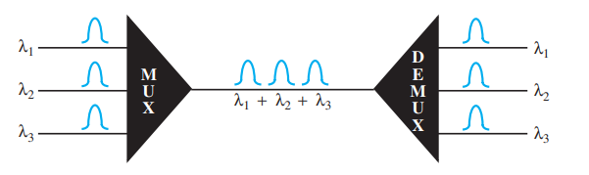
- The Problem: Fiber-optic cables have huge bandwidth. Using a single fiber line for one signal is a waste of capacity.
- The Solution: Multiplexing allows us to combine several lines into one.
- The Concept: WDM is conceptually the same as FDM. We are combining different signals of different frequencies.
  - Difference: The frequencies in WDM are extremely high (light waves).

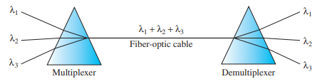
⚙️ Diagram Breakdown: The Prism Mechanism
Although the technology is complex, the physics is simple. We use a Prism.
- Multiplexer: A prism takes several input beams of light (each a narrow band/color) and combines them into one wider beam.
- Demultiplexer: A prism takes the wide combined beam and separates it back into individual narrow beams based on the angle of incidence and frequency.
Applications:
- SONET: A network standard where multiple optical fiber lines are multiplexed.
- Dense WDM (DWDM): A new method that packs a very large number of channels very close together (dense spacing) for even greater efficiency.

Time-Division Multiplexing (TDM) (6.1.3)
TDM is a digital process.
- The Difference: Instead of sharing a portion of the bandwidth (like FDM/WDM), users share a portion of Time.
- The Concept: The high bandwidth of the link is essentially one "fast lane." Users take turns occupying the link sequentially.
  - User 1 goes, then User 2, then User 3, then User 4, then back to User 1.

⚙️ Diagram Breakdown: Time Slots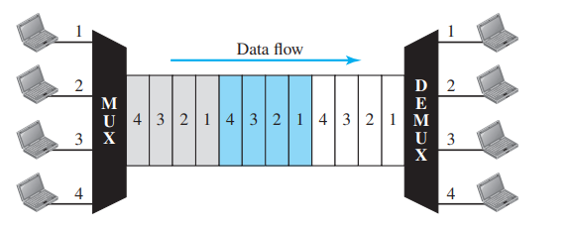

- FDM: Slices the link horizontally (Frequency bands).
- TDM: Slices the link vertically (Time slots).
- Note: Even though it is a digital technique, analog sources can be used if they are sampled and converted to digital first.
Types of TDM:
- Synchronous TDM
- Statistical TDM

Synchronous TDM
In Synchronous TDM, the term "synchronous" implies that the multiplexer allocates the same slot to the same device at all times.
- The Rule: Each input connection has an allotment in the output even if it is not sending data.
- Implication: If a device is silent, its time slot is sent empty. The bandwidth is reserved strictly for it.

Time Slots and Frames
Data flow is divided into Units (which can be 1 bit, 1 character, or 1 block).

⚙️ Diagram Breakdown: The Speed-Up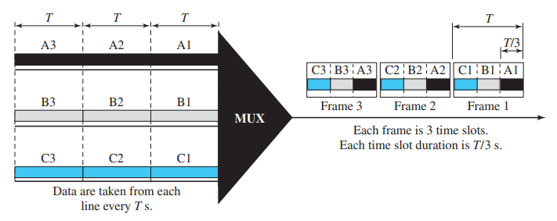
- Input:
  - Imagine 3 input lines (n=3).
  - Each unit lasts for T seconds on the input line.
- Multiplexing:
  - The multiplexer takes one unit from each line and packs them into a Frame.
  - A Frame consists of one complete cycle of slots (one slot for every input line).
- Output:
  - Slot Duration: Since we must fit 3 items into the time it usually takes to send 1, the output time slot is shorter.
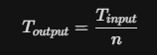
  - Travel Speed: A unit in the output connection travels faster.
  - Frame Duration: The total duration of the frame is usually the same as the duration of one input unit (T).
Data Rate Relationship:
To guarantee smooth flow, the speed of the main link must match the combined speed of the inputs.
- Formula:


Visualization: In diagrams, you will often see the input blocks drawn as "wide" rectangles and the output blocks as "thin" rectangles. This conveys that the unit is long in duration before multiplexing and short (fast) after multiplexing.

Chapter 7: Transmission Media

Introduction (7.1)
Transmission media are the physical pathways that carry information from source to destination.
- Layer Zero: While the Physical Layer (Layer 1) controls transmission, the media itself technically lies below it. We can conceptually call this Layer 0.
Definition:
- General: Anything that carries information (e.g., air for a dinner conversation, a truck for mail).
- Data Communications: Specifically refers to Free Space, Metallic Cable, or Fiber-Optic Cable.
Evolution of Media:
- 19th Century: Telegraph (Morse) introduced long-distance electric signals using metallic media.
- 1869: Telephone allowed voice extension over wires, though early lines were noisy and unreliable.
- 1895: Hertz initiated wireless communication by sending high-frequency signals.
- Marconi: Later sent telegraph messages wirelessly across the Atlantic.
- Modern Era: We now use advanced metallic media (Coaxial/Twisted-pair), Optical Fiber for incredible speeds, and highly efficient free-space technologies.

The Electromagnetic Spectrum
Computers transmit signals as Electromagnetic Energy—a combination of electric and magnetic fields vibrating in relation to one another.
- The Spectrum: Includes power, radio waves, infrared, visible light, ultraviolet, X-rays, gamma rays, and cosmic rays.
- Usability: Not all parts of the spectrum are usable for telecommunications; we are currently limited to specific portions (mostly radio and light).

Taxonomy of Transmission Media
Media is divided into two broad categories based on how the signal is constrained.
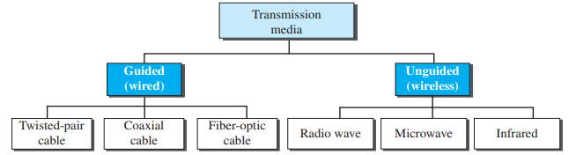
1. Guided Media (Wired)
- The signal is contained within a physical boundary.
- Examples: Twisted-pair cable, Coaxial cable, Fiber-optic cable.
2. Unguided Media (Wireless)
- The signal travels through free space without a physical conductor.
- Examples: Air, Vacuum, Water.

Guided Media (7.2)
Guided media provide a physical conduit from one device to another. The signal is directed and contained within the physical limits of the medium.
Types:
- Twisted-Pair Cable: Metallic (copper) conductors. Transports electric current.
- Coaxial Cable: Metallic (copper) conductors. Transports electric current.
- Fiber-Optic Cable: Glass or plastic. Transports light.

Twisted-Pair Cable (7.2.1)
A twisted pair consists of two copper conductors, each with its own plastic insulation, twisted together.
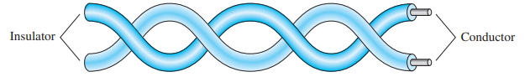
How it Works:
- Wire 1: Carries the signal to the receiver.
- Wire 2: Used only as a ground reference.
- The Receiver: Uses the difference between the two wires to interpret the data.
Why do we twist them? (The Noise Problem)
Signals are often affected by external interference (noise) and crosstalk (signals leaking from nearby wires).
- If wires were Parallel: The wire closer to the noise source would pick up more interference than the farther one. This creates a disparity that the receiver cannot easily filter out.
- Because they are Twisted: The wires swap positions regularly. In one twist, Wire A is closer to the noise; in the next, Wire B is closer.
- The Result: Over the length of the cable, both wires are equally affected by the noise. Since the receiver looks at the difference between the wires, and the noise is now equal on both, the noise cancels itself out.
  - Rule: More twists per inch = Better quality (better noise cancellation).

Unshielded vs. Shielded Twisted-Pair

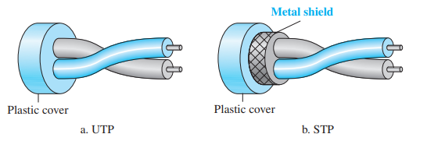
1. Unshielded Twisted-Pair (UTP)
- Description: The most common type used in communications. Just the twisted wires and plastic casing.
- Pros: Cheap, flexible, easy to install.
- Cons: More susceptible to noise than STP.
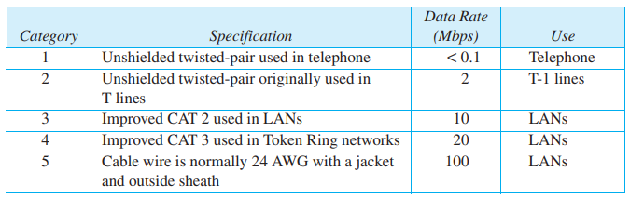
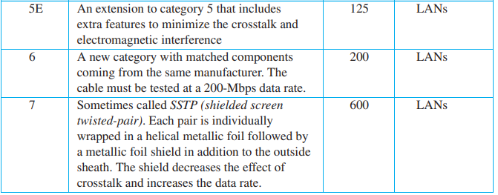

2. Shielded Twisted-Pair (STP)
- Description: Originally produced by IBM. Each pair is encased in a metal foil or braided-mesh covering.
- Pros: The metal casing prevents noise and crosstalk penetration.
- Cons: Bulkier, heavier, and more expensive.

Categories
The EIA (Electronic Industries Association) classifies UTP into seven categories based on quality (1 is lowest, 7 is highest). Each category is suitable for specific uses (e.g., voice vs. high-speed data).

Connectors
The most common connector for UTP cable is the RJ45 (Registered Jack).

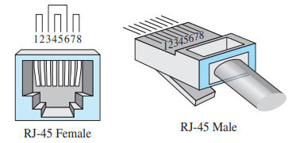

- Keyed Design: The connector is "keyed," meaning it has a specific shape that allows it to be inserted in only one way.

Performance
The performance of twisted-pair cable is often measured by comparing attenuation against frequency and distance.
- The Relationship: Twisted-pair cable can pass a wide range of frequencies. However, attenuation (signal loss) sharply increases as frequency increases, especially above 100 kHz.
- Gauge: The thickness of the wire (gauge) also affects performance. Thicker wires generally offer less resistance and better performance.

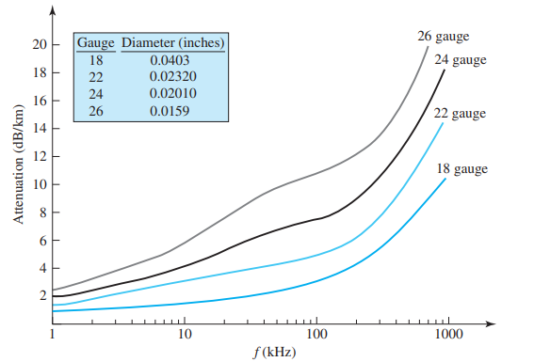

Applications
Twisted-pair cables are ubiquitous in telecommunications.
- Telephone Lines:
  - Used in the Local Loop (the line connecting a subscriber's home to the central telephone office).
  - Can carry both voice and data channels.
- DSL Lines (Digital Subscriber Line):
  - Telephone companies use the high-bandwidth capability of existing UTP cables to provide high-speed internet connections.

Coaxial Cable (7.2.2)
Coaxial cable (or coax) carries signals of higher frequency ranges than twisted-pair cable. This is due to its unique construction.
Structure:

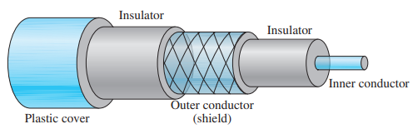

Instead of two side-by-side wires, coax has a layered design:
- Central Core: Solid or stranded wire (usually copper) that carries the signal.
- Insulating Sheath: Encloses the core.
- Outer Conductor: Metal foil or braid.
  - Dual Function: It serves as a shield against noise AND as the second conductor to complete the circuit.
- Plastic Cover: Protects the whole cable.

Standards (RG Ratings)
Coaxial cables are categorized by Radio Government (RG) ratings. Each number denotes a specific set of physical specifications (wire gauge, insulator thickness, etc.).

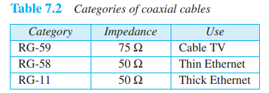

Connectors
To connect coax to devices, we use BNC (Bayonet Neill-Concelman) connectors.
Types:

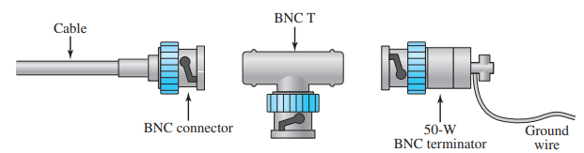

- BNC Connector: Used to connect the end of the cable to a device (like a TV).
- BNC T-Connector: Used in Ethernet networks to branch out to a computer.
- BNC Terminator: Used at the very end of the cable to prevent signal reflection (which would corrupt the data).

Performance

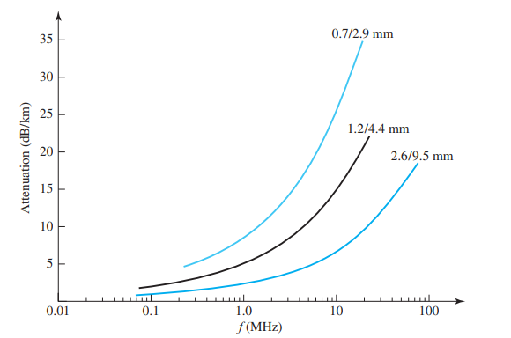
- Bandwidth: Much higher than twisted-pair.
- Attenuation: Surprisingly, attenuation is much higher in coax than in twisted-pair.
- Result: Although it can carry more data, the signal weakens rapidly, requiring the frequent use of repeaters.

Applications
- Telephone Networks: Formerly used to carry up to 10,000 voice signals. Mostly replaced by fiber-optic now.
- Cable TV:
  - Traditionally used for the entire network.
  - Hybrid Networks: Now, fiber is used for the backbone, and Coax (RG-59) is used only at the network boundaries (near the consumer's house).
- Ethernet LANs:
  - 10Base-2 (Thin Ethernet): Uses RG-58. Range: 185 m.
  - 10Base-5 (Thick Ethernet): Uses RG-11. Range: 5000 m.

Fiber-Optic Cable (7.2.3)
A fiber-optic cable is made of glass or plastic and transmits signals in the form of light.

The Physics of Light

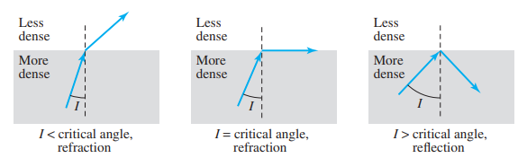
To understand how fiber works, we must look at how light travels through different substances.
- Refraction: When light moves from a dense substance to a less dense one, the ray changes direction (bends away from the vertical).
- Reflection: If the angle of the light hits the boundary steeply enough (greater than the Critical Angle), it doesn't leave the substance. Instead, it makes a turn and travels back into the denser substance.

How Fiber Uses This:

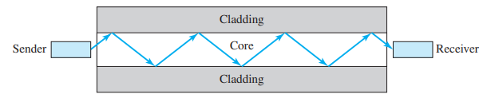

- Core: The center glass/plastic (High Density).
- Cladding: The outer layer (Lower Density).
- The Mechanism: Because the cladding is less dense, light traveling through the core hits the boundary and reflects back into the core. This is called Total Internal Reflection. It guides the light down the wire like water in a pipe.

Propagation Modes
Current technology supports two main modes for sending light.
1. Multimode
Named because multiple beams from a light source move through the core in different paths.
- Step-Index:
  - Core Density: Constant.
  - Movement: Light travels in straight lines and bounces abruptly at the edge.
  - Result: Distortion (signal spreads out).
- Graded-Index:
  - Core Density: Varies (Highest at center, decreases towards the edge).
  - Movement: Light moves in smooth curves.
  - Result: Less distortion than step-index.
2. Single-Mode
- Core: Extremely small diameter.
- Source: Highly focused laser.
- Movement: The critical angle is close to 90°, so the beam travels almost horizontally.
- Result: Negligible distortion. All beams arrive together. Used for long distances.
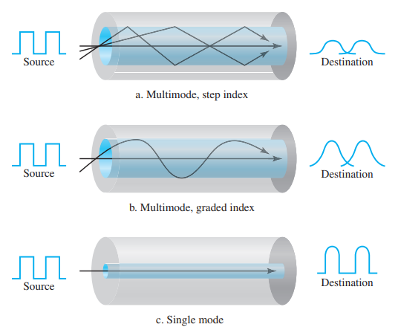

Cable Composition
The cable is not just the glass strand; it requires protection.
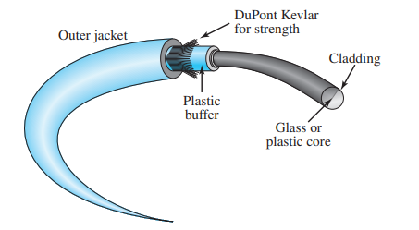
- Outer Jacket: PVC or Teflon.
- Kevlar: Strands of strong material (used in bulletproof vests) to strengthen the cable and prevent breakage during pulling.
- Plastic Coating: Cushions the fiber.
- Cladding & Core: The actual optical transmission vehicle.

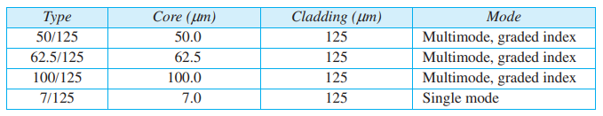

Connectors
There are three main types of connectors.
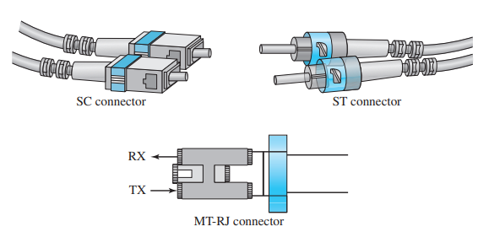
- SC (Subscriber Channel): Push/pull locking system. Used for Cable TV.
- ST (Straight-Tip): Bayonet locking system (twist and lock). Used for Networking.
- MT-RJ: Same size as an RJ45 connector.

Performance & Applications
- Performance: Attenuation is flatter and much lower than copper.

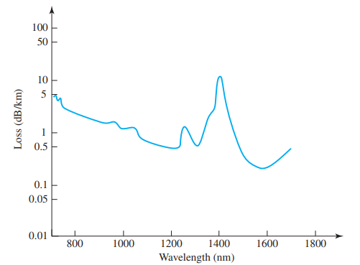

  - Copper: Needs repeaters every 5 km.
  - Fiber: Can go 50 km without regeneration.
- Applications:
  - Backbone Networks: (e.g., SONET) due to high bandwidth.
  - Hybrid Networks: Cable TV uses fiber for the long haul and coax for the "last mile" to the house.
  - LANs: Fast Ethernet (100Base-FX) and Gigabit Ethernet.

Advantages and Disadvantages
✅ Advantages
- Higher Bandwidth: Significantly higher data rates than copper.
- Less Signal Attenuation: Can transmit over much longer distances without repeaters.
- Immunity to EMI: Electromagnetic noise (motors, lightning) passes right through glass without affecting the light signal.
- Light Weight: Much lighter than copper.
- Security: Very difficult to tap. Copper radiates energy (antenna effect); glass does not.
❌ Disadvantages
- Installation/Maintenance: Requires specialized expertise and equipment (splicing glass is harder than twisting wire).
- Unidirectional: Light only goes one way. You need two fibers for bidirectional communication.
- Cost: Interfaces and cable are more expensive than copper.

Unguided Media: Wireless (7.3)
Unguided media transport electromagnetic waves without using a physical conductor. Signals are broadcast through free space and are available to anyone with a receiving device.
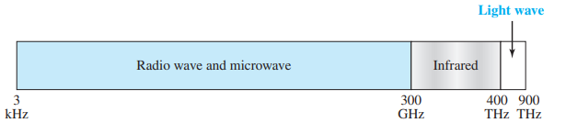

Propagation Methods
Signals travel from source to destination in three ways, depending on their frequency.

⚙️ Diagram Breakdown: How Waves Travel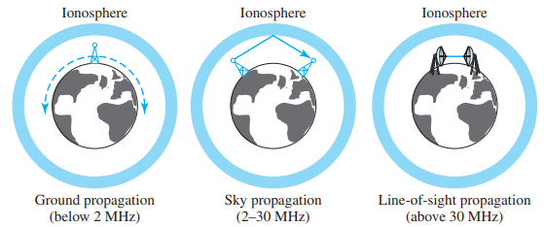
- Ground Propagation (Low Frequency):
  - Waves follow the curvature of the earth.
  - They "hug" the ground and radiate in all directions.
  - Distance: Depends on power (more power = farther reach).
- Sky Propagation (Higher Frequency):
  - Waves radiate upward into the Ionosphere.
  - The ionosphere acts like a mirror, reflecting the waves back to earth.
  - Benefit: Allows long-distance communication with lower power.
- Line-of-Sight Propagation (Very High Frequency):
  - Waves travel in straight lines directly from antenna to antenna.
  - Requirement: Antennas must face each other and be tall enough to see over the curve of the earth.

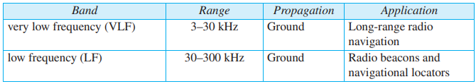
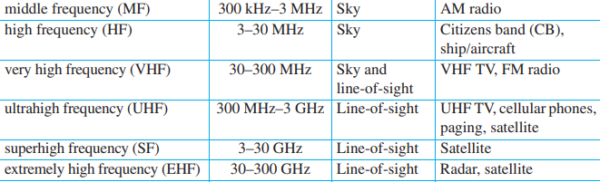

1. Radio Waves (7.3.1)
- Frequency: 3 kHz to 1 GHz.
- Key Characteristic: Omnidirectional.
  - When an antenna transmits, waves go in all directions.
  - Pro: Sending and receiving antennas do not need to be aligned.
  - Con: Susceptible to interference from other antennas.
Properties:
- Penetration: Can penetrate walls (e.g., you can listen to AM radio inside your house).
  - Disadvantage: You cannot isolate communication to just the inside of a building.
- Data Rate: The bands are narrow, leading to lower digital data rates.
Applications:
- Multicasting: One sender, many receivers.
- Examples: AM/FM Radio, Television, Paging systems.

2. Microwaves (7.3.2)
- Frequency: 1 GHz to 300 GHz.
- Key Characteristic: Unidirectional.
  - Waves can be narrowly focused.
  - Requirement: Sending and receiving antennas must be aligned (Line-of-Sight).
Properties:
- No Penetration: Cannot pass through walls.
  - Pro: Secure. Communications inside a building stay inside.
- High Data Rate: The band is very wide (299 GHz), allowing for high-speed transmission.
- Line-of-Sight Issues: Because they travel in straight lines, the curvature of the earth blocks them. Long-distance transmission requires very tall towers and repeaters.
Antennas:
Microwaves use specific antennas to focus the beam.
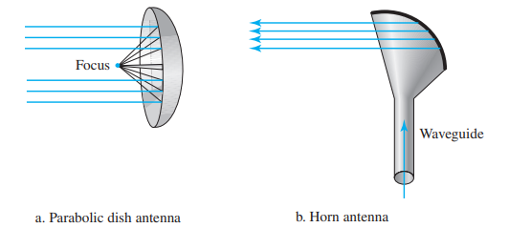
- Parabolic Dish: Based on the geometry of a parabola. It works like a funnel, catching waves and directing them to a single focus point.
- Horn Antenna: Looks like a giant scoop. Deflects outgoing transmissions outward and collects incoming ones down into the stem.
Applications:
- Unicast: One-to-one communication.
- Examples: Cellular phones, Satellite networks, Wireless LANs (Wi-Fi).

3. Infrared (7.3.3)
- Frequency: 300 GHz to 400 THz.
- Key Characteristic: Short-range communication.
Properties:
- No Penetration: Cannot pass through walls.
  - Pro: No interference between rooms. Your TV remote won't change your neighbor's channel.
- Indoor Only: Cannot be used outside because the sun emits infrared waves that interfere with the signal.
- High Potential: The band is massive (400 THz), offering potential for very high data rates.
Applications:
- Remote controls.
- IrDA Ports: Wireless keyboards, mice, printers (requires line-of-sight pointing).

Summary Comparison Table
Type | Frequency | Direction | Wall Penetration | Usage
Radio Waves | 3 kHz – 1 GHz | Omnidirectional | Yes | Multicast (Radio, TV)
Microwaves | 1 GHz – 300 GHz | Unidirectional | No | Unicast (Cell phones, Wi-Fi)
Infrared | 300 GHz – 400 THz | Line-of-Sight | No | Short-range (Remotes)

