1. Write a program to implement following vector operations: at(i), insert (i,e), erase(i,e), set(i,e), push_back(), pop_back()
#include <iostream>
#include <vector>
using namespace std;

/* 1. Write a program to implement following vector operations: at(i), insert (i,e), erase(i,e), set(i,e), push_back(), pop_back(). */

void printVector(const string& operation, const vector<int>& vec) {
cout << operation << ": [ ";
for (int val : vec) {
cout << val << " ";
}
cout << "]\n\n";
}

int main() {
vector<int> v;
cout << "=== Vector Operations Demonstration ===\n\n";

// 1. push_back(e) - Adds an element to the end
v.push_back(10);
v.push_back(20);
v.push_back(30);
v.push_back(40);
v.push_back(50);
printVector("1. After push_back (added 10, 20, 30, 40, 50)", v);

// 2. pop_back() - Removes the last element
v.pop_back();
printVector("2. After pop_back (removed last element)", v);

// 3. at(i) - Accesses the element at index i (throws an error if out of bounds)
cout << "3. Using at(i): Element at index 2 is " << v.at(2) << "\n\n";

// 4. set(i, e) - C++ uses assignment to set a new value at an index
// Setting element at index 1 to 99
v.at(1) = 99; // Alternately, you can use: v[1] = 99;
printVector("4. After 'set(1, 99)' via v.at(1) = 99", v);

// 5. insert(i, e) - Inserts element 'e' at index 'i'
// C++ requires an iterator (v.begin() + i) rather than just an integer
int insertIndex = 2;
int insertValue = 100;
v.insert(v.begin() + insertIndex, insertValue);
printVector("5. After 'insert(2, 100)'", v);

// 6. erase(i) - Erases an element at a specific index
int eraseIndex = 3;
v.erase(v.begin() + eraseIndex);
printVector("6a. After 'erase(3)' (removed element at index 3)", v);

// 6b. erase(start, end) - Erases a range of elements from start to end (exclusive)
// erasing from index 1 up to index 3 (erases index 1 and 2)
int start = 1;
int end = 3;
v.erase(v.begin() + start, v.begin() + end);
printVector("6b. After 'erase(1, 3)' (removed range from index 1 up to 3)", v);

return 0;
}

Output:
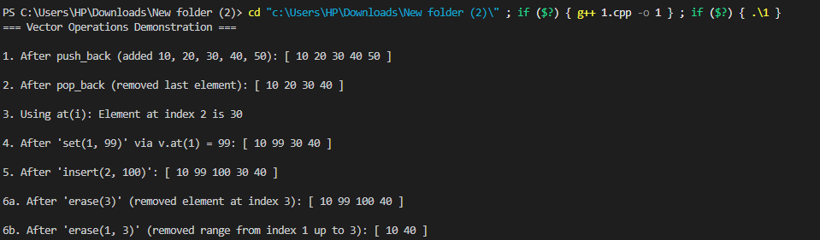

2. Write a cpp program to implement a vector and perform extended array (Insertion, deletion) operations using vector class.
#include <iostream>
#include <limits>
using namespace std;

template<class T>
class Vector {
int size;
int capacity;
T* arr;

void doublingSystem() {
cout << "-> Capacity Exceeded. Time to Double the Capacity!" << endl;
capacity *= 2;

T* temp = new T[capacity];
for (int i = 0; i < size; i++) {
*(temp + i) = *(arr + i);
}
delete[] arr;
arr = temp;
}

public:
~Vector() {
delete[] arr;
}

Vector() {
size = 0;
capacity = 1;
arr = new T[capacity];
}

Vector(int x) {
if (x < 0) {
size = 0;
capacity = 1;
arr = new T[capacity];
return;
}
size = x;
capacity = x;
arr = new T[capacity];
}

Vector(int x, T* list) {
if (list == nullptr) {
throw invalid_argument("List is a nullptr");
}
if (x < 0) {
size = 0;
capacity = 1;
arr = new T[capacity];
return;
}

size = x;
capacity = x;
arr = new T[capacity];

for (int i = 0; i < x; i++) *(arr + i) = *(list + i);
}

T at(int i) {
if (i < 1 || i > size) {
cout << "-> Error: Position out of bounds!" << endl;
return -1;
}
return *(arr + i - 1);
}

void insert(int i, T e) {
if (i < 1 || i > size + 1) {
cout << "-> Error: Position out of bounds!" << endl;
return;
}
if (size == capacity) doublingSystem();

for (int it = size; it > i - 1; it--) {
*(arr + it) = *(arr + it - 1);
}

*(arr + i - 1) = e;
size++;
}

void erase(int i) {
if (i < 1 || i > size) {
cout << "-> Error: Position out of bounds!" << endl;
return;
}
if (size == 0) {
cout << "-> Error: Vector is empty!" << endl;
return;
}

for (int it = i - 1; it < size - 1; it++) {
*(arr + it) = *(arr + it + 1);
}
size--;
}

void set(int i, T e) {
if (i < 1 || i > size) {
cout << "-> Error: Position out of bounds!" << endl;
return;
}
*(arr + i - 1) = e;
}

void push_back(T e) {
if (size == capacity) doublingSystem();
*(arr + size) = e;
size++;
}

void pop_back() {
if (size == 0) {
cout << "-> Error: Vector is already empty!" << endl;
return;
}
size--;
}

void print() {
cout << "Vector: [ ";
for (int i = 0; i < size; i++) {
cout << *(arr + i) << " ";
}
cout << "] (Size: " << size << ", Capacity: " << capacity << ")\n";
}
};

int main() {
Vector<int> v;
int choice, pos, value;

while (true) {
cout << "\n=== Custom Vector Menu (1-Based Positions) ===\n";
cout << "1. Push Back (push_back)\n";
cout << "2. Pop Back (pop_back)\n";
cout << "3. Insert at Position (insert)\n";
cout << "4. Erase at Position (erase)\n";
cout << "5. Set Element at Position (set)\n";
cout << "6. Get Element at Position (at)\n";
cout << "7. Print Vector\n";
cout << "8. Exit\n";
cout << "Enter your choice (1-8): ";

if (!(cin >> choice)) {
cout << "Invalid input! Please enter a number.\n";
cin.clear();
cin.ignore(numeric_limits<streamsize>::max(), '\n');
continue;
}

if (choice == 8) {
cout << "Exiting program...\n";
break;
}

switch (choice) {
case 1:
cout << "Enter value to push back: ";
cin >> value;
v.push_back(value);
v.print();
break;

case 2:
v.pop_back();
v.print();
break;

case 3:
cout << "Enter position (1 to " << (v.at(1) == -1 ? 1 : 999) << /*placeholder*/ ") to insert at: ";
cin >> pos;
cout << "Enter value to insert: ";
cin >> value;
v.insert(pos, value);
v.print();
break;

case 4:
cout << "Enter position to erase (1-based): ";
cin >> pos;
v.erase(pos);
v.print();
break;

case 5:
cout << "Enter position to set (1-based): ";
cin >> pos;
cout << "Enter new value: ";
cin >> value;
v.set(pos, value);
v.print();
break;

case 6:
cout << "Enter position to retrieve (1-based): ";
cin >> pos;
value = v.at(pos);
if (value != -1) {
cout << "-> Value at position " << pos << " is: " << value << "\n";
}
break;

case 7:
v.print();
break;

default:
cout << "Invalid choice! Please select an option between 1 and 8.\n";
}
}

return 0;
}

Output:
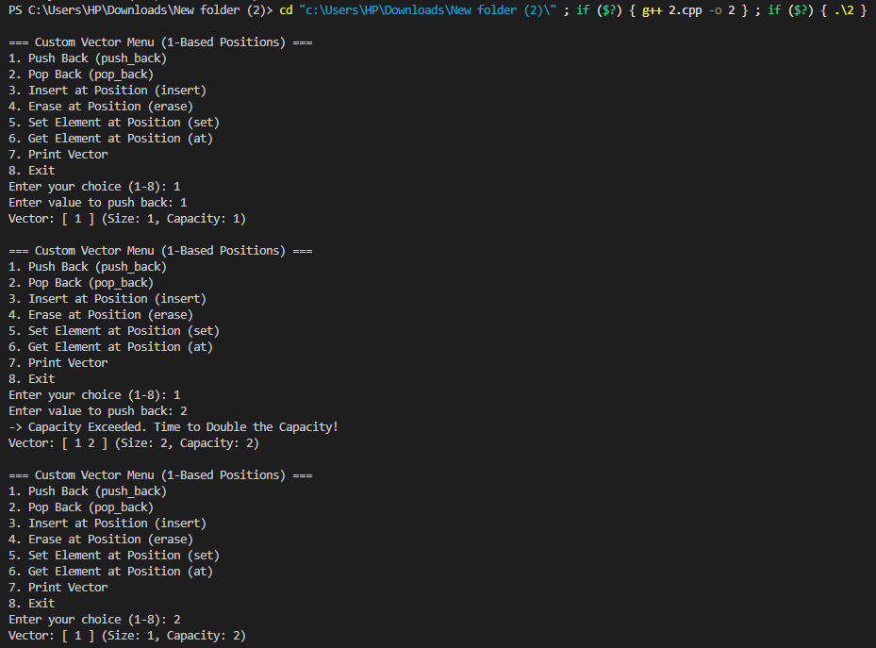
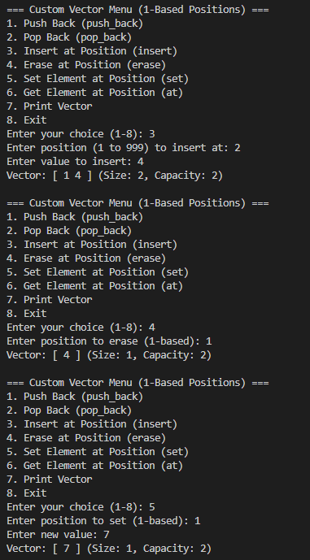
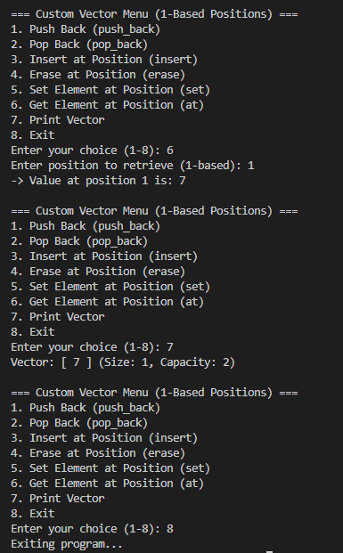

3. Given a vector of integers and a target value, return the indices of two numbers whose sum equals the target eg: nums = [2, 7, 11, 15]. target = 9.
#include <iostream>
#include <vector>
#include <unordered_map>

std::vector<int> twoSum(const std::vector<int>& nums, int target) {
std::unordered_map<int, int> num_map;

for (int i = 0; i < nums.size(); ++i) {
int complement = target - nums[i];

if (num_map.find(complement) != num_map.end()) {
return {num_map[complement], i};
}

num_map[nums[i]] = i;
}

return {};
}

int main() {
std::vector<int> nums = {2, 7, 11, 15};
int target = 9;

std::vector<int> result = twoSum(nums, target);

if (!result.empty()) {
std::cout << result[0] << " " << result[1] << std::endl;
} else {
std::cout << "No pair found" << std::endl;
}

return 0;
}

Output:

4. Write a menu-driven C++ program that performs the following operations on a vector:
1. Display the vector
2. Rotate left by one position
3. Rotate right by one position
4. Rotate left by K positions
5. Rotate right by K positions
6. Exit
#include <iostream>
#include <vector>
#include <algorithm>

void displayVector(const std::vector<int>& vec) {
if (vec.empty()) {
std::cout << "Vector is empty.\n";
return;
}
std::cout << "Vector elements: ";
for (int val : vec) {
std::cout << val << " ";
}
std::cout << "\n";
}

void rotateLeft(std::vector<int>& vec, int k) {
if (vec.empty()) return;
int n = vec.size();
k = k % n; // Handle cases where k >= vector size
std::rotate(vec.begin(), vec.begin() + k, vec.end());
}

void rotateRight(std::vector<int>& vec, int k) {
if (vec.empty()) return;
int n = vec.size();
k = k % n; // Handle cases where k >= vector size
std::rotate(vec.rbegin(), vec.rbegin() + k, vec.rend());
}

int main() {
int n;
std::cout << "Enter initial size of vector: ";
std::cin >> n;

std::vector<int> vec(n);
std::cout << "Enter " << n << " elements: ";
for (int i = 0; i < n; ++i) {
std::cin >> vec[i];
}

int choice;
do {
std::cout << "\n==============================\n";
std::cout << "1. Display the vector\n";
std::cout << "2. Rotate left by 1 position\n";
std::cout << "3. Rotate right by 1 position\n";
std::cout << "4. Rotate left by K positions\n";
std::cout << "5. Rotate right by K positions\n";
std::cout << "6. Exit\n";
std::cout << "Enter your choice: ";
std::cin >> choice;

switch (choice) {
case 1:
displayVector(vec);
break;
case 2:
rotateLeft(vec, 1);
std::cout << "Vector rotated left by 1 position.\n";
break;
case 3:
rotateRight(vec, 1);
std::cout << "Vector rotated right by 1 position.\n";
break;
case 4: {
int k;
std::cout << "Enter value for K: ";
std::cin >> k;
rotateLeft(vec, k);
std::cout << "Vector rotated left by " << k << " position(s).\n";
break;
}
case 5: {
int k;
std::cout << "Enter value for K: ";
std::cin >> k;
rotateRight(vec, k);
std::cout << "Vector rotated right by " << k << " position(s).\n";
break;
}
case 6:
std::cout << "Exiting program.\n";
break;
default:
std::cout << "Invalid choice! Please select a valid option.\n";
}
} while (choice != 6);

return 0;
}

Output:
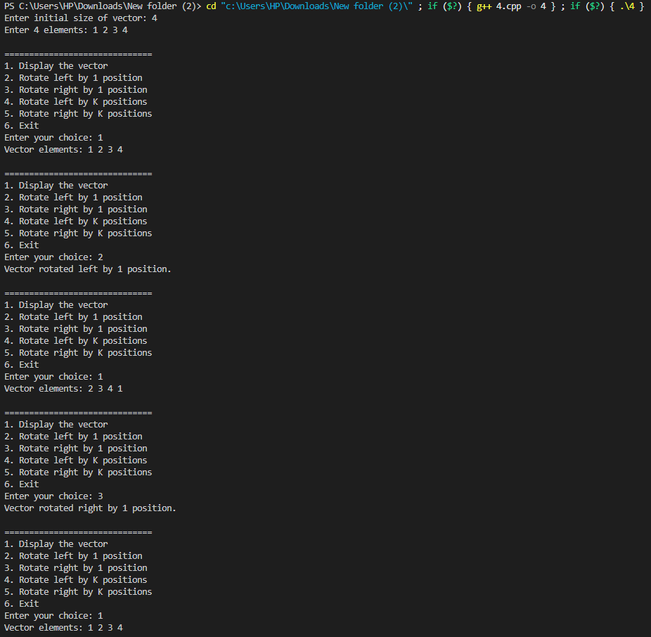
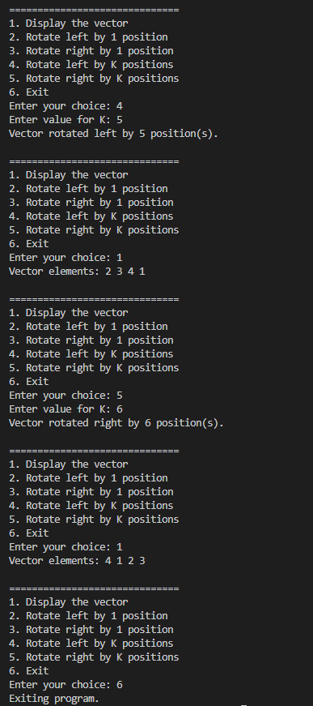

5. Write a C++ program to remove duplicate elements from a sorted vector of integers.
#include <iostream>
#include <vector>
#include <algorithm>

void removeDuplicates(std::vector<int>& nums) {
auto it = std::unique(nums.begin(), nums.end());
nums.erase(it, nums.end());
}

int main() {
std::vector<int> nums = {1, 1, 2, 2, 3, 4, 4, 4, 5, 5};

std::cout << "Original vector: ";
for (int num : nums) {
std::cout << num << " ";
}
std::cout << "\n";

removeDuplicates(nums);

std::cout << "Vector after removing duplicates: ";
for (int num : nums) {
std::cout << num << " ";
}
std::cout << "\n";

return 0;
}

Output:

