1. Implement a push function. Start with an array size of 2. If a student pushes an item into a full stack, create a new array that is double the size. Copy all old items over.
#include <iostream>

class DynamicStack {
private:
int* arr;
int capacity;
int top;

public:
DynamicStack() {
capacity = 2;
arr = new int[capacity];
top = -1;
}

~DynamicStack() {
delete[] arr;
}

void push(int value) {
if (top + 1 == capacity) {
int newCapacity = capacity * 2;
int* newArr = new int[newCapacity];

for (int i = 0; i <= top; ++i) {
newArr[i] = arr[i];
}

delete[] arr;
arr = newArr;
capacity = newCapacity;

std::cout << "Stack full. Resized capacity to " << capacity << "\n";
}

arr[++top] = value;
std::cout << "Pushed " << value << "\n";
}

void display() const {
std::cout << "Stack elements: ";
for (int i = 0; i <= top; ++i) {
std::cout << arr[i] << " ";
}
std::cout << "\n";
}
};

int main() {
DynamicStack stack;

stack.push(10);
stack.push(20);
stack.push(30);
stack.push(40);
stack.push(50);

stack.display();

return 0;
}

Output:
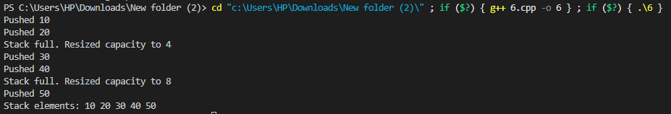

2. Track the exact number of operations. For a normal push, the cost is 1. For a resizing push, the cost is 1 plus the number of copied items.
#include <iostream>

class DynamicStack {
private:
int* arr;
int capacity;
int top;
int totalOps;

public:
DynamicStack() {
capacity = 2;
arr = new int[capacity];
top = -1;
totalOps = 0;
}

~DynamicStack() {
delete[] arr;
}

void push(int value) {
int opCost = 1; // Base cost for insertion

if (top + 1 == capacity) {
int copiedItems = top + 1;
opCost += copiedItems; // Add cost of copying existing items

int newCapacity = capacity * 2;
int* newArr = new int[newCapacity];

for (int i = 0; i <= top; ++i) {
newArr[i] = arr[i];
}

delete[] arr;
arr = newArr;
capacity = newCapacity;
}

arr[++top] = value;
totalOps += opCost;

std::cout << "Pushed: " << value
<< " | Cost: " << opCost
<< " | Total Ops: " << totalOps
<< " | Capacity: " << capacity << "\n";
}

int getTotalOps() const {
return totalOps;
}
};

int main() {
DynamicStack stack;

// Push sequence to demonstrate cost tracking
for (int i = 1; i <= 6; ++i) {
stack.push(i * 10);
}

return 0;
}

Output:
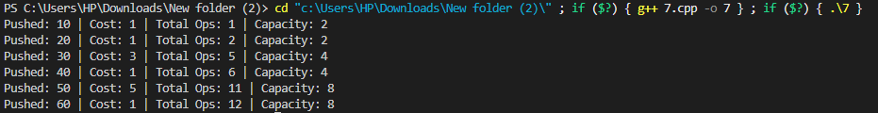

3. Push 1,000 items in a loop. Print out the total cost and the average cost per push at the very end.
#include <iostream>

class DynamicStack {
private:
int* arr;
int capacity;
int top;
long long totalOps;

public:
DynamicStack() {
capacity = 2;
arr = new int[capacity];
top = -1;
totalOps = 0;
}

~DynamicStack() {
delete[] arr;
}

void push(int value) {
int opCost = 1;

if (top + 1 == capacity) {
int copiedItems = top + 1;
opCost += copiedItems;

int newCapacity = capacity * 2;
int* newArr = new int[newCapacity];

for (int i = 0; i <= top; ++i) {
newArr[i] = arr[i];
}

delete[] arr;
arr = newArr;
capacity = newCapacity;
}

arr[++top] = value;
totalOps += opCost;
}

long long getTotalOps() const {
return totalOps;
}
};

int main() {
DynamicStack stack;
const int numPushes = 1000;

for (int i = 1; i <= numPushes; ++i) {
stack.push(i);
}

long long totalCost = stack.getTotalOps();
double averageCost = static_cast<double>(totalCost) / numPushes;

std::cout << "Total Pushes: " << numPushes << "\n";
std::cout << "Total Cost (Operations): " << totalCost << "\n";
std::cout << "Average Cost per Push: " << averageCost << "\n";

return 0;
}

Output:

4. Change the resizing rule. Instead of doubling, increase the size by adding +10 slots each time it fills up. Run 1,000 pushes again. Compare the average costs of both methods.
#include <iostream>

class DynamicStackPlus10 {
private:
int* arr;
int capacity;
int top;
long long totalOps;

public:
DynamicStackPlus10() {
capacity = 2;
arr = new int[capacity];
top = -1;
totalOps = 0;
}

~DynamicStackPlus10() {
delete[] arr;
}

void push(int value) {
int opCost = 1;

if (top + 1 == capacity) {
int copiedItems = top + 1;
opCost += copiedItems;

int newCapacity = capacity + 10; // Resizing rule: +10 slots
int* newArr = new int[newCapacity];

for (int i = 0; i <= top; ++i) {
newArr[i] = arr[i];
}

delete[] arr;
arr = newArr;
capacity = newCapacity;
}

arr[++top] = value;
totalOps += opCost;
}

long long getTotalOps() const {
return totalOps;
}
};

int main() {
DynamicStackPlus10 stack;
const int numPushes = 1000;

for (int i = 1; i <= numPushes; ++i) {
stack.push(i);
}

long long totalCost = stack.getTotalOps();
double averageCost = static_cast<double>(totalCost) / numPushes;

std::cout << "Total Pushes: " << numPushes << "\n";
std::cout << "Total Cost (Operations): " << totalCost << "\n";
std::cout << "Average Cost per Push: " << averageCost << "\n";

return 0;
}

Output:

