1.
<!DOCTYPE html>
<html>
<head>
<title>Anonymous Function</title>
</head>
<body>
<h2>Anonymous Function Demo</h2>
<button onclick="show()">Click Me</button>
<p id="result"></p>

<script>
// Anonymous function assigned to variable
var greet = function(name) {
return "Hello " + name;
};

function show() {
document.getElementById("result").innerHTML = greet("Student");
}
</script>
</body>
</html>


2.
<!DOCTYPE html>
<html>
<head>
<title>Armstrong Number</title>
</head>
<body>
<h2>Check Armstrong Number</h2>
Enter number: <input type="text" id="num">
<button onclick="checkArmstrong()">Check</button>
<p id="result"></p>

<script>
function checkArmstrong() {
var n = parseInt(document.getElementById("num").value);
var original = n;
var sum = 0;
while (n > 0) {
var digit = n % 10;
sum = sum + (digit * digit * digit);
n = parseInt(n / 10);
}
if (original == sum) {
document.getElementById("result").innerHTML = original + " is Armstrong";
} else {
document.getElementById("result").innerHTML = original + " is not Armstrong";
}
}
</script>
</body>
</html>
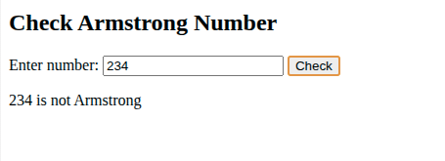

3.
<!DOCTYPE html>
<html>
<head>
<title>Calculator</title>
</head>
<body>
<h2>Simple Calculator</h2>
First Number: <input type="text" id="num1"><br><br>
Second Number: <input type="text" id="num2"><br><br>
<button onclick="calculate('+')">+</button>
<button onclick="calculate('-')">-</button>
<button onclick="calculate('*')">*</button>
<button onclick="calculate('/')">/</button>

<script>
function calculate(op) {
var n1 = parseFloat(document.getElementById("num1").value);
var n2 = parseFloat(document.getElementById("num2").value);
var result;
if (op == '+') result = n1 + n2;
else if (op == '-') result = n1 - n2;
else if (op == '*') result = n1 * n2;
else if (op == '/') result = n1 / n2;
alert("Result: " + result);
}
</script>
</body>
</html>
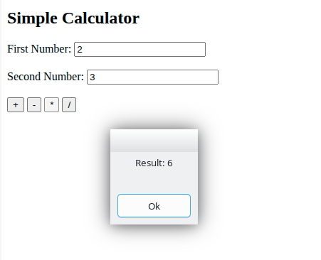

4.
<!DOCTYPE html>
<html>
<head>
<title>Chess Board</title>
</head>
<body>
<h2>Chess Game</h2>
<table border="1" cellpadding="0" cellspacing="0">
<!-- Row 8 -->
<tr>
<td><img src="https://upload.wikimedia.org/wikipedia/commons/f/ff/Chess_rdt45.svg" width="50" height="50"></td>
<td bgcolor="#D3D3D3"><img src="https://upload.wikimedia.org/wikipedia/commons/e/ef/Chess_ndt45.svg" width="50" height="50"></td>
<td><img src="https://upload.wikimedia.org/wikipedia/commons/9/98/Chess_bdt45.svg" width="50" height="50"></td>
<td bgcolor="#D3D3D3"><img src="https://upload.wikimedia.org/wikipedia/commons/4/47/Chess_qdt45.svg" width="50" height="50"></td>
<td><img src="https://upload.wikimedia.org/wikipedia/commons/f/f0/Chess_kdt45.svg" width="50" height="50"></td>
<td bgcolor="#D3D3D3"><img src="https://upload.wikimedia.org/wikipedia/commons/9/98/Chess_bdt45.svg" width="50" height="50"></td>
<td><img src="https://upload.wikimedia.org/wikipedia/commons/e/ef/Chess_ndt45.svg" width="50" height="50"></td>
<td bgcolor="#D3D3D3"><img src="https://upload.wikimedia.org/wikipedia/commons/f/ff/Chess_rdt45.svg" width="50" height="50"></td>
</tr>
<!-- Row 7 -->
<tr>
<td bgcolor="#D3D3D3"><img src="https://upload.wikimedia.org/wikipedia/commons/c/c7/Chess_pdt45.svg" width="50" height="50"></td>
<td><img src="https://upload.wikimedia.org/wikipedia/commons/c/c7/Chess_pdt45.svg" width="50" height="50"></td>
<td bgcolor="#D3D3D3"><img src="https://upload.wikimedia.org/wikipedia/commons/c/c7/Chess_pdt45.svg" width="50" height="50"></td>
<td><img src="https://upload.wikimedia.org/wikipedia/commons/c/c7/Chess_pdt45.svg" width="50" height="50"></td>
<td bgcolor="#D3D3D3"><img src="https://upload.wikimedia.org/wikipedia/commons/c/c7/Chess_pdt45.svg" width="50" height="50"></td>
<td><img src="https://upload.wikimedia.org/wikipedia/commons/c/c7/Chess_pdt45.svg" width="50" height="50"></td>
<td bgcolor="#D3D3D3"><img src="https://upload.wikimedia.org/wikipedia/commons/c/c7/Chess_pdt45.svg" width="50" height="50"></td>
<td><img src="https://upload.wikimedia.org/wikipedia/commons/c/c7/Chess_pdt45.svg" width="50" height="50"></td>
</tr>
<!-- Row 6 -->
<tr>
<td height="50"></td>
<td bgcolor="#D3D3D3" height="50"></td>
<td height="50"></td>
<td bgcolor="#D3D3D3" height="50"></td>
<td height="50"></td>
<td bgcolor="#D3D3D3" height="50"></td>
<td height="50"></td>
<td bgcolor="#D3D3D3" height="50"></td>
</tr>
<!-- Row 5 -->
<tr>
<td bgcolor="#D3D3D3" height="50"></td>
<td height="50"></td>
<td bgcolor="#D3D3D3" height="50"></td>
<td height="50"></td>
<td bgcolor="#D3D3D3" height="50"></td>
<td height="50"></td>
<td bgcolor="#D3D3D3" height="50"></td>
<td height="50"></td>
</tr>
<!-- Row 4 -->
<tr>
<td height="50"></td>
<td bgcolor="#D3D3D3" height="50"></td>
<td height="50"></td>
<td bgcolor="#D3D3D3" height="50"></td>
<td height="50"></td>
<td bgcolor="#D3D3D3" height="50"></td>
<td height="50"></td>
<td bgcolor="#D3D3D3" height="50"></td>
</tr>
<!-- Row 3 -->
<tr>
<td bgcolor="#D3D3D3" height="50"></td>
<td height="50"></td>
<td bgcolor="#D3D3D3" height="50"></td>
<td height="50"></td>
<td bgcolor="#D3D3D3" height="50"></td>
<td height="50"></td>
<td bgcolor="#D3D3D3" height="50"></td>
<td height="50"></td>
</tr>
<!-- Row 2 -->
<tr>
<td><img src="https://upload.wikimedia.org/wikipedia/commons/4/45/Chess_plt45.svg" width="50" height="50"></td>
<td bgcolor="#D3D3D3"><img src="https://upload.wikimedia.org/wikipedia/commons/4/45/Chess_plt45.svg" width="50" height="50"></td>
<td><img src="https://upload.wikimedia.org/wikipedia/commons/4/45/Chess_plt45.svg" width="50" height="50"></td>
<td bgcolor="#D3D3D3"><img src="https://upload.wikimedia.org/wikipedia/commons/4/45/Chess_plt45.svg" width="50" height="50"></td>
<td><img src="https://upload.wikimedia.org/wikipedia/commons/4/45/Chess_plt45.svg" width="50" height="50"></td>
<td bgcolor="#D3D3D3"><img src="https://upload.wikimedia.org/wikipedia/commons/4/45/Chess_plt45.svg" width="50" height="50"></td>
<td><img src="https://upload.wikimedia.org/wikipedia/commons/4/45/Chess_plt45.svg" width="50" height="50"></td>
<td bgcolor="#D3D3D3"><img src="https://upload.wikimedia.org/wikipedia/commons/4/45/Chess_plt45.svg" width="50" height="50"></td>
</tr>
<!-- Row 1 -->
<tr>
<td bgcolor="#D3D3D3"><img src="https://upload.wikimedia.org/wikipedia/commons/7/72/Chess_rlt45.svg" width="50" height="50"></td>
<td><img src="https://upload.wikimedia.org/wikipedia/commons/7/70/Chess_nlt45.svg" width="50" height="50"></td>
<td bgcolor="#D3D3D3"><img src="https://upload.wikimedia.org/wikipedia/commons/b/b1/Chess_blt45.svg" width="50" height="50"></td>
<td><img src="https://upload.wikimedia.org/wikipedia/commons/1/15/Chess_qlt45.svg" width="50" height="50"></td>
<td bgcolor="#D3D3D3"><img src="https://upload.wikimedia.org/wikipedia/commons/4/42/Chess_klt45.svg" width="50" height="50"></td>
<td><img src="https://upload.wikimedia.org/wikipedia/commons/b/b1/Chess_blt45.svg" width="50" height="50"></td>
<td bgcolor="#D3D3D3"><img src="https://upload.wikimedia.org/wikipedia/commons/7/70/Chess_nlt45.svg" width="50" height="50"></td>
<td><img src="https://upload.wikimedia.org/wikipedia/commons/7/72/Chess_rlt45.svg" width="50" height="50"></td>
</tr>
</table>
</body>
</html>

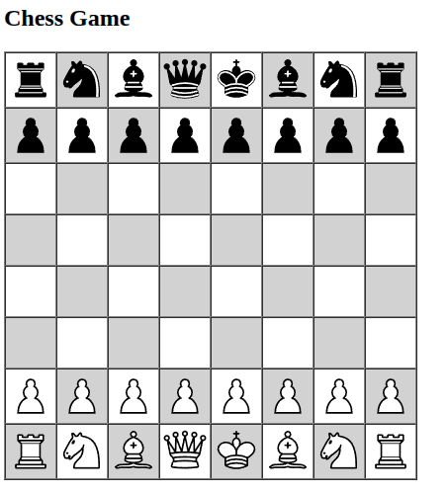

5.
<!DOCTYPE html>
<html>
<head>
<title>CSS Tutorial Demo</title>
<!-- Embedded CSS - Method 1 -->
<style type="text/css">
/* This is a CSS comment */
/* Universal Selector - applies to all elements */
* {
font-family: Arial;
}
/* Type Selector - targets specific HTML tags */
h1 {
color: #36C;
text-align: center;
}
/* Class Selector - reusable style */
.highlight {
background-color: yellow;
padding: 10px;
}
.center {
text-align: center;
}
/* ID Selector - unique style */
#special-box {
border: 2px solid red;
padding: 15px;
margin: 10px;
}
/* Descendant Selector - targets elements inside others */
ul li {
color: green;
}
/* Child Selector - direct children only */
div > p {
color: blue;
font-weight: bold;
}
/* Attribute Selector - targets elements with specific attributes */
input[type="text"] {
background-color: #f0f0f0;
width: 200px;
}
/* Grouping Selectors - apply same style to multiple elements */
h2, h3 {
color: #C00;
border-bottom: 1px solid #C00;
}
/* Multiple properties in one rule */
.box {
width: 200px;
height: 100px;
background-color: #36CFFF;
margin: 10px;
padding: 10px;
border: 2px solid black;
}
</style>
<!-- Imported CSS - Method 4 (commented out as example) -->
<!-- @import url("external.css"); -->
</head>
<body>

<h1>CSS Tutorial Demonstration</h1>
<!-- Type Selector Demo -->
<h2>1. Type Selectors</h2>
<p>This paragraph uses default styling from universal selector.</p>
<!-- Class Selector Demo -->
<h2>2. Class Selectors</h2>
<p class="highlight">This text has yellow background (class="highlight")</p>
<p class="center">This text is centered (class="center")</p>
<p class="highlight center">This uses both classes (class="highlight center")</p>
<!-- ID Selector Demo -->
<h2>3. ID Selectors</h2>
<div id="special-box">This box has unique ID styling with red border</div>
<!-- Descendant Selector Demo -->
<h2>4. Descendant Selectors</h2>
<ul>
<li>This list item is green (inside ul)</li>
<li>Another green item</li>
</ul>
<li>This list item is NOT green (outside ul)</li>
<!-- Child Selector Demo -->
<h2>5. Child Selectors</h2>
<div>
<p>This paragraph is blue and bold (direct child of div)</p>
<span><p>This paragraph is NOT styled (not direct child)</p></span>
</div>
<!-- Attribute Selector Demo -->
<h2>6. Attribute Selectors</h2>
<form>
Text input (gray background): <input type="text" value="Type here"><br><br>
Password input (no special style): <input type="password" value="password">
</form>
<!-- Grouping Selectors Demo -->
<h2>7. Grouping Selectors</h2>
<h3>This h3 has same style as h2 (grouped selector)</h3>
<!-- Measurement Units Demo -->
<h2>8. CSS Measurement Units</h2>
<div class="box">
This box uses px units:<br>
width: 200px<br>
height: 100px<br>
padding: 10px<br>
margin: 10px<br>
border: 2px
</div>
<!-- Colors Demo -->
<h2>9. CSS Colors</h2>
<p style="color: red;">Red using color name</p>
<p style="color: #FF0000;">Red using Hex code (#FF0000)</p>
<p style="color: rgb(255, 0, 0);">Red using RGB (255, 0, 0)</p>
<p style="color: #F00;">Red using Short Hex (#F00)</p>
<!-- Inline CSS Demo -->
<h2>10. Inline CSS</h2>
<p style="color: purple; font-size: 20px;">This uses inline style attribute (highest priority)</p>
<!-- External CSS Link Demo (commented) -->
<h2>11. External CSS</h2>
<p>To use external CSS, add this in head section:</p>
<code>&lt;link rel="stylesheet" type="text/css" href="mystyle.css"&gt;</code>

</body>
</html>

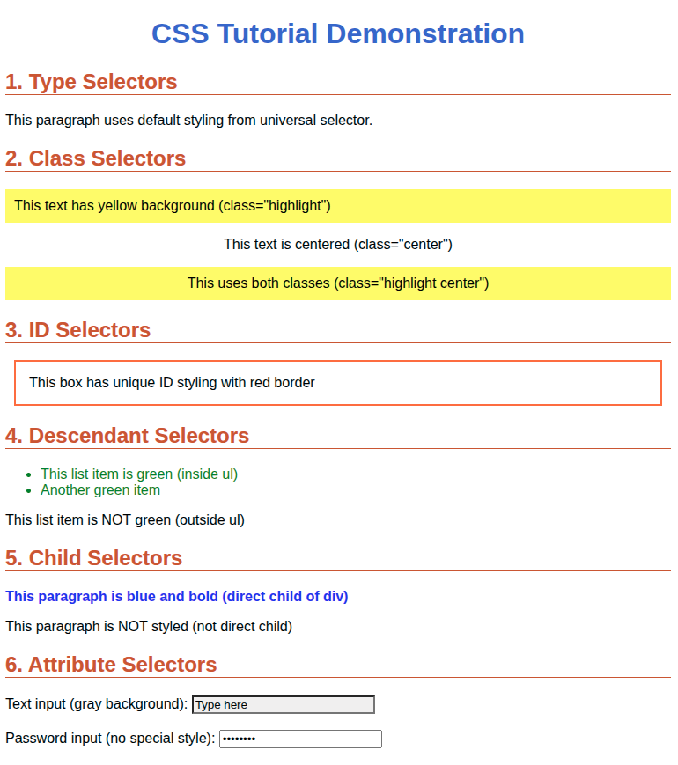

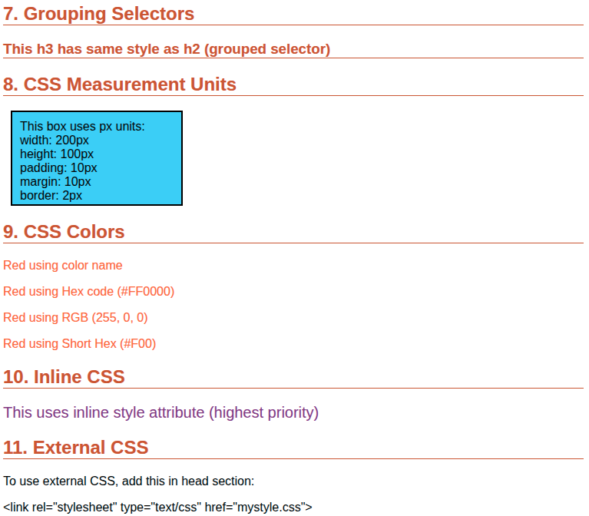

6.
<!DOCTYPE html>
<html>
<head>
<title>My CV</title>
</head>
<body>
<h1>John Smith</h1>
<p>Email: john@email.com | Phone: 1234567890</p>
<h2>Education</h2>
<p>Bachelor of Science - XYZ University (2020-2024)</p>
<h2>Skills</h2>
<ul>
<li>HTML</li>
<li>JavaScript</li>
<li>Python</li>
</ul>
<h2>Experience</h2>
<p>Web Developer Intern - ABC Company (2023)</p>
</body>
</html>

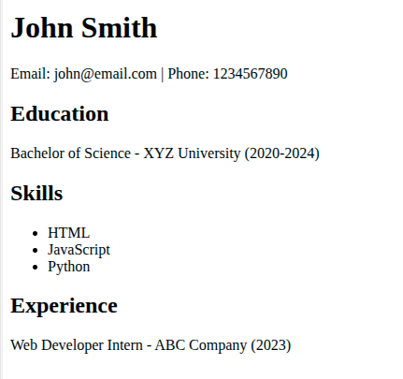

7.
<!DOCTYPE html>
<html>
<head>
<title>Educational Qualifications</title>
</head>
<body>
<h1>My Educational Qualifications</h1>
<table border="1">
<tr>
<th>Degree</th>
<th>Institution</th>
<th>Year</th>
<th>Percentage</th>
</tr>
<tr>
<td>10th (SSC)</td>
<td>City High School</td>
<td>2018</td>
<td>85%</td>
</tr>
<tr>
<td>12th (HSC)</td>
<td>City College</td>
<td>2020</td>
<td>82%</td>
</tr>
<tr>
<td>Bachelor of Technology</td>
<td>XYZ University</td>
<td>2024</td>
<td>80%</td>
</tr>
</table>
</body>
</html>

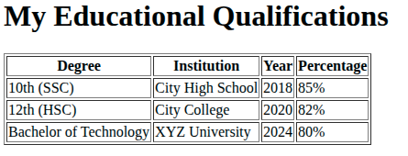

8.
<!DOCTYPE html>
<html>
<head>
<title>Staff Board</title>
</head>
<body>
<h1>Staff Board</h1>
<h2 id="staff-name">Junior Developer</h2>
<ul id="employee-list">
<li>Alice - Marketing</li>
</ul>
<br>
<button onclick="hireIntern()">Hire Intern</button>
<button onclick="promoteManager()">Promote Manager</button>
<button onclick="resignEmployee()">Resign Employee</button>

<script>
function hireIntern() {
var newItem = document.createElement("li");
newItem.innerHTML = "New Intern";
document.getElementById("employee-list").appendChild(newItem);
}

function promoteManager() {
var staffName = document.getElementById("staff-name");
staffName.innerHTML = "Senior Project Manager";
staffName.style.backgroundColor = "gold";
staffName.style.fontSize = "30px";
}

function resignEmployee() {
document.getElementById("employee-list").remove();
}
</script>
</body>
</html>

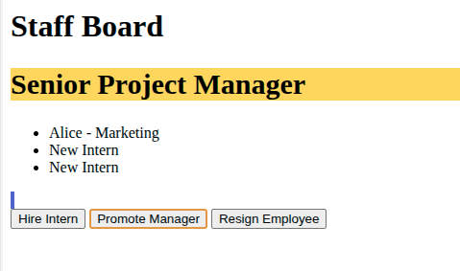

9.
<!DOCTYPE html>
<html>
<head>
<title>Fibonacci Series</title>
</head>
<body>
<h2>Fibonacci Series</h2>
Enter terms: <input type="text" id="num">
<button onclick="printFibonacci()">Print</button>
<p id="result"></p>

<script>
function printFibonacci() {
var n = parseInt(document.getElementById("num").value);
var a = 0;
var b = 1;
var result = "";
for (var i = 0; i < n; i++) {
result = result + a + " ";
var next = a + b;
a = b;
b = next;
}
document.getElementById("result").innerHTML = result;
}
</script>
</body>
</html>
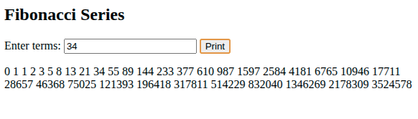

10.
<!DOCTYPE html>
<html>
<head>
<title>Form Validation</title>
</head>
<body>
<h2>Student Registration</h2>
<form onsubmit="return validateForm()">
Roll Number (7 digits): <input type="text" id="rollno"><br><br>
Name (alphabets only): <input type="text" id="name"><br><br>
Date of Birth: <input type="text" id="dob" placeholder="DD/MM/YYYY"><br><br>
<input type="submit" value="Submit">
</form>

<script>
function validateForm() {
// Validate Roll Number - 7 digits
var rollno = document.getElementById("rollno").value;
if (rollno.length != 7 || isNaN(rollno)) {
alert("Roll number must be exactly 7 digits");
return false;
}
// Validate Name - alphabets only
var name = document.getElementById("name").value;
for (var i = 0; i < name.length; i++) {
var char = name.charAt(i);
if (!((char >= 'a' && char <= 'z') || (char >= 'A' && char <= 'Z') || char == ' ')) {
alert("Name should contain only alphabets");
return false;
}
}
// Validate DOB - non-empty
var dob = document.getElementById("dob").value;
if (dob == "") {
alert("Date of Birth cannot be empty");
return false;
}
alert("Form submitted successfully!");
return true;
}
</script>
</body>
</html>
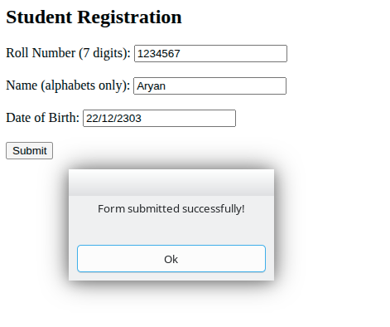

11.
<!DOCTYPE html>
<html>
<head>
<title>Form Validation</title>
</head>
<body>
<h2>Registration Form</h2>
<form onsubmit="return validateForm()">
Name: <input type="text" id="name"><br><br>
Email: <input type="text" id="email"><br><br>
Phone: <input type="text" id="phone"><br><br>
<input type="submit" value="Submit">
</form>

<script>
function validateForm() {
var name = document.getElementById("name").value;
var email = document.getElementById("email").value;
var phone = document.getElementById("phone").value;
if (name == "") {
alert("Name must be filled");
return false;
}
if (email == "") {
alert("Email must be filled");
return false;
}
if (phone == "" || phone.length != 10) {
alert("Phone must be 10 digits");
return false;
}
alert("Form submitted successfully");
return true;
}
</script>
</body>
</html>

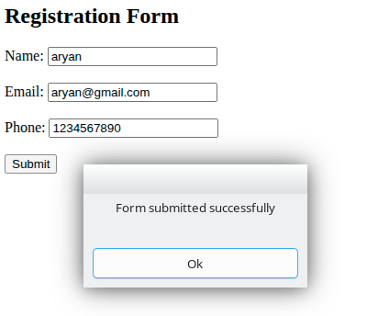

12.
<!DOCTYPE html>
<html>
<head>
<title>Links Demo</title>
</head>
<body>
<h1>Types of Links</h1>
<h2>External Link (goes to another website)</h2>
<a href="https://www.google.com">Visit Google</a>
<h2>Internal Link (goes to page on same website)</h2>
<a href="about.html">About Page</a>
<a href="contact.html">Contact Page</a>
<h2>Internal Link (goes to section on same page)</h2>
<a href="#section1">Go to Section 1</a>
<br><br><br><br><br><br><br><br><br><br>
<h2 id="section1">Section 1</h2>
<p>This is section 1 content.</p>
</body>
</html>
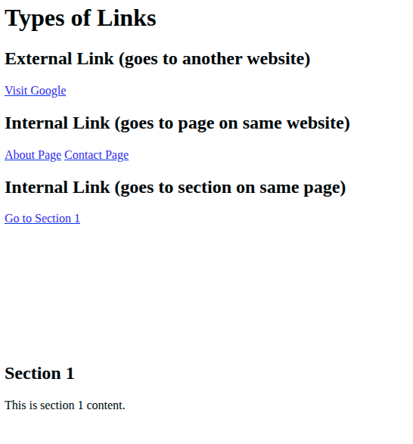

13.
<!DOCTYPE html>
<html>
<head>
<title>Multiplication Table</title>
</head>
<body>
<h2>Multiplication Table</h2>
<button onclick="printTable()">Enter Number</button>
<p id="result"></p>

<script>
function printTable() {
var num = prompt("Enter a number:");
num = parseInt(num);
var result = "";
for (var i = 1; i <= 10; i++) {
result = result + num + " x " + i + " = " + (num * i) + "<br>";
}
document.getElementById("result").innerHTML = result;
}
</script>
</body>
</html>
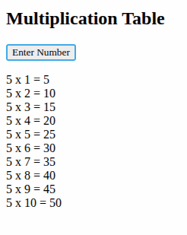

14.
<!DOCTYPE html>
<html>
<head>
<title>Focus Demo</title>
</head>
<body>
<h2>Text Box Focus Effect</h2>
Name: <input type="text" onfocus="changeColor(this)" onblur="resetColor(this)"><br><br>
Email: <input type="text" onfocus="changeColor(this)" onblur="resetColor(this)"><br><br>
Phone: <input type="text" onfocus="changeColor(this)" onblur="resetColor(this)">

<script>
function changeColor(textbox) {
textbox.style.backgroundColor = "yellow";
}
function resetColor(textbox) {
textbox.style.backgroundColor = "white";
}
</script>
</body>
</html>

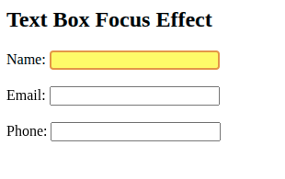

15.
<!DOCTYPE html>
<html>
<head>
<title>Palindrome</title>
</head>
<body>
<h2>Check Palindrome Number</h2>
Enter number: <input type="text" id="num">
<button onclick="checkPalindrome()">Check</button>
<p id="result"></p>

<script>
function checkPalindrome() {
var n = parseInt(document.getElementById("num").value);
var original = n;
var reverse = 0;
while (n > 0) {
var digit = n % 10;
reverse = reverse * 10 + digit;
n = parseInt(n / 10);
}
if (original == reverse) {
document.getElementById("result").innerHTML = original + " is Palindrome";
} else {
document.getElementById("result").innerHTML = original + " is not Palindrome";
}
}
</script>
</body>
</html>

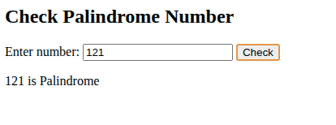

16.
<!DOCTYPE html>
<html>
<head>
<title>Login Page</title>
</head>
<body>
<h2>Login Form</h2>
<form>
Login ID: <input type="text" name="userid"><br><br>
Password: <input type="password" name="password"><br><br>
<input type="submit" value="Login">
<input type="reset" value="Clear">
</form>
</body>
</html>
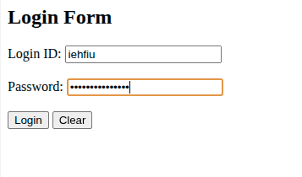

17.
<!DOCTYPE html>
<html>
<head>
<title>Prime Number</title>
</head>
<body>
<h2>Check Prime Number</h2>
Enter number: <input type="text" id="num">
<button onclick="checkPrime()">Check</button>
<p id="result"></p>

<script>
function checkPrime() {
var n = parseInt(document.getElementById("num").value);
var isPrime = true;
if (n <= 1) {
isPrime = false;
} else {
for (var i = 2; i < n; i++) {
if (n % i == 0) {
isPrime = false;
break;
}
}
}
if (isPrime) {
document.getElementById("result").innerHTML = n + " is Prime";
} else {
document.getElementById("result").innerHTML = n + " is not Prime";
}
}
</script>
</body>
</html>
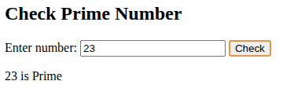

18.
<!DOCTYPE html>
<html>
<head>
<title>Recursive Function</title>
</head>
<body>
<h2>Factorial using Recursion</h2>
Enter number: <input type="text" id="num">
<button onclick="calculate()">Calculate</button>
<p id="result"></p>

<script>
function factorial(n) {
if (n == 0 || n == 1) {
return 1;
} else {
return n * factorial(n - 1);
}
}

function calculate() {
var n = parseInt(document.getElementById("num").value);
document.getElementById("result").innerHTML = "Factorial: " + factorial(n);
}
</script>
</body>
</html>
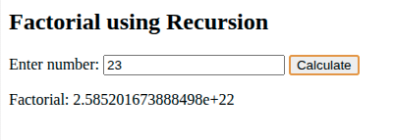

19.
<!DOCTYPE html>
<html>
<head>
<title>Tic Tac Toe</title>
</head>
<body>
<h2>Tic Tac Toe</h2>
<table border="2" cellpadding="0" cellspacing="0">
<tr>
<td>
<a href="?move=1">
<div style="position: relative; width: 100px; height: 100px;">
<img src="https://kimi-web-img.moonshot.cn/img/img.freepik.com/a707932fe84b2de9084f306ae97efdaeba8f2e43.jpg" width="100" height="100">
<div style="position: absolute; top: 25px; left: 30px; font-size: 40px; color: red; font-weight: bold;">X</div>
</div>
</a>
</td>
<td>
<a href="?move=2">
<div style="position: relative; width: 100px; height: 100px;">
<img src="https://kimi-web-img.moonshot.cn/img/themeparkreview.com/a2e71cb3811cf711f64eaa35b77ab927f7448b48.JPG" width="100" height="100">
<div style="position: absolute; top: 25px; left: 30px; font-size: 40px; color: blue; font-weight: bold;">O</div>
</div>
</a>
</td>
<td>
<a href="?move=3">
<div style="position: relative; width: 100px; height: 100px;">
<img src="https://kimi-web-img.moonshot.cn/img/img.freepik.com/31308edc81c1b801eedab80d7a7ce912e9d3796a.jpg" width="100" height="100">
<div style="position: absolute; top: 25px; left: 30px; font-size: 40px; color: red; font-weight: bold;">X</div>
</div>
</a>
</td>
</tr>
<tr>
<td>
<a href="?move=4">
<div style="position: relative; width: 100px; height: 100px;">
<img src="https://kimi-web-img.moonshot.cn/img/africanoverlandtours.com/5905334f4547597088ed0034b6775c905d7ba67d.jpg" width="100" height="100">
<!-- Empty cell -->
</div>
</a>
</td>
<td>
<a href="?move=5">
<div style="position: relative; width: 100px; height: 100px;">
<img src="https://kimi-web-img.moonshot.cn/img/previews.123rf.com/fb922fe1b1b55a78b4b5922fdf9731acc969aafa.jpg" width="100" height="100">
<div style="position: absolute; top: 25px; left: 30px; font-size: 40px; color: blue; font-weight: bold;">O</div>
</div>
</a>
</td>
<td>
<a href="?move=6">
<div style="position: relative; width: 100px; height: 100px;">
<img src="https://kimi-web-img.moonshot.cn/img/cdn.mos.cms.futurecdn.net/26ba20b053682e393d796da467de7f6b1aecd3ac.jpg" width="100" height="100">
<!-- Empty cell -->
</div>
</a>
</td>
</tr>
<tr>
<td>
<a href="?move=7">
<div style="position: relative; width: 100px; height: 100px;">
<img src="https://kimi-web-img.moonshot.cn/img/upload.wikimedia.org/695da35abd088067b25abf0a5bb581cbc76d6c82.jpeg" width="100" height="100">
<div style="position: absolute; top: 25px; left: 30px; font-size: 40px; color: red; font-weight: bold;">X</div>
</div>
</a>
</td>
<td>
<a href="?move=8">
<div style="position: relative; width: 100px; height: 100px;">
<img src="https://kimi-web-img.moonshot.cn/img/www.shutterstock.com/f630fd1d5c13c851c3e548d49a11fdf12e601edc.jpg" width="100" height="100">
<!-- Empty cell -->
</div>
</a>
</td>
<td>
<a href="?move=9">
<div style="position: relative; width: 100px; height: 100px;">
<img src="https://kimi-web-img.moonshot.cn/img/i.natgeofe.com/146a08bb9cc7526a88ce74343654e5e924c54640.jpg" width="100" height="100">
<div style="position: absolute; top: 25px; left: 30px; font-size: 40px; color: blue; font-weight: bold;">O</div>
</div>
</a>
</td>
</tr>
</table>
</body>
</html>
