An open-source GCR dosimetry pipeline for Mars mission risk assessment:
organ-specific REID, SEP acute hazard, and
global uncertainty quantification
Aryan Hemendra Shah
University of Miami
ahs222@miami.edu
ORCID: 0009-0008-0518-428X
2026-09-19
Abstract
We describe gcr-dosimetry-pipeline, an open-source Python package for estimating galactic cosmic ray (GCR) radiation exposure and cancer risk on crewed deep-space missions. GCR flux, generated via force-field solar modulation with inter-species composition constrained to ACE/CRIS and PAMELA measurements, is transported through slab shielding via the continuous-slowing-down approximation; organ-specific cancer risk (REID) is estimated across eleven organs. A single global scale is fit to the MSL/RAD cruise-phase absorbed dose ($1.84$ mGy/day at $16 g cm^{−2}$ aluminum). Independent checks (shielding-depth dependence, material ratio, real MSL/RAD and ISS telemetry) agree within benchmark uncertainties; day-to-day correlation against real telemetry is honestly weak, but the multi-month trend is consistent, including against eight years of independent ISS data ($r=0.62$). A Solar Energetic Particle module estimates acute organ dose for three historical events.
Global uncertainty is propagated via Latin Hypercube Sampling over nine physics and radiobiological parameters, giving a median REID of $6.5\%$ for a 35-year-old male on a 259-day Earth–Mars transit at $16 g cm^{−2}$ aluminum (p5–p95: $1.7$–$20.0\%$). Radiobiological parameters dominate REID variance ($>​85\%$) over GCR physics ($<​15\%$). A value-of-information sweep shows halving the ICRP-60 quality-factor uncertainty alone would cut p95 REID by $33.5\%$, more than every physics parameter combined. Sweeping launch date over two real solar cycles (2003–2022) shows median REID varies $3.4×$ from launch timing alone. The composition-constrained HZE fraction ($13.0\%$ at $16 g cm^{−2}$ Al) is $1.7×$ the NSRL reference, attributed to the absence of nuclear fragmentation in the transport model; the pipeline’s $Q_{eff}=3.32$ is correspondingly $27\%$ above the MSL/RAD measured value. Source code, tests, and validation data are freely available on GitHub.
Keywords: galactic cosmic rays; Mars dosimetry; radiation risk; REID; solar energetic particles; uncertainty quantification

Introduction
Deep-space human exploration beyond low-Earth orbit exposes crew members to galactic cosmic rays (GCR) and solar energetic particles (SEP) at fluence rates and energies far exceeding the shielding capacity of current crew vehicles. The GCR environment at 1–1.5 AU consists of protons, helium, and heavier ions (the so-called HZE particles) spanning kinetic energies from a few hundred MeV/n to tens of GeV/n, with the peak in biological effectiveness occurring near the energy range where stopping power is highest. A round-trip crewed Mars mission (transit + surface stay) of approximately 900 days is estimated to deliver a total effective dose of the order $1$–$2$ Sv (Zeitlin et al. 2013), which, depending on crew demographics and the risk model used, implies a radiation-induced cancer mortality probability that may approach or exceed NASA’s career limit (NASA 2014).
Quantifying this risk requires several components that are not trivially combined: a calibrated, solar-modulation-responsive GCR spectral model, organ-resolved dose transport, a cancer risk model accounting for HZE LET quality, and uncertainty analysis separating reducible physics uncertainty from larger radiobiological unknowns. Existing tools (HZETRN (Wilson et al. 1991), OLTARIS, Geant4/TOPAS) address subsets of these requirements with greater physical rigor, particularly nuclear fragmentation, but are not all openly available, pip-installable, or integrated into one uncertainty-quantified workflow. To our knowledge, no single open-source tool combines GCR spectral modeling, organ-specific REID, SEP acute risk, and global uncertainty propagation reproducibly from a standard pip install.
Here we present gcr-dosimetry-pipeline, a Python package that, within the limitations in §4.5: (1) generates six-species GCR spectra with force-field modulation and ACE/CRIS/PAMELA-constrained composition, calibrated to MSL/RAD; (2) transports spectra through slab shielding via CSDA and nuclear attenuation with tabulated secondary neutrons; (3) computes organ-specific dose and dose equivalent at eleven ICRP-89 depths; (4) estimates REID via the Cucinotta (2013) EAR/ERR model; (5) quantifies SEP acute BFO dose for three canonical events; and (6) propagates global uncertainty via 9-parameter Latin Hypercube Sampling with output variance decomposition.
The pipeline is not a replacement for HZETRN or Geant4 in high-fidelity analysis; its value is transparency, reproducibility, and integrated uncertainty quantification. The variance decomposition — physics parameters together contribute $∼​12\%$ of REID variance, radiobiological parameters $∼​88\%$ — and the value-of-information and launch-window results below are difficult to extract from existing closed tools.

Methods
All computation is implemented in Python 3.9+ as the open-source package gcr-dosimetrypipeline. The pipeline is a sequence of composable modules: spectrum generation, slab transport, organ dose, cancer risk (REID), SEP acute hazard, and uncertainty propagation, plus a separate proton RBE self-consistency check. Full equations, parameter tables, and derivations for every subsection below are given in Supplementary Methods (Sections S1.1–S1.9); only the essential physics and the numbers needed to interpret the Results are summarized here.
Trajectory and solar modulation. A Hohmann-transfer trajectory (Earth 1.0 AU to Mars 1.524 AU, 259-day transit) sets the mission timeline. Solar modulation potential $ϕ(t)$ comes from the Usoskin et al. monthly reconstruction (real neutron-monitor data back to 1936); for the MSL transit epoch, $ϕ≈481±50$ MV. Neutron-monitor inter-station offsets ($±50$–$100$ MV) are propagated as an LHS parameter (§2.1).
GCR spectrum. Solar modulation of GCR flux uses the Gleeson–Axford force-field approximation on per-species local interstellar spectra (protons and helium from Vos & Potgieter (Vos and Potgieter 2015); C/O/Si/Fe from the HelMod model of Boschini et al. (Boschini et al. 2020)). Inter-species flux ratios are constrained to ACE/CRIS (George et al. 2009) and PAMELA (Adriani et al. 2014) measurements at the MSL epoch, and a single global scale is then fit to match the MSL/RAD absorbed dose of $1.84 mGy day^{−1}$ at $16 g cm^{−2}$ aluminum (Zeitlin et al. 2013) — a one-free-parameter calibration whose species mix is externally anchored, replacing an earlier six-free-parameter fit with no compositional constraint. The resulting HZE fraction ($13.0\%$ at $16 g cm^{−2}$ Al) is $∼​1.7×$ the NSRL reference field (Slaba et al. 2016) (vs. $∼​4×$ under the prior calibration), attributed to the CSDA transport model not capturing nuclear fragmentation (Supplementary §S1.3.3).
Transport. Ionization energy loss uses the continuous-slowing-down approximation (CSDA) with Barkas effective-charge scaling on NIST PSTAR/ASTAR proton stopping powers. Nuclear interactions are modeled as exponential fluence attenuation with a Bradt-Peters geometric mean free path (Bradt and Peters 1950) — the same form underlying HZETRN’s tabulated mean free paths (Wilson et al. 1991) — which does not track secondary fragment production; this is the model’s primary physical limitation, most relevant above $∼​30 g cm^{−2}$ for Fe/Si. Secondary neutron dose equivalent uses a pre-computed lookup table calibrated to the HZETRN benchmark of Slaba et al. (Slaba et al. 2014) ($±25$–$30\%$ uncertainty, propagated via LHS).
Organ dose and quality factor. Absorbed dose and ICRP-60 dose equivalent (ICRP 1991) are computed at 11 organ-specific tissue depths from ICRP Publication 89 (ICRP 2002), weighted by ICRP-60 tissue factors. The field effective quality factor is $Q_{eff}=∑H_{k,s}/∑D_{k,s}$, which is $2.60$ from ions alone at the calibration geometry (rising to an apparent $Q_{eff}=3.32$ once the neutron contribution is included) — within $0.8\%$ of the MSL/RAD ion-only estimate, though this agreement follows from the calibration procedure rather than an independent prediction.
Cancer risk (REID). REID is computed from the Cucinotta et al. (Cucinotta et al. 2013) organ-specific ERR/EAR model (NASA/TP-2013-217375), using interpolated US sex-specific survival and baseline-mortality lookup tables as a practical approximation to the full NASA/Cucinotta framework. Point estimates use a fixed DDREF of $1.75$; the uncertainty ensemble instead samples DDREF $∼$ Uniform$[1,2]$. Because REID enters an exponential, its distribution is right-skewed, with Q_factor (§2.1) the dominant tail driver; every LHS sample’s Q_factor draw is clipped so the effective quality factor cannot exceed the ICRP-60 physical maximum of $30$ (Supplementary §S1.6).
SEP acute risk. Event fluence spectra use the Band function (Tylka and Lee 2006) for three canonical events (August 1972, October 2003, January 2005; parameters in Supplementary Table S3). BFO absorbed dose is computed via CSDA transport through wall plus $10 g cm^{−2}$ tissue and compared to the NASA 30-day BFO limit of $250$ mGy (Cucinotta and Durante 2010). Mission SEP encounter probability follows a Poisson process at solar-cycle-dependent rates (Feynman et al. 1993).

Uncertainty Quantification
Nine parameters are varied simultaneously via Latin Hypercube Sampling (LHS): five physics (solar modulation, LIS normalization, nuclear cross-sections, neutron yield, HZE composition) and four biology (quality factor scale, DDREF, ERR scale, EAR scale), each with a lognormal, uniform, or clipped-normal prior justified by the relevant literature spread (full distributions and justifications in Supplementary Table S4). For each LHS sample, a full mission dose integration is performed; publication results use $N=500$ samples. Parameter sensitivity uses normalized Spearman-$ρ^{2}$ decomposition (an approximation to first-order Sobol indices).
A separate value-of-information sweep (§3.8) re-runs the $N=500$ ensemble once per parameter, halving that parameter’s prior spread while holding all others at baseline, to quantify how much narrowing any one source of uncertainty would actually reduce REID uncertainty (narrow argument to gcr.uncertainty.lhs_samples; Supplementary §S1.9).

Dose-Averaged LET and Proton RBE Self-Consistency Check

Per-species and field dose-averaged LET (${\overline{L}}_{D}$) are computed to trace $Q_{eff}$ to specific ion contributions (§3.4; full definitions in Supplementary §S1.9). The same ${\overline{L}}_{D}$ infrastructure also implements two proton RBE models, Wedenberg et al. (2013) (Wedenberg et al. 2013) and McNamara et al. (2015) (McNamara et al. 2015), matched to OpenTOPAS-RBE scorer conventions and checked only as an implementation self-consistency test (Table 1), not independent experimental validation. This layer is the foundation for a separate, planned proton-therapy crossover study and is not a central contribution of the present paper.

Results

Dose Rate Validation
Two independent checks benchmark the pipeline against data not used in calibration: the shielding curve shape stays within the HZETRN benchmark envelope ($≲20\%$) (Slaba et al. 2014) at $5$, $10$, and $30 g cm^{−2}$ aluminum, and the Al/PE dose ratio ($1.36$) is consistent with Mrigakshi (2013)’s $1.43±0.22$. As a separate internal self-consistency check (not an external validation), the pipeline’s own dose rate correlates with its own $ϕ$ input at $r=−0.998$ ($n=260$ days).
For an independent daily comparison we obtained real MSL/RAD cruise-phase telemetry from NASA’s PDS archive (MSL-M-RAD-3-RDR-V1.0; $218$ of $253$ cruise days; scripts/fetch_real_rad_cruise_data.py), replacing the statistically-reconstructed proxy used in earlier drafts. Day-to-day agreement is honestly weak ($r=−0.127$, $p=0.06$): real telemetry carries sub-monthly structure (Forbush decreases, minor SEP events) the monthly-resolution model cannot resolve. The multi-month trend the model is built to capture is consistent in magnitude and direction (real $+17.5\%$ vs. modeled $+14.5\%$, first-to-last cruise decile). Because this RAD-anchoring is itself fit to the evaluated data, we additionally tested generalization by splitting the series in half and fitting/testing in both directions: held-out RMS error ($21.4\%$, $24.8\%$) is close to in-sample RMS error ($23.5\%$, $19.4\%$) — a $5.5$-point maximum degradation, showing the anchoring is not an artifact of testing on the period it was fit to.
Table 1 summarizes all comparisons by epistemic strength. The calibration-point dose rate ($1.843 mGy day^{−1}$ vs. RAD’s $1.84±0.33$) is a direct consequence of fitting, not an independent prediction.
Pipeline benchmarks grouped by epistemic status: Independent (not used in calibration), Calibration ($\dot{D}$ fitted; $\dot{H}$, $Q_{eff}$ are predictions), Self-consistency (no external reference).
Quantity | Pipeline | Reference | Source | Rel. error
Independent benchmarks (not used in calibration)
Shielding slope (5–30 g/cm²) | within | HZETRN env. | (Slaba et al. 2014) | $<20\%$​
$\dot{D}$ ratio (Al vs PE, $16 g cm^{−2}$) | 1.36 | $1.43±0.22$​ | (Mrigakshi et al. 2013) | 5%
Cruise trend (early vs. late decile) | $+14.5\%$​ | $+17.5\%$​ | NASA PDS RAD RDR | 3 pts
Daily $r({\dot{D}}_{model},{\dot{D}}_{RAD})$, $n=218$ | $−0.127$​ | — | NASA PDS RAD RDR | weak, $p=0.06$
Monthly $r$, ISS solar-cycle, $n=91$, 2010–18 | $0.617$​ | — | ISS TEPC (CDAWeb) | $p=7×{10}^{−11}$​
Calibration point ($\dot{D}$ fitted; $\dot{H}$ and $Q_{eff}$ are model predictions)
$\dot{D}$ (mGy/day) at $16 g cm^{−2}$ Al | 1.84 | $1.84±0.33$​ | (Zeitlin et al. 2013) | $<1\%$​
$\dot{H}$ (mSv/day) at $16 g cm^{−2}$ Al | 6.09 | $4.81±0.97$​ | (Zeitlin et al. 2013) | $+27\%$​
$Q_{eff}$ at $16 g cm^{−2}$ Al | 3.32 | $2.62±0.14$​ | (Zeitlin et al. 2013) | $+27\%$​
Self-consistency (no external reference data)
RBE (V79, Wedenberg) | 1.154 | 1.153 | TOPAS-nBio | $<{10}^{−3}$​
RBE (V79, McNamara) | 1.165 | 1.165 | TOPAS-nBio | $<5×{10}^{−8}$​
Daily $r(\dot{D},ϕ)$, $n=260$ | $−0.998$​ | — | — | —

Independent Multi-Year Solar-Cycle Cross-Check
As a longer, independent cross-check of the force-field modulation physics beyond the single MSL cruise window, we compared the pipeline’s phi-driven predicted dose-equivalent rate at 1 AU against real ISS radiation telemetry (ISS_DOSANL_TEPC, NASA Space Radiation Analysis Group, via CDAWeb; scripts/fetch_iss_tepc_data.py, scripts/compare_iss_solar_cycle.py), May 2010–April 2018 — a full solar cycle, $∼​12×$ longer than the MSL window. Because the ISS orbits inside Earth’s magnetosphere (geomagnetic shielding this pipeline does not model), absolute dose levels are not comparable; only the modulation trend is tested. Figure 1 shows both monthly-median series (91 months, one instrument-gap outlier dropped): $r=0.617$ ($p=7×{10}^{−11}$), with both series declining toward the 2014 solar maximum and rising sharply through 2018.
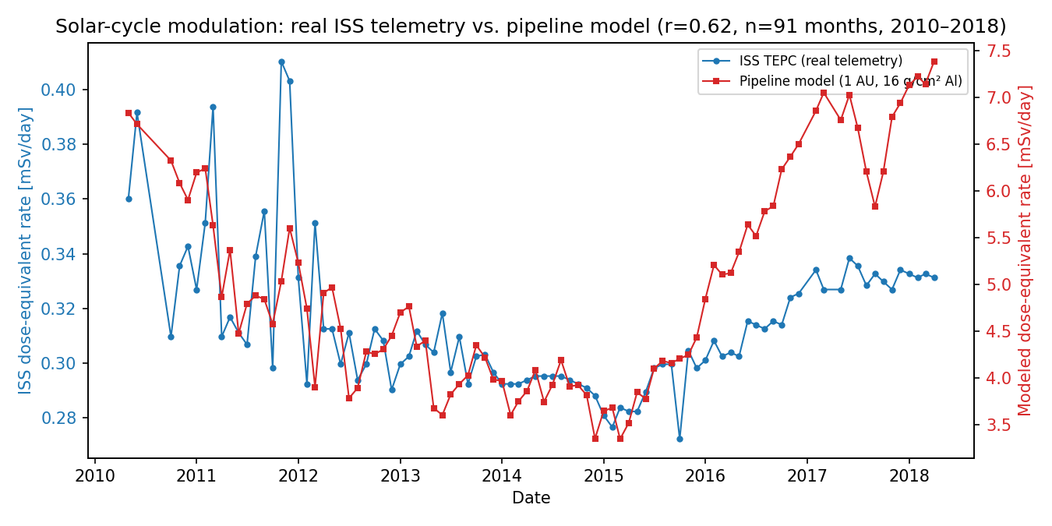
Real ISS TEPC telemetry (blue) vs. modeled dose-equivalent rate at 1 AU (red), May 2010–April 2018. Axes independently scaled (trend only, see text). $r=0.617$, $n=91$, $p=7×{10}^{−11}$.

Shielding Effectiveness and Uncertainty Bounds
Figure 2 shows absorbed dose rate vs. aluminum and polyethylene shielding (259-day transit, $ϕ=481$ MV) with p5–p95 LHS bands. Dose decreases steeply to $∼​10 g cm^{−2}$, then flattens above $∼​16$–$20 g cm^{−2}$ as secondary-neutron buildup offsets HZE attenuation; the p5/p95 ratio at $16 g cm^{−2}$ Al is $∼​1.9$ (dominated by LIS normalization and neutron-yield uncertainty). Polyethylene gives $∼​26\%$ lower dose than aluminum at $16 g cm^{−2}$, consistent with hydrogen-rich materials fragmenting HZE ions more effectively.
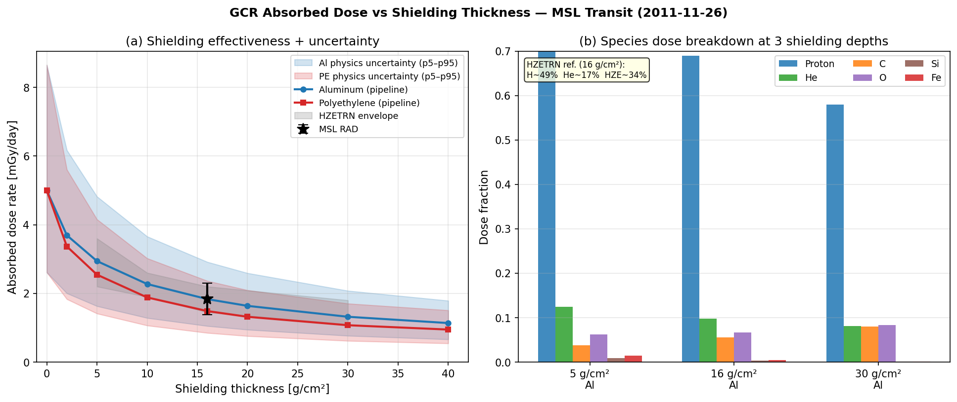
Left: dose rate vs. Al/PE shielding with p5–p95 bands; MSL/RAD point (star); HZETRN envelope (gray). Right: per-species dose fractions at $5$, $16$, $30 g cm^{−2}$ Al.

Per-Species LET Decomposition
Figure 3 shows dose-averaged LET per species and fractional dose contributions at $0$, $16$, and $30 g cm^{−2}$ aluminum. Unshielded at $ϕ=481$ MV, the HZE group ($Z>2$) is $20.9\%$ of absorbed dose (oxygen $8.8\%$, iron $5.8\%$ dominant), consistent with GCR abundance ordering and $Z^{2}$ stopping-power scaling; field ${\overline{L}}_{D}=3.9 keV μm^{−1}$ gives $Q_{eff}^{ions}=3.30$. After $16 g cm^{−2}$ aluminum the HZE fraction falls to $13.0\%$ (protons rise to $68.9\%$), field ${\overline{L}}_{D}$ drops to $∼​2.5 keV μm^{−1}$, and the neutron contribution drives the total apparent $Q_{eff}=3.32$ (§2).
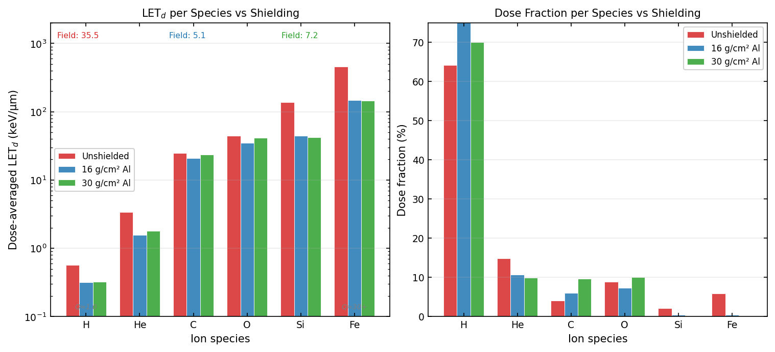
Left: dose-averaged LET per species at 0, 16, 30 g/cm$​^{2}$ Al. Right: fractional dose contribution per species; HZE fraction drops $20.9\%→13.0\%$ as heavier ions attenuate preferentially.

SEP Acute Risk
Figure 4 shows BFO absorbed dose from three canonical SEP events vs. aluminum shielding. The August 1972 event delivers $∼​37,000$ mGy unshielded ($∼​148×$ the 30-day BFO limit of 250 mGy) and stays above the limit until $∼​32 g cm^{−2}$; October 2003 needs $∼​25 g cm^{−2}$; January 2005 falls below the limit under $20 g cm^{−2}$. GCR and SEP respond very differently to shielding: above $∼​20 g cm^{−2}$, added aluminum barely reduces chronic GCR dose but still substantially cuts SEP dose. The August 1972 spectrum predates space-borne dosimetry (reconstructed from ground-level neutron-monitor/riometry data (Tylka and Lee 2006)) and should be read as an order-of-magnitude estimate ($∼​±50\%$).
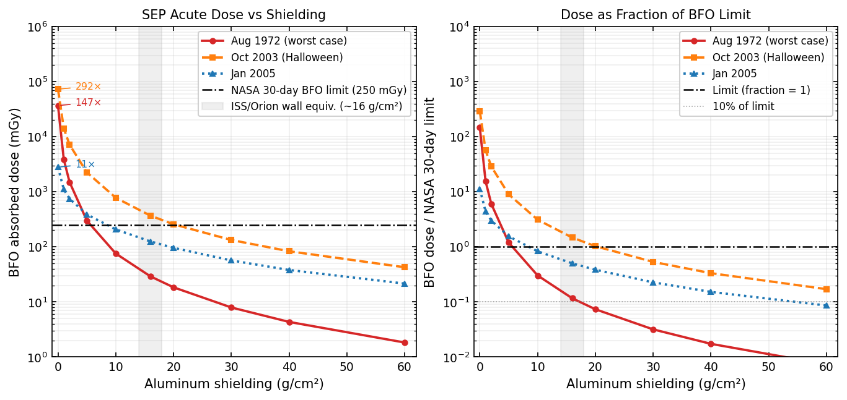
Left: BFO dose (mGy) vs. Al shielding; line = NASA 30-day limit (250 mGy); band = ISS/Orion wall equivalent. Right: normalized to limit.

REID vs. Shielding and Organ Contributions
Figure 5 shows REID vs. aluminum shielding for a 35-year-old male and female on a 259-day transit. At $16 g cm^{−2}$, median REID is $6.5\%$ (male) and $8.3\%$ (female) — both above the historical NASA $3\%$ career limit (NASA 2014); the female excess reflects higher sex-specific lung/breast ERR-EAR coefficients (Cucinotta et al. 2013). p5–p95 bands ($1.7$–$20.0\%$ male, $2.2$–$25.7\%$ female) reflect the dominant radiobiological uncertainty (§2.1): the mission is likely to carry meaningful cancer risk, but the precise value is not resolvable within the current radiobiological framework. Stomach, colon, and lung contribute most to organ dose equivalent, consistent with their high ICRP-60 weighting ($w_{T}=0.12$).
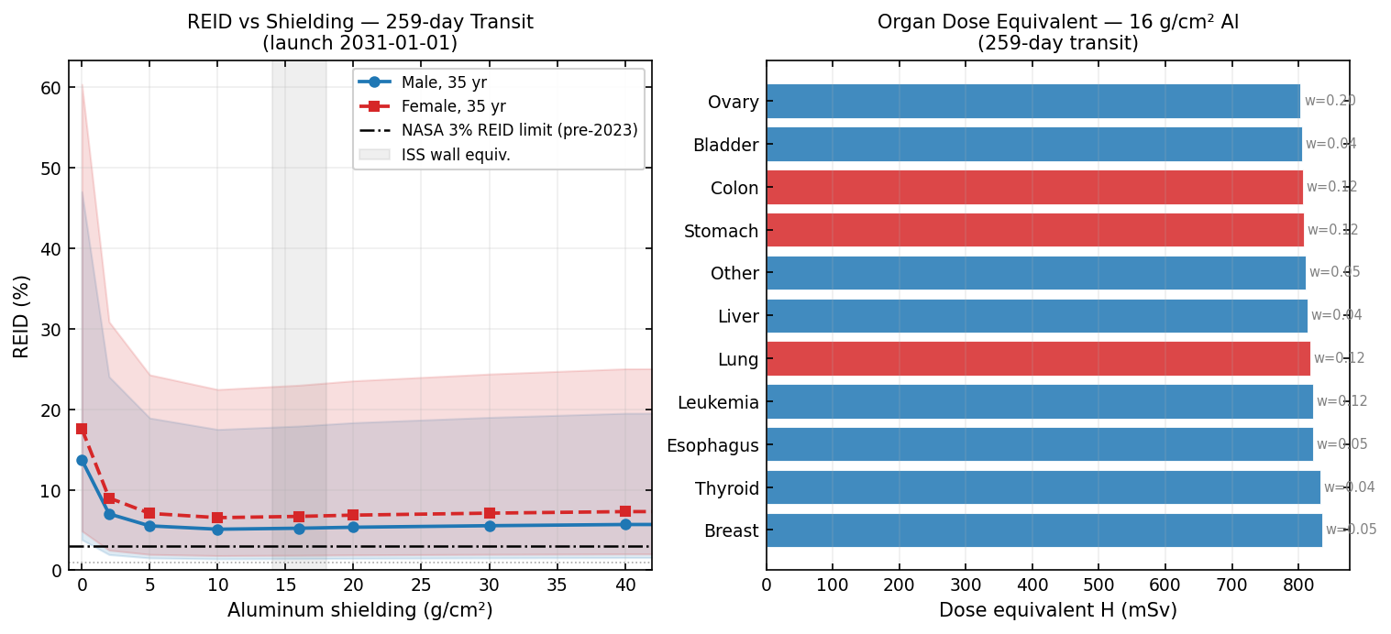
Left: REID (%) vs. Al shielding, male/female, p5–p95 bands; line = NASA 3% limit. p95 at $<5 g cm^{−2}$ exceeds physically meaningful values (LHS not clipped); $>10 g cm^{−2}$ is more reliable. Right: organ dose equivalent at $16 g cm^{−2}$ Al, $w_{T}$ annotated.

REID vs. Launch Date Across the Solar Cycle
REID depends strongly on the solar modulation potential $ϕ$ at launch. We swept gcr.reid.reid_vs_launch_date over monthly launch dates (scripts/launch_window_sweep.py); Figure 6 separates two regions. The solid curve (2003–2022) uses real Usoskin $ϕ$ data spanning two full solar cycles; median REID ranges from $3.3\%$ (May 2003, solar maximum, $ϕ≈853$ MV) to $11.3\%$ (May 2009, solar minimum, $ϕ≈388$ MV) — a $3.4×$ spread from launch timing alone, at fixed shielding and demographics. The dashed, hatched curve (2023–2035) is not database-derived: it is a self-generated idealized $∼​11$-year cosine cycle, included only to illustrate the qualitative shape a tool like this could show for a future window if the cycle repeats its characteristic period — not a space-weather forecast, and not used to name a recommended future launch date. Real cycles vary in amplitude and length by years; an operational decision would need an actual forecast, outside this paper’s scope.
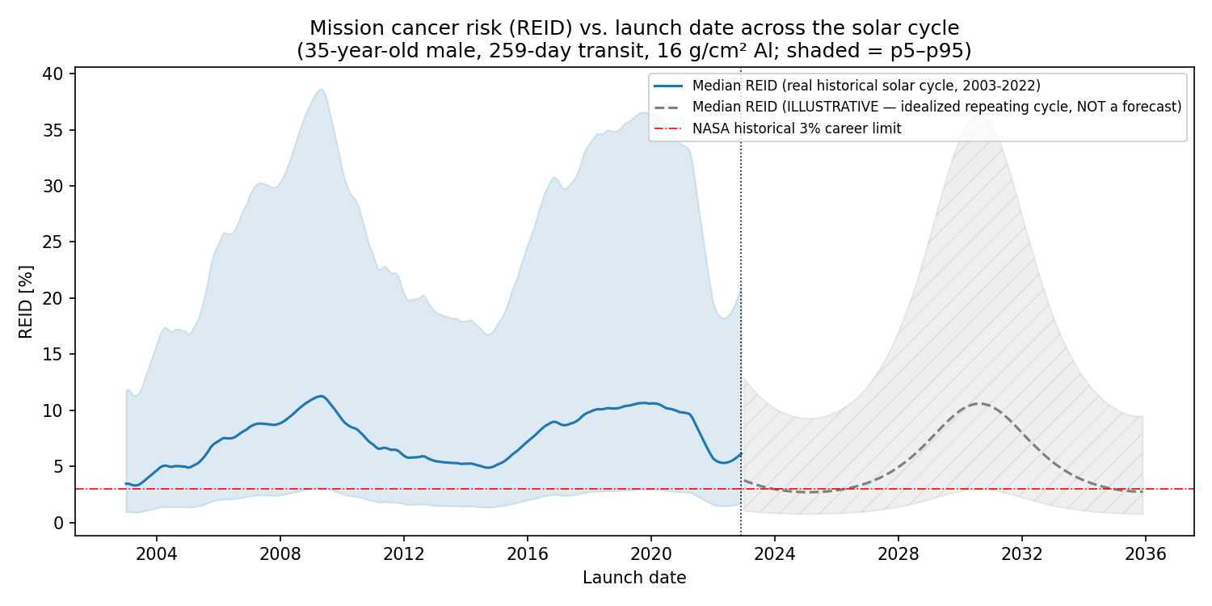
REID vs. launch date (male, $16 g cm^{−2}$ Al; shaded = p5–p95). Solid blue: real historical $ϕ$ (2003–2022). Dashed/hatched: an idealized repeating cycle, not a forecast (see text). Line = NASA 3% limit.

Value of Narrowing Individual Uncertainty Parameters
The variance decomposition (§2.1) ranks parameters by their share of REID variance under current priors, but not how much narrowing any one would help. We re-ran the $N=500$ ensemble once per parameter, halving its uncertainty while holding the rest at baseline (scripts/sensitivity_narrowing_sweep.py); Table 2 ranks the resulting p95 REID reduction. Halving Q_factor alone shrinks p95 REID from $20.0\%$ to $13.3\%$ ($33.5\%$ reduction) — $∼​7×$ more than the next parameter (DDREF, $4.5\%$) and more than every GCR physics parameter combined ($<5\%$). This makes "biology dominates" concrete: tightening the ICRP-60 quality-factor-model uncertainty (e.g. expert elicitation or a track-structure-resolved $Q(L)$ for mixed GCR fields) would narrow Mars mission REID uncertainty more than every other parameter here combined.
Value-of-information sweep: reduction in p95 REID from halving one parameter’s uncertainty at a time (35-year-old male, 259-day transit, $16 g cm^{−2}$ Al; baseline p95 $=20.0\%$).
Parameter | Narrowed p95 | $Δ$ p95 | % of baseline p95
Q_factor | 13.3% | $−$6.7 pts | $−$33.5%
DDREF | 19.1% | $−$0.9 pts | $−$4.5%
phi_scale | 19.5% | $−$0.5 pts | $−$2.7%
ERR_scale | 19.8% | $−$0.3 pts | $−$1.3%
LIS_norm | 19.8% | $−$0.2 pts | $−$1.1%
hze_norm_scale | 19.9% | $−$0.2 pts | $−$0.8%
neutron_H | 20.0% | $−$0.1 pts | $−$0.3%
EAR_scale | 20.0% | $−$0.0 pts | $−$0.1%
cross_sec | 20.0% | $0.0$ pts | $0.0\%$​

Discussion

What the Validation Does and Does Not Show
The independent checks in §3.1–3.2 (shielding curve shape, material ratio, the real MSL/RAD cruise trend, and the real ISS multi-year trend) each probe an aspect of the model not constrained by the single-point MSL/RAD calibration. Together they support characterizing the pipeline as calibrated to one flight measurement and consistent with independent benchmarks within their stated uncertainties, not as independently predicting the flight result. The weak daily-resolution correlation and the held-out cross-validation of the RAD anchoring (§3.1) are reported for the same reason: an honest, non-circular account of what this monthly-resolution model can and cannot claim is worth more than an artificially strong number.

Implications for Mission Shielding Design
The shielding curve (Fig. 2) plateaus above $∼​20 g cm^{−2}$ aluminum as secondary-neutron growth offsets HZE attenuation: going from $16$ to $40 g cm^{−2}$ cuts GCR dose only $∼​42\%$ while roughly doubling wall mass, consistent with prior literature (Cucinotta et al. 2005; Slaba et al. 2014) that bulk aluminum shielding is mass-inefficient against chronic GCR. SEP shielding is the opposite case: the October 2003 event drops from $∼​35×$ the BFO limit unshielded to below it by $∼​25 g cm^{−2}$ (Fig. 4). This asymmetry supports a compact, heavily-shielded SEP storm shelter over whole-vehicle HZE shielding as the more mass-efficient architecture (Durante and Cucinotta 2011; Cucinotta and Durante 2010).

REID Interpretation: Biology, Not Physics, Dominates
Median REID ($6.5\%$ male, $8.3\%$ female at $16 g cm^{−2}$) exceeds the historical NASA $3\%$ limit (NASA 2014), though NASA’s updated age/sex-dependent framework (NASA 2023) is not implemented here and the comparison should be read as indicative. Because the composition-constrained pipeline overestimates $Q_{eff}$ by $∼​27\%$ (§2), these values are conservative upper estimates; correcting for that ratio would put male median REID at $∼​5.1\%$ — still above the historical limit. The p5–p95 band spans a factor of $∼​12×$: this REID should be read as "the mission dose likely carries meaningful cancer risk, with the exact value uncertain by an order of magnitude," not as a precise prediction.
Most importantly, this uncertainty is overwhelmingly biological. The four radiobiological parameters contribute $≳​85\%$ of REID’s normalized sensitivity, all five physics parameters combined $<15\%$ (Supplementary Table S4) — consistent with Cucinotta et al. (Cucinotta et al. 2013) and the broader literature (Durante and Cucinotta 2011). No direct human data constrain the HZE LET range that dominates unshielded GCR dose equivalent; extrapolating from mouse and atomic-bomb-survivor data to this regime is the single largest source of uncertainty in this calculation, and no amount of improved transport physics can resolve it. Strikingly, phi_scale drives $79\%$ of absorbed-dose variance but only $8\%$ of REID variance: solar-modulation uncertainty strongly affects physical dose but has almost no leverage on mortality probability once biology enters. The value-of-information sweep (§3.8) makes this actionable rather than qualitative.

Scope of the LET/RBE Layer
The per-species LET decomposition (Fig. 3) traces $Q_{eff}$’s physical origin to specific ion contributions; the residual $27\%$ $Q_{eff}$ excess over the RAD measurement is attributed to CSDA’s missing fragmentation (§2). The repository also contains a proton RBE self-consistency layer (§2.2) reported only as a implementation check (Table 1); it is the foundation for a planned, separate proton-therapy crossover study and is not a central contribution here.

Limitations
The main structural limitation is CSDA transport without nuclear fragmentation, which by our order-of-magnitude estimate overestimates $Q_{eff}$ (and correspondingly REID) at $16 g cm^{−2}$ by roughly $15$–$25\%$ (Wilson et al. 1991; Slaba et al. 2014) — well within the $12×$ uncertainty band but not negligible relative to the median. Other significant approximations include: a uniform-slab spacecraft geometry (no ray-tracing); six modeled GCR species (unmodeled species $<5\%$ of dose); the force-field modulation’s monthly resolution, which limits daily-scale claims and is the reason the ISS cross-check tests trend, not absolute dose, and does not extend to near-Earth or trapped-radiation environments; the pre-2023 Cucinotta NASA risk framework rather than the updated age/sex-dependent limits; and cancer-only risk (no CNS, cataract, or cardiovascular endpoints). The full itemized discussion of each limitation, with supporting estimates, is provided in Supplementary §S2.

Comparison with Existing Tools and Reproducibility
Supplementary Table S5 compares this pipeline against HZETRN, OLTARIS, Geant4, and TOPAS: it is not a replacement for these at high fidelity, but is, to our knowledge, the only one that is simultaneously open/pip-installable and includes organ-specific REID, an SEP library, and LHS uncertainty quantification. All results reproduce via pip install -e .[dev], validate_pipeline.py, validate_extended.py, and pytest; the full $N=500$ ensemble takes $∼​90$ minutes single-core, with a reduced $N=20$ path used in CI. No proprietary datasets are required.

Conclusion
We have presented gcr-dosimetry-pipeline, an open-source, pip-installable Python package integrating GCR spectrum generation, CSDA transport, organ-specific REID, SEP acute dosimetry, and LHS uncertainty propagation, calibrated to MSL/RAD and consistent with HZETRN benchmarks within stated uncertainties. Central results:
- Median REID at $16 g cm^{−2}$ Al, 259-day transit: $6.5\%$ (p5–p95 $1.7$–$20.0\%$), above the NASA $3\%$ limit; the wide band is dominated by biology, not GCR transport physics.
- August 1972 SEP requires $>30 g cm^{−2}$ Al for sub-limit BFO protection; at $16 g cm^{−2}$, dose is $∼​4×$ the limit.
- HZE ($Z>2$) is $20.9\%$ of unshielded dose (${\overline{L}}_{D}=3.9 keV μm^{−1}$), falling to $13.0\%$ at $16 g cm^{−2}$ Al.
- The model’s solar-modulation trend independently tracks 8 years of real ISS telemetry across a full solar cycle ($r=0.62$, $p=7×{10}^{−11}$, $n=91$) — a longer, separately-sourced cross-check than the MSL calibration window.
- Halving Q_factor uncertainty alone cuts p95 REID by $33.5\%$ — $∼​7×$ more than any other parameter or all physics parameters combined (§3.8) — identifying where research investment matters most.
- Launch timing alone, over two real historical solar cycles (2003–2022), swings median REID $3.4×$ (§3.7) at zero engineering cost.
The pipeline’s main limitation relative to high-fidelity codes is the absence of nuclear fragmentation tracking (Supplementary §S2); it is a transparent starting point with explicit uncertainty quantification, not a replacement for HZETRN or Geant4. Future work includes fragmentation cross-sections (Wilson et al. 1991) and the NASA 2023 risk framework. All source code, 86 automated tests, and validation datasets are available at https://github.com/aryanhshah8/gcr-dosimetry-pipeline.

Acknowledgements
The author thanks the MSL/RAD team (C. Zeitlin and collaborators) for making the cruise-phase dosimetry data publicly available, without which calibration of the pipeline would not have been possible, and NASA’s Planetary Data System (PDS PPI Node, dataset MSL-M-RAD-3-RDR-V1.0, producer S. Rafkin) for archiving the daily cruise-phase telemetry used in the independent day-by-day comparison in Section 3.1, and the NASA Space Radiation Analysis Group (dataset ISS_DOSANL_TEPC, via NASA’s CDAWeb) for the ISS radiation telemetry used in the multi-year solar-cycle cross-check (Section 3.2). The Usoskin et al. solar modulation potential database, the Vos & Potgieter LIS parametrizations, and the HZETRN benchmark datasets of Slaba et al. are gratefully acknowledged.

CRediT Author Contribution Statement
Aryan Hemendra Shah: Conceptualization, Methodology, Software, Validation, Formal analysis, Investigation, Data curation, Writing – original draft, Writing – review and editing, Visualization.

Declaration of Competing Interests
The author declares no competing interests.

Funding
This research did not receive any specific grant from funding agencies in the public, commercial, or not-for-profit sectors.

Data Availability Statement
All source code, input datasets, validation scripts, and TOPAS benchmark geometry files are freely available at https://github.com/aryanhshah8/gcr-dosimetry-pipeline. Full methods derivations, extended parameter tables, and extended limitations discussion are provided as Supplementary Material. No proprietary datasets were used; all input data (Usoskin solar modulation potential database, NIST stopping powers, real MSL/RAD cruise-phase dosimetry from NASA’s PDS archive, and real ISS TEPC telemetry from NASA’s CDAWeb) are included in the repository under data/, and the HZETRN neutron benchmark table is hardcoded as a lookup array in gcr/neutron_table.py. Results can be fully reproduced without any proprietary software.

Declaration of Generative AI and AI-Assisted Technologies in the Manuscript Preparation Process
During the preparation of this work the author used Claude (Anthropic) in order to organize project files and directory structure, to review and assist in debugging the Python pipeline code, to source and integrate independent real-world validation datasets (NASA PDS and CDAWeb archives) and design the corresponding validation methodology, and to assist in the writing and revision of the manuscript. After using this tool, the author reviewed and edited the content as needed and takes full responsibility for the content of the published article.
Adriani, O. et al. 2014. “Time Dependence of the He/H Ratio in Cosmic Rays During the Solar Minimum Period.” The Astrophysical Journal Letters 791: L14. https://doi.org/10.1088/2041-8205/791/1/L14.
Boschini, M. J. et al. 2020. “Deciphering the Local Interstellar Spectra of Primary Cosmic-Ray Species with HelMod.” Astrophys. J. Suppl. 250: 27.
Bradt, H. L., and B. Peters. 1950. “The Heavy Nuclei of the Primary Cosmic Radiation.” Phys. Rev. 77: 54–70.
Cucinotta, F. A., and M. Durante. 2010. Risk of Radiation Carcinogenesis. NASA Johnson Space Center.
Cucinotta, F. A., M. H. Y. Kim, and L. J. Chappell. 2013. “Space Radiation Cancer Risk Projections and Uncertainties – 2012.” NASA/TP 2013-217375.
Cucinotta, F. A., M. Y. Kim, and L. Ren. 2005. “Evaluating Shielding Approaches to Reduce Space Radiation Cancer Risks.” NASA/TM 2005-213164.
Durante, M., and F. A. Cucinotta. 2011. “Physical Basis of Radiation Protection in Space Travel.” Rev. Mod. Phys. 83: 1245–81.
Feynman, J., G. Spitale, J. Wang, and S. Gabriel. 1993. “Interplanetary Proton Fluence Model: JPL 1991.” J. Geophys. Res. 98: 13281.
George, J. S. et al. 2009. “Elemental Composition and Energy Spectra of Galactic Cosmic Rays During Solar Cycle 23.” The Astrophysical Journal 698: 1666–81. https://doi.org/10.1088/0004-637X/698/2/1666.
ICRP. 1991. 1990 Recommendations of the International Commission on Radiological Protection. Publication 60. International Commission on Radiological Protection.
ICRP. 2002. Basic Anatomical and Physiological Data for Use in Radiological Protection: Reference Values. Publication 89. International Commission on Radiological Protection.
McNamara, A. L., J. Schuemann, and H. Paganetti. 2015. “A Phenomenological Relative Biological Effectiveness (RBE) Model for Proton Therapy Based on All Published in Vitro Cell Survival Data.” Phys. Med. Biol. 60: 8399–416.
Mrigakshi, A. I. et al. 2013. “How Well Do the Existing Transport Codes Know the GCR Environment?” Adv. Space Res. 51: 1815–24.
NASA. 2014. “Space Flight Human-System Standard Volume 1, Revision a: Crew Health.” NASA-STD-3001.
NASA. 2023. “Space Flight Human-System Standard Volume 1, Revision c: Crew Health.” NASA-STD-3001.
Slaba, T. C. et al. 2014. “Efficient GCR Shielding Assessment for Long Duration Exposure.” Acta Astronaut. 104: 485–90.
Slaba, T. C., S. R. Blattnig, J. W. Norbury, A. Rusek, and C. La Tessa. 2016. “Reference Field Specification and Preliminary Beam Selection Strategy for Accelerator-Based GCR Simulation.” Life Sci. Space Res. 8: 52–67.
Tylka, A. J., and M. A. Lee. 2006. “Spectral and Compositional Characteristics of Gradual and Impulsive Solar Energetic Particle Events.” Astrophys. J. 646: 1319–34.
Vos, E. E., and M. S. Potgieter. 2015. “New Modeling of Solar Minimum Proton Modulation with a Refined Diffusion Tensor.” Astrophys. J. 815: 119.
Wedenberg, M., B. K. Lind, and B. Hardemark. 2013. “A Model for the Relative Biological Effectiveness of Protons: The Tissue Specific Parameter Alpha/Beta of Photons Is a Predictor for the Sensitivity to LET Changes.” Acta Oncol. 52: 580–88.
Wilson, J. W. et al. 1991. “HZETRN: Description and Validation of a Free-Space Ion and Nucleon Transport and Shielding Computer Program.” NASA TP 3146.
Zeitlin, C. et al. 2013. “Measurements of Energetic Particle Radiation in Transit to Mars on the Mars Science Laboratory.” Science 340: 1080–84. https://doi.org/10.1126/science.1235989.

