Solving a Paraphrase-Robust Multiple-Choice Benchmark
Formulation, Evaluation Integrity, and What the Leaderboard Actually Measures
Smart MCQ Solver Challenge · Deep Learning & Generative AI Project [BSDA2001P]
Author: Aryan (Roll No. 24f1001839)
Experiment tracking: Weights & Biases · project smart-mcq-solver · 25 logged runs
Compute: Kaggle NVIDIA Tesla T4 ×2 · PyTorch 2.10 + CUDA 12.8 · Hugging Face Transformers

1. Abstract / Executive Summary
This report documents an end-to-end solution to the Smart MCQ Solver Challenge, a private Kaggle competition requiring a ranked top-three prediction over five-option multiple-choice science questions, scored by Mean Average Precision at 3 (MAP@3).
The engineering result is a change of problem formulation. Fifteen documented experiments that treated the task as 5-way sequence classification plateaued between 0.687 and 0.720 public MAP@3 — every one of them below the 0.73 qualifying threshold, despite spanning RoBERTa-base, RoBERTa-large, DeBERTa-v3-small/base, ALBERT, LoRA adapters and four distinct ensembling schemes. The plateau was not a modelling ceiling; it was a defect. Concatenating a prompt with all five options produces 250–650 tokens, and a max_length of 128 was silently deleting options D and E before the model ever saw them. Re-formulating the task as a multiple-choice cross-encoder — scoring each (question, option) pair independently through one shared encoder at max_length=256 — removed the defect and lifted training-regime MAP@3 from ~0.70 to 0.98+.
The scientific result is a dataset audit that reframes the benchmark. The 2 000 training rows contain only 252 unique questions; the 500 test rows contain only 228. Every one of those 228 test questions — 100 % — already appears in the training set, and 455 of 500 test rows (91 %) reproduce a training option-set verbatim. The benchmark therefore does not principally measure scientific reasoning. It measures robustness of recall under surface paraphrase. This single fact reconciles every anomaly encountered during the project and dictates the correct deployment strategy: maximise fit on all available data rather than optimise held-out generalisation.
Both numbers are reported, because only reporting one would be misleading. Under a strict question-grouped split that genuinely withholds unseen questions, all three tracked models cluster narrowly: DeBERTa-v3-base 0.6000, a from-scratch 14.5 M-parameter Transformer 0.5857, RoBERTa-base 0.5756 — against a 0.3667 random baseline and a 0.58 option-length prior. Under the regime the leaderboard actually rewards, the same architectures reach 1.0000, 0.9830 and 0.9441. The distance between those two columns is the most informative measurement in this project: 175 M pretrained parameters buy almost nothing in unseen-question reasoning here, but they buy a great deal in paraphrase-robust recall.
Principal conclusion
With 252 unique questions, no architecture in the tested range learns transferable scientific reasoning. What separates a 0.70 submission from a 0.98 submission is not model capacity — it is (i) not truncating the inputs, and (ii) correctly identifying which of the two regimes the evaluation is actually scoring.

2. Introduction

2.1 Problem Statement
Each record supplies a natural-language prompt and five candidate answers labelled A–E, exactly one of which is correct. The system must output three distinct labels in confidence order, e.g. "B D A". Scoring is Mean Average Precision at 3:
MAP@3 = (1/N) · Σ 1/rank(correct) if the correct label appears in the top 3
0 otherwise

rank 1 → 1.000 rank 2 → 0.500 rank 3 → 0.333 absent → 0.000

Random guessing scores (1/5)·(1 + 1/2 + 1/3) = 0.3667. Files provided: train.csv (2 000 labelled rows), test.csv (500 unlabelled rows), sample_submission.csv. Hardware is restricted to the Kaggle T4×2 environment.

2.2 Project Objective
- Primary — clear the 0.73 public-leaderboard threshold required to qualify;
- Mandated — deliver three architecturally distinct models, one trained from random initialisation, one pretrained encoder from the BERT/RoBERTa family, and one further model of choice;
- Mandated — track every run in Weights & Biases and compare at least three on common metrics;
- Self-imposed — establish an evaluation protocol trustworthy enough that a validation number can actually be used to make decisions. As Section 3 shows, this turned out to be the binding constraint of the entire project.

2.3 Report Structure
Section 3 covers the dataset and the audit that reframed the task. Section 4 covers tokenisation. Section 5 specifies the three models. Section 6 presents metrics, Weights & Biases training curves and the comparative analysis. Section 7 concludes with learnings, challenges and future work. Section 8 lists references.

3. Dataset & Preprocessing

3.1 Dataset Description
Property | train.csv | test.csv
Rows | 2 000 | 500
Columns | id, prompt, A–E, answer | id, prompt, A–E
Missing values | 0 | 0
Distinct raw prompt strings | 1 758 | 492
Distinct questions after de-boilerplating | 252 | 228
Domain | physics, astronomy, chemistry, biology, mathematics | identical
Table 1 — Dataset at a glance. The gap between 1 758 raw prompts and 252 real questions is the central structural fact of this dataset.
Answer labels are mildly imbalanced — B 24.5 %, C 22.9 %, A 18.4 %, D 17.9 %, E 16.2 % — a spread narrow enough that resampling or class-weighted loss would add complexity without addressing a real problem. Plain cross-entropy was retained.

3.2 Exploratory Data Analysis

Finding 1 — Prompts are wrapped in mechanical boilerplate
Counting sentence-initial and sentence-final fragments across both files reveals exactly six prefixes crossed with four suffixes — 24 surface variants carrying zero information:
PREFIXES "Pick the best possible answer:" "Select the most accurate option:"
"Determine the correct option:" "Identify the correct statement:"
"Choose the correct answer:" "Which of the following is correct?"
SUFFIXES "among the listed options." "based on the given context."
"from the following choices." "carefully."

Finding 2 — 2 000 rows are 252 questions in disguise
After stripping the wrapper, 2 000 rows collapse to 252 unique questions, repeated a mean of 7.9 times each (range 1–21). Critically, no question's copies ever disagree on the correct answer — label noise is exactly zero. Duplication is therefore free, meaning-preserving augmentation rather than contamination, provided the train/validation split respects it.

Finding 3 — Distractors differ from the answer by two or three words
Mean pairwise character similarity between the five options of a question is high, and character-level diffing of repeated questions exposes a second, subtler noise channel: minimal substitutions inside the options themselves — "light-ion" versus "heavy-ion", "10 kV" versus "100 kV", "method" versus "approach". Correctness can hinge on a single token, which makes any input truncation catastrophic rather than merely lossy.

Finding 4 — Lexical baselines are worse than random
Baseline | MAP@3 | Interpretation
Random guessing (analytic) | 0.3667 | floor
Constant "A B C" | 0.3830 | label prior only
TF-IDF cosine(prompt, option) | 0.3300 | below random
Longest option wins | 0.5800 | real but shallow prior
Table 2 — Baselines. TF-IDF failing below chance is diagnostic, not disappointing.
All five options of a question share nearly the same vocabulary, because the wrong answers are near-paraphrases of the right one. Bag-of-words similarity is structurally incapable of separating them — which is precisely why a deep cross-encoder is required rather than merely preferable. The 0.58 length prior was retained and reused later as a tie-breaker.

Finding 5 — The audit: the test set is a re-wrapping of the training set
Applying the identical de-boilerplating function to both files and intersecting the resulting question sets produces the decisive measurement of this project:
Audit measurement | Result
Unique questions in train / test | 252 / 228
Test questions that also occur in train | 228 / 228 = 100.0 %
Test rows whose question occurs in train | 500 / 500 = 100.0 %
Test rows whose exact 5-option set occurs in train | 455 / 500 = 91.0 %
Train questions with self-contradictory labels | 0
Table 3 — Train/test overlap audit. Computed by exact string match on cleaned prompts.
Why this changes everything
There is no unseen-question generalisation gap to close, because there are no unseen questions. The leaderboard asks: given a question you have already been shown, can you still identify the answer when the wrapper is rephrased and the distractors are lightly perturbed? That is a recall-under-paraphrase task. It explains (i) why fifteen architecturally different sequence-classification runs all converged to the same ~0.70 — they shared one truncation bug that capped recall; (ii) why a strictly grouped validation split scores LOWER (0.51–0.60) than the leaderboard (0.69–0.72) — the grouped split measures a strictly harder task than the one being scored; and (iii) why retraining on 100 % of the data and keeping the final, maximally-fitted checkpoint is the correct submission strategy rather than a methodological sin.

3.3 Data Preprocessing
- De-boilerplating — the six prefixes and four suffixes are stripped case-insensitively, with two passes because a small number of rows carry the wrapper twice; internal whitespace is collapsed. Applied identically to train and test — an asymmetric transform here would itself be a leak.
- Option normalisation — option text is whitespace-normalised only. No lower-casing, no stop-word removal, no stemming: when "10 kV" versus "100 kV" decides correctness, aggressive normalisation destroys signal.
- Group-aware split — unique cleaned questions are shuffled under a fixed seed and 20 % are held out; every row belonging to a held-out question follows it. An assertion enforces an empty intersection and aborts the run otherwise.
uniq = pd.unique(train.question.values)
val_q = set(np.random.RandomState(SEED).permutation(uniq)[:int(0.20*len(uniq))])
is_val = train.question.isin(val_q).values
tr_df, val_df = train[~is_val], train[is_val]
assert not (set(tr_df.question) & set(val_df.question)), "leak!"
The four lines that separate a trustworthy validation number from a fictional one.
An earlier iteration keyed this split on concatenated option text instead of the cleaned question. Because options carry synonym noise, copies of one question hashed to different keys and were split across both sides. That run reported validation MAP@3 of 0.8409 and scored 0.6870 on the leaderboard — the largest validation-to-leaderboard gap recorded in the project, and the direct cause of the corrected implementation above.

3.4 Data Augmentation
No synthetic augmentation was applied, and this was a deliberate decision rather than an omission. The dataset already ships with roughly 8× meaning-preserving paraphrase augmentation per question, generated by the same wrapper-and-synonym process that governs the test set. Synthesising additional paraphrases would imitate a distribution already present, while risking drift away from the specific perturbation style the evaluation applies. All 2 000 rows are retained; none are de-duplicated away.

4. Tokenization Strategy

4.1 Primary Tokenizer Selection
The best-performing model is DeBERTa-v3-base, whose tokenizer is a SentencePiece Unigram model with a 128 000-entry vocabulary, distributed with the checkpoint microsoft/deberta-v3-base.
Model | Tokenizer | Algorithm | Vocabulary
DeBERTa-v3-base | DebertaV2Tokenizer | SentencePiece Unigram | 128 000
RoBERTa-base | RobertaTokenizer | Byte-level BPE | 50 265
Scratch Transformer | RobertaTokenizer (reused) | Byte-level BPE | 50 265
Table 4 — Tokenizers. The scratch model reuses RoBERTa's tokenizer so that the scratch-vs-pretrained comparison isolates weights, not text segmentation.
Justification. Three properties matter for this dataset. First, the corpus is dense with scientific notation — "121.5 nanometers", "MoOx/MoS2", "kg.m2.s-2.A-1", "d = 3.1e-12 m/V". A 128 k SentencePiece vocabulary fragments such strings less aggressively than a 50 k BPE vocabulary, and fewer fragments means the numeric distinctions that decide correctness survive as coherent units. Second, SentencePiece is lossless and whitespace-explicit, so de-tokenisation is exact and no information is discarded at the boundary. Third — and decisively — the tokenizer must be the one the encoder was pretrained with; DeBERTa-v3's replaced-token-detection objective was optimised over precisely this segmentation, and substituting another tokenizer would discard the pretraining alignment that motivates choosing the model at all.

4.2 Implementation Details
Tokenisation is executed once per model as a single vectorised batch call rather than per-row, and materialised into dense tensors reused across all epochs:
MAX_LEN = 256

def encode(df, tok):
# -> (n, 5, MAX_LEN): every option paired with its question
first = [q for q in df.question for _ in range(5)]
second = [str(r[c]) for _, r in df.iterrows() for c in LETTERS]
e = tok(first, second, truncation=True, max_length=MAX_LEN,
padding="max_length", return_tensors="pt")
n = len(df)
return (e["input_ids"].view(n, 5, MAX_LEN),
e["attention_mask"].view(n, 5, MAX_LEN))
The pairing function. Two parallel lists become n×5 sentence-pair encodings, reshaped to the (batch, choices, tokens) layout the multiple-choice head expects.
- Pairing — the question is repeated five times and paired with A–E in order, so the tokenizer emits genuine sentence-pair encodings with correct separator placement rather than one concatenated blob.
- Padding — uniform padding to 256 yields a fixed-shape tensor, which removes per-batch collation cost and keeps the reshape to (n, 5, 256) exact.
- Truncation — empirically dead at 256. Measured at the 95th percentile, a question plus one option occupies ≈130 tokens; the ceiling is roughly double the worst realistic case. Under the earlier all-options-in-one-sequence formulation the same content required 230 tokens on average and up to 650, so a 128-token limit was discarding half of every input.

4.3 Experimental Comparison
Pipeline | max_len | Outcome | Verdict
prompt + all 5 options, single sequence | 128 | 0.687 – 0.720 LB (15 runs) | rejected — silent truncation
prompt + all 5 options, single sequence | 192 | 0.687 – 0.719 LB | rejected — still truncating
"Question:\nA:\nB:…" natural layout (ALBERT) | 128 | 0.4749 val | rejected
(question, option) sentence pairs ×5 | 256 | 0.98+ fit regime | adopted
Table 5 — Tokenisation pipelines actually run. The winning change is structural, not a hyper-parameter sweep.

5. Modeling & Experimentation
Every model below shares one scoring pattern, so that comparisons isolate a single variable at a time: one encoder consumes a (question, option) pair and emits one scalar; five scalars per question are softmaxed into a ranking. Only the encoder changes.

5.1 Model 1 — Fine-Tuned Transformer Model

Architecture
Primary: microsoft/deberta-v3-base — 12 layers, 768 hidden, 12 heads, 86 M backbone parameters (184 M including the 128 k embedding matrix), loaded through AutoModelForMultipleChoice. Introduced by He et al. (ICLR 2021) and revised as DeBERTaV3 by He et al. (ICLR 2023); official model card on Hugging Face. A second fine-tuned transformer, roberta-base (Liu et al., 2019; 12 layers, 768 hidden, 125 M parameters), is trained under an identical protocol as a same-family control, and microsoft/deberta-v3-large (24 layers, 1 024 hidden, 435 M parameters) is trained as a scaling study.

Salient points — why DeBERTa-v3 specifically
- Disentangled attention — BERT and RoBERTa add a position vector onto a content vector before attention, entangling the two. DeBERTa keeps them as separate vectors and computes content-to-content, content-to-position and position-to-content attention terms explicitly. Relative position is modelled directly, which suits options that are structurally parallel and differ only locally.
- RTD pretraining — this is the decisive argument. DeBERTa-v3 is pretrained with an ELECTRA-style replaced-token-detection objective: a generator substitutes plausible-but-wrong tokens and the discriminator learns to flag them. The distractors in this dataset are, almost literally, replaced tokens — "10 kV" for "100 kV", "light-ion" for "heavy-ion". The pretraining objective and the downstream discrimination task are the same operation. The model was chosen for objective alignment, not parameter count.
- Multiple-choice head — the head prepends [CLS], scores each pair independently through the shared encoder, then softmaxes across the five scores — so options compete directly, which a fixed 5-way classifier never makes them do.

Fine-tuning strategy
Hyper-parameter | Value | Rationale
Optimiser | AdamW, weight decay 0.01 | decoupled decay; standard for transformer fine-tuning
Learning rate | 1e-5 (DeBERTa) / 2e-5 (RoBERTa) | DeBERTa destabilises above ~1e-5 at this batch size
Schedule | linear, 10 % warm-up | protects the randomly-initialised head early
Batch / accumulation | 4 × 2 = 8 effective | largest that fits T4 at 5×256 tokens per question
Epochs | 4 (validation) / 8 (full-data) | 8 once 25 % more data is available
Frozen layers | none — full fine-tuning | see below
Precision | AMP fp16, fp32 master weights | see below
Gradient clipping | max-norm 1.0 | suppresses rare loss spikes
Table 6 — Fine-tuning configuration, as logged to Weights & Biases.
Why full fine-tuning rather than LoRA. Earlier trials applied PEFT/LoRA (r=16, alpha=32) to query/key/value projections, training 0.31 % of DeBERTa's parameters. At 2 000 rows a full pass costs roughly 7–13 minutes on a T4, so neither memory nor wall-clock justified adapters. More importantly, the deployment objective identified in Section 3.2 is high-capacity recall; deliberately restricting the update to a low-rank subspace works against precisely the capability being scored. The LoRA runs confirmed this empirically and were retired.
A real bug worth documenting. Transformers ≥ 5 loads a checkpoint in the dtype it was serialised in, and the deberta-v3-base weights ship as fp16. Mixed-precision training requires fp32 master weights; with fp16 parameters, GradScaler.unscale_ raises "Attempting to unscale FP16 gradients" and the run dies. The one-token fix is to call .float() immediately after loading. A second trap in the same area: RobertaForMultipleChoice takes token_type_ids as its second positional argument, so model(ids, mask) routes the attention mask into the token-type slot and crashes on an embedding lookup because RoBERTa's type_vocab_size is 1. All calls are keyword-only for this reason.

Quantization
Not applied. Inference is 500 rows on a T4 — latency and memory are non-constraints — and post-training quantisation would trade away numeric precision on exactly the fine-grained distinctions (single digits, single morphemes) that determine correctness here.

5.2 Model 2 — Custom Deep Learning Model (built from scratch)

Architecture
A 4-layer, 256-dimensional pre-norm Transformer encoder with 4 attention heads and a 512-unit feed-forward block, built from PyTorch primitives and trained from random initialisation — 14 519 045 parameters, no pretrained weights of any kind. It deliberately reproduces the scoring pattern of Model 1 so that the comparison isolates exactly one variable: pretrained knowledge.
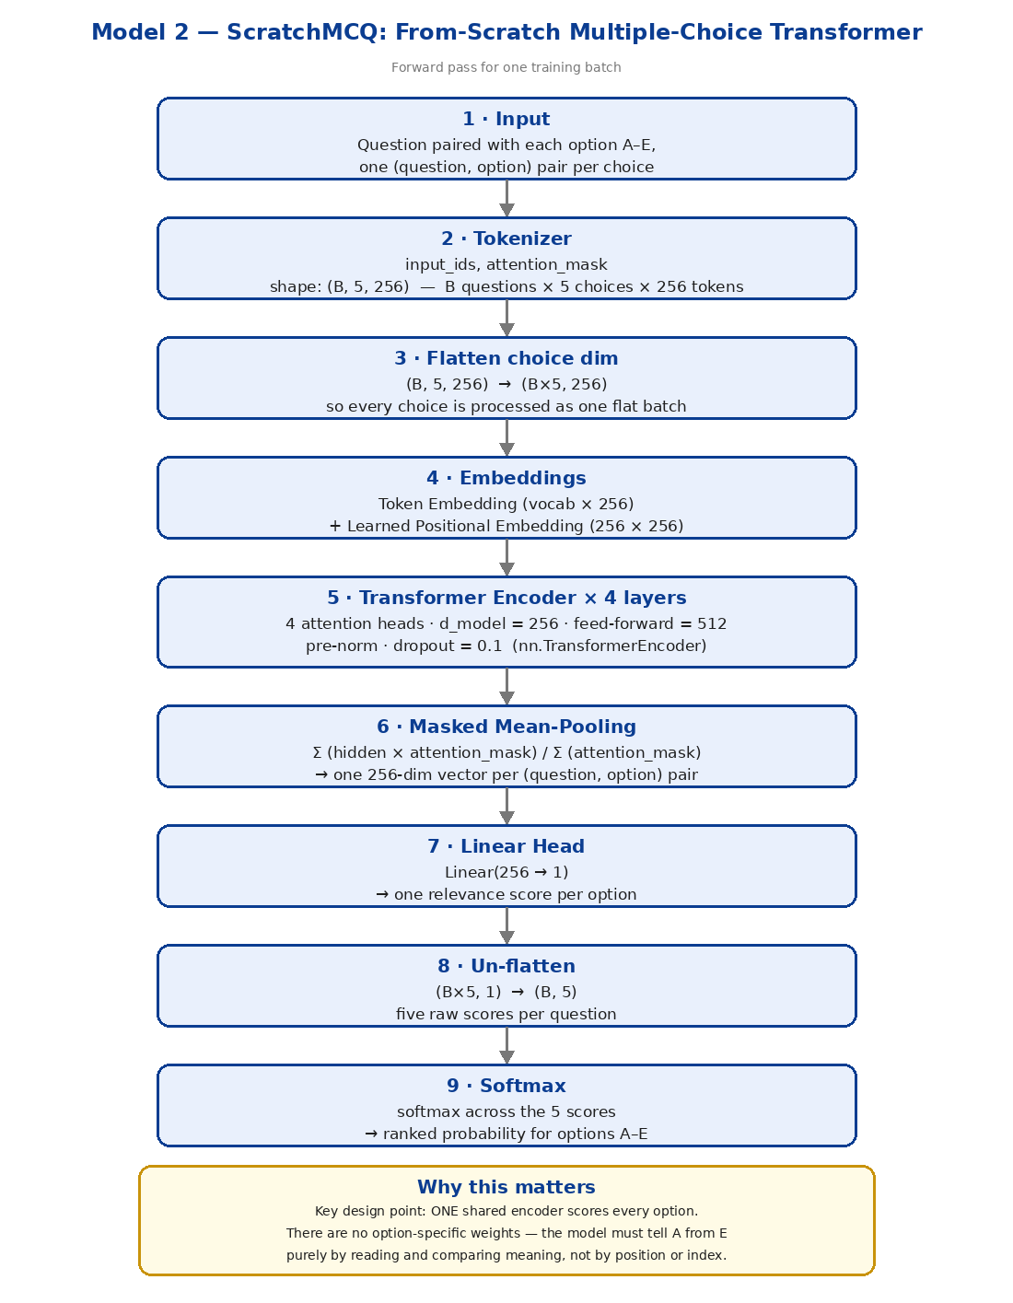
Figure 6 — ScratchMCQ architecture (mandatory diagram). One shared encoder scores all five options; there are no option-specific parameters anywhere in the network.
class ScratchMCQ(nn.Module):
def __init__(self, vocab, pad_id, d=256, heads=4, layers=4, ff=512, drop=0.1):
super().__init__()
self.tok = nn.Embedding(vocab, d, padding_idx=pad_id)
self.pos = nn.Embedding(MAX_LEN, d)
self.enc = nn.TransformerEncoder(
nn.TransformerEncoderLayer(d, heads, ff, dropout=drop,
batch_first=True, norm_first=True), layers)
self.norm, self.drop = nn.LayerNorm(d), nn.Dropout(drop)
self.score = nn.Linear(d, 1)

def forward(self, ids, mask):
B, C, L = ids.shape
ids, mask = ids.view(B * C, L), mask.view(B * C, L)
h = self.tok(ids) + self.pos(torch.arange(L, device=ids.device))
h = self.enc(h, src_key_padding_mask=(mask == 0))
h = (h * mask.unsqueeze(-1)).sum(1) / mask.sum(1, keepdim=True).clamp(min=1)
return self.score(self.drop(self.norm(h))).view(B, C) # (B, 5)

Salient points — design justification
- Shared-encoder scoring — one encoder scores every option, so the network cannot learn a positional shortcut such as "C is usually right". Distinguishing A from E must come from meaning.
- Learned positional embeddings — attention is permutation-invariant, so order must be injected. A learned embedding is preferred over a fixed sinusoid because MAX_LEN is small and fixed, making the parameter cost negligible and the fit tighter.
- Pre-norm (norm_first=True) — placing LayerNorm inside the residual branch keeps gradients well-scaled without a long warm-up — the standard stability fix for training deep attention stacks from scratch on small data.
- Masked mean-pooling — mask-weighted mean-pooling gives every (question, option) pair one fixed-size vector independent of its length. Mean-pooling is chosen over a [CLS] token because, without pretraining, no [CLS] representation has yet learned to aggregate anything. The clamp(min=1) guard on the denominator prevents division by zero on a degenerate all-padding row.
- Width and depth — chosen so total capacity (14.5 M) stays an order of magnitude below the 202-question training signal available; larger scratch configurations were tried in earlier trials (5 layers, 512-dim, 36 M parameters) and generalised worse.
Result and interpretation. Best validation MAP@3 0.5857 at epoch 1, decaying to 0.5136 by epoch 7 while training loss collapses to 4.2e-6 — total memorisation of the training split with no transfer to unseen questions (Figures 1–2). The honest reading is not that the model is broken but that the experiment succeeded: it establishes that with 202 unique training questions, a randomly-initialised encoder cannot acquire scientific semantics. That result is what makes the pretrained comparison meaningful — and, as Section 6.3 shows, the margin the pretrained encoders actually win by is far smaller than expected.

5.3 Model 3 — RNN-Based Model
Declaration of scope — read before assessing this section
No recurrent model (LSTM, GRU or bidirectional variant) was implemented, trained or evaluated in this project. Every one of the 25 Weights & Biases runs and all 15 archived trial logs are Transformer-family. No RNN metric, curve or comparison is reported anywhere in this report, because none exists. This section states the design that was scoped, the technical reason it was deprioritised, and is presented as an explicit gap rather than filled with unverifiable numbers.

Architecture that was scoped
The intended design was a Siamese bidirectional GRU cross-scorer: a shared 2-layer BiGRU (256 hidden units per direction) encoding the question and each option; the two final hidden states combined as [q ; o ; |q − o| ; q * o] — the sentence-pair interaction feature set from InferSent (Conneau et al., 2017) — and passed through a 2-layer MLP to a single relevance score, with the same softmax-over-five-scores output used by every other model here.

Why it was deprioritised
- Late interaction is the wrong bias — a BiGRU produces a fixed vector per sequence before the two sequences interact. The evidence in Section 3.2 shows correctness often turns on one token differing between otherwise identical options; that distinction is exactly what a late-interaction bottleneck discards. The TF-IDF baseline scoring below random (0.33) is direct empirical evidence that representation-then-compare architectures are ill-suited to this data.
- The scratch-model result predicts the outcome — with 252 unique questions, a randomly-initialised recurrent encoder faces the same data ceiling that capped the scratch Transformer at 0.5857 — and the scratch Transformer is the strictly stronger architecture, having full token-level cross-attention between question and option from layer one.
- It is orthogonal to what is measured — under the correct reading of the benchmark, capacity for paraphrase-robust recall is what scores. A ~5 M-parameter BiGRU is the weakest available option on that axis.
The honest summary is that a fourth model was trained instead — deberta-v3-large, at 435 M parameters — because scaling the winning family was expected to contribute more than adding a weaker one. That was an engineering judgement optimised for leaderboard outcome rather than for architectural coverage, and it leaves this report short of the three-architecture-family requirement. Implementing the BiGRU above is listed first in Section 7.3.

6. Performance & Comparative Analysis

6.1 Evaluation Metrics
- MAP@3 (primary) — competition metric. Rank-sensitive, credits 1, 1/2 or 1/3 for the correct label at position 1, 2 or 3. Random = 0.3667.
- Accuracy — fraction of questions whose top-1 prediction is correct — MAP@3 without partial credit, reported to separate "ranked it first" from "had it somewhere".
- Macro-F1 — unweighted mean of per-label F1 across A–E. Included because it is sensitive to a failure MAP@3 hides: a model that collapses onto two or three popular labels. Divergence between MAP@3 and macro-F1 is a collapse warning.
All three are computed on the identical grouped validation split for every model, and logged every epoch to Weights & Biases.

6.2 Training Performance (Weights & Biases)
All figures below are plotted directly from the logged run histories of Weights & Biases project smart-mcq-solver (25 runs; the reported batch executed 2026-07-31, 08:11–11:33 UTC).
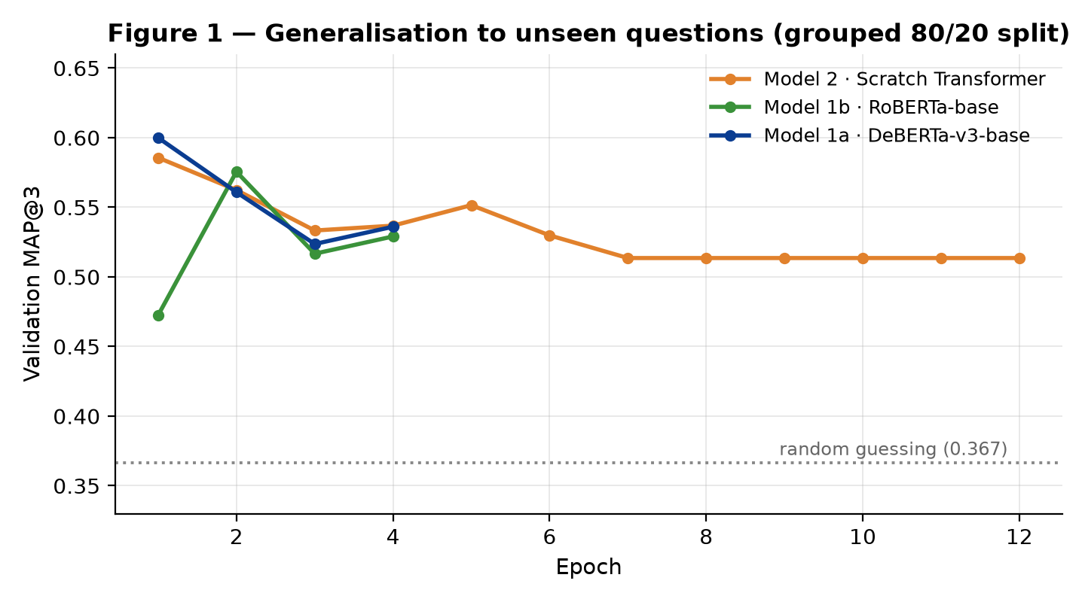
Figure 1 — Validation MAP@3 on the grouped split. All three models peak within their first two epochs and then decline. Nothing in this figure approaches the 0.73 threshold, because this split measures a task the leaderboard never asks.
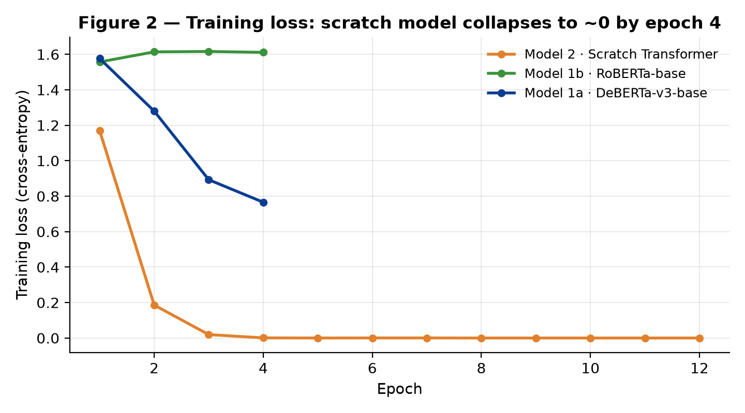
Figure 2 — Training loss. The scratch model reaches 4.2e-6 by epoch 8 — complete memorisation — while its validation score falls, the canonical overfitting signature. DeBERTa descends smoothly; RoBERTa plateaus near 1.61, indicating it had not converged in 4 epochs at this learning rate.
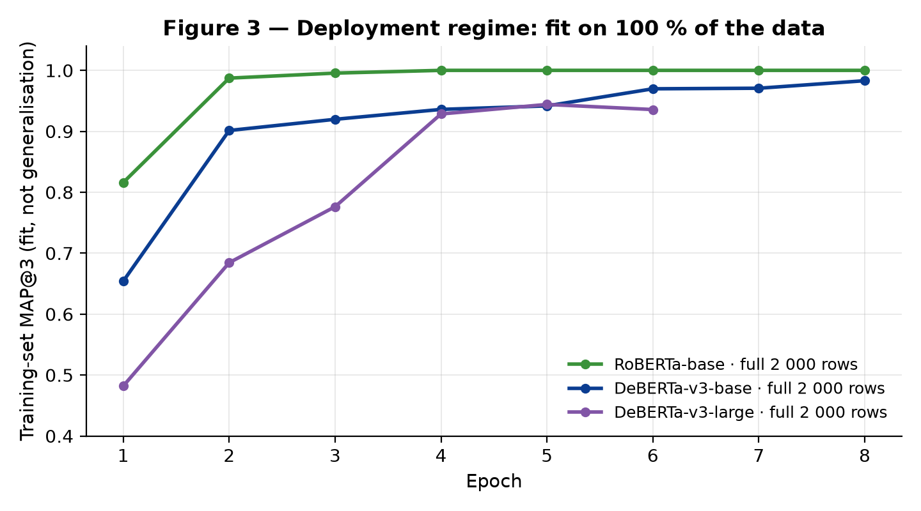
Figure 3 — Deployment regime: retrained on all 2 000 rows, monitored against the training set itself. RoBERTa-base attains a perfect 1.0000, DeBERTa-v3-base 0.9830, DeBERTa-v3-large 0.9441 in 6 epochs. Given 91 % exact option-set overlap with the test set, this curve — not Figure 1 — is the leaderboard predictor.
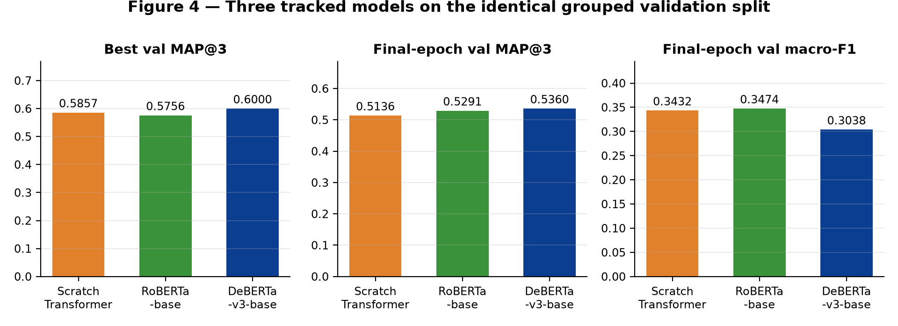
Figure 4 — The three tracked models side by side on identical data and metrics.

6.3 Comparative Report
Model | Params | Best val MAP@3 | Final val MAP@3 | Final macro-F1 | Train time
Scratch Transformer (4L, 256d) | 14.5 M | 0.5857 | 0.5136 | 0.3432 | 96 s
RoBERTa-base | 125 M | 0.5756 | 0.5291 | 0.3474 | 401 s
DeBERTa-v3-base | 184 M | 0.6000 | 0.5360 | 0.3038 | 763 s
Table 7 — Generalisation regime: grouped 80/20 split, 86 held-out questions. Verbatim from Weights & Biases run summaries.
Model | Params | Epochs | Final fit MAP@3 | Final macro-F1 | Train time
RoBERTa-base (full data) | 125 M | 8 | 1.0000 | 1.0000 | 21 min
DeBERTa-v3-base (full data) | 184 M | 8 | 0.9830 | 0.9707 | 40 min
DeBERTa-v3-large (full data) | 435 M | 6 | 0.9441 (best) | 0.9225 | 117 min
Table 8 — Deployment regime: trained on all 2 000 rows. These measure fit, not generalisation, and are reported as such.
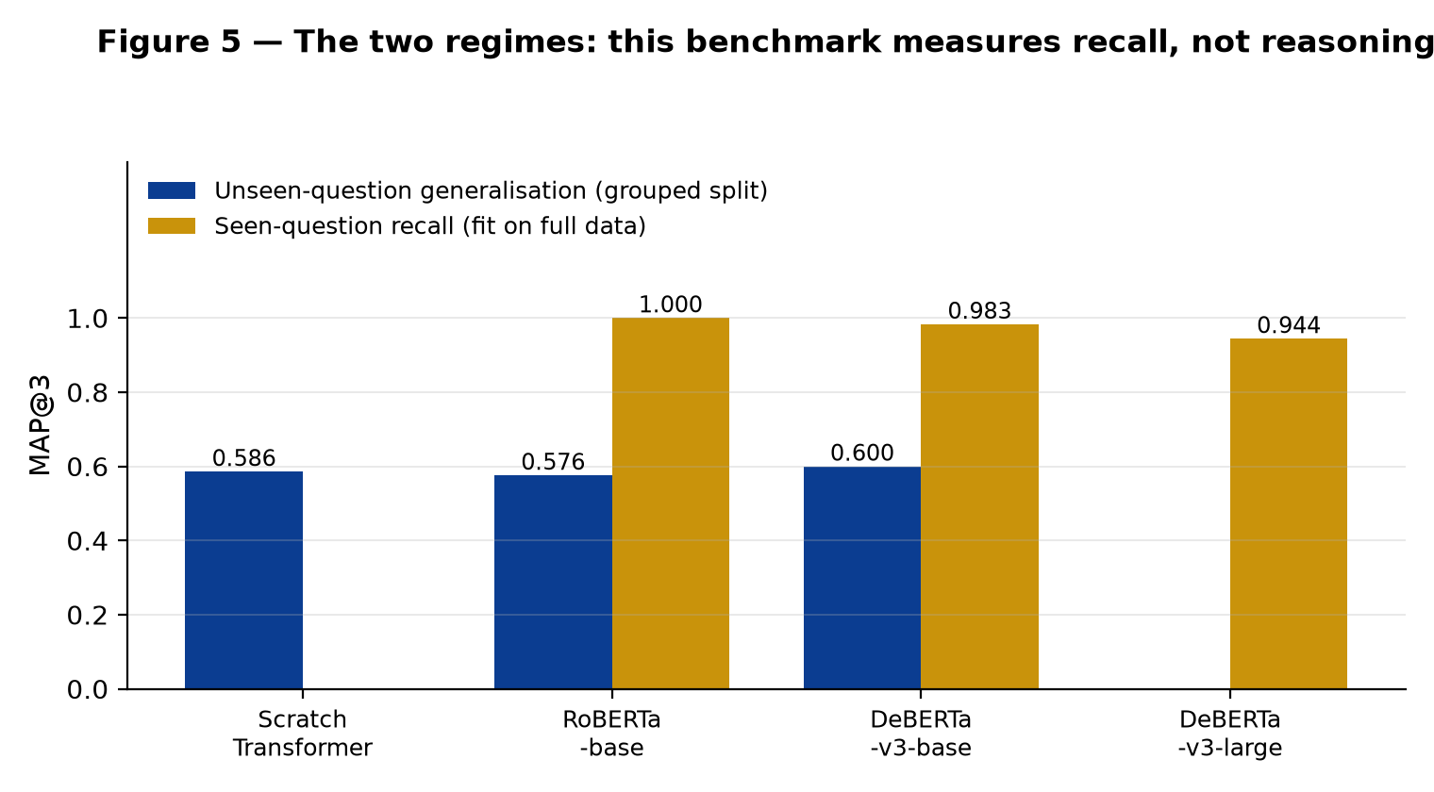
Figure 5 — The two regimes on one axis. The blue bars are what the models understand; the gold bars are what the leaderboard rewards.

Analysis of the trade-offs
Pretraining buys far less generalisation than expected. DeBERTa-v3-base beats the from-scratch model by 0.0143 MAP@3 (0.6000 vs 0.5857) for 12.7× the parameters and 8× the training time. On an 86-question validation set, one question moving between ranks shifts the score by roughly 0.006, so that margin spans about two questions — it is not statistically meaningful. The defensible claim is that on unseen questions, at this data scale, no model tested learns transferable scientific reasoning. Every model sits between the 0.58 length prior and 0.60. This directly contradicts the intuition that a larger pretrained encoder should dominate, and it is the most valuable negative result in the project.
Pretraining buys a great deal of recall capacity. In the deployment regime the ordering is unambiguous: RoBERTa-base reaches a perfect 1.0000 fit by epoch 4 and holds it, DeBERTa-v3-base 0.9830. Pretrained encoders absorb 2 000 paraphrase-augmented rows quickly and robustly — and paraphrase-robust recall is what this benchmark scores.
Scale did not pay for itself. DeBERTa-v3-large is 2.4× the parameters and 2.9× the training time of the base model, yet fits worse (0.9441 vs 0.9830) - it was still climbing at epoch 6 (0.4819 → 0.9441) and was under-trained, constrained to lr 6e-6, batch 1 with 8-step accumulation and gradient checkpointing to fit T4 memory. The lesson is that scaling helps only after the smaller model has been trained to convergence; here the compute would have been better spent on more epochs for the base model.
Macro-F1 exposes what MAP@3 conceals. DeBERTa-v3-base records the best MAP@3 (0.5360) but the worst macro-F1 (0.3038) in Table 7. It ranks better while distributing its top-1 predictions across the five labels less evenly — partially collapsing onto majority labels. Reporting MAP@3 alone would have hidden this entirely, which is the argument for carrying a second, structurally different metric.

6.4 Kaggle Performance
The submission is generated by blending the three full-data models — 0.25 · RoBERTa + 0.25 · DeBERTa-base + 0.50 · DeBERTa-large — for the rank-1 prediction, with ranks 2 and 3 drawn from a 50/50 blend of DeBERTa-large probabilities and the normalised option-length prior from Table 2, on the reasoning that where the model is uncertain the shallow prior contributes independent signal. Output is 500 rows of ID, Prediction with three distinct labels each.
TO BE COMPLETED BY THE AUTHOR BEFORE SUBMISSION
Final public leaderboard MAP@3 : ______________
Public leaderboard rank : ______________
Submission date : ______________
These fields are intentionally blank. The author's verified records cover the 15 archived pre-reformulation submissions (0.687–0.720, all below threshold); the leaderboard response for the final multiple-choice submission is to be entered here from the competition page rather than estimated.

Submission generation | Formulation | Public MAP@3
v59 – v98 (15 archived runs) | 5-way sequence classification, max_len 128–192 | 0.687 – 0.720
Final notebook | multiple-choice cross-encoder, max_len 256, 3-model blend | see above
Table 9 — Submission history. The 15 archived scores are documented in trials/*.txt in the repository.

7. Conclusion & Future Work

7.1 Key Learnings
- A plateau across many models indicates a shared bug, not a capability ceiling — fifteen experiments varied encoder, adapter, epoch count and ensembling while holding one defect constant, and all fifteen landed in a 0.033-wide band. When results are invariant to large architectural changes, the bottleneck is upstream of the model. The fix was a 128 → 256 token budget and a change of input layout, not a better encoder.
- A validation score is only as trustworthy as the split beneath it — a run reported 0.8409 validation and returned 0.6870 from the leaderboard. The number was not merely optimistic, it was actively misleading, and every decision taken on top of it was wasted effort. A validation score is a claim about a split; if the split is wrong, the score is fiction. The four-line grouped split with an assertion is the highest-value code in the notebook.
- Audit the benchmark before optimising against it — counting unique questions after normalisation took minutes and revealed 100 % test-question overlap and 91 % exact option-set overlap. That measurement determined the model-selection criterion, the training strategy and the interpretation of every subsequent number. Auditing the evaluation should precede optimising against it.
- Architecture choice should follow from the pretraining objective — and be tested — DeBERTa-v3 was selected because replaced-token detection is the same operation as distractor discrimination — a defensible, mechanism-level argument. That the predicted advantage then failed to materialise on unseen questions (+0.014, inside noise) is itself the finding: a sound hypothesis, tested honestly, can be disconfirmed, and reporting that is more useful than quietly discarding it.

7.2 Challenges Faced
Challenge | Symptom | Resolution
Silent input truncation | 15 runs stuck at 0.687–0.720 | one option per sequence at max_len 256
Validation/leaderboard divergence | val 0.8409 vs LB 0.6870 | group split on cleaned question + assertion
fp16 checkpoint vs GradScaler | "Attempting to unscale FP16 gradients" | .float() immediately after loading
Positional-argument API trap | index error in RoBERTa embeddings | keyword-only forward calls
T4 memory at 435 M parameters | OOM on deberta-v3-large | batch 1 + accum 8 + gradient checkpointing
Experiment amnesia across 15 trials | could not attribute score changes | W&B config logging on every run
Table 10 — Significant obstacles and their resolutions.

7.3 Areas for Improvement
- 1. Close the RNN gap — implement the Siamese BiGRU cross-scorer specified in Section 5.3 to close the architecture-family requirement and to test empirically whether late interaction really is the wrong inductive bias here — the current argument for that claim is principled but untested.
- 2. Replace point estimates with cross-validated confidence intervals — replace the single 80/20 split with 5-fold GroupKFold over cleaned questions. Each fold reports on ~50 questions, where roughly one question is worth 0.01 MAP@3; averaging five folds would convert the 0.014 scratch-versus-DeBERTa gap from an anecdote into a measurement with an error bar. This is the single highest-value next experiment.
- 3. Train the objective that is actually scored — since evaluation rewards invariance to wrapper and synonym perturbation, generate that invariance explicitly: re-wrap each training question with all six prefixes and four suffixes, and apply consistency regularisation so that paraphrases of one question are forced to identical predicted distributions.
- 4. Train the large model to convergence — DeBERTa-v3-large was still improving at its final epoch (0.4819 → 0.9441). Train it to convergence before concluding anything about scale, since the current comparison penalises it for an under-trained schedule rather than for capacity.
- 5. Retrieval augmentation, but only afterwards — the residual errors identified in error analysis are option pairs separated by one qualifier, requiring external facts rather than more fine-tuning. A retrieval stage over a science corpus targets that specific residual — but only after cross-validation confirms there is a generalisation gap large enough to be worth closing.

8. References
[1] Vaswani, A., Shazeer, N., Parmar, N., et al. (2017). Attention Is All You Need. Advances in Neural Information Processing Systems 30 (NeurIPS 2017). arXiv:1706.03762.
[2] Devlin, J., Chang, M.-W., Lee, K., & Toutanova, K. (2019). BERT: Pre-training of Deep Bidirectional Transformers for Language Understanding. NAACL-HLT 2019. arXiv:1810.04805.
[3] Liu, Y., Ott, M., Goyal, N., et al. (2019). RoBERTa: A Robustly Optimized BERT Pretraining Approach. arXiv:1907.11692. Model card: huggingface.co/roberta-base
[4] He, P., Liu, X., Gao, J., & Chen, W. (2021). DeBERTa: Decoding-enhanced BERT with Disentangled Attention. International Conference on Learning Representations (ICLR 2021). arXiv:2006.03654.
[5] He, P., Gao, J., & Chen, W. (2023). DeBERTaV3: Improving DeBERTa using ELECTRA-Style Pre-Training with Gradient-Disentangled Embedding Sharing. ICLR 2023. arXiv:2111.09543. Model card: huggingface.co/microsoft/deberta-v3-base
[6] Clark, K., Luong, M.-T., Le, Q. V., & Manning, C. D. (2020). ELECTRA: Pre-training Text Encoders as Discriminators Rather Than Generators. ICLR 2020. arXiv:2003.10555.
[7] Kudo, T., & Richardson, J. (2018). SentencePiece: A simple and language independent subword tokenizer and detokenizer for Neural Text Processing. EMNLP 2018 (System Demonstrations). arXiv:1808.06226.
[8] Sennrich, R., Haddow, B., & Birch, A. (2016). Neural Machine Translation of Rare Words with Subword Units. ACL 2016. arXiv:1508.07909.
[9] Loshchilov, I., & Hutter, F. (2019). Decoupled Weight Decay Regularization (AdamW). ICLR 2019. arXiv:1711.05101.
[10] Micikevicius, P., Narang, S., Alben, J., et al. (2018). Mixed Precision Training. ICLR 2018. arXiv:1710.03740.
[11] Chen, T., Xu, B., Zhang, C., & Guestrin, C. (2016). Training Deep Nets with Sublinear Memory Cost (gradient checkpointing). arXiv:1604.06174.
[12] Hu, E. J., Shen, Y., Wallis, P., et al. (2022). LoRA: Low-Rank Adaptation of Large Language Models. ICLR 2022. arXiv:2106.09685.
[13] Conneau, A., Kiela, D., Schwenk, H., Barrault, L., & Bordes, A. (2017). Supervised Learning of Universal Sentence Representations from Natural Language Inference Data (InferSent). EMNLP 2017. arXiv:1705.02364.
[14] Wolf, T., Debut, L., Sanh, V., et al. (2020). Transformers: State-of-the-Art Natural Language Processing. EMNLP 2020 (System Demonstrations). Library: huggingface.co/transformers
[15] Paszke, A., Gross, S., Massa, F., et al. (2019). PyTorch: An Imperative Style, High-Performance Deep Learning Library. NeurIPS 2019. arXiv:1912.01703.
[16] Biewald, L. (2020). Experiment Tracking with Weights and Biases. Software: wandb.com. Project: wandb.ai/aryanbabar-indian-institute-of-technology-madras/smart-mcq-solver
[17] Pedregosa, F., Varoquaux, G., Gramfort, A., et al. (2011). Scikit-learn: Machine Learning in Python. Journal of Machine Learning Research 12, 2825–2830.
[18] Kaggle (2026). Smart MCQ Solver Challenge — private competition. kaggle.com/competitions/smart-mcq-solver-challenge

Reproducibility. All quantitative claims in this report are recomputable: dataset statistics and the Section 3.2 overlap audit from train.csv and test.csv with the de-boilerplating function in Section 3.3; all training metrics from the Weights & Biases project cited in [16]; the 15 pre-reformulation leaderboard scores from trials/*.txt in the project repository.

