2.
Solution.
Digital Differential Analyzer Algorithm is a line drawing algorithm that is based on incremental method or slope-intercept equation, which calculates all intermediate points over the interval between start and end points.
For any given x interval ∂x along a line, we can compute the corresponding y interval, ∂y, as
∂y = m∂x
=> ∂x = ∂y/m (m is slope)
PSUEDO-CODE
//Get the input of two end points (X1,Y1) and (X2,Y2). Calculate dx, dy.

dx = X2 - X1;
dy = Y2 – Y1;
A line is sampled at unit intervals in one coordinate and the corresponding integer values nearest to the line path are determined for the other coordinate.
If the slope is more than 1, we sample at unit y intervals (∂y = 1) and compute
successive x values as:-
x _{k+1} = x _{k} + (1/ m)
// Depending upon absolute value of dx & dy, choose number of steps to put pixel as:
steps = abs(dy) > abs(dx) ? abs(dy) : abs(dx)
Subscript k takes integer values starting from 0, for the first point, and increase by 1 until the
final endpoint is reached.
// Calculate the increment in x coordinate and y coordinate for each step
xIncrement = dx / (float) step;
yIncrement = dy / (float) step;
Because m can be any real number between 0.0 and 1.0, each calculated x value must be
rounded to the nearest integer corresponding to a screen pixel position in the y column that
we are processing.
These equations are based on the assumption that lines are to be processed from the left end
point to the right end point. If this processing is reversed, so that the staring endpoint is at
the right, then we have, ∂y = -1, therefore,
x_{k+1} = x _{k} – (1/m)
// Put the pixel by successfully incrementing x and y coordinates accordingly and complete the line drawing.
X = X1;
Y = Y1;
//for first starting pixel of line
putpixel (X,Y,COLOR);
for (int i = 1; i <= step; i++)
{
putpixel (X,Y,COLOR);
X += xIncrement;
Y += yIncrement;
}Exit

3.
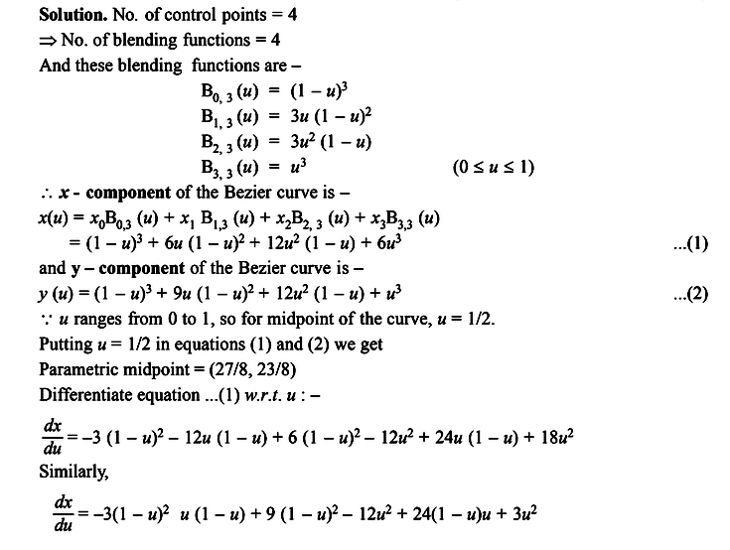
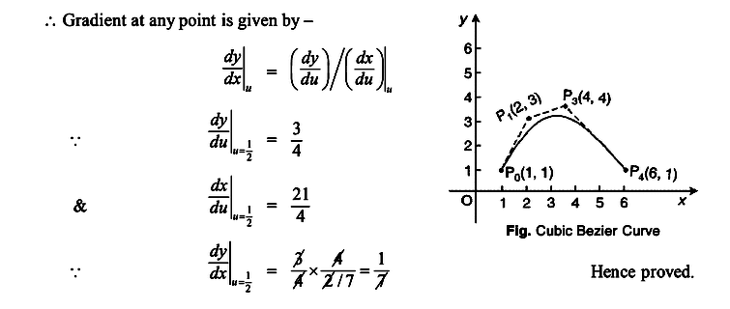

4.
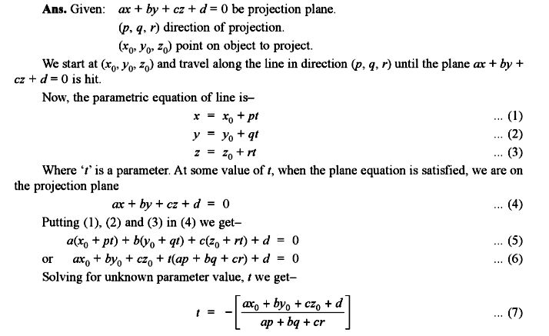
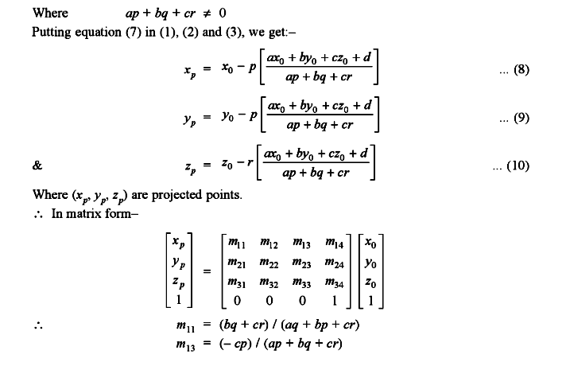

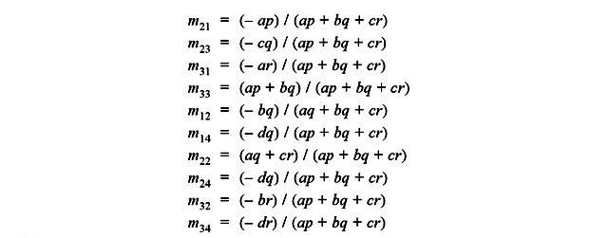

5.
Solutions.
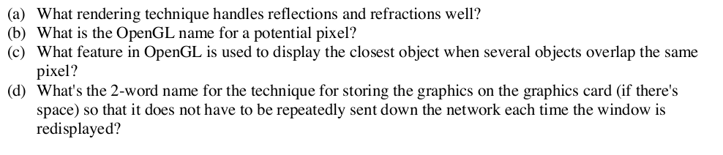
Environment Mapping(EM)
Fragment
Z-Buffer
Display List

