CycleGAN Image Translation Lab Practical
Unpaired apple and orange image translation using PyTorch on a Mac GPU
Name: [ENTER NAME] Roll number: [ENTER ROLL NUMBER]
Course and class: [ENTER COURSE AND CLASS]
Experiment number: [ENTER NUMBER] Date: [ENTER DATE]

1 Aim
To implement and execute a Cycle Generative Adversarial Network (CycleGAN) for unpaired image translation between apples and oranges, train it using the Mac GPU through PyTorch MPS, and inspect translations and cycle reconstructions on held-out test images.

2 Requirements
Component | Requirement
Hardware | Apple Silicon Mac with MPS support; sufficient free memory and disk space for the environment, dataset and checkpoints.
Software | macOS, native ARM64 Python 3.12, Terminal and a code editor.
Python packages | PyTorch 2.5.1, NumPy 2.1.3, Pillow 11.1.0 and tqdm 4.67.1.
Data and network | Internet for initial package installation and dataset download; subsequent training runs locally.

3 Dataset and scope
The practical uses the apple2orange dataset distributed by the original CycleGAN authors. Domain A contains apples and domain B contains oranges. The images are unpaired: an apple image has no corresponding orange target image. The lightweight configuration selects 200 images from each training domain using seed 42.
Folder | Domain | Available images | Default use
trainA | Apple | 995 | 200 selected images
trainB | Orange | 1019 | 200 selected images
testA | Apple | 266 | 20 images for inference
testB | Orange | 248 | 20 images for inference

Training images receive random augmentation. Test images receive deterministic preprocessing and are excluded from gradient updates. Test previews are used for qualitative inspection; there is no separate validation split in this practical.

4 Brief theory
A GAN learns through competition between a generator, which produces images, and a discriminator, which distinguishes real images from generated images. CycleGAN extends this idea to two unpaired domains by learning translations in both directions.
Let G map apples to oranges and F map oranges to apples. D_A distinguishes real apples from F(B), while D_B distinguishes real oranges from G(A). A PatchGAN discriminator produces a grid of local realism scores rather than one class label for the whole image.

Cycle and identity constraints
Cycle consistency encourages an image translated into the other domain and back to retain its original content: A → G(A) → F(G(A)) ≈ A, and B → F(B) → G(F(B)) ≈ B. Identity loss discourages unnecessary changes when a generator receives an image already belonging to its target domain.
L_cycle = mean|F(G(A)) - A| + mean|G(F(B)) - B|
L_identity = mean|F(A) - A| + mean|G(B) - B|
L_adv = mean(D_B(G(A)) - 1)^2
+ mean(D_A(F(B)) - 1)^2
L_G = L_adv + 10 L_cycle + 5 L_identity
The discriminators use least-squares loss: real image scores are encouraged toward 1 and generated image scores toward 0. Each domain contributes one half of the sum of its real and fake mean squared errors. The generator and discriminator objectives are optimized alternately.

5 Network architecture
Generator stage | Operation | Output shape per image
Input | RGB tensor normalized to [-1, 1] | 3 × 128 × 128
Encoder | 7×7 convolution; then two 3×3 stride 2 convolutions | 32×128×128 → 64×64×64 → 128×32×32
Residual processing | Six residual blocks, two 3×3 convolutions per block | 128 × 32 × 32
Decoder | Two 3×3 transposed convolutions, stride 2 | 64×64×64 → 32×128×128
Output | 7×7 convolution and Tanh | 3 × 128 × 128

Both generators share this architecture but have independent weights. Hidden layers use instance normalization and ReLU; residual blocks add their input to their output. Reflection padding is used at the image boundaries and inside residual blocks.
Each discriminator uses five 4×4 convolutions with channels 3 → 32 → 64 → 128 → 256 → 1 and strides 2, 2, 2, 1, 1. LeakyReLU has slope 0.2; intermediate layers use instance normalization. For a 128×128 input, the output is a 14×14 score map with a 70×70 receptive field per score. No sigmoid is used with the least-squares objective.

6 Coding architecture and implementation
File | Responsibility
scripts/download_data.py | Download and safely extract the archive; record split counts and SHA-256.
cyclegan/data.py | Read RGB images, resize/crop, augment, normalize, and sample unpaired domains.
cyclegan/models.py | Define residual blocks, generators, PatchGAN discriminators and initialization.
cyclegan/__main__.py | Provide train/infer commands, MPS selection, losses, replay buffers, checkpoints and metrics.
run.sh | Run or resume default training, then test both directions.
tests/test_pipeline.py | Check cycle gradients, preprocessing and replay buffer behavior.

Training algorithm
1. Select the training subset. Convert images to RGB, fit to a square, randomly crop and flip, and scale pixel values to [-1, 1].
2. Load one apple and one independently sampled orange. Move the tensors and all four networks to the MPS device.
3. Generate fake oranges and apples. Compute cycle reconstructions and identity outputs.
4. Freeze discriminator parameters, compute the combined generator loss, backpropagate and update both generators using Adam.
5. Enable discriminator gradients. Compare real images with detached generated images from the replay pools, then update both discriminators.
6. Repeat for the epoch. Save a test preview, the checkpoint and average losses; adjust the learning rate according to the schedule.

Default experimental configuration
Parameter | Value | Parameter | Value
Resolution | 128 × 128 | Batch size | 1
Images per domain | 200 | Epochs | 10
Base channels | 32 | Residual blocks | 6
Optimizer | Adam | Initial learning rate | 0.0002
Adam betas | 0.5, 0.999 | Replay capacity | 50 per domain
Cycle weight | 10 | Identity weight | 5
Seed | 42 | DataLoader workers | 0

Convolution weights are initialized from a normal distribution with mean 0 and standard deviation 0.02. Float32 is used without mixed precision. Replay pools are stored on CPU to reduce GPU memory use. With the implemented zero-based schedule, the learning rate remains 0.0002 through epoch 6, then decreases linearly from epoch 7 to epoch 10.

7 Laboratory procedure

Step 1 Open the project and activate the environment
cd /Users/aryanjain/Downloads/cyclegan
source .venv/bin/activate
For a fresh setup only, create the environment and download the data:
python3.12 -m venv .venv
source .venv/bin/activate
python -m pip install -r requirements.txt
python scripts/download_data.py

Step 2 Verify GPU access and basic checks
python -c "import torch; print(torch.backends.mps.is_available())"
python -m unittest discover -s tests -v
Confirm that the device check prints True and the tests pass. The training and inference commands also print Device: mps. Use a regular Terminal if an application sandbox hides GPU access.

Step 3 Train the model
python -m cyclegan train --device mps
Record the configuration and retain the final training log. Monitor runs/apple2orange/losses.csv and the epoch preview images. For the complete default training-and-testing sequence, use bash run.sh instead of running the separate commands.

Step 4 Resume if interrupted
python -m cyclegan train --resume runs/apple2orange/latest.pt --epochs 10
Resume restores the saved settings and continues after the last completed epoch, stopping at the requested total. A checkpoint at or above 10 epochs needs no further training. Work in an unfinished epoch is lost. Use a new --run directory for a new experiment; do not overwrite an existing run. MPS execution is not guaranteed to be bit-identical between runs.

Step 5 Test both translation directions
python -m cyclegan infer --direction ab \
--input data/apple2orange/testA --output outputs/apple2orange
python -m cyclegan infer --direction ba \
--input data/apple2orange/testB --output outputs/orange2apple
Both commands use runs/apple2orange/latest.pt and MPS by default. They translate 20 images per direction. Use --limit 0 to process the full test split. For a custom image, replace --input with its file path.

Step 6 Collect evidence and observations
Retain the training log, epoch preview and both test comparison grids. The evidence and observation sections contain outputs from the saved epoch-12 run. Add the repository URL and tested commit on the final page.

8 Training evidence
The recorded experiment completed 12 epochs on MPS using 200 selected images per domain at 128×128 resolution. It was started with the earlier 30-epoch configuration and stopped after epoch 12. The default for future runs is now 10 epochs. All results below use the existing epoch-12 checkpoint; no further training was performed for testing.

Recorded training output
The following values are transcribed from runs/apple2orange/losses.csv. They are training-log evidence, not a terminal screenshot. Losses are averaged over each epoch.
Epoch | Generator | Discriminator | Cycle | Identity
1 | 11.616535 | 0.734415 | 0.728213 | 0.678179
6 | 7.417646 | 0.460620 | 0.460129 | 0.410342
12 | 6.538583 | 0.426011 | 0.395572 | 0.352964

The sum of logged epoch durations is 200.59 seconds, approximately 3 minutes 21 seconds. This excludes environment setup and dataset download. The logged learning rate is 0.0002 throughout these 12 epochs because the run used the earlier decay schedule.

Figure 1 Training preview at epoch 12
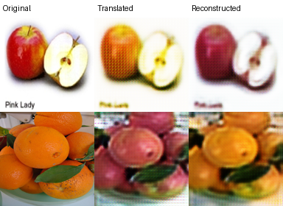
Source: runs/apple2orange/epoch_012.png. Top row: apple input. Bottom row: orange input. Columns show the original, translated and reconstructed image.
The preview shows changes toward the target-domain colors while approximately retaining the object outline. Blur and texture artifacts remain visible. The reconstruction restores some of the original appearance.

9 Testing evidence
Inference used the epoch-12 checkpoint on MPS. Twenty held-out images were processed in each direction. Each comparison grid below shows the first eight processed inputs, translations and reconstructions; it is not a selection of only successful examples.

Figure 2 Apple to orange translation
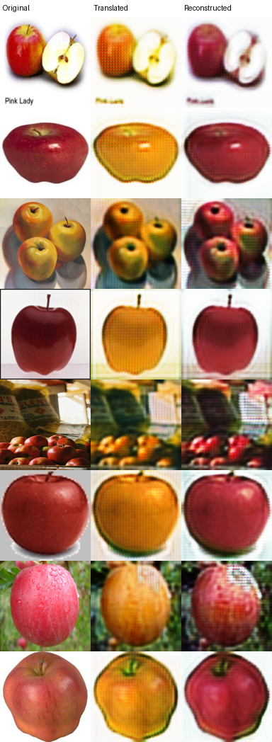
Source: outputs/apple2orange/comparison.png. Columns: Original, Translated, Reconstructed. Mean cycle MAE over 20 test images: 0.092801 on the [0, 1] pixel scale.

Testing evidence continued

Figure 3 Orange to apple translation
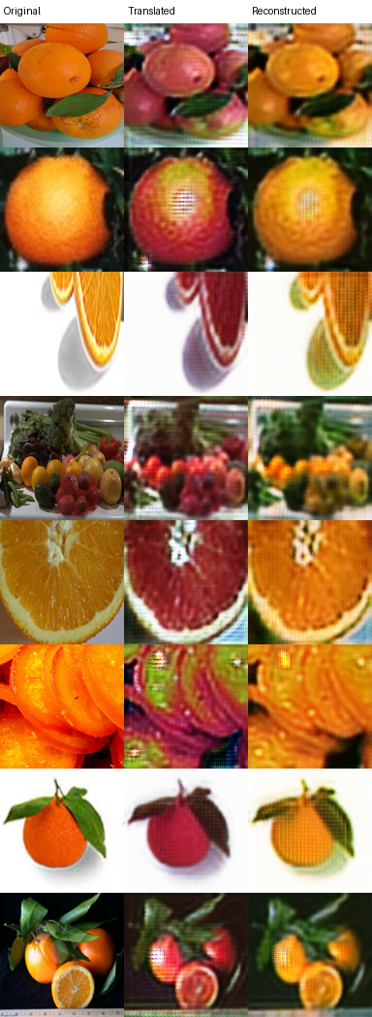
Source: outputs/orange2apple/comparison.png. Columns: Original, Translated, Reconstructed. Mean cycle MAE over 20 test images: 0.096417 on the [0, 1] pixel scale.
Several translations become red or pink while retaining orange-like shapes. Slices and complex scenes remain difficult, illustrating that the model has learned appearance changes more reliably than complete semantic conversion.

10 Observations and result
The following measurements are from the saved epoch-12 experiment. The CSV cycle and identity losses are unweighted sums across both directions on normalized [-1, 1] tensors. The inference cycle MAE is measured on the [0, 1] pixel scale, so these values are not directly interchangeable.
Observation | Recorded value | Evidence source
Hardware platform | Apple Silicon Mac | Local execution environment
Training device | MPS (Mac GPU) | Training terminal
Completed epochs | 12 | Checkpoint / terminal
Logged epoch time | 200.59 s (3 min 21 s) | Sum of seconds in losses.csv
Final generator loss | 6.538583 | Last row, generator
Final discriminator loss | 0.426011 | Last row, discriminator
Final cycle loss | 0.395572 | Last row, cycle
Final identity loss | 0.352964 | Last row, identity
Apple to orange images | 20 | apple2orange/metrics.json
Apple to orange cycle MAE | 0.092801 | apple2orange/metrics.json
Orange to apple images | 20 | orange2apple/metrics.json
Orange to apple cycle MAE | 0.096417 | orange2apple/metrics.json

Interpretation
Inspect whether the translated fruit acquires the target domain’s appearance while preserving approximate shape and scene content. Compare early and late previews, and note background changes, texture artifacts, color shifts and unsuccessful cases. A lower cycle error indicates more consistent reconstruction, but does not establish realistic translation. An identity-like mapping may also have low cycle error.
Visual observations: Apples generally acquire yellow or orange tones, and oranges often acquire red or pink tones. Approximate fruit outlines and scene layouts are retained, but fine details are blurred and repetitive texture artifacts appear. Cut fruit and crowded scenes do not consistently become convincing target-domain objects. Reconstructions recover much of the original color while losing some detail.

Result statement
The practical implements a bidirectional CycleGAN pipeline for unpaired apple and orange image translation with MPS acceleration, checkpointing and held-out inference. The recorded experiment completed 12 epochs, and inference successfully generated 20 translated images in each direction from that checkpoint. The outputs demonstrate bidirectional appearance transfer and approximate cycle reconstruction. They remain imperfect and should not be described as photorealistic fruit conversion.

Conclusion
CycleGAN combines adversarial learning with cycle consistency to learn image-domain translation without paired examples. The practical demonstrates the roles of two generators, two discriminators and identity regularization. A small dataset subset and compact network make local experimentation feasible, while final visual quality depends on training duration, data diversity and optimization stability. Reconstruction consistency must be considered together with the visible quality of translated images.

11 Precautions and troubleshooting
- Use an ARM64 Python environment and verify MPS availability before training. CUDA is not used on this Mac. Explicit --device mps prevents unnoticed CPU fallback.
- Keep test images outside the training folders. Do not report classification accuracy, PSNR or SSIM against unrelated target-domain images; this dataset has no paired ground truth.
- If memory is insufficient, start a new run with --size 64 --channels 16 --blocks 3. Image size must be at least 32 and divisible by 4.
- GAN losses can fluctuate. Check previews and artifacts instead of assuming that smaller losses always mean better images. A very short smoke test only checks execution.
- Save the checkpoint, configuration and metrics used for the report. Resume uses the saved schedule unless --epochs or --decay-start overrides it. The --epochs value is the total target, not additional epochs.
- Inference center-fits images to a square at the training resolution. Cropping can remove scene content. Use only images you are permitted to process and follow the dataset source terms.

12 Viva preparation
Why use CycleGAN? It learns domain translation when corresponding input and target image pairs are unavailable.
Why are two generators required? They learn opposite mappings and enable reconstruction through a complete translation cycle.
What does identity loss do? It discourages unnecessary modification of images already in the target domain.
What is a replay buffer? It mixes recent and earlier detached generated images during discriminator training to reduce rapid feedback changes.
What does MPS provide? It enables supported PyTorch operations to execute on the Mac GPU through Metal.
Does low cycle MAE prove realism? No. It measures reconstruction consistency, not whether the translated image looks realistic or belongs convincingly to the target domain.

13 Code repository
Git repository URL: [PASTE YOUR REPOSITORY LINK HERE]
Tested branch or commit: [ENTER BRANCH OR COMMIT HASH]
Include source files, requirements.txt and the README. The existing .gitignore excludes the virtual environment, dataset, run checkpoints and generated output folders.

14 References
Zhu, J. Y., Park, T., Isola, P., and Efros, A. A. Unpaired Image-to-Image Translation using Cycle-Consistent Adversarial Networks. ICCV, 2017. https://junyanz.github.io/CycleGAN/
Original CycleGAN implementation and dataset information: https://github.com/junyanz/pytorch-CycleGAN-and-pix2pix
PyTorch MPS backend documentation: https://docs.pytorch.org/docs/stable/notes/mps.html

