AMFIINTEL TERMINAL - Project Documentation
Enterprise Mutual Fund Intelligence & Portfolio Analytics Platform

Abstract
AMFIIntel Terminal is a production-grade Mutual Fund Intelligence and Portfolio Analytics Platform that transforms publicly available AMFI data into actionable investment insights. The platform automates data collection, historical NAV tracking, analytics generation, risk assessment, and portfolio analysis through a centralized fintech dashboard, enabling users to conduct comprehensive mutual fund research from a single interface.
Built using Next.js, FastAPI, PostgreSQL, and automated data engineering pipelines, the platform provides advanced capabilities such as fund comparison, portfolio overlap detection, diversification analysis, historical trend visualization, and professional report generation. By combining financial analytics with modern visualization and scalable backend architecture, AMFIIntel delivers a complete investment research ecosystem for investors, analysts, and financial professionals.

Introduction
AMFIIntel Terminal is a production-grade Mutual Fund Intelligence and Portfolio Analytics Platform designed to transform publicly available AMFI data into actionable investment insights. The platform automates data collection, historical NAV tracking, financial analytics, portfolio overlap detection, risk assessment, and report generation through a unified fintech dashboard. By combining data engineering, backend services, analytical processing, and modern visualization techniques, AMFIIntel enables investors and analysts to conduct comprehensive mutual fund research, performance evaluation, and portfolio analysis from a single platform.
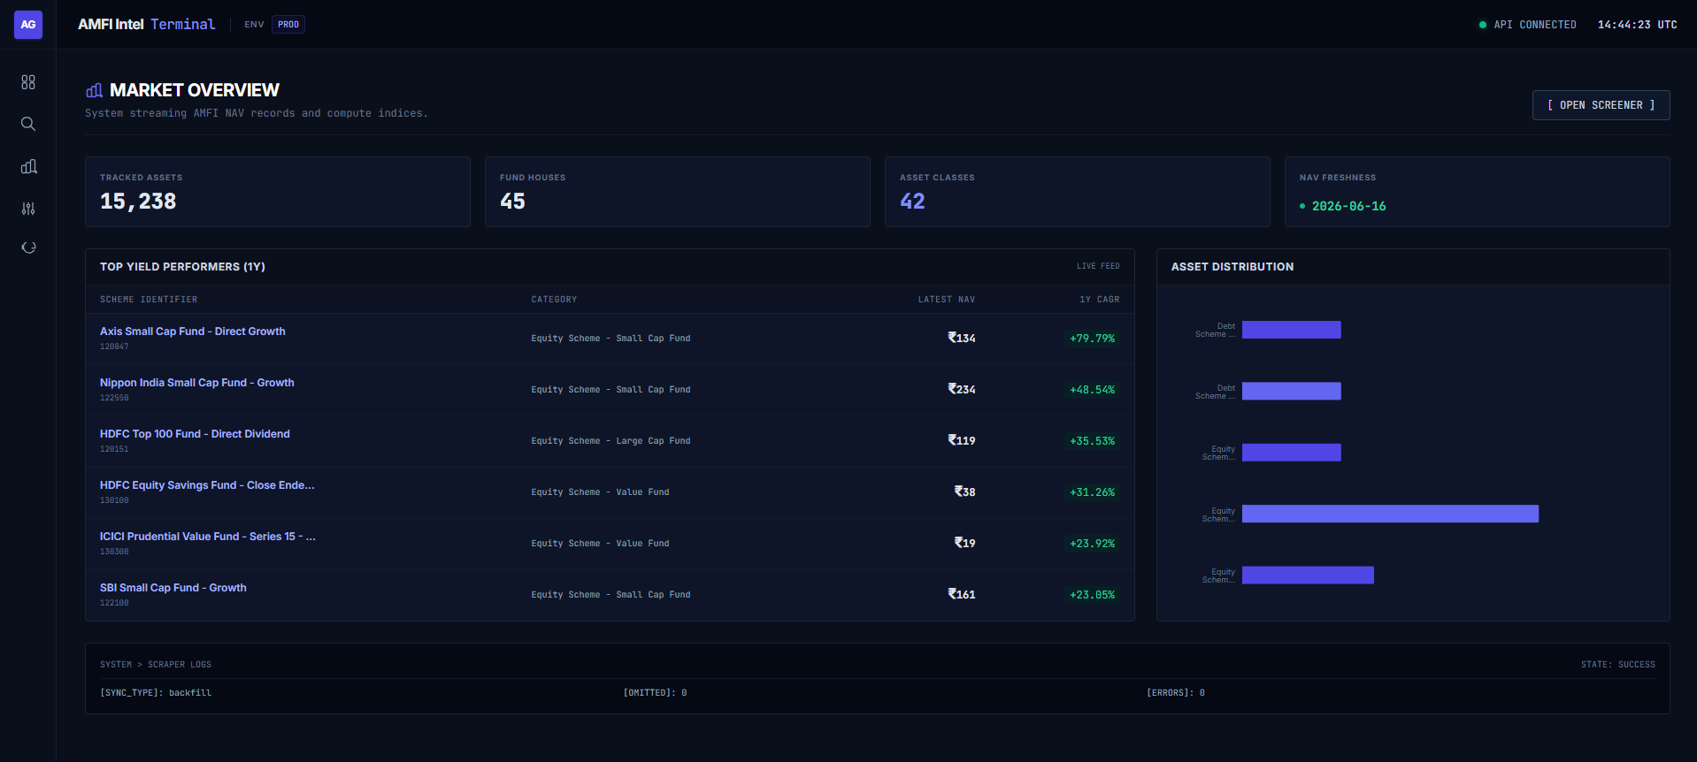

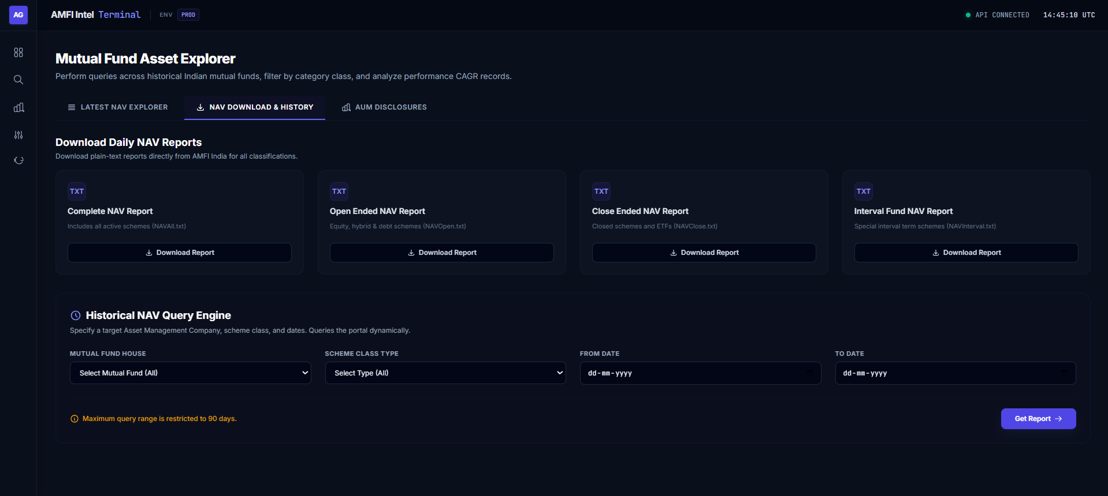
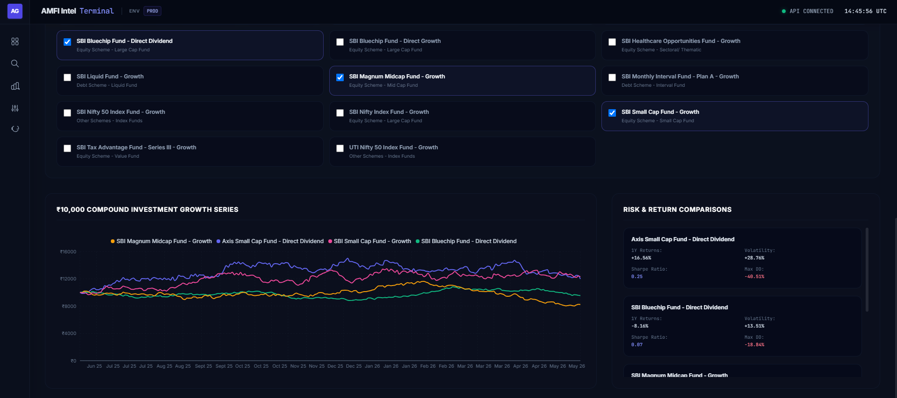
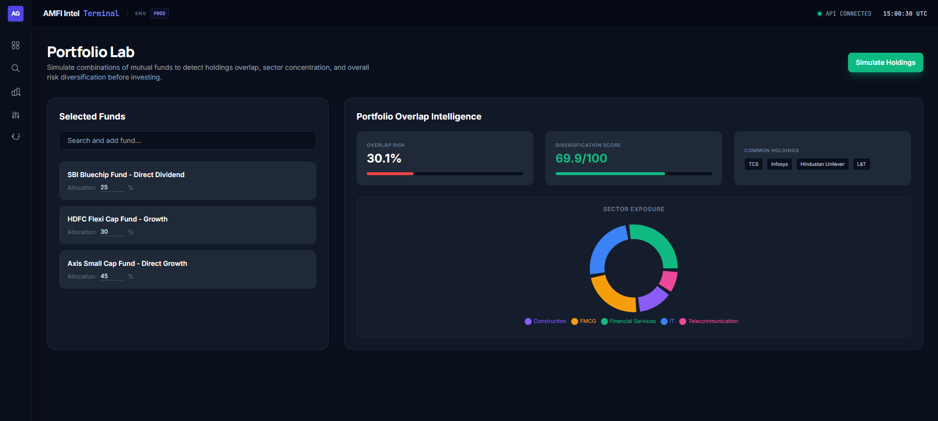

Problem Statement
The Indian mutual fund ecosystem comprises thousands of schemes across multiple Asset Management Companies (AMCs), categories, and investment strategies. Although data is publicly available through AMFI, AMC websites, and financial research portals, it remains fragmented and difficult to analyze efficiently. Investors often spend significant time gathering information from multiple sources, resulting in inconsistent research processes and limited visibility into fund performance, risk, and market trends.
Additionally, most platforms focus on displaying current fund data while offering limited historical analysis, portfolio intelligence, and reporting capabilities. Investors struggle to evaluate long-term performance, compare funds across key metrics, identify portfolio overlaps, and assess diversification risks. The absence of integrated analytics and research tools makes informed investment decision-making both complex and time-consuming.

Project Vision
The vision of AMFIIntel Terminal is to create a comprehensive Mutual Fund Intelligence Platform that transforms fragmented financial data into meaningful, actionable investment insights. The platform aims to bridge the gap between raw mutual fund information and informed decision-making by providing investors, analysts, and researchers with a centralized ecosystem for fund discovery, performance evaluation, risk assessment, and portfolio analysis.
To achieve this vision, the platform focuses on:
- Automated Data Intelligence through continuous synchronization and processing of AMFI mutual fund datasets.
- Historical Data Warehousing for maintaining and analyzing long-term NAV records, fund metadata, and market trends.
- Advanced Financial Analytics including CAGR, rolling returns, volatility metrics, risk scores, Sharpe ratios, and performance benchmarking.
- Portfolio Intelligence & Risk Assessment through holdings overlap detection, diversification analysis, concentration risk evaluation, and sector exposure insights.
- Professional Reporting & Data Accessibility through automated generation of CSV, Excel, and PDF reports for research, analysis, and decision support.
Ultimately, AMFIIntel Terminal aspires to evolve beyond a traditional mutual fund dashboard into a scalable fintech intelligence platform that empowers users to conduct comprehensive investment research, uncover portfolio risks, and make informed financial decisions with confidence.

System Architecture
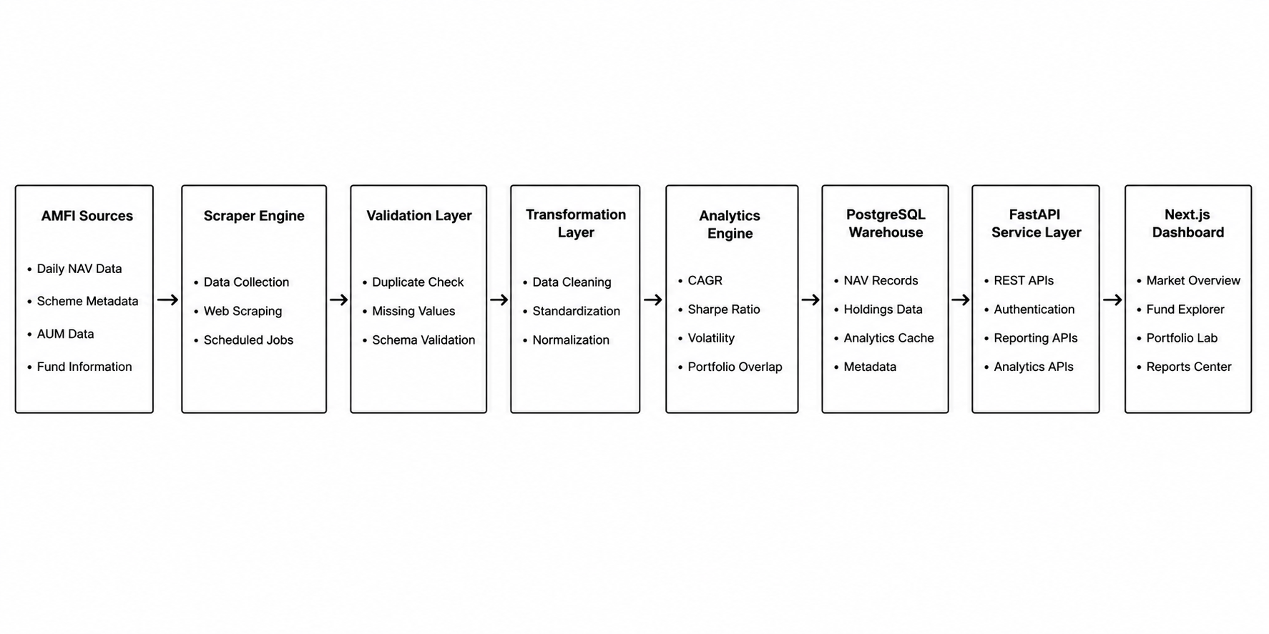

Technology Stack
Frontend
Next.js
Used for:
- Server-side rendering
- Routing
TypeScript
Provides:
- Type safety
Tailwind CSS
Used for:
- Consistent styling
- Rapid UI development
ShadCN UI
Provides:
- Accessible interfaces
- Enterprise design system
Recharts
Used for:
- NAV visualizations
- Performance analytics
Backend
FastAPI
Acts as the central API gateway.
Responsible for:
- Authentication
- Fund APIs
- Analytics APIs
- Reporting APIs
- Portfolio APIs

SQLAlchemy
Used as ORM layer.
Provides:
- Database abstraction
- Query optimization
- Relationship management

APScheduler
Handles:
- Daily synchronization jobs
- Historical backfills
- Automated refreshes

Database Layer
PostgreSQL
Used as the primary data warehouse.
Stores:
Fund Metadata
- AMC Information
- Scheme Information
- Categories
- Benchmarks
Historical NAV Records
Daily NAV history for all schemes.
Asset Allocation
Fund allocation across:
- Equity
- Debt
- Cash
- Gold
Holdings Repository
Stores:
- Company Holdings
- Sector Data
- Allocation Percentages
Analytics Cache
Stores:
- Rankings
- CAGR Metrics
- Risk Scores
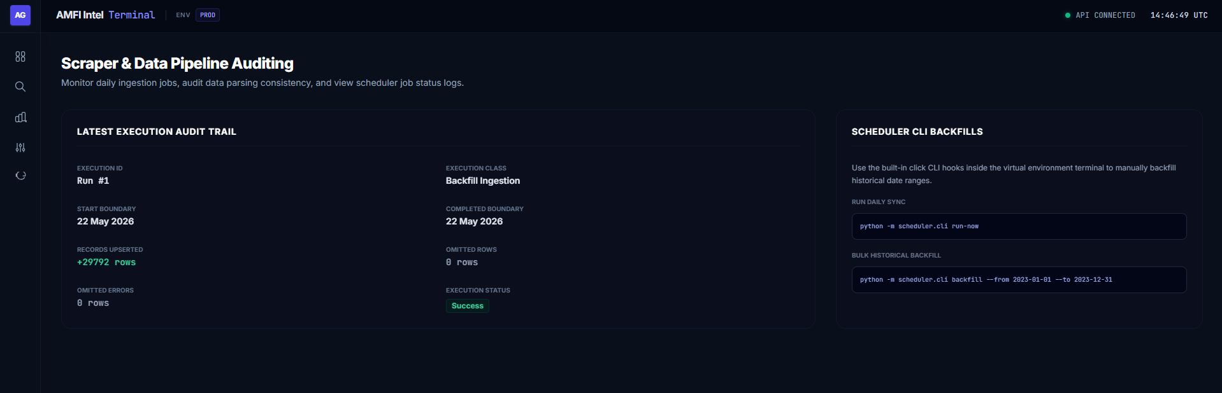

Data Engineering Pipeline
Step 1 — Data Extraction
The scraper collects:
- Scheme metadata
- Daily NAV records
- Historical NAV datasets
- AUM disclosures

Step 2 — Validation
The system validates:
- Missing values
- Invalid records
- Duplicate entries
before processing.

Step 3 — Transformation
Raw AMFI data is normalized into a structured format.
This includes:
- Date standardization
- Category mapping
- Numeric formatting

Step 4 — Analytics Generation
The analytics engine computes:
CAGR
Measures long-term annualized growth.
Rolling Returns
Evaluates consistency over time.
Volatility
Measures return fluctuations.
Sharpe Ratio
Evaluates risk-adjusted performance.
Drawdown
Measures downside exposure.

Step 5 — Database Synchronization
Validated records are inserted into PostgreSQL using optimized bulk operations.

Dashboard Modules

Module 1 — Market Overview
Provides a real-time snapshot of the mutual fund ecosystem.
Displays:
- Tracked Assets
- Fund Houses
- Asset Classes
- NAV Freshness
- Top Yield Performers
Purpose:
Enable users to quickly understand current market conditions.

Module 2 — Mutual Fund Asset Explorer
Core research workspace.
Supports:
- Fund Discovery
- Search
- Filtering
- Category Analysis
- Risk Evaluation
Users can explore thousands of mutual funds through a structured interface.

Module 3 — NAV Query Engine
Provides direct access to historical NAV records.
Supports:
- Date Range Queries
- AMC Filters
- Category Filters
Enables detailed historical analysis.

Module 4 — AUM Intelligence Dashboard
Analyzes Assets Under Management across:
- Fund Categories
- Fund Houses
- Direct vs Regular Plans
Provides market-wide capital allocation insights.

Module 5 — Fund Comparison Engine
Allows users to compare multiple funds simultaneously.
Comparison Metrics:
- CAGR
- NAV Growth
- Volatility
- Sharpe Ratio
- Drawdown
Provides side-by-side investment evaluation.

Module 6 — Portfolio Lab
One of the flagship features.
Users can simulate mutual fund combinations.
The system computes:
Overlap Risk
Detects common holdings.
Diversification Score
Measures portfolio diversity.
Sector Exposure
Analyzes allocation concentration.
Concentration Risk
Identifies hidden portfolio vulnerabilities.

Module 7 — Pipeline Auditing Console
Provides transparency into data ingestion operations.
Tracks:
- Scheduler Jobs
- Backfills
- Records Processed
- Errors
- Execution Logs
This module improves operational reliability and monitoring.

Reporting Engine
The reporting system generates:
CSV Exports
Raw analytical datasets.
Excel Reports
Structured spreadsheet reports.
PDF Reports
Investor-grade research documents.
Supported Reports:
- Fund Reports
- Portfolio Reports
- Comparison Reports
- Historical Trend Reports

Security & Authentication
Implemented using:
JWT Authentication
Provides secure API access.
Password Hashing
Protects user credentials.
Role-Based Access
Supports:
- Admin
- Analyst
- Investor
roles.

Key Achievements
- Automated collection of AMFI mutual fund data.
- Built a complete financial data engineering pipeline.
- Designed a scalable PostgreSQL analytical warehouse.
- Developed a FastAPI-based service architecture.
- Implemented portfolio overlap intelligence.
- Created a Bloomberg-inspired fintech dashboard.
- Developed professional reporting capabilities.
- Enabled historical research and comparative analytics.

Conclusion
AMFIIntel Terminal transforms publicly available mutual fund information into a comprehensive investment intelligence ecosystem. By integrating automated data engineering, financial analytics, portfolio intelligence, historical research capabilities, and modern visualization technologies, the platform provides investors and analysts with a powerful environment for conducting data-driven mutual fund research and portfolio evaluation.
The project demonstrates expertise in full-stack development, data engineering, backend architecture, financial analytics, database design, system automation, and modern dashboard engineering, making it a production-grade fintech application rather than a conventional academic project.

