Internship Report
Of
Junior Data Analyst – Digital Marketing & Advertising Internship at YuvaIntern
Submitted
To
School of Computer Science and Engineering
IILM University, Greater Noida, U.P.
In partial fulfilment of the requirement of degree of
B.Tech CSE

By
Roll Number of Student: 2410030342
Name of Student: ARYAN JHA
Batch: 2024–2028
2026-27

CANDIDATE'S DECLARATION
I, Aryan Jha, do hereby declare that the internship report titled “Junior Data Analyst – Digital Marketing & Advertising Internship at YuvaIntern” has been completed by me to fulfil the requirement for the award of the degree of Bachelor of Technology in CSE. All the references have been quoted and I have not taken as such any material from any other source. I affirm to you that this report is my own and has not been submitted to any other institute for any degree/diploma requirement and further I shall be solely responsible for any kind of copyright violation in this regard.

Signature
Student Name: Aryan Jha
Roll No.: 2410030342

ACKNOWLEDGEMENT
I am using this opportunity to express my gratitude to everyone who supported me throughout the Internship Program. I am thankful for their aspiring guidance, invaluably constructive criticism and friendly advice during this work. I am sincerely grateful to them for sharing their truthful and illuminating views on a number of issues related to this work.
I would like to thank YuvaIntern and its Founder, Mr. Kounal Gupta, for giving me the opportunity to work as a Junior Data Analyst – Digital Marketing & Advertising intern and for the mentorship and learning resources provided throughout the six-week program. I would also like to thank the faculty of the School of Computer Science and Engineering, IILM University, for their continuous support and encouragement.
I express my gratitude to my parents for their blessings.

Signature
Student Name: Aryan Jha
Roll No.: 2410030342

INTERNSHIP COMPLETION CERTIFICATE
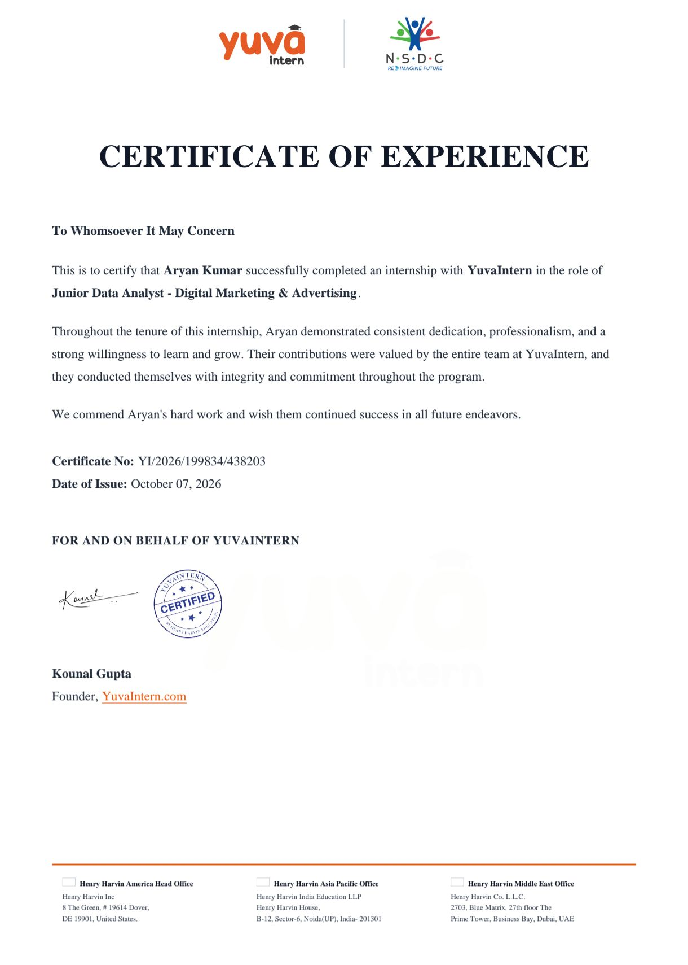

TABLE OF CONTENTS
Chapter No. | Chapter Name | Page Nos.
 | Cover Page | ---
1. | Candidate's Declaration | i
2. | Acknowledgment | ii
3. | Internship Completion Certificate | iii
4. | Project Description | 1
 | 4.1 Introduction
 | 4.2 Organization Profile
 | 4.3 Problem Statement
 | 4.4 Project Objectives
 | 4.5 Scope of the Project
 | 4.6 Technologies and Tools Used
 | 4.7 System Architecture
 | 4.8 Methodology
 | 4.9 Expected Outcomes
 | 4.10 Certificates of Completion and Communication Proof
5. | Bibliography/References

Chapter 4: Project Description
4.1 Introduction
This report presents the work carried out during my six-week internship as a Junior Data Analyst – Digital Marketing & Advertising with YuvaIntern, an internship and skill-development platform affiliated with the National Skill Development Corporation (NSDC), from August 26, 2026 to October 07, 2026. The internship was carried out remotely and focused on analysing digital marketing and advertising data to generate insights and recommendations that support data-driven decision-making for online campaigns.
As a B.Tech Computer Science student, this internship gave me the opportunity to apply my academic knowledge of data analysis and data-driven problem solving to a real-world digital marketing context, while also strengthening my understanding of how marketing analytics supports business decisions.
4.2 Organization Profile
YuvaIntern is an internship and career-readiness platform that connects students with practical, project-based internship opportunities across domains such as data analytics, digital marketing, web development, and business operations. Operating in partnership with the National Skill Development Corporation (NSDC), YuvaIntern focuses on providing hands-on, skills-based learning experiences to help students bridge the gap between academic learning and industry requirements. The platform is led by its Founder, Mr. Kounal Gupta, and issues verified internship offer letters and completion certificates to interns upon successful completion of their assigned projects.
4.3 Problem Statement
Digital marketing campaigns generate large volumes of data across multiple channels — including paid advertising platforms, social media, and website analytics — but this data is often scattered and difficult to interpret without a structured analytical approach. Organizations running digital campaigns need a way to consolidate this data, track key performance indicators, and translate raw numbers into actionable insights that improve campaign performance, audience engagement, and return on investment (ROI).
4.4 Project Objectives
- To understand the key metrics used to evaluate digital marketing and advertising campaigns.
- To collect, organize, and clean marketing data from various campaign sources.
- To analyse campaign performance, audience engagement, and ROI using appropriate analytical tools.
- To generate clear, data-backed insights and recommendations for improving campaign outcomes.
- To present findings through concise reports and dashboards for stakeholders.
4.5 Scope of the Project
The scope of the internship was limited to analysing digital marketing and advertising data made available through the internship program, including campaign performance metrics, audience engagement statistics, and ROI-related figures. The project covered data collection, cleaning, analysis, and reporting, but did not extend to the design or execution of live advertising campaigns, which remained the responsibility of the organization's marketing team.
4.6 Technologies and Tools Used
- Microsoft Excel / Google Sheets – for data organization, cleaning, and calculations
- Google Analytics – for website traffic and audience engagement analysis
- Meta Ads Manager and Google Ads – for tracking paid campaign performance
- Google Data Studio / Looker Studio – for building visual performance dashboards
- Python (Pandas, Matplotlib) – for deeper data analysis and visualization where required
4.7 System Architecture
The overall workflow followed a simple data pipeline: data was first collected from various digital marketing sources (ad platforms, website analytics, and social media insights); this raw data was then cleaned and consolidated into structured spreadsheets; the cleaned data was analysed to identify trends in campaign performance, audience engagement, and ROI; and finally, the insights were compiled into dashboards and summary reports for review. Each stage fed into the next, ensuring that the final recommendations were grounded in accurate, well-organized data.
4.8 Methodology
- Data Collection: Gathering campaign data from digital marketing and advertising platforms.
- Data Cleaning: Removing duplicates, correcting inconsistencies, and structuring the data for analysis.
- Data Analysis: Applying descriptive statistics and trend analysis to measure campaign performance, audience engagement, and ROI.
- Visualization: Creating charts and dashboards to make findings easier to interpret.
- Reporting: Summarizing insights and recommendations in a clear, actionable format.
4.9 Expected Outcomes
By the end of the internship, the expected outcomes included a clearer understanding of how digital marketing campaigns are measured and optimized, a set of organized datasets and dashboards summarizing campaign performance, and practical recommendations for improving audience engagement and ROI. On a personal level, the internship strengthened my data analysis skills, familiarity with marketing analytics tools, and ability to translate raw data into meaningful, actionable insights.
4.10 Certificates of Completion and Other Communication Proof
The Internship Offer Letter and the Certificate of Experience issued by YuvaIntern are attached below as proof of the internship undertaken and successfully completed.
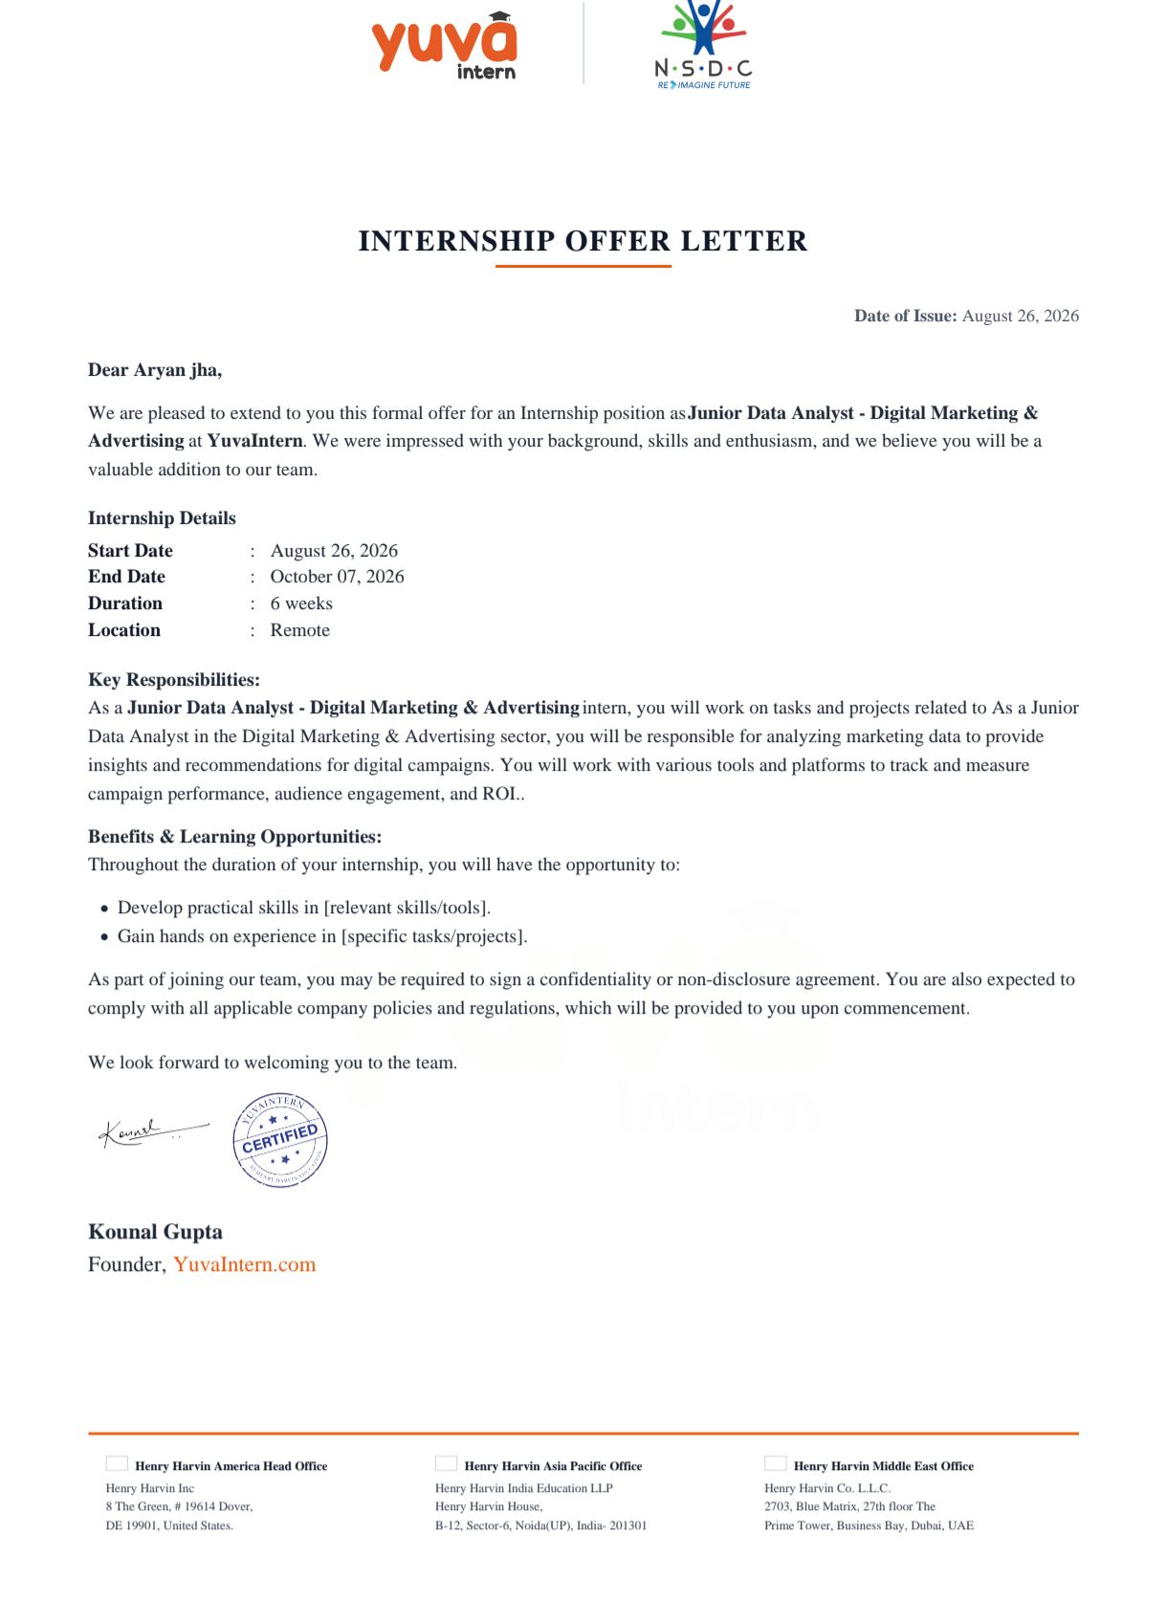

Chapter 5: Bibliography/References
1. YuvaIntern. Internship Offer Letter and Certificate of Experience, YuvaIntern.com, 2026.
2. Google Analytics Help Center. Google. Retrieved 2026, from https://support.google.com/analytics
3. Meta Business Help Center. Meta Platforms, Inc. Retrieved 2026, from https://www.facebook.com/business/help
4. Google Ads Help Center. Google. Retrieved 2026, from https://support.google.com/google-ads
5. Looker Studio Help Center. Google. Retrieved 2026, from https://support.google.com/looker-studio

