Subject-Independent EEG Mental-Workload Classification on STEW
Baselines · artifact analysis · augmentation · proposed artifact-robust training (ACCT)
Table 1. Key numbers at a glance.
Result | Value
Best baseline (Spectral + LR), balanced accuracy | 0.829 [0.796, 0.861]
Best deep baseline (ATCNet) | 0.803 ± 0.010
Best model without F7/F8/T7/T8 (ATCNet) | 0.783
Largest augmentation gain (EEG Conformer, 12 subjects, CWGAN-GP) | +8.2 points
ACCT vs. standard training, EEGNet (validation subjects) | 0.807 vs. 0.768 (+3.8, p_Holm = 0.035)
Prediction flips under injected artifacts ×3 | 24.5% → 7.0%
Calibration error (ECE) | 0.064 → 0.030

1. Data and protocol
Item | Setting
Dataset | STEW: 48 subjects, Emotiv EPOC, 14 channels, 128 Hz; rest vs. SIMKAP multitasking, 150 s each
Channels | AF3 F7 F3 FC5 T7 P7 O1 O2 P8 T8 FC6 F4 F8 AF4
Filtering | 0.5–45 Hz, 4th-order Butterworth, zero-phase
Windows | 4 s (512 samples), 50% overlap
Artifact rejection | Peak-to-peak > median + 60 × MAD, per subject, class-agnostic
Normalisation | z-score per window and channel (no per-recording normalisation: would leak the label)
Split | 10-fold cross-validation by subject; each subject tested once; 5 seeds
Validation | 15% of training subjects (subject-disjoint), early stopping only
Deep training | AdamW, lr 1e-3, batch 64, cosine schedule + warm-up, ≤ 100 epochs, same recipe for all
Metrics | Balanced accuracy (primary), accuracy, macro-F1, κ, MCC, ROC-AUC, PR-AUC, sensitivity, specificity, Brier, log-loss, ECE; window and recording level
Statistics | Subject-cluster bootstrap 95% CI; Friedman + Nemenyi; Wilcoxon signed-rank + Holm
Hardware | NVIDIA RTX A4000 16 GB, NGC PyTorch 26.07 container

2. Baseline benchmark (25 models)
Table 2. Subject-independent results, mean ± SD over 5 seeds. † uses unlabelled test-subject data (transductive).
Model | Family | BAcc | 95% CI | AUC | κ | ECE | Rec. Acc
Spectral + LR | Feature-based | 0.829 | [0.796, 0.861] | 0.904 | 0.658 | 0.022 | 0.938
Spectral + SVM (RBF) | Feature-based | 0.829 | [0.791, 0.865] | 0.903 | 0.657 | 0.018 | 0.906
Spectral + sLDA | Feature-based | 0.827 | [0.795, 0.858] | 0.905 | 0.655 | 0.061 | 0.958
Riemann re-centred TS + LR † | Riemannian | 0.825 | [0.778, 0.865] | 0.895 | 0.650 | 0.029 | 0.979
Spectral + RF | Feature-based | 0.821 ± 0.002 | [0.786, 0.854] | 0.897 | 0.641 | 0.097 | 0.927
Spectral + GBDT | Feature-based | 0.805 | [0.769, 0.840] | 0.893 | 0.609 | 0.037 | 0.917
ATCNet | EEG transformer | 0.803 ± 0.010 | [0.764, 0.841] | 0.882 | 0.605 | 0.062 | 0.898
EEGNet-8,2 | EEG CNN | 0.801 ± 0.014 | [0.763, 0.839] | 0.872 | 0.602 | 0.044 | 0.900
EEG-TCNet | EEG CNN | 0.797 ± 0.004 | [0.757, 0.836] | 0.877 | 0.594 | 0.054 | 0.879
Riemann TS + LR | Riemannian | 0.795 | [0.757, 0.831] | 0.875 | 0.590 | 0.040 | 0.885
TSception | EEG CNN | 0.794 ± 0.006 | [0.756, 0.830] | 0.877 | 0.587 | 0.030 | 0.885
ShallowConvNet | EEG CNN | 0.785 ± 0.012 | [0.750, 0.819] | 0.860 | 0.570 | 0.057 | 0.871
1D-CNN | Generic CNN | 0.784 ± 0.004 | [0.747, 0.819] | 0.855 | 0.567 | 0.049 | 0.875
EEG Conformer | EEG transformer | 0.778 ± 0.005 | [0.739, 0.815] | 0.858 | 0.553 | 0.135 | 0.873
CNN-LSTM | Generic CNN | 0.776 ± 0.012 | [0.742, 0.811] | 0.831 | 0.552 | 0.071 | 0.873
GRU | Recurrent | 0.766 ± 0.005 | [0.730, 0.801] | 0.830 | 0.531 | 0.057 | 0.854
BiLSTM | Recurrent | 0.765 ± 0.005 | [0.731, 0.798] | 0.827 | 0.529 | 0.045 | 0.871
LSTM | Recurrent | 0.763 ± 0.014 | [0.732, 0.792] | 0.824 | 0.525 | 0.035 | 0.902
DGCNN | Graph | 0.761 ± 0.010 | [0.725, 0.796] | 0.832 | 0.522 | 0.047 | 0.885
Swin (STFT) | Vision transformer | 0.740 ± 0.013 | [0.706, 0.774] | 0.817 | 0.480 | 0.082 | 0.844
ViT (STFT) | Vision transformer | 0.734 ± 0.008 | [0.699, 0.768] | 0.805 | 0.468 | 0.066 | 0.827
Electrode GCN | Graph | 0.724 ± 0.009 | [0.685, 0.762] | 0.799 | 0.446 | 0.034 | 0.819
Riemann MDM | Riemannian | 0.713 | [0.665, 0.762] | 0.783 | 0.426 | 0.191 | 0.729
Vanilla RNN | Recurrent | 0.703 ± 0.009 | [0.677, 0.730] | 0.753 | 0.407 | 0.034 | 0.867
DeepConvNet | EEG CNN | 0.633 ± 0.087 | [0.591, 0.678] | 0.769 | 0.268 | 0.216 | 0.656
Classical models are deterministic given the folds (SD = 0), except RF. Rec. Acc = accuracy after averaging each 150 s recording.
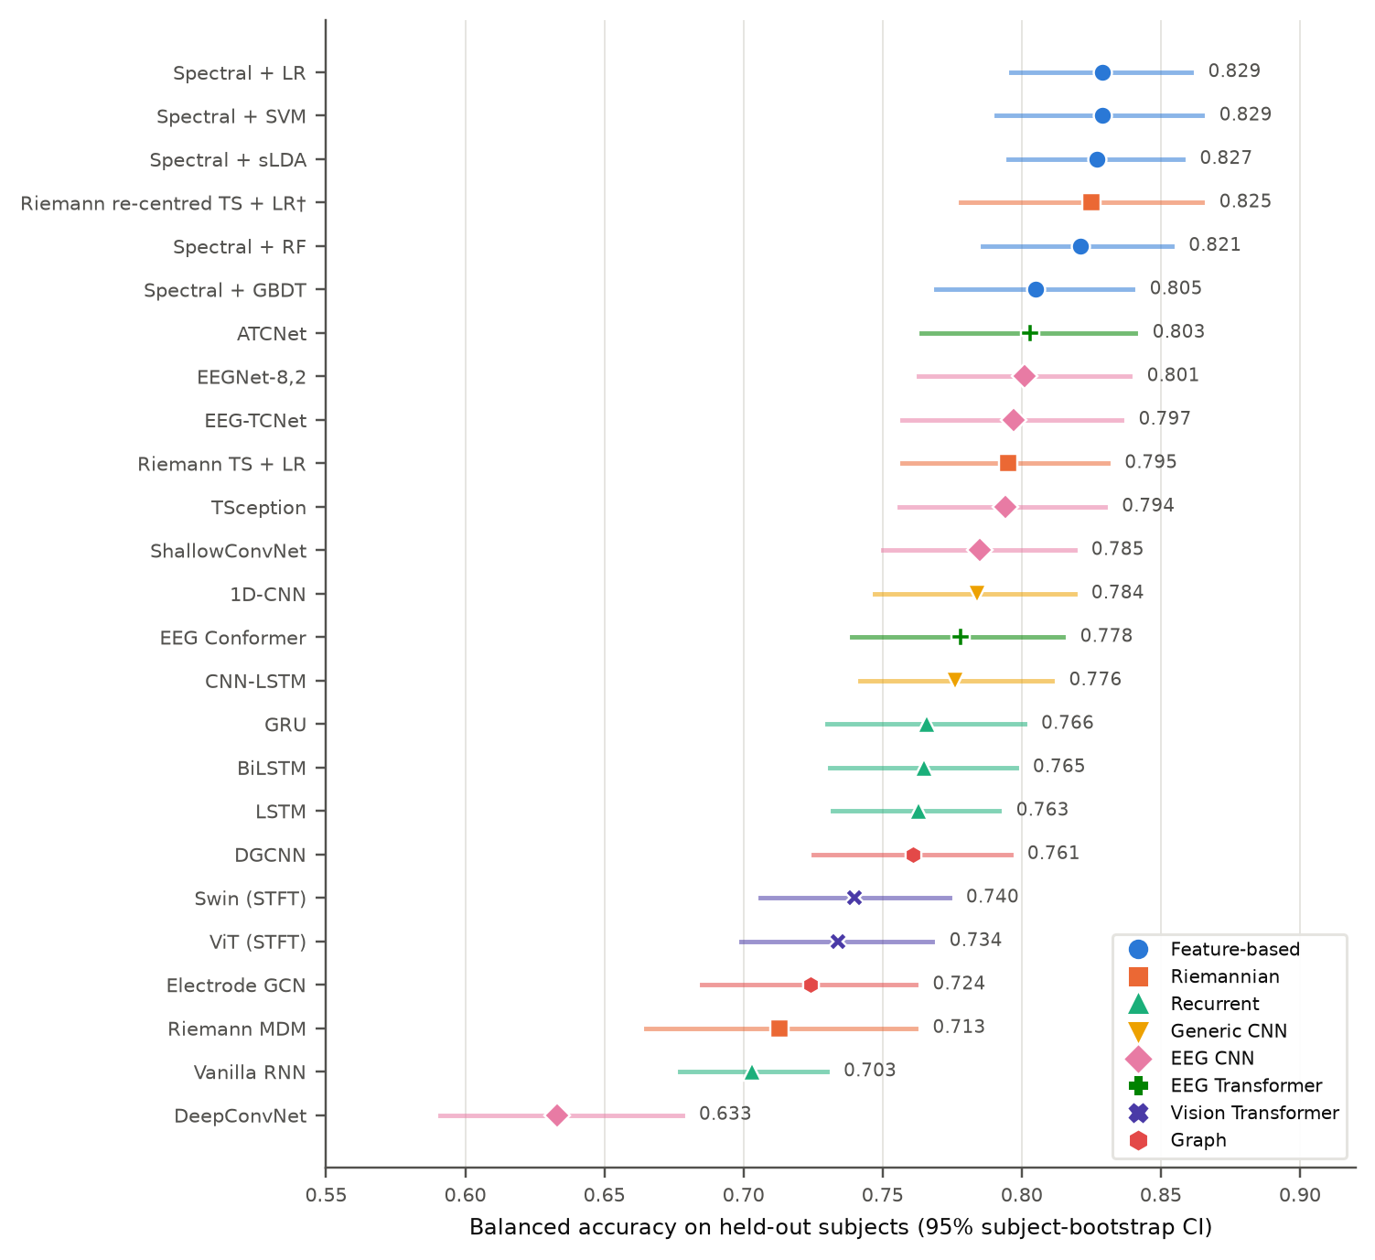
Figure 1. Balanced accuracy with 95% subject-bootstrap CIs, by model family.
- Friedman: χ² = 283.0, p = 4.3 × 10⁻⁴⁶; Nemenyi CD = 5.50 ranks.
- Wilcoxon vs. best (Holm): significantly worse only for MDM, vanilla RNN, LSTM, DeepConvNet, ViT, Swin, electrode GCN, DGCNN; top EEG CNNs and ATCNet not significantly different.
- Overfitting: several deep models peak at validation epoch 1–3 (ShallowConvNet, 1D-CNN, ViT, TSception).
- Calibration: feature models ECE ≈ 0.02; EEG Conformer over-confident (0.135); DeepConvNet unstable across seeds.
Table 3. Model cost (one 4 s window; GPU latency at batch size 1).
Model | Parameters | MFLOPs | GPU latency (ms) | Train time / fold (s)
EEGNet-8,2 | 1,842 | 7.7 | 0.23 | 10.3
EEG-TCNet | 3,814 | 2.2 | 0.46 | 11.5
TSception | 7,838 | 24.2 | 0.29 | 18.1
ShallowConvNet | 27,682 | 29.7 | 0.10 | 6.8
ATCNet | 112,650 | 11.8 | 2.01 | 22.8
BiLSTM | 140,546 | 141.6 | 1.29 | 23.2
EEG Conformer | 745,506 | 44.4 | 0.89 | 19.2

3. Task vs. rest band power
Table 4. Largest task − rest differences in log band power (paired t, n = 48, BH-FDR over 70 tests).
Channel | Band | t | d_z | q (FDR)
F8 | theta | +8.61 | +1.24 | 2.2 × 10⁻⁹
FC6 | theta | +6.68 | +0.96 | 8.8 × 10⁻⁷
F8 | delta | +5.87 | +0.85 | 9.9 × 10⁻⁶
F8 | gamma | +5.78 | +0.83 | 1.0 × 10⁻⁵
T8 | theta | +5.59 | +0.81 | 1.3 × 10⁻⁵
AF4 | theta | +3.93 | +0.57 | 1.5 × 10⁻³
P8 | alpha | −3.02 | −0.44 | 0.016
O2 | alpha | −2.88 | −0.42 | 0.021
- Expected workload pattern: frontal theta ↑, posterior alpha ↓.
- Artifact sign: F7, F8, T8 rise in every band (delta–gamma), typical of eye/muscle activity.

4. Artifact ablation
Table 5. Balanced accuracy when artifact-prone information is removed (3 seeds, same folds).
Model | All channels | No gamma | No F7/F8/T7/T8 | Both removed | Δ channels
Spectral + SVM | 0.829 | 0.825 | 0.778 | 0.785 | −5.1
Spectral + LR | 0.829 | 0.824 | 0.777 | 0.776 | −5.2
Spectral + sLDA | 0.827 | 0.819 | 0.770 | 0.769 | −5.7
Riemann TS + LR | 0.795 | 0.799 | 0.776 | 0.777 | −1.9
ATCNet | 0.803 | 0.797 | 0.783 | 0.777 | −2.0
EEGNet-8,2 | 0.801 | 0.795 | 0.780 | 0.770 | −2.1
EEG-TCNet | 0.797 | 0.789 | 0.775 | 0.769 | −2.2
TSception | 0.794 | 0.805 | 0.780 | 0.770 | −1.4
ShallowConvNet | 0.785 | 0.786 | 0.768 | 0.759 | −1.7
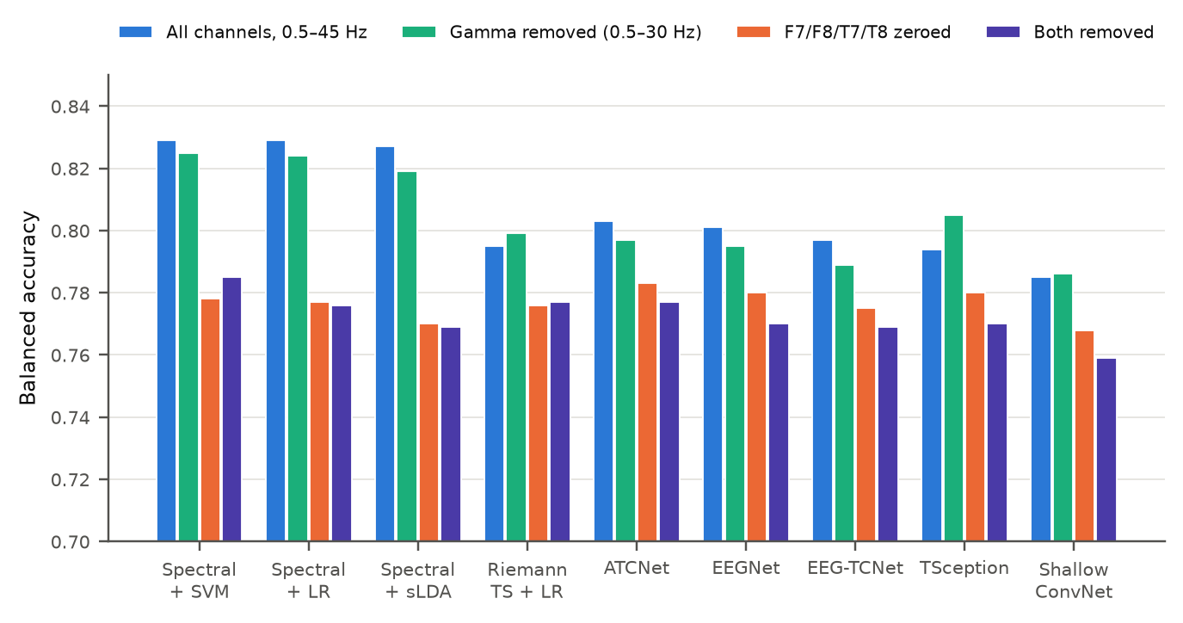
Figure 2. Effect of removing gamma and the eye-adjacent channels.
- Gamma: ≤ 1 point change → muscle activity is not the main factor.
- F7/F8/T7/T8: spectral models lose 5–6 points, deep models 1.4–2.2; ranking flips to deep models (ATCNet 0.783).
- Still ~0.78 without them: most of the decodable signal is neural.

5. Augmentation: standard vs. GAN vs. diffusion
8 online augmentations, CWGAN-GP and conditional DDPM; generators trained inside each fold on training subjects only; 3 seeds.
Table 6. All training subjects. Δ = paired change vs. none (* Holm p < 0.05).
Augmentation | EEG Conformer | EEGNet-8,2 | ShallowConvNet
None | 0.776 | 0.801 | 0.794
Channel dropout | 0.801 (+0.027*) | 0.807 (+0.007) | 0.810 (+0.017)
Mixup | 0.798 (+0.023*) | 0.795 (−0.006) | 0.797 (+0.004)
Gaussian noise | 0.792 (+0.017*) | 0.801 (+0.001) | 0.793 (−0.000)
CWGAN-GP, 50% extra | 0.787 (+0.012) | 0.778 (−0.021*) | 0.779 (−0.015)
CWGAN-GP, 100% extra | 0.782 (+0.008) | 0.768 (−0.033*) | 0.769 (−0.025*)
DDPM, 50% extra | 0.770 (−0.004) | 0.804 (+0.004) | 0.793 (+0.000)
DDPM, 100% extra | 0.780 (+0.005) | 0.790 (−0.010) | 0.799 (+0.007)
Table 7. Balanced accuracy by number of training subjects per fold (6 / 12 / 24 / all).
Augmentation | EEG Conformer | EEGNet-8,2 | ShallowConvNet
None | .632 / .668 / .773 / .776 | .712 / .742 / .775 / .801 | .733 / .743 / .774 / .794
CWGAN-GP 100% | .661 / .752 / .764 / .782 | .710 / .727 / .738 / .768 | .735 / .756 / .777 / .769
DDPM 100% | .641 / .733 / .773 / .780 | .703 / .727 / .763 / .790 | .726 / .772 / .780 / .799
Mixup | .679 / .698 / .780 / .798 | .707 / .727 / .770 / .795 | .710 / .746 / .775 / .797
Channel dropout | .657 / .674 / .778 / .801 | .717 / .745 / .780 / .807 | .745 / .752 / .788 / .810
Frequency shift | .698 / .686 / .762 / .789 | .732 / .745 / .773 / .800 | .714 / .738 / .772 / .788
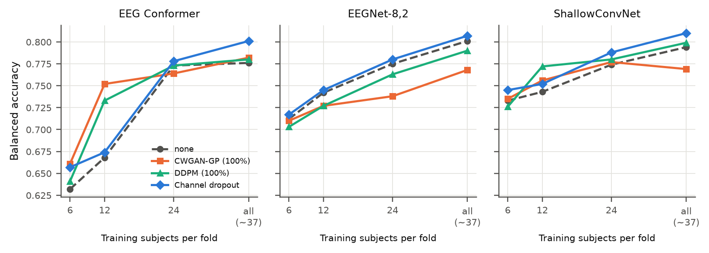
Figure 3. Accuracy vs. training subjects per fold.
Table 8. Synthetic-data quality (mean over folds, seeds, classes). TSTR = train synthetic, test real; TRTR = real → real.
Subjects | Generator | LSD (dB) | MMD | Density | Coverage | Memor. | TSTR | TRTR
6 | CWGAN-GP | 2.79 | 0.074 | 0.648 | 0.325 | 0.981 | 0.603 | 0.690
6 | DDPM | 3.92 | 0.321 | 0.446 | 0.138 | 0.989 | 0.647 | 0.690
12 | CWGAN-GP | 2.71 | 0.046 | 0.732 | 0.365 | 0.952 | 0.582 | 0.713
12 | DDPM | 3.65 | 0.141 | 1.081 | 0.367 | 0.931 | 0.688 | 0.713
24 | CWGAN-GP | 2.85 | 0.037 | 1.068 | 0.488 | 0.935 | 0.599 | 0.747
24 | DDPM | 4.67 | 0.211 | 0.985 | 0.403 | 0.915 | 0.709 | 0.747
all | CWGAN-GP | 2.55 | 0.034 | 1.278 | 0.572 | 0.941 | 0.600 | 0.760
all | DDPM | 5.12 | 0.246 | 0.997 | 0.453 | 0.907 | 0.707 | 0.760
- Few subjects (12): synthetic data helps the transformer: Conformer +8.2 (CWGAN), +6.4 (DDPM); ShallowConvNet + DDPM +3.0.
- All subjects: CWGAN hurts EEGNet (−3.3) and ShallowConvNet (−2.5); DDPM neutral; channel dropout most consistent.
- Fidelity ≠ usefulness: CWGAN matches spectra better (lower LSD/MMD) but carries less class information (TSTR 0.60 vs. 0.71).

6. Proposed method: ACCT
Artifact-counterfactual consistency training: the classifier is trained to give the same prediction for a window and for a copy with eye/muscle artifacts added or removed. No extra sensor (EOG) needed; inference is unchanged.
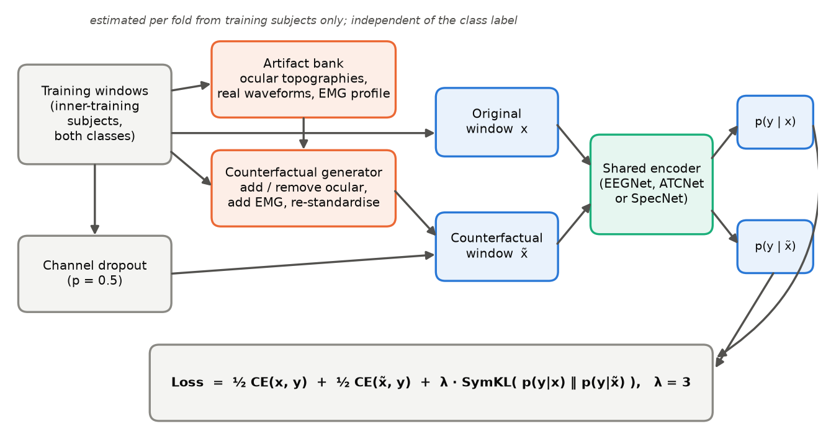
Figure 4. ACCT training scheme.
Table 9. Components.
Component | What it does
Artifact bank | Per fold, training subjects only, both classes pooled. Ocular: frontal-dominant principal components of < 4 Hz activity + bank of real waveforms. EMG: channel profile of excess 20–45 Hz power.
Counterfactual generator | Per window, label-independent: add ocular (p = 0.5), remove ocular subspace (p = 0.3), add EMG bursts (p = 0.5); re-z-scored.
Consistency loss | L = ½ CE(x, y) + ½ CE(x̃, y) + λ · ½ [KL(p(x)‖p(x̃)) + KL(p(x̃)‖p(x))], λ = 3
Channel dropout | Whole channels zeroed at random during training.
Encoder | Any network. EEGNet for development; ATCNet, TSception, EEG-TCNet and SpecNet (differentiable spectral model, ~7k parameters) in round 3.
Table 10. Development results, EEGNet, validation subjects only (3 seeds). CD = channel dropout.
Training | Clean BAcc | AUC | ECE | BAcc F7/F8/T7/T8 = 0 | BAcc high-ocular | Natural gap
Standard (ERM) | 0.768 ± 0.007 | 0.836 | 0.064 | 0.630 | 0.698 | +0.107
Channel dropout | 0.778 ± 0.020 | 0.849 | 0.058 | 0.683 | 0.710 | +0.105
Counterfactuals only | 0.768 ± 0.007 | 0.839 | 0.061 | 0.635 | — | —
ACCT λ = 1 | 0.780 ± 0.012 | 0.854 | 0.056 | 0.663 | 0.716 | +0.099
ACCT λ = 3 | 0.790 ± 0.011 | 0.860 | 0.046 | 0.673 | 0.726 | +0.099
ACCT + CD λ = 1 | 0.792 ± 0.002 | 0.871 | 0.032 | 0.711 | 0.718 | +0.120
ACCT + CD λ = 3 | 0.807 ± 0.008 | 0.880 | 0.030 | 0.710 | 0.730 | +0.117
Table 11. Injected-artifact stress test: balanced accuracy / predictions flipped.
Training | Strength ×1 | Strength ×2 | Strength ×3
Standard (ERM) | 0.752 / 7.6% | 0.707 / 17.5% | 0.667 / 24.5%
Channel dropout | 0.771 / 4.8% | 0.748 / 11.0% | 0.723 / 16.7%
Counterfactuals only | 0.766 / 4.2% | 0.752 / 9.7% | 0.732 / 15.1%
ACCT λ = 1 | 0.776 / 3.7% | 0.765 / 8.2% | 0.744 / 13.4%
ACCT λ = 3 | — | — | 0.761 / 10.6%
ACCT + CD λ = 1 | — | — | 0.778 / 7.8%
ACCT + CD λ = 3 | — | — | 0.793 / 7.0%
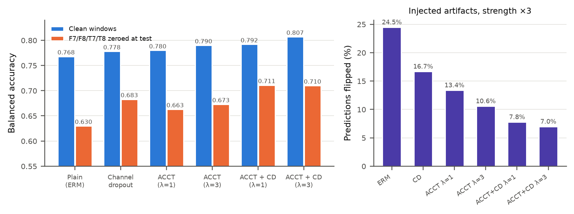
Figure 5. Clean vs. channel-ablated accuracy (left); flips under injected artifacts (right).
Table 12. Paired per-subject tests vs. standard training (Wilcoxon, Holm).
Training | Metric | Δ | p_Holm
ACCT + CD λ = 3 | Clean BAcc | +0.038 [+0.017, +0.060] | 0.035
ACCT + CD λ = 3 | BAcc, F7/F8/T7/T8 zeroed | +0.079 | 0.00059
ACCT + CD λ = 1 | BAcc, F7/F8/T7/T8 zeroed | +0.081 | 1.1 × 10⁻⁶
ACCT λ = 3 | BAcc, F7/F8/T7/T8 zeroed | +0.043 | 0.0025
ACCT λ = 1 | Clean BAcc | +0.012 | 0.14 (n.s.)
Counterfactuals only | Clean BAcc | ≈ 0 | n.s.
- Active ingredient: the consistency term (counterfactuals alone give no clean gain).
- Best configuration: ACCT + channel dropout, λ = 3.
- Limitations: stress test uses the same artifact family as training; natural gap (most vs. least eye-active windows) unchanged at ≈ 0.10–0.12; validation subjects only, test run pending.

7. Status
Item | Status
25-model benchmark, neurophysiology, ablations, augmentation study | Done
ACCT development rounds 1–2 (EEGNet) | Done
Round 3: ACCT on ATCNet, TSception, EEG-TCNet, SpecNet | Running
Final held-out test (5 seeds, run once after design freeze) | Pending
Confirmation on a second dataset (e.g. COG-BCI) | Planned
Own recordings: Emotiv EPOC + Meta Quest 3S (after ethics approval) | Planned

