Data Table Design Issue

There is two option available to make a table using Polaris Component.

1. [Resource List](https://polaris.shopify.com/components/lists-and-tables/resource-list)
2. [DataTable](https://polaris.shopify.com/components/lists-and-tables/data-table)

As we are not using HTML/CSS but custom builds Shopify component we are restricted to use one of the two options available to make a table structure.

### Issues in Implementation.

1. Resource List support Bulk Action, Multi-select data, & filter option but doesn’t support a header for the table as it works list a list. See the git Issue of Polaris.A user experiencing same issue as us.  
   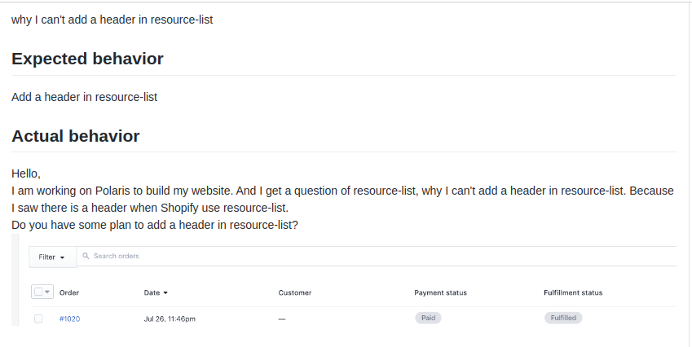

**Reply of Issue**

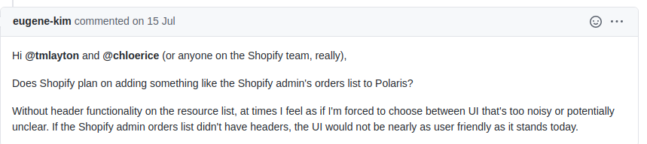

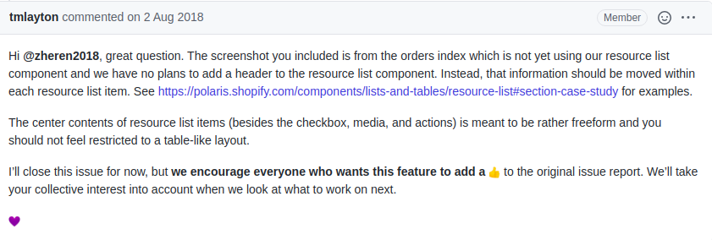

<https://github.com/Shopify/polaris-react/issues/390>

2: Datatable has table heading but doesn’t support bulk action, multi-select & filter functionality. I use this on Location Page as there we don’t have all these options.

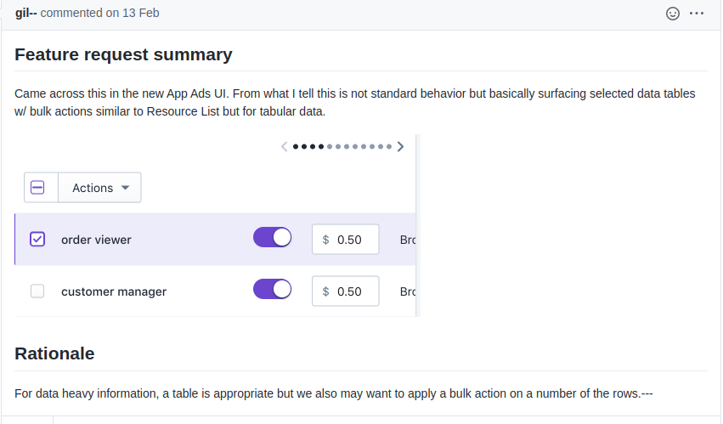

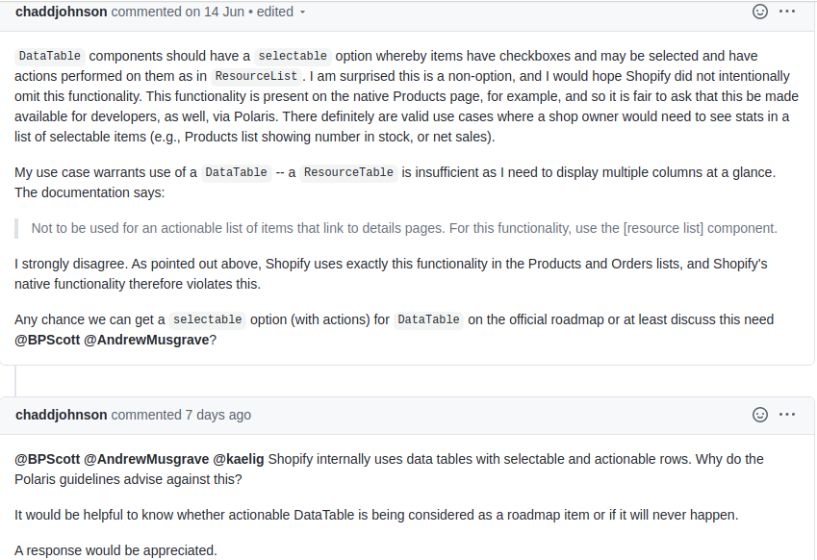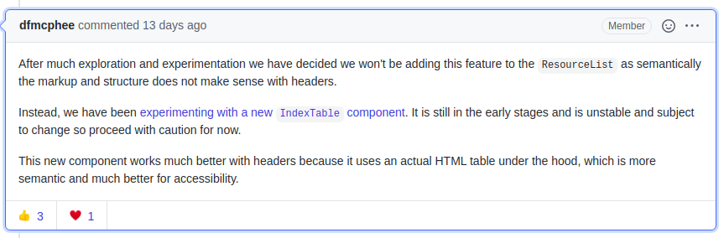

<https://github.com/Shopify/polaris-react/issues/2738>