AEGIS-NET

Technical Handbook
Network intelligence, AI root-cause analysis and a policy-gated DevSecOps agent: from first principles to implementation details
A learning guide, architecture reference and project handover for the Aegis-Net prototype.
Version | 1.0
Date | 2026-10-20
Repository state | commit 5d742e7 on branch master (working tree includes the documentation under deliverables/)
Author field | Aryan Khanna
Data notice | All data in Aegis-Net is synthetic. No claim is made about real networks.

Contents
1 Introduction to Aegis-Net 7
1.1 What Aegis-Net is 7
1.2 The problem it addresses 7
1.3 Who would use it, and where it sits 7
1.4 Capabilities and boundaries 8
1.5 High-level workflow 9
2 Foundations for a Beginner 10
2.1 What a telecommunications network does 10
2.2 Call-detail records (CDRs) 10
2.3 KPIs, counters and the metrics Aegis-Net tracks 10
2.4 Anomalies, incidents and root causes 11
2.5 APIs, databases, containers, deployments 11
2.6 What an LLM does, and what an agent adds 11
3 System Architecture 12
3.1 Components and why each exists 12
3.2 Why more than one language 13
3.3 Trust boundaries 13
4 The Complete Data Flow 14
5 The C Call-Analysis Library 16
5.1 Public API and header design 16
5.2 Structures 16
5.3 Parsing, validation, strict and lenient modes 16
5.4 Status-code classification and rate formulas 17
5.5 Aggregations 17
5.6 Call anomaly detection 17
5.7 Memory allocation and ownership 19
5.8 Build and test layers 19
6 Python and C Integration 20
6.1 ctypes from first principles 20
6.2 Structure layout and the ABI 20
6.3 Function prototypes and pointers 20
6.4 Native allocation, freeing and exception mapping 21
6.5 Library discovery 21
6.6 Why integer width and overflow validation matter 21
6.7 Why Python orchestrates and C computes 22
7 Synthetic Network Telemetry 23
7.1 What it produces 23
7.2 Baselines, load cycle, noise and determinism 23
7.3 The causal model 23
7.4 Incident scenarios 24
7.5 The seeded memory-leak and deployment incident 24
8 Anomaly Detection, From Basic to Advanced 27
8.1 Worked example used throughout 27
8.2 Moving average and rolling standard deviation 28
8.3 Z-score 28
8.4 EWMA 28
8.5 Absolute thresholds 28
8.6 Rate of change 28
8.7 Scoring, severity, episodes and baselines 29
8.8 Detectors versus the simulator 30
8.9 Strengths, failure modes and limits across all detectors 30
9 Correlation and Root-Cause Reasoning 31
9.1 Why symptoms share a cause 31
9.2 What the engine actually computes 31
9.3 The seeded evidence chain 32
10 Database and Backend API 35
10.1 Relational modelling in this project 35
10.2 SQLAlchemy, Alembic and PostgreSQL 36
10.3 FastAPI, Pydantic and validation 36
10.4 Endpoint reference 37
10.5 Pipeline execution 38
11 Authentication, Security, and Auditability 39
11.1 Authentication versus authorisation 39
11.2 Approval gates 40
11.3 Request identifiers, logging and audit 40
11.4 Input validation, limits and rate limiting 41
11.5 Prompt injection and untrusted log content 41
11.6 Safe command execution and secrets 41
12 LLM Provider Abstraction 42
12.1 Basics 42
12.2 Provider abstraction 42
12.3 Configuration 42
12.4 Sequence of an investigation 43
12.5 Deterministic testing with the mock 43
13 Root-Cause Analysis Engine 44
13.1 Workflow 44
13.2 Facts, inferences, hypotheses, recommendations 44
13.3 Worked example from the seeded incident 45
13.4 Presenting conclusions without exposing hidden reasoning 45
14 Report Generation 46
14.1 Data model and numeric consistency 46
14.2 Narrative and template fallback 46
14.3 Renderers and escaping 46
14.4 An actual excerpt 46
15 Autonomous DevSecOps Agent 48
15.1 The loop 48
15.2 Tools and risk classes 48
15.3 Policy and approval 49
15.4 The sandbox and the disposable workspace 49
15.5 Synthetic advisories 50
15.6 The three scenarios 50
15.7 What is real, simulated, approved and blocked 51
16 Frontend and Dashboard 52
16.1 Structure 52
16.2 Authentication handling 52
16.3 Pages and how users interact 52
17 Docker and Deployment 54
17.1 Concepts 54
17.2 The images 54
17.3 Services, ports, volumes 55
17.4 Commands 55
17.5 Troubleshooting 55
18 Testing and Quality Assurance 56
19 How to Run and Demonstrate Aegis-Net 57
19.1 Prerequisites and repository map 57
19.2 Environment 57
19.3 Offline demo (no key, no Docker) 57
19.4 Docker with the dashboard 57
19.5 A guided walk-through 57
19.6 Tests 58
19.7 Live providers 58
19.8 Common failures 58
20 Limitations, Trade-offs, and Future Work 59
20.1 Honest assessment 59
20.2 Prioritised roadmap (recommendations, not existing features) 59
21 Advanced Technical Deep Dives 60
21.1 C and Python ABI and memory ownership 60
21.2 Statistical detector design and trade-offs 60
21.3 Evidence provenance and hypothesis evaluation 60
21.4 Structured LLM tool execution 60
21.5 Policy enforcement and threat modelling 60
21.6 Database integrity 60
21.7 Audit-chain verification 60
21.8 Integration testing 61
21.9 Observability 61
21.10 Performance and scaling considerations 61
22 Glossary and Reference Appendix 62
22.1 Glossary 62
22.2 Important formulas 63
22.3 Repository map 63
22.4 Component and interface reference 63
22.5 Environment variables 64
22.6 Terminal commands 64
22.7 Most useful source files and tests 65
Appendix A: Screenshot Inventory 66
Appendix B: Verification Record 66
Appendix C: References 67

List of figures
Figure 1. High-level workflow from synthetic data to audited remediation 9
Figure 2. Aegis-Net system architecture, layered 12
Figure 3. End-to-end sequence of API calls for one incident 14
Figure 4. Call Analytics page: totals, drop rate by cell, status codes and C-library anomalies 18
Figure 5. C to Python call, ownership and release 21
Figure 6. The simulator's causal chain 23
Figure 7. Seeded run, affected cell versus an unaffected control cell 25
Figure 8. Network Overview page for the same incident 25
Figure 9. Detector processing pipeline 27
Figure 10. The worked example, with baseline, threshold and EWMA 27
Figure 11. Score as a function of z, with severity bands 29
Figure 12. Anomalies page filtered to critical severity 29
Figure 13. Evidence in, ranked hypotheses out 31
Figure 14. The timeline the engine builds 33
Figure 15. Why deployment_regression outranks memory_exhaustion 33
Figure 16. Incidents list: one critical incident with its leading hypothesis 34
Figure 17. Entity-relationship diagram of the 19 tables (from `app/models/`) 36
Figure 18. Dashboard behaviour when a viewer opens the Audit page 39
Figure 19. Separation of duties message in the agent panel 39
Figure 20. Audit Log page: hash chain valid (38 rows) 40
Figure 21. RCA tool-calling sequence 43
Figure 22. Root Cause Analysis page for INC-2026-001 (mock provider) 45
Figure 23. AI Reports page with the executive summary and KPI table 47
Figure 24. Agent lifecycle 48
Figure 25. Risk classification and approval workflow 49
Figure 26. DevSecOps Agent page: one closed run and two runs awaiting approval 50
Figure 27. Security page with the synthetic finding 51
Figure 28. Dashboard 52
Figure 29. Dashboard navigation and workflows 53
Figure 30. Container topology 54

1 Introduction to Aegis-Net
Implementation status. Status vocabulary used in this handbook. VERIFIED means the behaviour is implemented and a test or recorded run in this repository exercised it. UNVERIFIED HERE means the code exists but was not exercised in the relevant environment. SIMULATED means the behaviour is simulated or for demonstration only. NOT IMPLEMENTED means not implemented or deferred. Planning documents were not accepted as proof: each claim was checked against source code, tests, or a command run for this handbook (Appendix B).

1.1 What Aegis-Net is
Imagine you run a city's bus network. One morning passengers complain that buses are late on four routes. A dispatcher looks at a map, a spreadsheet of delays, and a list of changes made overnight: a new software release for the ticket machines, a road closure, a staff roster change. Finding which change caused the delays means gathering evidence from several places, ordering events in time, and ruling out suspects. Then someone has to decide what to do, and the decision should be recorded.
Aegis-Net does the same job for a mobile telecommunications network, in software. It is a prototype that:
- reads call-detail records (CDRs) with a C library and computes call statistics and outliers;
- watches network key performance indicators (KPIs) such as latency and packet loss for anomalies;
- correlates anomalies with deployments, configuration changes and security events into an incident;
- runs an AI-assisted root-cause analysis (RCA) that can only use read-only tools;
- writes an incident report; and
- runs a policy-gated DevSecOps agent that proposes fixes, waits for human approval where required, verifies the result, and records everything in a tamper-evident audit log.
Warning. All data in Aegis-Net is synthetic. The telemetry, call logs, deployments, security events and DEMO-CVE advisories are generated by this repository. No real network, customer or vulnerability is described, and the production rollback is a simulation. SIMULATED

1.2 The problem it addresses
Network operators run thousands of cells (radio sites) served by gateways and core software. When service degrades, three things make investigation slow:
1. Evidence is scattered. Metrics live in a monitoring system, deployment records in a CI/CD tool, security alerts in an intrusion detection system (IDS), and logs on servers.
2. Symptoms arrive in a cascade. A single fault shows up as a dozen alerts, not one. The first symptom is often not the one people notice.
3. Decisions need an audit trail. Rolling back a production release is risky and must be justified and approved.
Manual investigation typically means: confirm the problem, find the affected elements, build a timeline, list recent changes, compare symptom order with how the system should behave, form a hypothesis, test it, act, and verify recovery. Aegis-Net automates the evidence gathering, ordering and bookkeeping. It does not automate judgement: confidence is capped, every cause is labelled a hypothesis, and risky actions need a human.

1.3 Who would use it, and where it sits
Discipline | What it cares about | How Aegis-Net relates
Network operations (NOC) | Is the network healthy, what is broken, how severe | Dashboard, incidents, KPI charts
Site reliability engineering (SRE) | Service levels, incident response, postmortems | Incident timeline, RCA, reports
AIOps (AI for IT operations) | Using data and models to reduce operator toil | Anomaly detection, correlation, tool-using RCA
DevSecOps | Safe, secure change delivery | Agent scenarios: vulnerable dependency, failed CI, rollback

The intended readers of this handbook are a newcomer, a student, an interviewer evaluating the design, and a team reviewing technical decisions.

1.4 Capabilities and boundaries
Table 1. Capability summary with implementation status
Capability | Status | Evidence
C call-analysis library with strict warnings, sanitizers, fault injection | VERIFIED | make c-test, make c-test-asan run for this handbook: 2 of 2 tests passed in each
Python ctypes binding with ABI checks | VERIFIED | backend/tests/test_binding_abi_and_ownership.py (28 tests) passed
Deterministic telemetry simulator, 17 KPIs, 9 incident types | SIMULATED VERIFIED | test_simulation.py (31 tests); data is synthetic by design
Four interpretable anomaly detectors | VERIFIED | test_analytics.py (24 tests)
Correlation into incidents with ranked hypotheses | VERIFIED | test_correlation.py (29 tests); seeded run reproduced here
RCA engine, nine read-only tools, mock provider | VERIFIED | test_rca.py (45 collected, 44 run)
Anthropic, OpenAI, local LLM providers | UNVERIFIED HERE | Request shapes tested with fake clients; never called live (no key)
Reports in JSON, Markdown, HTML | VERIFIED | test_reporting.py (11 tests)
Report in PDF | NOT IMPLEMENTED | Not implemented
DevSecOps agent, policy engine, sandbox | VERIFIED | test_agent.py (36 tests)
Production rollback | SIMULATED | Re-simulates telemetry; no real infrastructure is touched
REST API, token RBAC, hash-chained audit | VERIFIED | test_api_core.py, test_security.py
React dashboard | VERIFIED | make frontend-test run for this handbook (Vitest 10 of 10, build ok); browser check recorded; screenshots supplied
Docker Compose stack | VERIFIED | Recorded smoke test in IMPLEMENTATION_PLAN.md; not re-run for this handbook
Isolation Forest, DBSCAN, OpenTelemetry, Grafana | NOT IMPLEMENTED | Optional in the specification; not built
Behaviour on real telemetry | NOT IMPLEMENTED | Never tested

Note. Aegis-Net is a working prototype. It is not production-ready: there is no TLS termination, no external identity provider, no secret manager and no high availability (Chapter 20).

1.5 High-level workflow
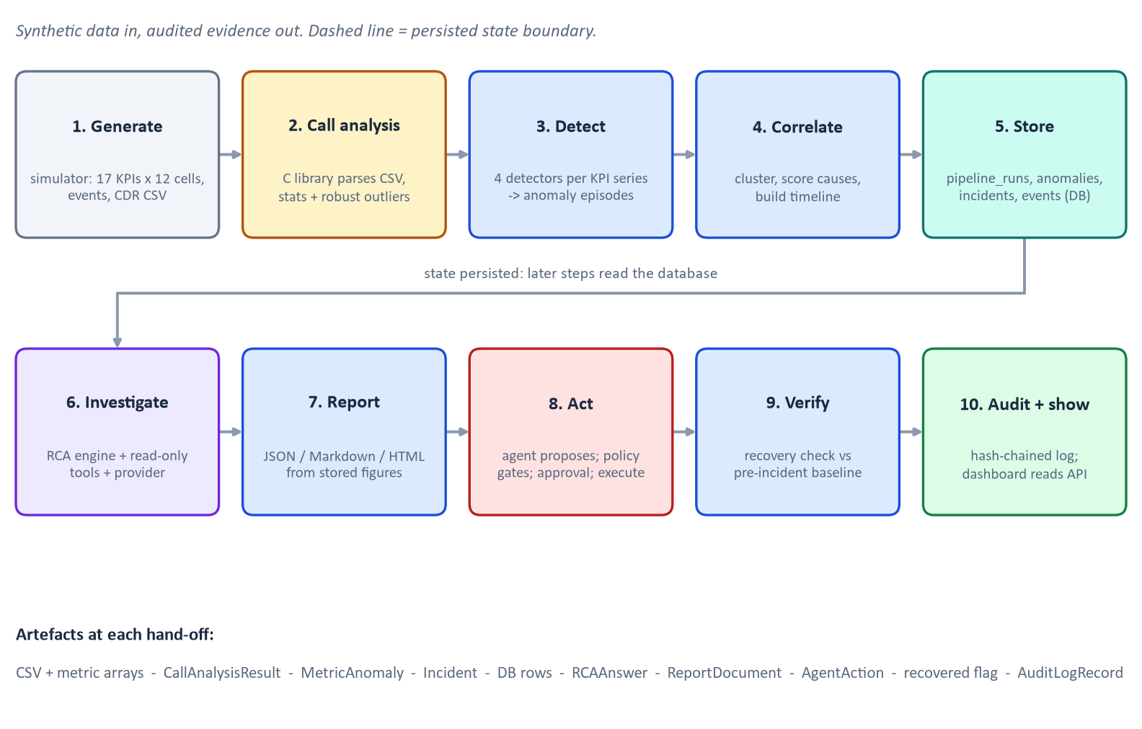
Figure 1. High-level workflow from synthetic data to audited remediation
Figure 1 shows the ten stages. Each stage reads the state left by the previous one; after stage 5 the evidence lives in the database, so the RCA engine, report builder and agent all work from stored facts rather than from in-memory objects. Chapter 4 follows one incident through every stage.

2 Foundations for a Beginner
Note. This chapter explains background concepts in plain language. It is general background, not a description of Aegis-Net features, except where it says "in Aegis-Net".

2.1 What a telecommunications network does
A mobile network connects phones to each other and to the internet. A phone talks by radio to a cell (a radio site, sometimes called a base station). Cells connect through a backhaul network to gateway software in the core network, which routes traffic onward. In Aegis-Net the synthetic topology has 12 cells (CELL-101 to CELL-112) served by three packet-gateway nodes (pgw-1 to pgw-3), four cells each. Nothing about this topology is real; it is chosen to make shared-node failures easy to see.

2.2 Call-detail records (CDRs)
A call-detail record is one row describing one call attempt: when it happened, who called whom, which cell carried it, how long it lasted, how it ended, and some radio quality numbers. Aegis-Net uses eight columns:
timestamp,caller,callee,cell_id,duration,status_code,signal_strength,packet_loss
2026-03-01T14:05:00Z,+15550001,+15550002,CELL-102,184,200,-82,1

Operators analyse millions of such rows. Counting how many calls dropped in each cell, and spotting a cell that is much worse than its neighbours, is a standard first diagnostic.

2.3 KPIs, counters and the metrics Aegis-Net tracks
A key performance indicator (KPI) is a number summarising service quality over a short interval. Aegis-Net samples 17 KPIs per cell every minute (units from backend/app/simulation/metrics.py):
Table 2. The 17 simulated KPIs
KPI | Unit | Bad direction | Plain meaning
latency_ms | ms | up | Round-trip delay. If you shout and hear the echo 22 ms later, latency is 22 ms
jitter_ms | ms | up | How much the delay varies from packet to packet
packet_loss_pct | % | up | Share of data packets that never arrive: 3 lost per 100 is 3 %
throughput_mbps | Mbit/s | down | Delivered data rate
retransmission_rate | % | up | Share of data sent again because it was lost
rssi_dbm, rsrp_dbm | dBm | down | Received signal strength (RSSI) and reference signal power (RSRP); closer to 0 is stronger, so -80 dBm is better than -110 dBm
rsrq_db, sinr_db | dB | down | Signal quality and signal to interference-plus-noise ratio (SINR)
handover_success_rate / failure_rate | % | down / up | Whether a phone moving between cells keeps its call
call_setup_success_rate | % | down | Share of call attempts that start
call_drop_rate | % | up | Share of established calls that end abnormally
cpu_utilization, memory_utilization | % | up | Load on the serving gateway: 57 % memory means 57 of every 100 units are in use
active_users | users | both | Connected users
bandwidth_utilization | % | up | Backhaul usage

"Bad direction" matters: a rise in latency is bad, a fall in throughput is bad, and users can be unusual in either direction.

2.4 Anomalies, incidents and root causes
An anomaly is a measurement that is unusual compared with what is normal for that series, such as memory at 100 % when it normally sits near 57 %. An incident is an operational event that needs attention, built from several related anomalies. Root-cause analysis (RCA) asks which underlying change explains the symptoms. A symptom (high latency) is not a cause (a software release that leaks memory, which raises CPU, which raises latency).

2.5 APIs, databases, containers, deployments
- An application programming interface (API) is how programs talk to each other. Aegis-Net exposes an HTTP REST API.
- A database stores structured records durably. Aegis-Net uses PostgreSQL in Docker and SQLite for the offline demo.
- A container packages software with its dependencies so it runs the same everywhere. Docker Compose starts several containers together.
- A deployment is a new software version going live on a server. Deployments are a prime suspect in incidents because they are deliberate changes.

2.6 What an LLM does, and what an agent adds
A large language model (LLM) predicts text. Given a question and descriptions of available tools, it can answer with a request such as "call get_anomalies with these arguments". It cannot, by itself, do anything; a program must run the tool and give the result back. An agent is a program that wraps repeated cycles of observe, decide, act. In Aegis-Net the LLM only helps the RCA step (and writes one summary paragraph in reports). The DevSecOps agent's plan is deterministic and rule-based, which is a deliberate safety choice (Chapter 15).
Example. A worked mini-example. Suppose a cell's latency has hovered around 22 ms with a standard deviation of 1 ms. A reading of 250 ms is 228 standard deviations away. No judgement is needed to call that unusual. A reading of 24 ms is two standard deviations away and could easily be noise. Chapter 8 turns this intuition into algorithms.

3 System Architecture

3.1 Components and why each exists
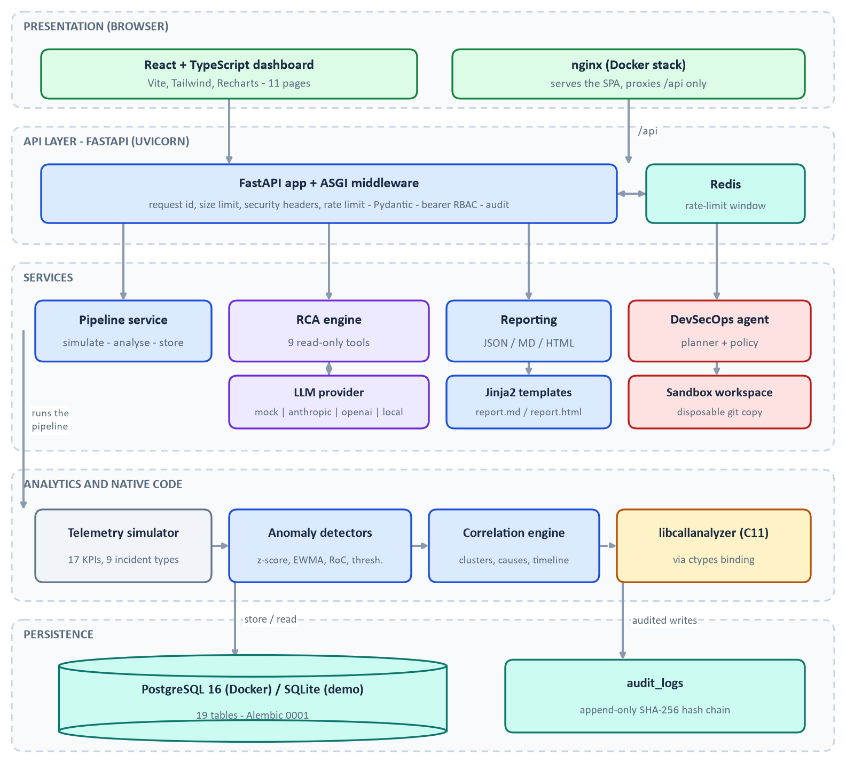
Figure 2. Aegis-Net system architecture, layered
Figure 2 groups the components into layers. Colour encodes kind: amber is native C, blue is Python backend, purple is AI, red is policy and security, teal is storage, green is the user interface, grey is synthetic data.
Table 3. Components, location, responsibility and rationale
Component | Location | Responsibility | Why it exists
C call-analysis library | c-library/ | Parse and validate CDR CSV, aggregate, detect call outliers | CDR files are large and untrusted; a small allocation-disciplined native library gives bounded parsing and speed behind a stable ABI
ctypes binding | backend/call_analyzer/ | Load the shared library, marshal structs to Python dicts, map errors to exceptions | Lets Python orchestrate without re-implementing the computations
Call-log generator | scripts/generate_call_logs.py | Seeded synthetic CDRs with an optional progressive cell fault | Reproducible test input with no dependency on the backend
Telemetry simulator | backend/app/simulation/ | Causal 17-KPI model, 9 incident injectors, events, deployments, rollback | A controllable test instrument with known ground truth
Anomaly detection | backend/app/analytics/detectors.py, engine.py, config.py | Four detectors, scoring, episodes | Interpretable detection whose every decision can be explained
Correlation engine | backend/app/analytics/correlation.py, causal_graph.py | Cluster symptoms, score candidate causes, build timeline | Turns many alerts into one explained incident
Database | backend/app/models/, backend/alembic/ | 19 tables, JSON for evidence documents | Durable shared state for services and the dashboard
FastAPI and Pydantic | backend/app/api/, schemas/ | 26 routes, validation, OpenAPI | A typed, documented boundary
Auth, RBAC, audit | backend/app/security/ | Hashed tokens, roles, hash-chained log | Accountability for every mutation
LLM abstraction | backend/app/llm/ | One interface over mock, Anthropic, OpenAI, local | Swappable providers; offline default
RCA engine and tools | backend/app/rca/ | Bounded tool loop, schema-validated answer | Evidence-cited conclusions
Reporting | backend/app/reporting/ | Report document, Markdown/HTML templates | Consistent, escaped outputs
DevSecOps agent | backend/app/agents/ | Playbooks, policy, sandboxed runner, 20 tools | Controlled remediation with approvals
Dashboard | frontend/ | React, TypeScript, Vite, Tailwind, Recharts | Operator view on the real API
Docker stack | docker-compose.yml, Dockerfiles | postgres, redis, backend, frontend (nginx) | One-command local deployment

3.2 Why more than one language
- C for the hot, untrusted-input path: CSV parsing, grouped aggregation, robust statistics. Memory is managed explicitly, which is both the risk and the reason it needs sanitizer and fault-injection testing (Chapter 5).
- Python for orchestration, analytics, the API and the agent. NumPy handles series maths; SQLAlchemy and FastAPI handle persistence and HTTP.
- TypeScript for the dashboard so the API's JSON shapes are checked at compile time.
- SQL (via PostgreSQL) for relational integrity.
The languages meet at three explicit interfaces: the C header (call_analyzer.h), the REST API with its OpenAPI schema, and the database schema. CLAUDE.md requires such interfaces to be kept explicit.

3.3 Trust boundaries
Four boundaries drive the security design: CSV into the C parser (untrusted, bounded); LLM output into the RCA engine and agent (untrusted, schema-validated); HTTP clients into the API (authenticated, authorised, rate-limited, size-limited); and the agent into the operating system (fixed executables, argument lists, confined directory, scrubbed environment).

4 The Complete Data Flow
This chapter follows INC-2026-001, the seeded incident, through every stage. Numbers come from make demo as run for this handbook (seed 7, exit status 0) unless stated.
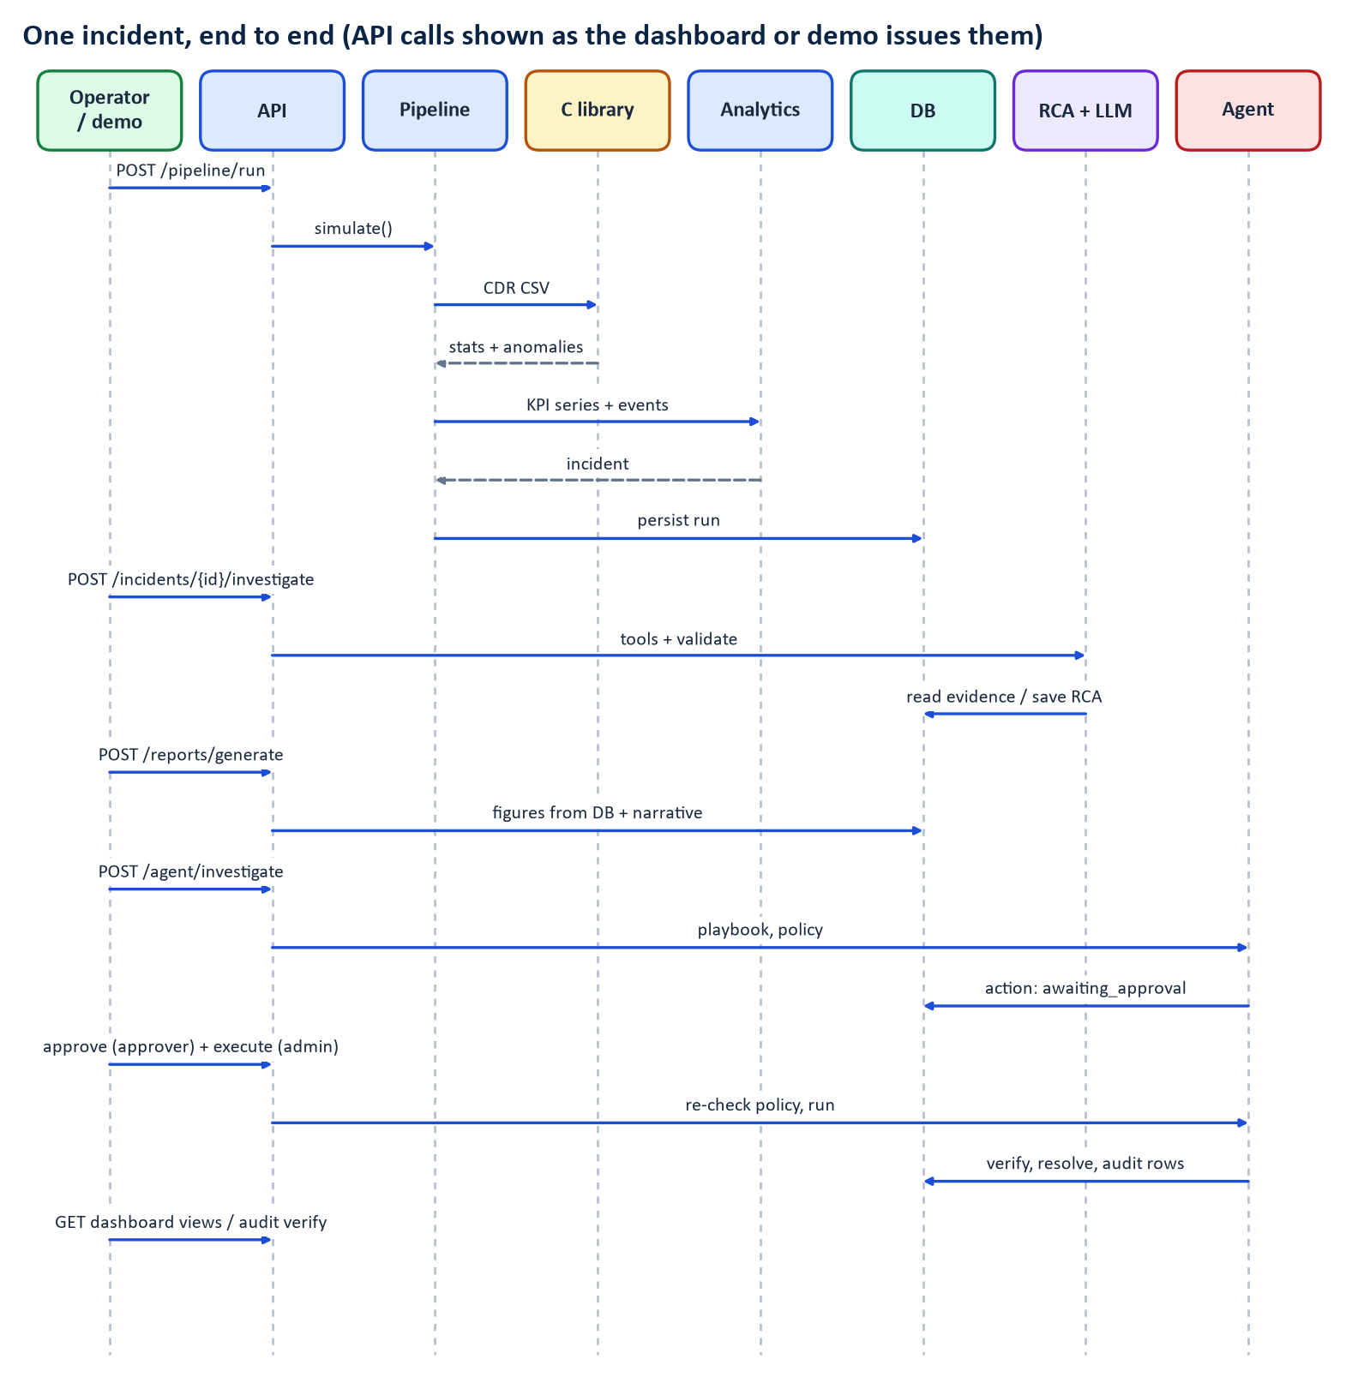
Figure 3. End-to-end sequence of API calls for one incident
Table 4. Step-by-step walk-through
# | Responsible component | Input | Processing | Output | Important error cases
1 | simulation.simulate | Scenario (seed 7, 360 min, memory-leak deployment at 14:05 on pgw-1) | Causal model with AR(1) noise; injectors alter drivers only | 17 KPIs x 12 cells per minute, events, deployment records | Invalid scenario raises ValueError (for example rollback without a deployment-induced incident)
2 | call_analyzer + C library | CDR CSV (21,400 calls) | Parse, validate, aggregate, robust outliers | Statistics and 8 call anomalies | Parse errors, limits, out-of-memory map to typed exceptions
3 | analytics.detect_anomalies | KPI series | Four detectors per series, episode grouping | 36 anomaly episodes | Unknown metric raises KeyError; non-increasing epochs raise ValueError
4 | analytics.correlate | Anomalies, events, call anomalies | Cluster, gate, score causes | One CRITICAL incident, leading cause deployment_regression 0.8947 | No incident if fewer than two metrics or no symptom of severity high or above
5 | services.pipeline | All of the above | Run-scoped ids; bulk inserts | Rows in 19 tables | Failures roll back; run status recorded
6 | rca.engine.investigate | Incident id | Tool loop, validation | Completed RCA (85 %, 12 tool calls with the mock) or failed | Provider error, bad tool arguments, invalid or uncited answer: reported, never invented
7 | reporting.build_report | Incident, RCA | Figures from the database; one narrative paragraph | Report in three formats | Ungrounded narrative numbers rejected; provider errors fall back to a template
8 | agents.service | Scenario production_anomaly | Playbook; policy evaluation per action | Proposed rollback_deployment (HIGH_RISK) awaiting approval | Policy denies when the high-risk flag is off
9 | agents.service.execute_action | Approved action | Policy re-checked; simulated rollback; recovery check | recovered=True, incident resolved | Execute before approval returns HTTP 409; wrong role returns 403
10 | security.audit, dashboard | Every action | SHA-256 chain; read views | Audit chain valid (24 rows in the demo) | Tampering detected by verify_chain

Note. Step 8 and 9 in the screenshot of Chapter 16 differ from the demo: the screenshot environment left high-risk actions disabled, so the rollback shows as blocked and the incident stays open. The demo run enables AGENT_ALLOW_HIGH_RISK for itself.

The detection chain observed in the demo run was: memory at 14:13, CPU at 14:31, latency at 14:40, jitter at 14:45, packet loss at 14:50, retransmissions at 14:52, call drop and throughput at 14:53. After the simulated rollback, the last 30 minutes of KPIs were within the practical deltas of the baseline: memory 57.832 (baseline 57.148), latency 23.216 ms (22.331), drop rate 0.771 % (0.773).

5 The C Call-Analysis Library
Implementation status. VERIFIED Built with -Wall -Wextra -Wpedantic plus 13 further warning flags and -Werror (c-library/CMakeLists.txt). make c-test and make c-test-asan were run for this handbook: both reported "100% tests passed, 0 tests failed out of 2" (a normal and an allocation-failure-injection executable). The same test source holds 28 test functions.

5.1 Public API and header design
The header c-library/include/call_analyzer.h is the authoritative contract. Its conventions are worth stating because every other layer relies on them:
- Functions returning int return CA_OK (0) or a negative CaStatus: CA_ERR_NULL_ARG (-1), CA_ERR_INVALID_ARG (-2), CA_ERR_IO (-3), CA_ERR_NOMEM (-4), CA_ERR_PARSE (-5), CA_ERR_OVERFLOW (-6), CA_ERR_LIMIT (-7).
- Arrays returned through out-parameters are allocated by the library and released only with the matching free_* function. On failure the output pointer is set to NULL and the count to 0.
- Fixed-size string fields (char[32]) are always NUL-terminated; inputs that do not fit are rejected, never truncated.
- There is no global mutable state in the production build, so calls are re-entrant.
- Only the public API is exported: the shared library is built with hidden visibility and CA_API marks the exported functions.
The main entry points are parse_call_log_ex, parse_call_log_buffer, calculate_statistics, calculate_cell_statistics, calculate_failure_code_statistics, calculate_time_window_statistics, calculate_caller_statistics and detect_call_anomalies.

5.2 Structures
CallRecord holds four 32-byte strings, four int fields (duration, status code, signal strength, packet loss) and an int64_t epoch_seconds. Statistics structures (CallStatistics, CellStatistics, TimeWindowStatistics, CallerStatistics, FailureCodeStatistics) hold counts as size_t and rates as double. CaStructSizes exports sizeof of every structure so the Python binding can verify its mirrors at load time (Chapter 6).

5.3 Parsing, validation, strict and lenient modes
The parser (src/parser.c) reads line by line, either from a file or from a memory buffer, and is deliberately strict about what it accepts.
- Header detection. If the first non-blank row's first field equals timestamp (case-insensitive), the row is treated as a header and all eight column names must match in order; otherwise the file is headerless. A UTF-8 byte-order mark on line 1 is skipped.
- Quoting. A hand-written splitter (split_csv) supports quoted fields with doubled quotes, rejects a stray quote inside an unquoted field, and rejects text after a closing quote.
- Limits. Lines longer than 1024 bytes, fields longer than the internal maximum, embedded NUL bytes and more than eight fields are rejected.
- Validation. Timestamps are ISO-8601 UTC; caller and callee are 1 to 31 characters from a restricted set; duration is 0 to 86,400 s; status code 100 to 999; signal strength -150 to 0 dBm; packet loss 0 to 100 %.
- Strict versus lenient. With ParseOptions.strict non-zero the first invalid row fails the whole parse; otherwise invalid rows are counted and skipped.
- Parse report. ParseReport records lines read, records parsed, records rejected, whether a header was present, and the line number, status and message of the first error. On failure records_parsed is reset to 0.
The default limit is 10,000,000 records (CA_DEFAULT_MAX_RECORDS); exceeding it returns CA_ERR_LIMIT.

5.4 Status-code classification and rate formulas
Warning. The ranges and formulas below are Aegis-Net's own conventions. They are SIP-inspired but are not a universal telecom standard, and real networks use many other cause-code schemes.

Table 5. Status-code classes (`call_outcome_for_status` in `src/utils.c`)
Range | Class | Meaning in this project
200 to 299 | CALL_COMPLETED | Completed normally
900 to 999 | CALL_DROPPED | Established, then ended abnormally (for example 901 radio link failure)
300 to 899 | CALL_SETUP_FAILED | Never established (for example 408 timeout, 486 busy, 503 unavailable)
100 to 199 | CALL_UNKNOWN | Provisional; counts as neither success nor failure

success_rate = completed / total
drop_rate = dropped / (completed + dropped)
setup_failure_rate = setup_failed / total
Drops are measured against established calls, the conventional definition. Example: 100 calls, of which 90 complete, 6 fail setup, 3 drop and 1 is provisional. Then success_rate = 90/100 = 0.90, drop_rate = 3/(90+3) = 0.0323, setup_failure_rate = 6/100 = 0.06. The code is short enough to read in full:
CallOutcome call_outcome_for_status(int status_code)
{
if (status_code >= 200 && status_code <= 299) {
return CALL_COMPLETED;
}
if (status_code >= 900 && status_code <= 999) {
return CALL_DROPPED;
}
if (status_code >= 300 && status_code <= 899) {
return CALL_SETUP_FAILED;
}
return CALL_UNKNOWN;
}

Note the order: the dropped range is tested before the wide 300 to 899 range only for readability; the ranges do not overlap.

5.5 Aggregations
Statistics are computed with running accumulators (CaAccumulator in ca_internal.h) that keep integer sums with overflow checks (ca_accumulator_add returns CA_ERR_OVERFLOW rather than wrapping) and a Welford running mean and second moment for duration spread. Cell statistics sort pointers to records by cell id; time windows align to multiples of the window size; caller statistics count distinct callees; failure-code statistics are sorted by count descending then code ascending. Results are sorted deterministically so tests and reports are stable.

5.6 Call anomaly detection
src/anomaly.c compares each group with its peers using a robust z-score:
z = (x - median) / max(1.4826 × MAD, floor)
where MAD is the median absolute deviation, the constant 1.4826 makes MAD comparable to a standard deviation for normally distributed data, and floor prevents tiny, tightly clustered baselines from inflating z. The score is
score = 1 - 2^(-z / threshold)
so a group exactly at the threshold scores 0.5 (ca_anomaly_score). Severity bands are score at least 0.9 critical, at least 0.75 high, at least 0.6 medium, otherwise low (ca_severity_for_score).
Note. External background (consulted): the NIST/SEMATECH e-Handbook defines a modified z-score as 0.6745 times the deviation from the median divided by MAD, and suggests flagging absolute values above 3.5 as potential outliers [R4]. 0.6745 is the reciprocal of 1.4826, and the library's default group threshold is also 3.5. Aegis-Net adds floors and minimum absolute deltas on top; it does not claim to implement the handbook procedure unchanged.

The defaults (anomaly_config_default): group z threshold 3.5, per-call duration threshold 10.0, at least 3 peer groups, at least 20 calls per cell, 10 per window, 20 per caller, 30 established calls for duration outliers, 300-second windows, minimum absolute deltas of 5 percentage points for rates, 6 dBm for signal, 3 points for packet loss, volume ratio 2.0, short-call ratio 0.6, and at most 1000 anomalies kept. A group is flagged only when both z reaches the threshold and the absolute deviation reaches the minimum delta. Anomaly types: cell drop rate, cell setup-failure rate, cell low signal, cell packet loss, window drop rate, window volume spike, caller high volume, and call duration.
The cell detector shows the pattern:
for (size_t k = 0; k < n; k++) {
const CellStatistics *c = &cells[idx[k]];
CallAnomaly a;
if (z[k] < cfg->z_threshold ||
(double)directions[m] * (values[k] - median) < deltas[m]) {
continue;
}
init_anomaly(&a, types[m], c->cell_id, values[k], median, z[k], cfg->z_threshold,
cell_sample(c, (CellMetric)m));
...
}

directions[m] is +1 when a higher value is worse (drop rate) and -1 when lower is worse (signal), so one comparison handles both. In the seeded run the library flagged setup-failure and packet-loss anomalies on exactly CELL-101 to CELL-104, for example "Cell CELL-103 setup failure rate 14.2% vs peer median 0.8% (1419 calls)" (Figure Figure 4).
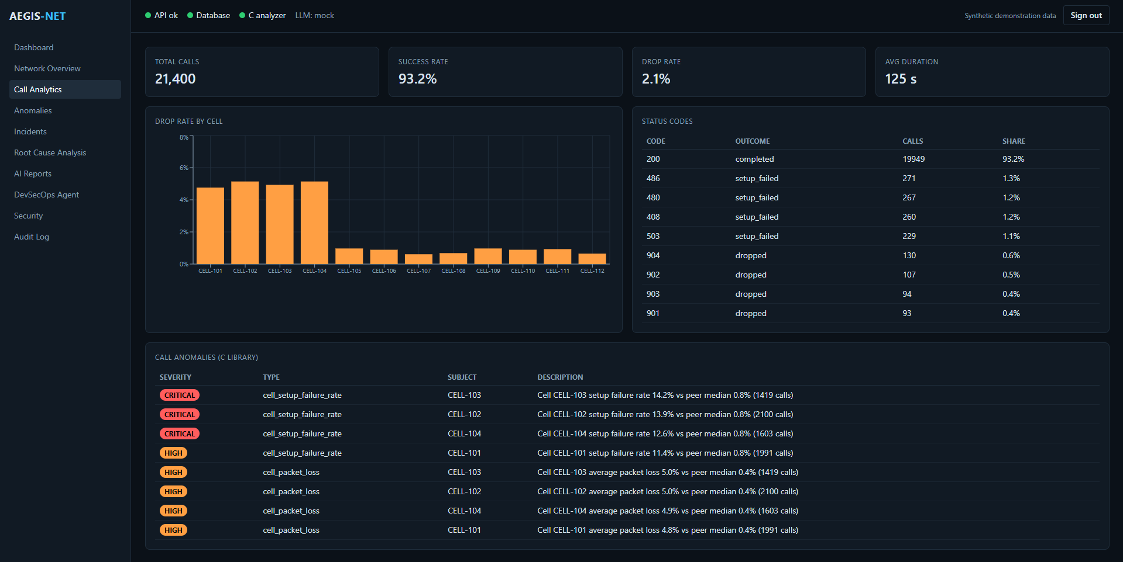
Figure 4. Call Analytics page: totals, drop rate by cell, status codes and C-library anomalies
In Figure 4 the four tall bars are CELL-101 to CELL-104 (about 5 % drop rate against under 1 % for the rest); the status-code table shows the project's classes (200 completed; 486, 480, 408, 503 setup failures; 901 to 904 drops); and the anomaly table at the bottom is the C library's output labelled "(C LIBRARY)". Source: supplied screenshot document, synthetic data.

5.7 Memory allocation and ownership
All allocation goes through wrappers (ca_malloc, ca_calloc, ca_realloc_array, ca_free). ca_realloc_array fails on multiplication overflow, which blocks the classic "count times size wraps around" bug. Under the build flag CA_FAULT_INJECTION the wrappers can be told to fail the *n*th allocation, which lets the test test_oom_all_operations force every allocation site to fail in turn and check that each returns CA_ERR_NOMEM, frees what it had and leaves outputs NULL. Multi-step functions use a single cleanup label (goto done) so every path releases its temporary buffers, as the cell detector above does.
Native memory ownership matters because a leak or double free in a long-running service is hard to see from Python, and because the Python process cannot be protected by garbage collection from native mistakes.

5.8 Build and test layers
Table 6. C test and build layers
Layer | What it checks | What it does not prove
Strict warnings, -Werror | Implicit conversions, shadowing, missing prototypes, unused values | Logic errors
Unit tests (28 functions) | Parsing, malformed rows, statistics, anomalies, NULL arguments | Behaviour on inputs nobody thought of
ASan, UBSan, LSan build | Out-of-bounds access, undefined behaviour, leaks on tested paths | Untested paths; other compilers
Fault-injection build | Every allocation site fails cleanly | Failures of other system calls
Hand-run mutation checks | The plan records mutations of gates in a scratch copy; they were detected | There is no mutation tool in the repository, so this is not repeatable by command

6 Python and C Integration
Implementation status. VERIFIED backend/tests/test_binding_abi_and_ownership.py (28 tests) and test_call_analyzer_binding.py (61 tests) passed in the full run: 352 passed, 3 skipped.

6.1 ctypes from first principles
A shared library (libcallanalyzer.so on Linux) is compiled code that other programs load at run time. Python's ctypes module can load one and call its functions, but C functions carry no type information at run time, so Python must be told each function's signature. The official documentation describes argtypes (the C types a function expects, so ctypes can check and convert arguments) and restype (the return type, default int), and structures declared as a subclass of Structure with a _fields_ list, laid out as the C compiler would [R1].
If a signature is wrong, nothing warns you: a 64-bit size_t passed as a 32-bit int silently truncates; a pointer returned as int is cut to 32 bits and crashes later. This is why Aegis-Net's binding is paranoid.

6.2 Structure layout and the ABI
The application binary interface (ABI) is the machine-level contract: field order, sizes, alignment and padding. In backend/call_analyzer/_native.py each C struct has a Python mirror. For example:
class CallRecord(ctypes.Structure):
_fields_ = [
("timestamp", ctypes.c_char * CA_FIELD_LEN),
("caller", ctypes.c_char * CA_FIELD_LEN),
("callee", ctypes.c_char * CA_FIELD_LEN),
("cell_id", ctypes.c_char * CA_FIELD_LEN),
("duration", c_int),
("status_code", c_int),
("signal_strength", c_int),
("packet_loss", c_int),
("epoch_seconds", c_int64),
]

Four 32-byte arrays occupy 128 bytes; four 4-byte ints bring the offset to 144, already a multiple of 8, so the 8-byte epoch_seconds needs no padding and the struct is 152 bytes. The binding does not assume this arithmetic. At load it calls call_analyzer_struct_sizes and compares every entry with ctypes.sizeof of the mirror; any mismatch raises LibraryLoadError. It also requires major version 1. The tests go further: they compile a C probe using offsetof, sizeof and _Generic against the header and compare each field's name, order, offset, size and type class with the Python mirror.

6.3 Function prototypes and pointers
_PROTOTYPES lists (restype, argtypes) for every function used, for example calculate_cell_statistics takes a POINTER(CallRecord), a size_t, a pointer to a POINTER(CellStatistics) and a pointer to a size_t. Out-parameters are created as ctypes.POINTER(T)() (a NULL pointer) and passed with ctypes.byref.

6.4 Native allocation, freeing and exception mapping
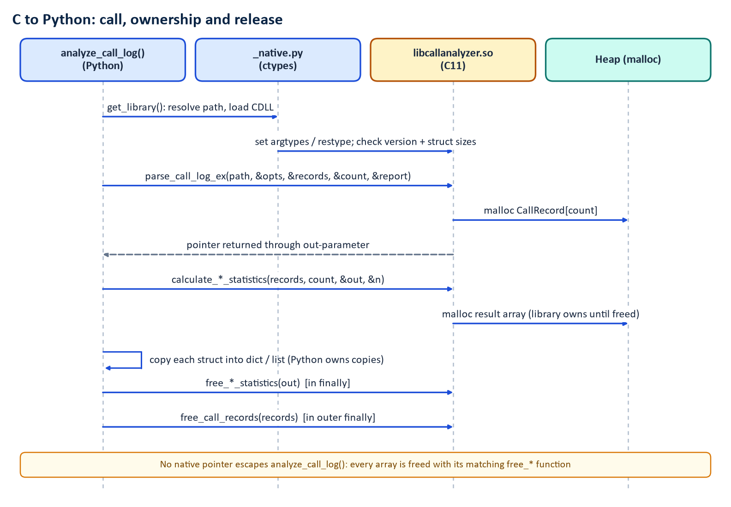
Figure 5. C to Python call, ownership and release
Figure 5 shows the rule: the library allocates, Python copies results into dictionaries, and then frees with the matching free_*. The helper _collect_array does this in a try/finally, so the array is freed even if conversion raises, relying on the C guarantee that out is NULL on failure and free(NULL) is harmless. The outer finally in analyze_call_log calls free_call_records after all analyses. Result: no native pointer escapes.
Non-zero statuses become exceptions through error_from_status: a CallAnalyzerError base class carrying code, code_name, the library's own message and, for parse failures, the parse report, with subclasses such as CallLogParseError, OutOfMemoryError, CallAnalyzerOverflowError and LimitExceededError, plus LibraryLoadError for loading failures.

6.5 Library discovery
resolve_library_path tries, in order: the CALL_ANALYZER_LIB environment variable (a non-blank value must point to a file or loading fails; there is no silent fallback), c-library/build/libcallanalyzer.so (from make c-build), then /usr/local/lib/libcallanalyzer.so (the Docker image). It always loads by absolute path, never through the dynamic linker search path.

6.6 Why integer width and overflow validation matter
Before calling C, the binding rejects arguments ctypes would silently wrap: window_seconds outside the int64 range, a negative max_records, overrides that overflow a C double or size_t, NUL bytes in the path, and unknown anomaly_config keys. Python integers are unbounded; C integers are not. Without these checks, window_seconds = 2**63 would become a negative number inside C.

6.7 Why Python orchestrates and C computes
The binding module states the rule: all computation happens in C. Python converts structs, names enum values using the C *_name functions, and takes anomaly defaults from anomaly_config_default. The only Python-side derivation is suspicious_time_windows, which groups the window-category anomalies C returned and joins them to that window's C statistics, and it raises an error rather than invent a value if C returned a window with no statistics. Keeping computation in one place prevents two implementations from drifting apart.

7 Synthetic Network Telemetry
Implementation status. SIMULATED The simulator is a testing instrument. VERIFIED Its determinism and causal properties are tested (test_simulation.py, 31 tests).

7.1 What it produces
simulate(Scenario) returns, for 12 cells at one-minute resolution (default 360 minutes starting 2026-03-01T12:00Z): the 17 KPIs of Chapter 2, operational events (deployments, configuration changes, security events, application logs), deployment records and a ground-truth description used only by tests and the demo. Detection and RCA never read the ground truth.

7.2 Baselines, load cycle, noise and determinism
- Diurnal load. diurnal_factor scales users by 1 + 0.25 sin(2 pi (hour - 12) / 24), so load peaks near 18:00 UTC and bottoms near 06:00.
- Per-cell profile. Each cell draws base users (160 to 260), base RSRP (-94 to -88 dBm) and base SINR (15 to 20 dB).
- Noise. Every metric carries autoregressive AR(1) noise with coefficient 0.7, so consecutive minutes are correlated rather than independent draws, as in real series.
- Seeding. NumPy SeedSequence spawns independent streams for profiles, incidents, background events and each cell, so identical scenarios give identical output. SimulationResult.fingerprint() is a SHA-256 over all values and events; the seeded scenario's fingerprint begins aed745627289.

7.3 The causal model
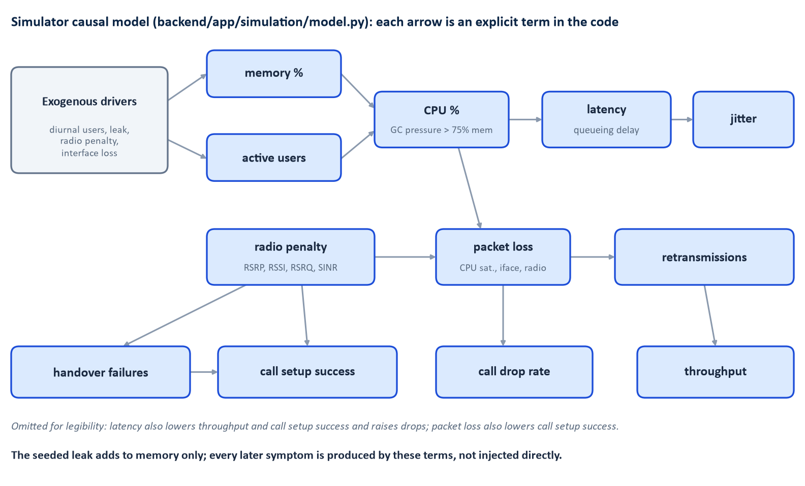
Figure 6. The simulator's causal chain
The terms in model.py implement Figure 6. In brief: memory is 50 + 8 × load plus any leak; CPU is 22 + 35 × load plus garbage-collection pressure 1.8 × max(0, memory - 75); queueing delay is 4 u / (1 - u) ms for utilisation u = CPU/100, capped at 400 ms, added to an 18 ms base for latency; packet loss adds a logistic overflow term that switches on near 93 % CPU. Because incident injectors change only drivers, the downstream symptoms emerge from these formulas.

7.4 Incident scenarios
Table 7. The nine incident types (`incidents.py`)
Type | Scope | Driver changed
overloaded_base_station | cell | users x (1 + 1.3 ramp)
failing_network_interface | cell | random link flaps add interface loss
packet_loss_burst | cell | +11 percentage points loss
abnormal_traffic_spike | cell | users x 1.8
degraded_radio_signal | cell | up to 14 dB radio penalty
software_deployment_regression | node | +38 CPU points; creates a deployment record
memory_leak | node | memory leak about 0.8 points per minute, capped at 41; creates a deployment record
security_attack | cell | users x 1.9, +22 CPU, 3 to 8 IDS events per minute
misconfiguration | cell | handover and setup penalties; creates a config-change event

7.5 The seeded memory-leak and deployment incident
seeded_memory_leak_scenario(seed=7) deploys packet-gateway 2.4.1 to pgw-1 at minute 125, which is 14:05, with a memory leak lasting 235 minutes. The leak starts after a one-minute warm-up. Warning logs ("GC pause ... ms in packet-processing worker") begin once the leak passes 30 points. A benign "hotfix1" deployment to pgw-3 at 13:10 is a deliberate distractor.
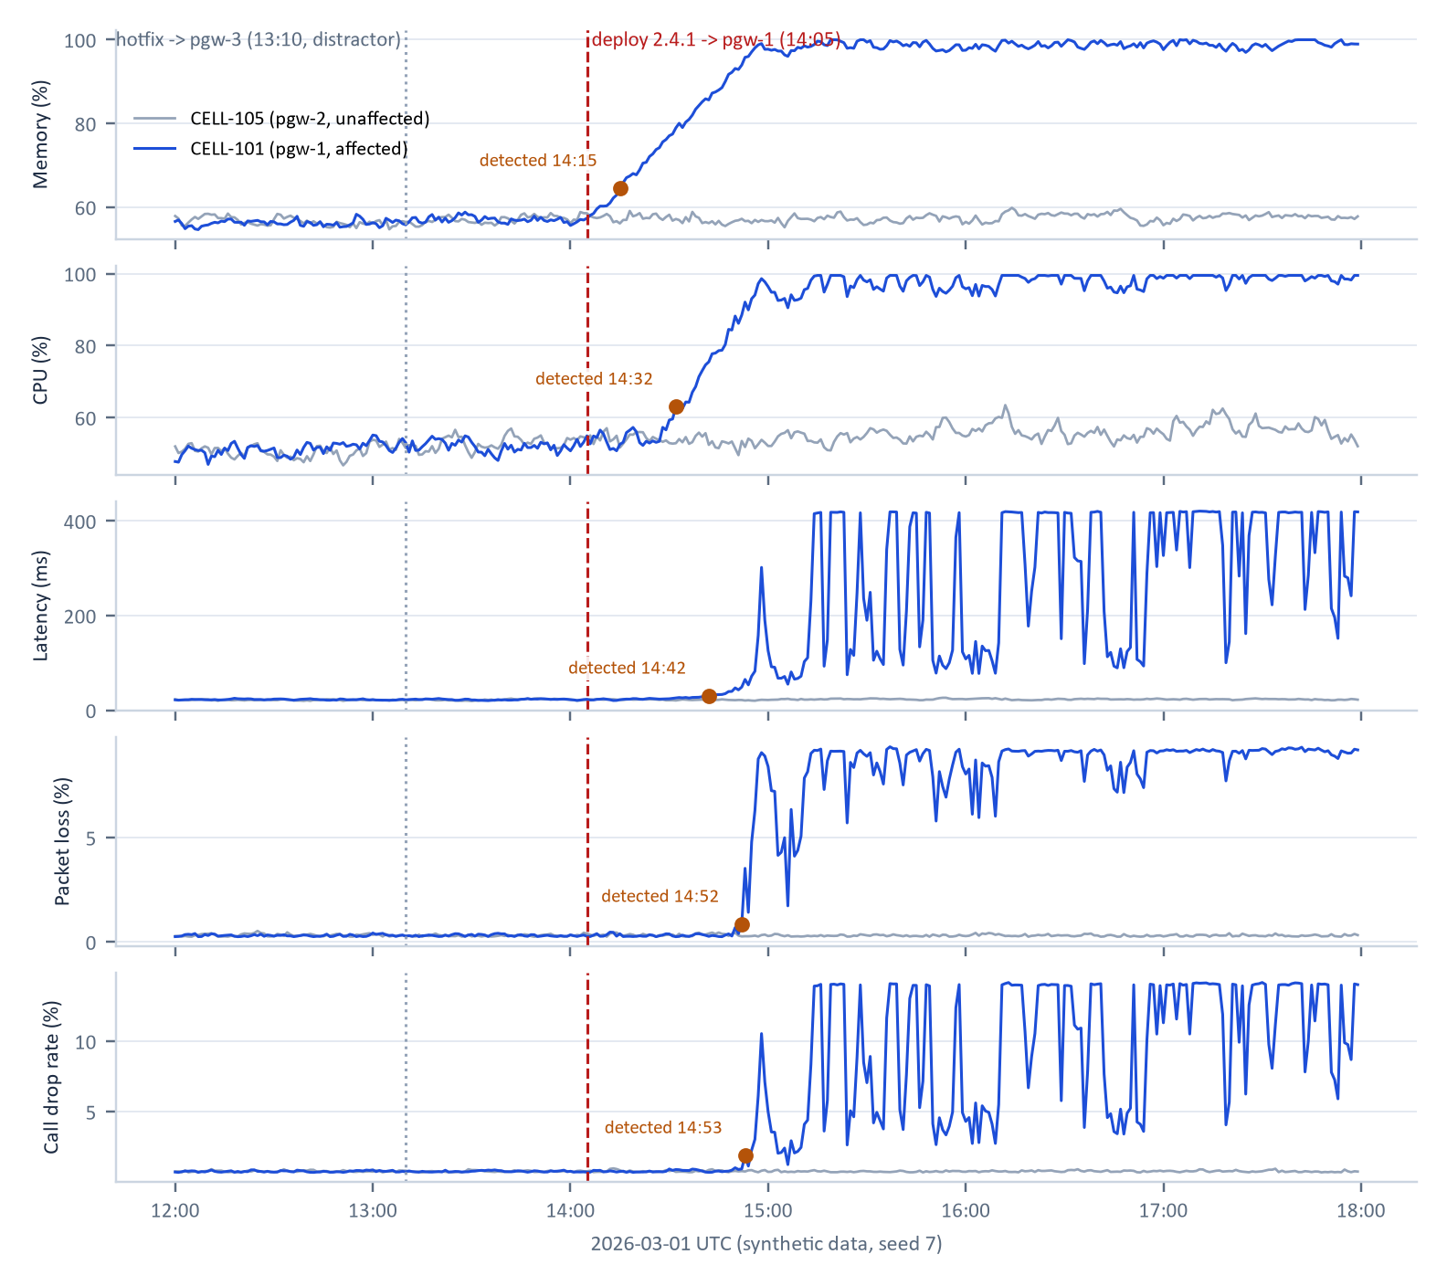
Figure 7. Seeded run, affected cell versus an unaffected control cell
Figure 7 is drawn from data computed by the repository's simulator and detectors (script scripts/documentation/extract_evidence.py). On CELL-101 memory climbs from the 14:05 deployment, CPU follows once memory passes 75 %, then latency, packet loss and call drops. CELL-105 on pgw-2 is flat. The amber markers are where the detectors first flagged CELL-101.
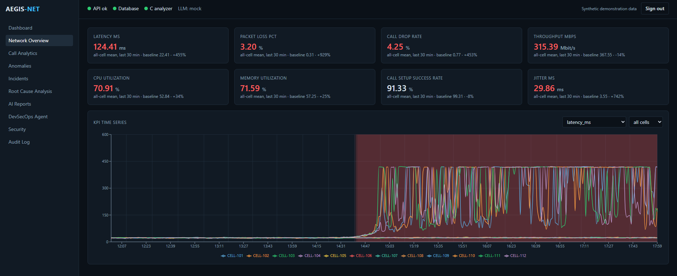
Figure 8. Network Overview page for the same incident
In Figure 8 the eight KPI cards compare the last 30 minutes (all-cell mean) with the baseline: latency 124.41 ms against 22.41 (+455 %), packet loss 3.20 % against 0.31, call drop rate 4.25 % against 0.77, memory 71.59 % against 57.25. The red shaded region is the detected anomaly window. All twelve cells are plotted; four climb, eight stay flat. The all-cell means are lower than the affected-cell means because eight healthy cells dilute them.
Warning. The simulator is a testing instrument. Detector performance measured on it does not show that the same performance would hold on real production telemetry. Thresholds were tuned on this simulator and on generic synthetic series.

8 Anomaly Detection, From Basic to Advanced
Implementation status. VERIFIED Implemented in backend/app/analytics/detectors.py, engine.py and config.py; 24 tests in test_analytics.py. Measured false-positive rate on healthy data recorded in the plan: 0.27 episodes per 100 series-days, none high or critical (a recorded result, not re-run here).

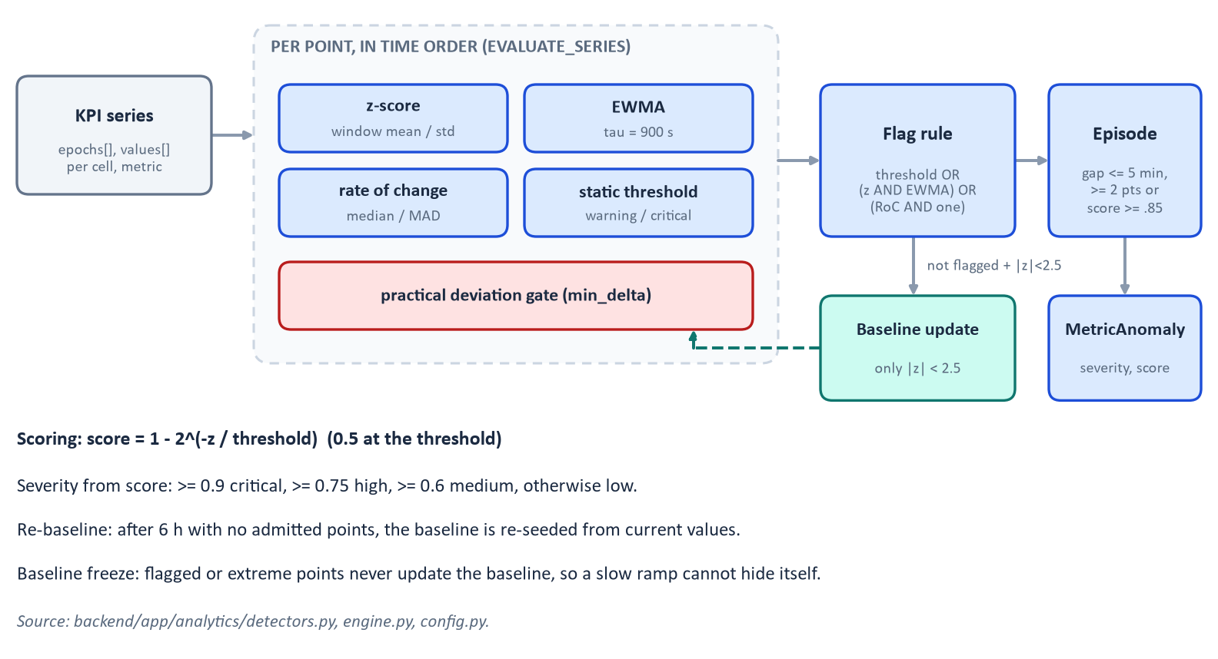
Figure 9. Detector processing pipeline
Figure 9 summarises evaluate_series, which walks each series in time order and, for every point, computes four detector scores, decides whether the point is flagged, and (only if it is clearly normal) lets the point update the baseline.

8.1 Worked example used throughout
Take ten one-minute readings of a KPI: 50, 51, 49, 50, 52, 50, 51, 49, 50, then 80.
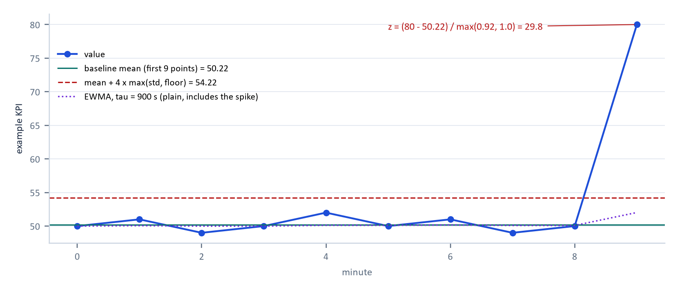
Figure 10. The worked example, with baseline, threshold and EWMA

8.2 Moving average and rolling standard deviation
Intuition. What has this series typically looked like recently? Definition. Over a trailing time window W (60 minutes by default), the mean is the sum of values divided by their count, and the standard deviation is the square root of the average squared distance from the mean. Example. For the first nine readings the mean is 50.22 and the standard deviation 0.92. Parameters. window_seconds = 3600, min_baseline_points = 20 before z-detection starts. Implementation. _Baseline keeps a deque of (time, value) pairs plus running sums, evicting old points by time rather than count so gaps and irregular sampling work. The helpers moving_average and rolling_std exist for charts and reports. Strengths. Simple, explainable. Weaknesses. A long window reacts slowly; a short one learns the anomaly. Tests. Detector unit tests on synthetic steps, ramps and gaps.

8.3 Z-score
Intuition. How many "typical wobbles" away is this reading? Definition.
z = (value - mean) / max(std, scale_floor)
oriented so that positive means the bad direction for that KPI. The floor is max(noise_floor, relative_floor x |mean|) per metric (config.DEFAULT_RULES), so a very quiet series cannot turn trivial changes into huge z. Example. Using latency's noise floor of 1.0: z = (80 - 50.22) / max(0.92, 1.0) = 29.8. How it is used. The z-score detector's score is 1 - 2^(-z/4) (threshold 4.0), but only counts if the deviation also exceeds the metric's practical min_delta (6 ms for latency). Strengths. Standard and interpretable. Weaknesses. Assumes roughly bell-shaped noise; one big outlier inflates the standard deviation; ramps can drag the mean along, which is why the baseline admits only clearly normal points. False positives. Seasonal peaks the window has not seen. Tests. Step, ramp, spike and noise cases.

8.4 EWMA
Intuition. A running average that forgets old data smoothly. Definition. EWMA_t = alpha x Y_t + (1 - alpha) x EWMA_(t-1), the form given in the NIST handbook with smoothing constant between 0 and 1 [R2]. Aegis-Net makes alpha time-aware: alpha = 1 - exp(-dt / tau) with tau = 900 s, so a one-minute step gives alpha of about 0.0645. A matching exponentially weighted variance gives a standard deviation. Example. Starting at 50 with tiny wobbles the EWMA stays near 50.1; if the 80 were admitted it would jump only to 52.0 (the plain ewma helper output for this series, last point), showing how slowly an EWMA moves. How it is used. Its z is computed against the EWMA mean and variance; the detector flags only when z-score and EWMA agree (z at least 4 on both). Strengths. Cheap, adapts to slow drift. Weaknesses. Lags a sudden shift; the detector therefore never feeds flagged points into it. Tests. Time-awareness with irregular spacing.

8.5 Absolute thresholds
Intuition. Some values are bad no matter what is normal. Definition. Per-KPI warning and critical levels, for example latency 100 ms and 200 ms, packet loss 2 % and 5 %, CPU 85 % and 95 %, memory 85 % and 95 %. A breach scores 0.7 (warning) or 0.95 (critical) and flags the point on its own. Strengths. Catches a series that has always been bad, and shows operators familiar numbers. Weaknesses. Fixed numbers encode judgement made for the simulator. False positives. A genuine, intended load increase.

8.6 Rate of change
Intuition. Is the series moving much faster than it usually moves? Definition. Per-minute change compared with the median and MAD of recent healthy changes: z = (rate - median) / max(1.4826 × MAD, floor), threshold 5.0, requiring at least 20 healthy changes and the practical-deviation gate. Strengths. Catches onset quickly. Weaknesses. Noisy at high sampling rates; on its own it does not flag, it needs support from z-score or EWMA.

8.7 Scoring, severity, episodes and baselines
Figure 11 plots the score against z for the C library (threshold 3.5), the Python z-score and EWMA detectors (4.0) and rate of change (5.0). Worked values at threshold 4: z = 4 gives 0.5, z = 8 gives 0.75, z = 12 gives 0.875.
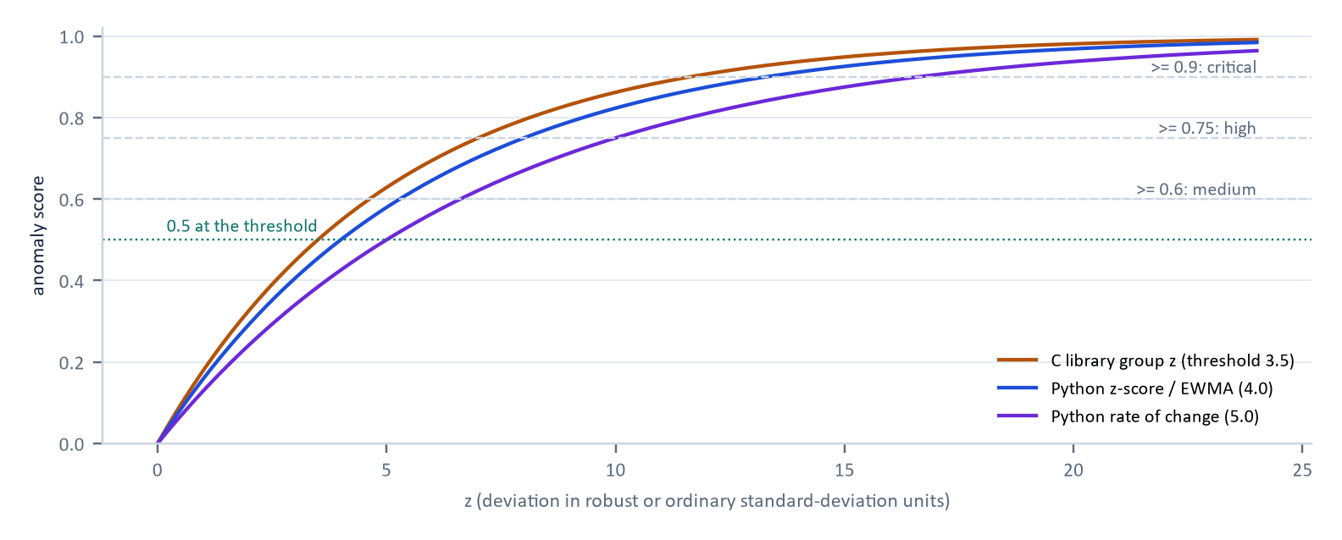
Figure 11. Score as a function of z, with severity bands
- Flag rule. A point is flagged if a static threshold is breached, or z-score and EWMA both reach 0.5, or rate of change reaches 0.5 together with one of them.
- Severity. severity_for_score: score at least 0.9 critical, 0.75 high, 0.6 medium, else low.
- Episodes. Flagged points closer than 300 seconds join one episode; an episode needs at least two points, or a single point scoring at least 0.85. The anomaly carries onset time, the most extreme value, the baseline at onset, the highest score, the detectors that fired and related_metrics (same-cell episodes overlapping within 15 minutes).
- Baseline freeze and re-baselining. Only points with |z| below 2.5 update the baseline, so neither a slow ramp nor a good-direction excursion can contaminate it. After six hours without any admitted point the series is re-seeded from current values, so a permanent level shift is eventually accepted as the new normal. Until then a permanent shift keeps being reported.
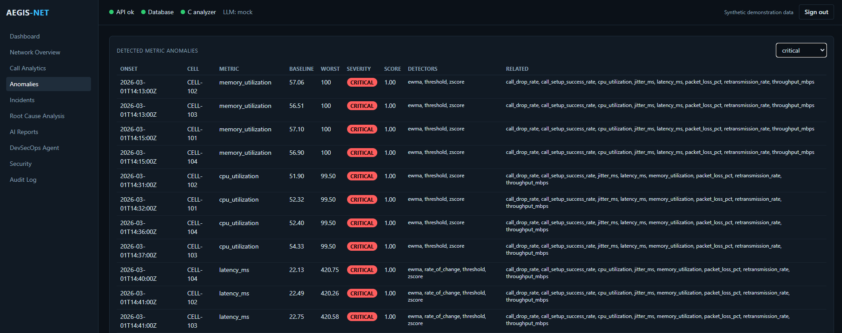
Figure 12. Anomalies page filtered to critical severity
Figure 12 lists, per cell, the onset time, metric, baseline, worst value, severity, score and which detectors fired. Reading the first rows: memory on CELL-102 and CELL-103 starts at 14:13 and on CELL-101 and CELL-104 at 14:15, baseline about 57, worst value 100, detectors ewma, threshold and zscore. The scores are all 1.00 because the extreme point saturates the score. The "related" column lists the other metrics that moved on the same cell.

8.8 Detectors versus the simulator
The simulator creates anomalies by changing drivers; the detectors know nothing about drivers. analytics modules import only the KPI catalogue from the simulator, and a test enforces that. This separation is what makes it meaningful that the detectors found the leak.

8.9 Strengths, failure modes and limits across all detectors
- All four are interpretable: each flag can be traced to numbers.
- Thresholds and floors are hand-set per metric; there is no learning.
- Slow drifts that stay under thresholds for hours can be absorbed by the baseline.
- Multivariate patterns (two KPIs jointly unusual) are not modelled; correlation handles that at the incident level.
Note. Future work (not implemented): Isolation Forest, an ensemble of random trees that isolates unusual points quickly, and DBSCAN, a density-based clustering method that labels sparse points as noise, are optional in the specification and are not part of Aegis-Net NOT IMPLEMENTED . They are mentioned only as candidates for Chapter 20.

9 Correlation and Root-Cause Reasoning
Implementation status. VERIFIED backend/app/analytics/correlation.py and causal_graph.py; 29 tests in test_correlation.py. The recorded healthy-data check found 0 incidents over 20 healthy days (a recorded result, not re-run here). The seeded outputs below were recomputed for this handbook.

9.1 Why symptoms share a cause
Nine KPIs turned critical in the seeded run, but there was one fault. A deployment leaked memory; memory pressure forced garbage collection and raised CPU; CPU raised queueing delay (latency, jitter); congestion lost packets; lost packets caused retransmissions, dropped calls and lower throughput. An operator who sees nine alerts needs the engine to group them and say which came first and what changed just before.

9.2 What the engine actually computes
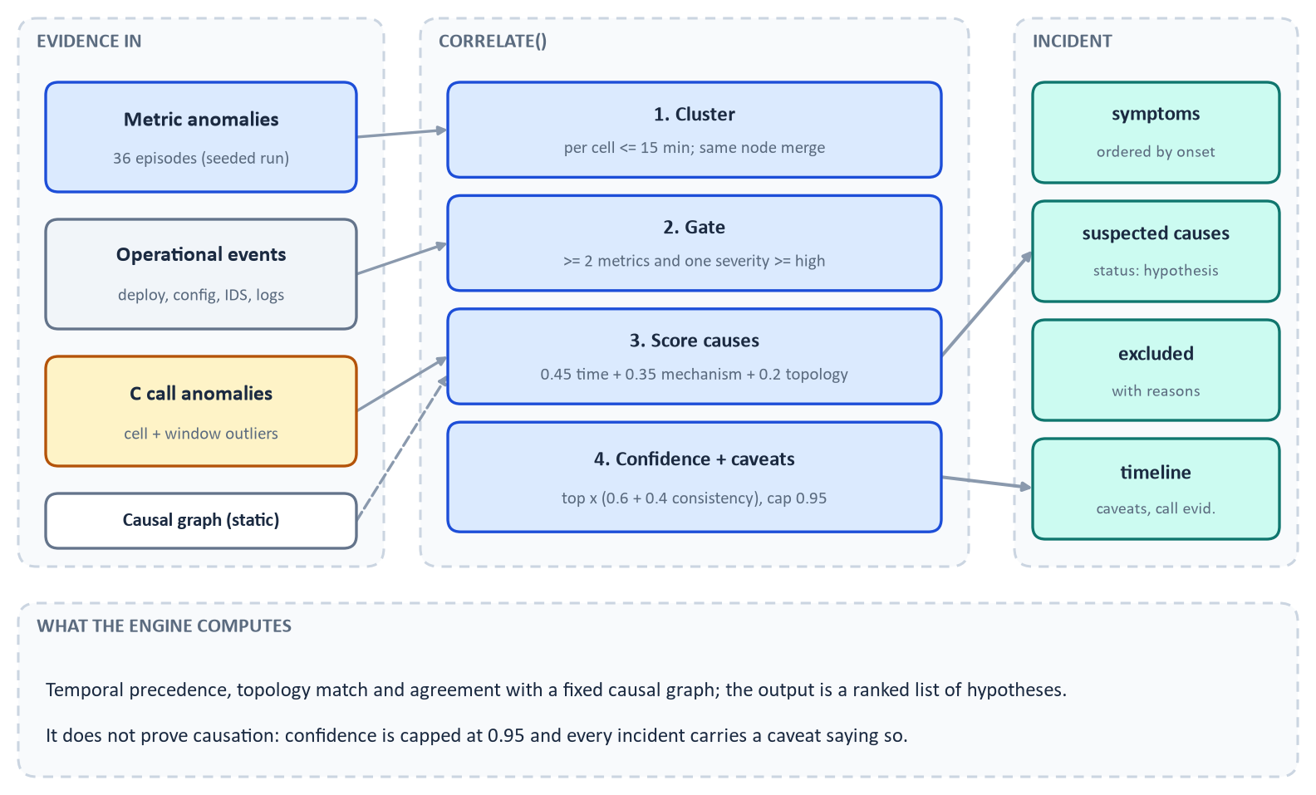
Figure 13. Evidence in, ranked hypotheses out
correlate() works in five steps (Figure 13).
1. Clustering. Anomaly episodes on one cell whose start lies within 15 minutes of the cluster's span form a cell cluster. Cell clusters on the same node merge if their onsets are within 15 minutes; clusters on different nodes never merge.
2. Incident gate. A cluster becomes an incident only with at least two distinct symptom metrics and at least one symptom of severity high or above. This is why coincidental noise does not open incidents.
3. Candidate causes. Each candidate gets
score = 0.45 × temporal + 0.35 × mechanism + 0.20 × topology
where temporal is exp(-lead / 30 min) for an event up to two hours before onset (0.3 for an event within five minutes after onset, 0.5 for symptom-only causes); mechanism is half the share of the earliest symptoms (within two minutes of onset) that the cause is expected to produce first plus half the share of all symptoms the cause explains in the causal graph; and topology is 1.0 when the event targets an affected node or cell and 0.5 otherwise. Event-backed classes are deployment regression, configuration change and security attack (needs at least 10 IDS events); symptom-only classes are memory exhaustion, traffic overload, radio degradation and transport fault.
1. Exclusion. Deployments and changes on other elements are listed in excluded_candidates with a reason.
2. Confidence = top score × (0.6 + 0.4 × chain consistency), multiplied by 0.9 if the top two scores are within 0.1, capped at 0.95. Chain consistency is the share of effects that are preceded (within a one-minute tolerance) by at least one observed upstream cause in the fixed causal graph (causal_graph.EDGES).
Warning. Time ordering plus a hand-written graph is evidence, not proof. Statistical correlation does not establish causation, and the engine says so: every suspected cause has status: "hypothesis", the incident carries a caveat to that effect, and confidence is capped.

The engine also records, for each adjacent pair of symptoms, the onset lag and (when series are available) the best lag of the Pearson correlation of first differences. In the seeded run that lag came out as 0 for most pairs (cross-correlation values from 0.44 to 1.0), so the onset ordering, not the cross-correlation lag, carries the temporal story. The report labels the sequence as temporal, not causal.

9.3 The seeded evidence chain
Table 8. Verified symptom onsets for INC-2026-001 (first onset across the four cells; recomputed for this handbook)
Onset (UTC) | Symptom | Baseline | Worst | Lag from previous
14:13 | memory_utilization | 56.5 % | 100 % | (first)
14:31 | cpu_utilization | 51.9 % | 99.5 % | +18 min
14:40 | latency_ms | 22.1 ms | 420.8 ms | +9 min
14:45 | jitter_ms | 3.7 ms | 105.9 ms | +5 min
14:50 | packet_loss_pct | 0.31 % | 9.46 % | +5 min
14:52 | retransmission_rate | 1.1 % | 15.8 % | +2 min
14:53 | call_drop_rate | 0.80 % | 14.2 % | +1 min
14:53 | call_setup_success_rate | 99.3 % | 67.6 % | +0
14:53 | throughput_mbps | 444 Mbit/s | 103.7 Mbit/s | +0

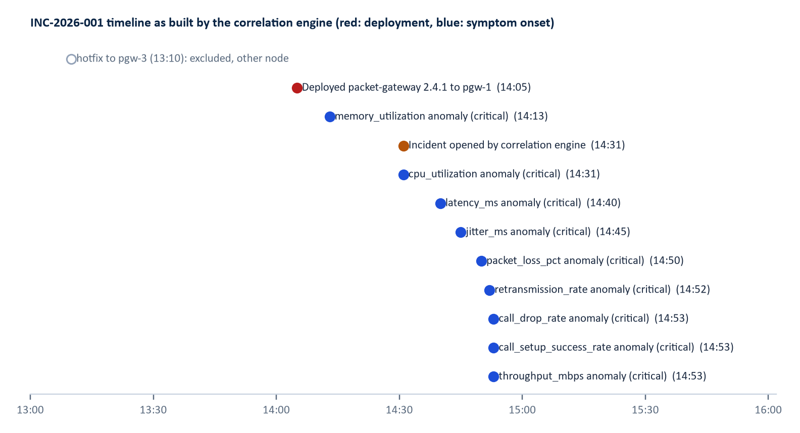
Figure 14. The timeline the engine builds
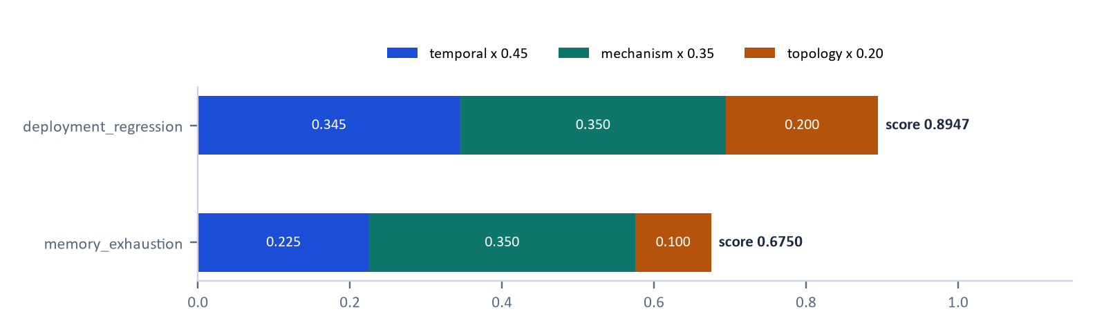
Figure 15. Why deployment_regression outranks memory_exhaustion
Figure 15 decomposes the scores: the deployment 8 minutes earlier on the same node has temporal 0.766 (exp(-8/30), since the deployment preceded the 14:13 onset by 8 minutes), mechanism 1.0, topology 1.0, so 0.45 × 0.7659 + 0.35 × 1 + 0.2 × 1 = 0.8947. Memory exhaustion has the same mechanism score but only the neutral temporal prior 0.5 and topology 0.5: 0.225 + 0.35 + 0.1 = 0.675. Chain consistency was 1.0, the margin 0.22 (not a close call), so confidence is 0.8947. The hotfix deployed to pgw-3 at 13:10 appears under excluded candidates: "targets pgw-3, outside the affected nodes ['pgw-1']". That is how the distractor is handled.
Note. The incident timeline shown on the dashboard includes the first ten warning and error application logs on the affected topology (for example "GC pause 382 ms in packet-processing worker" from 14:47), which Figure 14 omits for legibility.

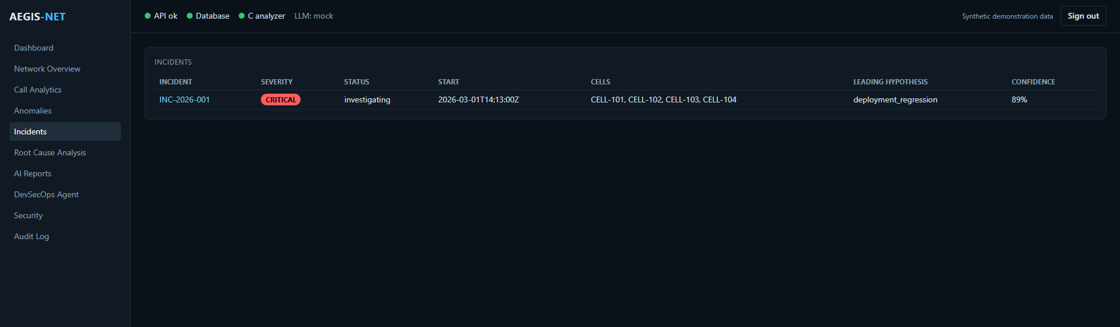
Figure 16. Incidents list: one critical incident with its leading hypothesis
Figure 16 shows the result as an operator sees it: INC-2026-001, critical, status investigating, start 14:13, four cells, leading hypothesis deployment_regression at 89 %. The 89 % is the correlation engine's confidence; the RCA page (Chapter 13) shows the RCA engine's own 85 %.

10 Database and Backend API
Implementation status. VERIFIED Models in backend/app/models/, migration backend/alembic/versions/0001_initial_schema.py, routes in backend/app/api/. Tests: test_api_core.py (30 collected, 29 run; the skipped one needs AEGIS_TEST_POSTGRES_URL). PostgreSQL migration was verified earlier against a postgres:16 container according to the plan; that PostgreSQL test was skipped in this session's run and not re-executed UNVERIFIED HERE .

10.1 Relational modelling in this project
Timestamps are stored as UTC epoch seconds in BigInteger columns so SQLite and PostgreSQL behave identically. JSON columns (JSONB on PostgreSQL) are reserved for evidence and documents such as symptoms, tool calls and report payloads; relational columns hold everything that needs filtering or joining. Foreign keys cascade from pipeline_runs so deleting a run removes its data. Identifiers produced by the analytics layer are deterministic per scenario, so stored ids are made run-scoped (R<run>-ANOM-...); incident ids are allocated globally (INC-2026-001, INC-2026-002, and so on).
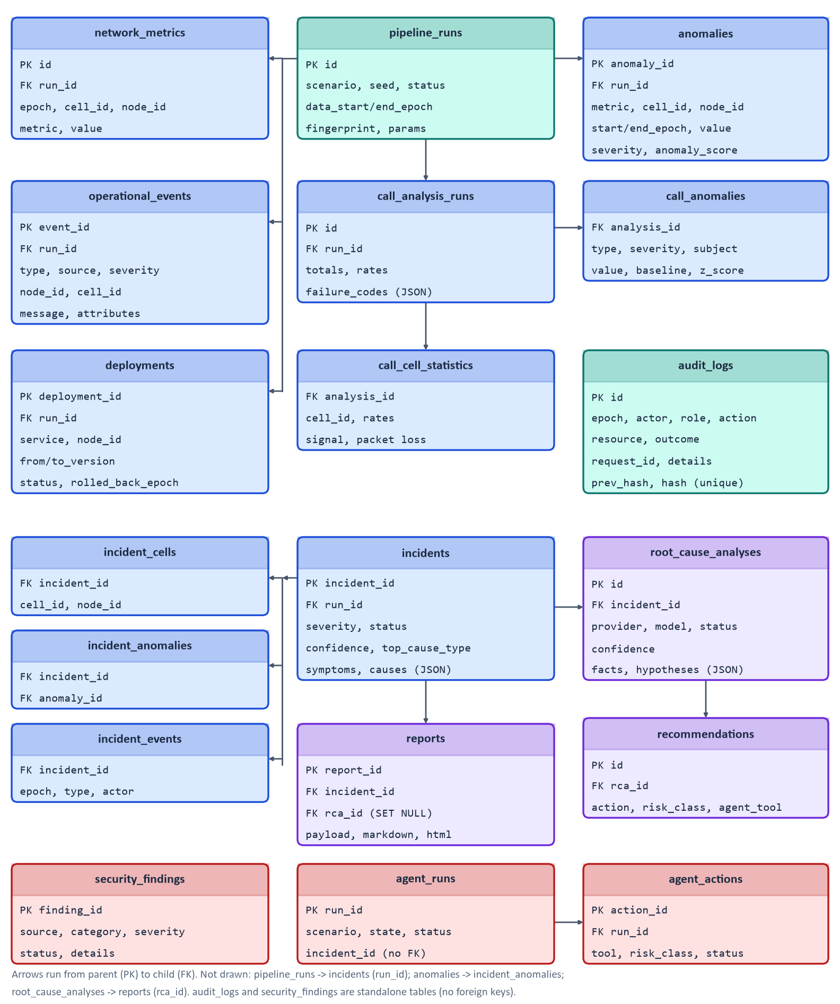
Figure 17. Entity-relationship diagram of the 19 tables (from `app/models/`)

10.2 SQLAlchemy, Alembic and PostgreSQL
SQLAlchemy 2 maps Python classes to tables (Mapped[...] annotations; a naming convention gives deterministic constraint names). Alembic holds one migration, 0001_initial_schema, applied by alembic upgrade head (in the Docker entrypoint and the demo). The same migration runs on SQLite (offline demo, tests) and PostgreSQL 16 (Docker). On PostgreSQL, audit appends take an advisory lock so the hash chain cannot fork.

10.3 FastAPI, Pydantic and validation
FastAPI builds the routes and an OpenAPI description served at /openapi.json and /docs. Request bodies are Pydantic models with extra="forbid": an unknown field is a 422, not silently ignored. Path and query parameters carry regular-expression patterns (incident ids, report ids, cell ids, metric names) and numeric bounds, for example minutes must be 60 to 1440. FastAPI's own documentation describes its fastapi.security utilities that integrate with the interactive docs [R3]; Aegis-Net uses an HTTPBearer dependency wrapped in require_role.
Status codes used: 200 or 201 for success, 401 invalid or missing token, 403 insufficient role or separation-of-duties violation, 404 unknown id, 409 invalid state (for example executing an unapproved action), 413 body too large, 422 validation failure, 429 rate limit, and a generic 500 with only a request id.

10.4 Endpoint reference
Table 9. REST endpoints (verified against `backend/app/api/*.py`; 26 routes plus `/metrics`)
Method and path | Minimum role | Purpose
GET /api/health | public | Status, database, C library and provider names; no secrets
POST /api/pipeline/run | operator | Run a pipeline. Body: {"scenario":"seeded"|"healthy","seed":7,"minutes":360,"rollback_minute":null}. Returns a run summary (201)
GET /api/pipeline/runs | viewer | List runs
GET /api/calls/statistics | viewer | C-library statistics for a run (?run_id, default latest)
GET /api/calls/anomalies | viewer | C-library anomalies
GET /api/network/metrics | viewer | KPI series (metric, cell_id, start, end, run_id)
GET /api/network/anomalies | viewer | Detected anomalies (cell_id, metric, severity)
GET /api/network/overview | viewer | Health score, KPI current versus baseline, per-cell status
GET /api/incidents | viewer | Incident summaries (status, severity)
GET /api/incidents/{id} | viewer | Detail with timeline, cells, symptoms, hypotheses, caveats
POST /api/incidents/{id}/investigate | operator | Run the RCA (201)
GET /api/incidents/{id}/rca | viewer | Latest RCA with the explanation chain
POST /api/reports/generate | operator | Body {"incident_id":"INC-2026-001"}; stores a report (201)
GET /api/reports | viewer | List (incident_id)
GET /api/reports/{report_id} | viewer | ?format=json|markdown|html
GET /api/agent/status | viewer | Policy table, pending approvals
GET /api/agent/actions | viewer | Actions (run_id)
GET /api/agent/runs, /api/agent/runs/{run_id} | viewer | Runs and detail
POST /api/agent/investigate | operator | Body {"scenario":"production_anomaly","incident_id":null} (201)
POST /api/agent/approve/{action_id} | approver | Body {"decision":"approve"|"deny","comment":""}
POST /api/agent/execute/{action_id} | operator (admin for HIGH_RISK) | Execute an approved action
GET /api/deployments | viewer | Deployment records
GET /api/security/findings | viewer | Synthetic security findings
GET /api/audit | operator | Audit rows (action, limit, offset)
GET /api/audit/verify | admin | Hash-chain verification: {"valid":true,"rows":24,"first_invalid_id":null,"reason":null}
GET /metrics | none (not proxied) | Prometheus text metrics

An example call, using a token from the git-ignored .aegis-tokens file (never printed here):
curl -s -H "Authorization: Bearer $VIEWER_TOKEN" http://127.0.0.1:8000/api/incidents

10.5 Pipeline execution
services/pipeline.py runs simulate, CDR generation, C analysis, detection, correlation and storage, then persists metrics in batches of 20,000 rows. In the demo this takes seconds and runs synchronously inside the request; there is no job queue (Chapter 20).

11 Authentication, Security, and Auditability
Implementation status. VERIFIED backend/app/security/, api/deps.py, agents/; test_security.py (22 tests, 21 run; the live-Redis test is skipped without AEGIS_TEST_REDIS_URL), test_api_core.py, test_agent.py.

11.1 Authentication versus authorisation
Authentication asks who you are; authorisation asks what you may do. Aegis-Net authenticates with bearer tokens: configured only as SHA-256 hashes in AEGIS_API_TOKENS (format name:role:sha256), compared in constant time against every entry (no early exit) with hmac.compare_digest. Raw tokens are generated by make env, written to the git-ignored .aegis-tokens file with mode 600, and shown only there. Tokens are accepted only in the Authorization: Bearer header, not in query strings, cookies or Basic auth (tested).
Authorisation uses four ordered roles, each including the lower ones: viewer (1), operator (2), approver (3), admin (4) (config.Role is an IntEnum).
Table 10. Role-permission matrix derived from `require_role` in `api/deps.py` and `agents/policy.py`
Capability | Viewer | Operator | Approver | Admin
Read dashboards, incidents, RCA, reports, agent state | yes | yes | yes | yes
Run pipeline, investigate, generate reports, start agent runs | no | yes | yes | yes
Read the audit log | no | yes | yes | yes
Approve or deny agent actions (not own runs) | no | no | yes | yes
Execute approved REQUIRES_APPROVAL actions | no | yes | yes | yes
Execute approved HIGH_RISK actions (when the flag is on) | no | no | no | yes
Verify the audit hash chain | no | no | no | yes

An approver is not blocked from starting runs, because roles are cumulative; the separation of duties rule instead blocks anyone approving an action of a run they started (principal.name == run.started_by).
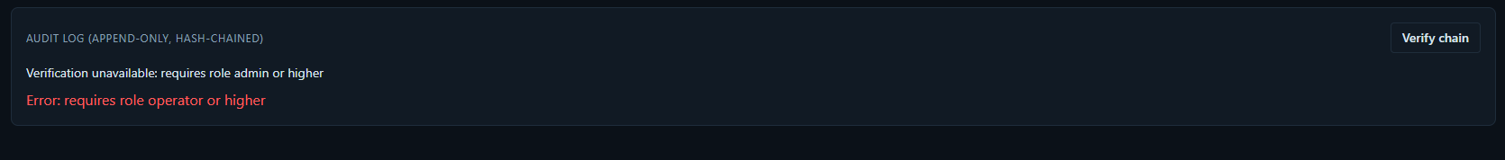
Figure 18. Dashboard behaviour when a viewer opens the Audit page
Figure 18 shows a signed-in viewer pressing "Verify chain": the page reports "Verification unavailable: requires role admin or higher" and "Error: requires role operator or higher" for the list. The control is visible but the server refused the calls. This is the right place for enforcement; hiding buttons would be cosmetic.
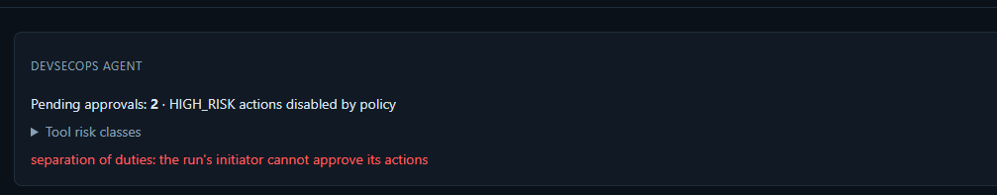
Figure 19. Separation of duties message in the agent panel

11.2 Approval gates
The policy (agents/policy.py) classifies each tool as READ_ONLY, LOW_RISK, REQUIRES_APPROVAL, HIGH_RISK or BLOCKED and returns allow, needs_approval or deny; Chapter 15 details the flow. The decisive point is that execute_action re-checks every rule immediately before running, so the API route is only a second line of defence.
Note. A policy written in a document is only a promise. A policy enforced in application code, re-checked at the moment of action and covered by tests that try to bypass it, is a control. Aegis-Net's agent policy is the latter: the repository's tests include a test that an unapproved action cannot execute via the service and one that the initiator cannot approve their own action.

11.3 Request identifiers, logging and audit
Every response carries X-Request-ID (a valid incoming value is echoed, otherwise generated); JSON access-log lines record method, route template, status, duration and actor. A log-record factory stamps request_id, incident_id and agent_run_id onto records. Tokens and API keys are never logged (tested).
The audit log is append-only. Each row stores prev_hash and hash, where the hash is the SHA-256 of a canonical JSON of the row's content plus the previous hash, starting from 64 zeros:
def _digest(prev_hash: str, fields: dict[str, Any]) -> str:
canonical = json.dumps({"prev": prev_hash, **fields}, sort_keys=True, separators=(",", ":"),
default=str)
return hashlib.sha256(canonical.encode("utf-8")).hexdigest()

verify_chain walks the rows in order and reports the first row whose prev_hash or content hash does not match. Editing or deleting a row therefore invalidates every later link. The application code only ever inserts audit rows (the other uses of the table are reads for listing and verification), but the database itself has no trigger or permission blocking UPDATE or DELETE, so "append-only" is a property of the code plus the tamper evidence of the chain, not of the database. A caveat: a database administrator who recomputes all later hashes could forge a consistent chain, so for stronger guarantees the head hash would need external anchoring, which is not implemented NOT IMPLEMENTED .
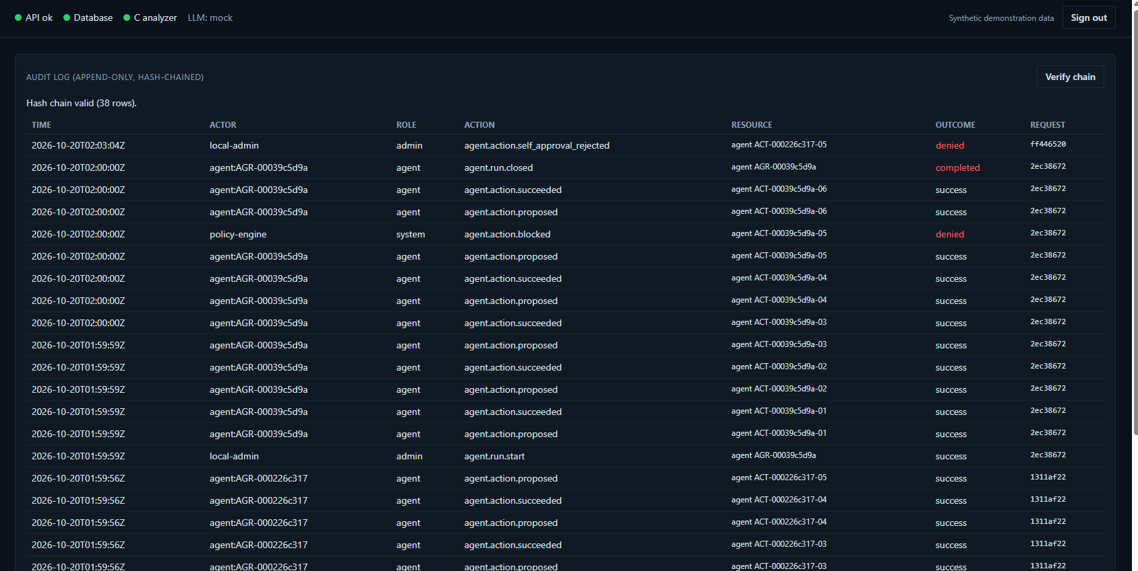
Figure 20. Audit Log page: hash chain valid (38 rows)
Figure 20 shows rows for agent runs (agent.run.start, agent.action.proposed, agent.action.succeeded), a policy-engine block (agent.action.blocked, outcome denied), and a rejected self-approval by local-admin (agent.action.self_approval_rejected, denied). The request column groups rows made in one request. Denied authentication attempts are audited too (auth.denied, auth.forbidden).

11.4 Input validation, limits and rate limiting
Pydantic extra="forbid" bodies; patterns on ids, metrics and cells; a 1 MB request limit enforced for declared and streamed bodies (413); security headers (nosniff, X-Frame-Options: DENY, Referrer-Policy: no-referrer, a restrictive Content-Security-Policy on /api/*); and a fixed per-minute rate-limit window keyed by a hash prefix of the Authorization header or the client IP, using Redis when REDIS_URL is set and an in-process limiter otherwise (default 120 per minute; the Docker stack uses 600).

11.5 Prompt injection and untrusted log content
Logs, security events and report text may contain attacker-controlled strings. Controls in the code: the RCA system prompt tells the model that tool results are data and any instructions inside them must be ignored; tools are read-only, incident-scoped and size-limited, so even a successful injection could only change what the model says, not what the system does; the model's answer must validate against a strict schema and cite real tool calls; and no LLM output ever becomes a shell command or tool choice in the agent. HTML reports are autoescaped and Markdown cells escape |, \, <, > and newlines (tested with injected <script> payloads), and the dashboard renders HTML reports in a sandboxed iframe.
Limitation. A prompt in the system message is not a guarantee: a live model could still be misled into a wrong conclusion. The mitigation is structural (read-only tools, validation, human approval), not the prompt wording. Live-model behaviour against injected content was not tested UNVERIFIED HERE .

11.6 Safe command execution and secrets
Agent commands run only through CommandRunner (Chapter 15): fixed executables, shell=False enforced by an AST test, argument allowlists, a confined working directory, a scrubbed environment, a timeout and truncated output. Secrets are read from environment variables only; Settings marks keys and token hashes repr=False; .env, .aegis-tokens and virtual environments are git- and docker-ignored; no secret value appears in this handbook, the slides or the screenshots (checked).

12 LLM Provider Abstraction
Implementation status. VERIFIED interface, mock provider, provider selection, schema validation, and request-shape tests with fake SDK clients. UNVERIFIED HERE Anthropic, OpenAI and local providers were never called live: no API key was available, and the opt-in live test (AEGIS_RUN_LIVE_LLM_TESTS=1) was skipped in this session's run.

12.1 Basics
An LLM receives a conversation and, when given tool schemas (JSON descriptions of functions with typed arguments), may reply with a request to call one. Structured output means the final answer must be a JSON object matching a schema. A JSON schema describes the allowed fields and types; Pydantic validates data against Python models and can export a JSON schema from them.

12.2 Provider abstraction
backend/app/llm/base.py defines a provider-neutral interface: messages (UserMessage, AssistantMessage carrying the provider's raw content, ToolResultsMessage), ToolSpec, ToolCall, ToolResult, LLMResponse, and an LLMProvider with two methods: generate(system, messages) for plain text and tool_call(system, messages, tools) for one turn that may request tools. Providers translate to their wire format and never execute tools. Errors are normalised to LLMRefusalError, LLMRateLimitError and LLMUnavailableError (both retryable) and LLMConfigurationError. The abstraction matters because the RCA engine, reports and tests can then run unchanged against a deterministic mock offline and against a real model online.
Table 11. Providers as implemented
LLM_PROVIDER | Class | Behaviour | Verification
mock (default) | MockProvider | Deterministic; delegates tool_call to a rule-based investigator and generate to a template; not an LLM | VERIFIED used by tests, demo, screenshots
anthropic | AnthropicProvider | Official SDK, lazy import; default model claude-opus-5-5; effort set explicitly (high); every tool strict; tool choice auto; server-side refusal fallback beta; refusals checked first; assistant content echoed unchanged; SDK errors mapped | UNVERIFIED HERE request shape tested with fakes
openai | OpenAIProvider | Chat Completions with strict function tools; MODEL_NAME is required; malformed tool-call JSON surfaces as an invalid-arguments error | UNVERIFIED HERE
local | OpenAIProvider(base_url=LOCAL_LLM_BASE_URL) | Any OpenAI-compatible server | UNVERIFIED HERE

Selection happens in factory.build_provider. If the chosen provider lacks its key, URL or SDK, the factory returns the mock and a fallback_reason that the API exposes; an unknown name also falls back. This keeps the system usable offline, but it means a misconfigured live provider silently becomes the mock unless someone reads the reason, so /api/health reports the provider name.

12.3 Configuration
Environment variables (no values here): LLM_PROVIDER, MODEL_NAME, ANTHROPIC_API_KEY, OPENAI_API_KEY, LOCAL_LLM_BASE_URL. Vendor SDKs are optional installs (backend/requirements-llm.txt; included in the Docker image).

12.4 Sequence of an investigation
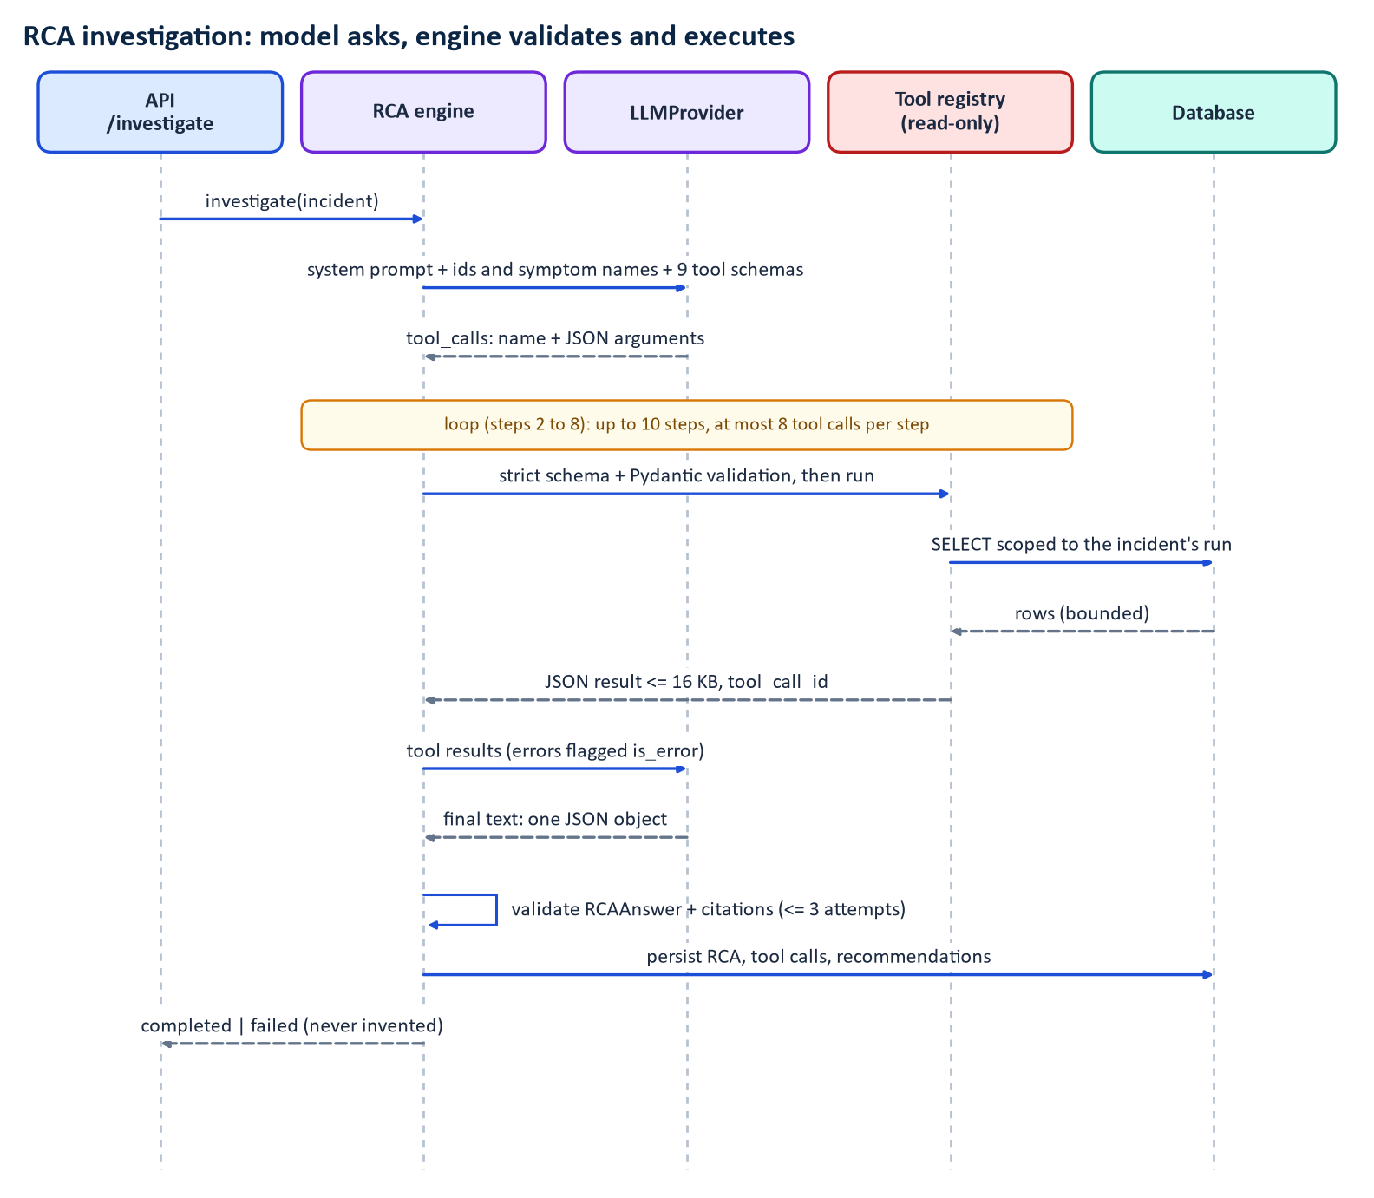
Figure 21. RCA tool-calling sequence
Figure 21 is the loop of rca/engine.py. The opening prompt contains only identifiers and symptom names, never raw data. The model requests tools; the engine looks each name up in the allowlisted registry, validates the arguments twice (the strict JSON schema sent to the model, and a Pydantic model with extra="forbid" and strict types), runs the tool, enforces a 16,000-character result limit and returns the result with its tool_call_id. Unknown tools, invalid arguments and tool errors go back to the model as is_error results and are recorded, never executed. Failures from the provider end the investigation as failed with the reason.

12.5 Deterministic testing with the mock
rca/mock_investigator.py follows a fixed plan through the same read-only tools and builds its answer only from the results it received, citing their ids; the answer then passes the same validation as a real model's. That makes the validation, citation and persistence paths testable offline. It also means mock RCA output demonstrates the pipeline, not language-model quality. In the seeded run the mock made 12 tool calls.
Warning. The mock provider is rule-based. Everything labelled "mock" in a screenshot (the header shows LLM: mock, the RCA page mock/mock-deterministic-v1) was produced by deterministic code, not by a language model. Do not read it as evidence of how a live model would reason.

13 Root-Cause Analysis Engine
Implementation status. VERIFIED with the mock provider; live providers UNVERIFIED HERE .

13.1 Workflow
1. Incident selection. POST /api/incidents/{id}/investigate (operator) loads the incident and moves it to investigating.
2. Evidence collection through nine read-only tools (rca/tools.py):
Table 12. RCA tools
Tool | Returns
get_call_statistics | Overall statistics from the C analyser with per-cell figures
get_cell_statistics | Call statistics, call anomalies and metric anomalies for one cell
get_metric_history | One KPI on one cell, downsampled to at most 120 points
get_anomalies | Metric anomalies overlapping a time range
get_related_events | The incident's timeline, correlation hypotheses (answers only for the incident under investigation)
get_recent_deployments | Recent packet-gateway deployments
get_security_events | IDS events aggregated by category and target
get_logs | Log entries for one known service
compare_baseline | KPI mean in a range versus the preceding 60 minutes, per cell

Tool limits: known metric names, cell patterns and services only; time spans of at most 24 hours; incident-scoped read-only database access; bounded output.
1. Hypothesis generation and evaluation. The answer must contain facts, inferences, hypotheses (cause type, confidence of at most 0.95, supporting and contradicting evidence, an assessment), recommended_actions (priority, risk class, optional agent tool) and verification_steps.
2. Citations. Facts and inferences cite tool-call ids. validate_citations rejects an answer that cites a call that did not happen, a fact with no successful call, or a leading hypothesis without supporting evidence from a successful call. The root cause must be the highest-confidence hypothesis and its confidence must match.
3. Limits and retries. At most 10 steps, 8 tool calls per step and 3 answer attempts; a rejected answer receives feedback; after the last attempt the RCA is stored as failed and no cause is invented.

13.2 Facts, inferences, hypotheses, recommendations
Observed measurements are facts (each with a tool-call id). Relationships derived from facts are inferences. Candidate causes with confidences are hypotheses, and the headline is always labelled a hypothesis. Recommendations carry a risk class. The dashboard shows this explicit chain: observed evidence, correlated events, candidate hypotheses and evaluation, most likely root cause, confidence, recommended remediation.

13.3 Worked example from the seeded incident
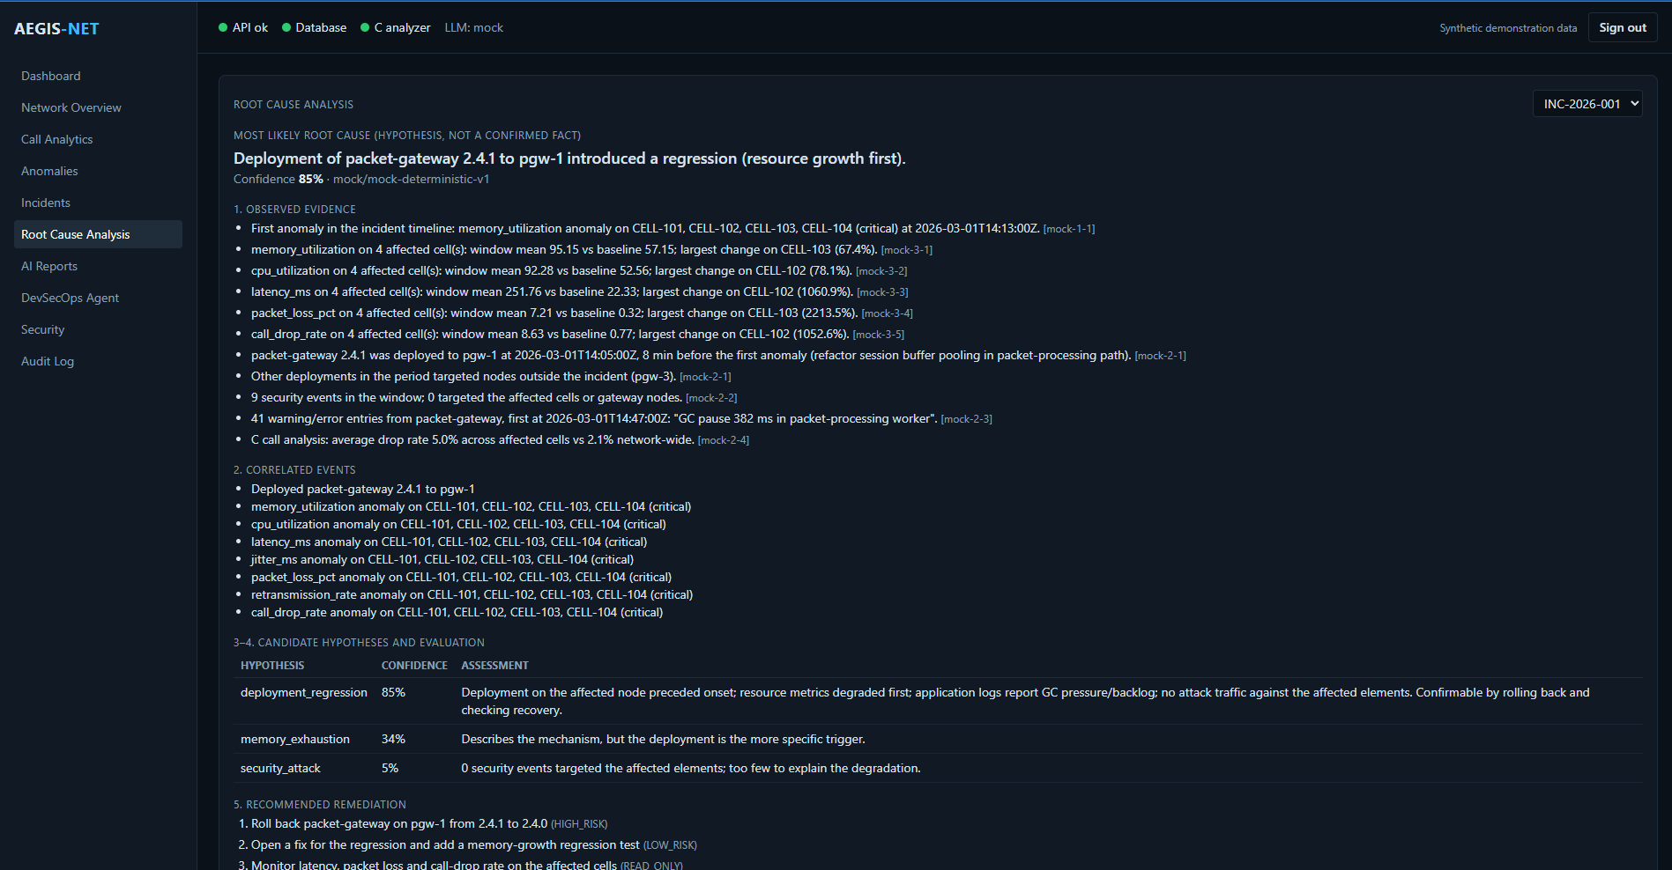
Figure 22. Root Cause Analysis page for INC-2026-001 (mock provider)
Figure 22 presents: "Deployment of packet-gateway 2.4.1 to pgw-1 introduced a regression (resource growth first)", confidence 85 %, labelled "hypothesis, not a confirmed fact". Under observed evidence each bullet ends with a tool-call id such as [mock-3-1], for example "memory_utilization on 4 affected cell(s): window mean 95.15 vs baseline 57.15; largest change on CELL-103 (67.4%)". Others state that packet-gateway 2.4.1 was deployed to pgw-1 at 14:05, 8 minutes before the first anomaly, that other deployments targeted other nodes, that 9 security events in the window targeted none of the affected cells, that 41 warning or error log entries from packet-gateway began at 14:47 with a GC pause, and that the C analysis found a 5.0 % average drop rate across the affected cells against 2.1 % network-wide. The hypothesis table gives deployment_regression 85 %, memory_exhaustion 34 % ("describes the mechanism, but the deployment is the more specific trigger") and security_attack 5 % ("0 security events targeted the affected elements"). Recommended remediation begins with rolling back packet-gateway on pgw-1 from 2.4.1 to 2.4.0, marked HIGH_RISK.

13.4 Presenting conclusions without exposing hidden reasoning
Provider "thinking" blocks are never stored or shown. What is stored is the structured facts, inferences, hypotheses, evidence references and recommendations plus the list of tool calls with arguments and results. That gives an auditor the evidence trail without a transcript of private reasoning, which also avoids presenting unverifiable narrative as evidence.

14 Report Generation
Implementation status. VERIFIED JSON, Markdown and HTML; 11 tests in test_reporting.py. NOT IMPLEMENTED PDF output.

14.1 Data model and numeric consistency
ReportDocument (reporting/document.py) is a Pydantic model with extra="forbid" and sections: KPI analysis, anomaly analysis, correlation analysis, root cause, impact, recommendations, verification steps, confidence, evidence references and timeline. build_report computes every figure from the database: for each KPI, the mean of the affected cells over the hour before onset (baseline) against the incident window, plus the worst value in the bad direction and the percentage change. Users connected is the sum over cells of mean active_users; call counts come from the C analysis and cover the whole analysed log for the affected cells (stated in the text, not just the incident window).

14.2 Narrative and template fallback
Only the executive summary is generated prose. It comes from LLMProvider.generate (the mock uses a deterministic template) and is accepted only if every number in it appears in the JSON context the model was given (_narrative_is_grounded); otherwise the template is used and narrative_provider records the rejection. Provider errors also fall back to the template.

14.3 Renderers and escaping
Jinja2 templates render Markdown and HTML from the same document. The HTML environment autoescapes, StrictUndefined makes a missing field an error, Markdown table cells escape special characters, and the HTML endpoint sends Content-Security-Policy: default-src 'none'; style-src 'unsafe-inline' and X-Content-Type-Options: nosniff.

14.4 An actual excerpt
The excerpt below is from the report written by make demo for this handbook (RPT-INC-2026-001-03). It covers the window up to the simulated rollback, so its means are lower than the report in the screenshot, which covers the full unmitigated window.
## KPI Analysis
| KPI | Baseline (1 h before) | Incident mean | Worst | Change |
| latency_ms (ms) | 22.331 | 48.059 | 418.673 | 115.2% |
| memory_utilization (%) | 57.148 | 81.375 | 99.281 | 42.4% |
Symptom onset sequence (temporal order, not proof of causation):
- memory_utilization -> cpu_utilization (+18 min)
- cpu_utilization -> latency_ms (+9 min)
Correlation hypotheses (ranked, not proven):
- deployment_regression - score 0.8947
- memory_exhaustion - score 0.675

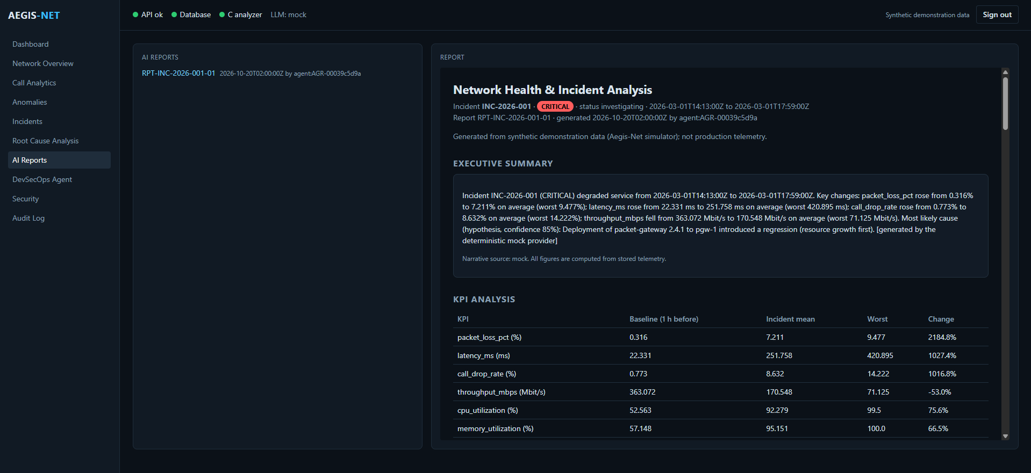
Figure 23. AI Reports page with the executive summary and KPI table
Figure 23 shows the report list (RPT-INC-2026-001-01), the synthetic-data notice, the executive summary ("... Most likely cause (hypothesis, confidence 85%) ... [generated by the deterministic mock provider]"), and the KPI table (for example packet loss 0.316 to 7.211 %, worst 9.477 %).
Limitation. No PDF renderer exists. Reports are consumed as JSON, Markdown or HTML. The report's call counts are for the whole call log, and the narrative is only as good as the provider behind it (the mock in all verified runs).

15 Autonomous DevSecOps Agent
Implementation status. VERIFIED backend/app/agents/ with 36 tests in test_agent.py; the offline demo exercises the production-anomaly chain. SIMULATED The rollback is a simulation. NOT IMPLEMENTED restart_service has no model behind it and always fails with an explanation.

Warning. "Autonomous" is used in the project's name, but the planner is a deterministic set of rule-based playbooks. The LLM influences only the RCA text. It never chooses an agent tool, an argument or a command. Treat the agent as a policy-controlled automation, not as an LLM-driven decision maker.

15.1 The loop
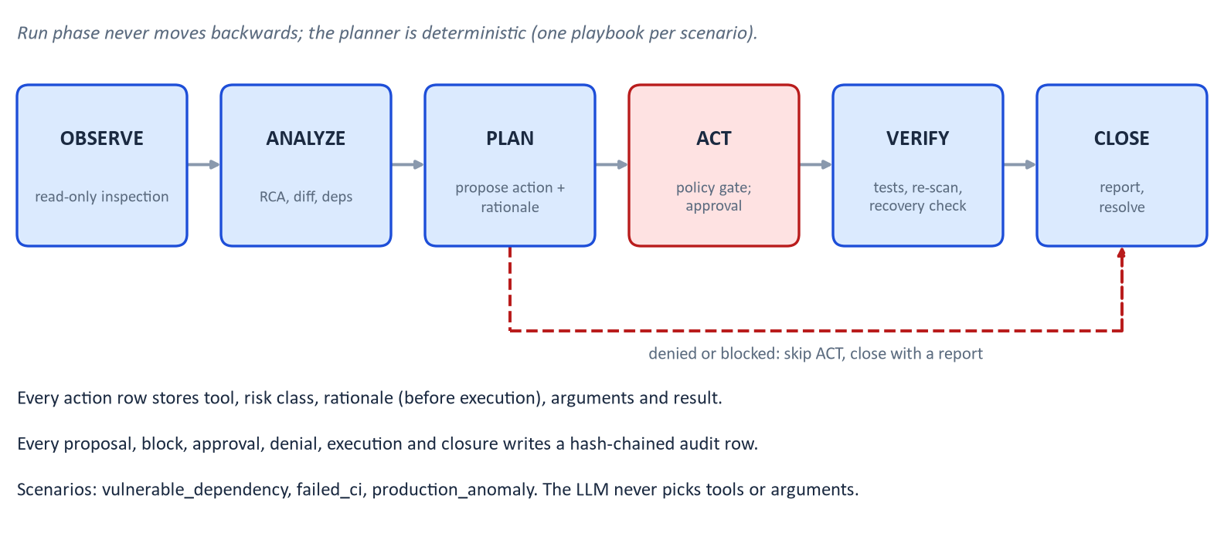
Figure 24. Agent lifecycle
A run moves OBSERVE, ANALYZE, PLAN, ACT, VERIFY, CLOSE and never backwards (service._advance raises if the planner attempts it). For each step the planner (planner.next_action) is a pure function of the run's action history: it names the tool, its arguments (built from earlier results, never from LLM text) and a rationale. _propose stores the action with that rationale before execution, evaluates the policy, and either executes immediately, parks it as awaiting_approval, or marks it blocked. A run stops advancing while any action awaits approval. A hard limit of 40 actions per run prevents loops.

15.2 Tools and risk classes
Table 13. The 20 registered tools (`agents/tools.py`)
Risk class | Tools
READ_ONLY | inspect_repository, inspect_git_diff, run_unit_tests, run_linter (pyflakes), run_tests, run_security_scan, inspect_dependencies, inspect_container, inspect_logs, inspect_metrics
LOW_RISK | create_incident, request_rca, generate_patch, generate_report, close_incident
REQUIRES_APPROVAL | apply_patch, modify_dependency, restart_service (always fails: not modelled)
HIGH_RISK | rollback_deployment (simulated)
BLOCKED | delete_infrastructure (no implementation)

Every tool has a Pydantic argument model with extra="forbid"; the executor validates arguments again at execution time.

15.3 Policy and approval
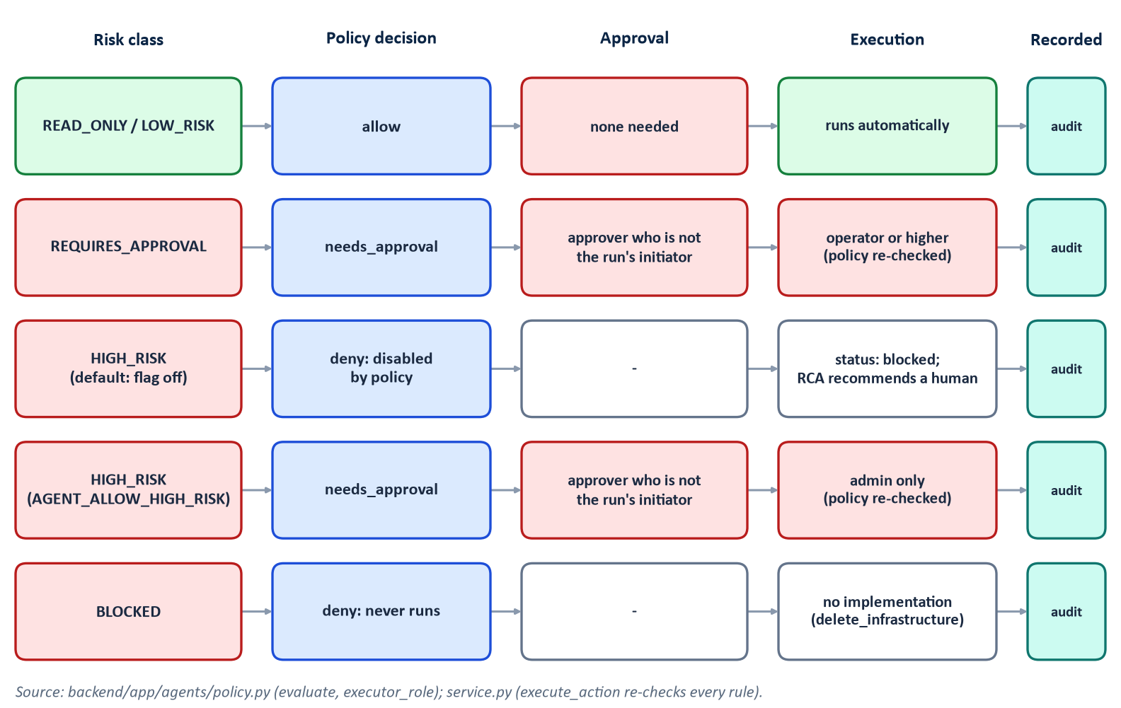
Figure 25. Risk classification and approval workflow
Figure 25 shows what policy.evaluate and execute_action enforce. READ_ONLY and LOW_RISK run automatically. REQUIRES_APPROVAL needs an approver who is not the run's initiator, then an operator or higher to execute. HIGH_RISK is denied (status blocked) unless AGENT_ALLOW_HIGH_RISK=true; when enabled it still needs approval and an admin to execute. BLOCKED never runs. execute_action re-evaluates the policy and the executor's role immediately before running, and writes agent.action.execute_rejected to the audit log on refusal.

15.4 The sandbox and the disposable workspace
Code scenarios run in a throwaway copy of demo-workspace/ (a small fictional packet-gateway service with tests) created under AGENT_WORKSPACE_ROOT/<run> with its own git history (workspace.create_workspace). CommandRunner (agents/runner.py) enforces:
- only two executables, python (this interpreter, -m pytest or -m pyflakes) and git (subcommands init, add, commit, diff, log, apply, status, rev-parse, show; no -c overrides);
- argument lists with shell=False, each argument checked for NUL bytes and length, a rule an AST test enforces over the codebase;
- the working directory must lie inside the workspace root, and workspace-relative paths are resolved and checked (inside);
- an environment scrubbed down to a fixed PATH, HOME set to the workspace, and git configuration disabled, so no inherited secret or LD_PRELOAD leaks in;
- a timeout (default 120 s) and output truncated at 20,000 characters.

15.5 Synthetic advisories
agents/data/advisories.json holds two invented advisories with a notice that they are fictional: DEMO-CVE-2026-0001 (netparse below 1.4.3, CRITICAL) and DEMO-CVE-2026-0002 (fastjsonx below 2.0.4, MEDIUM), and a fictional package index. The workspace's requirements.txt pins netparse==1.4.2 and fastjsonx==2.1.0. Nothing is downloaded or installed.

15.6 The three scenarios
Table 14. Scenario walk-through (`planner.py`)
Scenario | Steps | What really happens | Approval
vulnerable_dependency | scan, record finding, inspect dependencies for the smallest fixed release, modify_dependency, run tests, re-scan, report | Edits requirements.txt in the sandbox from 1.4.2 to 1.4.3 and re-scans against the synthetic database; never deployed | modify_dependency needs approval
failed_ci | run tests, read CI log, inspect_git_diff, generate_patch, apply_patch, run tests and linter, report | A staged commit "Optimise checksum carry folding" broke pgw/checksum.py; the hypothesis is that the changed module is exercised by a failing test; the patch is a revert of that file's change | apply_patch needs approval
production_anomaly | inspect_metrics, create_incident (acknowledge), request_rca, inspect_container, rollback_deployment, inspect_metrics on the verification run, close_incident, generate_report | If the RCA's leading cause is deployment_regression and an active deployment preceded the incident, propose a rollback. Execution re-simulates the scenario with a rollback 45 minutes after onset and checks that the last 30 minutes are back near baseline | HIGH_RISK: flag on, approval, admin

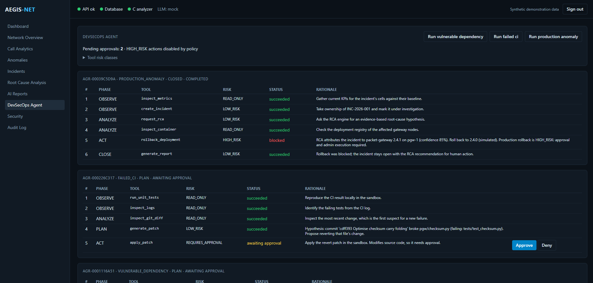
Figure 26. DevSecOps Agent page: one closed run and two runs awaiting approval
Figure 26 shows three runs. AGR-00039C5D9A (production_anomaly) is CLOSED: inspect_metrics, create_incident, request_rca and inspect_container succeeded, and rollback_deployment (HIGH_RISK) shows blocked because the header reads "HIGH_RISK actions disabled by policy"; the final generate_report rationale says the incident stays open with the RCA recommendation for human action. AGR-000226C317 (failed_ci) shows apply_patch (REQUIRES_APPROVAL) awaiting approval with Approve and Deny buttons; its rationale quotes the commit cdff393 Optimise checksum carry folding and the failing test file. A third run (vulnerable_dependency) is also waiting. The header shows "Pending approvals: 2". Each row displays the phase, tool, risk class, status and the rationale recorded before execution.
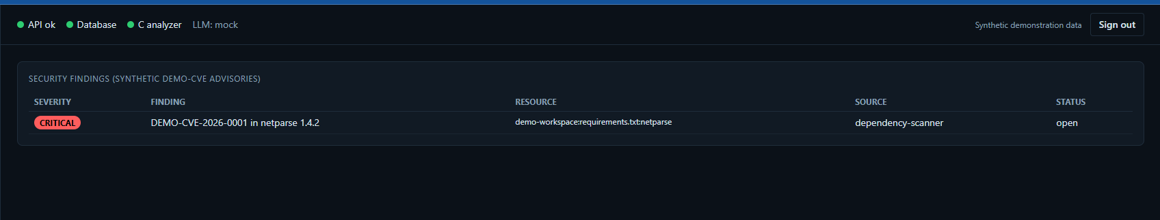
Figure 27. Security page with the synthetic finding
Figure 27 shows DEMO-CVE-2026-0001 in netparse 1.4.2 (CRITICAL, source dependency-scanner, status open), recorded by the dependency scenario.

15.7 What is real, simulated, approved and blocked
Table 15. Honest inventory of agent behaviour
Behaviour | Real in the sandbox | Simulated | Needs approval | Blocked by default
Run tests, linter, git inspection | yes | no | no | no
Scan dependencies | yes, against fictional advisories | advisory data is synthetic | no | no
Change a dependency pin | yes (sandbox file) | never deployed | yes | no
Generate and apply a revert patch | yes (sandbox git) | no | yes | no
Roll back a production deployment | no | yes (re-simulated telemetry) | yes, plus admin | yes (flag off)
Restart a service | no | not modelled | yes | no (it simply fails)
Delete infrastructure | no | no | n/a | always

Limitation. Because the simulated rollback regenerates telemetry from the same model, "recovery verified" demonstrates the control flow and the verification arithmetic. It cannot show that a real rollback would recover a real service, since the simulator was written to recover when the deployment effect is removed.

16 Frontend and Dashboard
Implementation status. VERIFIED frontend/ (React 18.3.1, TypeScript 5.6.3 strict, Vite 5.4.11, Tailwind 3.4.15, Recharts 2.13.3, React Router 6.28.0). make frontend-test was run for this handbook in a node:22-alpine container: type-check, Vitest (2 files, 10 tests passed) and the production build succeeded (exit 0). The recorded browser check of all 11 routes was not re-run.

16.1 Structure
App.tsx shows Login until a token exists, then a Layout (sidebar plus top status bar) with 11 routes: / Dashboard, /network, /calls, /anomalies, /incidents, /incidents/:incidentId, /rca, /reports, /agent, /security, /audit. Components: KpiCard, TimeSeriesChart (Recharts), IncidentTimeline, RcaPanel, AgentActionPanel, and shared helpers. hooks/useApi.ts is a small data-loading hook (loading, error, reload with cancellation). types/api.ts mirrors the Pydantic response models, and services/api.ts is the only place that talks to the network, with one function per endpoint (the frontend does not call /api/deployments).

16.2 Authentication handling
The token is typed on the sign-in page, validated against the API, and stored in sessionStorage (cleared when the tab closes) under one key; every request adds Authorization: Bearer. Path parameters are URL-encoded. There are no cookies. A consequence worth noting: any script running in the page origin could read the token, which is why the nginx configuration sets a restrictive Content-Security-Policy and why reports are rendered in a sandboxed iframe.

16.3 Pages and how users interact
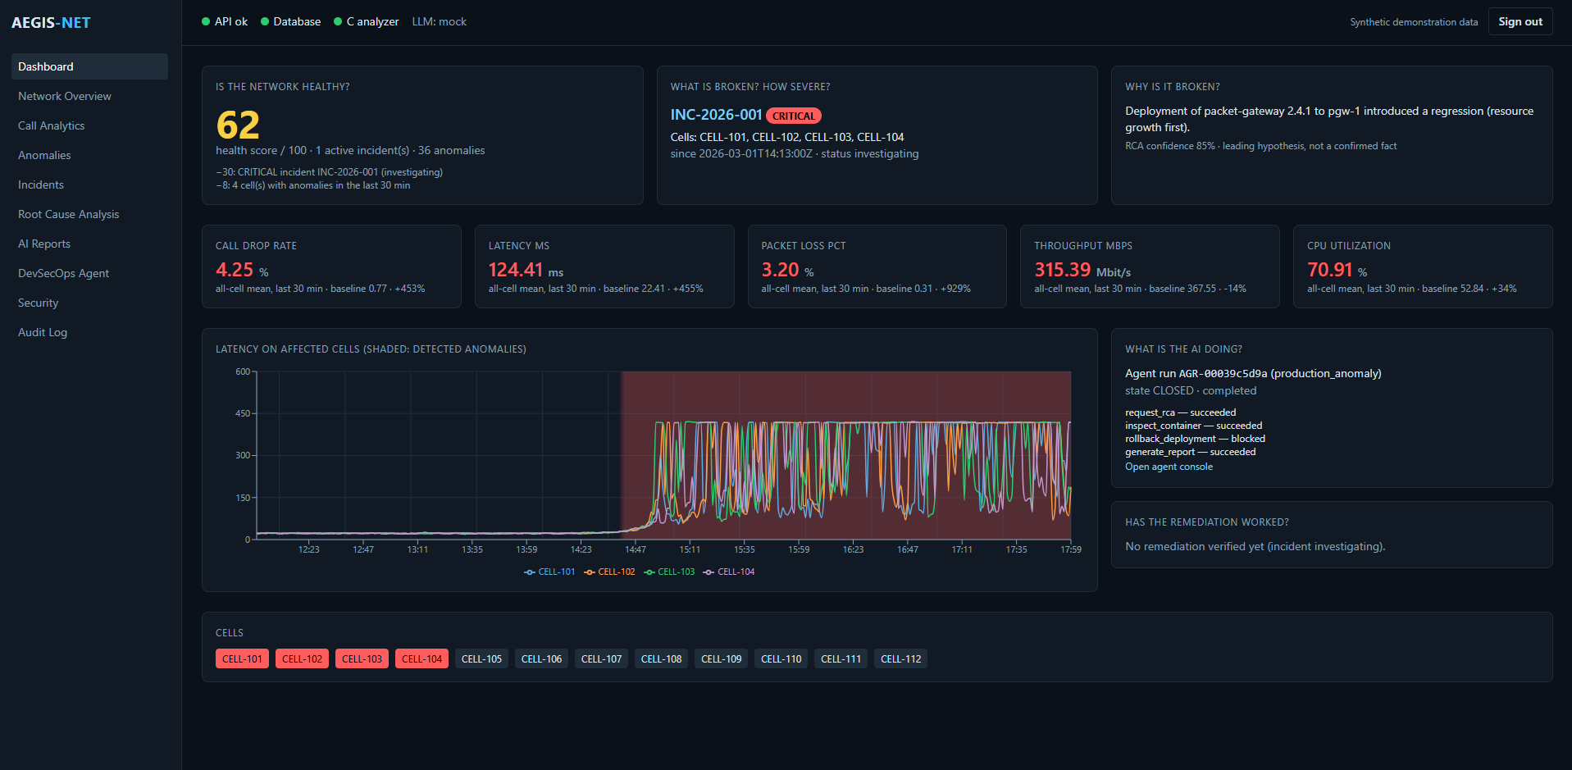
Figure 28. Dashboard
Figure 28 answers six operator questions in panels: Is the network healthy? (health score 62 of 100: minus 30 for the critical incident, minus 8 for four cells with anomalies), What is broken and how severe? (INC-2026-001, CRITICAL, cells CELL-101 to CELL-104, since 14:13, status investigating), Why? (the RCA headline with "RCA confidence 85 %, leading hypothesis, not a confirmed fact"), five KPI cards against baseline, a latency chart of the affected cells with shaded detected anomalies, What is the AI doing? (the agent run and its actions) and Has the remediation worked? ("No remediation verified yet (incident investigating)"). The cell strip colours CELL-101 to CELL-104 red. The top bar shows API, database and C analyzer status, LLM: mock, and a "Synthetic demonstration data" notice.
The health-score formula is documented in GET /api/network/overview: 100 minus 30, 20, 10 or 5 per active CRITICAL, HIGH, MEDIUM or LOW incident, minus 2 per cell with an anomaly in the last 30 minutes, floored at 0. Here 100 - 30 - 8 = 62.
Other pages (screenshots in earlier chapters): Network Overview (Figure 8), Call Analytics (Figure 4), Anomalies (Figure 12), Incidents (Figure 16), RCA (Figure 22), AI Reports (Figure 23), DevSecOps Agent (Figure 26), Security (Figure 27) and Audit Log (Figure 20). The incident detail page (no screenshot supplied) shows the timeline, symptoms, hypotheses with caveats, the RCA chain and actions (investigate, report, agent). Report HTML is displayed in an <iframe sandbox> with scripts disabled.
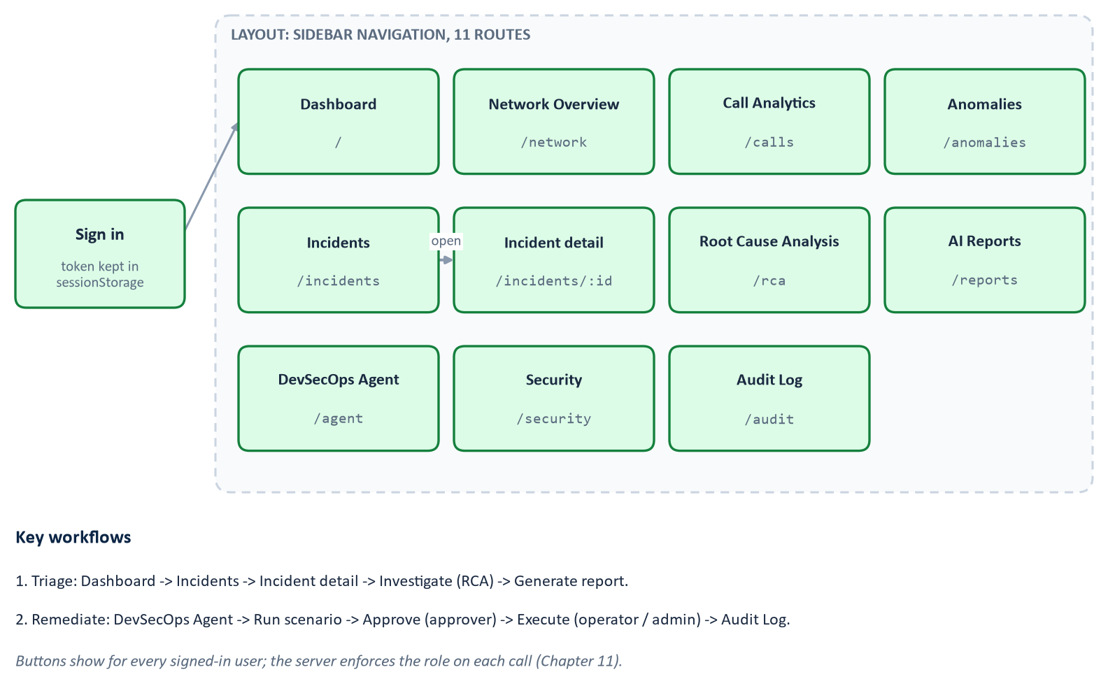
Figure 29. Dashboard navigation and workflows
Limitation. The recorded limitations are: no per-route code splitting, and no browser end-to-end test of the approval flow (the flow is covered by API tests).

17 Docker and Deployment
Implementation status. VERIFIED A clean --no-cache smoke build and the four-service start are recorded in IMPLEMENTATION_PLAN.md (M11 and the final sweep). They were not re-run for this handbook, so for this session the Docker stack is UNVERIFIED HERE . The C build and tests that the image also runs were executed on the host (Chapter 5). The Dockerfile, compose file and smoke script below were read.

17.1 Concepts
A container image is an immutable bundle of a filesystem and start command; a container is a running instance. A multi-stage build has several FROM lines, and files are copied between stages so the final image carries only the finished output, not the compilers [R5]. Docker Compose declares several containers, their networks, volumes and start order in one file.
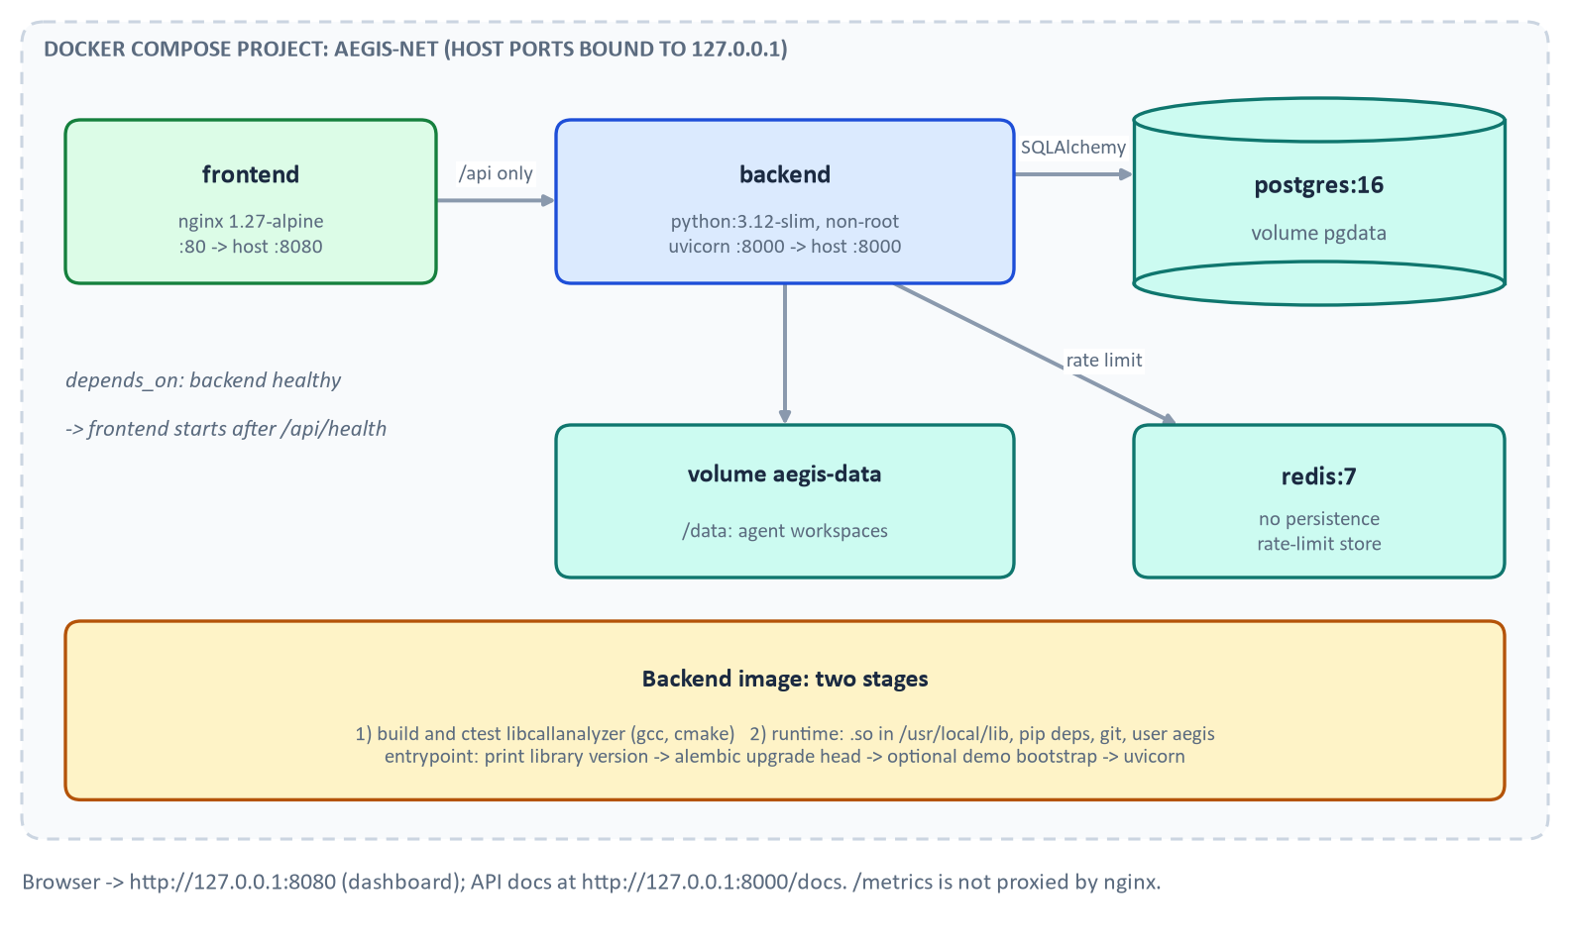
Figure 30. Container topology

17.2 The images
backend/Dockerfile: stage 1 (python:3.12-slim with gcc, libc headers, cmake, make) configures and builds libcallanalyzer in Release mode, runs ctest during the build (a failing C test fails the image build) and installs to a prefix. Stage 2 (python:3.12-slim) installs git (for the agent sandbox), creates the non-root user aegis (uid 10001), copies the library to /usr/local/lib and runs ldconfig, installs pinned requirements including the optional LLM SDKs, copies backend/ and demo-workspace/, sets AEGIS_DATA_DIR=/data, and defines a health check that GETs /api/health. The entrypoint prints the library version, runs alembic upgrade head, optionally runs python -m app.bootstrap (loads the seeded incident into an empty database when AEGIS_BOOTSTRAP_DEMO=true; idempotent) and starts uvicorn on port 8000.
frontend/Dockerfile: a Node 22 stage runs npm ci, Vitest and the build, then nginx 1.27-alpine serves dist. nginx.conf proxies only /api/ to backend:8000, falls back to index.html for client-side routes, answers /healthz, and sets security headers including a Content-Security-Policy. /metrics and /docs are not proxied.

17.3 Services, ports, volumes
Table 16. Compose services (`docker-compose.yml`)
Service | Image | Notes
postgres | postgres:16 | volume pgdata; health check pg_isready
redis | redis:7 | --save "" --appendonly no (no persistence); redis-cli ping health check
backend | built from backend/Dockerfile | environment passed explicitly; depends_on postgres and redis healthy; published on 127.0.0.1:${BACKEND_PORT:-8000}; volume aegis-data at /data
frontend | built from frontend/ | depends_on backend healthy; published on 127.0.0.1:${FRONTEND_PORT:-8080}

Ports bind to 127.0.0.1 only. POSTGRES_PASSWORD and AEGIS_API_TOKENS use the ${VAR:?message} form, so compose refuses to start without them and tells you to run make env.

17.4 Commands
Table 17. Commands, from the Makefile and compose file
Command | What it does
make env | Writes .env (hashed tokens, generated Postgres password) and .aegis-tokens (raw tokens, mode 600); refuses to overwrite an existing .env
docker compose up --build (or make docker-up, which adds -d) | Builds and starts all four services
docker compose down (or make docker-down) | Stops the stack and keeps volumes
make docker-build | docker compose build
make docker-smoke | Isolated project aegis-smoke on ports 18000 and 18080 with a throwaway env file; builds, waits for health, checks the API, then removes its containers and volumes (SMOKE_UI_CHECK=1 adds the browser check)
docker compose down -v | Standard Docker flag that also removes named volumes (deletes stored data); not run for this handbook

17.5 Troubleshooting
- "run make env to create .env": the required variables are missing; run make env once.
- Port already in use: set BACKEND_PORT or FRONTEND_PORT in the environment.
- Backend never becomes healthy: docker compose logs backend; the entrypoint prints the library version first, then Alembic output. The smoke script prints the last 50 log lines in this case.
- Agent reports odd test failures: the plan records an earlier defect in which pytest was missing from the runtime image and the agent misdiagnosed; the image now installs the pinned requirements, so a rebuild (docker compose build --no-cache backend) is the first thing to try.
- Dashboard shows login after a restart: tokens live in sessionStorage; re-enter one from .aegis-tokens.
- Provider shows `mock` although a key was set: check /api/health and the backend log for the fallback reason.
No credentials are published here; no production environment is needed.

18 Testing and Quality Assurance
Implementation status. Results below were produced by commands run for this handbook unless marked "recorded". Complete commands and outputs are in Appendix B.

Table 18. Test layers, what each proves and what it does not
Layer | Evidence in this session | Proves | Does not prove
C unit tests (28 functions) | make c-test: 2 of 2 passed | Parsing, statistics, anomaly logic behave on tested inputs | Behaviour on unseen inputs
Sanitizers (ASan, UBSan, LSan) | make c-test-asan: 2 of 2 passed | No detected memory errors or leaks on tested paths | Other compilers or platforms
Fault injection | included in the second C test executable | Every allocation failure path returns cleanly | Non-allocation failures
Python unit and integration tests (355 collected) | make py-test: 352 passed, 3 skipped in 207.68 s | Binding contract, simulator, detectors, correlation, RCA, reports, agent, API, security, end-to-end chains | Live LLMs, PostgreSQL and Redis (the three skips)
ctypes ABI tests | within the above (28 plus 61 tests) | Field-by-field layout match, ownership spies | Layout on other ABIs
Numerical reference tests | tests/reference.py used by binding tests | C results agree with an independent reference implementation | Statistical validity of thresholds
Static typing | make py-typecheck: mypy strict, 86 source files, no issues | Type consistency | Runtime correctness
Frontend | make frontend-test: tsc, Vitest 10 of 10, Vite build | Components and pages render fixtures | Real browser flows (recorded Playwright check only)
Docker smoke | recorded in the plan; not re-run | Stack starts and answers | Anything in this session
End-to-end demo | make demo: exit 0, 13 steps, audit chain valid (24 rows) | The whole chain through the real API in-process | Production behaviour

Three tests were skipped by design: PostgreSQL migration and pipeline (AEGIS_TEST_POSTGRES_URL), live Redis rate limiter (AEGIS_TEST_REDIS_URL), and live Claude RCA (AEGIS_RUN_LIVE_LLM_TESTS=1 with a key). The ASan variant of the Python suite (make py-test-asan) was not re-run for this handbook; the plan records 345 passed. Mutation testing in this project means hand-applied mutations in a scratch copy, recorded in the plan (for example six gate mutations in the agent policy, all detected). There is no mutation-testing tool in the repository, so those results are recorded rather than reproducible by command.
Limitation. Passing tests show that the code does what the tests assert. The simulator, thresholds and tests were written together, so the detection results measure internal consistency, not field accuracy.

19 How to Run and Demonstrate Aegis-Net

19.1 Prerequisites and repository map
Linux (the plan records Ubuntu under WSL2), gcc and CMake, Python 3.12 or newer, and Docker for the full stack and the dashboard build. Node is not needed on the host. Key directories: c-library/, backend/ (app/, call_analyzer/, alembic/, tests/), frontend/, scripts/, demo-workspace/, docs/, data/ (generated, git-ignored), reports/.

19.2 Environment
make c-build # build libcallanalyzer
make py-venv # backend/.venv with pinned dependencies

Environment variables (no values): DATABASE_URL, AEGIS_API_TOKENS, LLM_PROVIDER, MODEL_NAME, ANTHROPIC_API_KEY, OPENAI_API_KEY, LOCAL_LLM_BASE_URL, REDIS_URL, AEGIS_RATE_LIMIT_PER_MINUTE, AEGIS_MAX_REQUEST_BYTES, AGENT_ALLOW_HIGH_RISK, AGENT_WORKSPACE_ROOT, LOG_LEVEL, plus AEGIS_DATA_DIR, AEGIS_BOOTSTRAP_DEMO (Docker), POSTGRES_PASSWORD, BACKEND_PORT, FRONTEND_PORT.

19.3 Offline demo (no key, no Docker)
make demo

It builds the library, then runs scripts/demo.py: a fresh SQLite database, the mock provider, in-process API calls with role-scoped tokens generated on the fly, ending with DEMO COMPLETED. It enables high-risk actions for itself only. It writes a report to reports/ (git-ignored). This ran for this handbook (exit 0). Everything in the demo works without an LLM API key.

19.4 Docker with the dashboard
make env # once
docker compose up --build # dashboard http://127.0.0.1:8080, API docs http://127.0.0.1:8000/docs

Sign in with a token from .aegis-tokens: use the viewer token to explore read-only, operator to investigate and report, approver to approve, admin to execute high-risk actions and verify the audit chain. Note the stack starts with AGENT_ALLOW_HIGH_RISK=false, so a production rollback shows as blocked until you set it to true in the environment and restart.

19.5 A guided walk-through
1. Dashboard. Read the six panels (Figure 28); note the health score and the incident.
2. Incidents, then the incident row. Open INC-2026-001 and read the timeline and hypotheses.
3. Investigate (operator). The RCA page shows evidence with tool-call ids (Figure 22).
4. Generate a report (operator) and open it under AI Reports.
5. DevSecOps Agent. Start production_anomaly. With the flag off the rollback is blocked (Figure 26); start failed_ci, then approve with a different user than the one who started it (the same user gets the separation-of-duties message) and execute.
6. Audit Log. Press "Verify chain" as admin; read the rows (Figure 20).
7. Stop. docker compose down.

19.6 Tests
make test runs C, sanitizer C, Python, sanitizer Python, mypy and the frontend suite; make container-test repeats C and Python in python:3.12-slim. Opt-in tests need the environment variables of Chapter 18.

19.7 Live providers
Set LLM_PROVIDER to anthropic, openai or local, give the matching key or URL (and MODEL_NAME for openai and local), and install backend/requirements-llm.txt for a non-Docker run. Without these the system falls back to the mock and reports why. This path is untested live UNVERIFIED HERE .

19.8 Common failures
Library not found: run make c-build or set CALL_ANALYZER_LIB to an absolute path. 401: wrong or missing token. 403 on approve: you started the run, or your role is below approver. 409 on execute: the action is not approved yet. 429: rate limit; wait a minute.

20 Limitations, Trade-offs, and Future Work

20.1 Honest assessment
- Synthetic versus real data. All telemetry, incidents, CDRs, deployments and advisories are generated. Thresholds, floors and the false-positive bound were tuned on this simulator and generic synthetic series. Nothing here shows performance on real traffic.
- Circular validation. The simulator, the detectors' thresholds, the correlation graph and the tests share assumptions. The causal graph used for scoring mirrors the simulator's structure, so agreement is expected.
- Unverified provider integrations. Anthropic, OpenAI and local paths have never touched a live API; the mock is rule-based.
- Optional algorithms not built. Isolation Forest, DBSCAN; also no seasonal baseline, so a real daily cycle would raise false positives until the baseline learns it.
- Deferred. PDF reports; OpenTelemetry and Grafana.
- Simulated rollback and narrow agent. Patches are limited to reverting the last commit; restart_service is unmodelled.
- Correlation limits. Caller and per-call C anomalies are not turned into incidents; two independent faults on the same node with near-simultaneous onset would merge; correlation is not causation.
- Performance unknown. The pipeline runs synchronously in the request (a few seconds for 360 minutes of 12 cells). No load testing was performed.
- Security gaps for production. No TLS termination, no external identity provider or per-tenant RBAC, no secret manager, no high availability, /metrics is unauthenticated, the in-process rate limiter is per instance, and the audit chain is not externally anchored.

20.2 Prioritised roadmap (recommendations, not existing features)
1. Run a scored evaluation of live LLM RCA against the same tools, with injected adversarial log lines. Rationale: the largest unverified claim.
2. Replace the simulator's role in validation by replaying a recorded, anonymised telemetry sample, and measure detector precision and recall.
3. Move to asynchronous pipeline and agent runs (a job queue) so requests return immediately.
4. Add seasonal baselines and a model-based detector beside the interpretable ones, keeping explanations.
5. OIDC sign-in, TLS, secret manager, anchored audit head.
6. Patch generation beyond reverts, validated in the sandbox, and real CI integration.
7. OpenTelemetry traces across API, RCA and agent.

21 Advanced Technical Deep Dives
Each section says what is implemented and what is a production recommendation.

21.1 C and Python ABI and memory ownership
Implemented: struct-size handshake, per-field offsetof tests, out-parameter ownership with matching free_*, try/finally release, overflow-checked arithmetic, argument range checks before crossing the boundary, allocation-failure injection. Recommendation: fuzz the CSV parser (for example libFuzzer) to reach inputs the unit tests do not; run the Python suite against the sanitizer build in CI (the Makefile target exists).

21.2 Statistical detector design and trade-offs
The design chooses interpretability and low false positives over sensitivity. Requiring agreement of two detectors, a practical-deviation gate and baseline freezing trade some detection delay for a measured 0.27 false episodes per 100 series-days (recorded, synthetic). The cost is visible in the seeded run: memory is flagged at 14:13, eight minutes after the 14:05 deployment, which is consistent with the memory rule's practical deviation of 6 points while the leak grows about 0.8 points per minute. Recommendation: validate on real data before trusting any number.

21.3 Evidence provenance and hypothesis evaluation
Every fact in an RCA carries a tool-call id; the validator refuses uncited or phantom citations; the persisted tool_calls hold arguments and results, so each statement can be traced to a database query. The correlation hypotheses carry a score decomposition (temporal, mechanism, topology), which Figure 15 shows.

21.4 Structured LLM tool execution
The engine is the policy enforcement point: the model proposes, the engine validates and runs. Two layers of schema validation, bounded steps, bounded results and read-only incident-scoped access limit what a misled model can do to the cost of a wrong answer, which the citation check and human review then catch or not.

21.5 Policy enforcement and threat modelling
Assets: production deployments, repositories, the audit log, tokens. Threats considered in code: an LLM or attacker-influenced log steering actions (the agent ignores LLM text); a user approving their own action (blocked); an API caller bypassing the UI (policy re-checked in the service); a command escaping the sandbox (allowlist, shell=False, confinement); log or report injection into HTML (escaping, CSP, sandboxed iframe); brute force and flooding (rate limit, body limit). Not covered: a compromised host, a malicious database administrator, supply-chain attacks on dependencies (the project pins versions but does not verify signatures here).

21.6 Database integrity
Foreign keys with cascades, unique audit hashes, run-scoped ids, one migration verified on two engines (recorded), and JSONB reserved for documents. An open design point is agent_runs.incident_id, a plain column without a foreign key, which the schema permits to dangle.

21.7 Audit-chain verification
Verification is linear in the number of rows and needs only the stored columns. The dashboard's "Verify chain" requires admin. As noted, the scheme detects accidental or naive tampering but not a rewrite of the whole suffix.

21.8 Integration testing
test_e2e.py runs the data-to-report chain and the agent chain through the real API; test_offline_demo_runs_end_to_end runs scripts/demo.py. These tests catch interface drift between layers that unit tests miss.

21.9 Observability
Implemented: JSON logs with request, incident and agent-run ids; Prometheus metrics (aegis_http_requests_total, aegis_http_request_duration_seconds, aegis_http_errors_total, aegis_rate_limited_total, aegis_agent_actions_total, aegis_rca_runs_total) with bounded label cardinality (route templates). Not implemented: traces, dashboards, alerting.

21.10 Performance and scaling considerations
Known: metrics are stored as one row per (cell, metric, minute) (12 x 17 x 360 = 73,440 rows per run), which is simple but will not scale to real fleets; the C parser is linear and the aggregations are O(n log n). Unknown: throughput limits, memory under 10 million records, concurrent users. Recommendations: a time-series store, streaming ingestion and batch partitioning, but none of these is built.

22 Glossary and Reference Appendix

22.1 Glossary
Table 19. Terms and acronyms (alphabetical)
Term | Meaning
ABI | Application binary interface: the machine-level layout and calling contract between compiled components
AIOps | Applying data analysis and AI to IT operations
Alembic | Database migration tool for SQLAlchemy
Anomaly | A measurement unusual for its series; in Aegis-Net an episode of flagged points
API | Application programming interface
ASan, UBSan, LSan | AddressSanitizer, UndefinedBehaviorSanitizer, LeakSanitizer: compiler instrumentation that detects memory errors, undefined behaviour and leaks
Audit chain | Rows whose hashes include the previous row's hash, so edits are detectable
Baseline | What a series normally looks like; the reference for deviations
CDR | Call-detail record
Cell | A radio site serving phones
Chain consistency | Share of effects preceded by an observed upstream cause in the causal graph
Container | A running isolated process group started from an image
Correlation | Statistical or temporal association; not causation
ctypes | Python's standard foreign-function library
DevSecOps | Development, security and operations practised together
DEMO-CVE | Synthetic advisory identifier used only in this repository
EWMA | Exponentially weighted moving average
Fault injection | Deliberately making an operation fail to test error handling
Gateway (pgw) | Core-network node routing packet traffic for a group of cells
Hypothesis | A candidate explanation; every Aegis-Net cause is labelled one
IDS | Intrusion detection system
Incident | A correlated group of symptoms needing attention
Jitter | Variation in packet delay
KPI | Key performance indicator
LLM | Large language model
MAD | Median absolute deviation
Mock provider | Deterministic, rule-based stand-in for an LLM
NOC | Network operations centre
Pydantic | Python data-validation library
RBAC | Role-based access control
RCA | Root-cause analysis
RSRP, RSRQ, RSSI, SINR | Radio signal power, quality, strength and signal-to-interference-plus-noise ratio
SRE | Site reliability engineering
Robust z-score | Deviation from the median in units of 1.4826 times MAD
z-score | Deviation from the mean in standard deviations

22.2 Important formulas
Table 20. Formulas and meanings
Formula | Meaning
drop_rate = dropped / (completed + dropped) | Drops among established calls
z = (x - median) / max(1.4826 × MAD, floor) | Robust z-score (C library)
z = oriented(x - mean) / max(std, floor) | Ordinary z-score (Python detector)
score = 1 - 2^(-z / threshold) | Anomaly score, 0.5 at the threshold
alpha = 1 - exp(-dt / tau) | Time-aware EWMA smoothing factor
cause score = 0.45 temporal + 0.35 mechanism + 0.20 topology | Correlation ranking
temporal = exp(-lead / 1800 s) | Decay with time since a preceding event
confidence = top × (0.6 + 0.4 consistency) × (0.9 if close), cap 0.95 | Incident confidence
health = max(0, 100 - 30/20/10/5 per incident - 2 per degraded cell) | Dashboard health score
queueing_ms = min(400, 4 u / (1 - u)) | Simulator queueing delay

22.3 Repository map
Table 21. Where things live
Path | Contents
PROJECT_SPEC.md, IMPLEMENTATION_PLAN.md, ARCHITECTURE.md, CLAUDE.md, README.md | Specification, plan with verification log, architecture, engineering instructions, overview
c-library/ | include/call_analyzer.h, src/*.c, tests/, CMakeLists.txt
backend/call_analyzer/ | ctypes binding
backend/app/ | simulation/, analytics/, models/, schemas/, api/, security/, observability/, llm/, rca/, reporting/, agents/, services/
backend/alembic/, backend/tests/ | Migration, 12 test modules
frontend/ | Dashboard source, Dockerfile, nginx config
scripts/ | Demo, data generators, token and env helpers, smoke and container tests; scripts/documentation/ regenerates this handbook
demo-workspace/ | Fictional service copied into agent sandboxes
docs/ | Topic guides (agent.md, api.md, architecture.md, rca.md, security.md), source/aegis.docx screenshots
deliverables/ | This handbook, the deck, assets and documentation

22.4 Component and interface reference
Table 22. Interfaces between components
Interface | Provider | Consumer | Contract
C header | libcallanalyzer | call_analyzer binding | call_analyzer.h, CaStructSizes handshake
analyze_call_log() | binding | pipeline, RCA tools | CallAnalysisResult dict
detect_anomalies() | analytics | pipeline | MetricAnomaly list
correlate() | analytics | pipeline | Incident objects
LLMProvider | llm/ | RCA engine, reports | generate, tool_call
TOOLS registry | rca/tools.py | RCA engine | strict JSON schema plus Pydantic
RCAAnswer | rca/schemas.py | engine, API, reports | validated model
evaluate() / execute_action() | agents/ | API | policy decision, state machine
REST API | backend/app/api/ | dashboard, scripts | OpenAPI

22.5 Environment variables
Table 23. Environment variables (names only; defaults from `config.py`)
Variable | Default | Meaning
DATABASE_URL | SQLite under data/ | SQLAlchemy URL
AEGIS_DATA_DIR | data/ | Generated data directory
AEGIS_API_TOKENS | none | name:role:sha256 entries
LLM_PROVIDER | mock | mock, anthropic, openai, local
MODEL_NAME | empty | Model id (required for openai and local; Anthropic has a default)
ANTHROPIC_API_KEY, OPENAI_API_KEY, LOCAL_LLM_BASE_URL | empty | Provider credentials or endpoint
REDIS_URL | empty | Rate-limit store; in-process fallback
AEGIS_RATE_LIMIT_PER_MINUTE | 120 (compose 600) | Requests per window
AEGIS_MAX_REQUEST_BYTES | 1,000,000 | Body limit
AGENT_ALLOW_HIGH_RISK | false | Allow HIGH_RISK actions (still need approval and admin)
AGENT_WORKSPACE_ROOT | /tmp/aegis-agent-workspaces | Sandbox root
LOG_LEVEL | INFO | Logging level
CALL_ANALYZER_LIB | unset | Absolute path of the shared library

22.6 Terminal commands
Table 24. Most useful commands
Command | Purpose
make c-build, make c-test, make c-test-asan | Build and test the C library
make py-venv, make py-test, make py-test-asan, make py-typecheck | Python environment, tests, strict typing
make call-logs SEED=42 | Write a seeded CDR file and manifest
make network-data | Write simulated telemetry, events and ground truth to data/
make demo | Offline end-to-end demo
make env, docker compose up --build, make docker-smoke, make docker-down | Docker workflow
make frontend-test, make container-test, make test, make clean | Dashboard, Python 3.12 container, everything, cleanup
scripts/documentation/build_all.sh | Regenerate this handbook and the deck

22.7 Most useful source files and tests
Start with c-library/include/call_analyzer.h, backend/call_analyzer/_native.py, backend/app/simulation/model.py, backend/app/analytics/detectors.py, correlation.py, backend/app/rca/engine.py, schemas.py, backend/app/agents/policy.py, service.py, runner.py, backend/app/security/audit.py. Matching tests: c-library/tests/test_call_analyzer.c, test_binding_abi_and_ownership.py, test_simulation.py, test_analytics.py, test_correlation.py, test_rca.py, test_agent.py, test_security.py, test_e2e.py.

Appendix A: Screenshot Inventory
Table 25. Screenshots extracted from `docs/source/aegis.docx` into `deliverables/assets/screenshots/` (13 images, all present; none shows a token or secret)
File | Source position | Shows | Used in
shot_01_src-image11.png (1917 x 939) | first image | Dashboard, six-question layout | Ch. 16, slide 15
shot_02_src-image8.png (1919 x 784) | 2nd | Network Overview: 8 KPI cards, 12-cell latency chart | Ch. 7, slide 7
shot_03_src-image6.png (1919 x 962) | 3rd | Call Analytics with C-library anomalies | Ch. 5, slide 6
shot_04_src-image5.png (1897 x 753) | 4th | Anomalies table (critical filter) | Ch. 8, slide 8
shot_05_src-image12.png (1919 x 562) | 5th | Incidents list | Ch. 9, slide 10
shot_06_src-image9.png (1897 x 988) | 6th | RCA page, evidence and hypotheses (bottom edge cut off in the source) | Ch. 13, slide 11
shot_07_src-image13.png (1918 x 881) | 7th | AI Reports | Ch. 14, slide 12
shot_08_src-image7.png (1899 x 906) | 8th | DevSecOps Agent (bottom edge cut off in the source) | Ch. 15, slide 13
shot_09_src-image3.png (1007 x 197) | 9th | Separation-of-duties message | Ch. 11, slide 14
shot_10_src-image4.png (1696 x 323) | 10th | Security findings | Ch. 15
shot_11_src-image10.png (1688 x 849) | 11th | Audit log, chain valid (38 rows) (bottom edge cut off) | Ch. 11, slide 14
shot_12_src-image1.png (1689 x 268) | after the label "Viewer:" | Audit page, role error for a viewer | not embedded (same message as shot 13)
shot_13_src-image2.png (1670 x 178) | after the label "Viewer:" | Verification unavailable for a viewer | Ch. 11

Note. The source document has one text label, "Viewer:", so the last two images are viewer-role views. The audit log image shows actor names such as local-admin and short request ids; no token, key or password appears in any image. Images were embedded at their original aspect ratio (no stretching); text in the wide dashboard captures is legible when zoomed but small at page width.

Appendix B: Verification Record
Table 26. Commands executed for this handbook (working directory: repository root)
Command | Result
make c-test | 2 of 2 tests passed; exit 0
make c-test-asan | 2 of 2 tests passed; exit 0
make py-test | 352 passed, 3 skipped in 207.68 s; exit 0
make py-typecheck | "Success: no issues found in 86 source files"; exit 0
make demo | DEMO COMPLETED; exit 0; incident resolved; audit chain valid (24 rows)
make frontend-test | tsc and build succeeded; Vitest 10 of 10 passed; exit 0
backend/.venv/bin/python scripts/documentation/extract_evidence.py | One incident, CRITICAL, confidence 0.8947, 36 anomaly episodes

Not executed in this session: make py-test-asan, make container-test, make docker-smoke (Docker stack), PostgreSQL, live Redis and live LLM tests. Their recorded results come from IMPLEMENTATION_PLAN.md and are labelled as such.

Appendix C: References
All repository claims were checked against the repository. External sources consulted while writing (retrieved 2026-10-20):
- [R1] Python Software Foundation. ctypes: A foreign function library for Python. https://docs.python.org/3/library/ctypes.html (argtypes, restype, structures, pointers).
- [R2] NIST/SEMATECH. e-Handbook of Statistical Methods: EWMA Control Charts. https://www.itl.nist.gov/div898/handbook/pmc/section3/pmc324.htm (EWMA definition).
- [R3] FastAPI documentation. Security. https://fastapi.tiangolo.com/tutorial/security/ (the fastapi.security utilities).
- [R4] NIST/SEMATECH. e-Handbook: Detection of Outliers. https://www.itl.nist.gov/div898/handbook/eda/section3/eda35h.htm (modified z-score with MAD, 0.6745 and 3.5).
- [R5] Docker documentation. Multi-stage builds. https://docs.docker.com/build/building/multi-stage/.
No claim that Aegis-Net conforms to a named standard is made; where the code resembles a published method, the text says "resembles" and names the differences.

