FinExpert
A Smart Personal Finance & Budget Management System for Students
Project Report
Name:Aryan Ajay Kumar Jha
Registration Number: 25BAI10517
Course: Programming in Java
Professor:- Dr. Vipin Jain
Submission Date: 18/09/2026

1. Introduction:-
Money Management is a skill that most students pick up late,which is usually after making a few expensive mistakes along the way. Various things like food delivery, subscriptions, impulsive purchases, and the occasional big outing with friends, it's very easy to lose track of where the monthly allowance or stipend actually went. Most of the personal finance tools that exist today are built with adults in mind, for example:-people managing salaries, EMIs, taxes, and long-term investments and these Tools tend to be overkill for someone just trying to keep a monthly budget under control. I have built FinExpert exactly to fill this specific gap. It's a console-based Java application that lets a student log their income and expenses, set a budget for different categories, and get a direct read on their financial habits.
Two features were added specifically to make the project stand out beyond basic tracking, they are :-
1) Financial Health Score that reflects how well the user is managing their money overall, and
2)What-If Simulator that lets the user test out an imaginary situation for spending change before actually making it.
This report walks through the problem the project addresses, how it was thought out, designed, and built, and also the reasoning behind the major decisions which were made along the way, and what was learned in the process.

2. Problem Statement:-
Most students don't have a simple way to track their spending. Mental math and notes-app tracking are common alternatives, but they don't provide any real insight into spending patterns, budget management, or whether someone is actually on track to meet a savings goal. Existing finance apps solve this but only for salaried adults,which are simply not designed around a student's typical financial situation such as irregular income, smaller amounts, and a different set of spending categories (subscriptions, food delivery, and social outings rather than EMIs and insurance premiums).
This is the reason why FinExpert was made as it addresses this by giving students a light, purpose-built tool with simple and small steps such as: log transactions, set budgets per category, get warned before overspending, and understand overall financial health through a single computed score, without needing something as heavy as the modern tools which are solely based for adults who have different and way higher expenses to deal with.

3. Functional Requirements:-
There are a Few Functional Requirements which sum up our entire program. We have divided them into 3 modules for easier understanding. These are:-

Module 1: Transaction Management:-
- Add a new transaction (income or expense) with amount, category, date, and an optional note
- Edit or delete an existing transaction
- View all transactions in a formatted list
- Search/filter transactions by category, date range, or type
- Validate inputs:- no negative or zero amounts, valid date format, category must match the transaction type

Module 2: Budget & Alerts:-
- Set a monthly budget limit for each expense category
- Automatically track total spend per category against its budget
- Warn the user at 80% of budget usage, and alert at 100% (Basically telling the user they have exceeded their total limit).
- Display a Budget V/S Actual view with a text-based progress bar
- Allowance of editing or removing a budget limit

Module 3: Analytics, Health Score & What-If Simulator:-
- Generate a monthly summary of total income, total expenses, and net savings
- Show a category-wise percentage breakdown of expenses
- Compare the spending trends against the previous month’s trends to see a fair comparison whether theres a decline or improvement in the budget management
- Compute a Financial Health Score (0–100) which is solely based on savings rate, budget compliance, and spending diversity
- Run a What-If Simulation which will help you project the effect of a hypothetical percentage change in a category's spending on overall savings
- Set and track progress on a savings goal

4. Non-Functional Requirements:-
These are The Non-Functional Requirements of the App which we have met with our program. They are:-

Requirement | What it means for FinExpert
Performance | All processing happens in memory over a small, single-user dataset, so reports and searches return effectively instantly.
Reliability | Data files are rewritten safely on every save; a corrupted or malformed CSV row is skipped with a warning instead of crashing the whole load.
Usability | Menus are numbered and consistent, with clear prompts and error messages that explain what went wrong rather than showing a raw stack trace.
Maintainability | The codebase is split into model, storage, service, and UI packages by responsibility, so a change in one layer doesn't ripple through the others.
Error Handling | Invalid input (bad dates, non-numeric amounts, out-of-range choices) is caught and re-prompted instead of crashing the application.
Resource Efficiency | As a single-user, local tool with a small dataset, the app avoids unnecessary reprocessing and keeps memory use minimal.

5. System Architecture:-
FinExpert follows a simple three-layer architecture:
- Presentation layer :- ConsoleUI, which handles all menus and user interaction
- Business logic layer :- the service classes (TransactionManager, BudgetManager, AnalyticsEngine, HealthScoreCalculator, WhatIfSimulator, GoalManager), which contain all the actual logic
- Data access layer :- CSVStorageHandler, which is the only class that reads or writes the CSV files directly
Each layer only talks to the layer directly below it which also means that the UI never touches the CSV files directly, and the storage layer has no knowledge of menus or user input. This separation was made to make it possible to change one layer (for example, swapping CSV storage for a database later) without needing to rewrite the others.
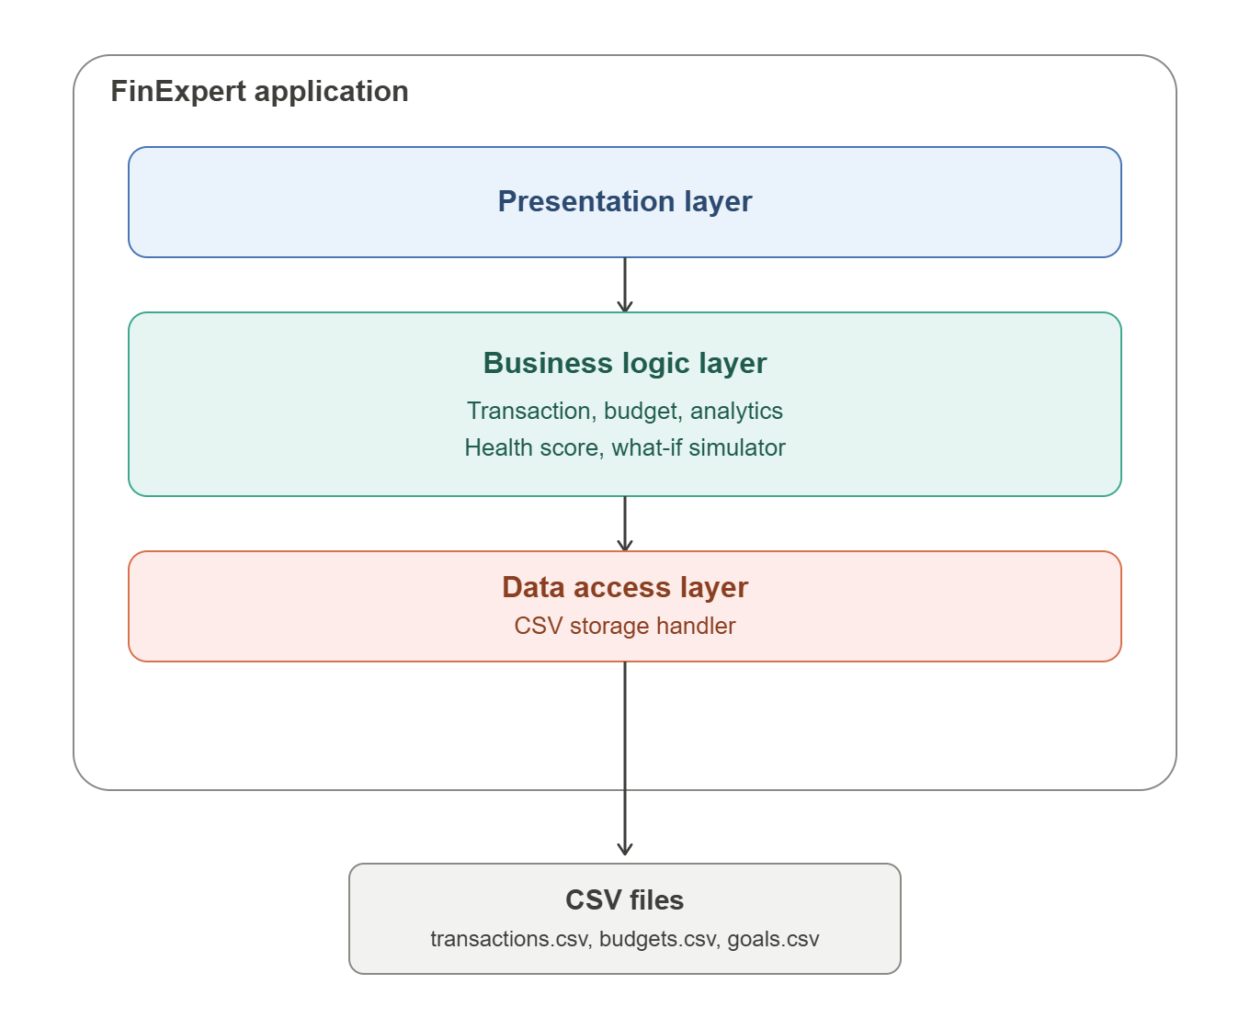

6. Design Diagrams:-
The following diagrams were prepared during the design phase of the project, before any code was written.

6.1 Use Case Diagram:-

6.2 Workflow Diagram:-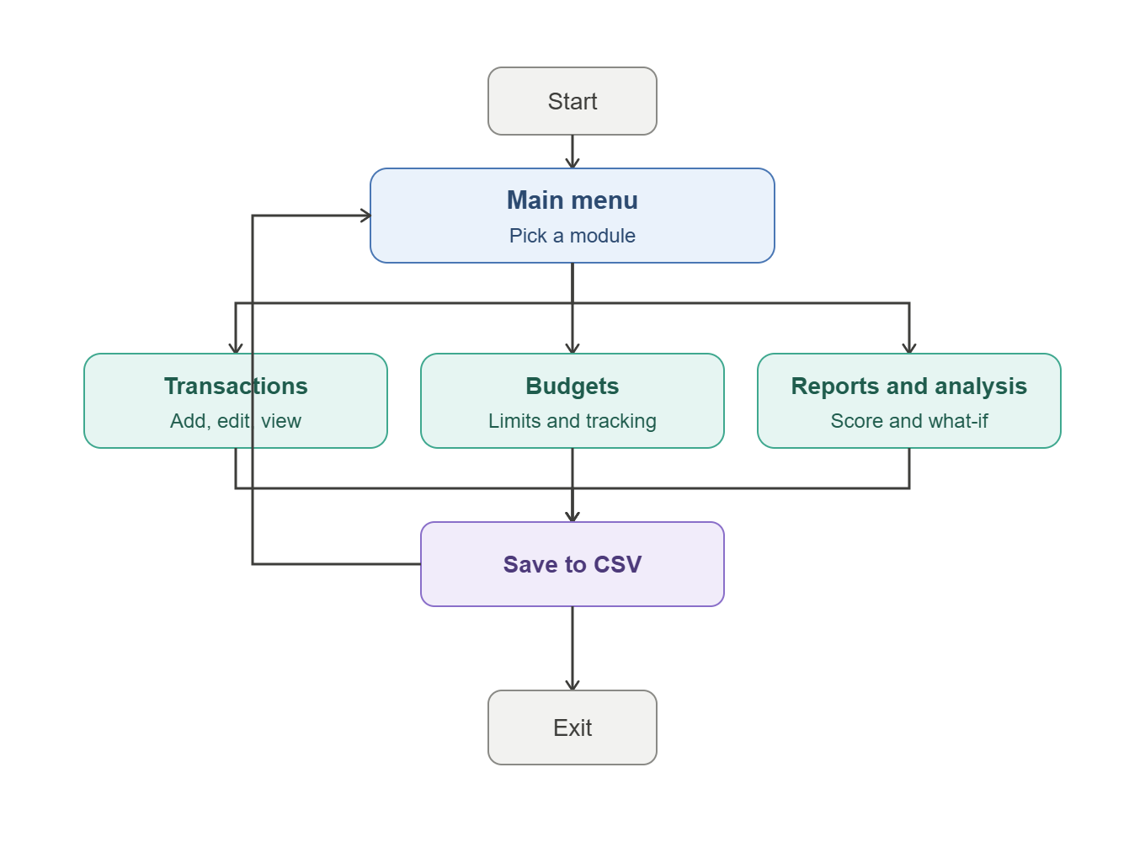

6.3 Class Diagram:-
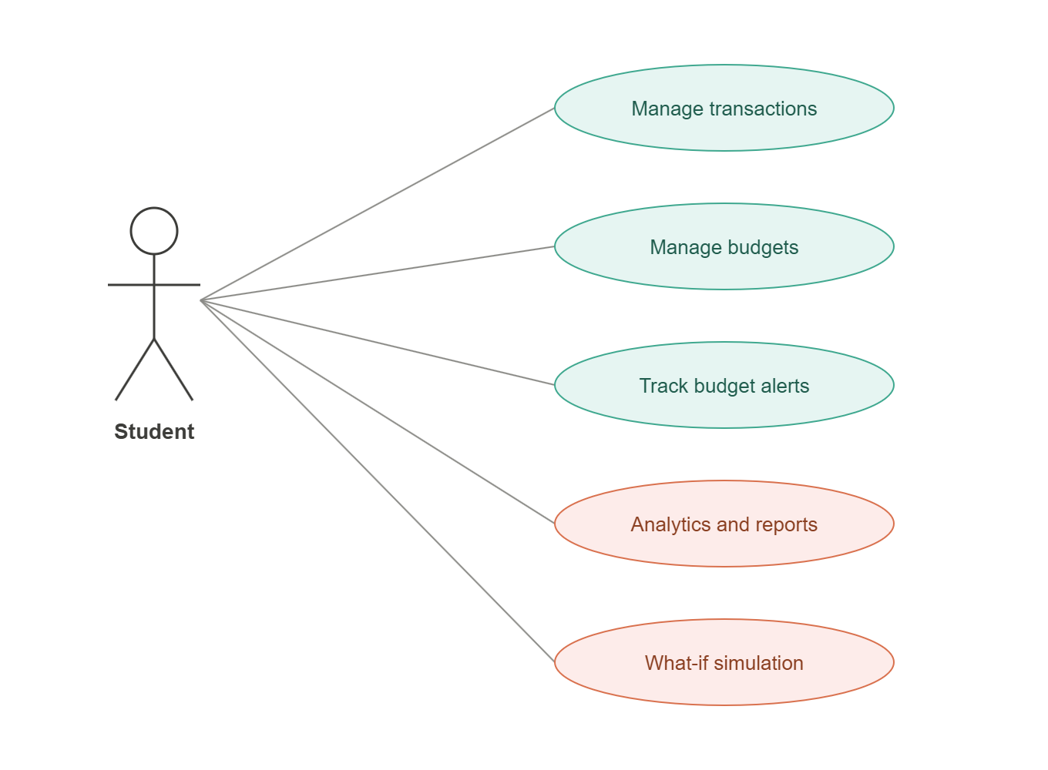

7. Design Decisions & Rationale:-
A few choices were made along the way which shaped how this project was built, each with their own trade-offs which I deem worth explaining:-

CSV storage instead of a database:-
JDBC and a real database would have added setup complexity (drivers, connection handling, SQL) without much benefit for a single-user, local tool with a small dataset. CSV files are simple to read, simple to inspect manually, and enough for this project's scale.

Console UI instead of a GUI:-
A Swing GUI would have shifted a lot of development time toward layout and event handling rather than the actual financial logic, which is where most of the course concepts (OOP, collections, exception handling, algorithms) actually get demonstrated. A well-formatted console interface, with numbered menus and a text-based progress bar, keeps the focus on the logic while still being clear and usable.

Fixed, predefined categories:-
Allowing freeform category names would have made analytics and budget matching unreliable. For example:- 'Food', 'food', and 'FOOD' would all be treated as different categories. Locking categories to fixed names and variables removes the entire class of bugs, which will simply cost a little bit of flexibility.

Immutable Transaction objects:-
Transaction objects are immutable once created, such as editing a transaction that actually builds a new object with the same ID rather than mutating fields in place. This was a simple choice I took to avoid accidental state changes and to keep the class simpler, even though it means edit operations now become slightly more verbose.

Skip and warn on corrupted CSV rows:-
Instead of crashing the entire application if one row in a CSV file is malformed or not functioning properly, I made sure that the storage handler skips that row, prints a warning, and continues loading the rest of the data. This keeps a single bad row (from manual editing, for example) from making all the user's other data inaccessible.

Health Score formula:-
The Financial Health Score is a simple combination of three factors:
1)savings rate (40 points),
2)budget adherence (35 points), and 3)spending diversity (25 points).
These weights were a simple design choice for this project rather than a professionally validated financial model as the savings rate was weighted highest since it's the most direct indicator of financial health for a student with irregular income.

8. Implementation Details:-
The project is divided into four packages under com.finexpert:-
- model:- Transaction, Budget, Goal, Category (enum), TransactionType (enum)
- storage:- CSVStorageHandler, StorageException
- service:- TransactionManager, BudgetManager, AnalyticsEngine, HealthScoreCalculator, WhatIfSimulator, GoalManager
- ui:- ConsoleUI
FinExpertApp, the entry point, sits directly under com.finexpert folder and wires all of the above packages together in their dependency order which is:- CSVStorageHandler is created first, followed by TransactionManager, then BudgetManager (which depends on TransactionManager), then AnalyticsEngine, HealthScoreCalculator, WhatIfSimulator, and GoalManager, before finally handing control to ConsoleUI.
Key implementation choices which are worth knowing: input validation happens at the model layer (example:-. a Transaction cannot be constructed with a negative amount or a mismatched category/type), so any sort of invalid data can never enter the system regardless of which part of the UI creates it. All CSV operations such as reading and writing are centralized in CSVStorageHandler, so no other class touches the file system directly.

9. Screenshots / Results:-
The following screenshots demonstrate the application running and its key features in action.
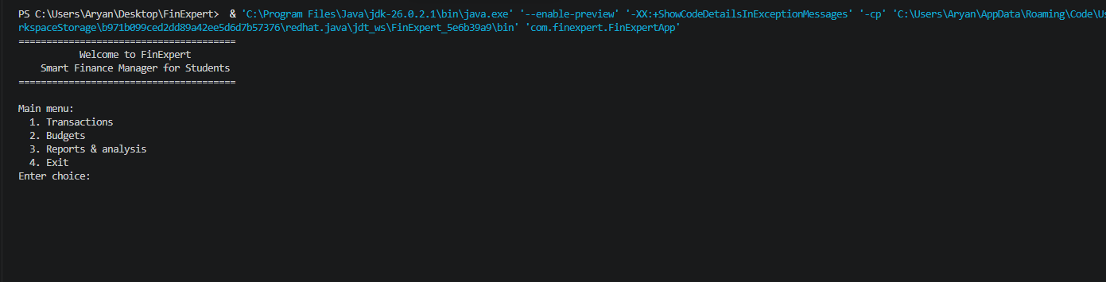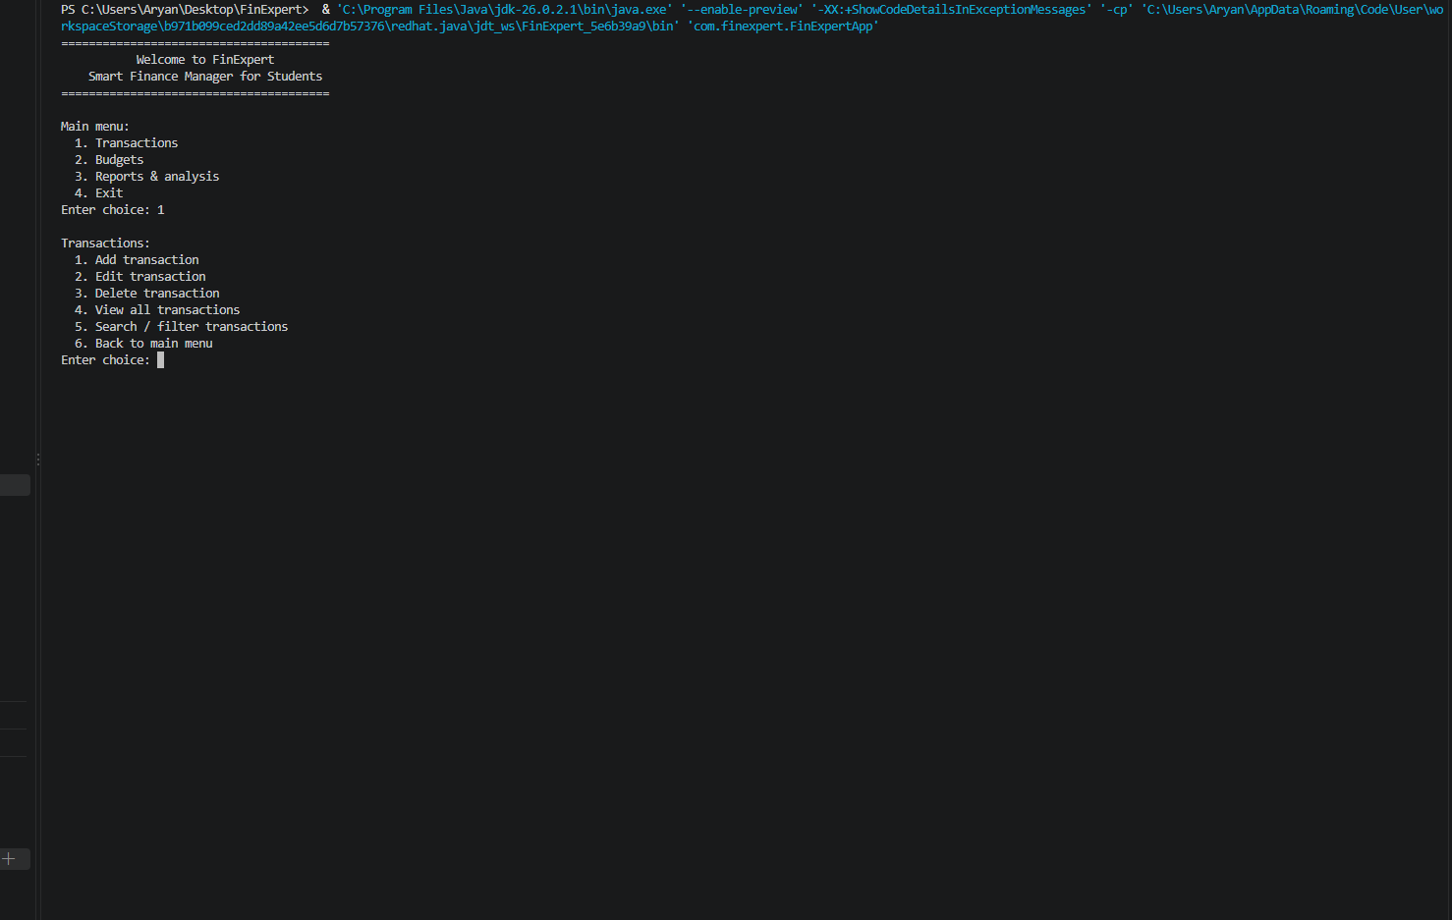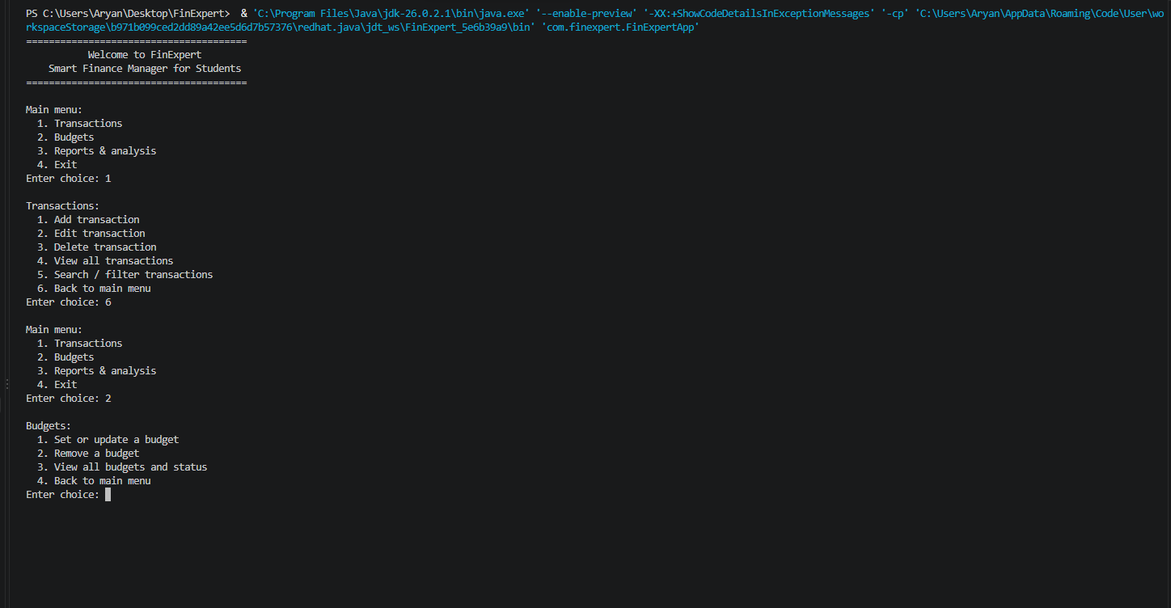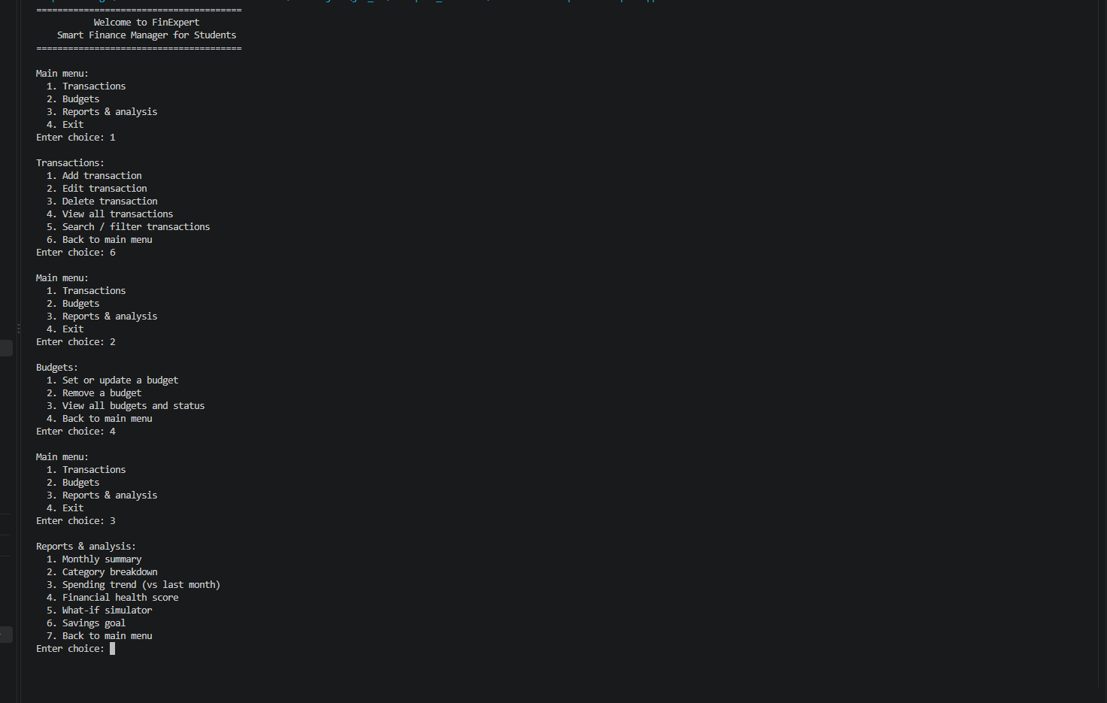

10. Testing Approach:-
Testing was done manually by going through every menu path directly, instead of automating a test suite. This included:
- Normal-path testing such as:- adding, editing, deleting, and searching transactions; setting and updating budgets; running each report
- Invalid input testing:- entering letters where numbers were expected, malformed dates, out-of-range menu choices, and confirming the app re-prompts instead of crashing
- Edge case testing :- editing or deleting a transaction ID that doesn't exist, checking budget status for a category with no budget set, running the Financial Health Score and What-If Simulator with no transactions recorded yet
- Persistence testing:- closing and reopening the application to confirm all data (transactions, budgets, goals) is correctly saved to and reloaded from the CSV files
- Sanity checking the What-If Simulator and Health Score outputs against a few different sample data scenarios to confirm the numbers behave as expected (For Example:- cutting spending should always project higher net savings, never lower)

11. Challenges Faced:-
There were a few practical issues which came up when i was getting the project to compile and run correctly such as:-
- Package and folder mismatch:- the source folders ended up with different capitalization than the package declarations in the Java files(For Example:-. a folder named FINEXPERT versus a package declared as com.finexpert), which caused a very long chain of 'cannot be resolved' errors across nearly every file that was imported from another package. Since Java treats folder paths and package names as case-sensitive, this had to be fixed by renaming the folders to match exactly to the packages we created.
- Malformed Javadoc comments:- a few documentation comments describing exceptions such as (using the @throws tag) ended up without their surrounding /** */ block markers, which caused the compiler to try to parse the comment text as actual code. This caused a handful of confusing 'identifier expected' and "';' expected" errors that took some tracing to connect back to the documentation issue rather than a logical bug.
- Designing the Financial Health Score formula:- there was no explicit ‘correct' way to combine multiple financial factors into a single score, so this was required before deciding on reasonable values and variables rather than looking up a standard formula for the same.

12. Learnings & Key Takeaways:-
- Designing the CSV schema and class structure before writing any code made the actual implementation much smoother:- most classes came together quickly once the data model was settled.
- Keeping layers separated (model / storage / service / UI) proved to be a good choice as it made it very easy to build and test each part independently, and to understand exactly where a bug was coming from and when something went wrong.
- Small compiler errors can actually just have simple causes:- both major issues encountered (folder casing, malformed comments) were big but actually all of it just stemmed through parsing and documentation problems.
- Deciding to keep the program simple (CSV instead of a database, console instead of a GUI) made it possible to actually finish a complete, working project rather than getting stuck halfway through more of an ambitious build which at the end of the day, is incomplete work which can neither be used nor be shown.

13. Future Enhancements:-
There are still many Advancements which can be done to the project. Few of which I think are the most prominent ones are:-
- Move from CSV storage to a proper database (e.g. SQLite via JDBC) which would provide better data integrity and query performance as the dataset grows
- Add a graphical interface (Swing or JavaFX) for a much more visual and less menu heavy experience
- Support weekly budgets in addition to monthly ones
- Allowing multiple savings goals to be tracked at once, rather than a single active goal
- Add recurring transaction detection (For Example:- automatically flagging subscription payments)
- Export reports to a shareable PDF or text summary for a much more user friendly experience which provides easier understanding as well as gives a way to share your stuff to yourself or your family etc.

14. References:-
These are few of the references which were used to make this project happen Such as:-

- Visual Studio Code Compiler:-https://code.visualstudio.com/
- Oracle Java Documentation — https://docs.oracle.com/en/java/
- VITyarthi — Build Your Own Project: General Project Instructions & Submission Guidelines (course-provided PDF)
- Java java.time API documentation (LocalDate, YearMonth) — https://docs.oracle.com/en/java/javase/17/docs/api/java.base/java/time/package-summary.html

