**1.0 Introduction**

Planning is a critical task that involves defining the problem definition, objectives, scope, limitation, feasibility study, schedule feasibility. It sets the foundation for project execution and control, ensuring that all team members and stakeholders have a clear understanding of the project's goals and how they will be achieved. Effective project planning increases the likelihood of project success by establishing a roadmap that guides the project from inception to completion.

**1.1 Background**

The Hotel Management System (HMS) is designed to improve the efficiency of hotel operations. With the increasing demand for quality service and operational efficiency in the hospitality industry, there is a need for a system that can streamline processes such as reservations, billing, and inventory management. The HMS aims to address these needs by providing a comprehensive solution that enhances the guest experience and simplifies management tasks. The hospitality industry is highly competitive and relies on efficient management systems to ensure customer satisfaction and operational excellence. Traditional hotel management practices often involve manual processes that are time-consuming and prone to errors, leading to issues such as overbooking, inefficient staff allocation, and delayed customer service. To address these challenges, the HMS automates and streamlines various aspects of hotel operations, including room bookings, guest services, staff management, and billing. By leveraging technology, hotels can enhance their service quality, improve operational efficiency, and increase profitability.

**1.2 Problem Definition**

Managing a hotel involves numerous repetitive and time-consuming tasks, which are prone to human error. Traditional manual processes can lead to issues such as double bookings, incorrect billing, and inventory mismanagement. Additionally, the rising expectations of guests for quick and seamless service add pressure on hotel management to adopt more efficient systems.

To address these problems, the Hotel Management System will:

* Automate the reservation process to avoid double bookings and streamline check-ins and check-outs.
* Integrate billing and payment systems to ensure accurate and timely transactions.
* Manage inventory effectively to ensure availability and reduce wastage.
* Enhance customer relationship management to improve guest satisfaction and loyalty.

**1.3 Objectives**

The objective of this project is to develop a comprehensive Hotel Management System that enhances operational efficiency, minimizes errors, and improves the guest experience. Specific goals include:

* To enhance the reservation process.
* To integrate billing and payment systems.
* To manage inventory efficiently.
* To improve customer relationship management.

**1.4 Scope**

The scope of the Hotel Management System project includes the design, development, and implementation of a comprehensive software solution to streamline various hotel operations. Key modules of the system encompass several critical functions. Reservation Management automates room bookings, cancellations, and scheduling. This module allows guests to make real-time reservations online, reducing the need for manual intervention and preventing overbooking. It also manages room availability and scheduling, including maintenance and special event block-outs. Front Desk Operations facilitate efficient check-in, check-out, and room assignment processes. This module reduces wait times and enhances the guest experience by enabling online pre-check-in and electronic key generation. It also handles guest inquiries and special requests, ensuring quick and efficient service. Billing and Payments integrates with various payment gateways to secure and streamline transaction processing. The system supports multiple payment methods and generates detailed invoices and receipts, providing accurate financial records and reports for management. Inventory Management tracks and manages hotel supplies and stock levels, ensuring optimal inventory control. The system issues automatic alerts for reordering supplies when stock levels fall below predefined thresholds, maintaining a continuous supply chain. Customer Relationship Management (CRM) stores and manages guest information, preferences, and feedback. This module enables personalized guest services and marketing efforts, enhancing guest satisfaction and loyalty. It also facilitates the collection and analysis of guest feedback for continuous service improvement.

**1.5 Limitations**

While the Hotel Management System offers significant benefits, it also has some limitations:

**Implementation Costs:** High initial setup and customization costs may be a barrier for small and medium-sized hotels. The system requires significant investment in hardware, software, and training.

**Technical Challenges:** The system may experience technical issues such as server downtime, software bugs, and compatibility problems with existing systems. These issues can disrupt hotel operations.

**Training Requirements:** Hotel staff will need extensive training to effectively use the new system. Training programs must be comprehensive and ongoing to ensure staff competency.

**Data Privacy Concerns:** Ensuring the security of guest and financial data is critical. The system must comply with data protection regulations and implement strong encryption and access control measures.

**Dependence on Technology:** Hotels will become highly dependent on the system for their operations. Any technical failure or cyber-attack could have a significant impact on service delivery and reputation.

**1.6.0 Feasibility Study**

A feasibility study evaluates the viability of the Hotel Management System project from various perspectives:

**1.6.1 Operational Feasibility**

The system must be user-friendly for hotel staff with varying levels of technical expertise. It should provide an intuitive interface, clear instructions, and streamlined processes to ensure efficient operations. The system should also support mobile access to allow staff to manage operations on the go.

**1.6.2 Technical Feasibility**

The system will utilize modern, scalable, and secure technologies. It must integrate seamlessly with existing hotel infrastructure and support features such as data encryption, user authentication, real-time processing, and cloud-based storage. The system should be designed for high availability and reliability to minimize downtime.

**1.6.3 Economic Feasibility**

A thorough cost-benefit analysis will be conducted to ensure the project is financially viable. This includes evaluating the initial investment, operational costs, and expected benefits. The project must demonstrate a positive return on investment (ROI) and a favorable net present value (NPV).

**NPV $=\sum_{t=0}^{n}{\frac{Rt}{(1+{i)}^{t}}}$**

**ROI= $\frac{Average Annual Profit}{Total Inestment}$*100**

where, t = time of the cash flow

i = discount rate

Rt = net cash flow

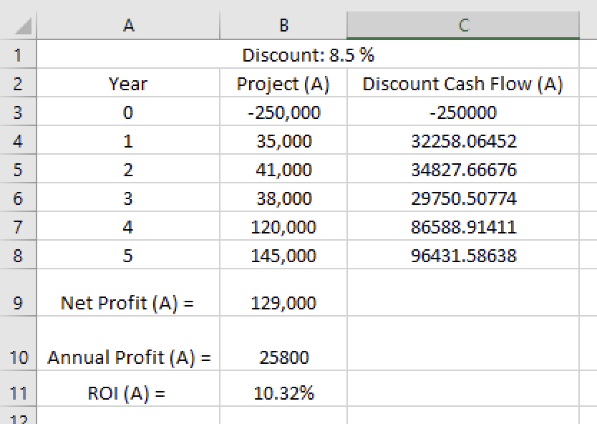

Fig 1: Calculation of NPV and ROI

Formula used (Excel):

Net Profit (A): =SUM (B3:B8)

Annual Profit (A): =B9/5

Return On Investment (A): =(B10/-B3) *100

The NPV of the project over 5 years is $ 129,000. This positive NPV suggests that the investment is expected to be profitable.

The ROI of the project over a year is 10.32%, which suggests a very positive outcome for our investment.

**1.6.4 Schedule Feasibility**

The schedule feasibility of the project assesses whether the proposed system can be completed within the allotted timeframe. This involves evaluating the project plan to ensure that all tasks can be accomplished on time, considering critical deadlines and milestones. Proper planning and monitoring of the project schedule are crucial to identify and mitigate potential delays, ensuring timely project completion.

A Gantt chart has been created to efficiently manage and monitor the advancement of the Hotel Management system project. The Gantt chart visually represents the project schedule, highlighting key tasks and objectives along with their start and end dates. This visualization helps ensure that all activities are aligned with the plan and keeps stakeholders informed about the project's status.

**Gantt Chart**

Below is a simple Gantt chart for the development of a Hotel Management System. This chart outlines the key phases and tasks involved in the project, along with their respective durations and timelines.

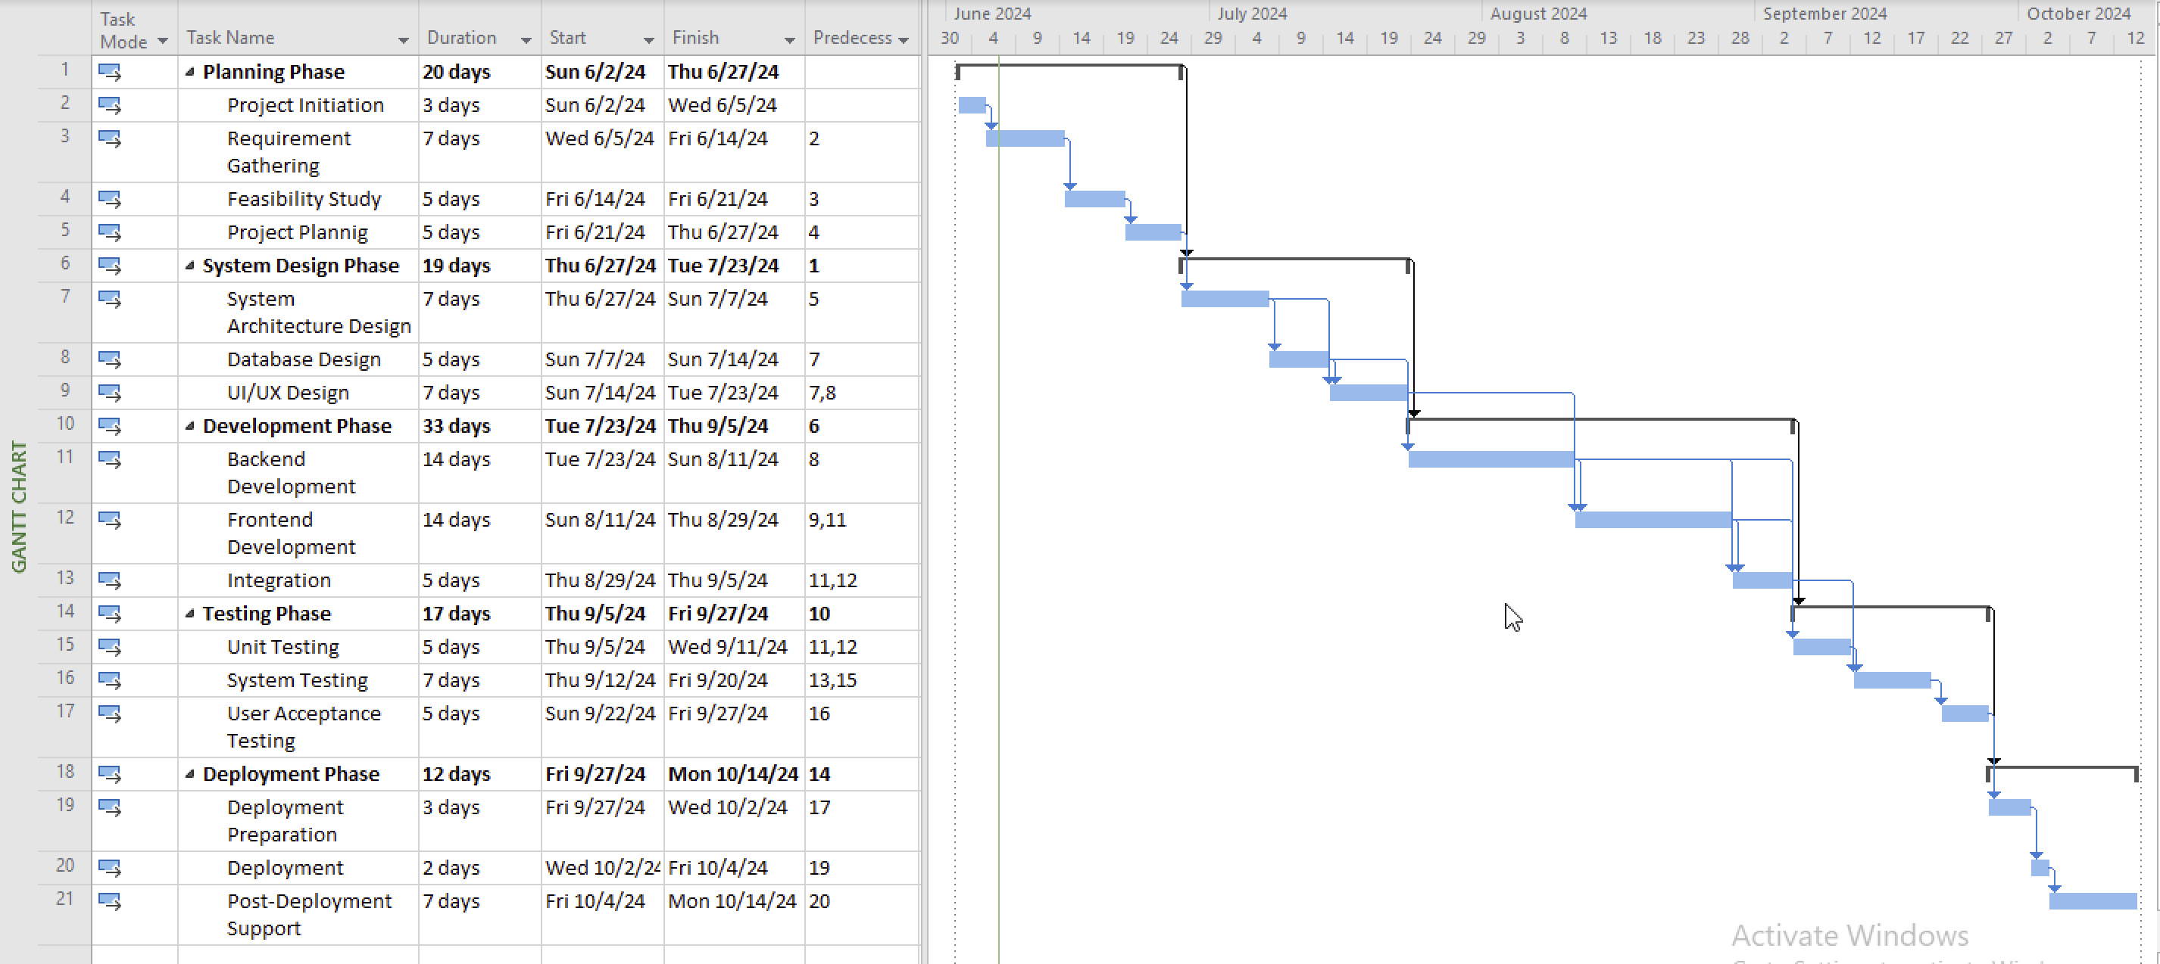Fig 2: Gantt Chart

**Explanation of Gantt Chart**

A Gantt chart is a visual representation of a project schedule, showing the start and finish dates of various elements of the project. It helps in planning, coordinating, and tracking specific tasks in a project.

**Project Planning:** Define project goals, scope, stakeholders, and develop a project plan. This is the foundational phase where the project's objectives and deliverables are clearly outlined.

**Requirements Gathering:** Collect and document the functional and non-functional requirements from stakeholders, such as hotel staff and management. This phase ensures that all the necessary features and specifications are understood.

**System Design:** Develop the architecture of the system, including database schemas and user interface mockups. This phase involves creating a blueprint for the system.

**Frontend Development:** Develop the user interface components of the system. This includes designing screens and forms that users will interact with.

**Backend Development:** Develop the server-side logic, including database interactions, API endpoints, and core functionalities. This phase involves building the logic that powers the frontend.

**Database Development:** Design and implement the database that will store all the system’s data. This includes creating tables, relationships, and ensuring data integrity.

**Integration:** Combine the front-end, back-end, and database components into a cohesive system. This phase ensures that all parts of the system work together seamlessly.

**Testing:** Thoroughly test the system to identify and resolve any issues or bugs. This phase ensures the system functions correctly and meets the specified requirements.

**Deployment:** Deploy the system to the production environment and launch it for use. This involves setting up the system on servers and making it accessible to users.