- Nmap installation
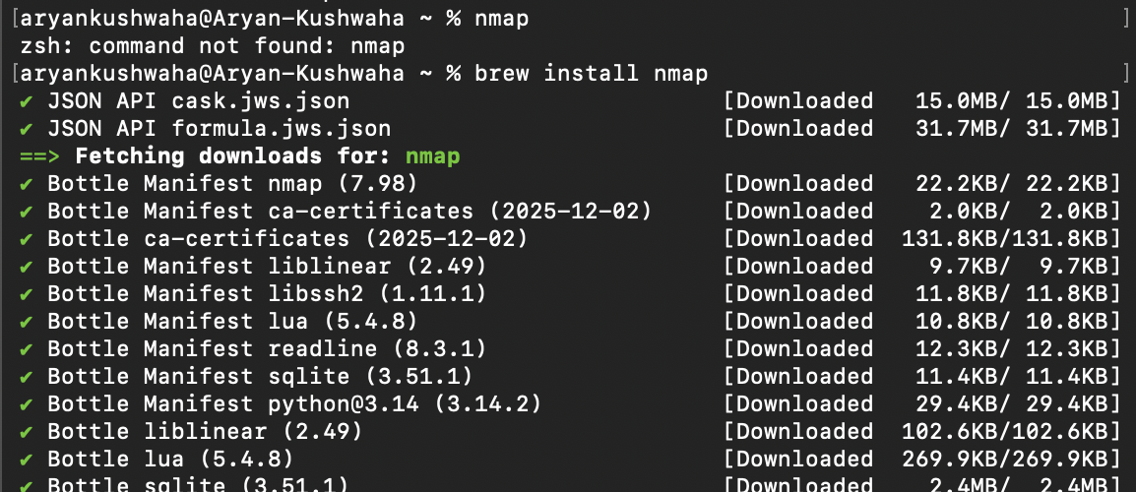
- Check Local Ip address
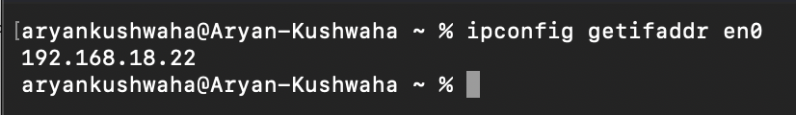
- Nmap scans Wi-Fi network.
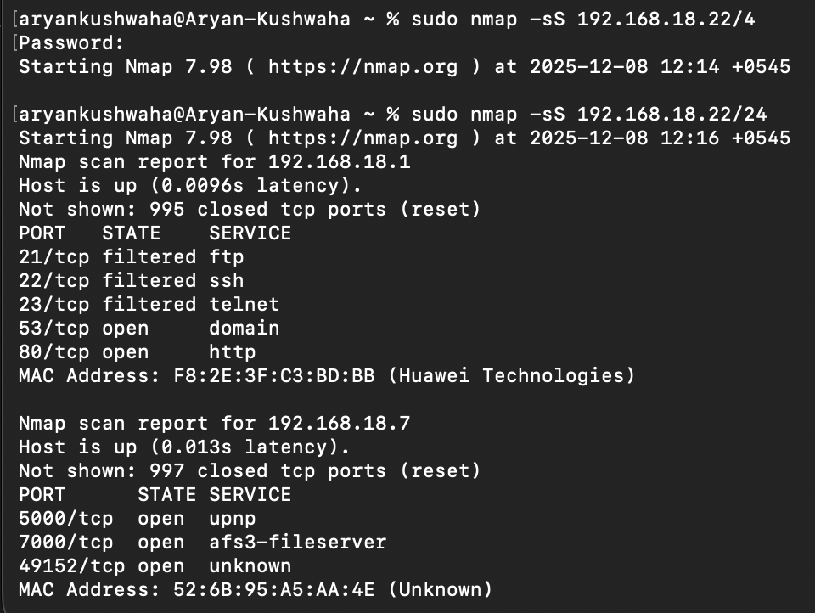
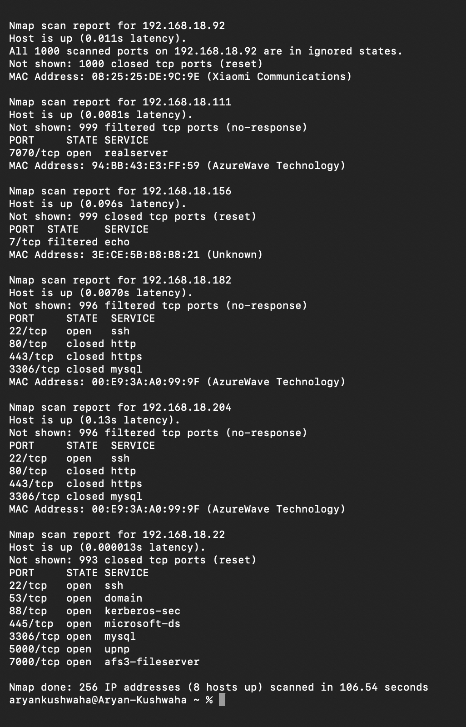

1. Port 21 - FTP (Filtered)
- Description: File Transfer Protocol for file sharing.
- Vulnerabilities: FTP transmits data (including passwords) in plaintext; susceptible to sniffing, brute force, and anonymous access risks.
- Prevention: Use SFTP/FTPS (encrypted alternatives), strong passwords, disable anonymous login, and firewall to limit access.

2. Port 22 - SSH (Open)
- Description: Secure Shell for encrypted remote login.
- Vulnerabilities: Weak passwords, outdated SSH versions, and brute force attacks.
- Prevention: Use key-based authentication, disable root login, limit allowed IPs via firewall, and keep SSH updated.

3. Port 23 - Telnet (Filtered)
- Description: Unencrypted remote login protocol (deprecated).
- Vulnerabilities: Sends data in plaintext, easily intercepted.
- Prevention: Avoid using Telnet; use SSH instead. Block Telnet ports via firewall.

4. Port 53 - DNS (Open)
- Description: Domain Name System for hostname resolution.
- Vulnerabilities: DNS cache poisoning, amplification DDoS attacks.
- Prevention: Use DNSSEC, restrict recursive queries, and secure DNS servers.

5. Port 80 - HTTP (Open/Closed)
- Description: Unencrypted web traffic.
- Vulnerabilities: Data sniffing, injection attacks if the web app is vulnerable.
- Prevention: Use HTTPS (TLS), keep web applications updated, and use web application firewalls.

6. Port 443 - HTTPS (Closed)
- Description: Secure web traffic with TLS encryption.
- Vulnerabilities: Misconfiguration, outdated TLS versions.
- Prevention: Use strong TLS configurations and keep certificates updated.

7. Port 3306 - MySQL (Open/Closed)
- Description: MySQL database server.
- Vulnerabilities: Default or weak passwords, SQL injection.
- Prevention: Restrict access to MySQL port, use strong passwords, update database software, and apply application-level protections.

8. Port 5000 - UPnP (Open)
- Description: Universal Plug and Play for automatic device discovery.
- Vulnerabilities: Can expose devices to remote attacks or unauthorized control.
- Prevention: Disable UPnP if not needed or restrict it within trusted networks.

9. Port 7000 - AFS3 Fileserver (Open)
- Description: Part of Andrew File System (distributed file system).
- Vulnerabilities: Uncommon, but misconfigurations can expose files.
- Prevention: Restrict access to trusted users, disable if unused.

10. Port 445 - Microsoft-DS (Open)
- Description: Microsoft Directory Services for file sharing and network browsing.
- Vulnerabilities: Exploited by ransomware (e.g., WannaCry), SMB vulnerabilities.
- Prevention: Block port 445 from the internet, keep Windows updated, disable SMBv1.
- Capturing Data Packets WireShark

- 