
TRIBHUVAN U NIVERSITY
Faculty of Institute of Science and Technology

ORCHID INTERNATIONAL COLLEGE
GAUSHALA BIJAY CHOWK, KATHMANDU (NEPAL)

A Project Report On
“HOUSE PERMIT PORTAL”
For
E-Governance (CSC366)

Submitted By:
Our Team Members :
- Aaryan Kushawaha (28900/78)
- Bivash Mainali ( 28913/78 )
- Madhav Aryal ( 28918/78 )
- Saurav Gautam ( 28939/78 )
6th semester (Bsc.CSIT)

Submitted To:
Suman Ranabhat
Department of Computer Science and Information Technology
Contents
1. Introduction 1
2. Objectives 1
3. Key Features 1
For Citizens: 1
For Admin/Government Authorities: 1
4. System Requirements 2
Hardware Requirements: 2
Software Requirements: 2
5. Use Case Diagram 2
Actors: 2
Use Cases: 2
6. Workflow of the System 3
7. User Interface 4
Dashboard: 4
Login & Registration: 5
House Permit Application: 6
Status Tracking: 7
Database: 8
8. Security Considerations 10
Conclusion 11

Introduction
The House Permit Project is an online system designed to facilitate the application, verification, and approval of house construction permits. This system streamlines interactions between applicants, government authorities, and construction regulators, ensuring efficiency, transparency, and compliance with legal requirements. The system is built to handle large volumes of applications while maintaining data security and ease of access for users.

Objectives
The primary objectives of the House Permit Project are:
- Provide an online platform for applying for house construction permits.
- Reduce manual paperwork and processing delays.
- Improve transparency and tracking of permit applications.
- Ensure compliance with building regulations and zoning laws.
- Enable government authorities to efficiently review and approve applications.

Key Features

For Citizens:
- User Registration and Login: Citizens can create accounts and securely log in to access services.
- Online Application for House Construction Permits: A guided process to fill out and submit permit applications.
- Upload Required Documents: Allows applicants to submit digital copies of essential documents like site plans, ownership proof, and architectural designs.
- Track Application Status: Provides real-time updates on the progress of applications.
- Receive Notifications and Updates: Automatic email/SMS alerts regarding application progress, approvals, or rejections.

For Admin/Government Authorities:
- Review Submitted Applications: Officials can view all submitted applications and their associated documents.
- Verify Uploaded Documents: Automated and manual checks to ensure the validity of documents.
- Approve or Reject Applications with Reasons: Decision-making interface with the ability to provide reasons for rejection.
- Issue Digital Permits: Approved applications result in the generation of a digital permit that can be downloaded by the applicant.
- Generate Reports: Statistical and analytical reports on application trends, approvals, and rejections for government monitoring.

System Requirements

Hardware Requirements:
- Server with High Availability: Ensures the system runs efficiently without downtime.
- Storage for Document Uploads: Secure file storage for applicant documents.
- Secure Database System: Ensures safe storage and retrieval of data.

Software Requirements:
- Web-Based Application: Built using modern web technologies such as HTML, CSS, JavaScript, and backend frameworks like Node.js , React.js.
- Database Management System: Supports databases such as MongoDB.
- Cloud Hosting or On-Premises Deployment: Flexible deployment options for scalability and security.

Use Case Diagram

Actors:
- Citizen: The applicant who submits the house permit request.
- Government Authority (Admin/Verifier): The official responsible for reviewing and approving applications.

Use Cases:
- Citizen Registers and Applies for a Permit: Submits necessary details and documents.
- Admin Verifies Application and Documents: Checks for completeness and authenticity.
- Admin Approves or Rejects the Application: Makes a decision based on regulations.
- Citizen Receives a Response and Can Download the Permit: If approved, the citizen downloads the permit. 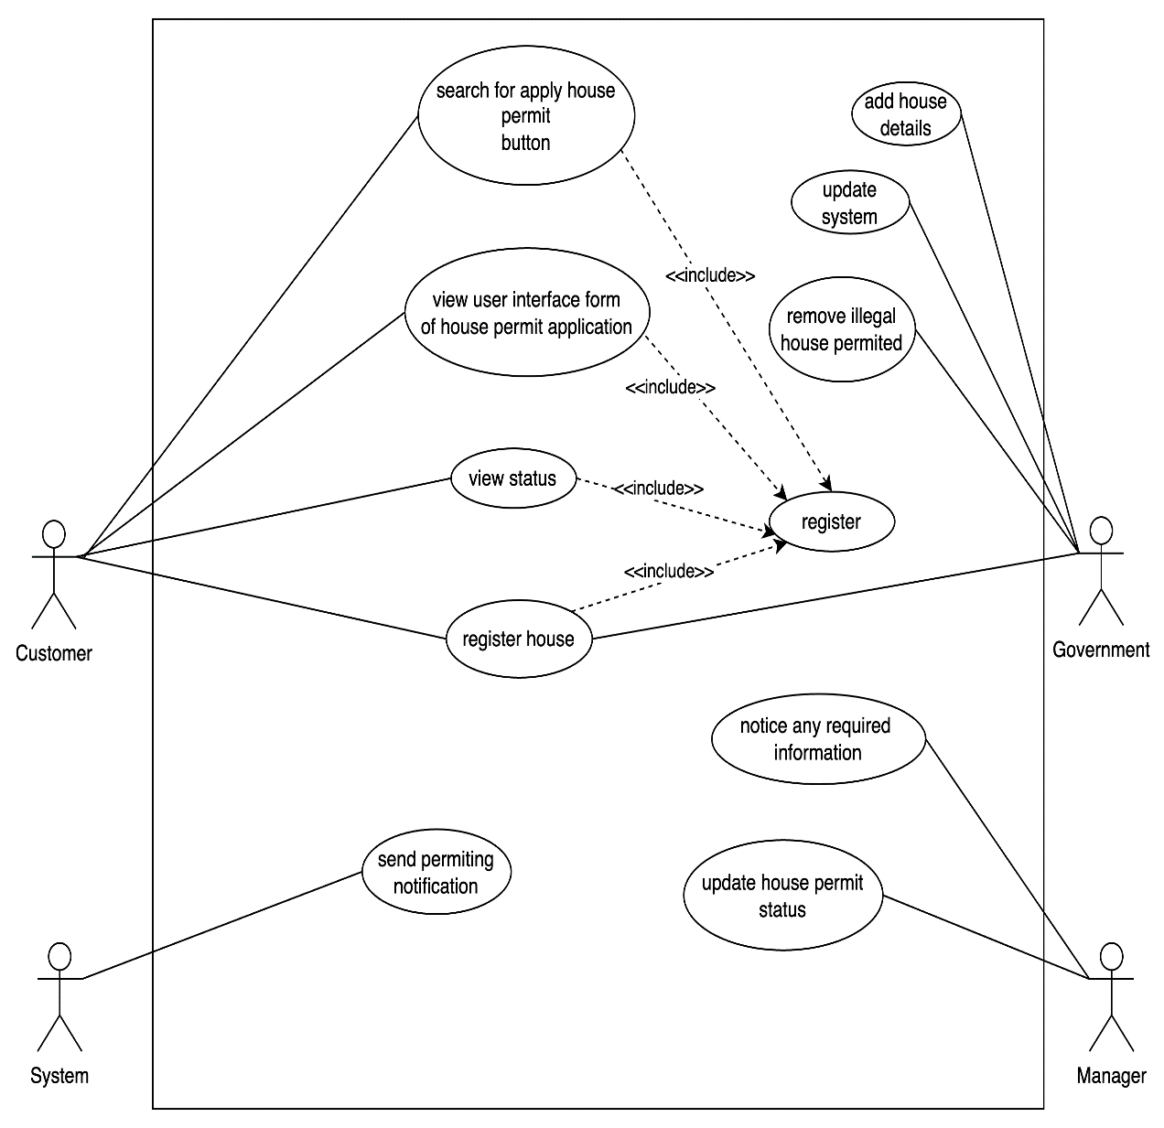
Fig 1 : Use Case Diagram of House Permit Portal

Workflow of the System
- The citizen registers on the platform: Provides basic details and identity verification.
- The citizen applies with required documents: Completes an online form and uploads necessary files.
- The government authority reviews and verifies the application: Ensures that the submitted documents are correct.
- Approval or rejection decision is made: Based on compliance with regulations.
- The citizen is notified of the decision: Gets a confirmation via email or SMS.
- If approved, the citizen can download the permit: A digital copy is available for use.
- Reports are generated for government monitoring: Data analytics help improve the process over time.

User Interface
The House Permit Portal UI is designed for a seamless and user-friendly experience, ensuring easy access to permit-related services. Key features include:

Dashboard:
A personalized interface displaying application status, notifications, and user details.

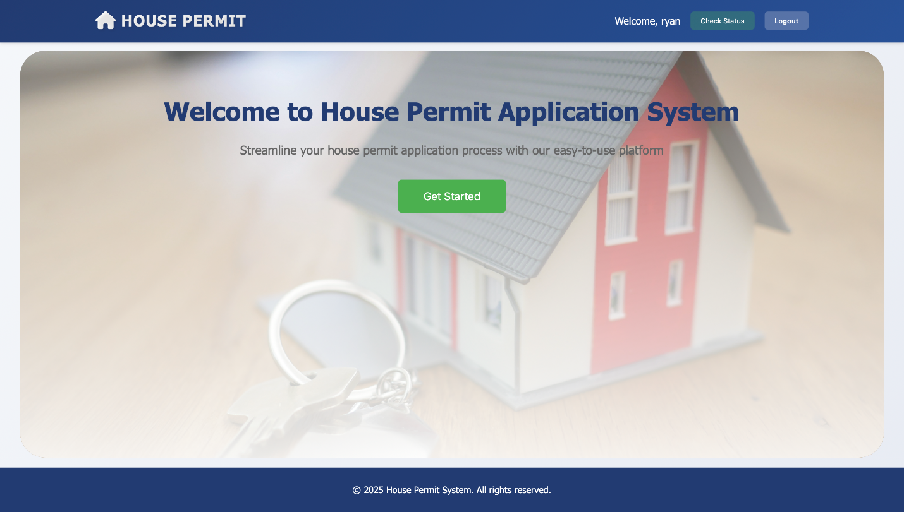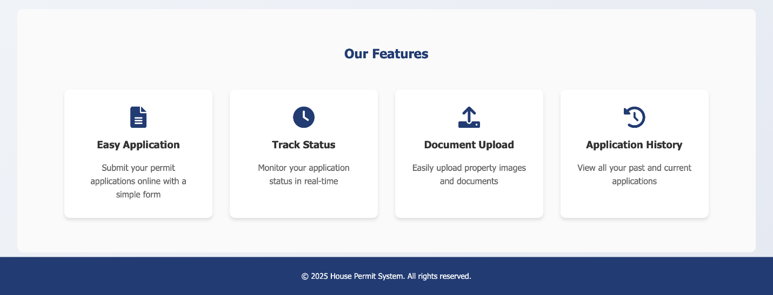
Fig 2 :Dashboard of House Permit

Login & Registration:
Users can securely register and log in using an intuitive authentication system.
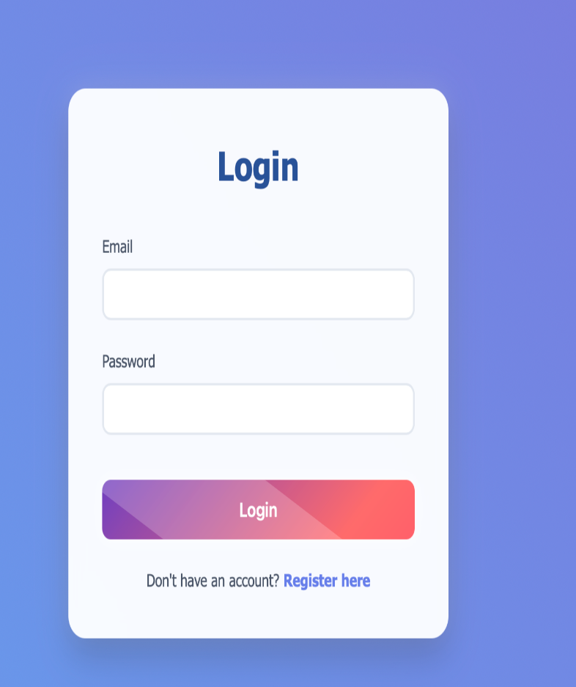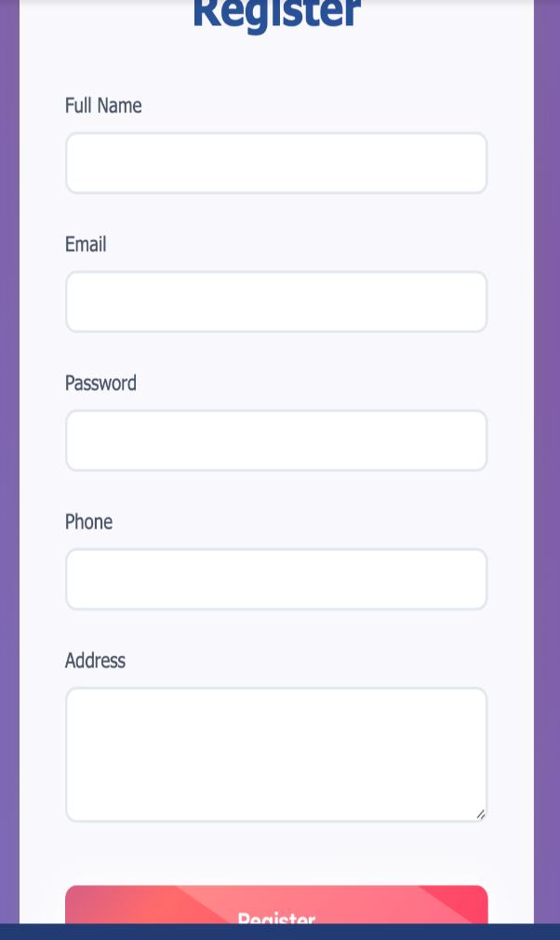
Fig 3: Login and Register Form of House Permit

House Permit Application:
A structured online form allowing users to submit permit requests with required documents.
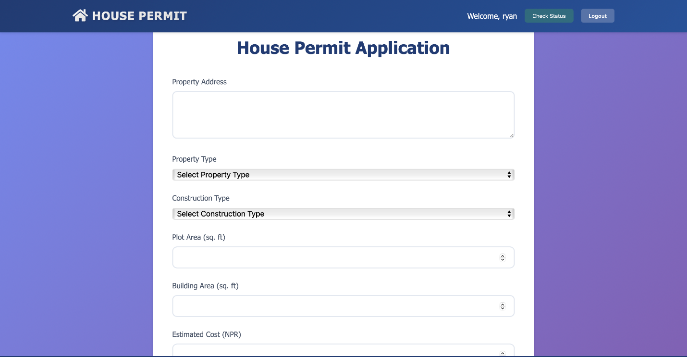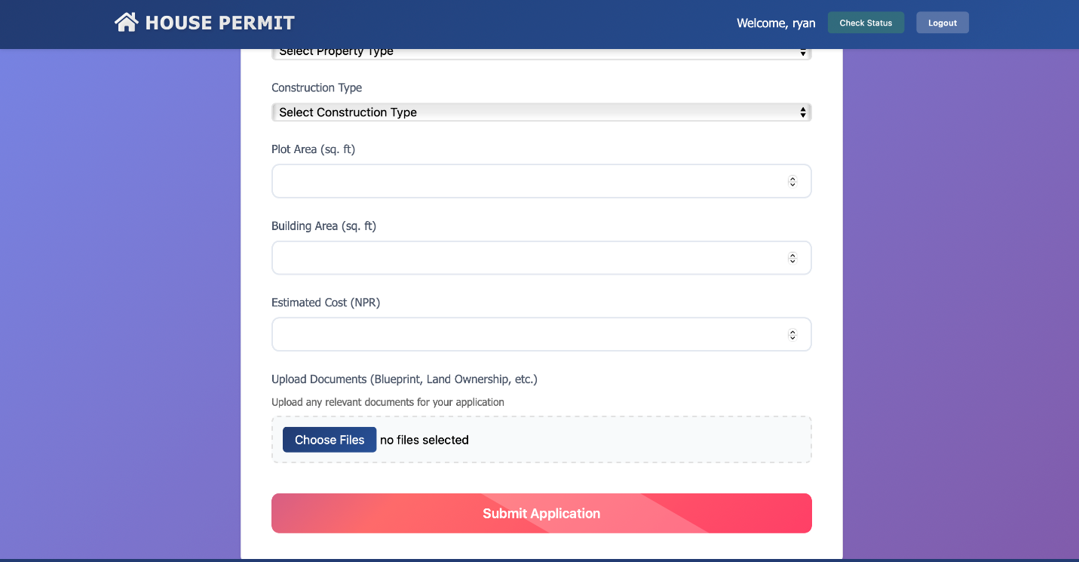
Fig 4: Form of House Permit

Status Tracking:
Real-time updates on the approval process of permit applications.

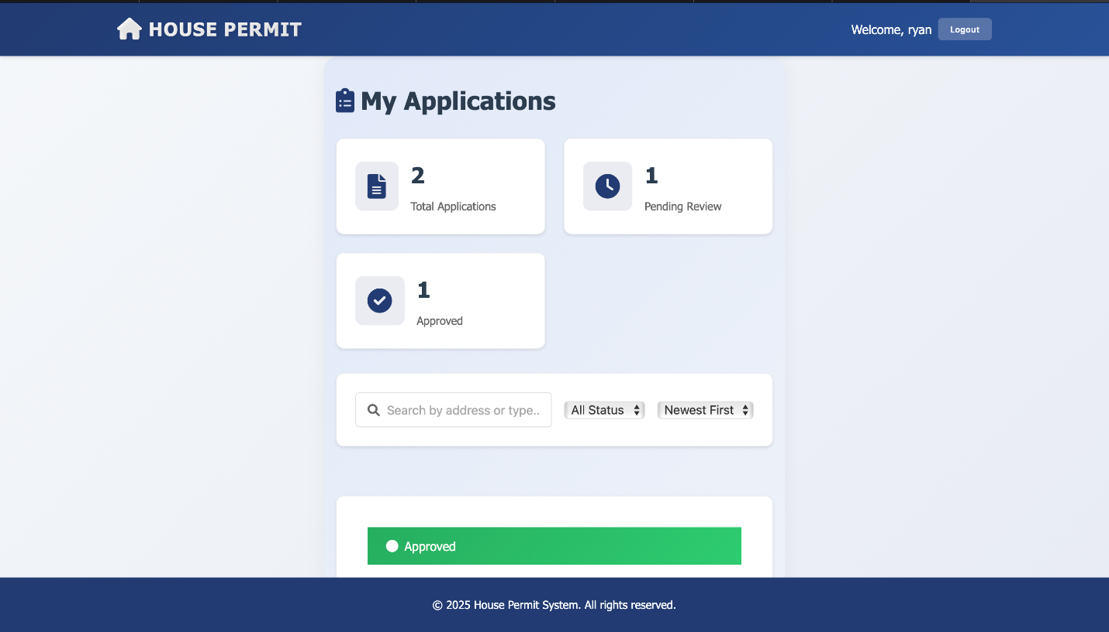
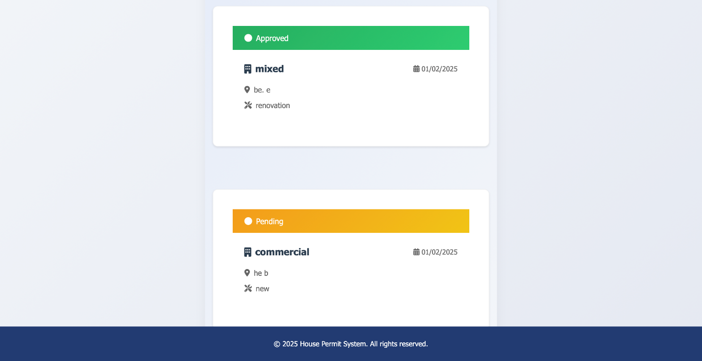
Fig 5: Status Tracking of House Permit

Database:
The House Permit Portal uses MongoDB as its database to efficiently store and manage data.

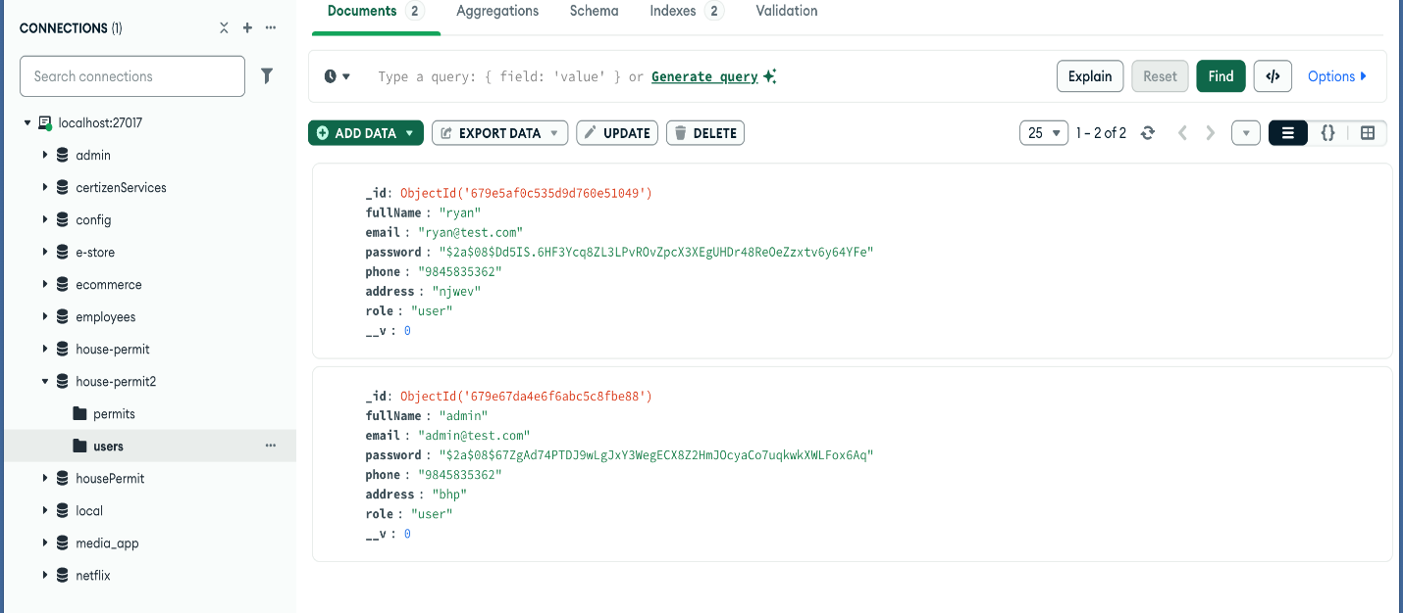

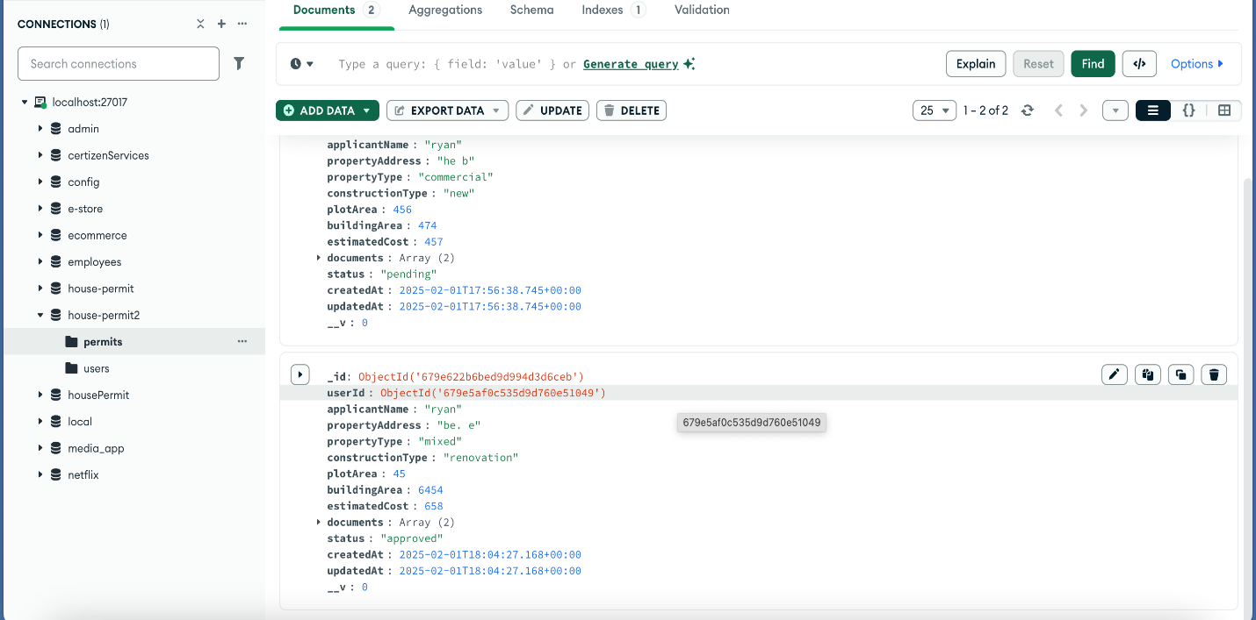
Fig 6: Storing Data of Citizens and House Details

8. Security Considerations
- Role-Based Access Control (RBAC): Restricts access based on user roles (citizen, admin, verifier, etc.).
- Encryption for Sensitive Data: Ensures that user information and documents are securely stored and transmitted.
- Secure Document Uploads: Uses validation mechanisms to prevent unauthorized or corrupt files.
- Audit Logs: Tracks all activities within the system to maintain accountability and detect fraudulent activities.

Conclusion
The House Permit Project simplifies and digitizes the process of obtaining house construction permits, reducing delays, enhancing security, and ensuring regulatory compliance. By automating this process, it improves efficiency for both applicants and government authorities. The system ensures that users have a seamless experience while adhering to legal requirements, making it a crucial solution for modern urban planning and governance.

