MiniDSP | Developer Quick Start
YOUR MISSION • Build a cloud-hosted Mini Data Discovery & Classification prototype in 3 hours, using AI efficiently as your developer and reviewer.

Start here: two Copilot chats
1. Open your assigned MiniDSP project folder in VS Code.
2. Open Copilot Chat 1 in Ask mode. Paste the full contents of START_HERE_INSTRUCTOR.md. This is your Instructor / Challenger.
3. Open a separate Copilot Chat 2 in Agent mode. Paste the full contents of START_HERE_DEVELOPER.md. This is your Developer.
4. IMPORTANT: Leave Chat 2 waiting after it reads its instructions. Do not ask it to build anything yet.
5. Go back to Chat 1. Discuss the architecture, ask questions and approve the first small task.
6. Copy Chat 1’s task prompt into Chat 2. Chat 2 writes code, runs tests, fixes issues and sends a short report.
7. Copy Chat 2’s report back into Chat 1. It challenges the result and suggests a follow-up. Send that to Chat 2.
8. Repeat. You approve important decisions, commits and deployment; ask whenever you do not understand something. At each milestone, Chat 2 updates WORK_LOG.md with real test results, decisions, Git evidence and gaps.
Keep BOTH chats open in the SAME VS Code project. They see the same files, but do not share chat history. Copy prompts and reports between them. Be token-efficient: short prompts, targeted file reads and concise reports; never skip essential testing or security checks.

Three-hour schedule
0–20 min Setup and architecture • 20–50 Detection engine • 50–85 Supabase and uploads
85–125 Dashboard and results • 125–155 Export and testing • 155–180 Deploy and demo

What completion looks like
A miniature version of Lepide’s data discovery and classification functionality, with a modern SaaS interface using the Lepidus design system. The dashboard and findings screenshots below are from the 15 October test run; upload and scan-history images remain illustrative design concepts, not exact implementation requirements.

Application screenshots — actual MiniDSP test run (15 October 2026)

1. Dashboard
Actual test-run dashboard: files scanned, findings, risk distribution and recent scans.
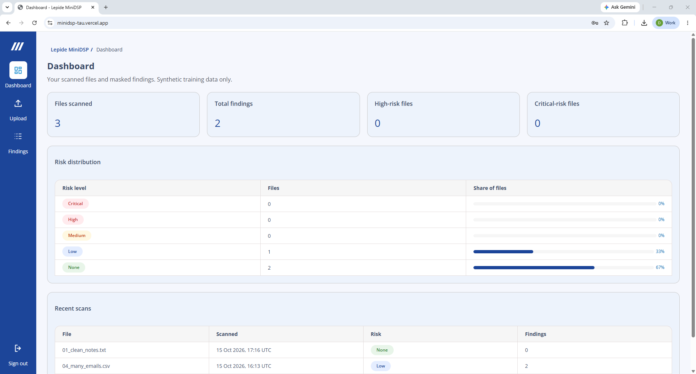

2. File upload
Actual test-run upload page: select a synthetic CSV or TXT file (up to 1 MiB) and run classification.
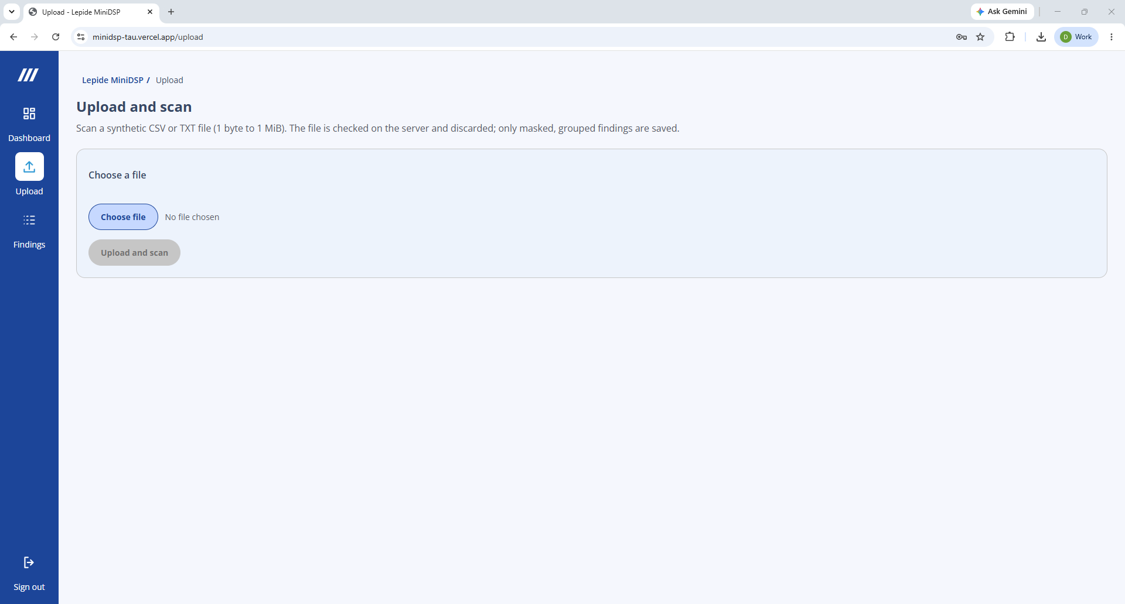

3. Dashboard — classified findings
Actual test-run dashboard after scanning files containing sensitive-data examples, including critical findings.
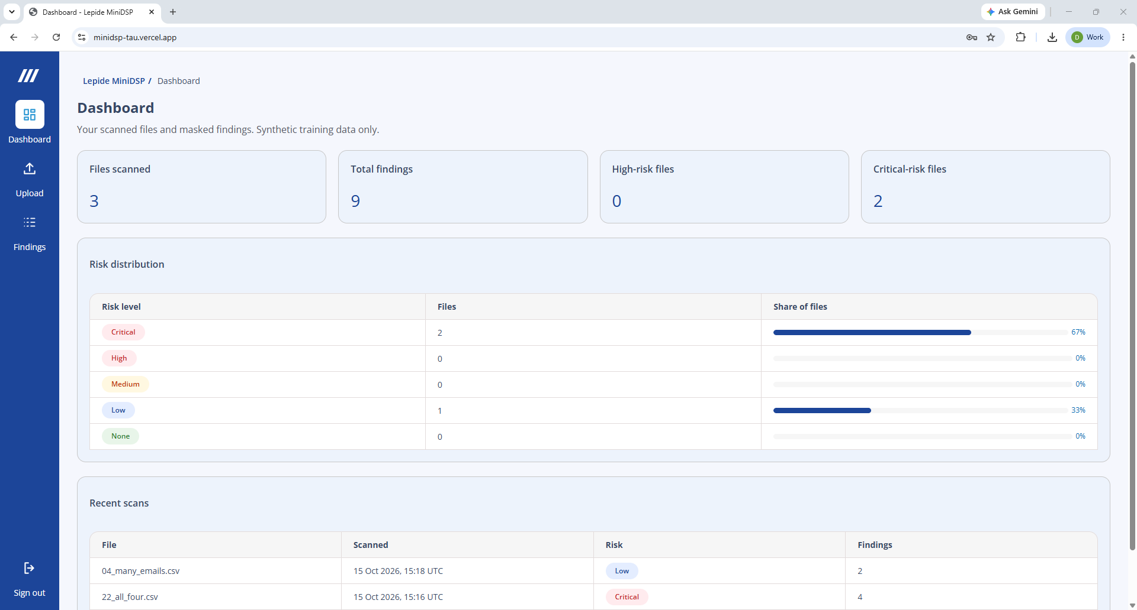

4. Recent scan history
Actual test-run recent scans: file names, timestamps, risk classification and finding counts.
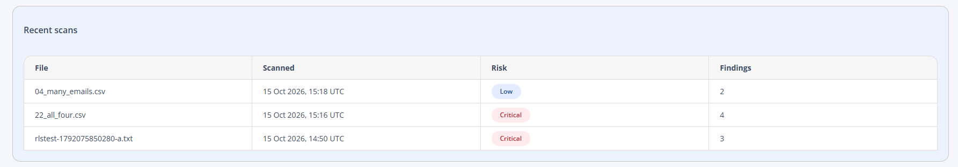

Required application capabilities
- Supabase user login.
- CSV and TXT upload up to 1 MB; synthetic data only.
- Detection of email addresses, UK phone numbers, UK National Insurance numbers and Luhn-valid payment card candidates.
- Low / Medium / High / Critical risk classification (None if no matches).
- Masked values in display and persistent storage; never store raw uploads or unmasked matches.
- Dashboard, scan history and filterable findings.
- Safe CSV report export.
- PostgreSQL scan metadata and masked findings, secured with user-level access controls (RLS).

Final demonstration
Open your Vercel URL, log in, upload a synthetic file, run a scan, show masked findings, review history and export a CSV. Show GitHub, actual test/build output, WORK_LOG.md and LEARNINGS.md. Explain one defect discovered through the Instructor challenge and how it was fixed.
A working prototype is the goal, not a production-ready product. Clearly state any missing functionality or tests not executed. AFTER the final demo, ask Chat 1 for the final scoring instruction, paste it into Chat 2, and have Chat 2 generate DEVELOPER_SCORECARD.md using the original 100-point rubric. Submit that file to your team lead. Do not generate or display scores earlier.

