**LAB 1 REPORT**

**Objective:** Familiarising ourselves with the digital testing kit and Arduino.

**Electronic Components Used:** Digital Testing kit, wire, NOT GATE (7404 IC), Arduino Uno

**Reference Circuit:**

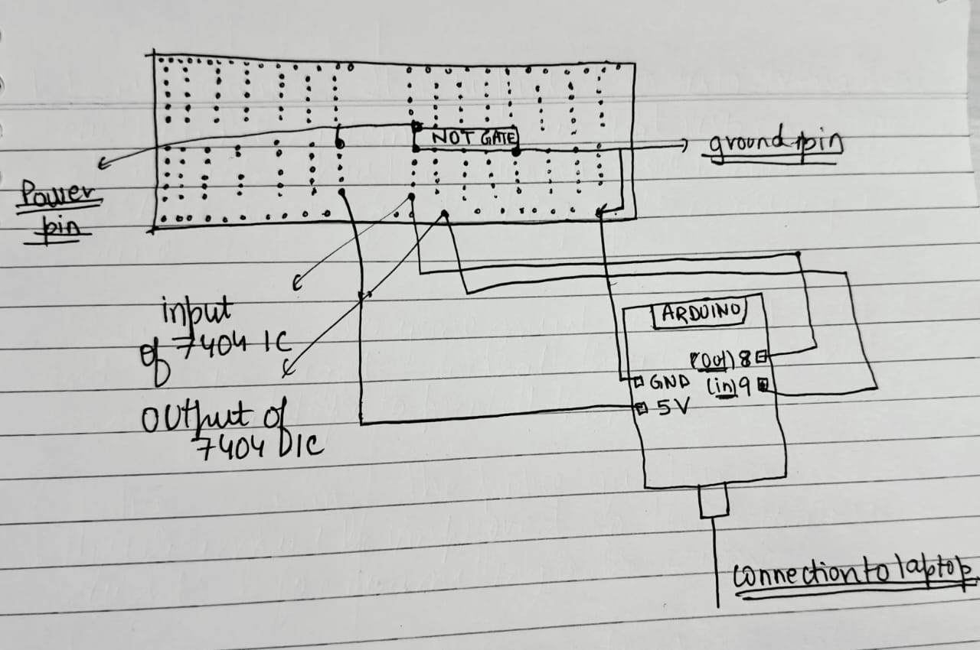

**Procedure:**

1. Familiarisation with Digital Testing kit:
   1. First take a digital circuit kit and turn the VCC supply on
   2. Use clock on fast mode. You would see the CLK led start glowing on turning it on.
   3. In the breadboard part of the digital testing kit attach a 7404 IC (NOT GATE) to the centre of the board.
   4. Verify the working of the LEDs by connecting an LED to a VCC power supply
   5. Connect the ground pin (7th pin) of the 7404 IC to the ground of the digital testing kit.
   6. Connect the power pin (14th pin) of the 7404 IC to the VCC of the digital testing kit.
   7. Connect one of the input switches of the 7404 IC to the input
   8. Connect the output pin corresponding to the input pin of step g to the LEDs
2. Familiarisation with Arduino:
   1. First connect the Arduino to your computer
   2. Open Arduino IDE and click on select board. Select Arduino UNO in the USB port you connected the Arduino to in step a
   3. Test the connection by compiling and uploading a simple print statement
   4. In the breadboard part of the digital testing kit attach a 7404 IC (NOT GATE) to the centre of the board.
   5. Connect the ground pin (7th pin) of the 7404 IC to the GND port on the Arduino Uno
   6. Connect the power pin (14th pin) of the 7404 IC to the 5V port on the Arduino Uno
   7. Connect one of the input pins of the 7404 IC to the input
   8. Now in the void setup define an input pin (7 pin of Arduino UNO) -> we will read data using this pin
   9. Connect the corresponding output pin of the pin in the g step to the input pin of the Arduino Uno
   10. Now in the void loop we read the input of the output of the NOT gate. Using digitalRead function
   11. Store this digitalRead in a variable of type integer. Now check if the input is HIGH OR LOW and print “Hello World!” when the input is HIGH.
   12. Put a delay of 1000 milliseconds.
3. Conclusion:

Thus, we were able to connect and program the Arduino to give output as well as read inputs from the logic gates

**TinkerCAD Simulation**:

*Link to tinker cad creation:* [*https://www.tinkercad.com/things/clXlf6pQlw4-lab1*](https://www.tinkercad.com/things/clXlf6pQlw4-lab1)

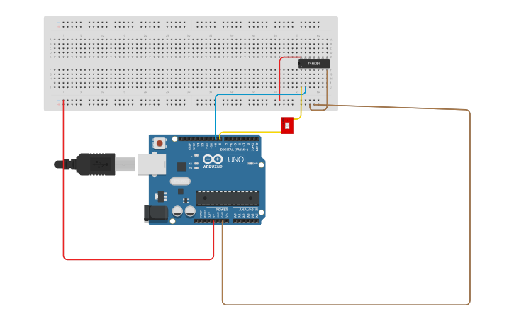

**Code:**

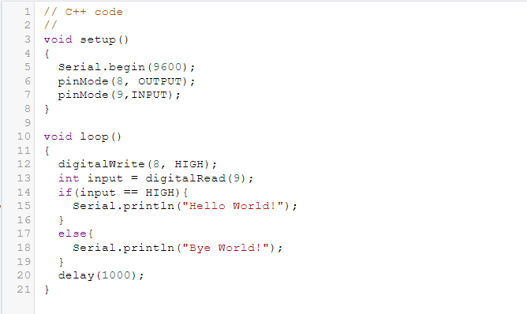

**Lab Images:**

