**LAB 3 REPORT**

**Objective:** A) making a half adder, B) making a full adder, C) Make a half subtracter, D) Make a full subtracter

**Electronic Components Used:** Digital Testing kit, wire, XOR gate, AND Gate, Arduino Uno

**Reference Circuit:**

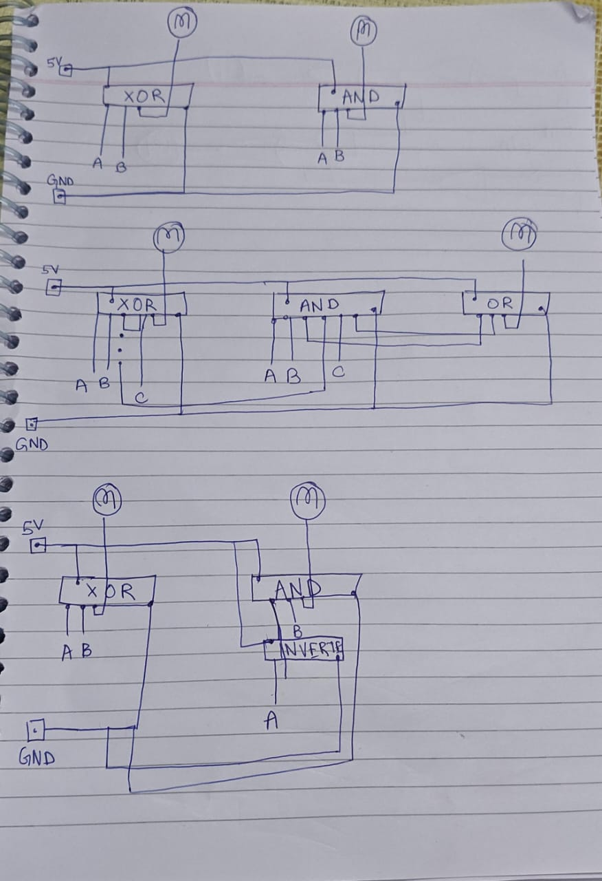

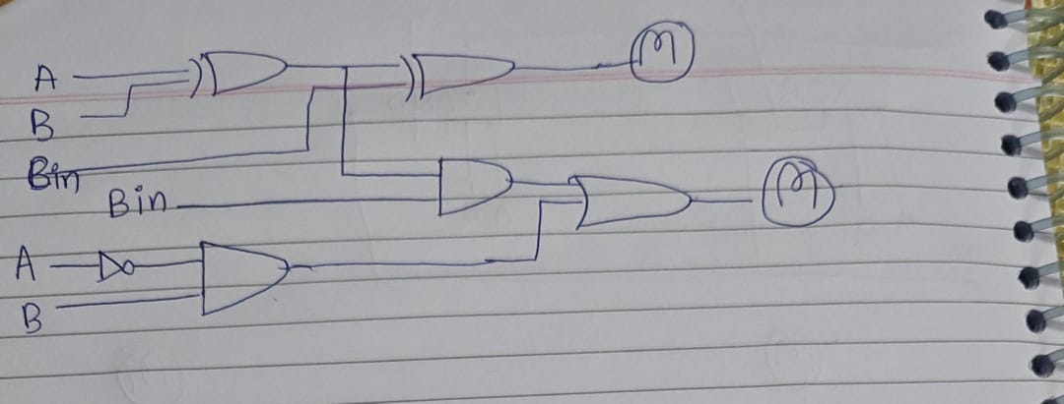

**Procedure:**

1. Building a Half Adder:
   1. First take a digital circuit kit and turn the VCC supply on
   2. Use clock on fast mode. You would see the CLK led start glowing on turning it on.
   3. In the breadboard part of the digital testing kit attach a XOR Gate and an AND gate to the centre of the board.
   4. Verify the working of the LEDs by connecting an LED to a VCC power supply
   5. Connect the ground pin (7th pin) of the XOR and the AND gate to the ground of the digital testing kit.
   6. Connect the power pin (14th pin) of the XOR and AND gate to the VCC of the digital testing kit.
   7. Connect one of the input switches of the XOR and AND to 2 input pins of the Arduino (pin 7 and 8)
   8. Connect the output pin corresponding to the input pins of step g to the LEDs
   9. NOW change the values of input 7 and 8 to see the output of the half adder
2. Full Adder:
   1. First take a digital circuit kit and turn the VCC supply on
   2. Use clock on fast mode. You would see the CLK led start glowing on turning it on.
   3. In the breadboard part of the digital testing kit attach 2 XOR gates, 2 AND gates and 1 OR gate to the centre of the board.
   4. Verify the working of the LEDs by connecting an LED to a VCC power supply
   5. Connect the ground pin (7th pin) of the 2 XOR gates, 2 AND gates and the OR Gate to the ground of the digital testing kit.
   6. Connect the power pin (14th pin) of the 2 XOR gates ,2 AND gates and the OR gate to the VCC of the digital testing kit.
   7. Connect one of the input switches of the first XOR to 2 output pins of the Arduino (pin 13 and 12).
   8. Connect the output of the first XOR gate to the input of the second XOR gate. Also add the other input of the second XOR gate to output pins of the Arduino (pin 11)
   9. Connect output pin of the second XOR gate to an LED (This will be out sum)
   10. Connect the output pin of the first XOR gate to the input of the first AND Gate. Also put the input of C (pin 11 of Arduino) also to the first AND gate.
   11. Connect A and B (pin 13 and 12) to the second AND gate.
   12. Connect to output of the first AND gate and the second AND gate to the OR gate.
   13. NOW connect the output of this OR gate to an LED (This will be the carry).
   14. Now the change the values of A B C to get different values of the full adder
3. Half Subtracter:
   1. First take a digital circuit kit and turn the VCC supply on
   2. Use clock on fast mode. You would see the CLK led start glowing on turning it on.
   3. In the breadboard part of the digital testing kit attach a XOR Gate, an AND gate and an inverter gate to the centre of the board.
   4. Verify the working of the LEDs by connecting an LED to a VCC power supply
   5. Connect the ground pin (7th pin) of the XOR, the AND gate and the NOT gate to the ground of the digital testing kit.
   6. Connect the power pin (14th pin) of the XOR, the AND gate and the NOT gate to the VCC of the digital testing kit.
   7. Connect one of the input switches of the XOR and AND to 2 input pins of the Arduino (pin 7 and 8)
   8. Connect the output pin corresponding to the input pins of step g to the LED this will be our difference
   9. Now connect the the 7th pin (A) to the inverter gate and connect the output of the inverter gate to an AND gate input pin
   10. Now connect the 8th pin (B) to the other input of the AND gate.
   11. Now connect the output of the AND gate to an LED
   12. NOW change the values of input 7 and 8 to see the output of the half subtracter
4. Full Subtracter:
   1. First take a digital circuit kit and turn the VCC supply on
   2. Use clock on fast mode. You would see the CLK led start glowing on turning it on.
   3. In the breadboard part of the digital testing kit attach 2 XOR Gates 2 AND gates 2 inverters and 1 OR gate to the centre of the board.
   4. Verify the working of the LEDs by connecting an LED to a VCC power supply
   5. Connect the ground pin (7th pin) of the 2 XOR gates and the 2 AND gates and 2 inverter gates and 1 or gate to the ground of the digital testing kit.
   6. Connect the power pin (14th pin) of the 2 XOR gates and 2 AND gates and 2 inverter gates and 1 OR gate to the VCC of the digital testing kit.
   7. Connect the input switches of the first XOR gate with the outputs from Arduino pin 13(B) and 12(Bin)
   8. Connect the input switches of the second XOR with the output from the first XOR gate and one output from the Arduino pin 11 (A)
   9. Connect the output of this second XOR gate to an LED (which will be our difference)
   10. Now connect the output pin B (13) of Arduino to the input pin of the inverter gate.
   11. Connect the input pins of the first AND gate with the output of the first inverter gate and pin 12 (Bin) of Arduino
   12. Now connect the input pin of the second inverter gate with the output of the first XOR gate
   13. Now connect the input pins of the second AND gate with the output of the second inverter gate and the 11(A) pin of the Arduino
   14. Now connect the OR gate with the output of the second AND gate and the first AND gate
   15. Now connect the output of the OR gate to an LED
   16. NOW change the values of input 12 and 11 and 13 to see the output of the full subtracter

**Conclusion:** Thus, we were able to check the working of the half adder full adder half subtracter and full subtracter

**TinkerCAD Simulation**:

*Link to tinker cad creation to part A half adder:* [*https://www.tinkercad.com/things/6pEONM88iB2-lab3a*](https://www.tinkercad.com/things/6pEONM88iB2-lab3a)

*Link to the tinker cad creation to part B full adder:* [*https://www.tinkercad.com/things/lzrEHnJY2p5-3b*](https://www.tinkercad.com/things/lzrEHnJY2p5-3b)

*Link to the tinker cad creation of part C half subtracter:* [*https://www.tinkercad.com/things/gCszNWwn23x-3c*](https://www.tinkercad.com/things/gCszNWwn23x-3c)

*Link to tinker cad creation of the part D full subtracter:* <https://www.tinkercad.com/things/3TSXcG8gu1C-3d>

1. 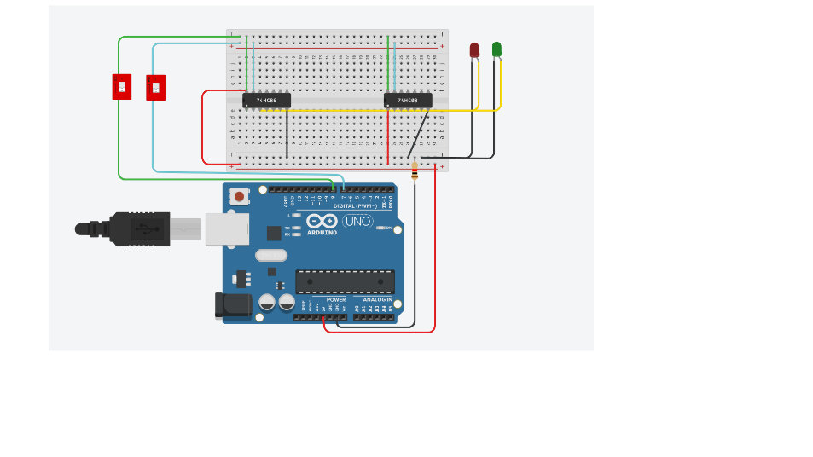
2. 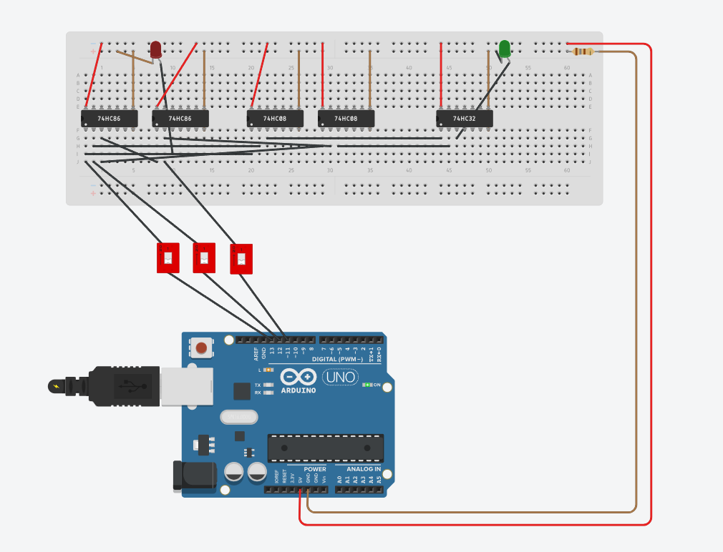
3. 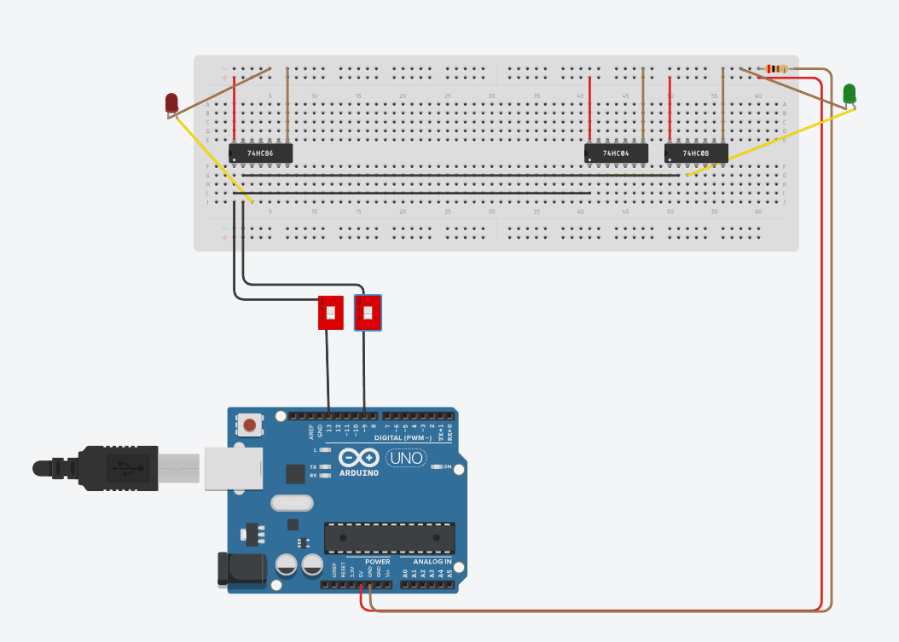
4. 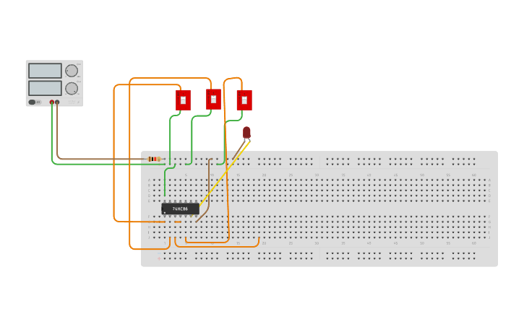

**Code:**

Part a and c

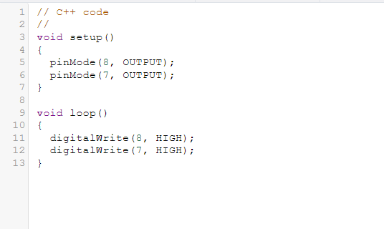

Part b and d

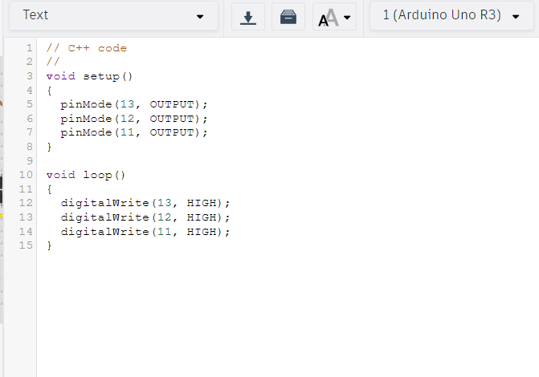

**Lab Images:**

a)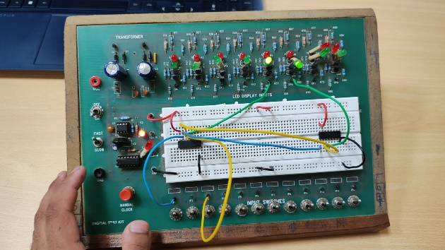

b)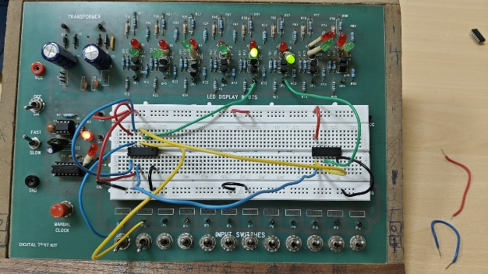

c)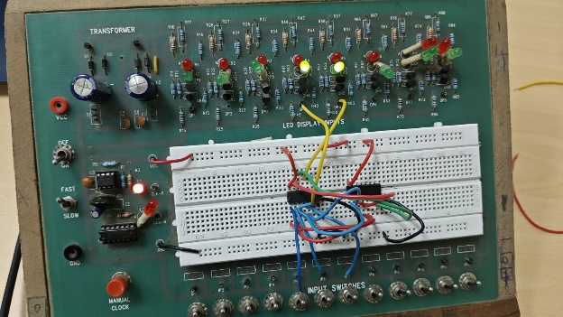

d)