PROJECT REPORT

ABSTRACT

&

WORKING

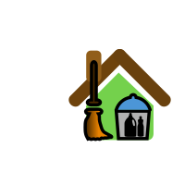

SWACHHAGRAH

-An Appeal for cleanliness…

BY: CMRCET students (3rd yr)

Aman Mishra, Sonali ,Aryan ,Gouthami, Himanshu Singh, Devender.

There are many factors which describes the development of a city .The most important of them all is cleanliness and hygiene of the area.

Many cities in India faces major environment challenges associated with waste generation and inadequate waste collection, transport and treatment.

Garbage management is a major problem in many urban areas, where urbanization, industrialisation and economic growth have resulted in increased municipal waste generation per person. High population density makes it more difficult to manage garbage collection in an area which can cause following problems-

*No proper dustbins (littering of places).

*Delayed collection of garbage (accumulation of garbage in residential areas).

*Open dustbins which let animal feed on non- biodegradable waste

Though the government is working on these issues but there is no proper mechanism to monitor it.

Our app “SWACHHAGRAH” is an android application which helps in monitoring waste management in locality.

“SWACHHAGRAH” focuses on the problems of locality which are not in notice of Municipal Corporation. It provides a public platform where citizens can upload the pictures with description of problems and the location

The project is developed in Java Programing Language by using Android Studio .we use the Android Software Development Kit (SDK) which includes a variety of custom tools that helps us to develop a mobile application on the Android platform

The application consist -

\****User login & registration page*** -which lets the user to register through email id or mobile number.

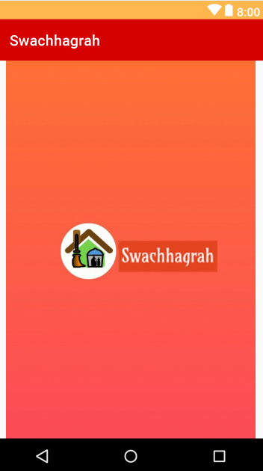

\****complain page***-user can upload a picture with a description of the problem along with the location, the picture will be posted in the timeline with the user name, which will be voted by the other users who are facing the same problem.

-The problem with highest number of votes will be prioritised and will be brought into notice of GHMC and solved first .

\****Reward page-***the GHMC areas can be voted according to the working of the problems mentioned by the users in the application, the most active user will be given points for rewards which will be stored in the database. Moreover this page will contain the best GHMC body based on the points.

Note : Reward will consists of certificate, cash prize etc.

***\*GHMC Rating page***-the purpose of this page is to give rating for the GHMC area based on the cleanliness which will be used for the reward generation for different GHMC body.

\****Feedback page*** -this page lets the user to send a valid feedback about the application for the further improvements.

*WHY IT IS DIFFERENT FROM THE OTHER APPLICAIONS?

Before working on the application we researched about other similar apps which exist. We found that apps were only focusing on the working of application but not on the user involvement.

-This application focuses on encouraging people to be active and responsible by providing rewards such as certificates, prizes and lucky draws to the active user and GHMC body. This will create awareness among citizens to be active and even responsible in keeping surrounding clean.

-Through this app it becomes easy for GHMC to keep track of the problems in the residential areas and progress in solving the problems .

-It encourages GHMC also to be active by providing ratings to different GHMC areas according to the votes.

Working of SWACHHAGRAH…

(SCREENSHOTS..)

When app launches ->



Login page appears ->

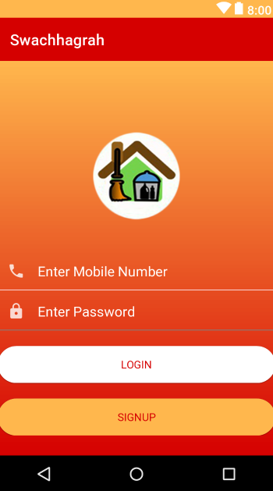

if user is not registered then open

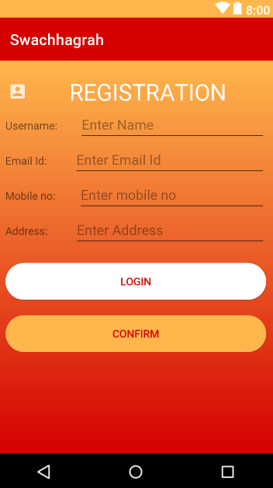 fill the details and continue with the login process. After login welcome page appears ->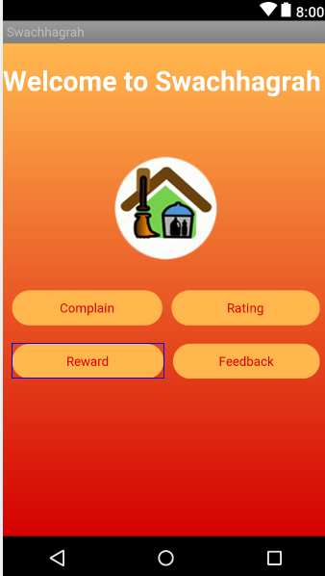

Which pops 4 options, if user clicks on complain -> 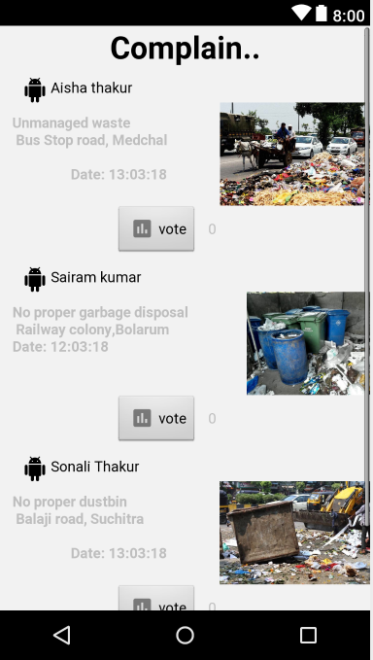 complain page. Appears and also give the option to upload complain.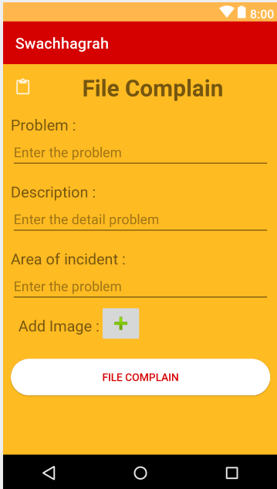

If rating is clicked then a page appears to rate the different GHMC bodies.

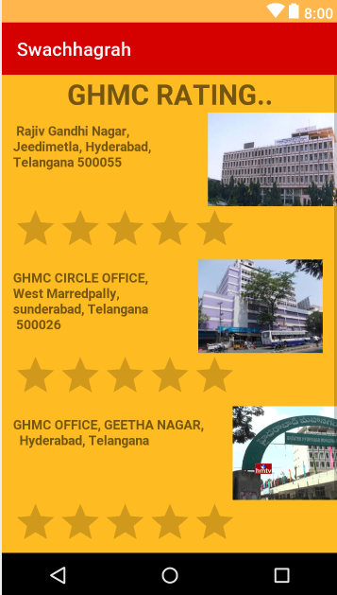

If the reward is clicked then a page containing the points of different GHMC body and the users.

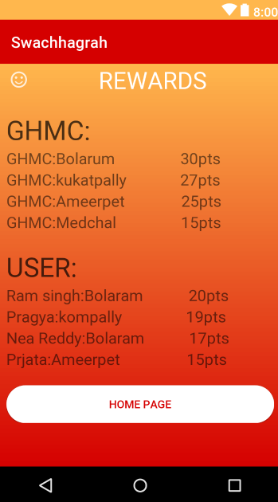

If the feedback is clicked then there is an option for giving feedback to us (developer) for the improvement as we respect the user’s opinions. 