EDUPREDICT AI
Student Academic Performance Prediction System
An End-to-End Machine Learning Web Application
PROJECT REPORT
Submitted by
Aryan Mishra
B.Tech CSE (Data Science)
ABES Engineering College
July 2026

Table of Contents
1. Executive Summary
2. Introduction
3. Problem Statement & Objectives
4. System Architecture
5. Technology Stack
6. Dataset Description
7. Methodology
8. Exploratory Data Analysis
9. Model Development & Training
10. Results & Evaluation
11. Web Application & Deployment
12. Testing & Sample Predictions
13. Limitations & Future Scope
14. Conclusion
15. References

1. Executive Summary
EduPredict AI is a full-stack machine learning application that predicts a student's final examination score from measurable study habits, lifestyle factors, and socio-academic background. The system moves through the complete data science lifecycle: data cleaning, feature encoding, exploratory analysis, multi-model training, evaluation, and deployment behind a REST API with a live web interface.
The project was trained on 6,607 student records spanning 19 predictor variables, including study hours, attendance, parental involvement, and access to learning resources. Four regression algorithms — Linear Regression, Decision Tree, Random Forest, and Gradient Boosting — were trained and benchmarked, with Gradient Boosting selected as the production model on the strength of the lowest error and highest explained variance (R² = 0.7253).
The trained model is served through a Flask backend exposing both a browser-based prediction form and a JSON REST endpoint, and the system is deployed publicly with the backend hosted on Render and the frontend hosted on Netlify. Beyond a raw score, the application converts each prediction into a performance category, a risk level, and a short list of personalised recommendations, making the output directly actionable for students and educators.

2. Introduction
Academic performance is shaped by far more than classroom instruction. Attendance, daily study routine, sleep, parental involvement, access to resources, and peer environment all interact to determine how a student ultimately performs in examinations. Educators are typically limited to reactive tools — report cards and term-end results — that surface a problem only after it has already occurred.
EduPredict AI addresses this gap by framing academic outcome prediction as a supervised regression problem. Given a student's current habits and circumstances, the system estimates a numeric exam score before the exam takes place, and translates that estimate into a plain-language performance band together with targeted guidance. This turns a lagging indicator (the exam result) into a leading one that can inform timely intervention.
The project was implemented as an end-to-end pipeline rather than a standalone notebook: a Python training script produces a serialized model artifact, and that artifact is loaded by a Flask web service that powers both an HTML form and a JSON API, with a separate static frontend for public access.

3. Problem Statement & Objectives

Problem Statement
Design and implement a machine learning system capable of predicting a student's exam score from a combination of behavioural, demographic, and environmental attributes, and expose that system through a usable, publicly accessible web application.

Objectives
- Clean and prepare a real-world, mixed-type (numeric + categorical) student performance dataset.
- Engineer a consistent encoding scheme so the model can be reused on new, unseen input at inference time.
- Train and fairly compare multiple regression algorithms using standard error and fit metrics.
- Select and persist the best-performing model along with its encoders and feature order.
- Expose the model via a REST API and a browser-based form, both returning an interpretable performance band and recommendations.
- Deploy the solution so it is accessible over the public internet.

4. System Architecture
The system follows a layered architecture that separates data processing, model training, model serving, and presentation. Each stage produces artifacts consumed by the next, which keeps training fully decoupled from the running web service.

Pipeline Overview
- Dataset (CSV) → Data Cleaning → Feature Engineering
- Categorical Encoding (Label Encoding, persisted per column)
- Model Training across four candidate algorithms
- Model Evaluation and automatic selection of the best performer
- Model Serialization to .pkl artifacts (model, encoders, feature order)
- Flask REST API loads the artifacts and serves predictions
- Netlify-hosted frontend / Flask-rendered form consume the API

Component Responsibilities
Component | Responsibility
train_model.py | Loads raw data, cleans and encodes it, trains and evaluates four models, saves the winning model and its metadata
models/ | Serialized model.pkl, encoders.pkl, features.pkl, and evaluation CSVs (metrics.csv, feature_importance.csv)
app.py | Flask application exposing /, /predict (form submission) and /api/predict (JSON REST endpoint)
templates/, static/ | Server-rendered HTML form, CSS, and client-side JavaScript served directly by Flask
frontend/ | Standalone static frontend deployed to Netlify, calling the Flask API over CORS

5. Technology Stack

Frontend
- HTML5, CSS3, JavaScript
- Bootstrap for responsive layout

Backend
- Python 3
- Flask (web framework) with Flask-CORS for cross-origin API access

Machine Learning
- Scikit-learn for model training and evaluation
- Pandas and NumPy for data manipulation
- Joblib for model serialization
- Matplotlib for visualization generation

Deployment
- Render – hosts the Flask backend and REST API
- Netlify – hosts the static frontend

6. Dataset Description
The model is trained on the StudentPerformanceFactors dataset, containing 6,607 student records described by 19 predictor features and a single continuous target variable, Exam_Score. The dataset blends numeric behavioural measures with categorical socio-environmental attributes, which makes it representative of the kind of mixed-type data typically found in real educational records.

Feature Summary
Feature | Type | Description
Hours_Studied | Numeric | Weekly hours spent studying
Attendance | Numeric | Percentage of classes attended
Previous_Scores | Numeric | Score in the previous academic assessment
Sleep_Hours | Numeric | Average hours of sleep per night
Tutoring_Sessions | Numeric | Number of tutoring sessions attended
Physical_Activity | Numeric | Weekly hours of physical activity
Parental_Involvement | Categorical | Level of parental engagement (Low / Medium / High)
Access_to_Resources | Categorical | Availability of learning resources
Motivation_Level, Peer_Influence, Family_Income, Teacher_Quality, School_Type, Internet_Access, Learning_Disabilities, Parental_Education_Level, Distance_from_Home, Gender, Extracurricular_Activities | Categorical | Remaining socio-demographic and lifestyle attributes
Exam_Score | Numeric (Target) | Final examination score to be predicted

Data Quality
Three columns contained missing values: Teacher_Quality (78 missing), Parental_Education_Level (90 missing), and Distance_from_Home (67 missing), out of 6,607 records — under 1.4% of rows for any single column. No missing values were present in the target column.

7. Methodology

Data Cleaning
Missing categorical values were imputed with the mode of their respective column, and missing numeric values were imputed with the column median. This preserves the overall distribution of each feature while avoiding the row loss that would come from dropping incomplete records.

Categorical Encoding
All categorical columns were transformed using Label Encoding, with a separate encoder fitted per column. Each fitted encoder was retained in encoders.pkl so that new input at prediction time can be transformed identically to the training data — this is essential for the deployed API, which receives raw text values such as “High” or “Low” from the client.

Train / Test Split
The cleaned and encoded dataset was split into training and testing subsets using an 80/20 ratio with a fixed random seed (random_state = 42) to ensure reproducibility. This produced 5,285 training records and 1,322 testing records.

Feature Ordering
The exact column order used during training was saved to features.pkl. The inference endpoint re-applies this exact order before calling the model, since scikit-learn models are sensitive to column order at prediction time.

8. Exploratory Data Analysis
Two exploratory visualizations were generated during training to understand feature relationships and the shape of the target variable.

Correlation Heatmap
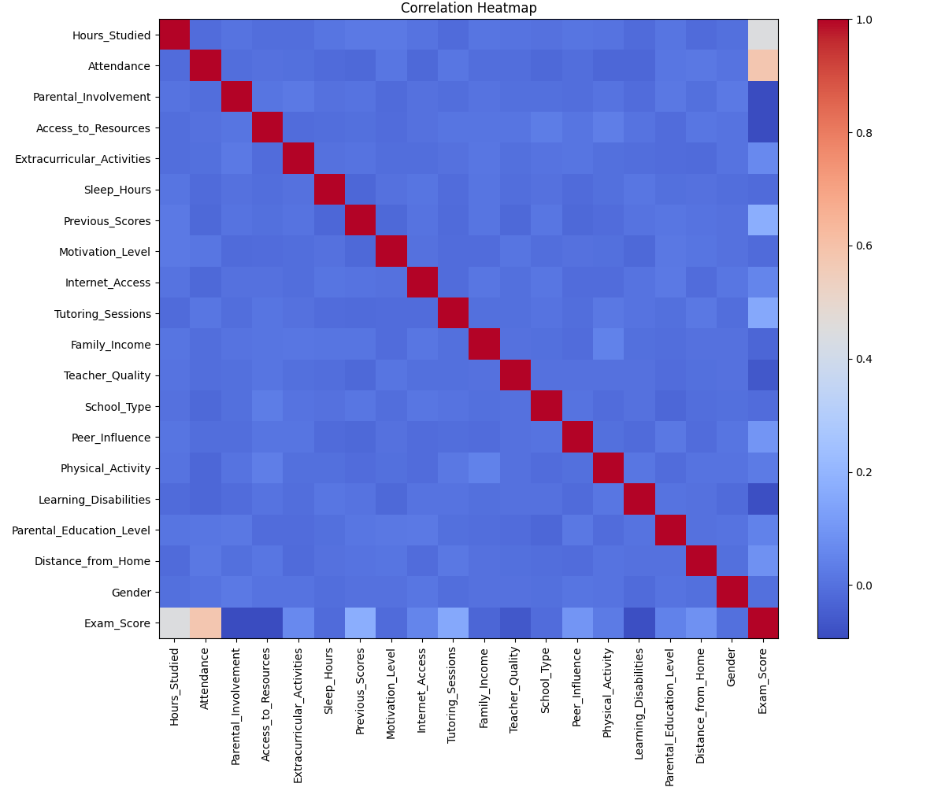
Figure 1: Correlation heatmap across all encoded features and the target variable.
The heatmap highlights that Attendance and Hours_Studied show the strongest positive association with Exam_Score, while most categorical, label-encoded lifestyle variables show comparatively weak linear correlation with the target — consistent with their more nuanced, non-linear influence captured later by the tree-based models.

Target Distribution
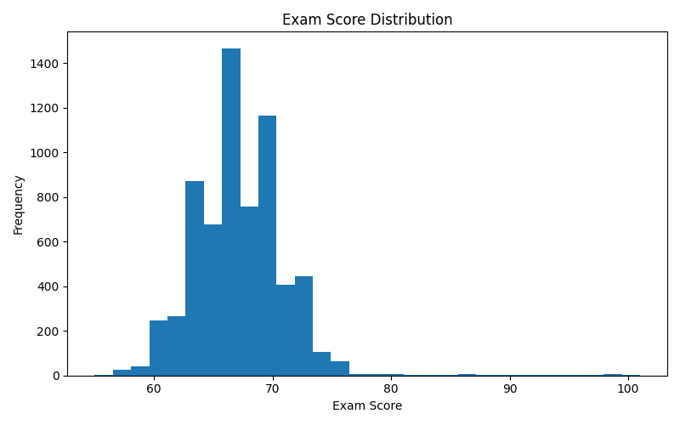
Figure 2: Distribution of Exam_Score across the dataset.
The exam score distribution is unimodal and approximately bell-shaped, concentrated in the mid-to-upper range, with a long, thin right tail representing a small number of exceptionally high-scoring students. This shape supports the use of standard regression error metrics such as MAE and RMSE.

9. Model Development & Training
Four regression algorithms, spanning a range of model complexity, were trained on the identical training split so that their performance could be compared fairly:
- Linear Regression – a simple, interpretable baseline assuming linear feature-target relationships
- Decision Tree Regressor – a single non-linear tree, prone to overfitting without ensembling
- Random Forest Regressor – an ensemble of 300 bagged decision trees to reduce variance
- Gradient Boosting Regressor – a sequential ensemble that iteratively corrects prior errors
Each model was evaluated on the held-out test set using Mean Absolute Error (MAE), Mean Squared Error (MSE), Root Mean Squared Error (RMSE), and the coefficient of determination (R²). The model with the highest R² was automatically selected as the production model and persisted to disk together with its supporting artifacts.

10. Results & Evaluation

Model Comparison
Model | MAE | MSE | RMSE | R²
Linear Regression | 1.016 | 4.399 | 2.097 | 0.6888
Decision Tree | 1.729 | 10.877 | 3.298 | 0.2305
Random Forest | 1.125 | 4.835 | 2.199 | 0.6580
Gradient Boosting ★ | 0.825 | 3.883 | 1.970 | 0.7253
★ Gradient Boosting achieved the lowest error across every metric and the highest R², and was selected as the production model.
Gradient Boosting outperforms the other candidates on every measured criterion: its MAE of 0.825 means predictions are, on average, within under one point of the true exam score, and its R² of 0.7253 indicates the model explains roughly 73% of the variance in exam scores using only the available behavioural and demographic features. The single Decision Tree performed worst, consistent with its tendency to overfit the training data without the variance reduction that ensembling provides.

Feature Importance
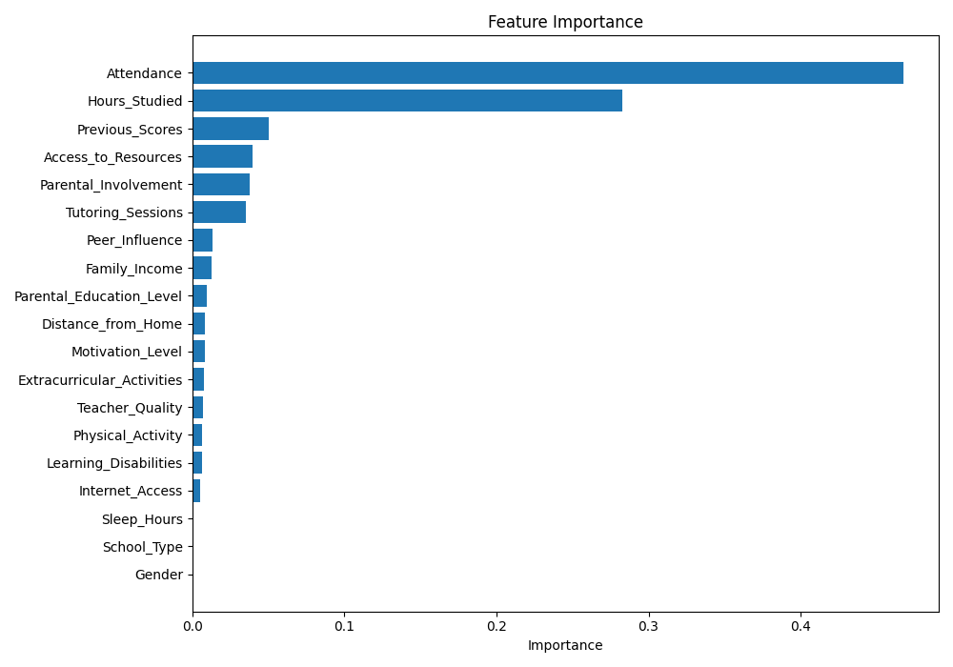
Figure 3: Relative feature importance from the selected Gradient Boosting model.
Attendance (47.4%) and Hours_Studied (28.3%) together account for over three-quarters of the model's predictive power, dwarfing every other feature. Previous_Scores, Access_to_Resources, Parental_Involvement, and Tutoring_Sessions contribute modestly, while attributes such as Gender and School_Type carry effectively no weight in the final model — a reassuring outcome, since it indicates the model is basing its predictions on actionable behaviour rather than fixed demographic traits.

Actual vs Predicted Scores
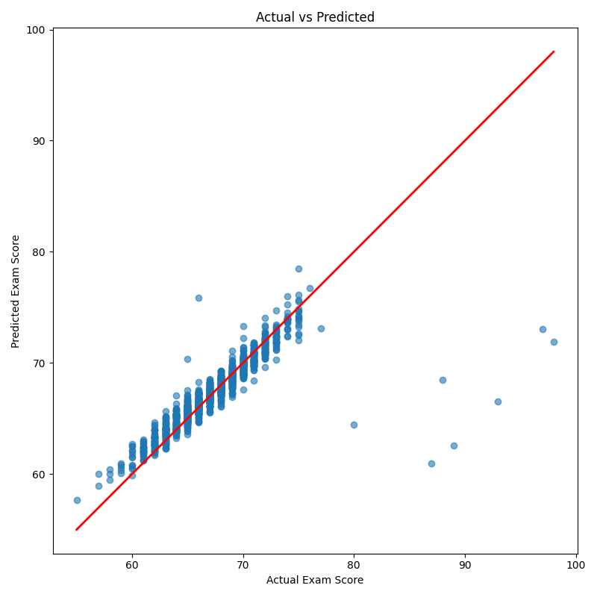
Figure 4: Actual vs predicted exam scores for the Gradient Boosting model on the test set.
Predicted scores cluster tightly around the diagonal reference line across the full range of actual scores, with only mild dispersion at the extremes where fewer training examples are available. This confirms the model generalises well rather than simply memorising the mid-range of the distribution.

11. Web Application & Deployment

Backend
The Flask backend loads the serialized model, encoders, and feature list once at startup and exposes three routes: a home route that renders the prediction form, a /predict route that accepts form submissions and re-renders the page with a formatted result, and a JSON /api/predict route intended for programmatic or frontend-driven consumption. Flask-CORS is configured on the /api/* routes so the separately hosted frontend can call the API across origins.

Prediction Post-Processing
Rather than returning a bare numeric score, the API converts the prediction into a four-tier performance band, each carrying a risk label, a display colour, and a short list of tailored recommendations:
Score Range | Performance Band | Risk | Example Guidance
≥ 85 | Outstanding Performance | Very Low | Maintain consistency; pursue contests/hackathons
70 – 84 | Good Performance | Low | Practice weak subjects; keep attendance above 90%
50 – 69 | Average Performance | Medium | Increase study hours; set weekly goals
< 50 | Needs Improvement | High | Strict timetable; seek mentorship; daily revision

Frontend
A responsive HTML/CSS/JavaScript frontend, styled with Bootstrap, collects the 19 input features through an interactive form and displays the prediction, performance band, and recommendations in real time. A second, template-based form is server-rendered directly by Flask for the same purpose, giving the project both a decoupled static frontend and a self-contained server-rendered fallback.

Deployment Architecture
- Backend: Flask REST API deployed on Render, defined via a Procfile and render.yaml
- Frontend: static site deployed on Netlify, configured via netlify.toml
- Cross-origin access between the two is enabled through Flask-CORS
This split-deployment approach mirrors common production practice, decoupling the stateless API layer from the presentation layer so each can be scaled, cached, or replaced independently.

12. Testing & Sample Predictions
The /api/predict endpoint was validated against representative input combinations to confirm correct encoding, feature ordering, and score clamping (predictions are bounded to the 0–100 range before being returned). A representative request/response pair is shown below.

Sample Request
{ "attendance": 85, "study_hours": 5, "sleep_hours": 7, "previous_grade": 82 }

Sample Response
{ "prediction": 91.42, "performance": "Outstanding Performance", "risk": "Very Low" }
Manual form submissions through the browser UI were also verified end-to-end, confirming that categorical inputs selected via dropdown are correctly label-encoded using the persisted encoders before being passed to the model.

13. Limitations & Future Scope

Current Limitations
- Label Encoding imposes an arbitrary ordinal relationship on nominal categories (e.g. School_Type), which can mislead linear models, though it affected the tree-based winning model less.
- The model is trained on a single static dataset and is not retrained automatically as new data becomes available.
- No authentication, prediction history, or persistence layer exists yet — each prediction is stateless.

Planned Improvements
- User authentication and saved prediction history
- A student-facing analytics dashboard with charts over time
- Database integration for persistent storage of predictions
- Explainable AI (e.g. SHAP values) for per-prediction feature attribution
- Automated PDF report generation for individual students

14. Conclusion
EduPredict AI demonstrates a complete, deployable machine learning pipeline for academic performance prediction, from raw data ingestion through to a publicly hosted web API. By systematically comparing four regression algorithms, the project makes an evidence-based model choice rather than an assumed one, and the resulting Gradient Boosting model explains roughly 73% of the variance in exam scores while keeping average prediction error under one point.
More importantly, the feature importance analysis confirms the model is grounded in genuinely actionable behaviours — attendance and study hours — rather than fixed demographic traits, which supports the project's underlying goal of giving students and educators early, actionable insight rather than a black-box number. With authentication, persistence, and explainability as natural next steps, the current system already provides a solid, production-deployed foundation.

15. References
1. Pedregosa, F. et al. “Scikit-learn: Machine Learning in Python.” Journal of Machine Learning Research, 2011.
2. McKinney, W. “Data Structures for Statistical Computing in Python.” Proceedings of the 9th Python in Science Conference, 2010.
3. Flask Documentation – Pallets Projects.
4. Render Documentation – Web Service Deployment Guide.
5. Netlify Documentation – Static Site Deployment Guide.
6. StudentPerformanceFactors Dataset (project training data, 6,607 records, 19 features).

