CS341: Software Testing & Quality Assurance
Assignment One Writeup
Semester 2, 2026

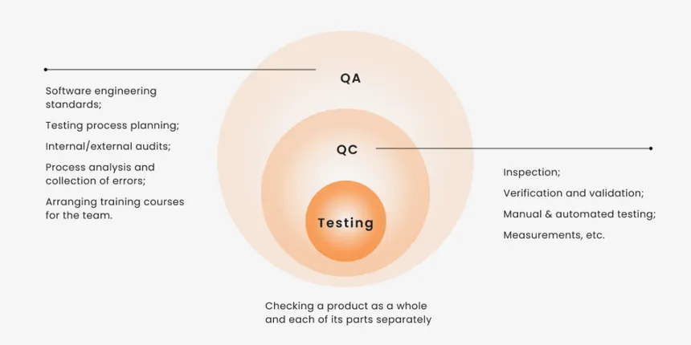

Group: 5
Group Name: The Dynamic Duo

The Project Team
Student Name | Student ID
Aryan Singh | S11230987
Shivan Prasad | S11231502

Table of Contents
Section A: Unit Testing with Junit & JaCoCo 3
A. section-a-employee-rating 3
B. section-b-overstay-charge 4
JaCoCo Testing Logs 5
Section B – Test Design, Execution and Defect Logging 7
Task 4 – Test case identification and Unit Test Plan 7
4.1 Test Design Approach 7
4.2 Equivalence Partitioning 7
4.3 Boundary Value Analysis 8
4.4 Unit Test Plan 9

Section A: Unit Testing with Junit & JaCoCo

A. section-a-employee-rating
These screenshots show the JUnit testing results for the employee rating test cases, and the command “mvn clean test” was used to get these results, and as shown all our test cases passed with zero failures.
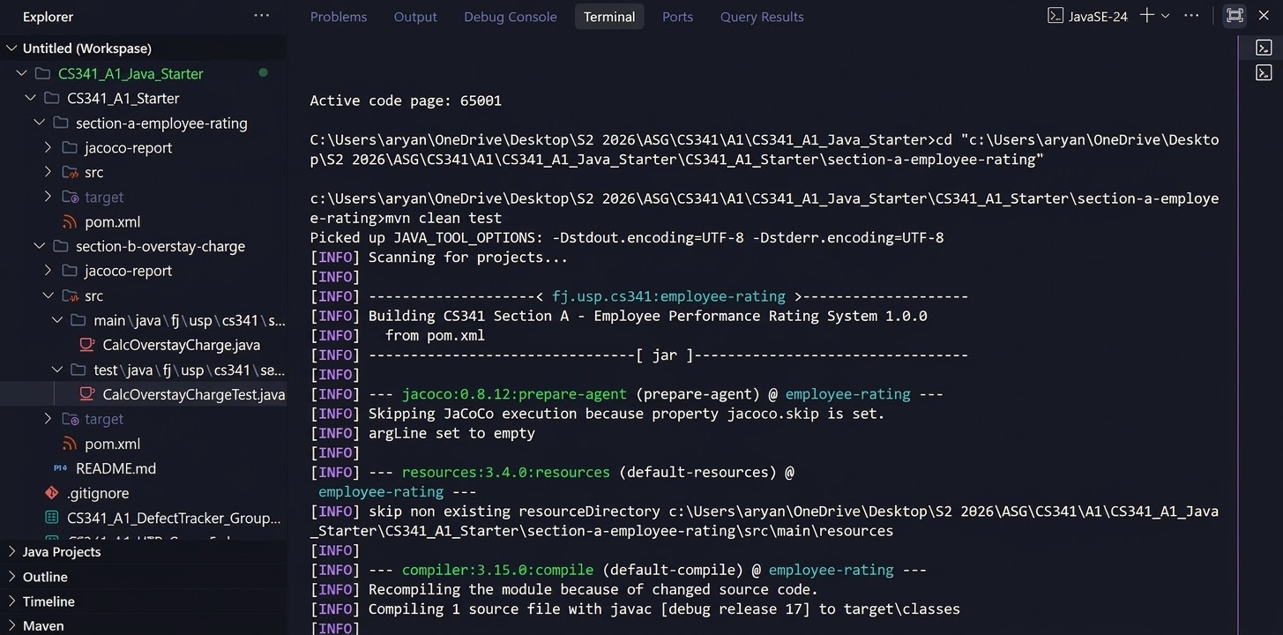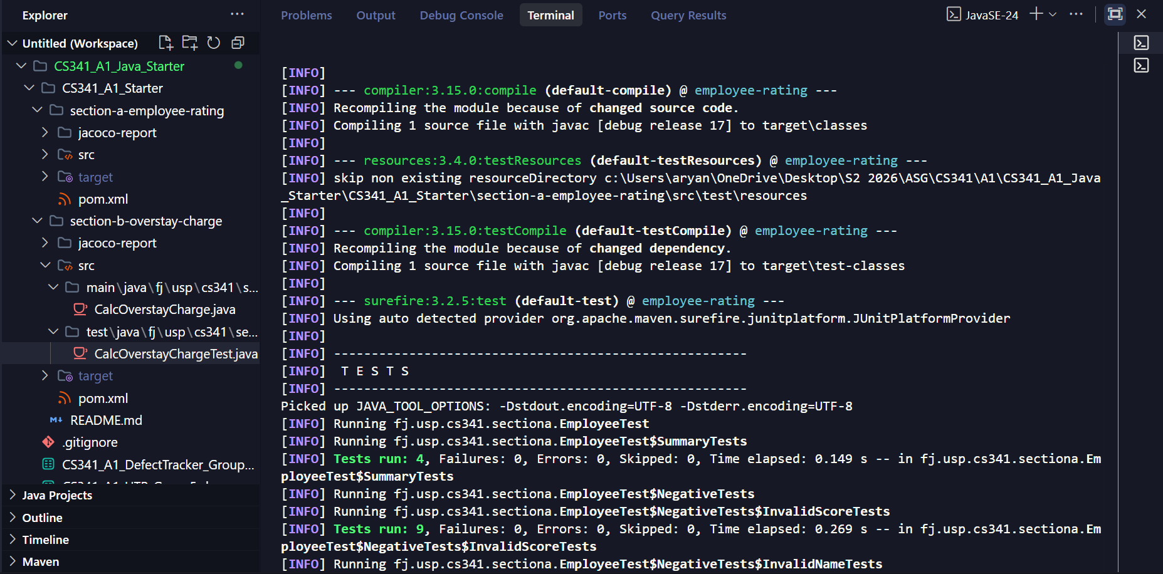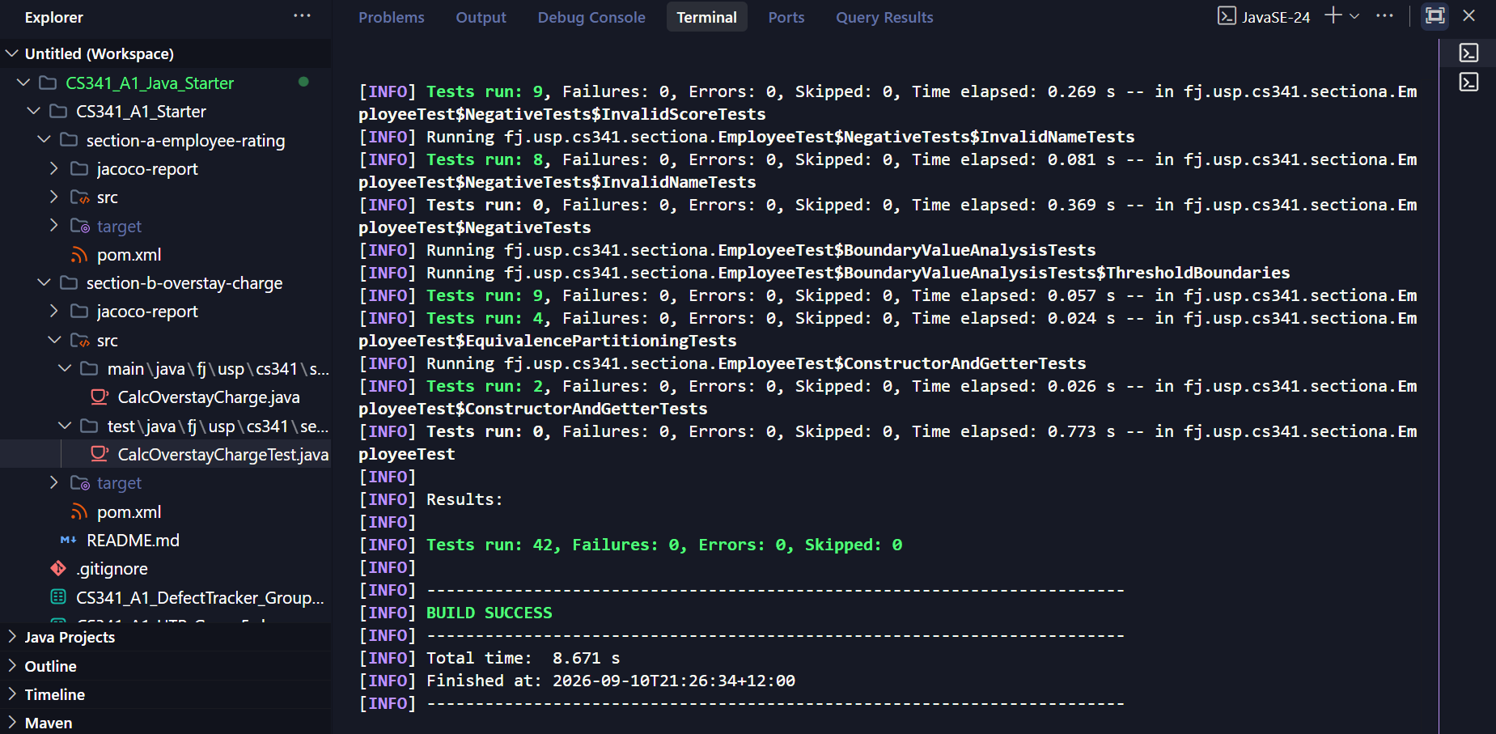

B. section-b-overstay-charge
These following screenshots are for the testing for the section-b-overstay-charge test cases, and we used the command “mvn clean test” to get these results. And as shown all our test cases passed with zero failures.
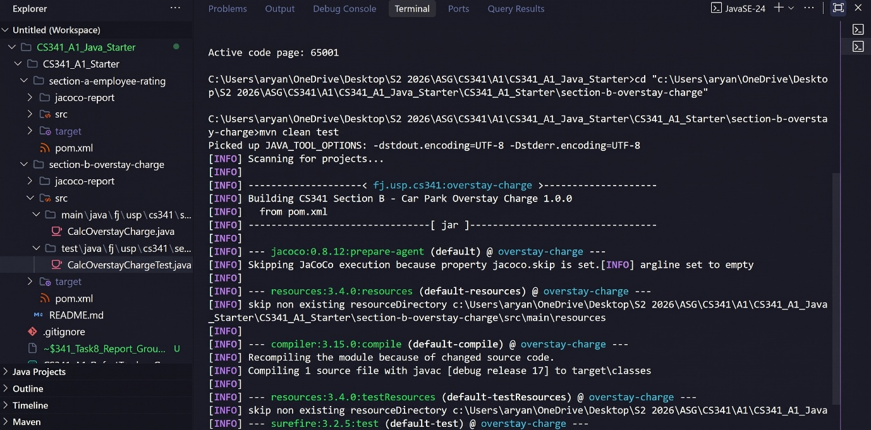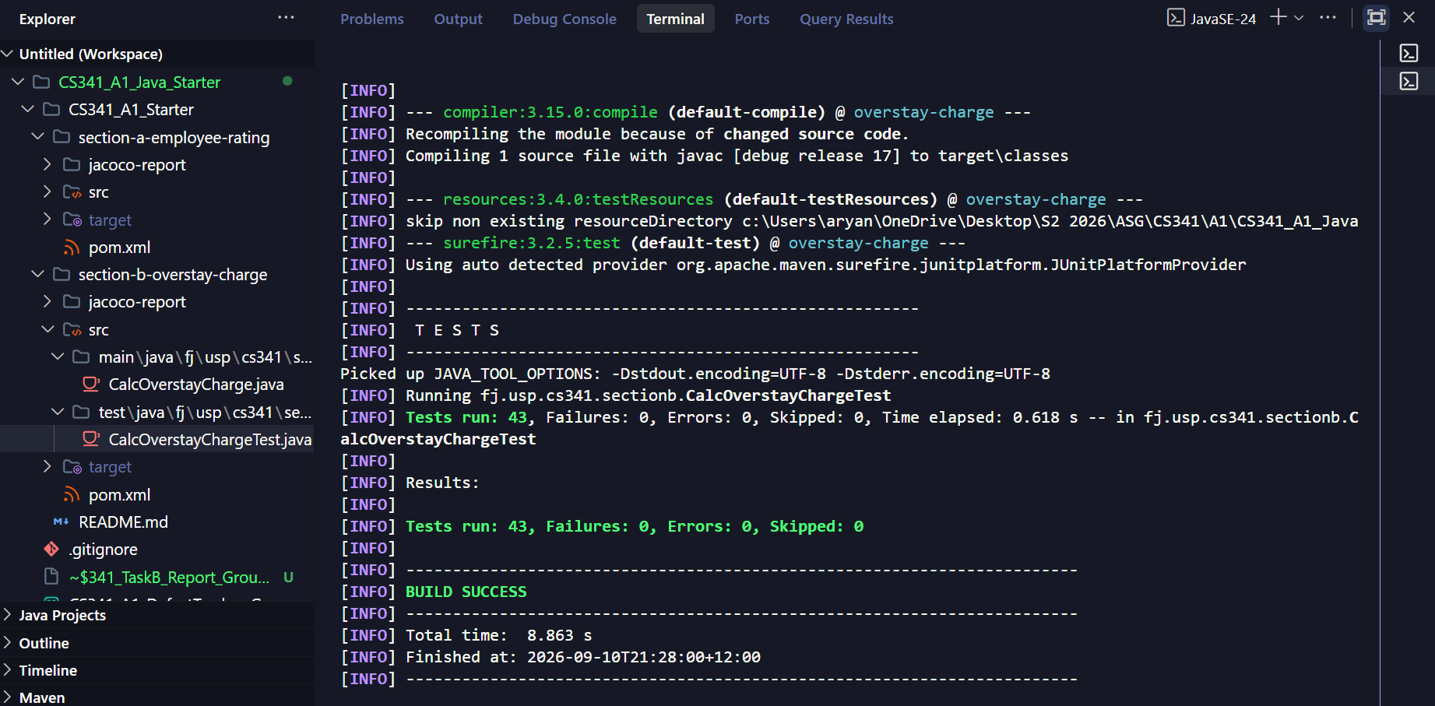

JaCoCo Testing Logs
The test suite and JaCoCo coverage reports were generated by running the command: mvn clean verify. The generated report was then viewed in the browser using the command: start target\site\jacoco\index.html (or by opening jacoco-report\index.html).
The following screenshots are for the Section A code (section-a-employee-rating)
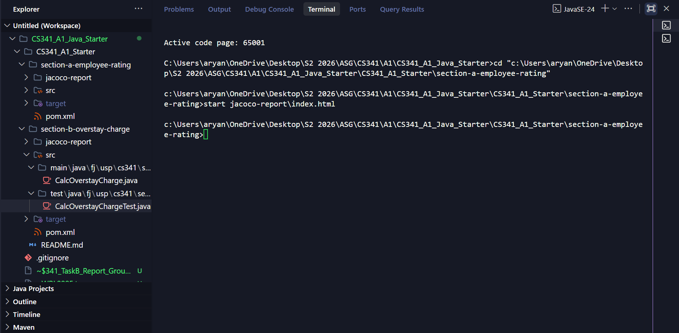

We were able to achieve a 100% branch & line coverage as shown in the pictures below.
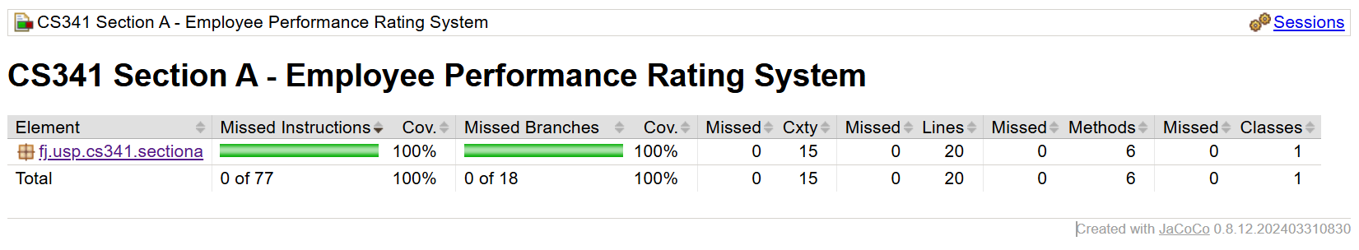
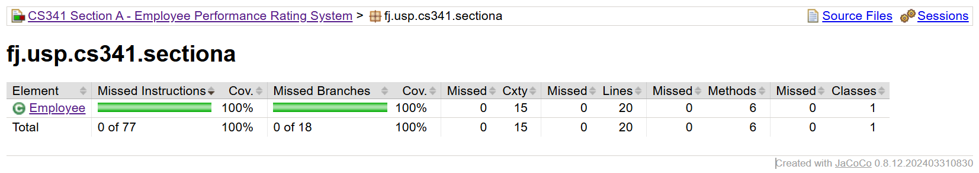
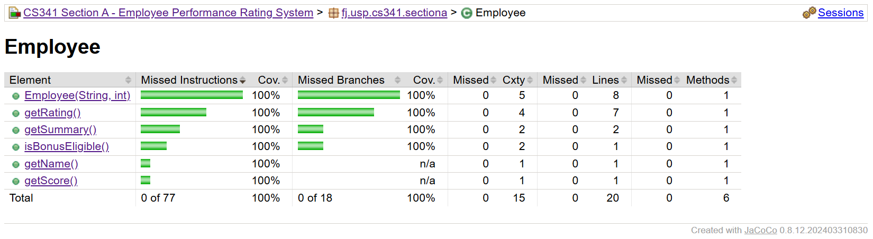
The test suite and JaCoCo coverage reports were generated by running the command: mvn clean verify. The generated report was then viewed in the browser using the command: start target\site\jacoco\index.html (or by opening jacoco-report\index.html).
The following screenshots are for the Section B code (section-b-overstay-charge).
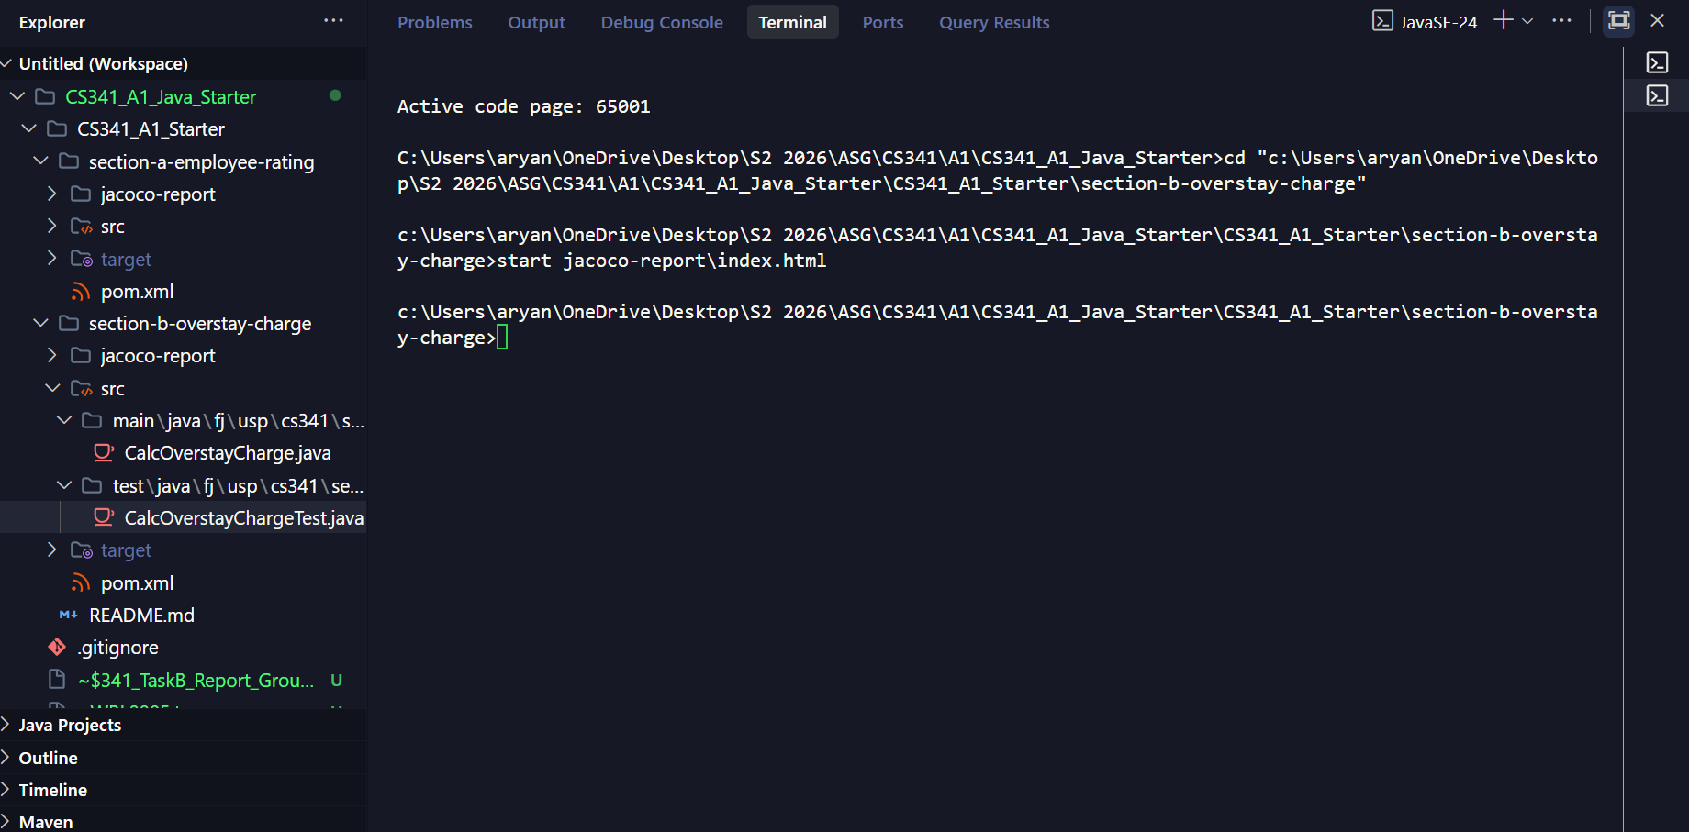

We were able to achieve a 100% branch & line coverage as shown in the evidence below.
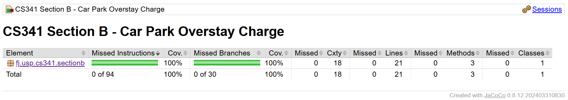
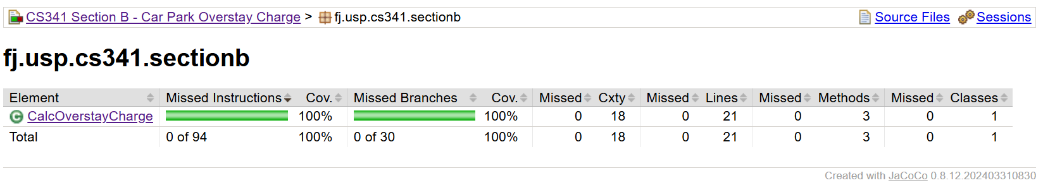
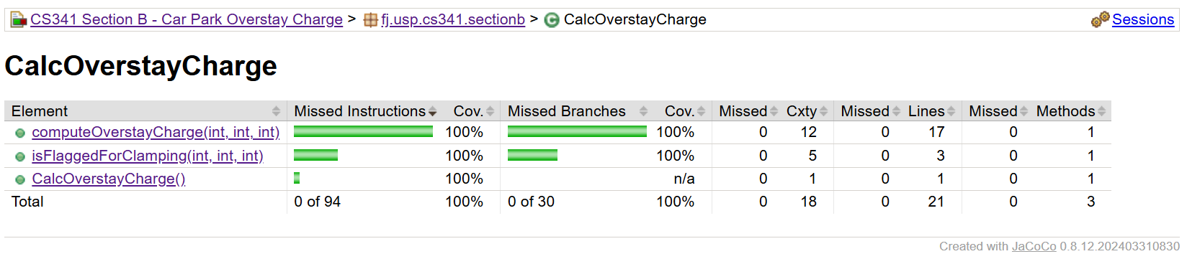

Section B – Test Design, Execution and Defect Logging

Task 4 – Test case identification and Unit Test Plan

4.1 Test Design Approach
Equivalence Partitioning and Boundary Value Analysis were used to analyze the computeOverstayCharger functionality. Equivalence Partitioning was used to divide the input parameters into valid and invalid classes and to identify the different charging partitions. For hoursOverstayed, Boundary Value Analysis was applied around the overall valid range of 1 to 48 hours together with the charging transitions at 4/5 and 12/13 hours. The expected results were derived from the assignment specification before executing the implementations supplied.

4.2 Equivalence Partitioning

4.2.1 hoursOverstayed
For hoursOverstayed the valid range is 1 to 48 hours inclusive and values below 1 and above 48 are invalid.
Class ID | Equivalence Class | Validity
H1 | hoursOverstayed < 1 | Invalid
H2 | 1 ≤ hoursOverstayed ≤ 48 | Valid
H3 | hoursOverstayed > 48 | Invalid
Since different charging rates are applied within the valid hours range, the valid range was divided into functional equivalence partitions.
Car With Visitor Permit
Class | Hours | Expected Behavior
HV1 | 1-4 | $ 2.00 per hour
HV2 | 5-12 | $4.00 per hour
HV3 | 13-48 | $8.00 per hour and flagged for clamping

Car with Resident Permit
Class ID | Hours | Expected Behavior
HR1 | 1-12 | $1.00 per hour
HR2 | 13-48 | $3.00 per hour

Truck
Class ID | Hours | Expected Behavior
HT1 | 1-48 | $15.00 per hour

4.2.2 vehicleType
Class ID | Value/Range | Description | Validity
V1 | 1 | Car | Valid
V2 | 2 | Truck | Valid
V3 | < 1 | Undefined Vehicle type | Invalid
V4 | > 2 | Undefined Vehicle type | Invalid
0 and 3 are the invalid values selected for testing

4.2.3 permitType
permitType Parameters uses integer codes. The valid value is 1 for Visitors and 2 for Residents, any other value is invalid.
Class ID | Value/Range | Description | Validity
P1 | 1 | Visitor | valid
P2 | 2 | Resident | valid
P3 | < 1 | Undefined Permit type | invalid
P4 | > 2 | Undefined permit type | invalid
The invalid values selected for testing are 0 and 3 and even though Trucks use the same hourly rate for either permit type, the specification defines only permit values 1 and 2 and state the method must return -1 if any input is invalid, that means invalid permits values must also be rejected for trucks.

4.3 Boundary Value Analysis
Boundary value analysis was applied to the hoursOverstayed input because the validity and charging rate change at specific hour boundaries. Values below, on and above important boundaries were selected.
Boundary | Test Values
Minimum Valid Value = 1 | 0, 1 and 2
Maximum Valid Value = 48 | 47. 48 and 49

Visitor Car 4/5 Hour Boundary
Position | Hours
Just below boundary | 3
Upper value of first band | 4
Lower value of second band | 5
Just above boundary | 6

Visitor car 12/13 Hour Boundary
Position | Hours
Just below boundary | 11
Upper value of second band | 12
Lower value of third band | 13
Just above boundary | 14

Resident Car 12/13 Hour Boundary
Position | Hours
Just below boundary | 11
Upper value of first band | 12
Lower value of second band | 13
Just above boundary | 14

For the vehicleType and permitType, Equivalence Partitioning will be the primary technique used because these inputs represent discrete categories rather than continuous numeric values. Values 0 and 3 were selected as invalid values which is immediately outside the valid values 1 and 2.

4.4 Unit Test Plan
All the identified Boundary Value Analysis and Equivalence Partitioning test cases are documented in the Unit Test Plan workbook. Test cases have unique test case ID, the partition being tested, test techniques, inputs, expected results, actual results and statuses. Expected results were derived before execution and the actual results and statuses were recorded during Task 5.

