
RV COLLEGE OF ENGINEERING
Bengaluru-560 059

REPORT ON
EXPERIENTIAL LEARNING
ACY 2025-26
CLUSTER
CIVIL
Title of the Project
Gravity-Driven Mechanical Energy Storage for Renewable Integration
Students Group
SL. No. | USN | Name | Prog.
1 | 1RV24CH041 | VIJAY S HALAGI | CH
2 | 1RV24IM064 | ARYAN LODHA | IEM
3 | 1RV24CV005 | AMITH B | CV
4 | 1RV24CV049 | SHASHANK JOGA | CV

Project Evaluators
SL. No. | Name of the Evaluators
 | Dr. Praveen Kumar Gupta
 | Dr. Vyshnavi D
 | Dr . Rajeshwari M
 | Dr. Vijay Kumar G

Dr. Praveen Kumar Gupta | Dr. Anjaneyappa
Name of the Faculty Mentor | Name of the Cluster Head

- Introduction
The global transition towards renewable energy sources such as solar and wind is accelerating rapidly due to concerns about climate change, fossil fuel depletion, and environmental sustainability. However, renewable energy systems suffer from a fundamental limitation—intermittency. Solar power is only available during daylight hours, and wind power is unpredictable. This mismatch between energy generation and demand creates a critical need for efficient and reliable energy storage systems.
According to the International Energy Agency (IEA), the world will require 8–10 times more energy storage by 2040 compared to present levels. Current dominant storage technologies, particularly lithium-ion batteries, provide only 2–4 hours of affordable storage and degrade significantly over time. Furthermore, nearly 70% of global renewable energy curtailment occurs because power grids lack sufficient storage capacity.
To address these challenges, gravitational energy storage, also known as gravity batteries, has emerged as a promising alternative. These systems store energy by lifting heavy masses using surplus electricity and recover energy by allowing the masses to descend in a controlled manner, converting gravitational potential energy into electrical energy. The fundamental principle governing this process is:
Energy = Ugh
Unlike chemical batteries, gravity-based systems use simple, abundant materials such as concrete, steel, or rock. They offer long operational life, minimal degradation, high safety (no fire or chemical hazards), and environmental friendliness. This project focuses on designing and developing a compact gravity-driven mechanical energy storage prototype to demonstrate the feasibility of this technology for renewable energy integration.

- Problem Definition
  - Problem Statement:
Renewable energy sources are inherently unpredictable and variable. Solar and wind power generation fluctuate with weather and time, leading to uncertainty in energy availability. At the same time, energy demand follows human activity patterns that do not align with renewable generation.
Conventional power plants, especially coal-based systems, are economically viable only when operated continuously (24×7). This creates a conflict between renewable integration and grid stability. Due to insufficient storage infrastructure, a significant portion of renewable energy is wasted. Reports indicate that around 70% of global renewable curtailment occurs because the grid lacks adequate storage capacity.
Hence, the central problem addressed in this project is:
How can surplus renewable energy be stored efficiently, safely, and sustainably for later use without relying on chemical batteries that degrade over time?
  - Background Information: (literature review)
The rapid growth of renewable energy has made energy storage a critical component of modern power systems. Solar and wind energy, though clean and sustainable, are inherently intermittent and unpredictable. This has exposed the limitations of existing storage technologies, especially chemical batteries such as lithium-ion systems. Numerous studies highlight that lithium-ion batteries suffer from chemical degradation, limited cycle life, high cost for long-duration storage, safety hazards such as thermal runaway and fire, and environmental concerns related to mining and disposal. These drawbacks make them unsuitable for large-scale, long-duration grid applications where energy must be stored for many hours or even days.
To overcome these limitations, research has increasingly shifted toward mechanical energy storage technologies. Mechanical systems store energy in physical forms rather than chemical bonds, which allows them to operate over decades with minimal degradation. Among these, gravitational energy storage has emerged as a highly promising solution. In such systems, surplus electrical energy is used to lift a heavy mass. The energy is stored as gravitational potential energy and later recovered by allowing the mass to descend in a controlled manner, driving a generator to produce electricity.
Literature indicates that gravity-based storage offers several advantages over chemical batteries. These systems exhibit extremely long operational lifetimes, often exceeding thirty years, with negligible performance degradation. They are inherently safe because they do not involve flammable or toxic materials. The use of simple and abundant materials such as concrete, steel, and rock reduces both cost and environmental impact. Unlike pumped hydro storage, gravity systems do not require specific geographical conditions or large water reservoirs, making them suitable for deployment in urban environments, abandoned mine shafts, high-rise structures, and underground installations.
Research also emphasizes the importance of long-duration storage for renewable-dominant grids. International agencies such as the IEA and IRENA predict that global energy storage capacity must increase by several times within the next two decades to enable round-the-clock renewable power. Studies reveal that a significant portion of renewable energy is currently wasted due to insufficient storage infrastructure. This curtailment directly reduces the effectiveness and economic viability of renewable power plants. Mechanical storage systems, particularly gravity-based technologies, are increasingly viewed as essential for bridging the gap between energy generation and consumption.
The theoretical foundation of gravitational energy storage lies in the law of conservation of energy. Electrical energy is converted into mechanical work to lift a mass, storing energy in the form of gravitational potential energy given by 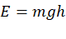. During periods of demand, this stored energy is released as the mass descends, converting potential energy back into mechanical energy and subsequently into electrical energy through a generator. This process eliminates chemical reactions and thereby avoids the aging mechanisms associated with batteries.
Contemporary research focuses on optimizing key parameters such as mass, height, descent speed, and generator efficiency to maximize energy recovery. Studies show that system performance is strongly dependent on these variables, and controlled descent is essential to achieve stable and efficient power output. Researchers also explore modular and decentralized gravity storage systems for rural electrification and microgrids, enabling localized energy independence. Emerging hybrid models combine gravity storage with batteries or supercapacitors to balance rapid response with long-duration capacity.
This project is closely aligned with these research directions. By developing a compact gravity-based energy storage prototype, it translates theoretical principles and industrial concepts into a practical experimental model. The prototype enables real-time measurement of voltage and current, analysis of efficiency, and evaluation of losses due to friction and mechanical constraints. In doing so, it contributes to the understanding of gravity-driven storage at a small scale and demonstrates its feasibility as a sustainable, low-maintenance alternative for renewable energy integration.
- Objectives
  - Primary Objectives:
The primary objective of this project is to design and develop a functional gravity-based mechanical energy storage prototype that demonstrates the practical feasibility of storing and releasing energy using gravitational potential. The project aims to experimentally analyze how varying the mass influences key electrical parameters such as voltage, current, power output, and overall system efficiency. A major goal is to determine the optimum operating mass that yields maximum power and efficiency under controlled conditions.
Another important objective is to implement real-time monitoring of electrical parameters using an Arduino UNO and appropriate sensors, enabling accurate measurement and analysis of system performance. Through this, the project seeks to validate gravity-driven energy storage as a reliable, low-maintenance, and sustainable alternative to chemical batteries for renewable energy integration.

  - Secondary Objectives:
In addition to the primary goals, the project aims to analyze energy losses occurring within the system due to friction, heat generation, mechanical constraints, and electrical inefficiencies. Understanding these losses is essential for identifying areas of improvement and optimizing system design.
The project also seeks to study the repeatability and stability of the system over multiple operating cycles, ensuring consistent and predictable performance. Another objective is to enhance practical understanding of energy conversion processes, bridging the gap between theoretical concepts and real-world implementation.
Furthermore, the project is intended to develop problem-solving, design, and experimental skills among team members, fostering a deeper appreciation of sustainable engineering solutions and experiential learning.

- Methodology
4.1 Approach:
The project adopts an experimental and system-oriented approach to demonstrate gravity-based mechanical energy storage at a laboratory scale. The overall strategy is to capture surplus renewable energy, convert it into gravitational potential energy by lifting a mass, and later reconvert it into electrical energy during controlled descent. The design is based on the fundamental energy relation , ensuring that all system parameters—mass, height, and motion control—directly influence the stored and recovered energy.
A compact vertical structure of approximately 0.6 m height is designed using lightweight yet stable materials such as PVC pipes and cardboard to provide mechanical support and insulation. The system is powered by a solar panel, representing a renewable energy source. Electrical energy from the panel is regulated through a DC–DC buck converter to obtain a stable supply suitable for driving the lifting motor.
The approach emphasizes modularity and simplicity, enabling clear observation of each stage of energy conversion. A shaft-locking mechanism is incorporated to securely hold the lifted mass, ensuring safe storage and controlled release. Precise motion control is achieved using a stepper motor and driver, while an Arduino-based system is used for sensing, monitoring, and data acquisition. This integrated approach allows real-time observation of voltage, current, power, and efficiency, providing a strong experimental foundation for analysis.
A flow-based methodology is followed: energy capture → mass lifting → energy storage → controlled descent → energy generation → data acquisition → analysis and optimization.
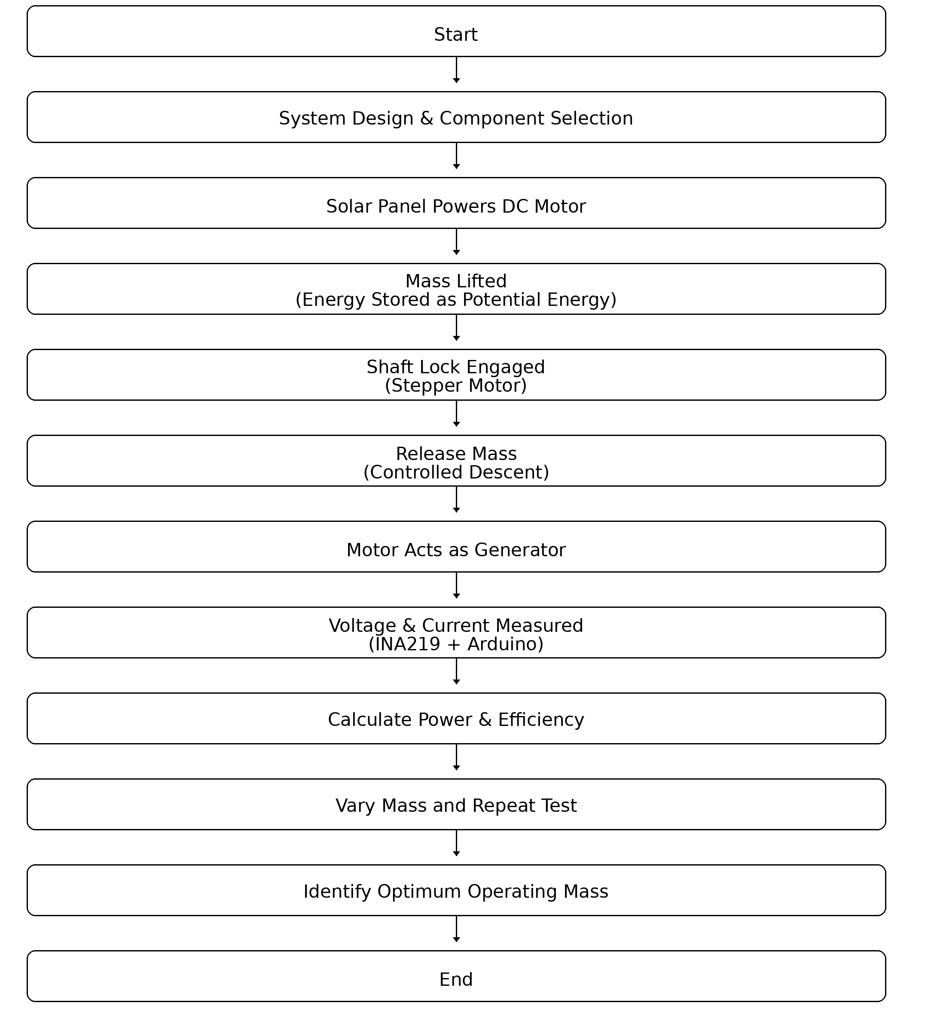

4.2 Procedures:
The project is executed through a structured sequence of steps. Initially, the mechanical structure is designed and assembled to provide a stable vertical guide for the moving mass. Suitable components are selected based on availability, power rating, compatibility, and safety. A solar panel is connected to a DC–DC buck converter to regulate the output voltage, which then supplies power to a DC motor acting as the lifting mechanism.
The lifting motor raises a predetermined mass vertically, converting electrical energy into gravitational potential energy. Once the mass reaches the top position, a shaft-locking mechanism controlled by a stepper motor is engaged to hold the load securely. A potentiometer is used to monitor shaft position and confirm proper locking. For reliability, a manual DPDT switch and a backup BO motor are incorporated as a secondary control system.
During the discharge phase, the locking mechanism is released in a controlled manner. The lifting motor now operates as a generator as the mass descends under gravity. The generated electrical energy is directed to a 12 V LED array, providing both a load and a visual indication of power generation.
An INA219 sensor is interfaced with an Arduino UNO to measure real-time voltage and current. The Arduino processes and records parameters such as voltage, current, power, descent time, and efficiency for each trial. Multiple experimental runs are conducted by varying the mass and repeating the charge–discharge cycle. The collected data is analyzed to determine trends, calculate efficiency, and identify the optimum operating conditions.
Losses due to friction, heat, structural flexibility, and electrical inefficiencies are observed and documented. Based on these observations, minor design refinements are implemented to improve stability and performance. The procedure concludes with validation of the working model through consistent LED illumination and repeatable electrical output during controlled descent.

5. Project Execution
5.1 Planning and Design:
The project began with a detailed brainstorming and planning phase in which the concept of gravity-based energy storage was translated into a practical and buildable model. The team studied existing gravity battery concepts and adapted them to a compact laboratory-scale system. The primary design objective was to create a vertical structure capable of safely lifting and lowering a mass while allowing smooth and controlled motion.
A vertical frame of approximately 0.6 m height was conceptualized using PVC pipes and cardboard to ensure light weight, ease of assembly, and sufficient mechanical stability. The placement of components such as the solar panel, DC motor, stepper motor, shaft, pulleys, and mass holder was planned to minimize friction and mechanical losses. Safety considerations, such as secure locking of the mass at the top position and controlled release during descent, were incorporated at the design stage itself.
Block diagrams and rough sketches were prepared to visualize the energy flow from the solar panel to the lifting mechanism and from the descending mass to the electrical output. The design also included provisions for sensor placement and wiring to enable real-time data acquisition using Arduino. This phase ensured that the system architecture was clear, feasible, and aligned with the project objectives.

  - Implementation:
The implementation phase involved constructing the physical prototype and integrating all mechanical and electrical components. The vertical frame was assembled first, ensuring proper alignment and rigidity. A DC motor was mounted to act as the lifting mechanism, connected to a shaft and pulley system to raise the mass vertically.
A 20 W solar panel was connected through a DC–DC buck converter to provide a regulated 12 V supply to the lifting motor. The mass was attached using a durable thread and guide system to prevent lateral motion. A shaft-locking mechanism was developed using a NEMA17 stepper motor driven by a DRV8825 driver to precisely engage and disengage the lock. A potentiometer was used to monitor shaft position and confirm locking status.
During discharge, the locking mechanism was released in a controlled manner, allowing the mass to descend. The same DC motor then acted as a generator, converting mechanical energy into electrical energy. The generated power was supplied to a 12 V LED array, which provided a visible indication of energy output.
An INA219 voltage and current sensor was interfaced with an Arduino UNO to measure real-time electrical parameters. The Arduino was programmed to continuously acquire voltage and current data and compute power output. Multiple test cycles were conducted to verify repeatability, stability, and safety of operation. Minor adjustments were made to reduce friction and improve alignment, ensuring smooth motion and consistent results.

6. Tools and Techniques Used
6.1 Tools:
The project employed a combination of mechanical, electrical, and digital tools. A solar panel served as the renewable energy source. A DC–DC buck converter was used to regulate voltage. A DC motor functioned both as a lifting motor and as a generator. A NEMA17 stepper motor with a DRV8825 driver enabled precise control of the locking mechanism.
An Arduino UNO acted as the central control and data-processing unit. An INA219 sensor measured real-time voltage and current. A potentiometer was used for shaft position feedback. A 12 V LED array served as the output load and visual indicator. Mechanical tools such as PVC pipes, pulleys, shafts, threads, clamps, and supporting frames formed the structural components.
Each tool was selected for reliability, availability, and compatibility with the overall system.
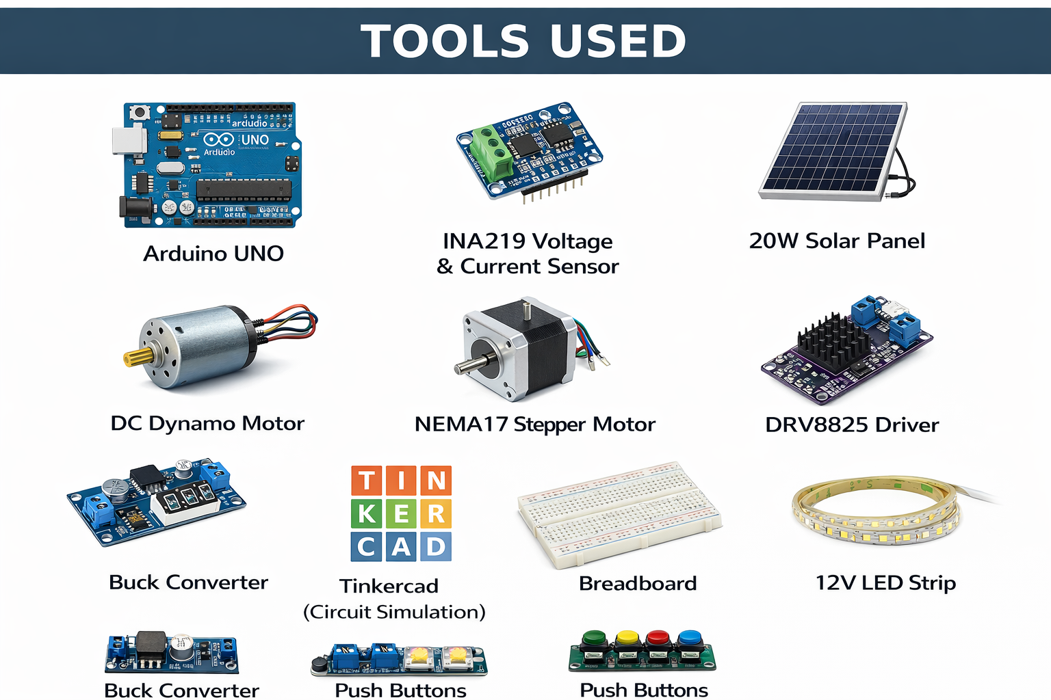

6.2 Techniques:
The project applied experimental prototyping techniques to convert theoretical concepts into a functional system. Controlled lifting and descent were implemented to ensure safe and repeatable operation. Energy conversion analysis was carried out by comparing theoretical potential energy with measured electrical output.
Real-time data acquisition techniques were employed using Arduino and sensors to monitor voltage, current, and power. Iterative testing was used, where the system was repeatedly operated with varying mass values to observe trends and optimize performance. Loss analysis techniques were applied to identify inefficiencies arising from friction, heat, and mechanical limitations.
These techniques enabled systematic evaluation, optimization, and validation of the gravity-based energy storage model.

7. Partial Results
7.1 Initial Findings:
During early testing, the system successfully demonstrated electrical energy generation during the controlled descent of the mass. The illumination of the LED array confirmed the conversion of gravitational potential energy into electrical energy. Initial trials revealed a clear relationship between the mass and electrical output: as the mass increased, both current and power output increased.
However, at lower mass values, the output was weak due to dominant fixed losses such as friction and generator inefficiency. The system showed stable mechanical behavior and repeatable operation across multiple cycles, validating the reliability of the basic design.

7.2 Iterative Improvements:
Based on initial observations, several refinements were made to improve performance. Mechanical alignment was corrected to reduce lateral motion and friction. The guide system for the mass was improved to ensure smoother descent. Wiring and sensor connections were stabilized to enhance measurement accuracy.
The locking and release mechanism was optimized to achieve smoother engagement and disengagement, preventing sudden jerks and energy losses. These iterations resulted in improved consistency of descent speed and more stable electrical output.
Through repeated experimentation and refinement, the system evolved into a reliable prototype capable of producing measurable and repeatable electrical energy, laying the foundation for final performance evaluation and analysis.

8. Results and Discussion
8.1 Final Results:
The completed gravity-based energy storage prototype successfully demonstrated the conversion of gravitational potential energy into electrical energy during controlled descent of the mass. The system operated reliably over multiple charge–discharge cycles, confirming the feasibility of the proposed mechanism.
Experimental trials were conducted by varying the mass and recording real-time voltage and current using the INA219 sensor and Arduino UNO. The results showed a clear and consistent trend: as the mass increased, the generated current and power output also increased. An optimum operating mass of approximately 1.0 kg was identified, at which the system delivered maximum performance.
At this optimal condition, the prototype achieved:
- Maximum current of approximately 0.72 A
- Maximum power output of approximately 0.74 W
- Peak system efficiency of approximately 17.9%
Beyond this mass, the system performance began to decline due to mechanical and electrical limitations, such as increased friction, structural flexibility, and generator inefficiencies. The illumination of the LED array during descent provided direct visual confirmation of energy generation.
These results validate that gravitational energy storage is practically achievable even at a small scale and that system performance is strongly dependent on mass and controlled descent.

8.2 Discussion:
The experimental outcomes demonstrate that gravity-based energy storage follows predictable and repeatable behavior governed by physical principles. The efficiency trend indicates that fixed losses dominate at small scale. Losses primarily arise from friction in mechanical components, inefficiencies in the motor-generator system, heat dissipation, and structural deformation.
At lower masses, these losses consume a significant portion of the available energy, resulting in lower output. As mass increases, the relative impact of losses decreases, improving efficiency up to an optimal point. Beyond this point, mechanical constraints and increased resistance lead to reduced performance.
Sensor limitations, particularly current saturation, may have introduced minor underestimation in the measured output. Despite this, the observed trends remain consistent and reliable.
The results confirm that gravity-driven storage systems are best suited for larger-scale applications, where greater height and mass significantly reduce the relative impact of losses. Even at prototype scale, the system demonstrates the fundamental viability of this technology.

9. Prototype (Hardware/Software)
The developed prototype is a compact gravity-based mechanical energy storage system consisting of a vertical structure of approximately 0.6 m height that guides a suspended mass. A DC motor mounted at the top acts as the lifting mechanism, powered through a regulated supply derived from a solar panel. The mass is connected using a pulley and shaft arrangement, enabling smooth vertical motion. A shaft-locking mechanism operated by a NEMA17 stepper motor ensures secure storage of energy at the top position. During discharge, the same DC motor functions as a generator as the mass descends in a controlled manner, converting gravitational potential energy into electrical energy. The generated power is delivered to a 12 V LED array, serving as both an electrical load and a visual indicator of energy generation. An Arduino UNO forms the control and monitoring core of the system, interfaced with an INA219 sensor for real-time measurement of voltage and current. A potentiometer provides feedback on shaft position, enabling accurate engagement and release of the locking mechanism.
The development of the prototype followed an iterative process. Initial construction focused on assembling the vertical frame and integrating the lifting mechanism. Early trials revealed issues such as friction, misalignment, and unstable locking. These challenges were resolved through progressive refinements, including improving structural alignment, optimizing pulley and shaft positioning, reducing frictional contact points, and stabilizing wiring and sensor connections. The locking and release mechanism was fine-tuned to ensure smooth engagement and controlled descent, preventing sudden jerks and energy loss. Each iteration improved mechanical reliability, operational safety, and electrical output consistency, resulting in a stable and functional system.
Testing and validation were carried out through multiple charge–discharge cycles using different mass values. During each cycle, voltage, current, power, and descent time were recorded using the Arduino and sensor system. Consistent illumination of the LED array during descent confirmed successful energy generation. The prototype demonstrated repeatable behavior across trials, validating mechanical stability and control accuracy. The system operated reliably up to a mass of approximately 1.0 kg without structural failure or unsafe behavior. The collected data enabled efficiency calculations and performance analysis, confirming that the prototype effectively demonstrates the feasibility of gravity-driven mechanical energy storage at a small scale.

10. Conclusion
10.1 Summary:
This project successfully demonstrated a gravity-based mechanical energy storage system powered by a renewable source. A working prototype was designed, constructed, and experimentally evaluated. Electrical energy was stored as gravitational potential energy by lifting a mass and later recovered during controlled descent.
The system showed a strong dependence on mass, with an optimal operating point at approximately 1.0 kg. Peak performance achieved included a maximum current of about 0.72 A, maximum power of about 0.74 W, and a peak efficiency of approximately 17.9%. The results confirm that gravitational energy conversion is feasible, predictable, and repeatable.

10.2 Personal Reflection:
This project provided deep practical insight into energy conversion, storage mechanisms, and system integration. It transformed theoretical concepts such as conservation of energy into tangible engineering experience. Designing, building, and optimizing the prototype enhanced understanding of mechanical design, electrical systems, and sensor-based data acquisition.
The project emphasized the importance of iterative development, problem-solving, and teamwork. Challenges related to friction, alignment, and control revealed the gap between theory and real-world implementation. Overcoming these challenges strengthened technical confidence and analytical thinking.
Most importantly, the project fostered awareness of sustainable engineering solutions and highlighted the potential of alternative energy storage technologies. It reinforced the idea that innovation in energy systems is essential for a renewable and sustainable future.

11. Visuals:
