

School of Computer Science and Engineering
Winter Semester 2022-2023
CAT – 1I
SLOT: C1 + TC1
Programme Name &Branch: B.Tech – Computer Science and Engineering & Specializations
Course Name & code: Data Structures and Algorithms & BCSE202L
Class Number (s): All C1 Slots
Duration: 90 Min. Maximum Marks: 50
Answer all questions.
Instructions: Wherever steps required, they must be explained clearly (with diagrams, if required).
Q.No. | Question | Max Marks
1. | a) Develop a pseudocode and illustrate with neat diagrams to group all odd nodes followed by the even nodes for the given singly linked list 2,1,3,5,6,4,7  Note : Consider the first node is odd and the second node is even and so on  Solution  Two pointers will be used. The first will point to the head and the second will point to the next of the head. Now in each iteration, each of the pointers will skip one element add the even positioned and odd positioned nodes respectively.  Pseudocode  ListNode oddEvenList(ListNode head) {  if(head == nullptr or head->next == nullptr)  return head  ListNode oddPointer = head  ListNode evenPointer = head.next  ListNode even = head.next  while(evenPointer != null and evenPointer.next != null){  oddPointer.next = oddPointer.next.next  oddPointer = oddPointer.next  evenPointer.next = evenPointer.next.next  evenPointer = evenPointer.next  }  oddPointer.next = even  return head  }  b) Develop a pseudocode to find the node having the largest value in the circular linked list having the values 20, 14,181,100. Assume that the circular linked list is having only one reference ‘last/tail’ and the reference ‘head’ is not available. Hint: The first node is the next of ‘last/tail’.  Solution:  - Create a function named “printMax” that takes the head node of a circular linked list as an input parameter.  - Create an integer variable max and initialize them to Integer.MAX_VALUE.  - Define a pointer “current” and initialize it with the head node.  - Start a while loop till current. Next is not equal to null.  - In each iteration of the while loop, compare the data of the current node with the value of max. If the data is greater than the value of max, assign the data to the max variable.  - Update the current pointer to the next  node.  - Now after the while loop, print the value of max. | 6 Marks  4 Marks
2. | a) Convert the following generic tree to binary tree and write the postfix expression of the obtained binary tree [5+2]:  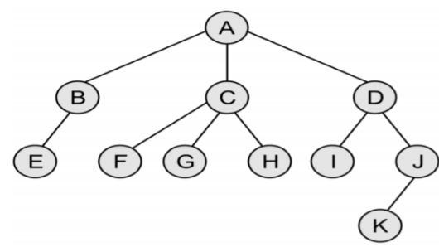  Solution:  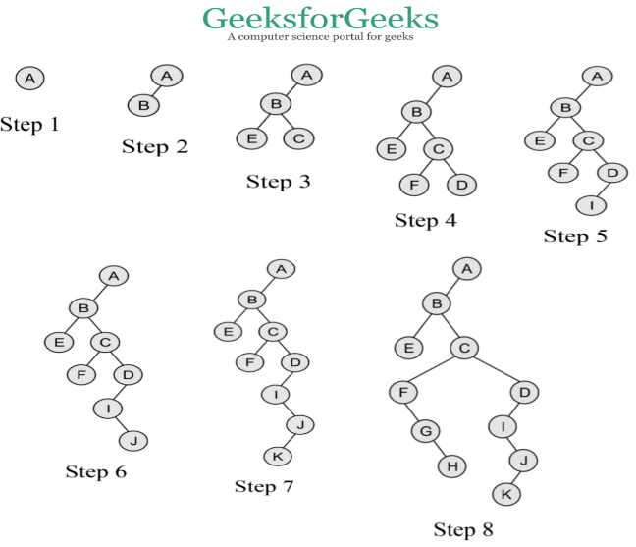  Postfix: EHGFKJIDCBA  b) Given the infix expression OQRSPT and the prefix expression RQOTSP, construct the corresponding binary tree. Assume the capital alphabets are the nodes of the tree.  Solution:  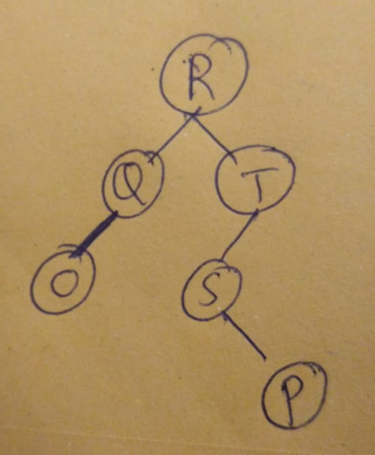 | 7 Marks  3 Marks
3. | a) Construct a Binary Search Tree (BST) for the following sequence of numbers  50, 70, 60, 20, 90, 10, 40, 80, 110, 30, 75, 65  Solution:  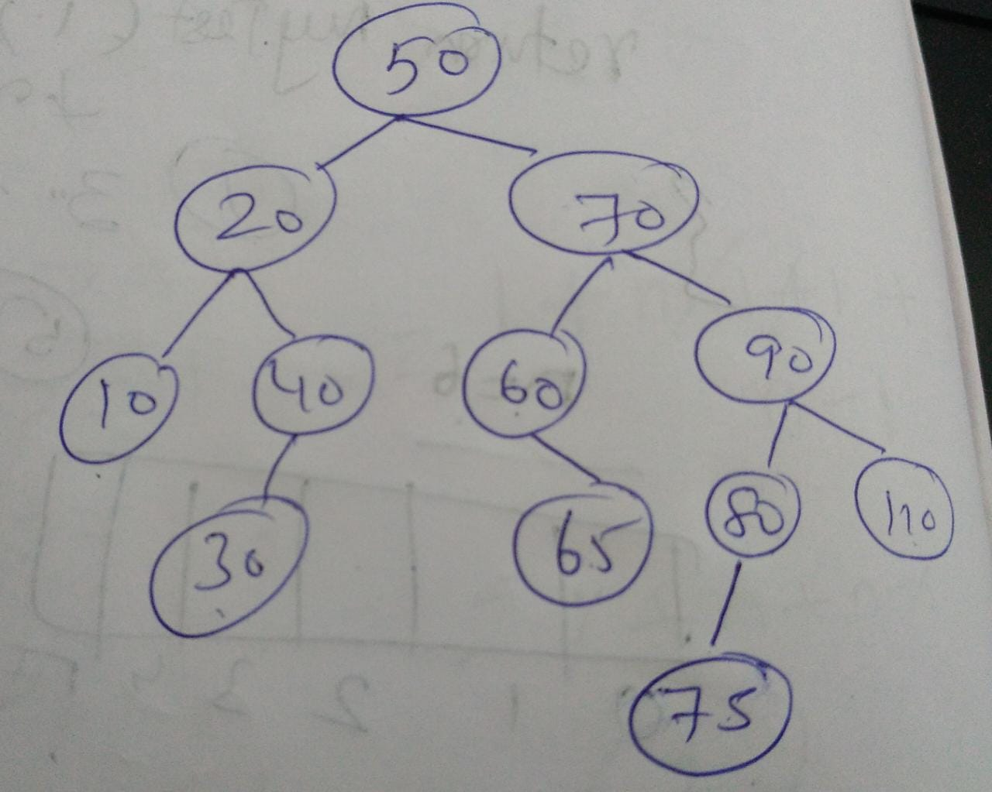  b) In the above Binary tree, delete the node having the value 70 and obtain the resulting binary tree. Which concept (to replace the deletion node) did you use in the (deletion) process?  Solution: Inorder Successor | 6 Marks  4 Marks
4. | Apply the heapsort to the following characters using maxheap and extract the top 3 characters (i.e., in descending order). Show the heapified tree after each extraction (of the root). Note: You are not expected to sort the whole given characters. Do the sorting up to 3 characters only.  ‘E’,’D’,’U’,’C’,’A’,’T’,’I’,’O’,’N’  Solution:  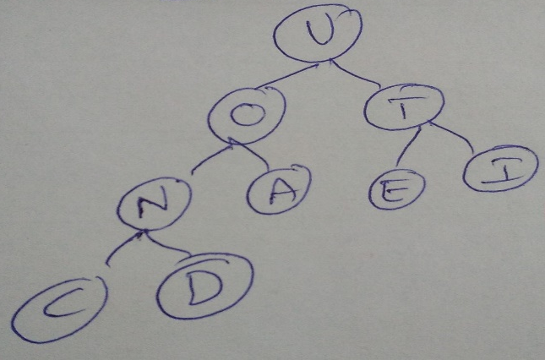  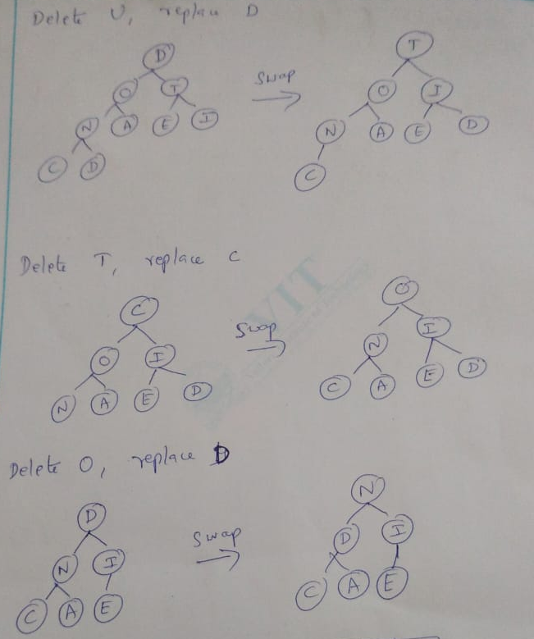  The sorted characters in descending order : ‘U’,’T’,’O’ | 10 Marks
5. | Sort the given numbers 9,7,5,11,12,2,14,3,10,6 in the increasing order. Identify the type of sorting and fill the following blanks (given are step 0 and step 1).  Solution:  Quick Sort  The last element is taken as pivot. | 10 Marks
  9 | 7 | 5 | 11 | 12 | 2 | 14 | 3 | 10 | 6
  5 | 2 | 3 | 6 | 12 | 7 | 14 | 9 | 10 | 11
  2 | 3 | 5 | 6 | 7 | 9 | 10 | 11 | 14 | 12
  2 | 3 | 5 | 6 | 7 | 9 | 10 | 11 | 12 | 14
  2 | 3 | 5 | 6 | 7 | 9 | 10 | 11 | 12 | 14
  2 | 3 | 5 | 6 | 7 | 9 | 10 | 11 | 12 | 14

