**Assignment - 1 Introduction to ASP.NET Controls & State Management**

**Module - 1**

1. A basic contact form where the user enters their name, and on button click, the name is displayed in a label.
   * **Aim :**
   * **Objective :**
   * **Theory :**
   * **Code :**
   * **Output :**
2. Take three Button controls, Red, Green, and Blue, and one Label control. Using CSS class, when a user presses any of the three buttons, the appearance of the label will change accordingly.
3. Write a program to give font effects (name, size, effect) to the text (without using Button control).
4. Design a web application as follows. On submitting the form data confirm the selection made in the following format on one LABEL Control.

Thank you very much _____.

You have chosen _____ for breakfast. I will prepare it for you _____.

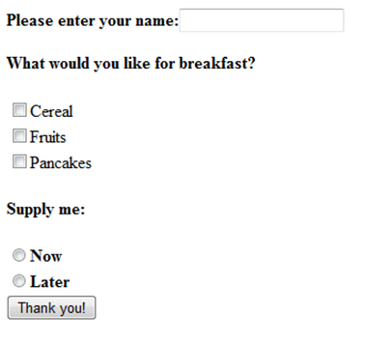

5. Write a program to demonstrate Postback.

6. Write a program to upload your profile picture and display it in image control (file format should be .jpg, .jpeg or .png format)

7. Write a program to demonstrate Ad Rotator Control.

8. Write a program to demonstrate Navigation Controls.

9. Create a registration form having the following UI.

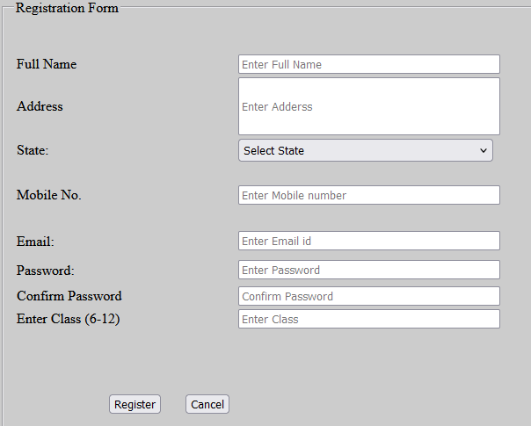

Implement proper Validations by using all below Validation Controls:

* All fields are required
* Mobile No. must be 10 integer digits
* Email must be in a valid form
* Password must be 8 characters or grater and match with confirm password
* At last display all the error messages

If there is no validation error then display message “Successful registration” else display

error using Validation Summary.

<appSettings>

<add key="ValidationSettings:UnobtrusiveValidationMode" value="None" />

</appSettings>

10. Write a program to demonstrate Master Page.

* <https://javascript.plainenglish.io/40-portfolio-templates-free-for-web-design-d0611a372763>
* <https://drive.google.com/drive/folders/19b30QjydFUvY0PWV00kvfjJQoIruzquw?usp=sharing>

11. Write a program to demonstrate Calendar control.

**Module - 2**

12. Write a program to demonstrate the ViewState.

13. Write a program to demonstrate the Hidden Object.

14. Write a program to demonstrate the Query String

15. Create a web application to get following information from a user. Name, Age, height, Email, Gender. Validate the input by using proper validation control. If the gender is male then navigate to Male.aspx web page, and if the gender is female then navigate to Female.aspx. Then depending upon the gender and height of the individual suggest the ideal weight.

[Note : use cookies to pass information between pages]

The height to weight ratio is as follows

|  |  |  |  |  |  |
| --- | --- | --- | --- | --- | --- |
| Height (CM) | 150 | 160 | 170 | 180 | 190 |
| Ideal weight for Male | 60 | 65 | 70 | 75 | 80 |
| Ideal weight for Female | 55 | 60 | 65 | 70 | 75 |

16. Write a program to demonstrate session state.

17. Write a program to count the number of live users in your web application.

18. Write a web application to display digital clock using ajax.

19. Write a web application to create an image slider using ajax.

20. Write a program to select state and on the basis of state fill city information using ajax.

21. Write a web application to demonstrate page output caching.

22. Write a web application to demonstrate data caching.

**Assignment - 2 Database Programming and Entity Framework**

1. Write a program to demonstrate Gridview Control.
2. Write a program to select product name from dropdown list and display details of product in the details view control.
3. Write a program to select Product Name from the dropdownlist and using querystring parameters fetch the product details in the next page.
4. Write a program to enter the Employee name and display the details in the second page using session parameters.
5. Write a program to demonstrate and filter the records based on Product Name.
6. Write a program to demonstrate Datalist Control.
7. Write a program to demonstrate the Form View Control.
8. Write a program to demonstrate insert and select operation in connected architecture with ADO.NET objects.
9. Write a program to demonstrate update and delete operation in connected architecture using ADO.NET objects.
10. Write a program to demonstrate insert and select operation in disconnected architecture with ADO.NET objects.
11. Write a program to demonstrate update and delete operation in disconnected architecture using ADO.NET objects.
12. Write a program to fetch the record from the database using Entity Framework.

**Assignment-3**

**Web Services & MVC Architecture**

1. Write a program to create a web service which performs arithmetic operations and also create a client to call that web service.
2. Create a web service that demonstrates insert, select and searching functionality.
3. Write a program to create a WCF Service which adds two numbers and also create a client to call that service.
4. Create a WCF service which is used to display student information and also create a client that displays the same information.
5. **Write a program to create a currency converter (Dollar to INR) using web service.**
6. **Write a program to create WCF Service that has two buttons. One shows the students having first class and the second button displays the students with distinction.**
7. Create a MVC application that displays data from the model.
8. Write an application that accepts data from one page and displays it in another page using MVC (Passing data between views).
9. Write a program that shows crud operation using MVC.
10. Write a program to perform CRUD operations in MVC using entity framework.