PHASE 3
Project Design
Architecture, flows, component design, API and data design
Field | Value
Project | EduGenie — Intelligent Academic Learning Assistant
Stack | React 19 + Vite + Tailwind CSS v4 • Express.js (TypeScript) • Google Gemini (@google/genai)
Document version | 1.0
Date | September 2026
Prepared by | [Add author / team name]
Repository | [Add GitHub repository URL]

1. Design Goals
- Keep the browser thin: it never talks to Gemini and never holds a secret.
- One request pattern for all five modules so behaviour is predictable.
- Fail soft: a provider problem should degrade the answer source, not the feature.
- Structured output where structure matters (quiz) — enforced by schema, not by prompt wording.

2. System Architecture
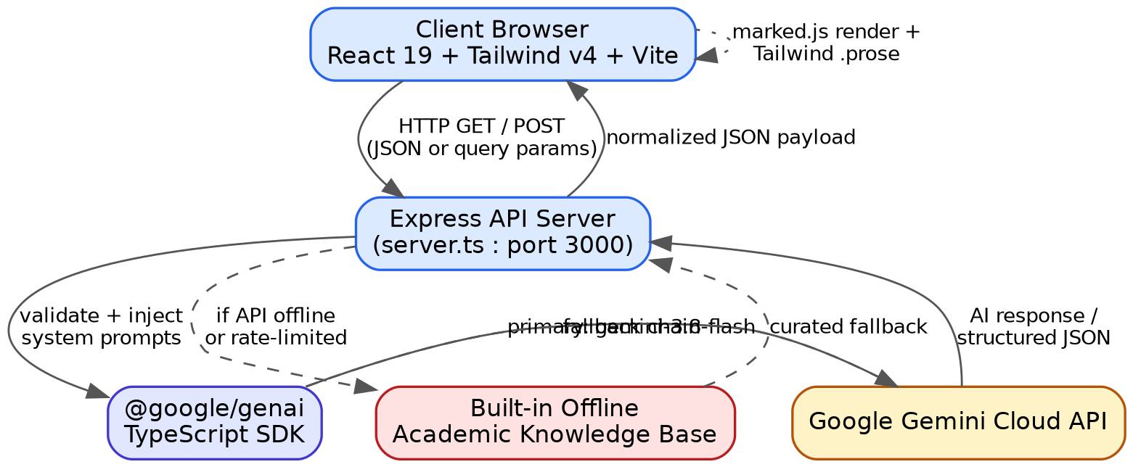
Figure 3.1 — High-level system architecture
Layer | Component | Responsibility
Client | React 19 + Tailwind v4 (Vite) | Input capture, view state, Markdown rendering, quiz interaction
Server | Express (server.ts, port 3000) | Validate requests, inject system prompts, run cascade, normalise responses, serve built frontend
AI SDK | @google/genai | Typed access to Gemini generateContent with JSON mode and schemas
AI Provider | Google Gemini API | Text generation
Fallback | Offline academic knowledge base | Curated responses when the API is unavailable or unconfigured

3. Multi-Model Cascade Design
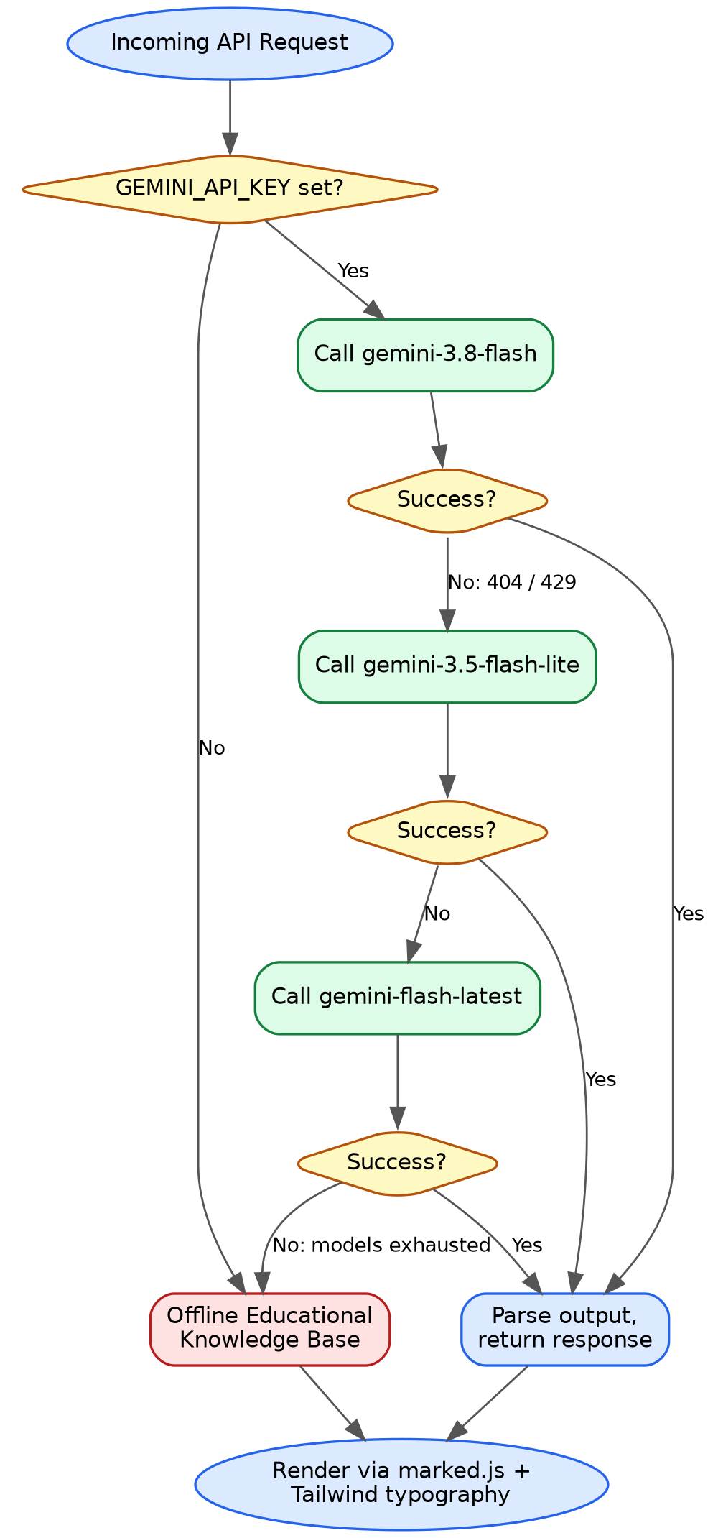
Figure 3.2 — Cascade and fallback flowchart
Step | Condition | Action
1 | GEMINI_API_KEY missing | Skip network entirely; use offline knowledge base
2 | Key present | Call gemini-3.8-flash
3 | Primary returns 404 or 429 | Call gemini-3.5-flash-lite
4 | Second tier fails | Call gemini-flash-latest
5 | Third tier fails | Use offline knowledge base
6 | Any success | Parse, attach model field, return normalised JSON

4. Quiz Generation Flow
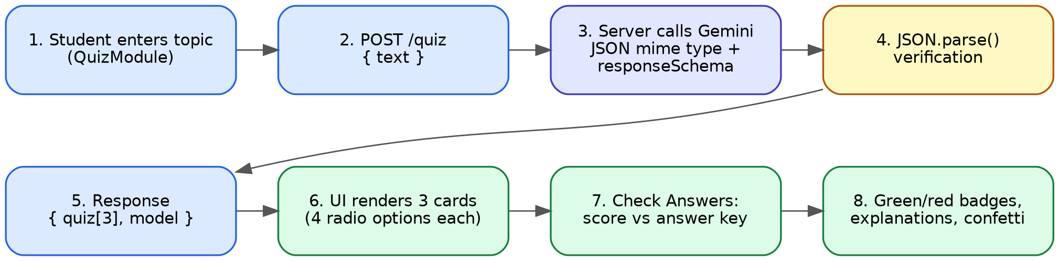
Figure 3.3 — Quiz generation and validation flow
The quiz is the only module with a strict machine-readable contract, so it is constrained at the API level (responseMimeType application/json plus a response schema) and verified server-side with JSON.parse before the client sees it.

5. Application Webflow & Navigation
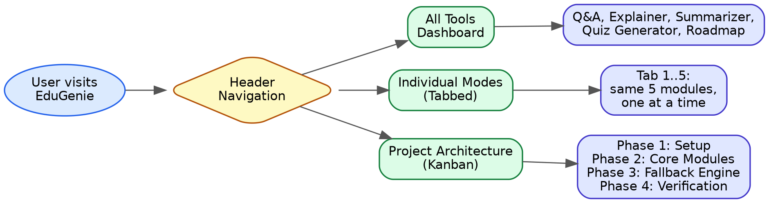
Figure 3.4 — Application webflow
View | Purpose | Best for
All Tools | All 5 modules on one page | Desktop study sessions
Individual Modes | One module per tab | Mobile / focused work
Project Architecture | Kanban (Setup, Core Modules, Fallback Engine, Verification) + architecture inspector | Demos and evaluation

6. Frontend Component Design
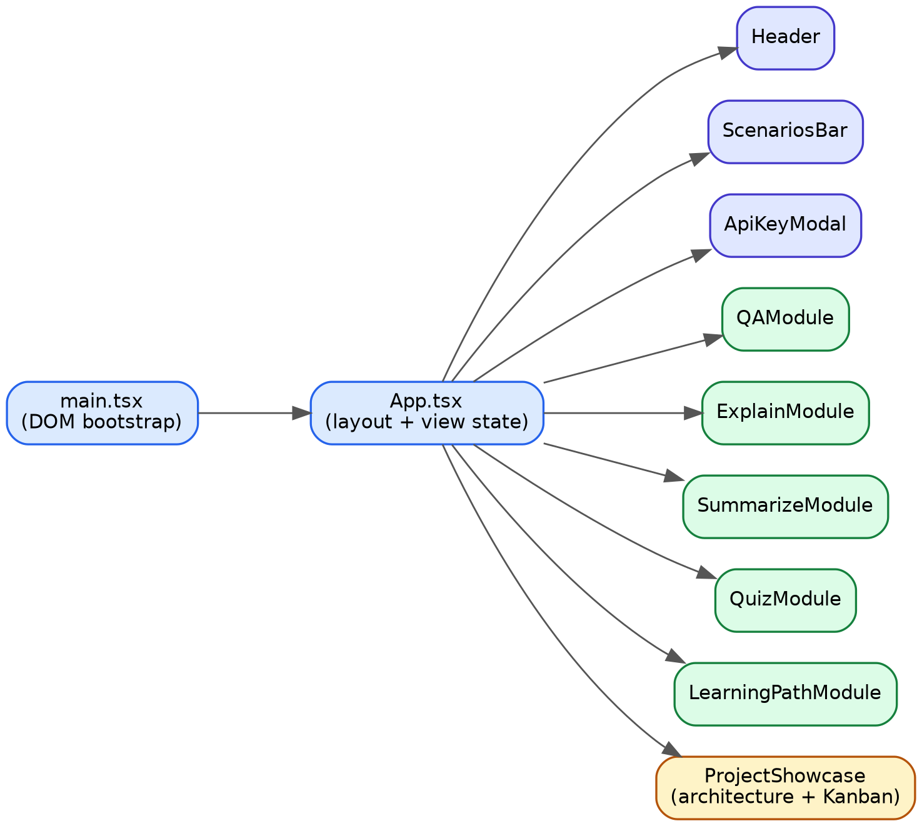
Figure 3.5 — React component tree
Component | Responsibility
main.tsx | DOM bootstrap
App.tsx | Root layout and which view is active
Header.tsx | Navigation between the three views
ScenariosBar.tsx | One-click scenarios that fill module inputs
ApiKeyModal.tsx | Shows configuration status from /api/status
QAModule / ExplainModule / SummarizeModule / LearningPathModule | Input, request, loading/error state, Markdown result with copy button
QuizModule.tsx | Topic input, 3 question cards, scoring, explanations, confetti
ProjectShowcase.tsx | Architecture inspector and Kanban board
types.ts | Shared TypeScript interfaces for request/response shapes

7. API Design
Route | Aliases | Methods | Input | Output
/qa | /api/qa | GET, POST | question | answer, model
/explain | /api/explain | GET, POST | topic | topic, explanation, model
/summarize | /api/summarize | GET, POST | text | summary, model
/quiz | /api/quiz | GET, POST | text | quiz[], model
/learn/recommendations | /api/learn/recommendations | GET, POST | topic | topic, recommendation, model
/api/status | — | GET | — | status, hasApiKey, defaultModel, fallbackModel, version, appName

7.1 Quiz item schema
{
"question": string,
"options": [string, string, string, string],
"answer": string, // must equal one of options
"explanation": string
}

8. Error-Handling Design
Situation | Handling
Missing / empty input | Reject with a client-error status before any model call
No API key | Offline knowledge base; /api/status shows hasApiKey=false
Model 404 / 429 | Advance to next cascade tier
All tiers fail | Offline knowledge base
Invalid quiz JSON | Treat as a failed tier: retry next tier, then offline
Client network error | Inline error message in the module; inputs preserved

9. Security Design
- Secrets: GEMINI_API_KEY only in server environment; .env in .gitignore; .env.example committed with a placeholder.
- Browser never calls Gemini; all provider traffic is server-side.
- Output handling: sanitize the HTML produced by marked before injecting it into the page (marked does not sanitize by itself).
- Abuse control: because the server holds the key, a public deployment lets anyone spend the quota — add request rate limiting and input-size limits.
- GET support: query strings have length limits, so long text for /summarize should use POST; keep GET for short inputs and quick testing.

10. UI / UX Design Notes
- Typography: Tailwind .prose for all AI output; headings, lists and bold terms rendered natively.
- Feedback: loading indicators, green/red quiz badges, temporary “Copied” state, confetti on quiz completion.
- Layout: single-column, responsive; tabbed mode for small screens.
- Icons: Lucide React.

11. Deployment Architecture
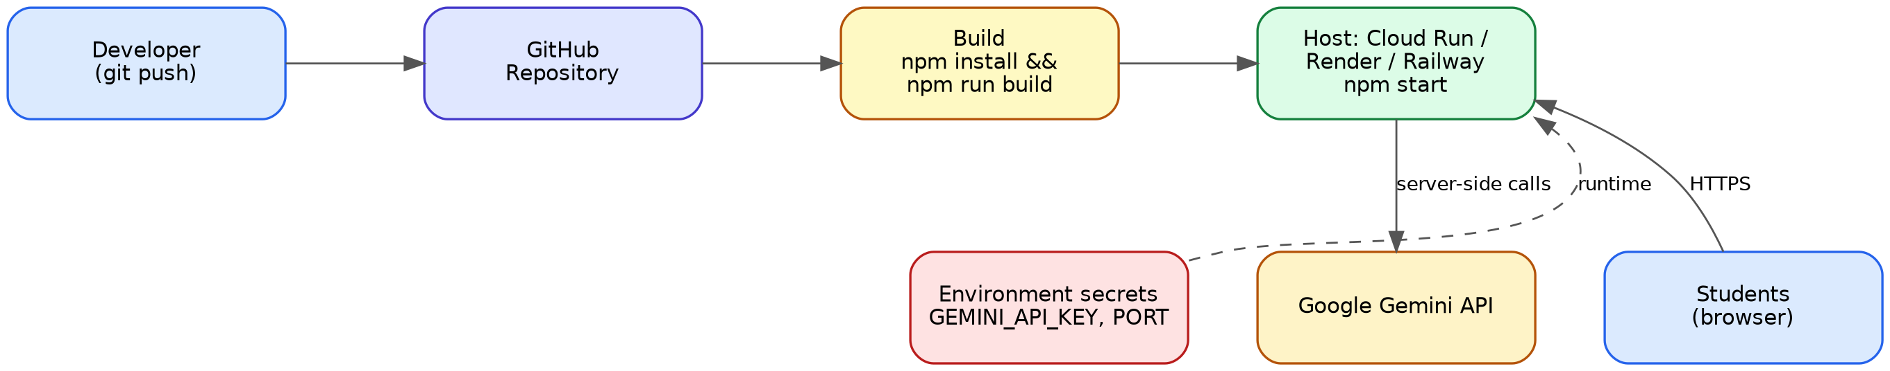
Figure 3.6 — Build and deployment topology

12. Technology Decisions
Decision | Choice | Rationale
Frontend framework | React 19 + Vite | Component model fits five similar modules; fast dev server and build
Styling | Tailwind CSS v4 + typography plugin | Utility classes plus .prose for consistent AI output
Backend | Express.js on Node 18+, run with tsx | Minimal HTTP layer; one language across the stack
AI access | @google/genai server-side | Official SDK; supports JSON mode and schemas
State | React local state | App is stateless; no store needed
Persistence | None in v1 | Keeps deployment trivial; moved to backlog

13. Exit Criteria
- ☐ Architecture, cascade and quiz flows reviewed
- ☐ API contracts frozen
- ☐ Component tree agreed

