PHASE 4
Project Planning
Work breakdown, schedule, roles, risks and delivery process
Field | Value
Project | EduGenie — Intelligent Academic Learning Assistant
Stack | React 19 + Vite + Tailwind CSS v4 • Express.js (TypeScript) • Google Gemini (@google/genai)
Document version | 1.0
Date | September 2026
Prepared by | [Add author / team name]
Repository | [Add GitHub repository URL]

1. Delivery Approach
The project is delivered in eight sequential phases, each with its own folder and document in the repository. Development itself follows the four Kanban stages shown in the app: Setup, Core Modules, Fallback Engine, Verification.
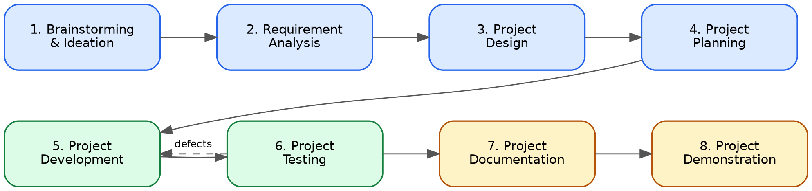
Figure 4.1 — Eight-phase lifecycle

2. Work Breakdown Structure
WBS | Work package | Key tasks | Deliverable
1 | Brainstorming & Ideation | Problem framing, personas, idea scoring, scope | Phase 1 document
2 | Requirement Analysis | FR/NFR, user stories, traceability | Phase 2 document
3 | Project Design | Architecture, flows, components, API design | Phase 3 document + diagrams
4 | Project Planning | WBS, schedule, risks, process | Phase 4 document
5.1 | Dev — Setup | Repo, Vite + React + Tailwind, Express + tsx, env config, scripts | Runnable skeleton
5.2 | Dev — Core Modules | Five module endpoints + five UI components, Markdown rendering, copy button | Working modules
5.3 | Dev — Fallback Engine | Cascade, offline knowledge base, status endpoint, quiz schema | Resilient backend
6 | Project Testing | Test plan, execution, defect log | Phase 6 document + results
7 | Project Documentation | Technical doc, README, API reference, user guide | Phase 7 document
8 | Project Demonstration | Demo script, rehearsal, evidence, submission | Phase 8 document + demo video

3. Suggested Schedule
Durations are suggested effort; replace the date columns with your real submission timeline.
Phase | Suggested effort | Start | End | Depends on | Status
1 Brainstorming | 1 day | [dd-mm] | [dd-mm] | — | ☐
2 Requirements | 1–2 days | [dd-mm] | [dd-mm] | 1 | ☐
3 Design | 2 days | [dd-mm] | [dd-mm] | 2 | ☐
4 Planning | 1 day | [dd-mm] | [dd-mm] | 2, 3 | ☐
5 Development | 5–7 days | [dd-mm] | [dd-mm] | 3, 4 | ☐
6 Testing | 2–3 days | [dd-mm] | [dd-mm] | 5 | ☐
7 Documentation | 2 days | [dd-mm] | [dd-mm] | 5, 6 | ☐
8 Demonstration | 1–2 days | [dd-mm] | [dd-mm] | 6, 7 | ☐

4. Milestones
Milestone | Definition of done
M1 — Skeleton runs | npm run dev serves the app and /api/status responds
M2 — Modules complete | All five routes and UI modules work against Gemini
M3 — Resilient | Cascade and offline fallback verified (TC-10 to TC-12)
M4 — Tested | All Must test cases executed; no open Critical/High defects
M5 — Documented | All eight phase documents and README present in the repo
M6 — Demonstrated | Demo delivered; video and screenshots added; release tagged

5. Roles & Responsibilities
Fill in names. One person can hold several roles.
Role | Responsibilities | Owner
Project lead | Scope, schedule, submission | [name]
Frontend developer | React components, Tailwind styling, quiz UX | [name]
Backend developer | Express routes, cascade, offline KB, schema | [name]
Tester | Test plan execution, defect log | [name]
Documentation owner | Phase documents, README, diagrams | [name]

6. Tools & Environment
Purpose | Tool
Source control | Git + GitHub
Runtime / packages | Node.js 18+, npm 9+
Build | Vite; tsx for server
AI access | Google AI Studio API key
API testing | curl (see Phase 6 script)
Diagrams | Graphviz DOT sources in 03_Project_Design_Phase/diagrams
Docs | Microsoft Word (.docx) + Markdown

7. Repository & Git Workflow
- main is always demo-ready; work happens on feature/<name> branches merged by pull request.
- Commit messages: type: summary (feat, fix, docs, test, chore).
- Each phase folder is committed when its exit criteria are ticked; tag releases (v0.x during build, v1.0.0 at submission).
- Never commit .env; .env.example carries the placeholder.

8. Risk Register
ID | Risk | Likelihood | Impact | Mitigation
R1 | Free-tier quota exhausted (429) during demo | High | High | Cascade + offline KB; rehearse offline mode; keep a spare key
R2 | A model ID is retired or renamed | Medium | High | Keep model IDs configurable; check Google’s model list before release
R3 | AI gives inaccurate content | Medium | Medium | Prompt for concise, checkable facts; show model used; note limitation in docs
R4 | API key leaked to Git or browser | Low | High | Server-side only; .gitignore; TC-21; rotate if exposed
R5 | XSS from unsanitized Markdown output | Medium | High | Sanitize HTML; TC-23
R6 | Public deployment lets others burn quota | Medium | Medium | Rate limiting and input-size caps
R7 | Scope creep (accounts, uploads) | Medium | Medium | Backlog list from Phase 1; freeze scope
R8 | Schedule slips near submission | Medium | High | Phase-wise commits; documentation written alongside development

9. Definition of Done
- Code merged to main, builds with npm run build, runs with npm start.
- Mapped test cases executed and results recorded.
- Relevant phase document updated and committed.

10. Exit Criteria
- ☐ Schedule dates filled in
- ☐ Roles assigned
- ☐ Risk register reviewed

