PHASE 7
Project Documentation
Complete technical documentation, user guide and operations notes
Field | Value
Project | EduGenie — Intelligent Academic Learning Assistant
Stack | React 19 + Vite + Tailwind CSS v4 • Express.js (TypeScript) • Google Gemini (@google/genai)
Document version | 1.0
Date | September 2026
Prepared by | [Add author / team name]
Repository | [Add GitHub repository URL]

Contents
1. Overview
2. Architecture
3. Technology Stack
4. Setup & Installation
5. API Reference
6. Directory Structure
7. User Guide
8. Testing
9. Deployment
10. Troubleshooting
11. Security & Known Limitations
12. Maintenance
13. Glossary
14. License

1. Overview
EduGenie is an intelligent academic learning assistant. Instead of returning raw model output, it applies student-centric prompting, renders clean typography, and offers structured tools — self-grading quizzes and phased roadmaps — on top of a resilient multi-model Gemini backend with an offline fallback.
Feature | Endpoint | Description
Instant Academic Q&A | /qa | Structured answers to academic, historical and scientific questions
Concept Explainer | /explain | Analogy-based explanations with key takeaways
Text Summarizer | /summarize | Revision-ready summaries of chapters, papers, transcripts
Interactive Quiz Engine | /quiz | 3 MCQs, 4 options each, instant scoring, explanations, confetti
Adaptive Roadmap Advisor | /learn/recommendations | 3-stage Beginner → Advanced roadmap with timeframes
Project Kanban | In-app view | Milestones and architecture inspector

2. Architecture
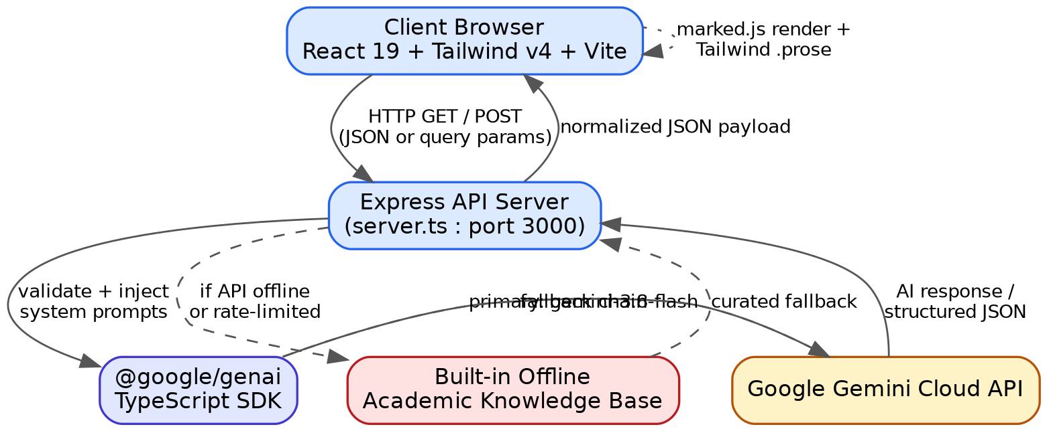
Figure 7.1 — System architecture
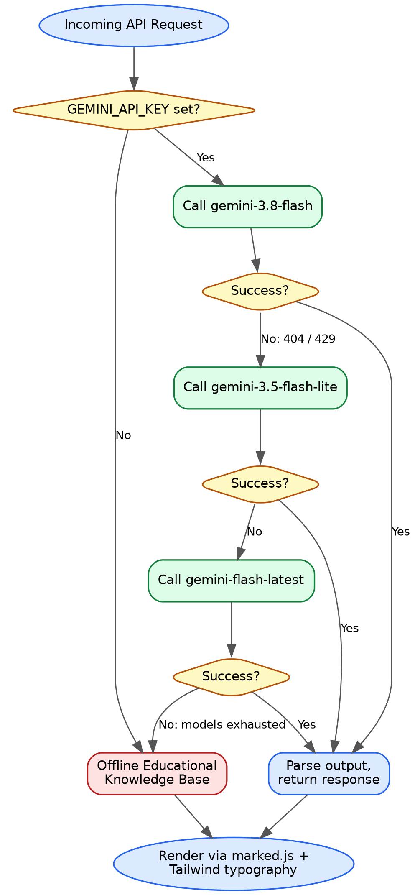
Figure 7.2 — Cascade and fallback flow
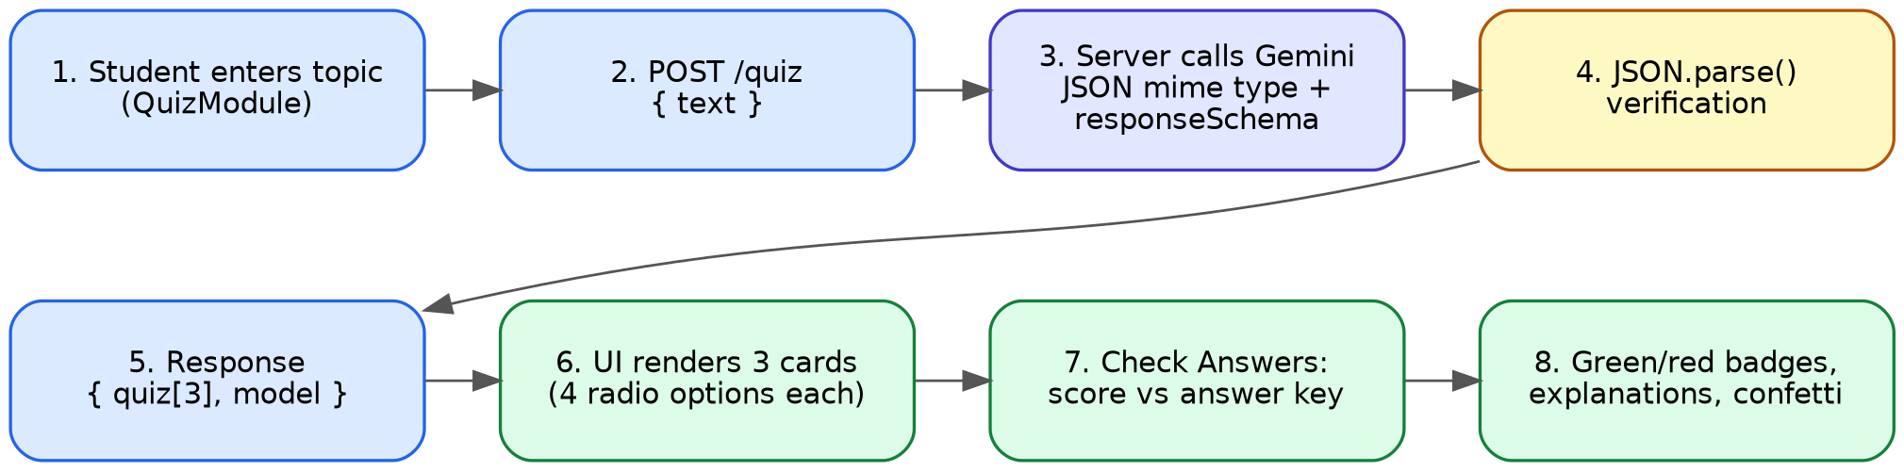
Figure 7.3 — Quiz generation flow
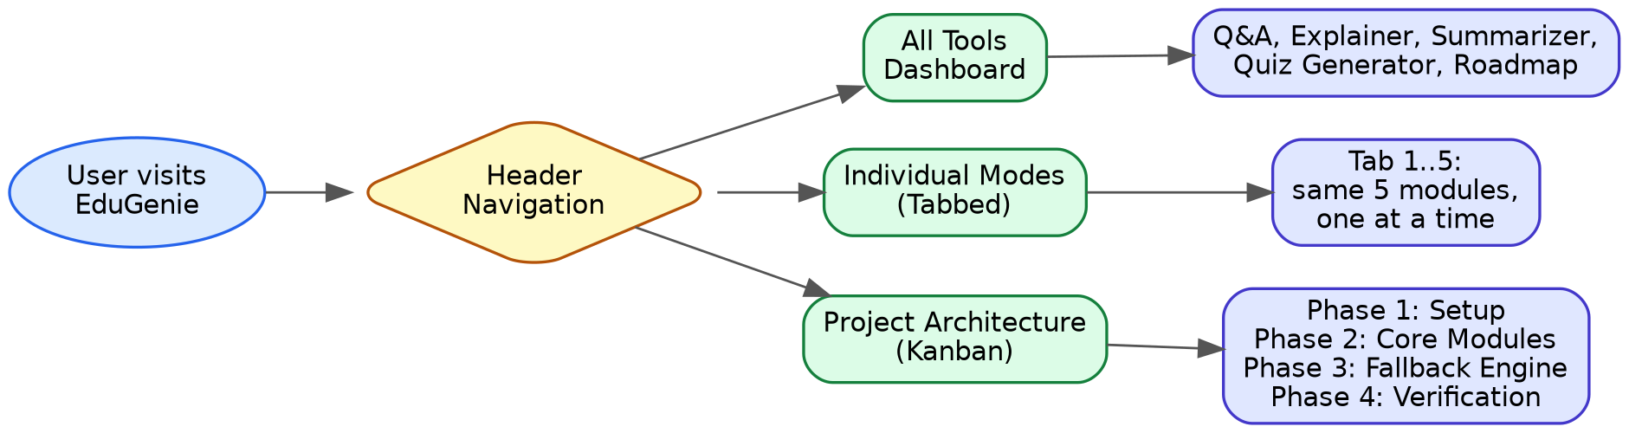
Figure 7.4 — Application webflow
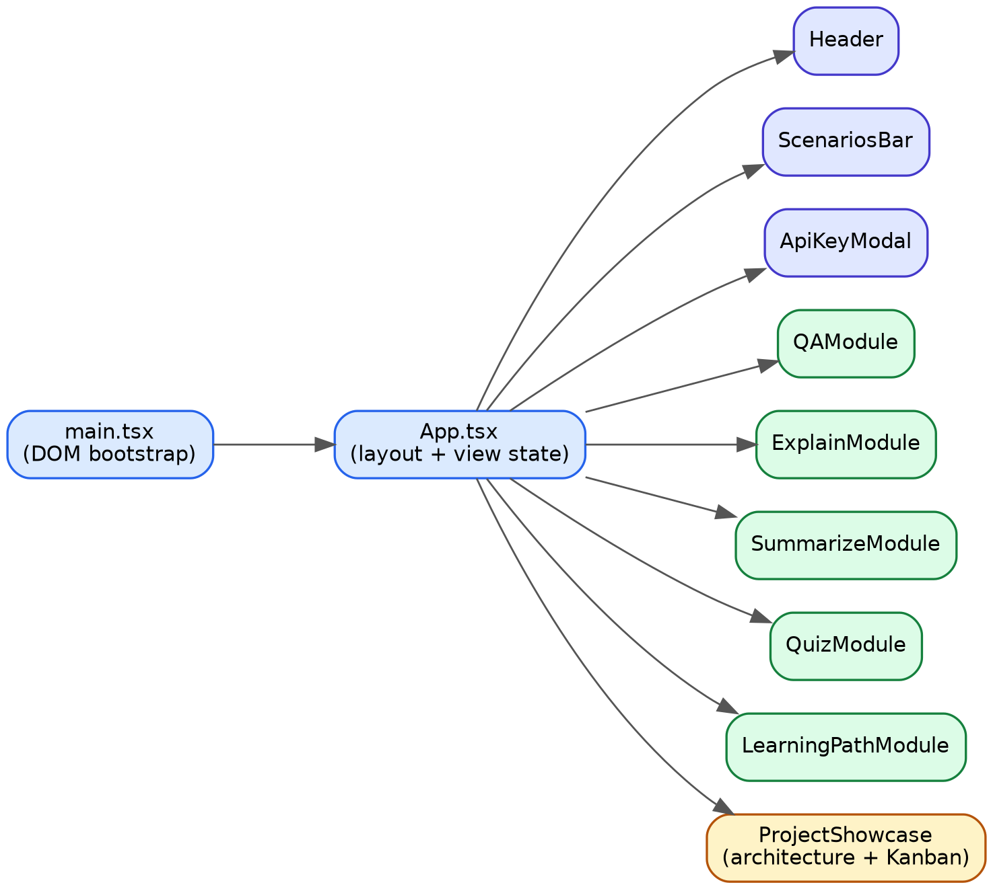
Figure 7.5 — Component tree

3. Technology Stack
Frontend : React 19, Tailwind CSS v4, Marked, Canvas Confetti, Lucide React, Vite
Backend : Node.js 18+/20+, Express.js, tsx, Archiver
AI : @google/genai SDK
gemini-3.8-flash (primary)
gemini-3.5-flash-lite (fallback 1)
gemini-flash-latest (fallback 2)
Offline academic knowledge base (final fallback)

4. Setup & Installation

4.1 Prerequisites
- Node.js 18+, npm 9+
- Gemini API key (free from https://aistudio.google.com/)

4.2 Install and run
git clone https://github.com/<your-username>/edugenie.git
cd edugenie
npm install
cp .env.example .env # Windows: copy .env.example .env
# edit .env and set GEMINI_API_KEY
npm run dev # http://localhost:3000

4.3 Getting a Gemini API key
1. Open https://aistudio.google.com/ and sign in with a Google account.
2. Click “Get API key”.
3. Choose “Create API key in new project” (or an existing project).
4. Copy the key.
5. Paste it into .env as GEMINI_API_KEY.
6. Restart the server.

4.4 Environment variables
GEMINI_API_KEY="YOUR_GEMINI_API_KEY_HERE"
PORT=3000
Security
Never commit .env. It is listed in .gitignore; only .env.example (placeholder value) belongs in the repository.

4.5 Production build
npm run build
npm start

5. API Reference
All study routes accept GET (query parameters) and POST (JSON body) and are available with or without the /api prefix.

5.1 Q&A
Route: /qa (alias /api/qa)
Request (POST body):
{ "question": "Which is the largest ocean on Earth?" }
Response:
{
"answer": "The largest ocean on Earth is the **Pacific Ocean**! ...",
"model": "gemini-3.8-flash"
}

5.2 Concept Explainer
Route: /explain (alias /api/explain)
Request (POST body):
{ "topic": "XGBoost Machine Learning" }
Response:
{
"topic": "XGBoost Machine Learning",
"explanation": "Imagine building a LEGO tower with friends... ### Key Takeaways ...",
"model": "gemini-3.5-flash-lite"
}

5.3 Summarizer
Route: /summarize (alias /api/summarize)
Request (POST body):
{ "text": "The Industrial Revolution was the transition to ... 1760 to 1840." }
Response:
{
"summary": "**Industrial Revolution: Key Points** ...",
"model": "gemini-3.8-flash"
}

5.4 Quiz Generator
Route: /quiz (alias /api/quiz)
Request (POST body):
{ "text": "Photosynthesis" }
Response:
{
"quiz": [
{
"question": "Which pigment absorbs sunlight during photosynthesis?",
"options": ["Hemoglobin", "Chlorophyll", "Melanin", "Carotene"],
"answer": "Chlorophyll",
"explanation": "Chlorophyll is the green pigment that traps light energy."
} // … 2 more
],
"model": "gemini-3.8-flash"
}

5.5 Learning Recommendations
Route: /learn/recommendations (alias /api/learn/recommendations)
Request (POST body):
{ "topic": "Full Stack Web Development" }
Response:
{
"topic": "Full Stack Web Development",
"recommendation": "## Learning Path ... ### Stage I: Beginner (2 to 3 weeks) ...",
"model": "gemini-3.8-flash"
}

5.6 Status
Route: GET /api/status
{
"status": "ok",
"hasApiKey": true,
"defaultModel": "gemini-3.8-flash",
"fallbackModel": "gemini-3.5-flash-lite",
"version": "1.0.0",
"appName": "EduGenie"
}

6. Directory Structure
edugenie/
├── server.ts index.html vite.config.ts package.json
├── tsconfig.json tsconfig.node.json metadata.json
├── .env.example .gitignore README.md LICENSE
├── src/ (App.tsx, main.tsx, index.css, types.ts, components/*)
├── 01_Brainstorming_Ideation_Phase/
├── 02_Requirement_Analysis_Phase/
├── 03_Project_Design_Phase/ (+ diagrams/)
├── 04_Project_Planning_Phase/
├── 05_Project_Development_Phase/
├── 06_Project_Testing_Phase/ (+ api-smoke-test.sh)
├── 07_Project_Documentation_Phase/
└── 08_Project_Demonstration_Phase/

7. User Guide

7.1 Choosing a view
- All Tools — every module on one page (desktop).
- Individual Modes — one module per tab (mobile / focus).
- Project Architecture — Kanban and architecture inspector.

7.2 Using the modules
Module | What to enter | What you get
Q&A | A question, e.g. “What causes the tides?” | Structured bullet answer with a Copy button
Explainer | A topic, e.g. “Quantum Superposition” | Analogy + key takeaways
Summarizer | Paste a chapter or notes | Concise revision points
Quiz | A topic, e.g. “Solar System” | 3 MCQs; Check Answers gives green/red feedback, explanations, confetti
Roadmap | A subject, e.g. “SQL” | Beginner → Intermediate → Advanced plan with timeframes

7.3 Tips
- Use the scenarios bar for one-click sample inputs.
- Verify important facts against your course material — AI answers can be wrong.
- If the response model shows offline-kb, the AI provider was unavailable and a curated answer was used.

8. Testing
curl -s http://localhost:3000/api/status
curl -s "http://localhost:3000/qa?question=What%20causes%20the%20tides"
curl -s -X POST http://localhost:3000/explain -H "Content-Type: application/json" -d '{"topic":"Quantum Computing"}'
curl -s -X POST http://localhost:3000/quiz -H "Content-Type: application/json" -d '{"text":"Pythagorean Theorem"}'
The full test plan is in 06_Project_Testing_Phase.

9. Deployment
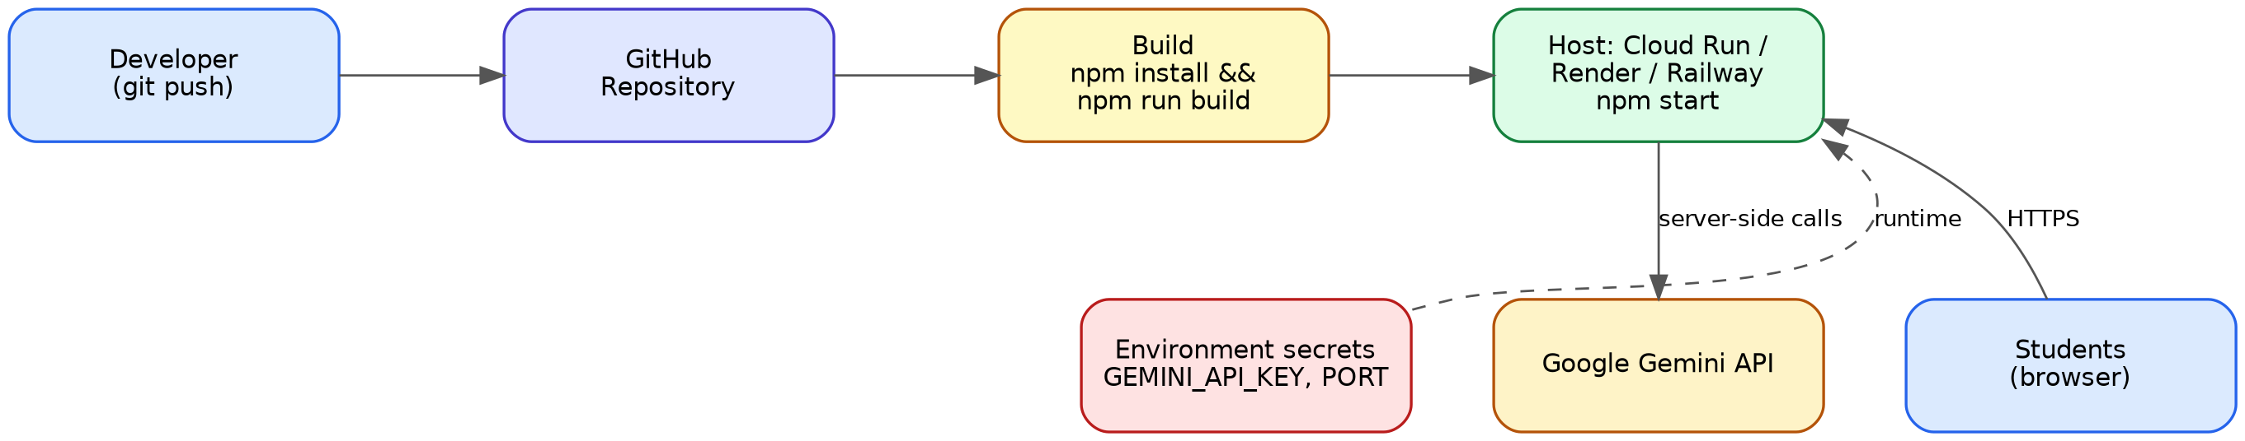
Figure 7.6 — Deployment topology

Google Cloud Run / container platforms
1. Provide PORT and GEMINI_API_KEY as environment secrets.
2. Build: npm run build
3. Start: npm start

Render / Railway
1. Connect the GitHub repository; environment: Node.
2. Build: npm install && npm run build
3. Start: npm start
4. Add GEMINI_API_KEY in the environment settings.

10. Troubleshooting
Symptom | Likely cause | Fix
Answers look generic / model shows offline-kb | No key, or all models failed | Check /api/status; set GEMINI_API_KEY; restart
Frequent fallback to 2nd/3rd model | Quota (429) on primary | Wait, use a billed key, or reduce request rate
Every model fails | Model IDs retired/renamed | Check Google’s current model list; update IDs
Port already in use | Another process on 3000 | Set PORT in .env
npm install fails | Old Node | Use Node 18+ (20+ recommended)
Copy button does nothing | Clipboard needs secure context | Use localhost or HTTPS

11. Security & Known Limitations
- Key is server-side only; never commit .env.
- Model output is untrusted: sanitize rendered HTML.
- A public deployment exposes your quota: add rate limiting.
- AI content can be inaccurate; the app does not fact-check.
- v1 is stateless: no accounts, history, or progress saving.

12. Maintenance
- Model IDs are provided by Google and get retired. Before each release, confirm gemini-3.8-flash, gemini-3.5-flash-lite and gemini-flash-latest against Google’s current model list at https://ai.google.dev/gemini-api/docs/models.
- Keep dependencies updated (npm outdated) and re-run the Phase 6 smoke test after upgrades.
- Bump the version in package.json and /api/status together.

13. Glossary
Term | Meaning
Cascade | Ordered list of models tried until one succeeds
Offline KB | Built-in curated answers used when the AI provider is unavailable
MCQ | Multiple-choice question
Response schema | JSON structure the model output is constrained to follow
429 / 404 | Rate-limit / not-found HTTP errors that trigger the next cascade tier

14. License
Released under the MIT License (see LICENSE).

