Aim: - To write C++ code of the given following tasks.

Software Used: -

Cloud Keil Studio IDE and Tera Term

Theory: -

The mbed NXP LPC11U24 Microcontroller in particular is designed for prototyping low-cost USB devices, battery powered applications and 32-bit ARM® Cortex™-M0 based designs. It is packaged as a small DIP form-factor for prototyping with through-hole PCBs, stripboard and breadboard, and includes a built-in USB FLASH programmer.

Specifications of LPC11U24:

* NXP LPC11U24 MCU
* Low power ARM® Cortex™-M0 Core
* 48MHz, 8KB RAM, 32KB FLASH
* USB Device, 2xSPI, I2C, UART, 6xADC, GPIO
* Prototyping form-factor
* 40-pin 0.1" pitch DIP package, 54x26mm
* 5V USB, 4.5-9V supply or 2.4-3.3V battery
* Built-in USB drag 'n' drop FLASH programmer
* mbed.org Developer Website
* Lightweight Online Compiler
* High level C/C++ SDK
* Cookbook of published libraries and projects

API Used:

* Syntax used for digital output:
* DigitalOut (PinName pin)
* For LED blinking we’ve used:
* DigitalOut variable(LEDn); where n= 1,2,3,4
* For delay:
* wait(t); where ‘t’ is in seconds

Task 1: - Interface Bluetooth with STM and Print in Serial Monitor.

Code: -

#include "mbed.h"

Serial pc(USBTX,USBRX);

Serial bt(PC_10,PC_11);

int main(void)

{

    char ch;

    bt.baud(9600);

    pc.baud(9600);

    pc.printf("Hello World\n\r");

    while(1)

    {

        if(bt.readable())

        {

            ch =bt.getc();

            pc.printf("%c",ch);

        }

        if(pc.readable())

        {

            ch=pc.getc();

            bt.printf("%c",ch);

        }

    }

}

Output: -

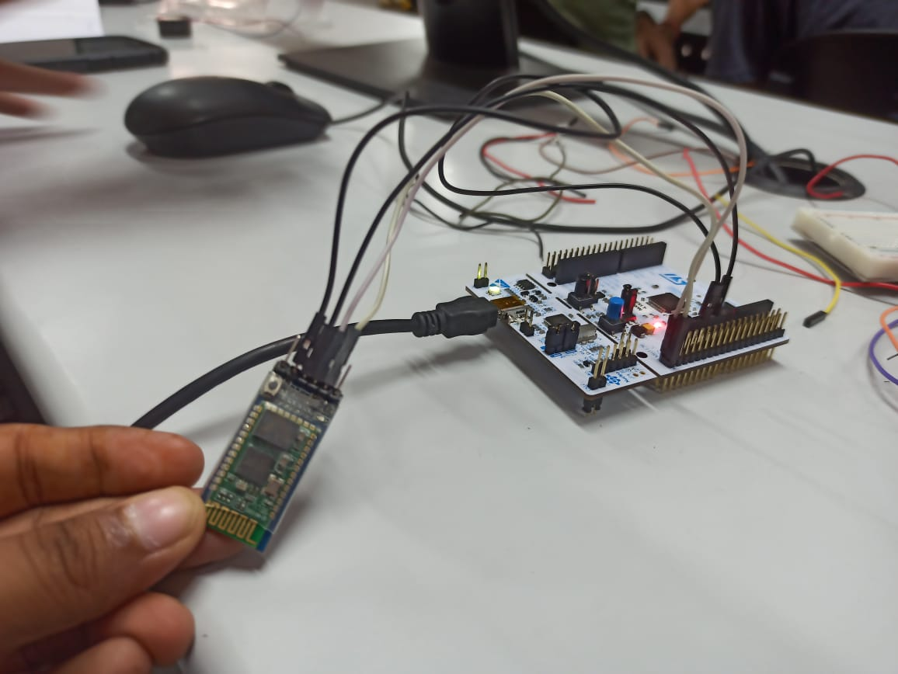

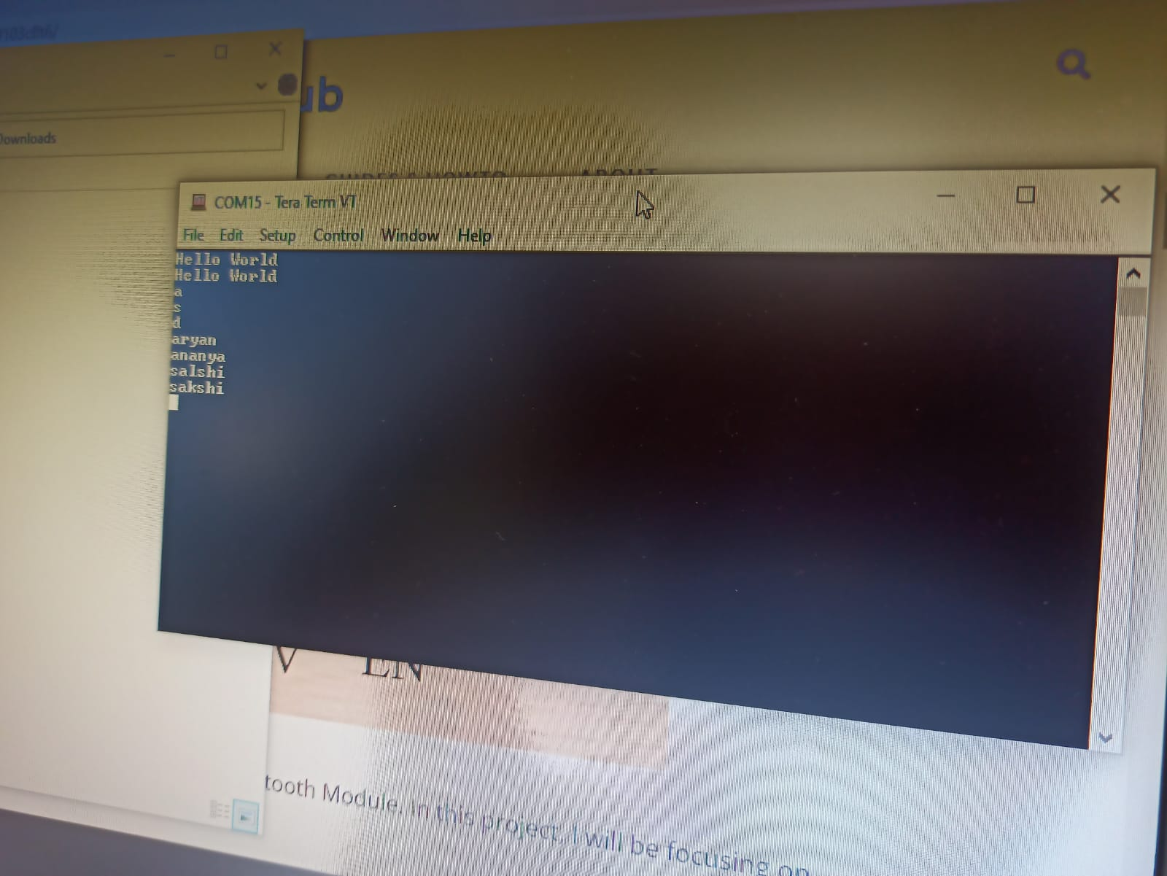

Task 2 and 3: -

Code: -

#include "mbed.h"

Serial pc(USBTX,USBRX);

Serial bt(PC_10,PC_11);

DigitalOut led1(PC_3);

DigitalOut buzz(PC_2);

int main(void)

{

    char ch;

    bt.baud(9600);

    pc.baud(9600);

    pc.printf("Hello World\n\r");

    while(1)

    {

        if(bt.readable())

        {

            ch =bt.getc();

            pc.printf("%c",ch);

        }

        if(ch == '1')

        {

            led1 = 0;

        }

        if(ch == '2')

        {

            led1 = 1;

        }

        if(ch == '3')

        {

            buzz =0;

        }

        if(ch == '4')

        {

            buzz =1;

        }

    }

}

Output: -

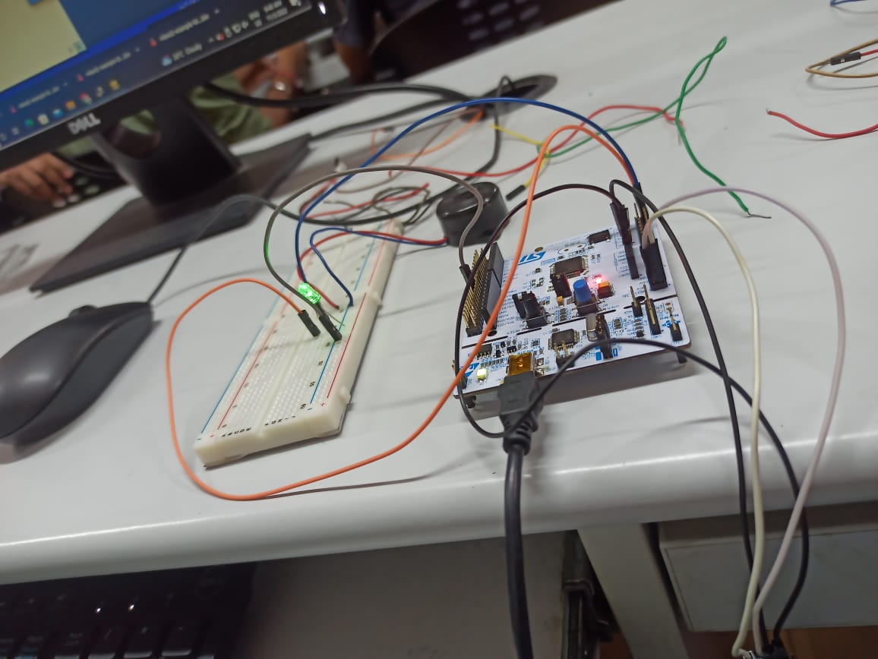

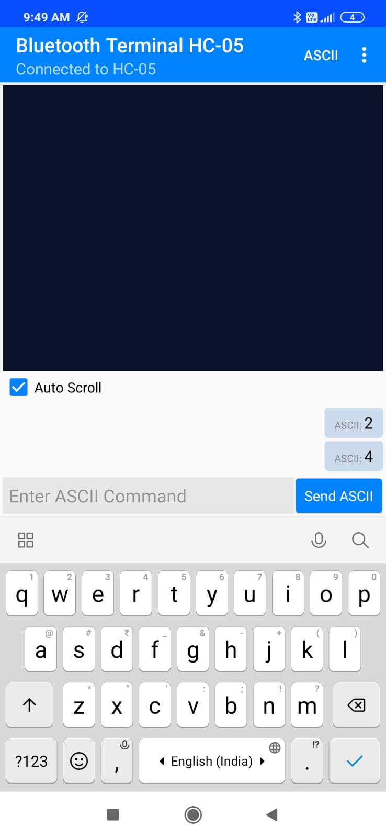

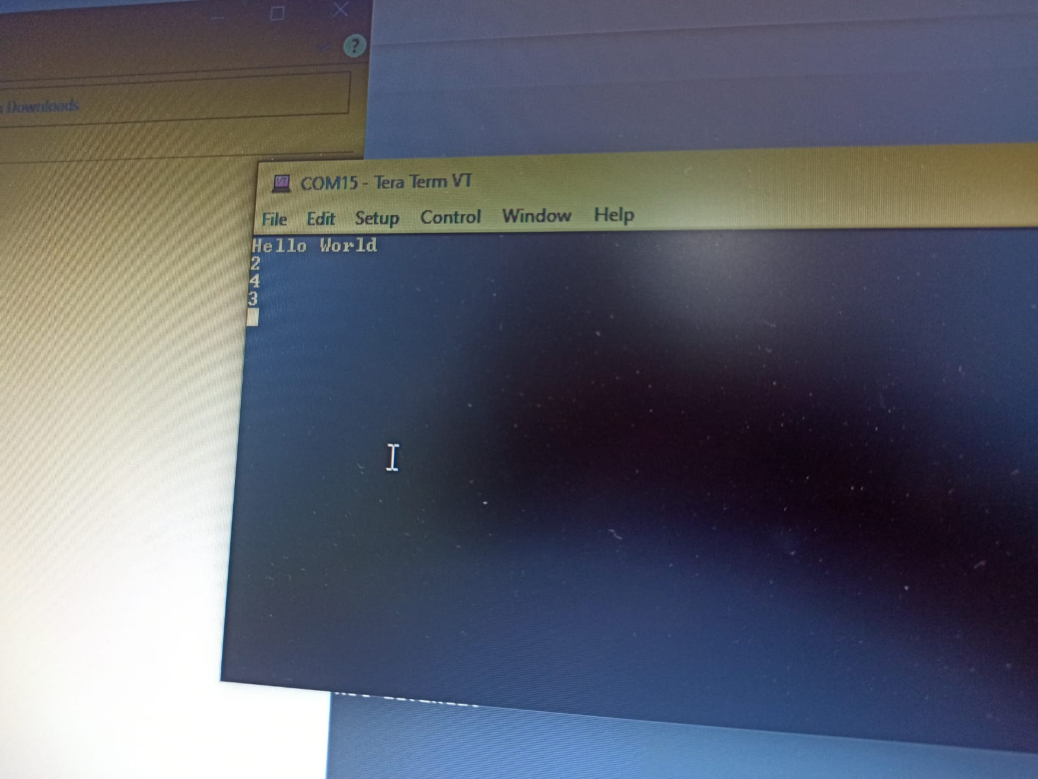

Verification Status: -

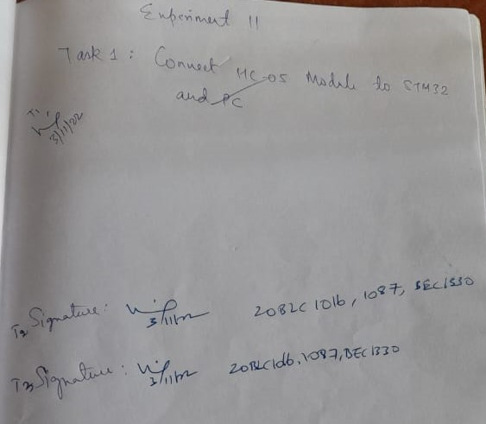

Result: -

Successfully understood and performed all the given tasks.