Question 1: - 1st Part



VARIATION OF PARAMETER

CODE: -

clc

syms x r c1 c2

p1 = input('Enter the coefficient of D2y: ');

p2 = input('Enter the coefficient of Dy: ');

p3 = input('Enter the coefficient of y: ');

eq = p1*r^2+p2*r+p3;

r = solve(eq,r);

p = real(r(1));

q = imag(r(1));

if q~=0

y1 = exp(p*x)+cos(q*x);

y2 = exp(p*x)+sin(abs(q)*x);

elseif r(1)==r(2)

y1 = exp(r(1)*x);

y2 = x*exp(r(1)*x);

else

y1 = exp(r(1)*x);

y2 = exp(r(2)*x);

end

y_c = c1*y1 + c2*y2;

w = simplify(y1*diff(y2)-y2*diff(y1));

f = input('Enter the non homogenous part: ');

y_p = -y1*int(y2*f/w)+y2*int(y1*f/w);

y = simplify(y_c+y_p);

disp('The general solution of the given ODE is: ')

disp(y)

a = input('Enter the value of a: ');

b = input('Enter the value of b: ');

c = input('Enter the value of y(a): ');

d = input('Enter the value of y(b): ');

eq1 = subs(y,x,a)-c;

eq2 = subs(y,x,b)-d;

[c1, c2] = solve(eq1,eq2);

y = subs(y);

disp('Solution of the boundary value problem is given by: ')

disp(y)

ezplot(y,[a,b])

INPUT: -

COMMAND WINDOW: -

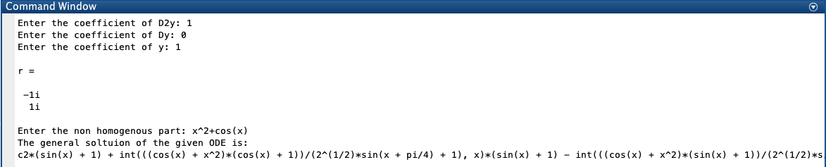

The general solution of the given ODE is:

c2*(sin(x) + 1) + int(((cos(x) + x^2)*(cos(x) + 1))/(2^(1/2)*sin(x + pi/4) + 1), x)*(sin(x) + 1) - int(((cos(x) + x^2)*(sin(x) + 1))/(2^(1/2)*sin(x + pi/4) + 1), x)*(cos(x) + 1) + c1*(cos(x) + 1)

GRAPH: - Cannot be made because the boundary value is too big but if I use fplot instead of ezplot then a graph is coming.

COMMAND WINDOW: -

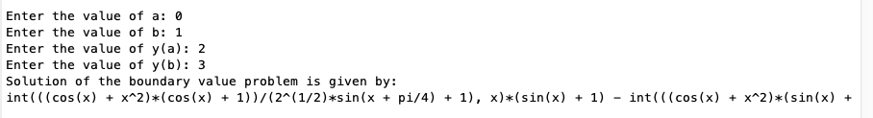

int(((cos(x) + x^2)*(cos(x) + 1))/(2^(1/2)*sin(x + pi/4) + 1), x)*(sin(x) + 1) - int(((cos(x) + x^2)*(sin(x) + 1))/(2^(1/2)*sin(x + pi/4) + 1), x)*(cos(x) + 1) - ((sin(x) + 1)*(2*cos(1) - 2*cos(1)*subs(int(((cos(x) + x^2)*(sin(x) + 1))/(2^(1/2)*sin(x + pi/4) + 1), x), x, 1) + 2*sin(1)*subs(int(((cos(x) + x^2)*(cos(x) + 1))/(2^(1/2)*sin(x + pi/4) + 1), x), x, 1) + 2*subs(int(((cos(x) + x^2)*(cos(x) + 1))/(2^(1/2)*sin(x + pi/4) + 1), x), x, 1) - 2*subs(int(((cos(x) + x^2)*(sin(x) + 1))/(2^(1/2)*sin(x + pi/4) + 1), x), x, 1) - cos(1)*subs(int(((cos(x) + x^2)*(cos(x) + 1))/(2^(1/2)*sin(x + pi/4) + 1), x), x, 0) + 2*cos(1)*subs(int(((cos(x)……and so on the eq. is too big.

GRAPH: -

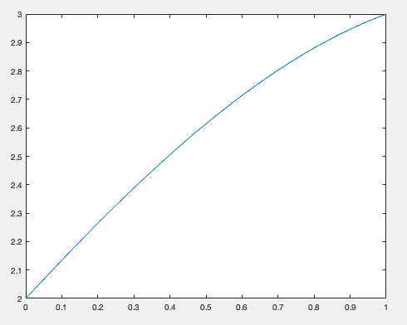

Question 1: - 2nd Part

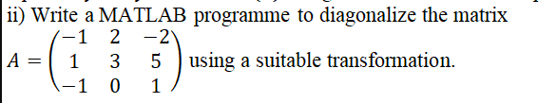

DIAGONALIZATION

CODE: -

clc

A = input('Enter the square matrix A: ');

n=length(A);

[X,D] = eig(A);

disp('The Eigenvalue of A are')

disp(diag(real(D)))

disp('The eigen vectors for the corresponding eigenvalues')

disp(X)

option = input('If you want to diagonalize by similarity tranformation then press 1 or any other key if you want to diagonalize orthogonal matrix. ')

if(option==1)

P=X;

disp('Modal Matrix associated with A is ')

D=inv(P)*A*P

disp('D = inv(P)*A*P')

disp('Thus A is reduced to the diagonal matrix D through P by similarity transformation')

else

for i=1:n

x = X(:,i);

u(:,i)=x/norm(x)

end

disp('Orthogonal matrix associated with A is the matrix')

P1 = u(:,1:n)

disp('D=transpose(P1)*A*P1')

D = (P1)'*A*(P1)

disp('Thus A is reduced to the diagonal matrix D through P1by orthogonal tranformation.')

end

INPUT: -

COMMAND WINDOW: -

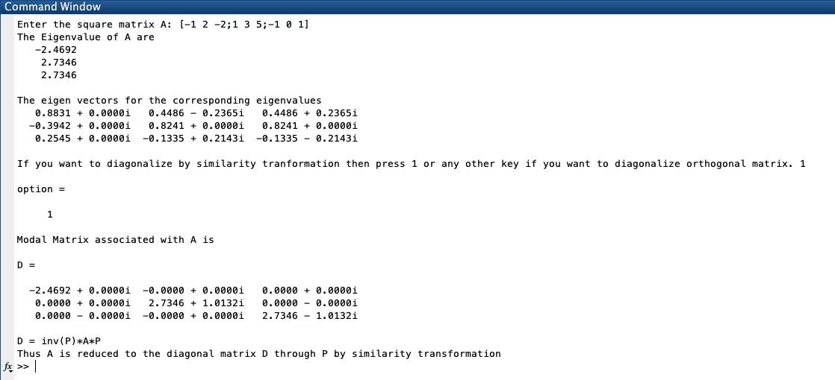

*This Question is done by similarity transformation not by orthogonal transformation. *

Question 2: - (Debugging)

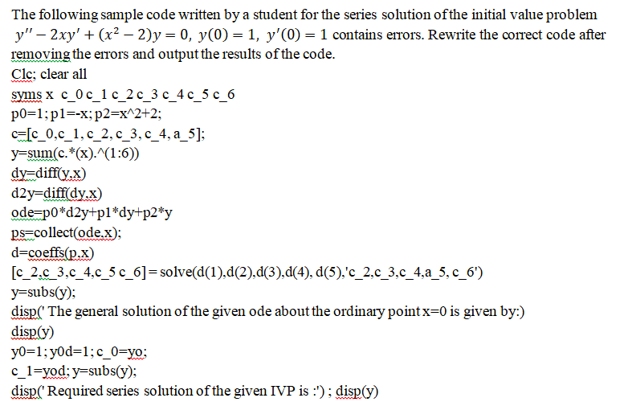

CORRECT CODE: -

clear all

clc

syms x c_0 c_1 c_2 c_3 c_4 c_5 c_6

p0=1;

p1=-2*x;

p2=x^2-2;

c = [c_0,c_1,c_2,c_3,c_4,c_5,c_6];

y = sum(c.*(x).^(0:6));

dy=diff(y);

d2y = diff(dy);

ode=p0*d2y+p1*dy+p2*y;

ps=collect(ode,x);

d = coeffs(ps,x);

[c_2,c_3,c_4,c_5,c_6] = solve(d(1),d(2),d(3),d(4),d(5),c_2,c_3,c_4,c_5,c_6);

z = subs(y);

disp(' The general solution of the given ode around x=0 is given by: ')

disp(z)

y0=1;

y0d=1;

zz = subs(z,[c_0,c_1],[y0,y0d]);

disp(' The Particular solution of the given ode around is given by: ')

disp(zz)

ezplot(zz,[-4 4])

COMMAND WINDOW: -

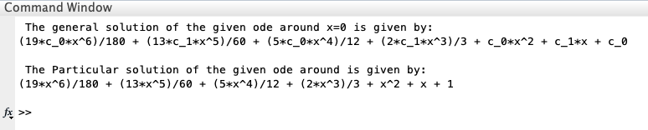

GRAPH: -

