|  |  |  |  |
| --- | --- | --- | --- |
| **Course Code:** | **ECE1002** | **Course Name:** | **Semiconductor Devices and Circuits Lab** |
| **Faculty In – Charge:** | **Dr. Pradeep Naryanan. S.** | **Department:** | **SENSE** |
| **Name of the Student:** | **Aryan Pandey** | **Registration Number:** | **20BLC1087** |
| **Experiment No.:** | **6** | **Date of Experiment:** | **12.04.2021** |
| **Name of the Experiment:** | **DESIGN AND VERIFICATION OF CLAMPER CIRCUIT** | | |

**OBJECTIVE:**

To design and verify the function of the Clamper circuit using LTSPICE Simulator and observe its characteristics.

**TOOLS:**

LTSPICE XVII Simulator.

**THEORY**

**Positive Clamper: -**

The positive clamper is made up of a voltage source Vi, capacitor C, diode D, and load resistor RL. In the below circuit diagram, the diode is connected in parallel with the output load. So the positive clamper passes the input signal to the output load when the diode is reverse biased and blocks the input signal when the diode is forward biased.

During the negative half cycle of the input, the diode starts conducting and charges the capacitor rapidly to its peak input value. Thus the waveforms are clamped towards the positive direction as shown above.

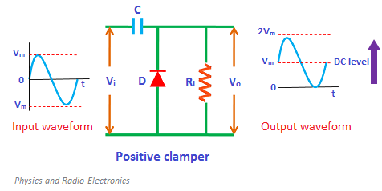

**Negative Clamper: -**

During Positive Half Cycle: -

During the positive half cycle of the input AC signal, the diode is forward biased and hence no signal appears at the output. In forward biased condition, the diode allows electric current through it. This current will flows to the capacitor and charges it to the peak value of input voltage in inverse polarity -VM. As input current or voltage decreases after attaining its maximum value VM, the capacitor holds the charge until the diode remains forward biased.

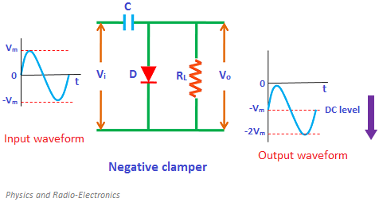

**BIASED POSITIVE CLAMPER: -**

If positive biasing is applied to the clamper then it is said to be a positive clamper with positive bias. The positive clamper with positive bias is made up of an AC voltage source, capacitor, diode, resistor, and dc battery.

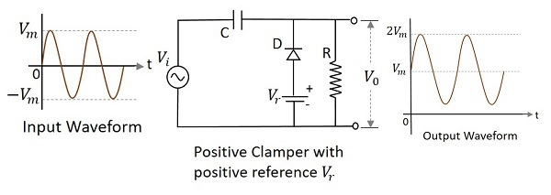

**BIASED NEGATIVE CLAMPER: -**

During Positive Half Cycle: -

During the positive half cycle, the battery voltage reverse biases the diode when the input supply voltage is less than the battery voltage. When the input supply voltage becomes greater than the battery voltage, the diode is forward biased by the input supply voltage and hence allows electric current through it. This current will flows to the capacitor and charges it.

During Negative Half Cycle:

During the negative half cycle, the diode is reverse biased by both input supply voltage and battery voltage. As a result, the signal appears at the output.

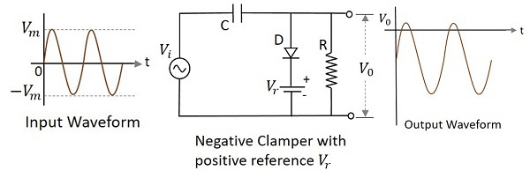

**COMBINED BIASED CLAMPER: -**

When a portion of both positive and negative of each half cycle of the input voltage is to be clipped (or removed), combination clipper is employed. The circuit for such a clipper is given in the figure below.

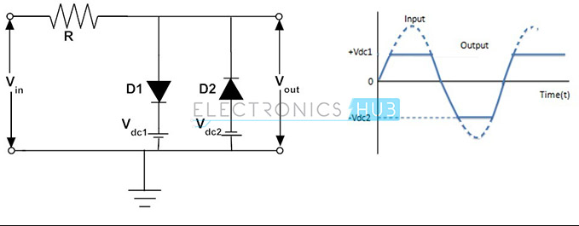

**PROCEDURE**

**For Positive and Negative Series Clampers: -**

* **Draw the AC voltage source: -**

1. Input is connected into the main AC supply from the components menu. The normal ac input voltage is 230V and 1000 Hz.

Peak Voltage = VM

1. Construct this, click on the component icon in the LT Spice and select voltage source and Click Ok. Right-click on the voltage source, Click on the advanced button.
2. By clicking the advanced button a pop-up window will open. In this window, you will have multiple options to select. Examples “PULSE”, “SINE”, etc.
3. Here we need a “SINE” waveform and provide the values in the corresponding fields.
4. DC Offset = 0
5. Amplitude = 230
6. Frequency = 1000Hz

* **Draw the Diode: -**

We need one diodes here. To do this, click on the diode button and position it on the required place on the screen. Right-click on the diode and click “Pick New diode” and select “1N4148 Silicon Diode”.

* **Draw the Resister: -**

1. To do this, click on the resister and position it on the required place on the screen. To give the value right click on the resister and type the value maybe 1.5k ohm.
2. Now, the last step is to label the input and output port. To do this click on the “label net” icon. If you want to label the input port, then type Vin and port type “input”.
3. Similarly, if you want to label the output port then type Vout and port type “output”. Then place the input and output label to the corresponding place on the screen.

* **Draw a Capacitor: -**

To do this, click on the “Capacitor” and position it on the required place on the screen. To give the value right click on the resister and type the value maybe 5µF.

For Positive Series Clamper: -

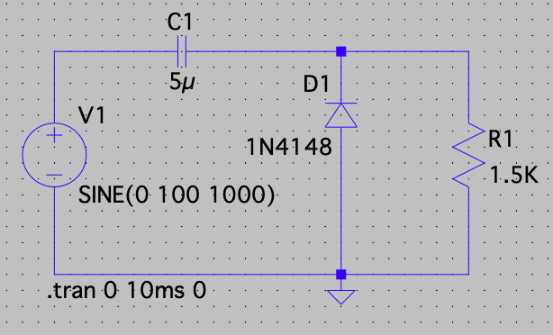

For Negative Series Clamper: -

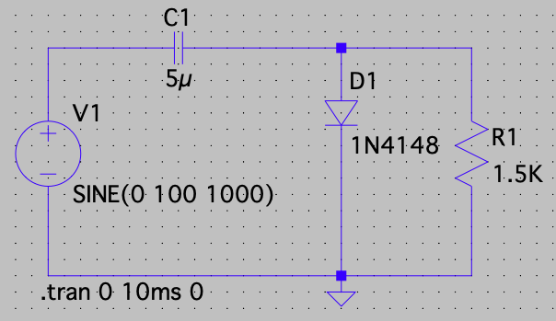

* **Simulation of Positive and Negative Clamper: -**

1. To do simulation click on the “Simulate” button and select “Edit Simulation Command”. Now, you will see a pop-up window. For the rectifier, we have to plot the waveform in the time domain. So, we are using transient analysis here.
2. Click on “Transient Analysis”. And a submenu will appear. In this only enter (trans. 0 10ms 0) and click ok. Then, click the “Run” button. Run button is available in the simulate icon on the title bar.
3. You will see the graphical window on your screen. In order to display both the input and output simultaneously in one plane, right click on the graphic plane and click on the “add plot” plane.
4. Then two plot planes will appear. For displaying the input and output, right click on the graphic plane and then click on the add traces. Here we need Vin and Vout.

**For Positive and Negative Series Biased Clamper: -**

* **Draw the AC voltage source: -**

1. Input is connected into the main AC supply from the components menu. The normal ac input voltage is 230V and 1000 Hz.

Peak Voltage = VM

1. Construct this, click on the component icon in the LT Spice and select voltage source and Click Ok. Right-click on the voltage source, Click on the advanced button.
2. By clicking the advanced button a pop-up window will open. In this window, you will have multiple options to select. Examples “PULSE”, “SINE”, etc.
3. Here we need a “SINE” waveform and provide the values in the corresponding fields: -
4. DC Offset = 0
5. Amplitude = 230
6. Frequency = 1000Hz
7. Use another voltmeter and set it to 5V for Biasing.

* **Draw the Diode: -**

We need one diodes here. To do this, click on the diode button and position it on the required place on the screen. Right-click on the diode and click “Pick New diode” and select “1N4148 Silicon Diode”.

* **Draw the Resister: -**

1. To do this, click on the resister and position it on the required place on the screen. To give the value right click on the resister and type the value maybe 1k ohm.
2. Now, the last step is to label the input and output port. To do this click on the “label net” icon. If you want to label the input port, then type Vin and port type “input”.
3. Similarly, if you want to label the output port then type Vout and port type “output”. Then place the input and output label to the corresponding place on the screen.

* **Draw the Diode: -**

We need one diodes here. To do this, click on the diode button and position it on the required place on the screen. Right-click on the diode and click “Pick New diode” and select “1N4148 Silicon Diode”.

* **Draw a Capacitor: -**

To do this, click on the Capacitor and position it on the required place on the screen. To give the value right click on the resister and type the value maybe 5µF.

**For Positive Biased Clamper: -**

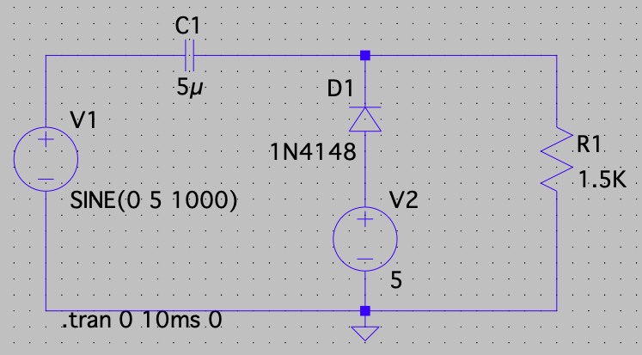

**For Negative Biased Clamper: -**

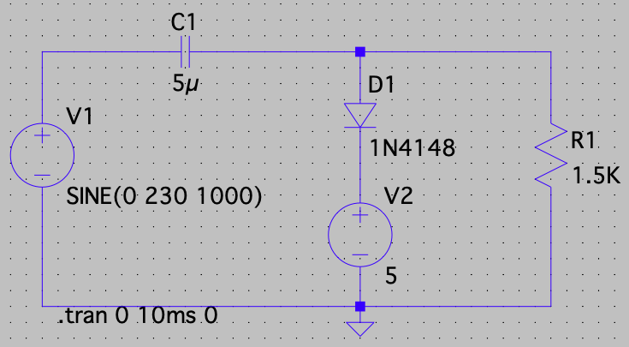

* **Simulation of positive and negative BIASED CLAMPERS-**

1. To do simulation click on the “Simulate” button and select “Edit Simulation Command”. Now, you will see a pop-up window. For the rectifier, we have to plot the waveform in the time domain. So, we are using transient analysis here.
2. Click on “Transient Analysis”. And a submenu will appear. In this only enter (trans. 0 10ms 0) and click ok. Then, click the “Run” button. Run button is available in the simulate icon on the title bar.
3. You will see the graphical window on your screen. In order to display both the input and output simultaneously in one plane, right click on the graphic plane and click on the “Add Plot” plane.
4. Then two plot planes will appear. For displaying the input and output, right click on the graphic plane and then click on the add traces. Here we need Vin and Vout.

**For Combined Clamper: -**

* **Draw the AC voltage source: -**

1. Input is connected into the main AC supply from the components menu. The normal ac input voltage is 230V and 1000 Hz.

Peak Voltage = VM

1. Construct this, click on the component icon in the LT Spice and select voltage source and Click Ok. Right-click on the voltage source, Click on the advanced button.
2. By clicking the advanced button a pop-up window will open. In this window, you will have multiple options to select. Examples “PULSE”, “SINE”, etc.
3. Here we need a “SINE” waveform and provide the values in the corresponding fields.
4. DC Offset = 0
5. Amplitude = 230
6. Frequency = 1000Hz
7. Use 2 other voltmeter and set it to 5v for Biasing .

* **Draw the Diode: -**

We need two diodes here. To do this, click on the diode button and position it on the required place on the screen. Right-click on the diode and click “Pick New diode” and select “1N4148 Silicon Diode”.

* **Draw the Resister: -**

1. To do this, click on the resister and position it on the required place on the screen. To give the value right click on the resister and type the value maybe 1k ohm.
2. Now, the last step is to label the input and output port. To do this click on the “label net” icon. If you want to label the input port, then type Vin and port type “input”.
3. Similarly, if you want to label the output port then type Vout and port type “output”. Then place the input and output label to the corresponding place on the screen.

* **Draw the Diode: -**

We need one diodes here. To do this, click on the diode button and position it on the required place on the screen. Right-click on the diode and click “Pick New diode” and select “1N4148 Silicon Diode”.

* **Draw the Capacitor: -**

To do this, click on the Capacitor and position it on the required place on the screen. To give the value right click on the resister and type the value maybe 5µF.

**Arrange your Circuit as given below: -**

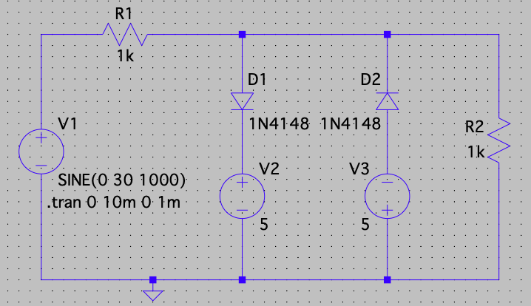

* **Simulation of Positive and Negative Biased Clampers: -**

1. To do simulation click on the “Simulate” button and select “Edit Simulation Command”. Now, you will see a pop-up window. For the rectifier, we have to plot the waveform in the time domain. So, we are using transient analysis here.
2. Click on “Transient Analysis”. And a submenu will appear. In this only enter (trans. 0 10ms 0) and click ok. Then, click the “Run” button. Run button is available in the simulate icon on the title bar.
3. You will see the graphical window on your screen. In order to display both the input and output simultaneously in one plane, right click on the graphic plane and click on the “add plot” plane.
4. Then two plot planes will appear. For displaying the input and output, right click on the graphic plane and then click on the add traces. Here we need Vin and Vout.

**VERIFICATION OF CLAMPER CIRCUIT**

**POSITIVE CLAMPER: -**

It is almost similar to the negative clamper circuit, but the diode is connected in the opposite direction. During the positive half cycle, the voltage across the output terminals becomes equal to the sum of the input voltage and capacitor voltage (considering the capacitor as initially fully charged).

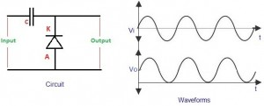

During the negative half cycle of the input, the diode starts conducting and charges the capacitor rapidly to its peak input value. Thus the waveforms are clamped towards the positive direction as shown above.

**Components Required: -**

* Diode
* Resistor
* Ground
* Voltage Source
* Wires
* Capacitors

**Logic Diagram: -**

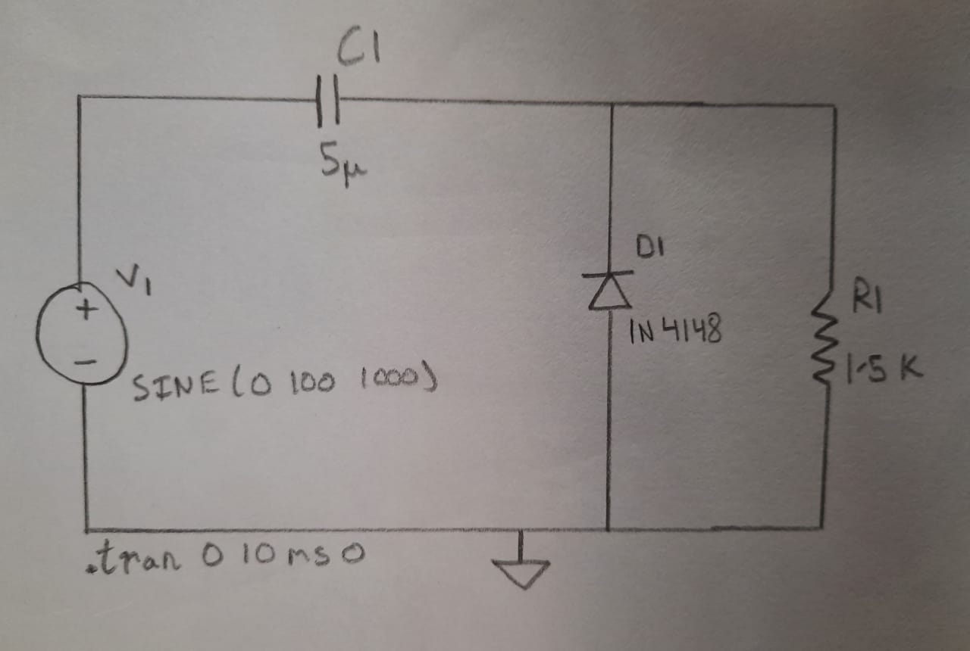

**Simulator Diagram - Schematic: -**



**Input Waveform: -**

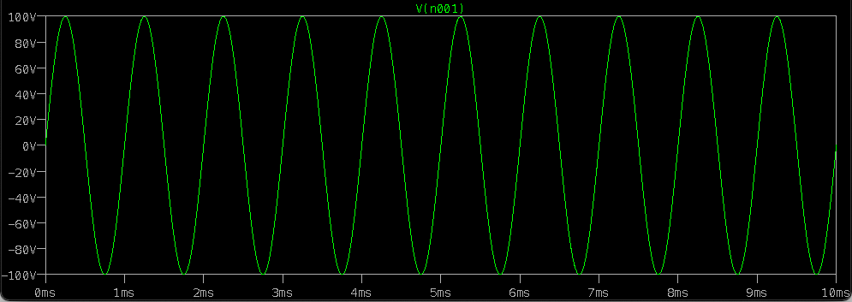

**Output Waveform: -**

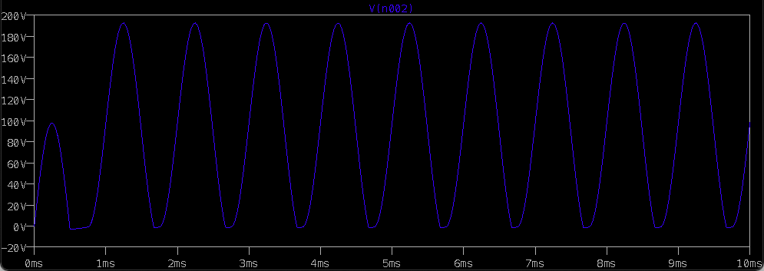

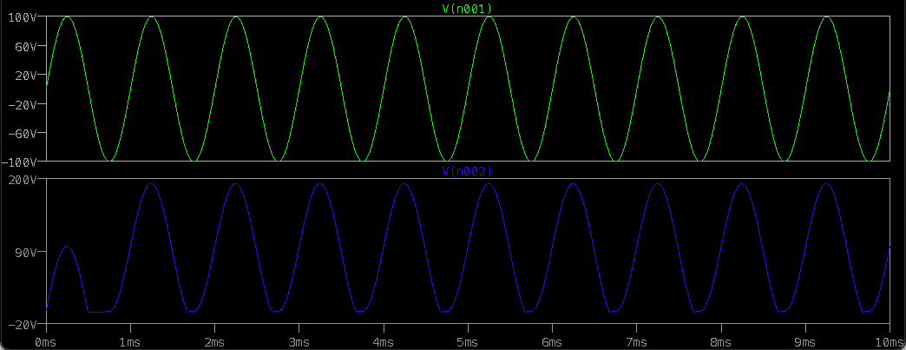

**Negative Clamper: -**

During the positive half cycle, the input diode is in forwarding bias- and as the diode conducts-capacitor gets charged (up to peak value of input supply). During the negative half-cycle, the reverse does not conduct and the output voltage becomes equal to the sum of the input voltage and the voltage stored across the capacitor.

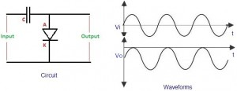

**Components Required: -**

* Diode
* Resistor
* Ground
* Voltage Source
* Wires
* Capacitors

**Logic Diagram: -**

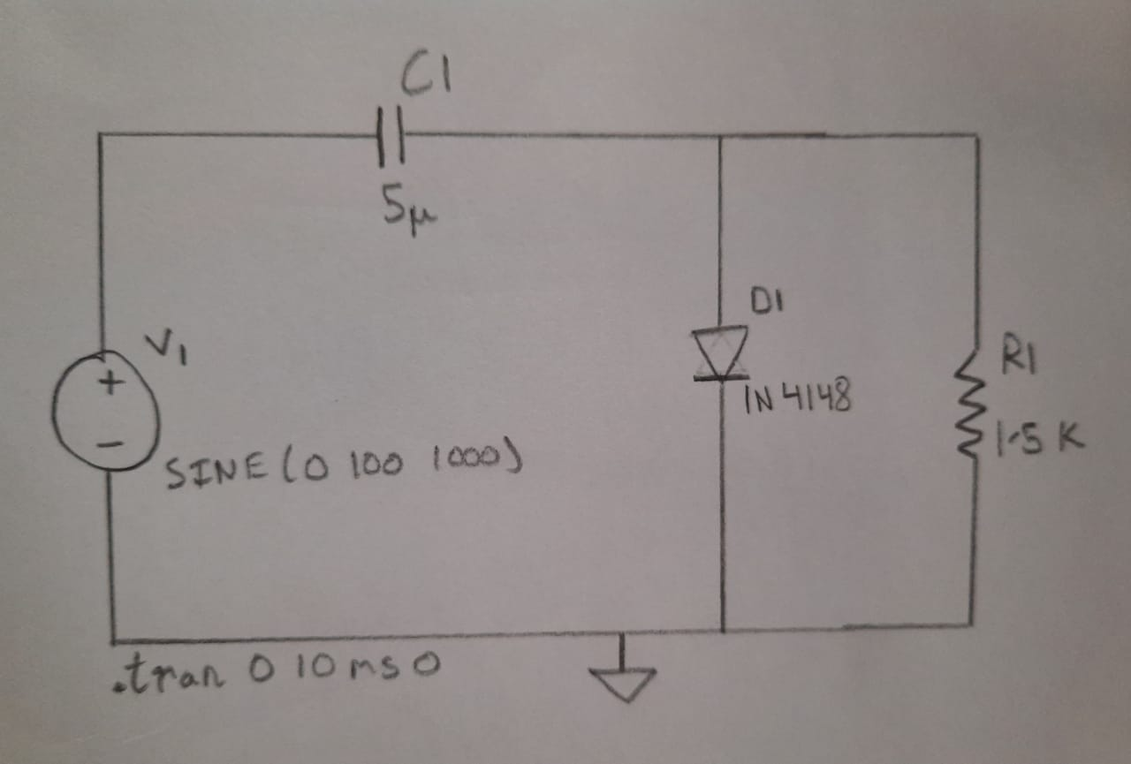

**Simulator Diagram – Schematic: -**



**Input Waveform: -**

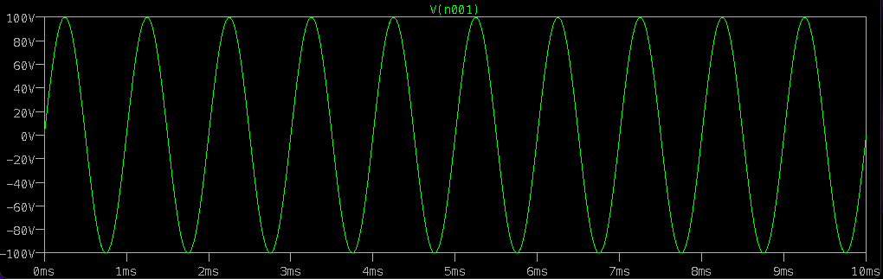

**Output Waveform: -**

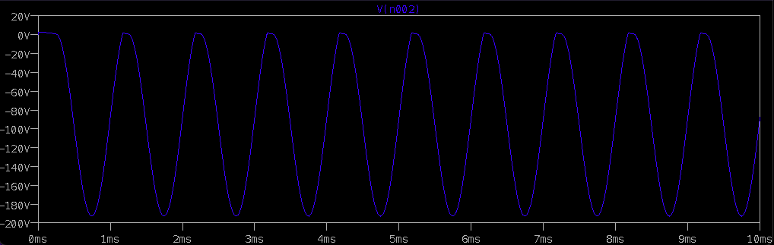

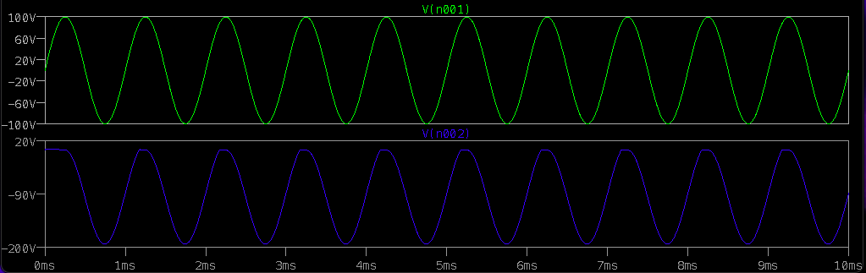

**Positive Biased Clamper: -**

A Positive clamper circuit if biased with some positive reference voltage, that voltage will be added to the output to raise the clamped level. Using this, the circuit of the positive clamper with positive reference voltage is constructed as below.



**Components Required: -**

* Diode
* Resistor
* Ground
* Voltage source
* Wires
* Capacitors

**Logic Diagram: -**

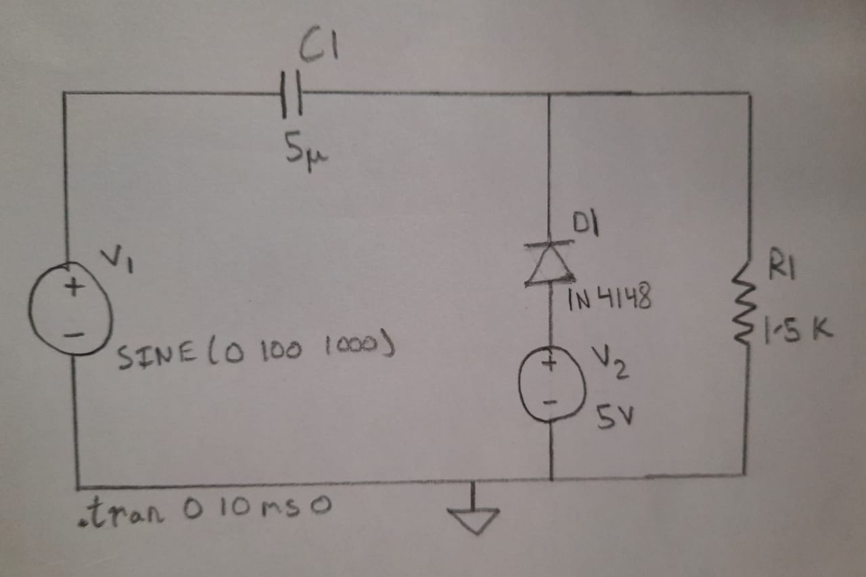

**Simulator Diagram – Schematic (with Positive Biasing): -**



**Input Waveform: -**

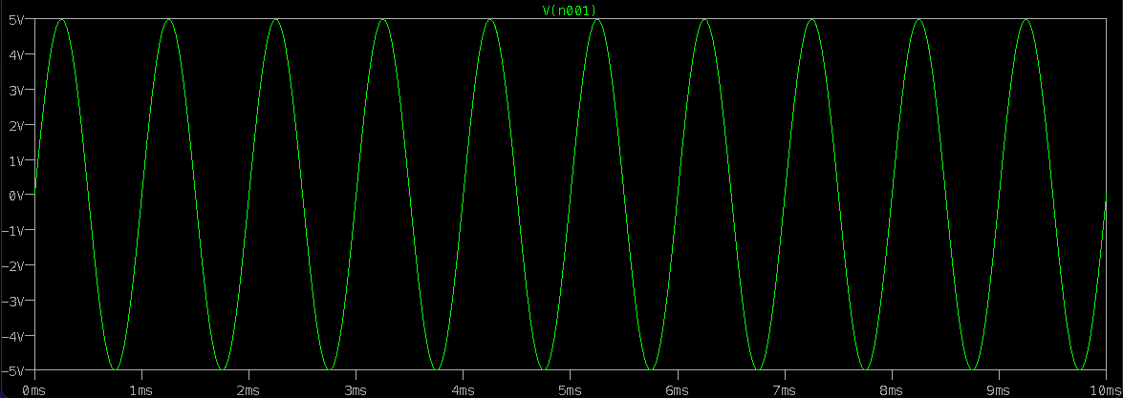

**Output Waveform: -**

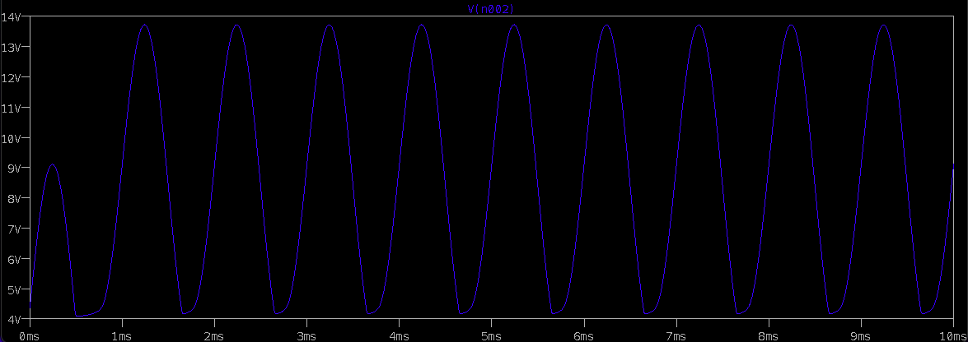

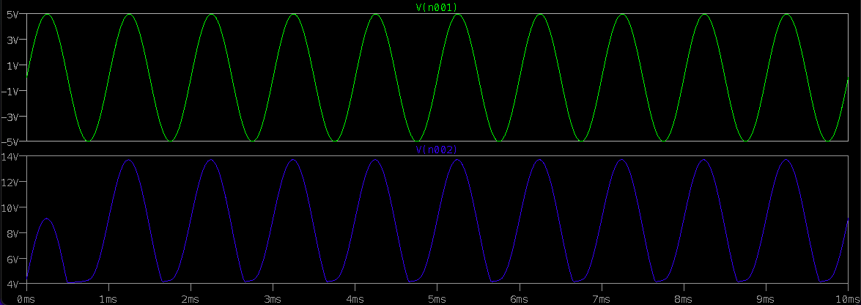

**Simulator Diagram – Schematic (with Negative Biasing): -**

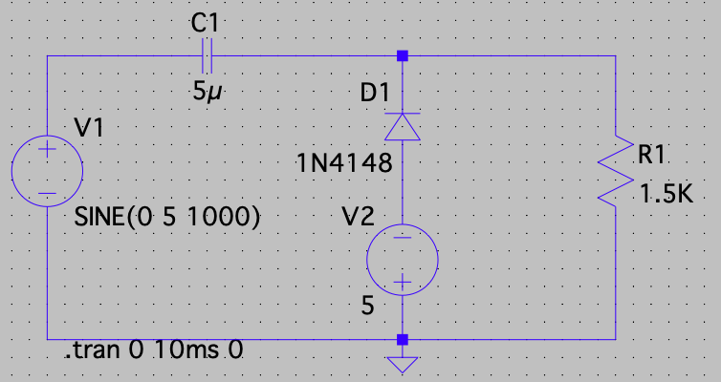

**Output Waveform: -**

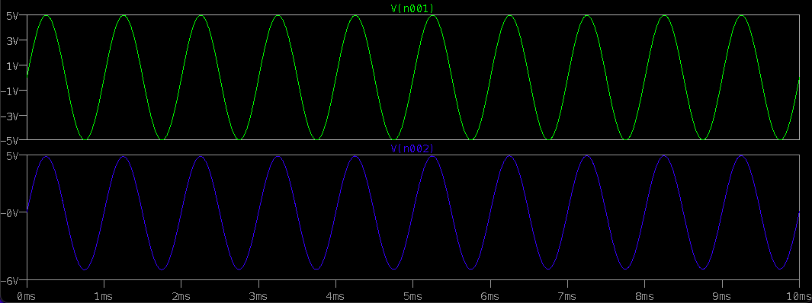

**Negative Biased Clamper: -**

A Negative clamper circuit if biased with some positive reference voltage, that voltage will be added to the output to raise the clamped level. Using this, the circuit of the negative clamper with positive reference voltage is constructed as below.



**Components Required: -**

* Diode
* Resistor
* Ground
* Voltage source
* Wires
* Capacitors

**Logic Diagram: -**

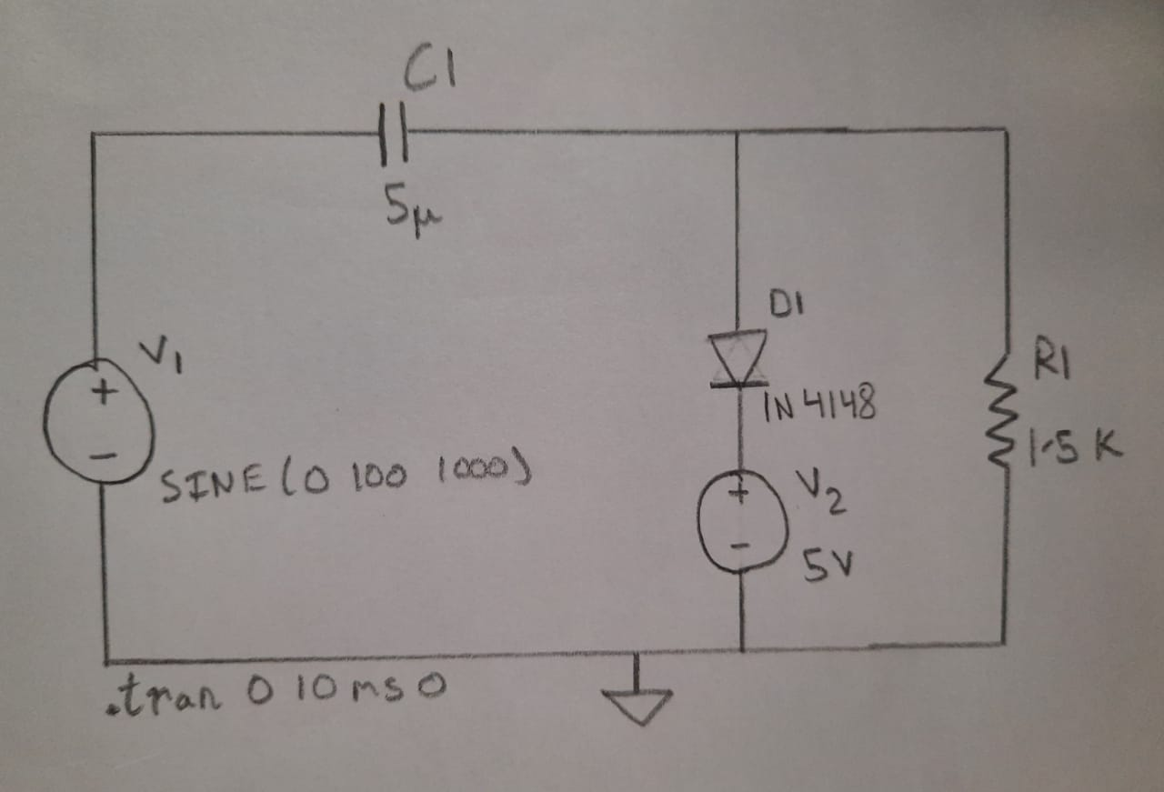

**Simulator Diagram – Schematic (with Positive Biasing): -**



**Input Waveform: -**

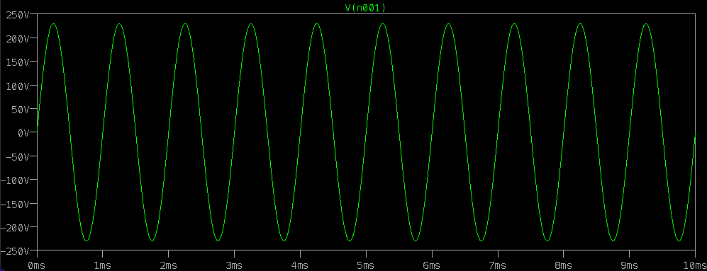

**Output Waveform: -**

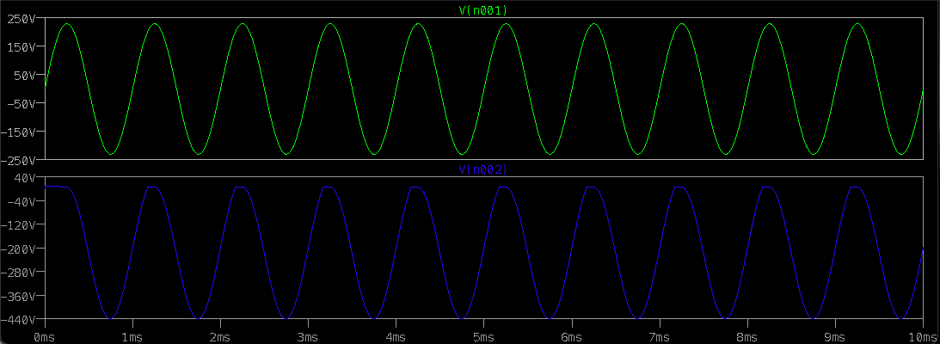

**Simulator Diagram – Schematic (with Negative Biasing): -**

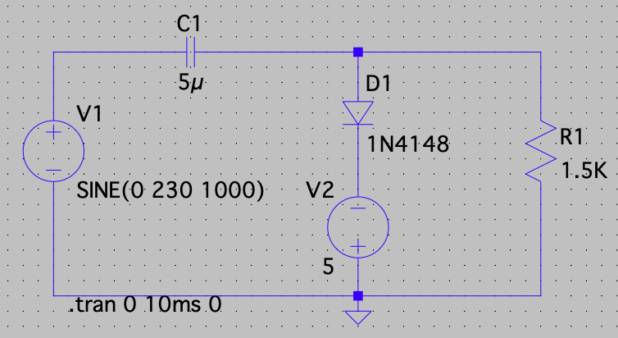

**Input Waveform: -**



**Output Waveform: -**

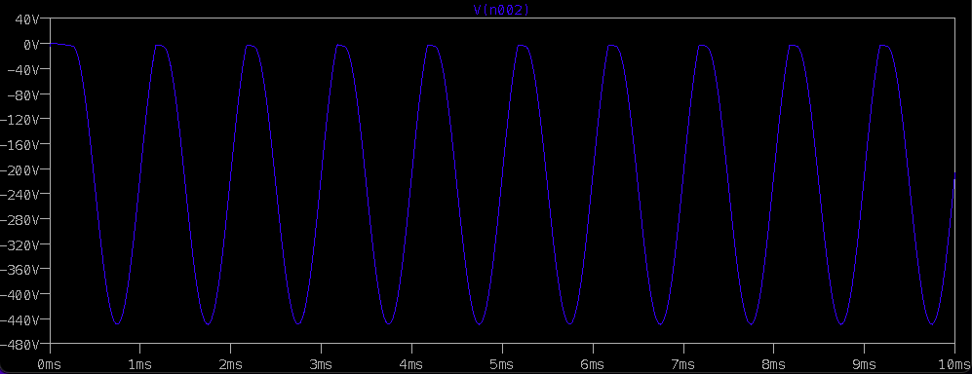

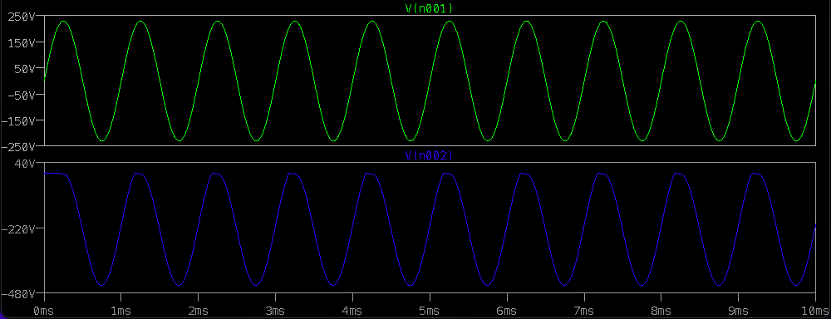

**Combined Biased Clamper: -**

When a portion of both positive and negative of each half cycle of the input voltage is to be clipped (or removed), combination clipper is employed. The circuit for such a clipper is given in the figure below.

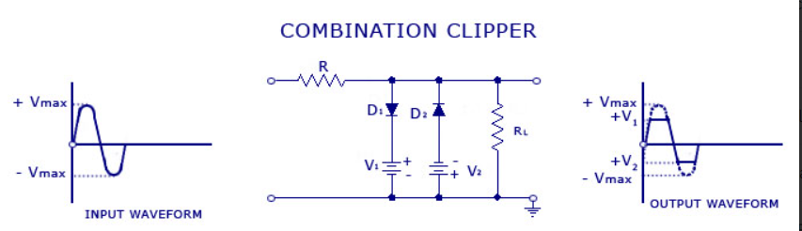

**Components Required: -**

* Diode
* Resistor
* Ground
* Voltage Source
* Wires
* Capacitors

**Logic Diagram: -**

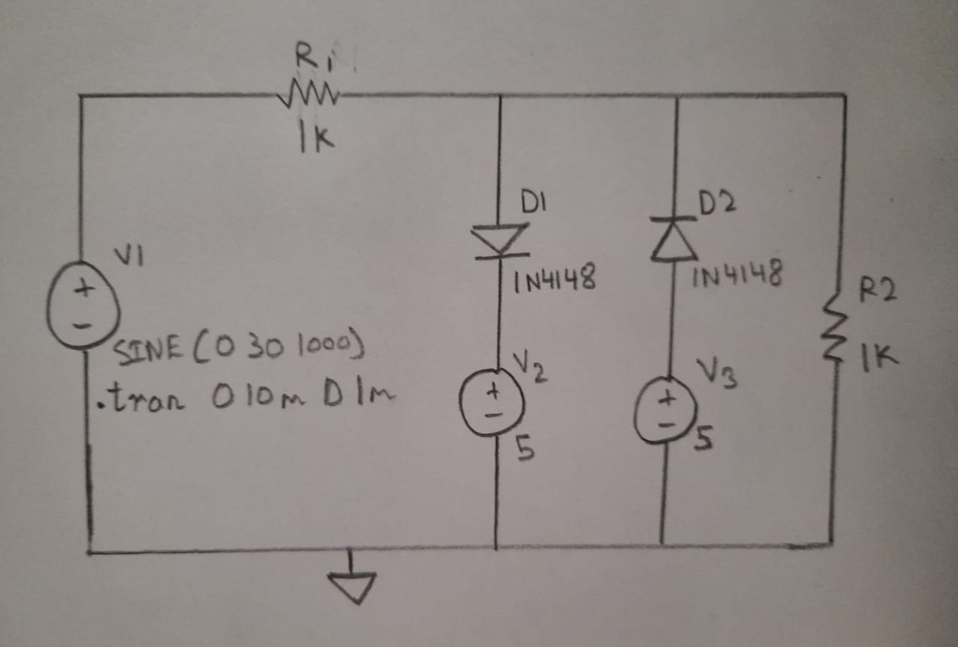

**Simulator Diagram – Schematic: -**



**Input Voltage Waveform: -**

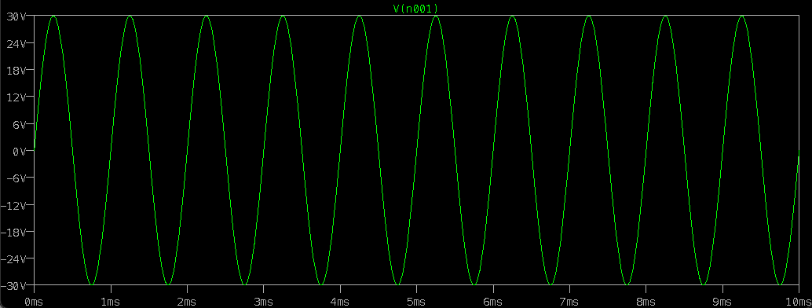

**Output Voltage Waveform: -**

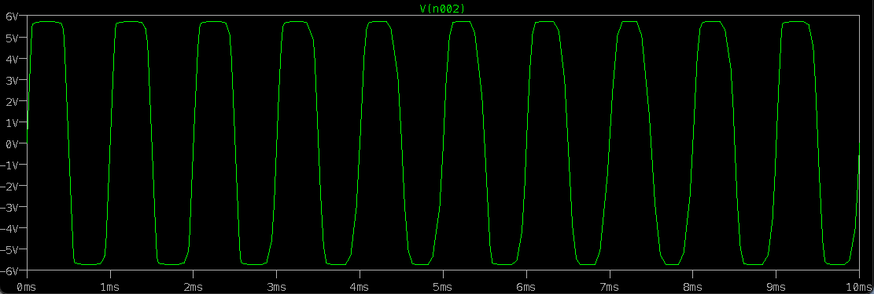

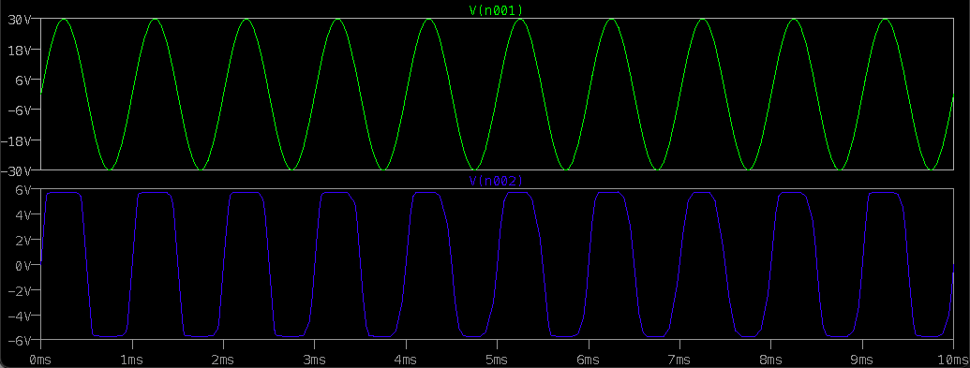

**INFERENCE**

**POSITIVE CLAMPER: -**



During Negative Half Cycle: -

During the negative half cycle of the input AC signal, the diode is forward biased and hence no signal appears at the output. In forward biased condition, the diode allows electric current through it. This current will flows to the capacitor and charges it to the peak value of input voltage VM. The capacitor charged in inverse polarity (positive) with the input voltage. As input current or voltage decreases after attaining its maximum value -VM, the capacitor holds the charge until the diode remains forward biased.

During Positive Half Cycle: -

During the positive half cycle of the input AC signal, the diode is reverse biased and hence the signal appears at the output. In reverse biased condition, the diode does not allow electric current through it. So the input current directly flows towards the output.

When the positive half cycle begins, the diode is in the non-conducting state and the charge stored in the capacitor is discharged (released). Therefore, the voltage appeared at the output is equal to the sum of the voltage stored in the capacitor (VM) and the input voltage (VM) (i.e. VO = VM + VM = 2VM) which have the same polarity with each other.

As a result, the signal shifted upwards. The peak to peak amplitude of the input signal is 2Vm, similarly the peak to peak amplitude of the output signal is also 2Vm. Therefore, the total swing of the output is same as the total swing of the input.

The basic difference between the clipper and clamper is that the clipper removes the unwanted portion of the input signal whereas the clamper moves the input signal upwards or downwards.

**NEGATIVE CLAMPER: -**



During Negative Half Cycle: -

During the negative half cycle of the input AC signal, the diode is reverse biased and hence the signal appears at the output. In reverse biased condition, the diode does not allow electric current through it. So the input current directly flows towards the output.

When the negative half cycle begins, the diode is in the non-conducting state and the charge stored in the capacitor is discharged (released). Therefore, the voltage appeared at the output is equal to the sum of the voltage stored in the capacitor (-VM) and the input voltage (-VM) (i.e. VO = -VM - VM = -2VM) which have the same polarity with each other. As a result, the signal shifted downwards.

**Positive Biased Clamper: -**

Positive Clamper with Positive Voltage Inference: -

During positive half cycle: -

The battery voltage forward biases the diode when the input supply voltage is less than the battery voltage. This current or voltage will flows to the capacitor and charges it.

When the input supply voltage becomes greater than the battery voltage then the diode stops allowing electric current through it because the diode becomes reverse biased.

During negative half cycle: -

The diode is forward biased by both input supply voltage and battery voltage. So the diode allows electric current. This current will flows to the capacitor and charges it.

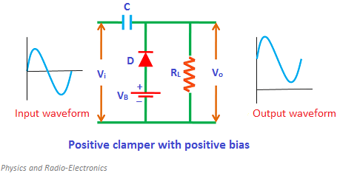

**Biased Negative Clamper: -**

During Positive Half Cycle: -

During the positive half cycle, the battery voltage reverse biases the diode when the input supply voltage is less than the battery voltage. When the input supply voltage becomes greater than the battery voltage, the diode is forward biased by the input supply voltage and hence allows electric current through it. This current will flows to the capacitor and charges it.

During Negative Half Cycle: -

During the negative half cycle, the diode is reverse biased by both input supply voltage and battery voltage. As a result, the signal appears at the output.

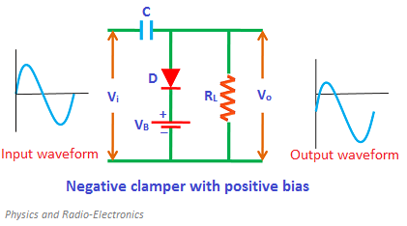

**Combination Clamper: -**

Positive Half Cycle: In this cycle, cathode of first diode D1 is maintained at +VDC1 and its anode observes a variable positive voltage. Similarly anode of diode D2 is maintained at -VDC2 and its cathode observes a variable positive voltage. The diode D2 will be completely reverse biased during the whole positive half cycle.

* When Vin < VDC1 + VD1 – Diodes D1 &D2 are reverse biased.

Output voltage (VO) = Vin Volts.

* When Vin > VDC1 + VD1 – Diode D1 will be forward biased and D2 will be reverse biased, Output voltage (VO) = (VDC1 + VD1) Volts

Negative Half Cycle: In this cycle, cathode of diode D1 is maintained at +VDC1 and its anode observes a variable negative voltage. Similarly anode of diode D2 is maintained at -VDC2 and its cathode observes a variable negative voltage. The diode D1 will be completely reverse biased during the whole negative half cycle.

* When Vin < VDC2 + VD2 – Diodes D1 &D2 are reverse biased.

Output voltage (VO) = Vin Volts.

* When Vin > VDC2 + VD2 – Diode D2 will be forward biased and D1 will be reverse biased, Output voltage (VO) = (-VDC2 - VD2) Volts

In this two side clipping circuit, both the positive and negative clipping levels can be varied independently. This type of circuit is called as Parallel based Clipper. It uses two diodes and two voltage sources connected in opposite directions.

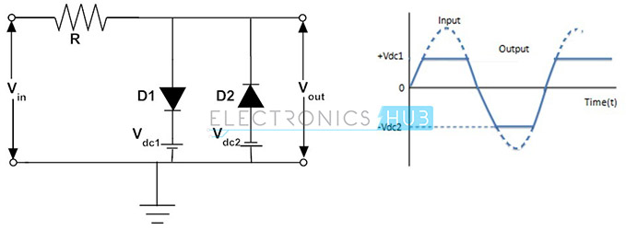

**RESULT:**

**THE CLAMPER CIRCUITS FOR POSITVE, NEGATIVE, POSITIVE BIASED, NEGATIVE BIASED AND COMBINITION CIRCUIT ARE VERIFIED WITH THEIR RESPECTIVE INPUT AND OUTPUT WAVEFORM CHARACTERSTICS.**