|  |  |  |  |
| --- | --- | --- | --- |
| **Course Code:** | **ECE1002** | **Course Name:** | **Semiconductor Devices and Circuits Lab** |
| **Faculty In – Charge:** | **Dr. Pradeep Naryanan. S.** | **Department:** | **SENSE** |
| **Name of the Student:** | **Aryan Pandey** | **Registration Number:** | **20BLC1087** |
| **Experiment No.:** | **5** | **Date of Experiment:** | **12.04.2021** |
| **Name of the Experiment:** | **DESIGN AND VERIFICATION OF CLIPPER CIRCUIT** | | |

**OBJECTIVE:**

To design and verify the function of the Clipper circuit using LTSPICE Simulator and observe its characteristics.

**TOOLS:**

LTSPICE XVII Simulator.

**THEORY**

**POSITIVE CLIPPER: -**

**Positive Series Clipper: -**

A Clipper circuit in which the diode is connected in series to the input signal and that attenuates the positive portions of the waveform, is termed as Positive Series Clipper.

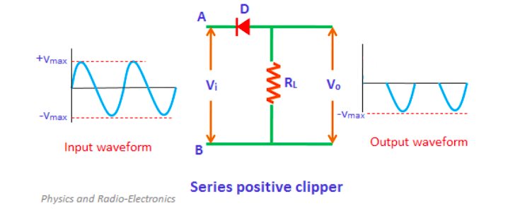

Positive Cycle of the Input − When the input voltage is applied, the positive cycle of the input makes the point A in the circuit positive with respect to the point B. This makes the diode reverse biased and hence it behaves like an open switch. Thus the voltage across the load resistor becomes zero as no current flows through it and hence VO will be zero.

Negative Cycle of the Input − The negative cycle of the input makes the point A in the circuit negative with respect to the point B. This makes the diode forward biased and hence it conducts like a closed switch. Thus the voltage across the load resistor will be equal to the applied input voltage as it completely appears at the output VO.

**NEGATIVE CLIPPER: -**

**Negative Series Clipper: -**

A Clipper circuit in which the diode is connected in series to the input signal and that attenuates the negative portions of the waveform, is termed as Negative Series Clipper. The following figure represents the circuit diagram for negative series clipper.

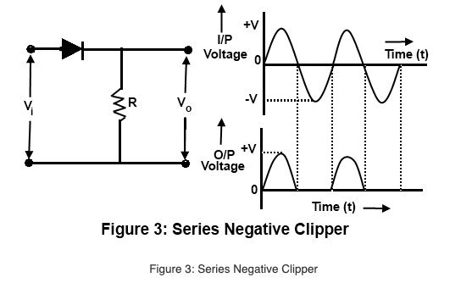

Positive Cycle of the Input − When the input voltage is applied, the positive cycle of the input makes the point A in the circuit positive with respect to the point B. This makes the diode forward biased and hence it acts like a closed switch. Thus the input voltage completely appears across the load resistor to produce the output VO.

Negative Cycle of the Input − The negative cycle of the input makes the point A in the circuit negative with respect to the point B. This makes the diode reverse biased and hence it acts like an open switch. Thus the voltage across the load resistor will be zero making VO zero.

**BIASED POSITIVE CLIPPER: -**

**Positive Series Clipper with Positive VR: -**

A Clipper circuit in which the diode is connected in series to the input signal and biased with positive reference voltage VR and that attenuates the positive portions of the waveform, is termed as Positive Series Clipper with positive VR. The following figure represents the circuit diagram for positive series clipper when the reference voltage applied is positive.

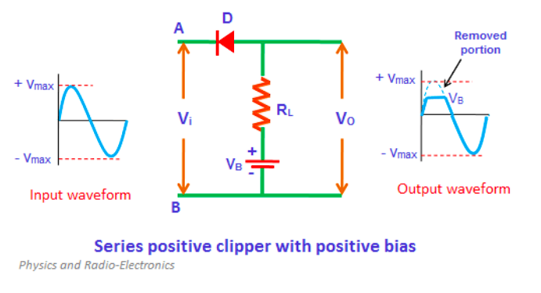

During the positive cycle of the input the diode gets reverse biased and the reference voltage appears at the output. During its negative cycle, the diode gets forward biased and conducts like a closed switch. Hence the output waveform appears as shown in the above figure.

**Positive Series Clipper with Negative VR: -**

A Clipper circuit in which the diode is connected in series to the input signal and biased with negative reference voltage VR and that attenuates the positive portions of the waveform, is termed as Positive Series Clipper with negative VR. The following figure represents the circuit diagram for positive series clipper, when the reference voltage applied is negative.

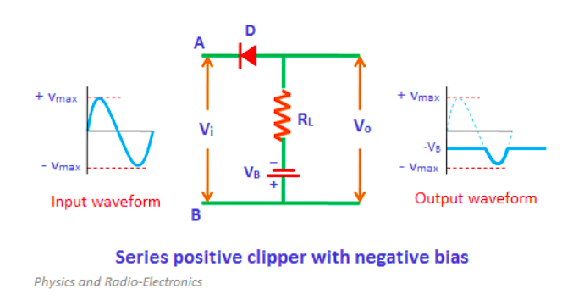

**BIASED NEGATIVE CLIPPER: -**

**Negative Bias Diode Clipping: -**

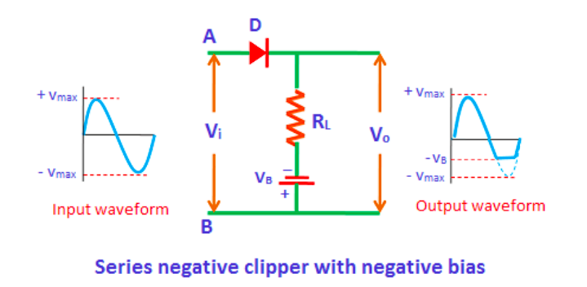

A variable diode clipping or diode limiting level can be achieved by varying the bias voltage of the diodes. If both the positive and the negative half cycles are to be clipped, then two biased clipping diodes are used. But for both positive and negative diode clipping, the bias voltage need not be the same.

**COMBINED BIASED CLIPPER: -**

When a portion of both positive and negative of each half cycle of the input voltage is to be clipped (or removed), combination clipper is employed. The circuit for such a clipper is given in the figure below.

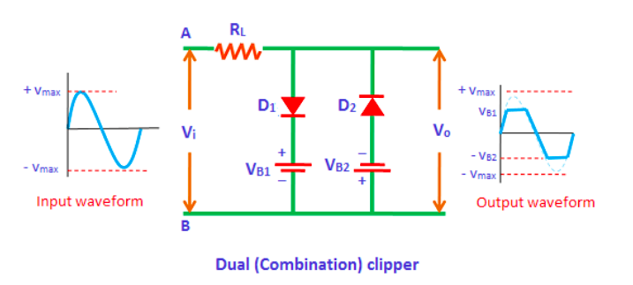

The action of the circuit is summarized below. For positive input voltage signal when input voltage exceeds battery voltage “+V1” diode D1 conducts heavily while diode D2 is reversed biased and so voltage “+ V1” appears across the output. This output voltage “+ V1” stays as long as. the input signal voltage exceeds “+V1”. On the other hand for the negative input voltage signal, the diode “D1” remains reverse biased and diode “D2” conducts heavily only when input voltage exceeds battery voltage “V2” in magnitude. Thus during the negative half cycle the output stays at “-V2” so long as the input signal voltage is greater than “-V2”.

**PROCEDURE**

**For Positive and Negative Series Clippers:-**

* **Draw the AC voltage source: -**

1. The main AC supply from the components menu is connected to the input. The normal AC input voltage is 10V and 1000 Hz. Click on the component icon in the LT Spice and select voltage source. Right-click on the voltage source, Click on the advanced button.
2. By clicking the advanced button a pop-up window will open. In this window, you will have multiple options to select. Examples “PULSE”, “SINE”, etc.
3. Here we need a “SINE” waveform and provide the values in the corresponding fields.
4. DC offset= 0
5. Amplitude = 10
6. Frequency = 1000Hz

* **Draw the Diode: -**

We need one diodes here. To do this, click on the diode button and position it on the required place on the screen. Right-click on the diode and click “Pick New Diode” and select “1N4148 Silicon Diode”.

* **Draw the Resister: -**

1. To do this, click on the resister and position it on the required place on the screen. To give the value right click on the resister and type the value maybe 1k ohm.
2. Now, the last step is to label the input and output port. To do this click on the “label net” icon. If you want to label the input port, then type Vin and port type “input”. Similarly, if you want to label the output port then type Vout and port type “output”. Then place the input and output label to the corresponding place on the screen.

**For Positive Series Clipper: -**

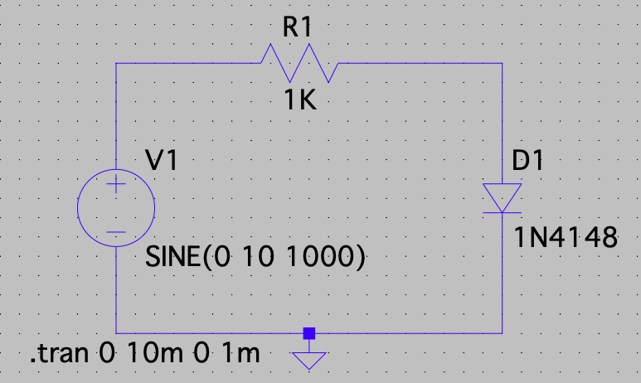

**For Negative Clipper Arrange your Circuit: -**

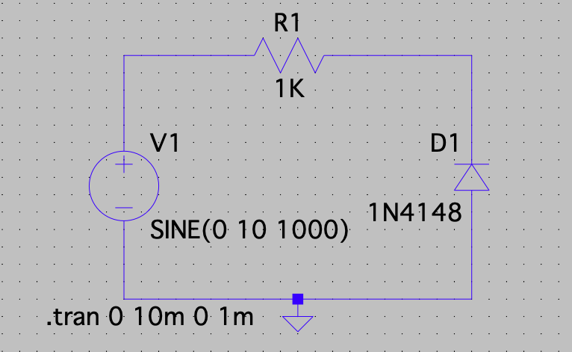

* **Simulation of Positive and Negative Clipper Series: -**

1. To do simulation click on the “Simulate” button and select “Edit Simulation Command”. Now, you will see a pop-up window. For the rectifier, we have to plot the waveform in the time domain. So, we are using transient analysis here.
2. Click on “Transient Analysis”. And a submenu will appear. In this only enter (trans. 0 10m 0 1m) and click ok. Then, click the “Run” button. Run button is available in the simulate icon on the title bar.
3. You will see the graphical window on your screen. In order to display both the input and output simultaneously in one plane, right click on the graphic plane and click on the “add plot” plane.
4. Then two plot planes will appear. For displaying the input and output, right click on the graphic plane and then click on the add traces. Here we need Vin and Vout.

**For Positive and Negative Biased Clipper: -**

**For Positive and Negative Series Biased Clipper: -**

* **Draw the AC voltage source: -**

1. The main AC supply from the components menu is input. The normal AC input voltage is 10V and 1000 Hz. Click on the component icon in the LT Spice and select voltage source. Right-click on the voltage source, Click on the advanced button.
2. By clicking the advanced button a pop-up window will open. In this window, you will have multiple options to select. Examples “PULSE”, “SINE”, etc.
3. Here we need a “SINE” waveform and provide the values in the corresponding fields.
4. DC offset= 0
5. Amplitude = 10
6. Frequency = 1000Hz

* **Draw the Diode: -**

We need one diodes here. To do this, click on the diode button and position it on the required place on the screen. Right-click on the diode and click “Pick New diode” and select “1N4148 Silicon Diode”.

* **Draw the Resister: -**

1. To do this, click on the resister and position it on the required place on the screen. To give the value right click on the resister and type the value maybe 1k ohm.
2. Now, the last step is to label the input and output port. To do this click on the “label net” icon. If you want to label the input port, then type Vin and port type “input”. Similarly, if you want to label the output port then type Vout and port type “output”. Then place the input and output label to the corresponding place on the screen.

**For Positive Series Clipper Biased: -**

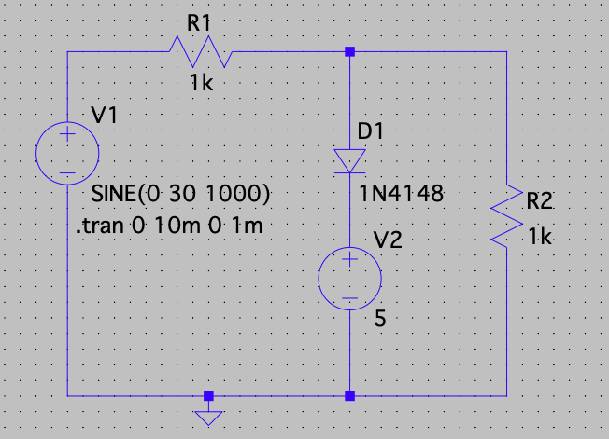

**For Negative Clipper Biased arrange your Circuit: -**

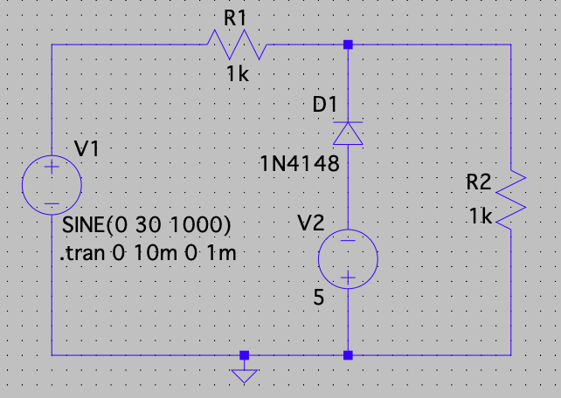

* **Simulation of Positive and Negative Clipper Series: -**

1. To do simulation click on the “Simulate” button and select “Edit Simulation Command”. Now, you will see a pop-up window. For the rectifier, we have to plot the waveform in the time domain. So, we are using transient analysis here.
2. Click on “Transient Analysis”. And a submenu will appear. In this only enter (trans. 0 10m 0 1m) and click ok. Then, click the “Run” button. Run button is available in the simulate icon on the title bar.
3. You will see the graphical window on your screen. In order to display both the input and output simultaneously in one plane, right click on the graphic plane and click on the “add plot” plane.
4. Then two plot planes will appear. For displaying the input and output, right click on the graphic plane and then click on the add traces. Here we need Vin and Vout.

**For Combined Biased Clipper: -**

**For Positive and Negative Series Biased Clipper: -**

* **Draw the AC voltage source: -**

1. Input is connected into the main AC supply from the components menu. The normal ac input voltage is 10V and 1000 Hz. Construct this, click on the component icon in the LT Spice and select voltage source and Click Ok. Right-click on the voltage source, Click on the advanced button.
2. By clicking the advanced button a pop-up window will open. In this window, you will have multiple options to select. Examples “PULSE”, “SINE”, etc.
3. Here we need a “SINE” waveform and provide the values in the corresponding fields.
4. DC offset= 0
5. Amplitude = 10
6. Frequency = 1000Hz

* **Draw the Diode: -**

We need two diodes here. To do this, click on the diode button and position it on the required place on the screen. Right-click on the diode and click “Pick New diode” and select “1N4148 Silicon Diode”.

Both should be arranged in a proper way with positive biased one and the other negative biased.

* **Draw the Resister: -**

1. To do this, click on the resister ( 2 resisters) and position it on the required place on the screen. To give the value right click on the resister and type the value maybe 1k ohm.
2. Now, the last step is to label the input and output port. To do this click on the “label net” icon. If you want to label the input port, then type Vin and port type “input”. Similarly, if you want to label the output port then type Vout and port type “output”. Then place the input and output label to the corresponding place on the screen.

**For positive series clipper biased: -**

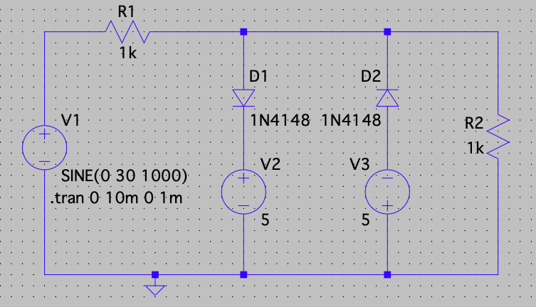

* **Simulation of positive and negative clipper biased in series-**

1. To do simulation click on the “Simulate” button and select “Edit Simulation Command”. Now, you will see a pop-up window. For the rectifier, we have to plot the waveform in the time domain. So, we are using transient analysis here.
2. Click on “Transient Analysis”. And a submenu will appear. In this only enter (trans. 0 10m 0 1m) and click ok. Then, click the “Run” button. Run button is available in the simulate icon on the title bar.
3. You will see the graphical window on your screen. In order to display both the input and output simultaneously in one plane, right click on the graphic plane and click on the “add plot” plane.
4. Then two plot planes will appear. For displaying the input and output, right click on the graphic plane and then click on the add traces. Here we need Vin and Vout.

**VERIFICATION OF CLIPPER CIRCUIT**

1. **POSITIVE CLIPPER: -**

A Clipper circuit in which the diode is connected in series to the input signal and that attenuates the positive portions of the waveform, is termed as Positive Series Clipper. The following figure represents the circuit diagram for positive series clipper.

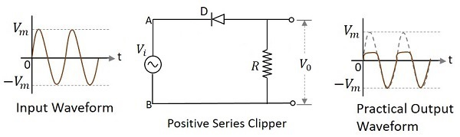

**Components Required: -**

* + Resister
  + Voltage source
  + Diodes
  + Wires
  + Ground

**Logic Diagram: -**

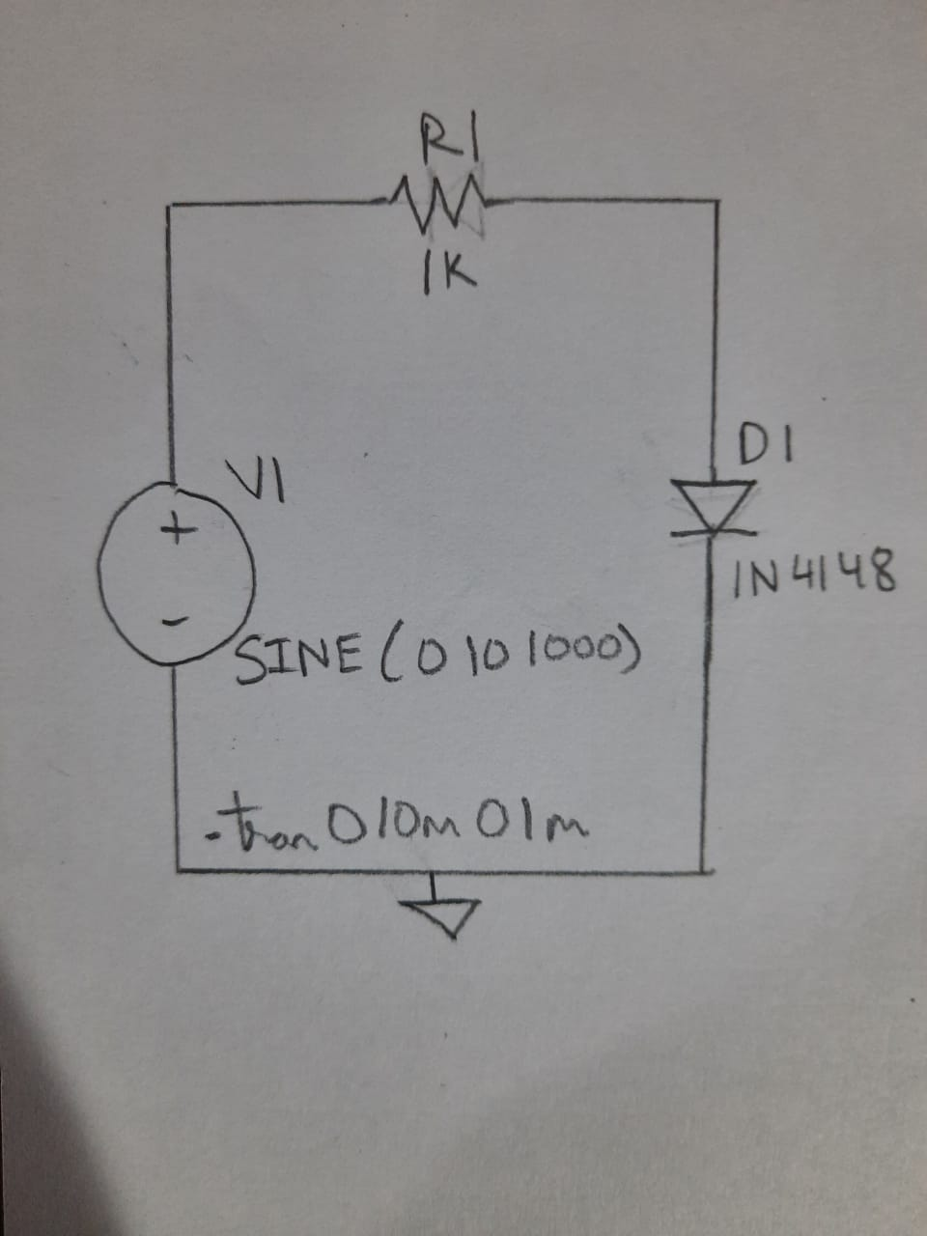

**Simulator Diagram - Schematic: -**



**Input Waveform: -**

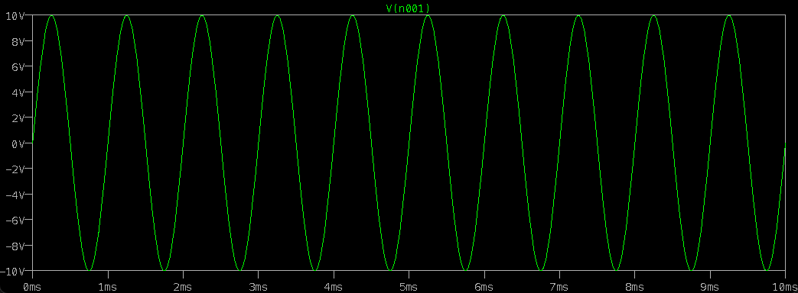

**Output waveform:**

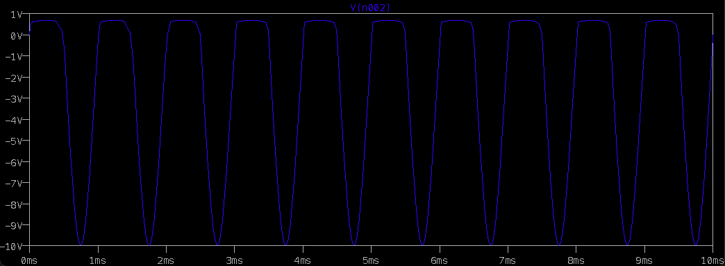

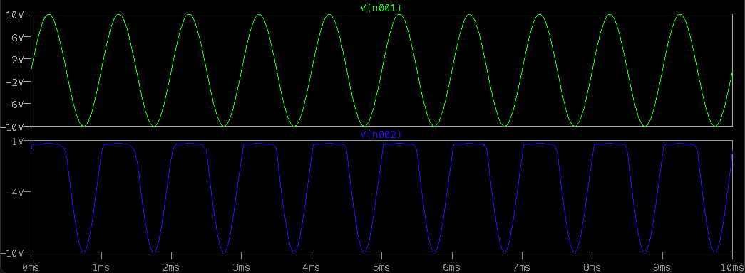

1. **NEGATIVE CLIPPER: -**

## **Negative Series Clipper: -**

A Clipper circuit in which the diode is connected in series to the input signal and that attenuates the negative portions of the waveform, is termed as Negative Series Clipper. The following figure represents the circuit diagram for negative series clipper.

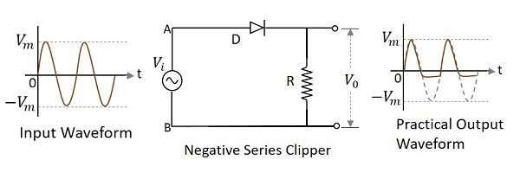

**Components Required: -**

* Resister
* Voltage Source
* Diodes
* Wires
* Ground

**Logic Diagram: -**

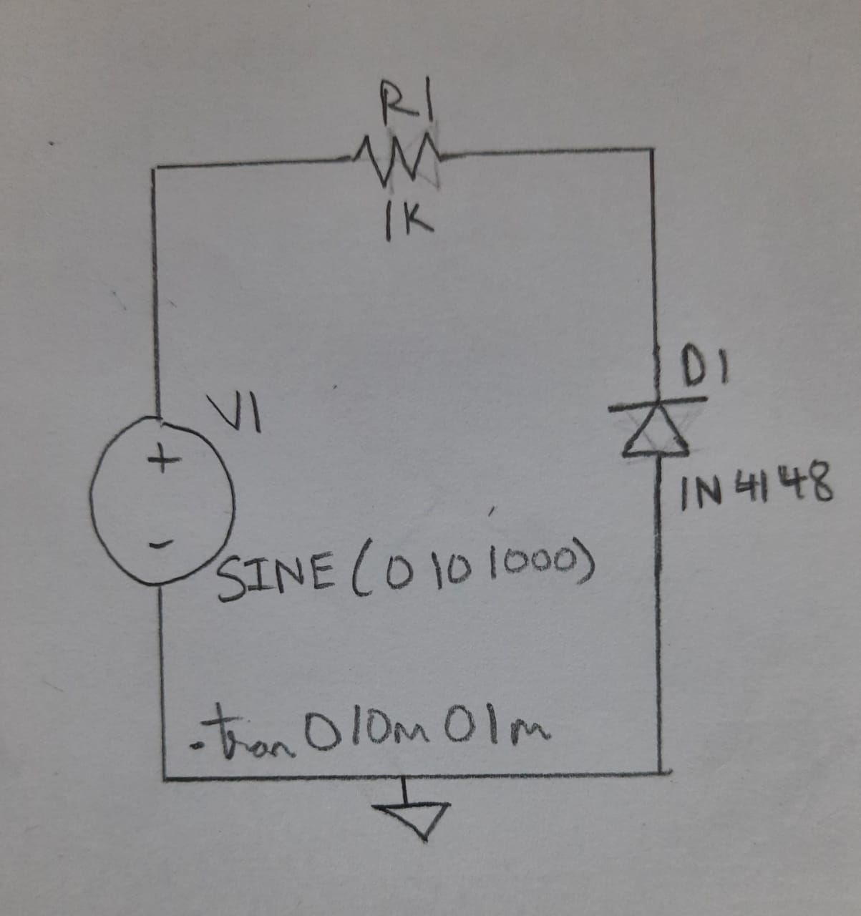

**Simulator Diagram – Schematic: -**



**Input Wave Form: -**

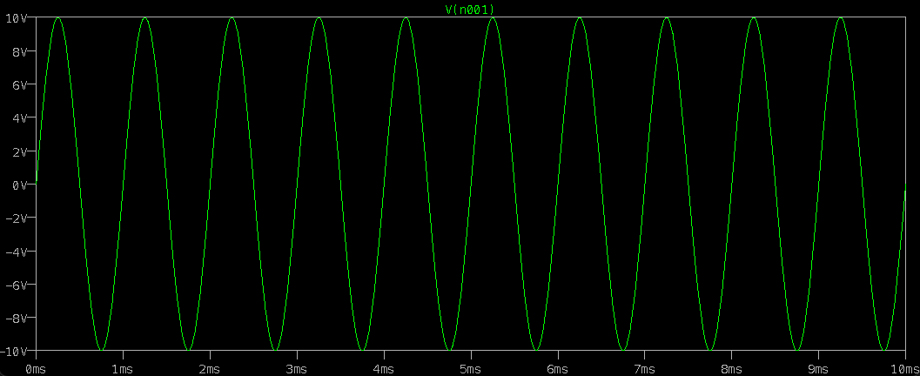

**Output Waveform: -**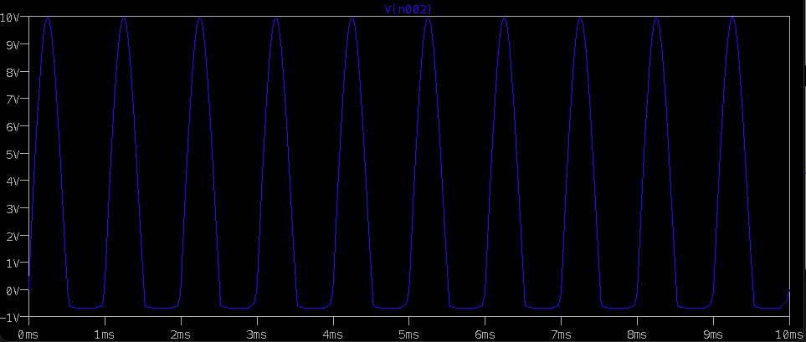

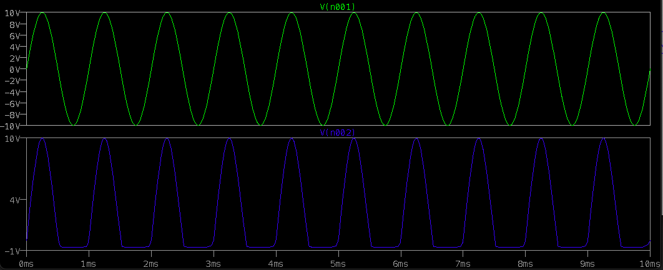

**(III) BIASED POSITIVE CLIPPER: -**

Positive Series Clipper with positive VR. The following figure represents the circuit diagram for positive series clipper when the reference voltage applied is positive.

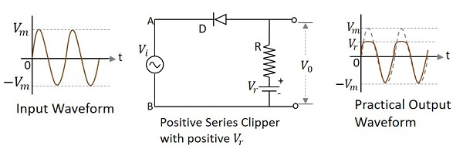

During the positive cycle of the input the diode gets reverse biased and the reference voltage appears at the output. During its negative cycle, the diode gets forward biased and conducts like a closed switch. Hence the output waveform appears as shown in the above figure.

**Positive Series Clipper with negative VR: -**

A Clipper circuit in which the diode is connected in series to the input signal and biased with negative reference voltage VR and that attenuates the positive portions of the waveform, is termed as Positive Series Clipper with negative VR. The following figure represents the circuit diagram for positive series clipper, when the reference voltage applied is negative.

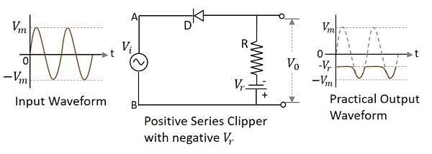

**Components Required: -**

* Resister
* Voltage source
* Diodes
* Wires
* Ground

**Logic Diagram: -**

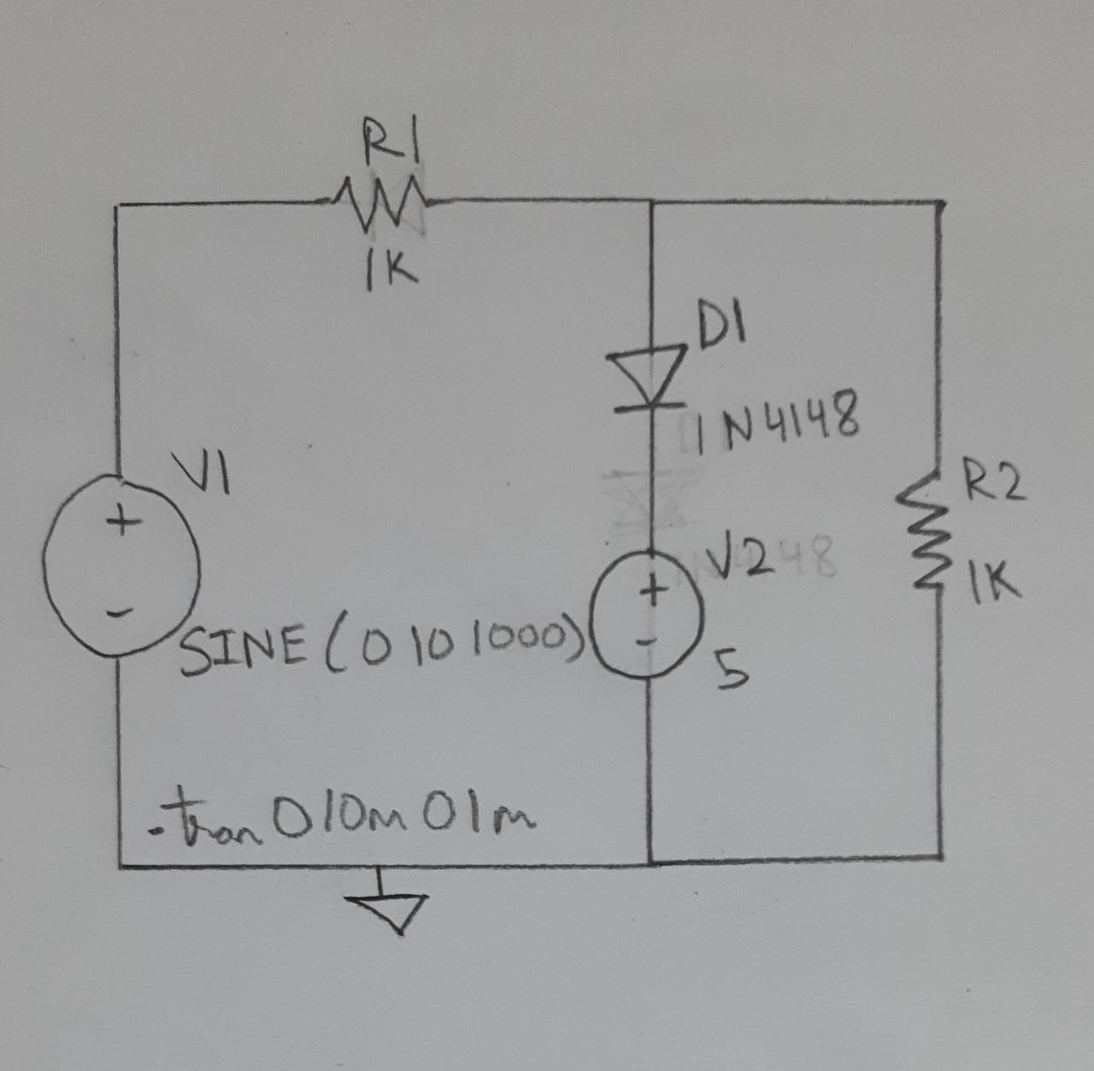

**Simulator Diagram - Schematic: -**



**Input Waveform: -**

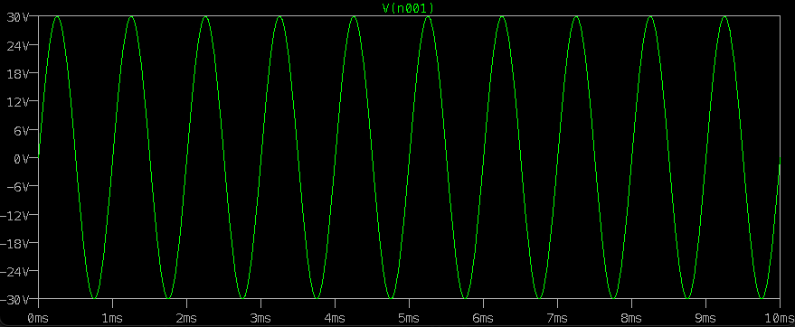

**Output waveform:**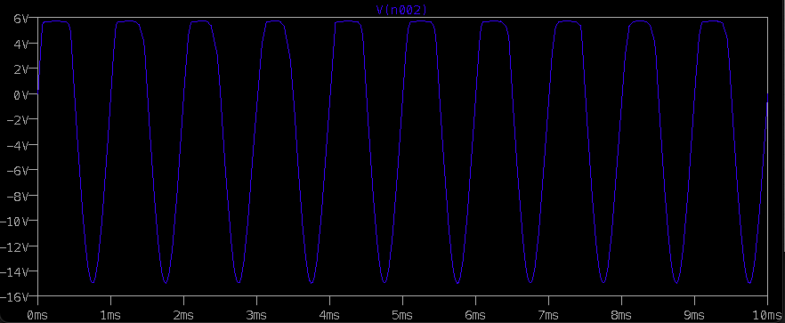

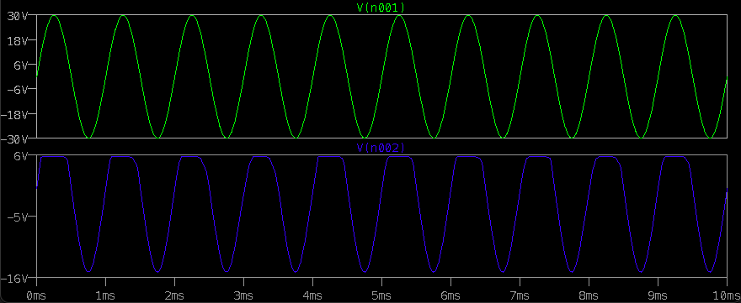

**(IV) BIASED NEGATIVE CLIPPER: -**

## **Series negative clipper: -**

In series negative clipper, the negative half cycles of the input AC signal is removed at the output. The circuit construction of the series negative clipper is shown in the figure.

If the diode is arranged in such a way that the arrowhead of the diode points towards the output and the diode is in series with the output load resistance, then the clipper is said to be a series negative clipper. In simple words, in a series negative clipper, the diode is connected in a direction opposite to that of the series positive clipper.

The vertical line in the diode symbol represents the cathode (n-side) and the opposite end represents the anode (p-side).

**During Positive Half Cycle: -**

During the positive half cycle, terminal A is positive and terminal B is negative. That means the positive terminal A is connected to p-side and the negative terminal B is connected to n-side of the diode. As we already know that if the positive terminal is connected to p-side and the negative terminal is connected to n-side then the diode is said to be forward biased. Therefore, the diode D is forward biased during the positive half cycle.

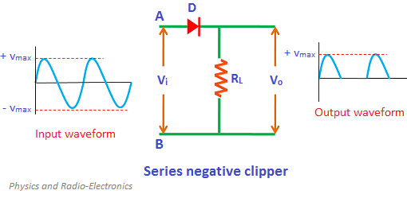

During forward biased condition, electric current flows through the diode. So the positive half cycle is allowed at the output. Therefore, a series of positive half cycles appears at the output.

**Components Required: -**

* Resister
* Voltage source
* Diodes
* Wires
* Ground

**Logic Diagram: -**

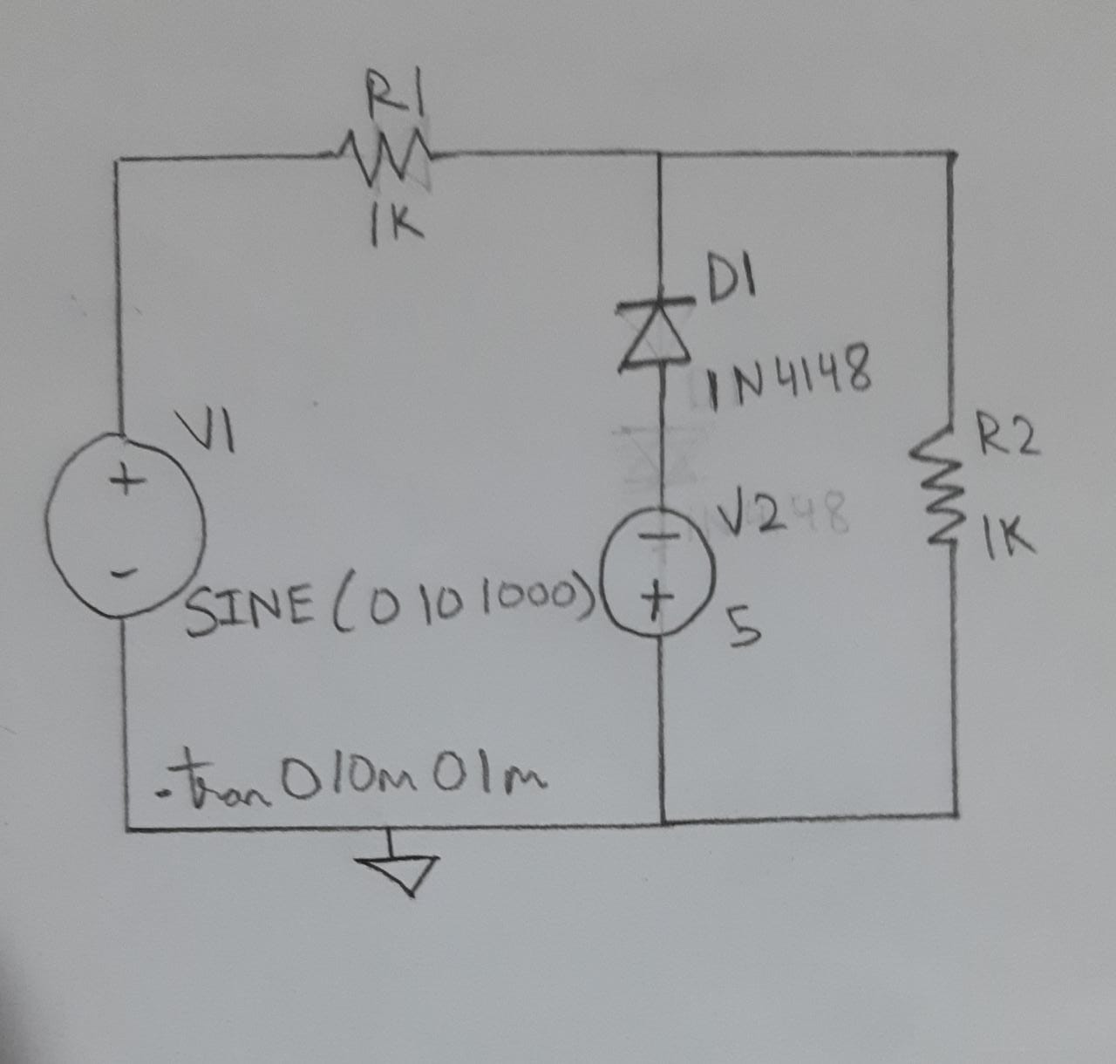

**Simulator Diagram - Schematic: -**



**Input Waveform: -**

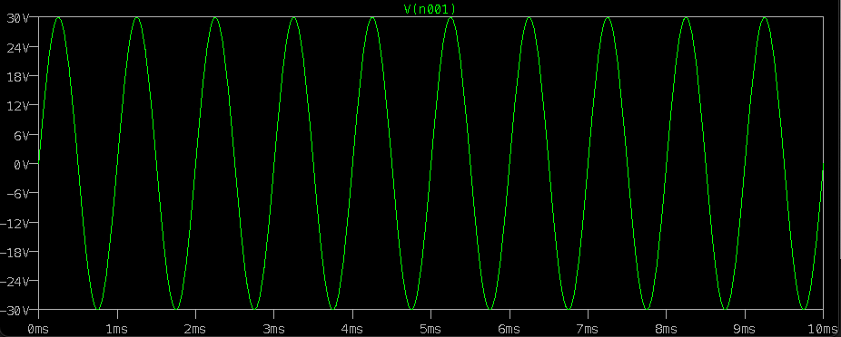

**Output Waveform: -**

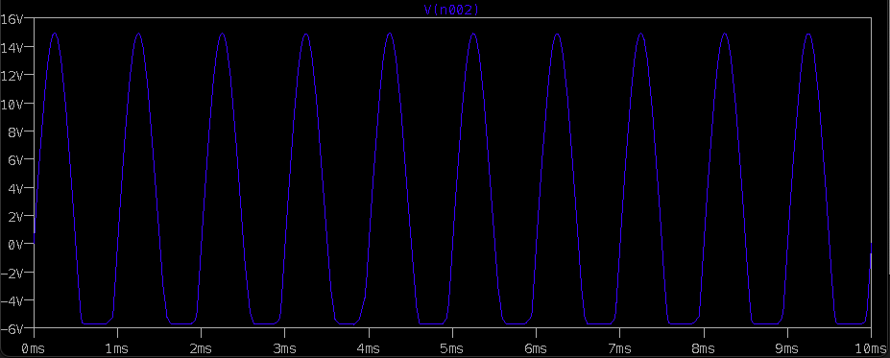

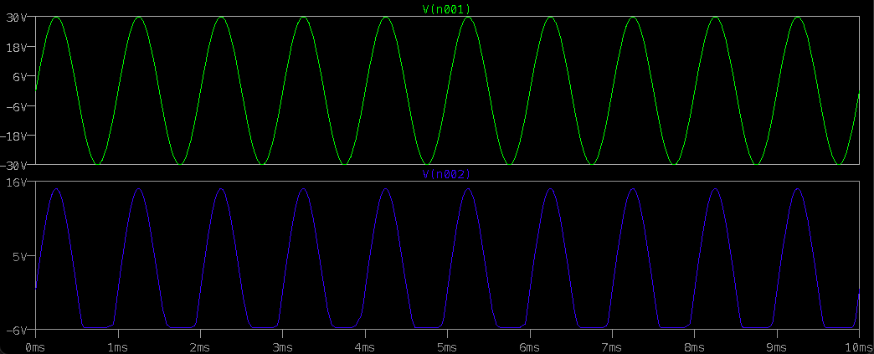

**(V) COMBINED BIASED CLIPPER: -**

### Clipping of Both Half Cycles: -

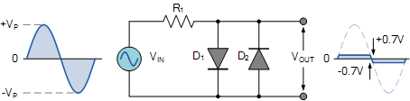

If we connected two diodes in inverse parallel as shown, then both the positive and negative half cycles would be clipped as diode D1 clips the positive half cycle of the sinusoidal input waveform while diode D2 clips the negative half cycle. Then diode clipping circuits can be used to clip the positive half cycle, the negative half cycle or both.

For ideal diodes the output waveform above would be zero. However, due to the forward bias voltage drop across the diodes the actual clipping point occurs at +0.7 volts and –0.7 volts respectively. But we can increase this ±0.7V threshold to any value we want up to the maximum value, (VPEAK) of the sinusoidal waveform either by connecting together more diodes in series creating multiples of 0.7 volts, or by adding a voltage bias to the diodes.

**Components Required: -**

* Resister
* Voltage source
* Diodes
* Wires
* Ground

**Logic Diagram: -**

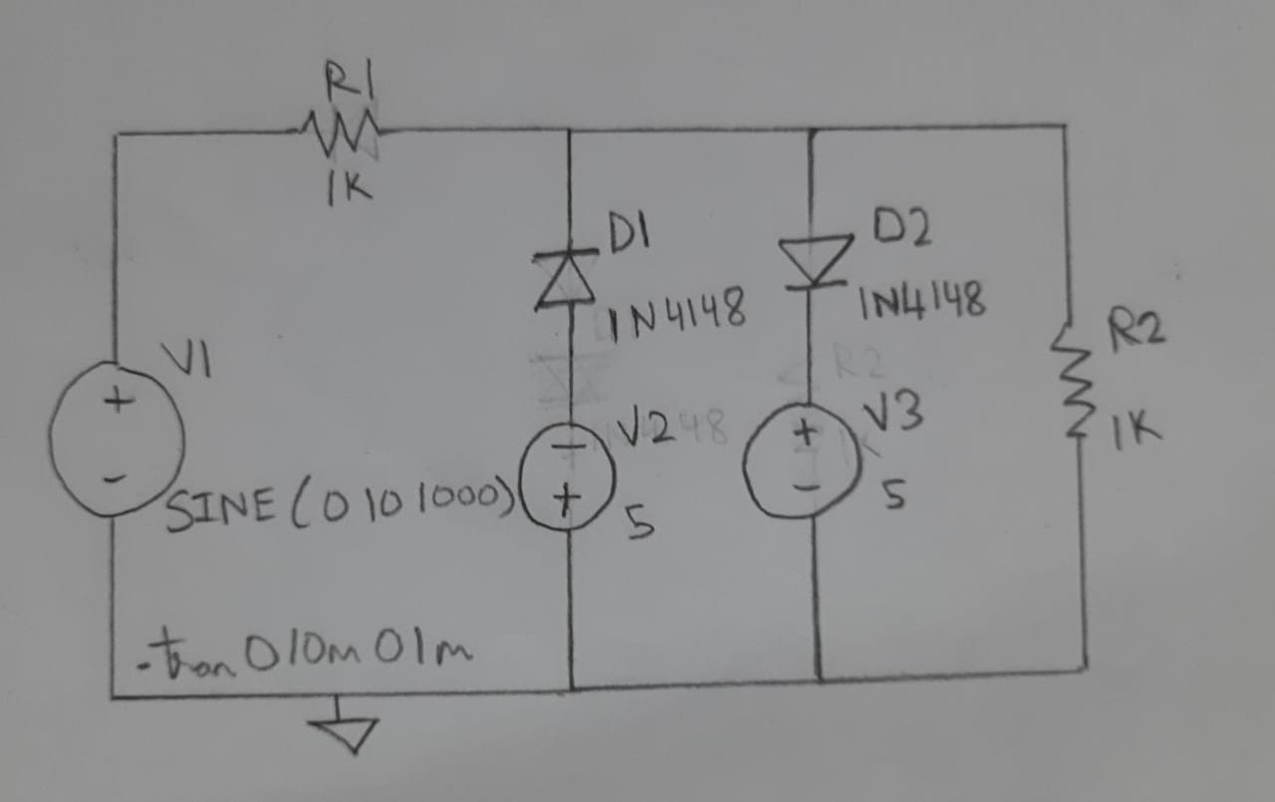

**Simulator Diagram – Schematic:**



**Input Waveform: -**

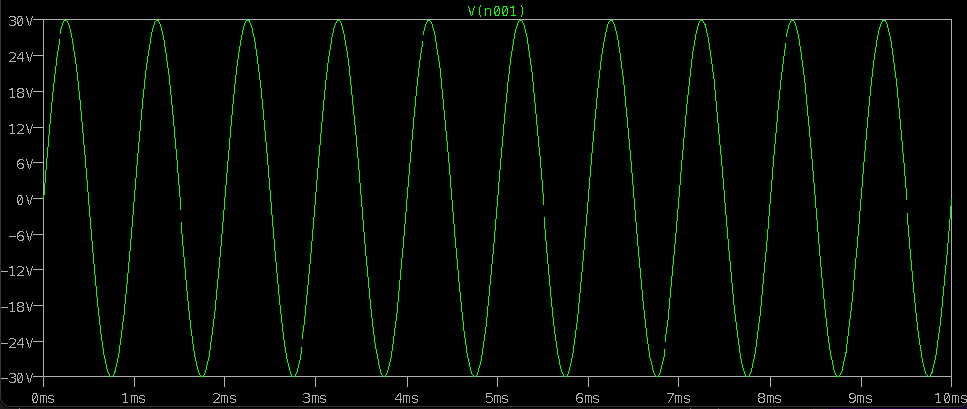

**Output Waveform:**

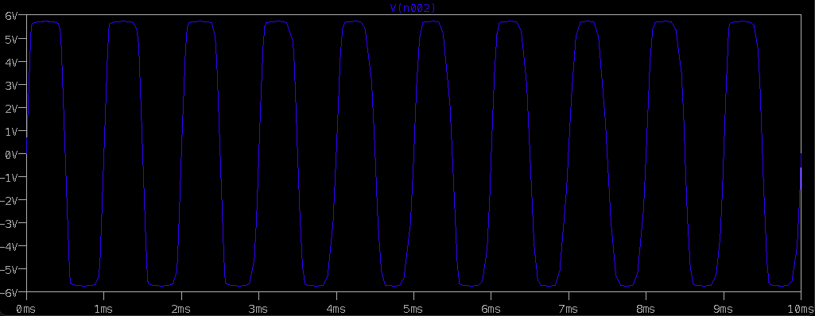

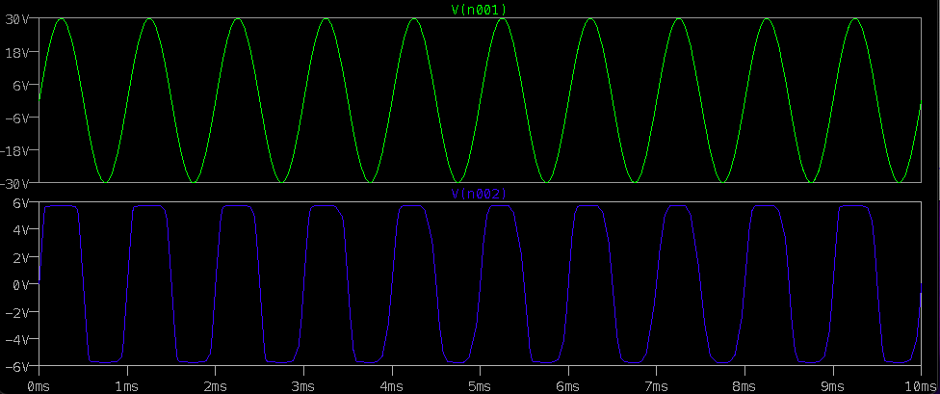

**INFERENCE**

**Positive Clipper: -**

In the above figures, if the waveforms are observed, we can understand that only a portion of the positive peak was clipped. This is because of the voltage across V0. But the ideal output was not meant to be so. Let us have a look at the following figures.

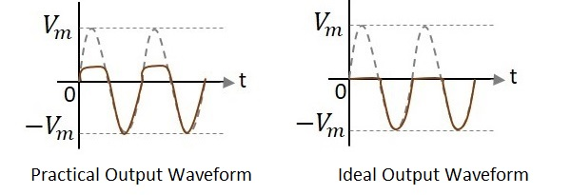

Unlike the ideal output, a bit portion of the positive cycle is present in the practical output due to the diode conduction voltage which is 0.7V. Hence there will be a difference in the practical and ideal output waveforms.

**Negative Series Clipper: -**

**Waveforms: -**

In the above figures, if the waveforms are observed, we can understand that only a portion of the negative peak was clipped. This is because of the voltage across VO. But the ideal output was not meant to be so. Let us have a look at the following figures.

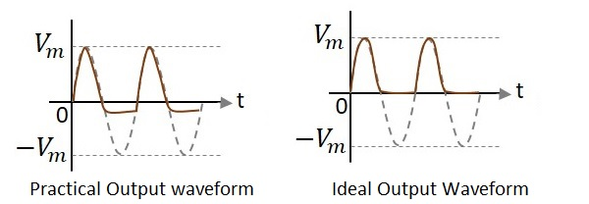

Unlike the ideal output, a bit portion of the negative cycle is present in the practical output due to the diode conduction voltage which is 0.7V. Hence there will be a difference in the practical and ideal output waveforms.

### Series Positive Clipper with Positive Bias Voltage: -

[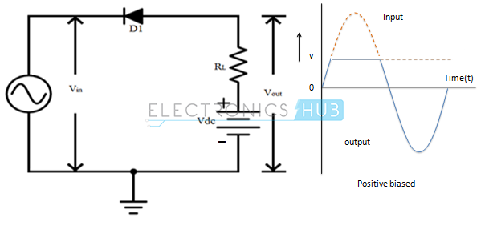](https://www.electronicshub.org/wp-content/uploads/2015/01/8.-Series-Positive-Clipper-with-positive-bias-voltage.png)

Positive Half Cycle: Cathode is connected to the positive supply and the anode is maintained at positive bias potential.

* When Vin < VD + VDC, Output Voltage (VO) = (Vin + VD) Volts
* When Vin > VD + VDC, Output Voltage (VO) = + VDC Volts

Negative Half Cycle: Cathode is connected to the negative supply and anode is maintained at positive bias potential.

* Output voltage (VO) = (Vin + VD)

### Series Positive Clipper with Positive Bias Voltage Connected in Series: -

[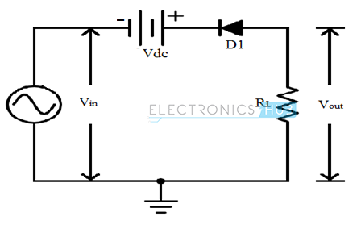](https://www.electronicshub.org/wp-content/uploads/2015/01/9.-Series-Positive-clipper-with-positive-bias-voltage-connected-in-series.png)

Positive Half Cycle: Anode is maintained at ground potential and cathode is connected to a positive voltage. The diode is reverse biased during the whole positive half cycle.

* Output Voltage (VO) = 0 Volts

Negative Half Cycle: Anode is maintained at ground potential and cathode is connected to a negative supply.

* When Vin < Vd + Vdc, Output voltage (VO) = 0 Volts
* When Vin > Vd + Vdc, Output voltage (VO) = (Vin +Vdc +Vd) Volts

### Series Positive Clipper with Negative Bias Voltage:

[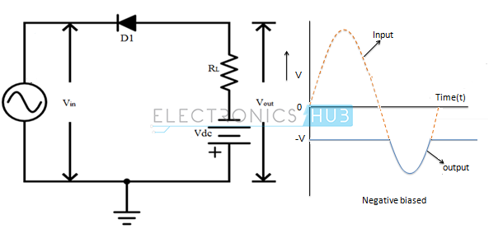](https://www.electronicshub.org/wp-content/uploads/2015/01/10.-Series-Positive-clipper-with-negative-bias-voltage.png)

Positive Half Cycle: Cathode is connected to the positive supply and the anode is maintained at negative bias potential.

* Output Voltage (VO) = -Vdc Volts

Negative Half Cycle: Cathode is connected to the negative supply and anode is maintained at negative bias potential.

* When Vin < Vd + Vdc, Output Voltage (VO) = – Vdc Volts.
* When Vin > Vd + Vdc, Output Voltage (VO) = (Vin + Vd) Volts.

### Series Positive Clipper with Negative Bias Voltage Connected in Series: -

[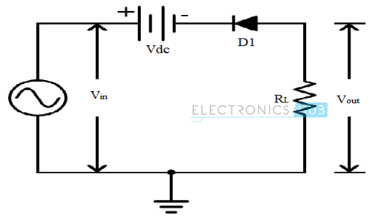](https://www.electronicshub.org/wp-content/uploads/2015/01/11.-Series-Positive-clipper-with-negative-bias-voltage-connected-in-series.png)

Positive Half Cycle: Anode is maintained at ground potential and cathode observes a variable voltage. The diode is forward biased during the whole positive half cycle.

* When Vin < Vdc – Vd, Output voltage (VO) = (Vin –Vdc +Vd) Volts
* When Vin > Vd + Vdc, Output voltage (VO) = 0 Volts

Negative Half Cycle: Anode is maintained at ground potential and cathode observes variable negative voltage. The diode will be forward biased during the negative cycle.

* Output Voltage (VO) = (Vin –Vdc +Vd) Volts

### Series Negative Clipper with Positive Bias Voltage

[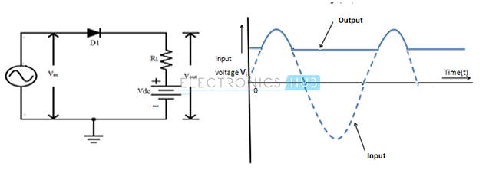](https://www.electronicshub.org/wp-content/uploads/2015/01/12.-Series-Negative-clipper-with-positive-bias-voltage.png)

Positive Half Cycle: In this case the anode is connected to the positive supply and the cathode is maintained at positive bias potential.

* When Vin < Vd + Vdc, Output Voltage (VO) = Vdc Volts
* When Vin > Vd + Vdc, Output Voltage (VO) = (Vin – Vd) Volts

Negative Half Cycle: In this case the anode is connected to the negative supply and the cathode is maintained at positive bias potential.

* Output Voltage (VO) = + Vdc Volts

### Series Negative Clipper with Positive Bias Voltage Connected in Series: -

[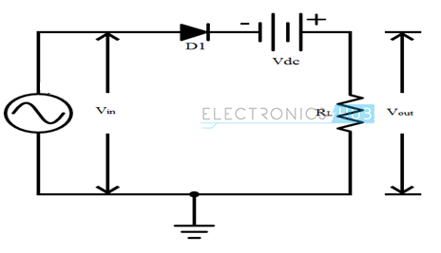](https://www.electronicshub.org/wp-content/uploads/2015/01/13.-Series-Negative-clipper-with-positive-bias-voltage-connected-in-series.png)

Positive Half Cycle: Cathode is maintained at negative potential, anode observes a variable voltage. The diode is forward biased during the whole positive half cycle.

* When Vin < Vd + Vdc, Output Voltage (VO) = (Vin +Vdc – Vd) Volts
* When Vin > Vd + Vdc, Output voltage (VO) = 0 Volts

Negative Half Cycle: Cathode is maintained at negative potential and anode observes variable negative voltage.

* When Vin < Vdc – Vd, Output voltage (VO) = (Vin +Vdc –Vd) Volts
* When Vin > Vdc – Vd, Output voltage (VO) = 0 Volts

### Series Negative Clipper with Negative Bias Voltage Connected in Parallel: -

[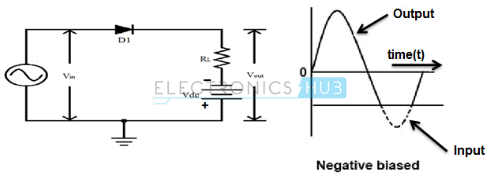](https://www.electronicshub.org/wp-content/uploads/2015/01/14.Series-Negative-clipper-with-negative-bias-voltage-connected-in-parallel.png)

Positive Half Cycle: In this circuit the anode is connected to the positive supply and the cathode is maintained at negative bias potential.

* When Vin < Vd + Vdc, Output Voltage (VO) = (Vin + Vd) Volts
* When Vin > Vd + Vdc, Output Voltage (VO) = + Vdc Volts

Negative Half Cycle: In this circuit the anode is connected to the negative supply and the cathode is maintained at negative bias potential.

* Output Voltage (VO) = (Vin + Vd) Volts

### Series Negative Clipper with Negative Bias Voltage Connected in Series: -

[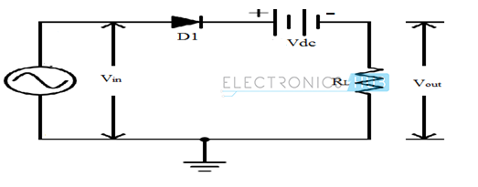](https://www.electronicshub.org/wp-content/uploads/2015/01/15.-Series-Negative-clipper-with-negative-bias-voltage-connected-in-series.png)

Positive Half Cycle: Cathode is maintained at Vdc and anode observes a variable voltage.

* When Vin < Vd + Vdc, Output Voltage (VO) = 0 Volts
* When Vin > Vd + Vdc, Output voltage (VO) = (Vin –Vdc –Vd) Volts

Negative Half Cycle: Cathode is maintained at Vdc and anode observes a variable negative voltage.  The diode will be reverse biased during the negative cycle.

* Output voltage (VO) = 0 Volts

**RESULT:**

**CLIPPER CIRCUITS ARE SUCCESSFULLY DESIGNED AND VERIFIED ON LT SPICE WITH ITS CHARACHTERSTICS**