
PROJECT REPORT ON
GroundLens
Evidence-Grounded Multi-Document
Question Answering
Using Retrieval-Augmented Generation
In the subject of
RETRIEVAL-AUGMENTED GENERATION
RAG Systems & Agentic Workflows
with Pinecone and LangGraph (Coursera)
BTI–Computer Engineering
Sem-9
Name of Student | Aryan Paode
Roll No. | C033

Department of Computer Engineering
MPSTME – NMIMS University
AY: 2026–27

Abstract
GroundLens is a working Retrieval-Augmented Generation (RAG) application for question answering over selected academic PDFs. It extracts page-level text, divides it into overlapping chunks, creates local sentence embeddings and stores the resulting passages in ChromaDB. A question is answered by retrieving a small evidence set and sending that evidence, the question and limited recent conversational context to Gemini. The response is accompanied by source labels, document names, page references and separate retrieval and generation timings. [1], [2]
The final demonstrated corpus contains four PDFs covering three subject areas: Management Through Movies, Image and Video Processing, and Software Engineering. Together, the files contain 99 pages and produce 124 indexed chunks. Five manually reviewed questions tested factual synthesis, multi-page comparison, focused retrieval, a technical formula and a two-document explanation. Four answers addressed their questions correctly; one broad question incorrectly reported insufficient information because essential source pages were not retrieved. [2]–[7]
The recorded total response times range from 5.46 to 26.10 seconds. The mean is 12.94 seconds and the median is 8.13 seconds across these five individual observations. These results demonstrate a functioning, inspectable mini-project, not a general accuracy estimate or a production latency guarantee. The report preserves the failed case, API-availability limit and distinction between source labels and verified factual support. [3]
Keywords: Retrieval-Augmented Generation; semantic retrieval; PDF question answering; local embeddings; ChromaDB; Gemini; source citations.
Table 1. Summary of the demonstrated GroundLens configuration and results. [1]–[3]
Project measure | Recorded value
Final corpus | 4 PDFs; 99 pages; 124 local chunks
Manual functional outcomes | 4 passes; 1 incorrect abstention
Generation configuration | gemini-3.1-flash-lite; one request attempt
Deployment | Windows; Python 3.11; 8 GB RAM; CPU embeddings

Table of Contents
Abstract 2
1. Introduction 5
1.1 Project contribution 5
1.2 Relationship to the course 5
2. Problem Definition, Objectives and Scope 6
2.1 Problem statement 6
2.2 Objectives 6
2.3 Scope and boundaries 6
3. System Architecture and Workflow 7
4. Detailed Methodology 8
4.1 PDF ingestion and page-aware chunking 8
4.2 Embeddings and persistent storage 8
4.3 Retrieval and document coverage 8
4.4 Grounded generation and citation handling 9
4.5 Conversation state and error paths 9
5. Implementation and User Interface 10
5.1 Technology and operating configuration 10
5.2 Interface organization 10
5.3 Recorded interface and factual response 11
6. Experimental Methodology 12
6.1 Final corpus and environment 12
6.2 Manual procedure and scoring 12
6.3 Metrics and evidence boundaries 13
7. Results and Evaluation 13
7.1 Functional outcomes and latency 13
7.2 Focused retrieval and technical explanation 14
8. Cross-Document Demonstration 15
8.1 Question, scope and observed answer 15
8.2 Traceable passages from both PDFs 16
9. Failure Analysis and Limitations 17
9.1 Multi-page retrieval failure 17
9.2 Improvement directions, not implemented results 17
9.3 API, extraction and evaluation limitations 18
10. Reproducibility and Deliverables 18
10.1 Local execution 18
10.2 Repository and evidence status 19
11. Conclusion 19
References 20
Appendix A. Recorded Test Questions 21
Appendix B. Implementation Map 22
List of Figures
1. End-to-end workflow 7
2. GroundLens dashboard 11
3. Organizational-change answer excerpt 11
4. Focused economic-resistance answer 14
5. Gamma-transformation answer 14
6. Two-document question and response 15
7. Image Fundamentals evidence 16
8. Image Enhancement evidence 16
List of Tables
1. Project summary 2
2. Course alignment 5
3. Project scope and boundaries 6
4. Technologies and responsibilities 10
5. Final test corpus 12
6. Observed v2 test results 13
7. Cross-document source coverage 15
8. Evidence behind the incorrect abstention 17
9. Implementation modules 22

1. Introduction
Academic study material is often distributed across separate lecture PDFs. A useful answer may appear in a short paragraph, a later explanation or a different unit. GroundLens was developed to make this material searchable through natural-language questions while keeping the evidence visible. The application is more than a file-upload interface: its Python code performs extraction, chunking, embedding, filtered retrieval and prompt construction before requesting an answer from the hosted language model. [1]

1.1 Project contribution
The project separates the retrieval system from the generative model. PDF processing and semantic search run on the laptop; Gemini performs only the answer-generation stage. This division makes the implementation practical for the specified 8 GB RAM, CPU-only environment and allows the retrieved passages to be examined independently of the final wording. No model is trained or fine-tuned as part of the project. [1], [3]

1.2 Relationship to the course
Table 2. Course concepts represented by the implemented application. [1], [8]
Course area | Implemented in GroundLens
RAG fundamentals | PDF ingestion, local embeddings, retrieved context and grounded answer generation.
Vector databases and search | Persistent ChromaDB storage, semantic retrieval and document filters.
Conversational workflows | Streamlit session history and a lightweight follow-up query heuristic; no LangGraph agent.
Optimization and observability | Evidence explorer, separate latency measurements and retrieval-benchmark code; no LangSmith or Langfuse integration.

The course title mentions Pinecone and LangGraph, but the delivered application uses ChromaDB and a direct Python workflow. The report distinguishes the concepts studied from the particular tools actually implemented. [1], [8]

2. Problem Definition, Objectives and Scope

2.1 Problem statement
Given a set of text-selectable PDFs and a natural-language question, retrieve relevant passages only from the documents selected by the user, generate an answer supported by those passages, and expose the originating filenames and pages. When the retrieved evidence is insufficient, the system should avoid inventing an answer. [1]

2.2 Objectives
- Preserve source identity and one-based page references during text extraction and chunking.
- Create and search a persistent local index without a dedicated graphics card.
- Support focused questions and optional comparison across selected PDFs.
- Display retrieved evidence, response-specific citations and measured stage timings.
- Evaluate successful answers and failure cases using actual application outputs.

2.3 Scope and boundaries
Table 3. Declared project boundaries. [1], [3]
Within the delivered scope | Outside the delivered scope
Selectable PDF text; multiple-document library; local vector index. | Built-in OCR, image interpretation and general document-layout reconstruction.
Gemini generation over supplied excerpts; limited session context. | An offline local LLM, model training, or a fully autonomous agent.
Citation-label checks and manual evidence review. | Automatic semantic proof of every claim or guaranteed hallucination prevention.
Local single-user academic application and reproducibility files. | Hosted multi-user deployment or live web retrieval.

3. System Architecture and Workflow
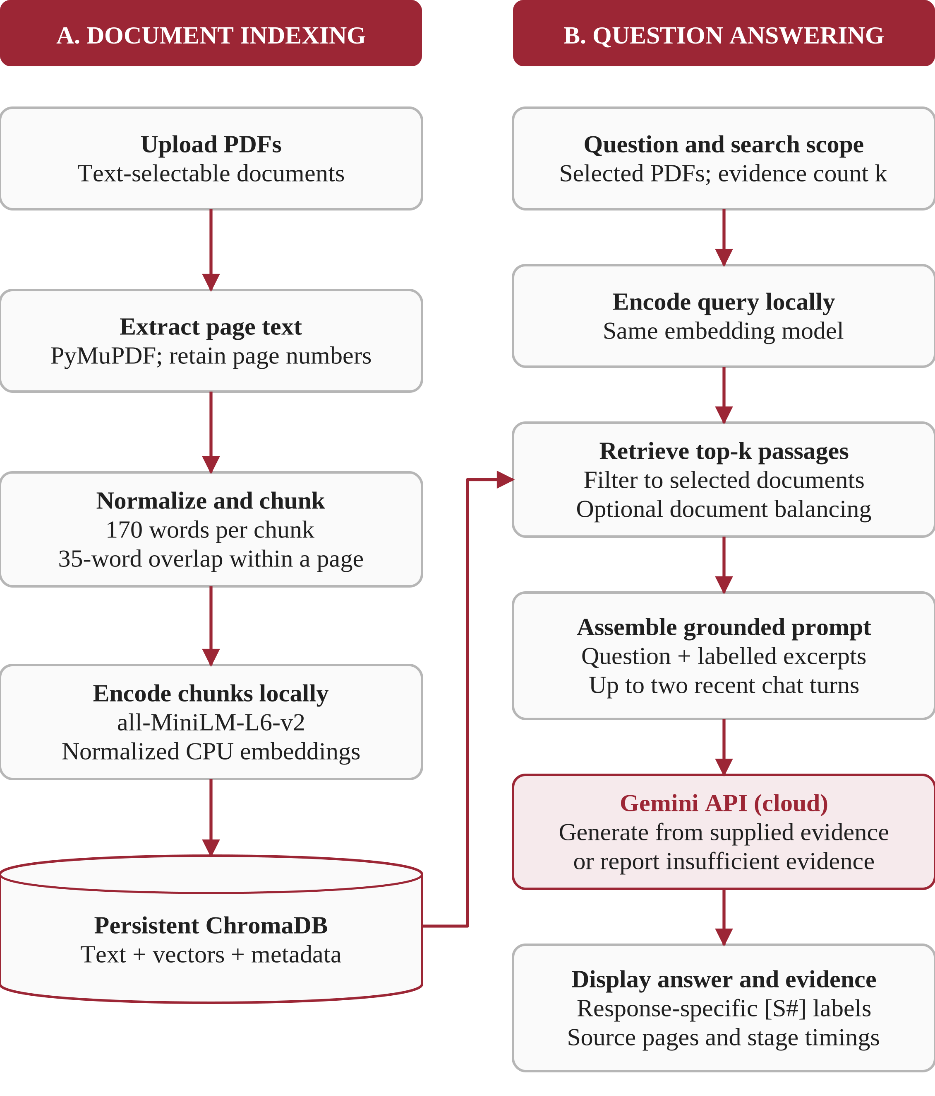
Figure 1. Implemented end-to-end workflow. The two local pipelines meet at ChromaDB retrieval; only the assembled generation prompt crosses to the cloud. [1]
Indexing occurs when files are added. Question answering reuses the stored passages rather than extracting every PDF again. Validation errors, empty retrieval results and API failures are handled separately in the application. [1]

4. Detailed Methodology

4.1 PDF ingestion and page-aware chunking
The upload control accepts PDFs up to 12 MB each. PyMuPDF extracts selectable text page by page and retains one-based page numbers. Normalization removes soft-hyphen artifacts and repeated whitespace. Empty, unreadable, password-protected or image-only files produce an error rather than a usable index. [1]
Each page is split into chunks of at most 170 words with a 35-word overlap. The next chunk normally begins 135 words after the previous one. Chunks never cross page boundaries, and tiny overlapping fragments are suppressed. Page-aware chunking allows an answer’s source label to be traced back to a specific PDF page, although text extraction does not preserve every diagram or mathematical layout. [1]

4.2 Embeddings and persistent storage
The application uses sentence-transformers/all-MiniLM-L6-v2 on the CPU to encode both document chunks and questions. Embeddings are normalized before being passed to ChromaDB. Streamlit caches the embedding-model resource and the local-store object so they can be reused across interaction reruns. [1]
A SHA-256 hash identifies duplicate files. Each record stores text, an embedding, document ID, filename, page number, chunk number and page count. The collection groundlens_pdf_chunks is stored under runtime/chroma. The index retains extracted passages and metadata, not the original PDF file. [1]

4.3 Retrieval and document coverage
The user selects the searchable PDF set and the evidence count k. The tested interface uses k = 5, with a selectable range of two to eight. A document-ID filter restricts the database query before passages are returned. Ordinary mode keeps the closest k results. [1]
“Cover multiple documents” retrieves up to five times k candidates, subject to collection size. It reserves one passage per distinct document encountered, then fills remaining slots with other close passages. This encourages source diversity without guaranteeing every selected document, requested topic or necessary page. [1]

4.4 Grounded generation and citation handling
Retrieved passages receive labels [S1], [S2] and so on for the current response. Each excerpt in the prompt includes its filename and page. The system instruction asks Gemini to use only these excerpts as factual evidence, disregard instructions embedded inside documents, cite supported claims and acknowledge contradictions or insufficient information. These are prompt constraints rather than a separate fact-verification engine. [1]
The configured model is gemini-3.1-flash-lite, with temperature 0.1, a maximum output budget of 1,200 tokens, a 60,000 ms request timeout and one SDK attempt. The same request configuration was used after the earlier connectivity troubleshooting. The raw PDF is not uploaded through this generation call, but the question, selected text and limited recent context do leave the laptop. [1], [3]
The citation utility checks whether recognized standalone [S#] references point to an existing supplied source number. It does not test semantic entailment, and it is not a full parser for every possible grouped-citation format. The evidence explorer therefore remains essential: a visible label confirms a reference mechanism, not that the accompanying claim has been proved. [1]

4.5 Conversation state and error paths
Up to two recent question–answer turns are included in the generation prompt, explicitly labelled as context rather than factual evidence. For a short follow-up containing a pronoun or “what about”, the retrieval query may be prefixed with the previous question. This is a lightweight reference-resolution heuristic, not an independently planning agent or a persistent long-term memory system. [1]
If no passages are returned, the application can respond without a Gemini call. If passages are returned but lack the answer, the model is instructed to abstain. The fixed abstention wording refers to the “uploaded documents”, although only retrieved excerpts have been examined; the failed test in Section 9 shows why that wording can overstate the conclusion. API exceptions are displayed as errors rather than converted into unsupported answers. [1], [3]

5. Implementation and User Interface

5.1 Technology and operating configuration
Table 4. Technologies and responsibilities in the delivered source package. [1], [3]
Layer | Implementation and responsibility
Interface | Streamlit: uploads, source filters, chat, document management and evidence explorer.
Extraction | PyMuPDF: selectable page text and original page references.
Embedding | Sentence Transformers; all-MiniLM-L6-v2; CPU execution.
Index | ChromaDB PersistentClient; normalized vectors, passages and metadata.
Generation | Google Gen AI SDK; Gemini model selected through the local configuration.
Evaluation | Python, pandas/CSV and pytest; retrieval routines and test files included.
Environment | Windows, Python 3.11, 8 GB RAM and no dedicated graphics card.

5.2 Interface organization
The sidebar contains the source library, PDF selection, evidence count, cross-document option and model setting. The main area separates Ask documents, Manage PDFs, Evaluate retrieval and About. Removing a document from the search selection changes the query scope; it does not delete the corresponding index. Deletion is a separate confirmed operation in Manage PDFs. [1], [2]
The final interface uses a red, ivory and pale-rose theme. Answers remain separate from the expandable evidence panel, and each successful turn reports retrieval, Gemini and total elapsed time. Figures 2 and 3 show the working application and a genuine grounded response, rather than a mock-up. [2]

5.3 Recorded interface and factual response
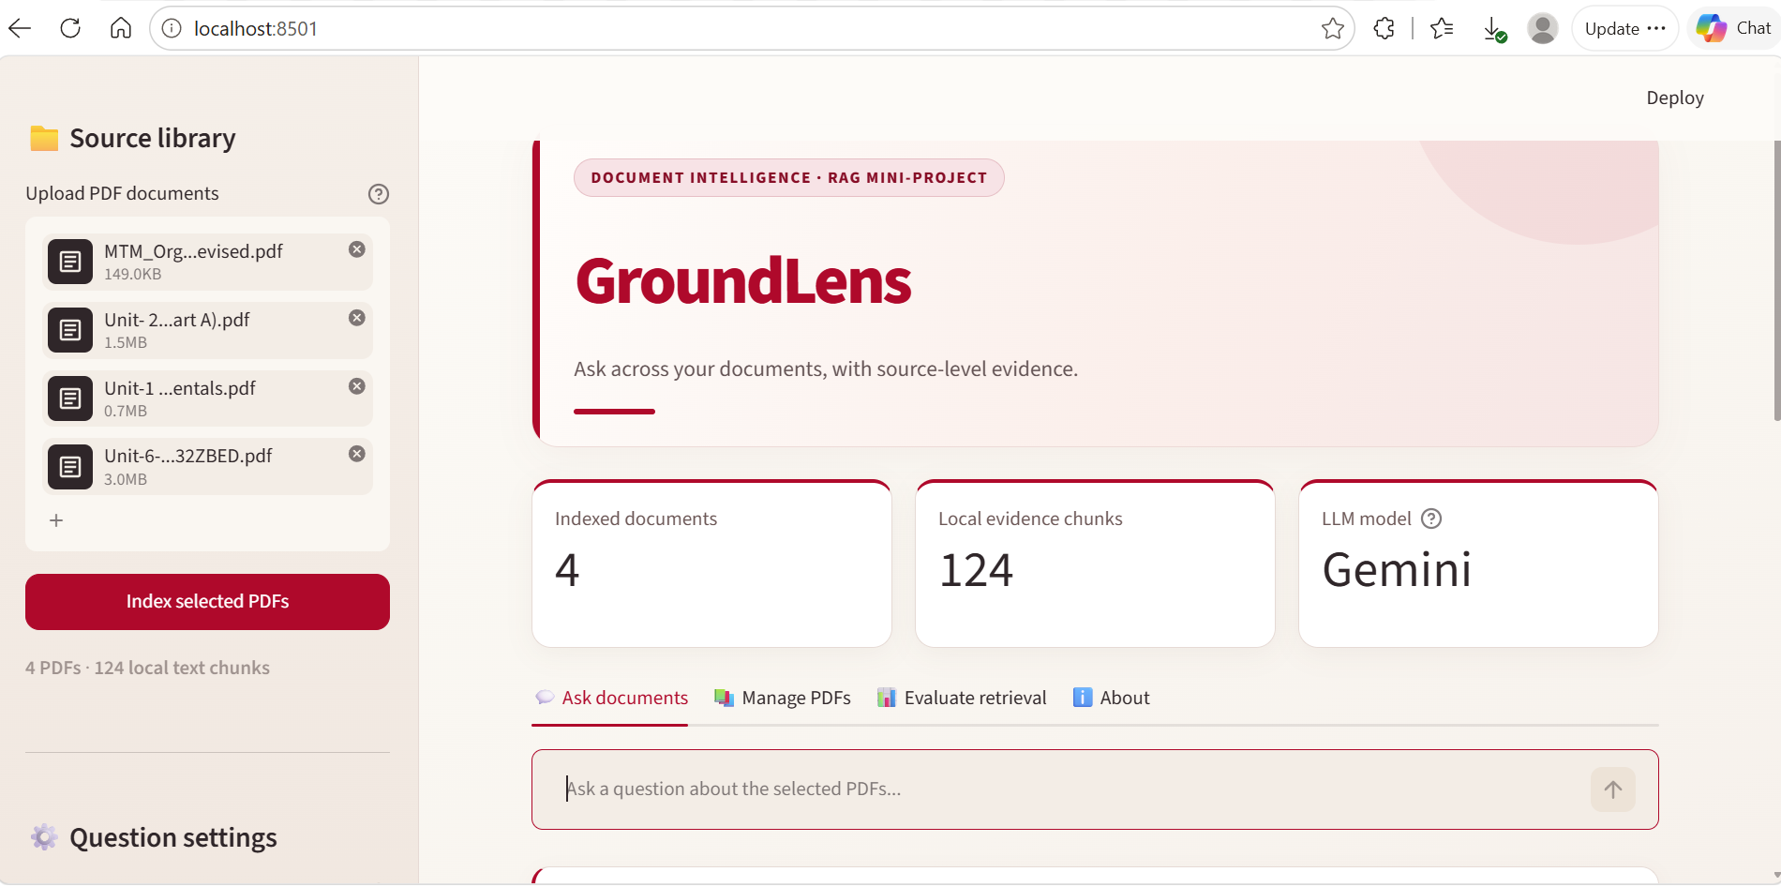
Figure 2. GroundLens dashboard showing four indexed PDFs, 124 local chunks and the document-question interface. [2]
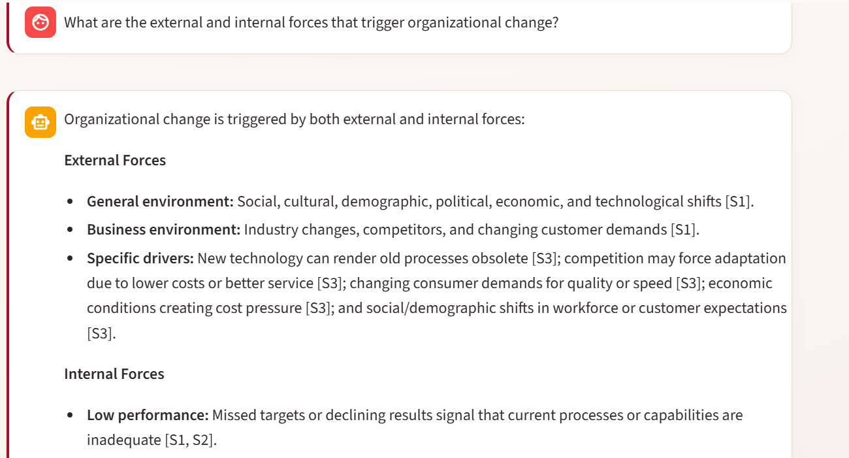
Figure 3. Q1 response excerpt: external and internal forces of organizational change, with source labels. The complete response and timings are recorded in the test log. [2], [3]

6. Experimental Methodology

6.1 Final corpus and environment
The final index contains four lecture PDFs across three subject areas. The two image-processing units belong to the same subject area. The image-only Game Design lecture and the earlier fictional-event demo are not part of this final corpus. [2], [4]–[7]
Table 5. Final four-document corpus. Page counts refer to PDF pages. [2], [4]–[7]
Document | Pages | Role in the recorded tests
MTM: Organizational Change | 18 | Q1–Q3: change drivers and resistance categories.
Unit 1: Image Fundamentals | 14 | Q5: sampling and quantization.
Unit 2: Image Enhancement, Part A | 52 | Q4–Q5: gamma transformation and enhancement.
Unit 6: User Interface Design | 15 | Indexed background document; no standalone scored question in this set.
Total | 99 | 4 PDFs; 124 chunks displayed by the application.

6.2 Manual procedure and scoring
Five questions were reviewed individually. A functional pass means that the answer addressed the main requested distinction or fact and agreed with the relevant lecture material. An incorrect abstention counts as a failure when the uploaded source contains the requested information. Citation coverage is reported separately: source labels were visible in the answers, but the supplied expanded evidence is most complete for Q2 and Q5. [2], [3]
The screenshots show k = 5. For Q5, only Image Fundamentals and Image Enhancement were selected and cross-document coverage was enabled. The exact source-filter and balancing settings for every earlier turn were not preserved; consequently, this is a documented manual demonstration rather than a controlled retrieval ablation. Appendix A retains the five questions. [2], [3]

6.3 Metrics and evidence boundaries
Retrieval time covers embedding-resource loading when needed, query encoding, vector search and passage selection. Gemini time covers generation; total time includes both blocks and application overhead. These are application observations, not independently instrumented network or model-server timings. [1], [3]
The manual pass proportion is 4/5 = 80% for these five selected questions. It is not a population-level accuracy estimate, an automated benchmark score, or a measure of citation entailment. The latency summaries below include the unsuccessful answer as well as the successful ones. [3]

7. Results and Evaluation

7.1 Functional outcomes and latency
Table 6. Observed v2 results from the supplied test record. Each row is one recorded completed response. [3]
Test | Outcome | Retrieval  (s) | Gemini  (s) | Total  (s)
Q1 | Pass | 17.41 | 8.69 | 26.10
Q2 | Fail | 0.73 | 18.32 | 19.05
Q3 | Pass | 0.05 | 8.08 | 8.13
Q4 | Pass | 0.05 | 5.41 | 5.46
Q5 | Pass | 0.05 | 5.90 | 5.95

Across the five runs, total time has a mean of 12.94 seconds, a median of 8.13 seconds and a range of 5.46–26.10 seconds. Q1 retrieval took 17.41 seconds, compared with 0.05–0.73 seconds in subsequent turns. This is consistent with initialization or caching overhead, but initialization was not independently timed, so its exact contribution is not established. [3]
Q1 summarized change drivers; Q3 identified the four economic reasons; Q4 returned the formula and gamma cases in the notes; and Q5 distinguished digitization from enhancement. These content-level passes do not imply that every citation was validated. [3]–[6]

7.2 Focused retrieval and technical explanation
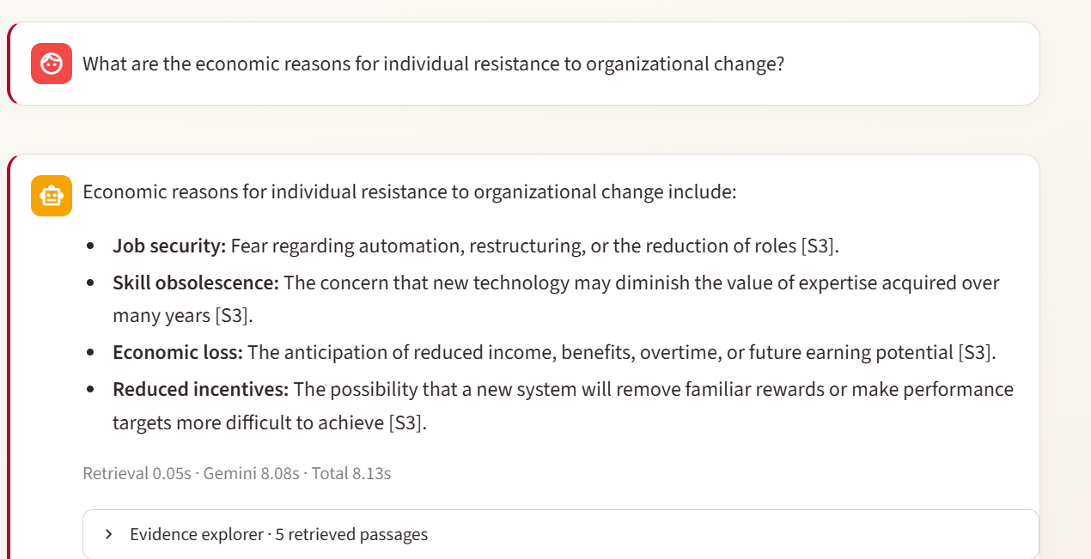
Figure 4. Q3: economic resistance was answered with job security, skill obsolescence, economic loss and reduced incentives. Total time: 8.13 s. [2]–[4]
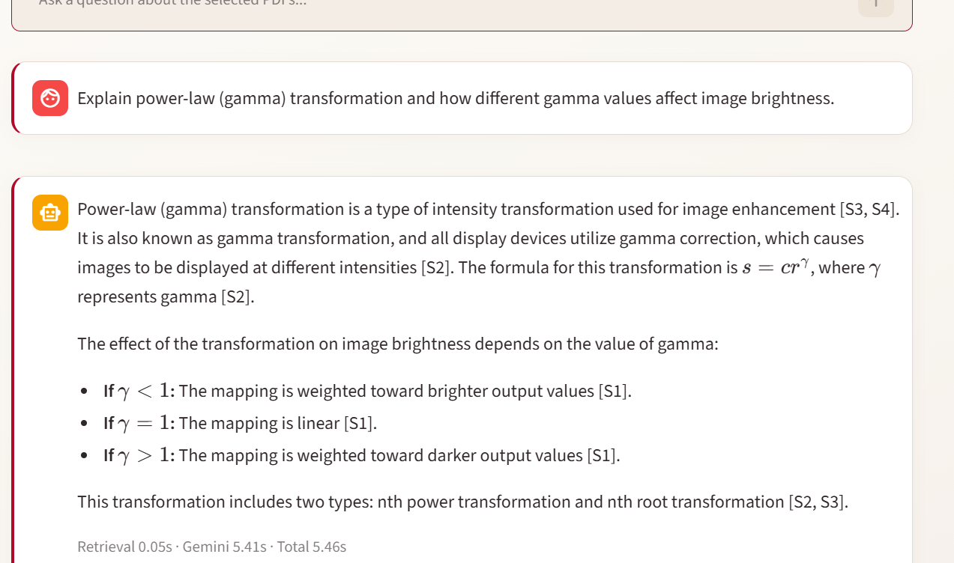
Figure 5. Q4: the response gives s = cr^{γ} and the brightness cases shown in Image Enhancement, pages 25–26. Total time: 5.46 s. [2], [6]

8. Cross-Document Demonstration

8.1 Question, scope and observed answer
Q5 asks how sampling and quantization differ from intensity transformations. The final successful run selected only the two image-processing PDFs and enabled “Cover multiple documents”. The response distinguished creating a digital image from modifying an existing image, while the evidence explorer exposed passages from both units. [2], [3]
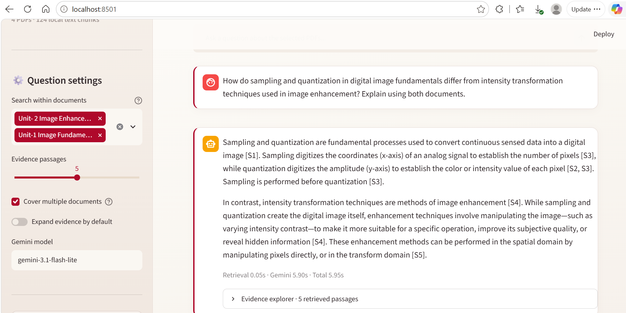
Figure 6. Q5: a two-document response with the correct source selection and a recorded total time of 5.95 s. [2]
Table 7. Source coverage visible in the expanded Q5 evidence. [2]
Response labels | Retrieved source | Contribution
[S1]–[S3] | Image Fundamentals, pp. 6–7 | Digitization, sampling and quantization.
[S4]–[S5] | Image Enhancement, pp. 3–4 | Purpose of enhancement and broad processing domains.

The comparison succeeds at its main conceptual distinction. The retrieved enhancement evidence is introductory rather than a complete treatment of point transformations, so the output should not be described as an exhaustive mathematical comparison. Figures 7 and 8 preserve the actual source passages. [2], [5], [6]

8.2 Traceable passages from both PDFs
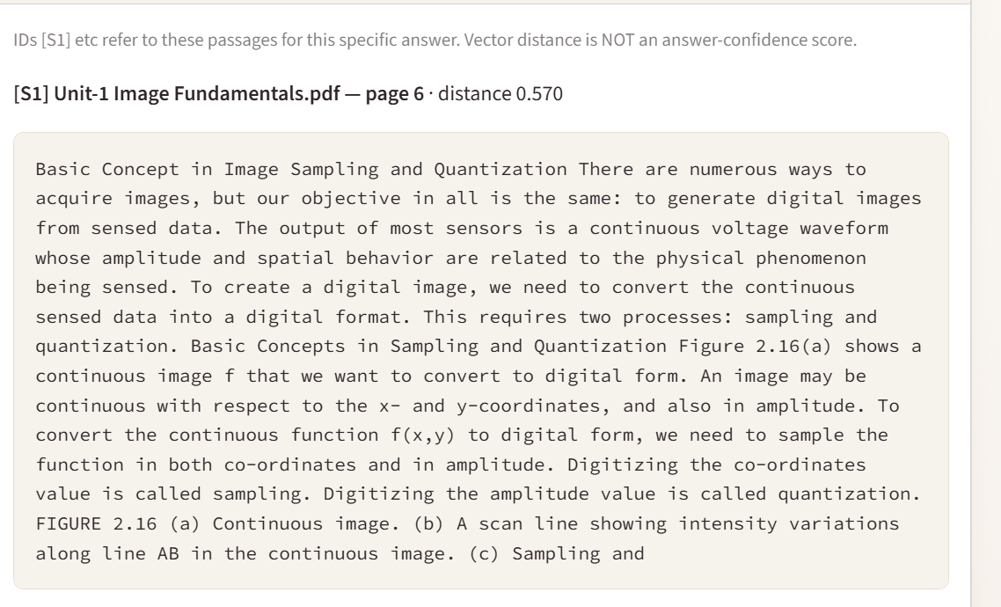
Figure 7. Q5 evidence [S1]: Image Fundamentals, page 6, on sampling and quantization. Cropped from the original evidence-explorer capture. [2]
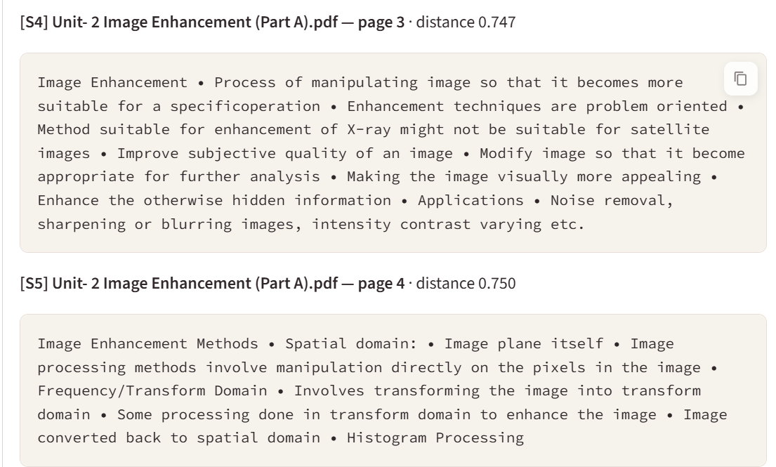
Figure 8. Q5 evidence [S4] and [S5]: Image Enhancement, pages 3–4. Document names and page references establish two-source retrieval. [2]

9. Failure Analysis and Limitations

9.1 Multi-page retrieval failure
Q2 requested a comparison of economic, psychological, social and organizational resistance. The answer incorrectly stated that the documents did not explain these categories. The source actually explains economic reasons on page 8, psychological and social reasons on page 9, and organizational barriers on page 10. [3], [4]
Table 8. Evidence coverage behind the incorrect abstention. [3], [4]
Required evidence | What the Q2 retrieval supplied
Economic reasons: p. 8 | Missing from the top five passages.
Psychological and social reasons: p. 9 | Missing from the top five passages.
Organizational barriers: p. 10 | Retrieved, but not used to provide a partial explanation.
Actual retrieved pages | 18, 2, 10, 7 and 3; overview pages outranked key explanations.

The failure combines incomplete retrieval coverage with an over-conservative answer. The model did not invent the missing categories, but it also failed to make use of the organizational explanation already present. Absence from the selected excerpts was incorrectly treated as absence from the whole uploaded document. A focused follow-up about economic reasons subsequently succeeded, showing that the source content was indexed but not selected for the broader query. [3]

9.2 Improvement directions, not implemented results
Possible next steps are multi-part query decomposition, a larger candidate pool, keyword-assisted retrieval, neighboring-page expansion and reranking. These would need evaluation on an aligned dataset; none is claimed as an implemented fix or a measured improvement in the submitted version. [1], [3]

9.3 API, extraction and evaluation limitations
An earlier Q5 attempt returned 503 UNAVAILABLE with a high-demand message. A later retry succeeded. This is retained as an observed service-availability limitation, not counted as an additional completed answer in the five-row functional table. The application depends on external generation availability even when local retrieval works. [3]
Image-only PDFs require a separately prepared searchable copy. The final corpus includes diagrams and formula images whose complete visual structure is not sent to Gemini. The presence of an indexed page therefore does not establish that all information on that page has been captured. Text extraction and answer generation can also reproduce imprecision in the source notes. [1], [5], [6]
The built-in retrieval benchmark has not been run against a fully aligned version of this final corpus in the supplied record. Its “Four academic subjects” CSV still contains Game Design cases, while the final library uses Image Enhancement instead. Some filenames also differ from their benchmark labels. No retrieval hit-rate or rank score is reported here; a future run would first need matching filenames and source requirements. [1]

10. Reproducibility and Deliverables

10.1 Local execution
The delivered package contains the Streamlit entry point, reusable RAG modules, benchmark routines, sample files, tests and documentation. Configure the API key locally, keep it out of shared files, and start the application from the project folder. The tested configuration uses the model ID shown below. [1]
py -3.11 -m venv .venv
.\.venv\Scripts\python.exe -m pip install -r requirements.txt
Copy-Item .env.example .env
.\.venv\Scripts\python.exe -m streamlit run app.py
In the local .env file, set GEMINI_API_KEY and GEMINI_MODEL=gemini-3.1-flash-lite before launch. Index the four final PDFs once. For Q5, select only the two image-processing units and retain k = 5. [1]–[3]

10.2 Repository and evidence status
The report is supported by the delivered source ZIP, the original screenshot document, the recorded test outputs and the lecture PDFs. No public GroundLens repository URL was supplied for this revision, so the report does not present an unverified publication link. The code can be published without the private .env file, runtime index or lecture PDFs not intended for redistribution. [1]–[3]
The package includes unit-test and integration-test files. Earlier development notes reported local test runs, but a new complete automated-test result is not substituted for the five observed application tests in this report. The presence of test code is distinguished from evidence that a particular test suite was executed on the final laptop setup. [1], [3]

11. Conclusion
GroundLens demonstrates a complete, working document-question-answering pipeline with local PDF extraction, page-aware chunking, CPU embeddings, persistent ChromaDB retrieval and Gemini-based generation. The final interface exposes both the generated response and its supporting passages, making the retrieval process inspectable instead of hiding it behind a chat window. [1], [2]
The final four-PDF corpus spans 99 pages across three subject areas and yields 124 indexed chunks. Four of five recorded functional questions were answered correctly, including a two-document comparison supported by evidence from Image Fundamentals and Image Enhancement. The remaining question exposed missing multi-page coverage and an unnecessarily broad abstention. Successful warm queries had short local retrieval times, but total latency still varied with generation and initialization. [2]–[7]
The project’s strongest contribution is the separation of evidence retrieval, answer generation and visible source inspection. Its limits are equally important: broad questions may miss needed pages, citation labels do not prove factual support, image-only content is not processed directly, and cloud availability is external to the application. These observations provide a credible basis for the mini-project submission without claiming unmeasured benchmark performance. [1]–[3]

References
Implementation details and measured findings are supported by the following project sources and execution evidence.
[1] A. Paode, GroundLens RAG V2 — NMIMS Refined, delivered source package GroundLens_RAG_V2_NMIMS_Refined.zip, October 2026. Includes app.py, rag/ modules, evaluation/ and tests/.
[2] A. Paode, screenshots.docx, original GroundLens application and evidence-explorer captures supplied for report preparation, October 2026.
[3] A. Paode, GroundLens development and manual test record, October 2026. Includes the five completed v2 questions, stage timings, Q2 retrieved passages and the transient Q5 API error.
[4] Management Through Movies, MTM_Organizational_Change_Detailed_Revised.pdf, 18-page supplied study deck. Principal test references: pp. 4–10.
[5] Unit-1 Image Fundamentals.pdf, 14-page supplied lecture document. Principal cross-document references: pp. 6–7.
[6] Unit-2 Image Enhancement (Part A).pdf, 52-page supplied lecture deck. Uploaded copy: Unit- 2 Image Enhancement (Part A)(1).pdf. Principal references: pp. 3–4 and 25–26.
[7] Unit 6 — User Interface Design, supplied lecture PDF Unit-6-UID_JIeh32ZBED(1).pdf, 15 pages.
[8] Coursera, RAG Systems & Agentic Workflows with Pinecone and LangGraph, module outline supplied by the student: RAG fundamentals; vector search; conversational workflows; optimization and observability.

Appendix A. Recorded Test Questions
The following are the five questions associated with the result table. They are the observed manual set, not the older built-in Game Design benchmark. [3]
Q1 — Factual synthesis
What are the external and internal forces that trigger organizational change?
Expected source: Organizational Change, pp. 4–6. Outcome: pass.
Q2 — Multi-page comparison
Explain the difference between economic, psychological, social, and organizational resistance to change.
Expected source: Organizational Change, pp. 8–10. Outcome: fail; pages 8–9 omitted from retrieval.
Q3 — Focused retrieval
What are the economic reasons for individual resistance to organizational change?
Expected source: Organizational Change, p. 8. Outcome: pass.
Q4 — Technical explanation
Explain power-law (gamma) transformation and how different gamma values affect image brightness.
Expected source: Image Enhancement, pp. 25–26. Outcome: pass.
Q5 — Cross-document comparison
How do sampling and quantization in digital image fundamentals differ from intensity transformation techniques used in image enhancement? Explain using both documents.
Observed evidence: Image Fundamentals, pp. 6–7, and Image Enhancement, pp. 3–4. Outcome: pass for the core distinction.

Appendix B. Implementation Map
Table 9. Code modules in the delivered source package. [1]
Source file | Responsibility
app.py | Streamlit interface, resource caching, source selection, session history, stage timers and error display.
rag/pdf_processing.py | Text normalization, word-based chunking and one-based PDF page tracking.
rag/vector_store.py | Persistent ChromaDB index, duplicate hash checks, document filters and deletion.
rag/retrieval_utils.py | SearchHit data structure and optional document-diversity selection.
rag/generation.py | Grounded prompt, Gemini request, limited history and citation-number checks.
evaluation/benchmark.py | Source/page/phrase matching and retrieval-only result summaries.
tests/ | Chunking, generation helpers, source selection, benchmark and integration test files.
.streamlit/config.toml | Application theme and Streamlit configuration.

For multi-source benchmark cases, the implemented reciprocal-rank summary uses the rank at which all required sources have been found, and assigns zero when a required source is missing. It should be interpreted using that definition rather than as proof of answer correctness. No value from this routine is claimed as measured for the final corpus. [1]

