
PROJECT REPORT ON
GroundLens
Adaptive Multi-Document
Question Answering
Hybrid Retrieval, RAPTOR-Inspired Indexing
and LangGraph Workflows
In the subject of
RETRIEVAL-AUGMENTED GENERATION
RAG Systems & Agentic Workflows
with Pinecone and LangGraph (Coursera)
BTI–Computer Engineering
Sem-9 Div B
Name of Student | Roll No.
Aryan Paode | C033

Department of Computer Engineering
MPSTME – NMIMS University
AY: 2026–27
October 2026

Abstract
GroundLens is a Retrieval-Augmented Generation (RAG) application for evidence-grounded question answering across multiple academic PDFs. The application retains a simple interaction: upload documents, select a source collection, ask a question and inspect the answer with its original-page passages. Its implementation combines local document processing and CPU embeddings with Pinecone Serverless retrieval, LangGraph orchestration and Gemini answer generation. [1], [2]
The indexing pipeline supports PyMuPDF and IBM Docling, embedding-aware semantic chunking, bounded Gemini-generated context descriptions and RAPTOR-inspired hierarchical summary nodes. At question time, optional capabilities include Pinecone dense retrieval fused with local SQLite FTS5 BM25, Cross-Encoder reranking, a bounded corrective retrieval branch, HyDE and pattern-based multi-topic expansion. DSPy MIPROv2 supplies an offline-optimized generation program; RAGAS and Langfuse provide separate evaluation and observability workflows. [1]
The final demonstrated collection contains four PDFs, 106 pages and 188 original-source passages, together with four hierarchical summary nodes. Live captures establish relevant source-cited responses, corrective routing, hierarchical rank fusion, DSPy execution and received Langfuse observations. A completed RAGAS faithfulness evaluation scored 1.0000 on one exported answer in 48.78 seconds. This is a single evaluator judgement, not a corpus-wide accuracy result. [2]
Keywords: Retrieval-Augmented Generation; Pinecone; LangGraph; Docling; hybrid search; RAPTOR-inspired retrieval; DSPy; RAGAS; Langfuse.
Table 1. Summary of the completed demonstration.
Measure | Recorded result
Academic collection | 4 PDFs; 106 pages; 188 source passages
Hierarchical navigation | 4 additional summary nodes
RAGAS faithfulness | 1.0000 for 1 evaluated answer
Live observability | Question, retrieval and generation observations received

Table of Contents
Abstract 2
1. Introduction 5
2. Problem Definition, Objectives and Scope 6
3. System Architecture 7
3.1 LangGraph Control Flow 8
4. Technology and Runtime Configuration 9
5. Document Ingestion and Indexing 10
5.2 Semantic Chunking 11
5.3 Contextual Embedding Preparation 12
5.4 RAPTOR-Inspired Hierarchical Indexing 13
6. Retrieval and Evidence Refinement 14
6.2 Hierarchical Retrieval and Topic Expansion 15
6.3 Cross-Encoder and Corrective Retrieval 16
6.4 HyDE and Query Preparation 17
7. Grounded Generation and Citation Handling 18
7.4 DSPy Optimization Evidence 19
7.5 DSPy ON/OFF Observation 20
8. Application and Final Document Collection 21
8.1 Cross-Document Evidence Demonstration 22
9. Experimental Methodology 23
9.1 Recorded Timing Results 24
9.3 RAGAS Evaluation Procedure 26
9.4 Measured RAGAS Result 27
10. Langfuse Observability 28
11. Reliability and Integration Findings 29
11.1 Limitations and Responsible Interpretation 30
12. Reproducibility and Repository Preparation 31
12.3 Evaluation and Tracing Reproduction 32
12.4 Implementation Map and Local Checks 33
13. Conclusion 34
References 35
Appendix A. Recorded Test Questions 37
Appendix B. Evidence Register 38

List of Figures and Tables
Figure 1. System architecture 7
Figure 2. LangGraph control flow 8
Figure 3. Docling indexing evidence 10
Figure 4. Semantic chunking manifest 11
Figure 5. Contextual indexing manifest 12
Figure 6. Hierarchical summary-node indexing 13
Figure 7. Hybrid retrieval and RRF evidence 14
Figure 8. Hierarchical retrieval and topic expansion 15
Figure 9. Cross-Encoder route 16
Figure 10. Corrective retrieval and abstention 16
Figure 11. HyDE-enabled question answering 17
Figure 12. DSPy optimization output 19
Figure 13. DSPy generation evidence 20
Figure 14. Final document collection 21
Figure 15. Cross-document response 22
Figure 16. Final traced Unit-8 answer 25
Figure 17. Completed RAGAS evaluation 27
Figure 18. Langfuse synthetic observation 28
Figure 19. Langfuse live observations 28

Tables
Table 1. Project summary 2
Table 2. Course alignment 5
Table 3. Scope and boundaries 6
Table 4. Technology configuration 9
Table 5. DSPy ON/OFF observation 20
Table 6. Final academic corpus 21
Table 7. Cross-document source coverage 22
Table 8. Evidence matrix 23
Table 9. Recorded timings 24
Table 10. RAGAS result 27
Table 11. Integration findings 29
Table 12. Implementation map 33

1. Introduction
Academic knowledge is distributed across lecture notes, worked examples and subject-specific PDF units. A question may require one definition, a comparison between two chapters or an explanation assembled from several passages. GroundLens addresses this problem through a multi-document interface that exposes the evidence used for each answer. Uploaded documents define its knowledge scope, while the evidence explorer keeps retrieved passages visible independently of the generated wording. [1]–[3]

1.1 RAG foundation and project contribution
RAG combines retrieval from an external collection with language generation. GroundLens applies this pattern without training a new language model: local encoders produce search vectors, the retriever selects source excerpts, and Gemini constructs a response from those excerpts. The contribution is a configurable end-to-end workflow that combines established retrieval methods with inspectable evidence and measured execution. [1], [8]
The core application remains unchanged when advanced options are used. Index-time options determine how a new PDF becomes a searchable collection. Question-time options determine how evidence is retrieved and refined. Offline optimization and evaluation are kept outside the normal upload-and-answer interaction. [1]
Table 2. Alignment with the RAG course themes.
Course concept | GroundLens implementation
Ingestion and embeddings | Page-aware extraction; MiniLM; semantic and contextual preparation
Vector and hybrid retrieval | Pinecone dense index; local BM25; reciprocal rank fusion
Agentic workflows | LangGraph state and bounded conditional branches
Optimization and evaluation | DSPy MIPROv2; RAGAS faithfulness
Observability | Langfuse question, retrieval and generation observations

2. Problem Definition, Objectives and Scope

2.1 Problem statement
Given a set of selected PDFs and a natural-language question, retrieve relevant original passages, generate an evidence-grounded answer and display the filename and page behind each response-specific source label. The workflow should support focused and multi-part questions while making insufficient evidence and service failures visible. [1]

2.2 Design objectives
The design preserves document identity and page provenance, runs embeddings on the available CPU, keeps optional features individually configurable, bounds additional searches and model calls, and exposes execution routes for verification. It also separates measured evaluation from feature-availability claims and retains the same repository location for reproducibility. [1]–[3]
Table 3. Functional scope and interpretation boundaries.
Within the implemented scope | Not established by this project
Multi-PDF text-grounded question answering | Arbitrary visual understanding of every diagram or equation
Docling conversion and custom semantic splitting | A separate LlamaIndex or Microsoft GraphRAG implementation
Pinecone dense + local BM25 fusion | Native Pinecone sparse-vector indexing
RAPTOR-inspired summary navigation | Exact reproduction of the full RAPTOR research pipeline
Heuristic corrective search within selected PDFs | Web fallback or a trained relevance-confidence classifier
One completed RAGAS score and live Langfuse traces | 100% overall accuracy or complete cost/latency benchmarking

The application is a single-user academic prototype. It does not provide production multi-tenant authorization, a persistent conversation checkpoint service or guaranteed availability of external APIs. These limits do not change the demonstrated document-reading and question-answering use case. [1]

3. System Architecture
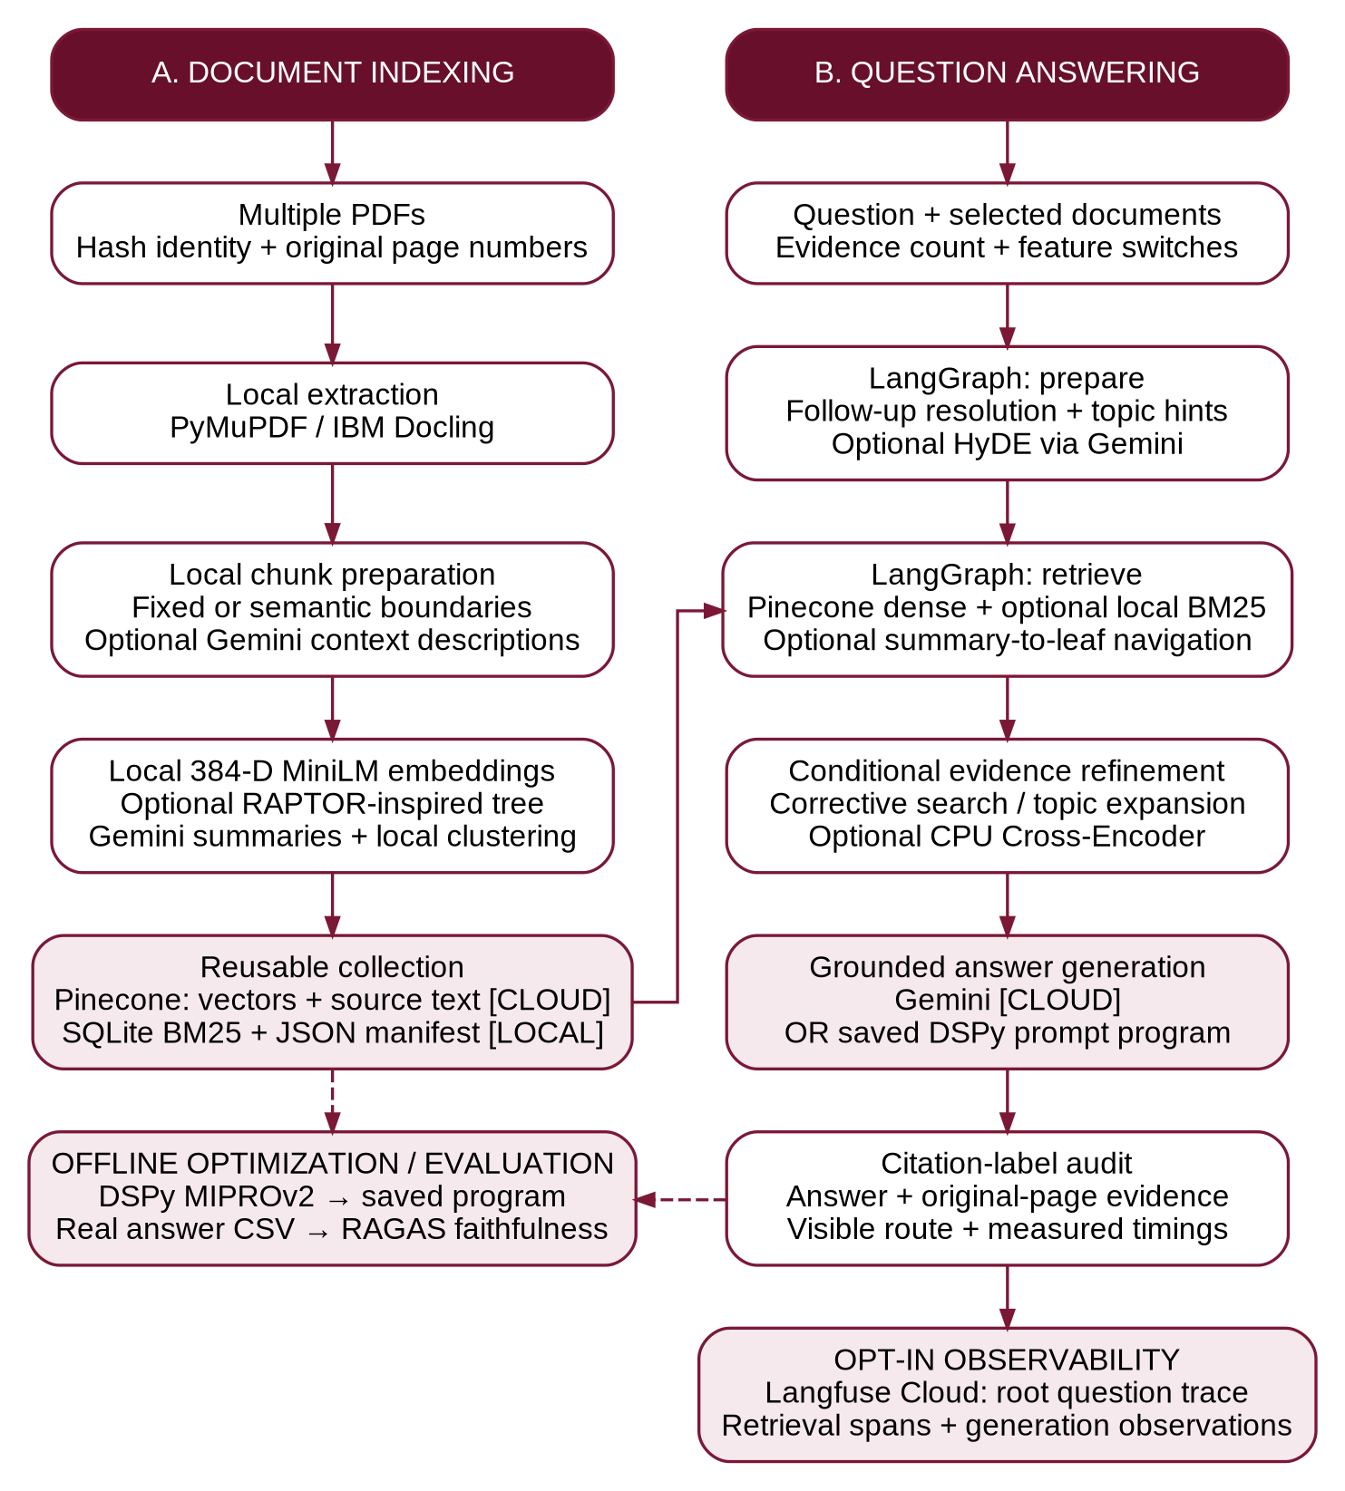
Figure 1. GroundLens architecture, separating indexing, answering, offline evaluation and opt-in tracing. [1]
Original files and the embedding model remain local. Pinecone receives vectors, text and metadata; Gemini receives excerpts for generation and optional enrichment. The BM25 database is local. Langfuse receives configured trace data only after explicit enablement. Dashed arrows indicate offline workflows, not mandatory stages of every question. [1]

3.1 LangGraph Control Flow
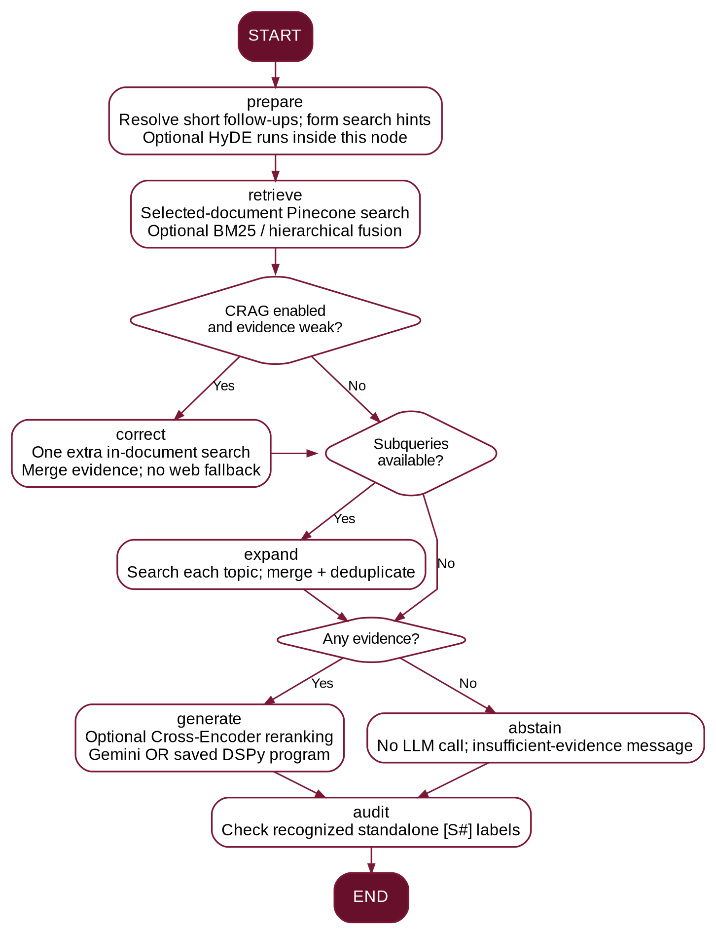
Figure 2. Implemented conditional control flow, including correction, expansion, generation, abstention and audit. [1]
The actual graph nodes are prepare, retrieve, correct, expand, generate, abstain and audit. The displayed rerank and dspy_generate labels record operations inside generate; they are not separate compiled graph nodes. HyDE executes inside prepare. This distinction explains the visible routes without implying two answer-generation calls. [1], [10]

4. Technology and Runtime Configuration
Table 4. Technology responsibilities and observed runtime.
Layer | Implementation used
Interface | Streamlit with NMIMS burgundy/red/white theme
Document processing | PyMuPDF; optional IBM Docling DocumentConverter
Embedding model | sentence-transformers/all-MiniLM-L6-v2; 384 dimensions; CPU
Storage and retrieval | Pinecone Serverless dense cosine index; local SQLite FTS5
Workflow and generation | LangGraph StateGraph; Google Gen AI SDK; Gemini
Relevance model | cross-encoder/ms-marco-MiniLM-L-6-v2 on CPU
Prompt optimization | DSPy 3.4.1 with MIPROv2 and Optuna, as shown in execution
Evaluation environment | RAGAS 0.3.9 in separate .venv-ragas
Observability | Langfuse SDK integration; cloud receipt confirmed
Recorded host | Windows; Python 3.11; 8 GB RAM; no dedicated GPU

4.1 Recorded deployment
The completed screenshots identify the answer model as gemini-3.5-flash-lite, the index as groundlens-rag-384 and the namespace as groundlens-raptor-test. These are recorded deployment settings, not recommendations that a particular model identifier or service quota will remain available indefinitely. Credentials remain in a private .env file. [2]
The final application runs on local port 8503. Its namespace isolates the document collection. The local manifest and SQLite cache must remain paired with the same Pinecone index and namespace; a mismatched manifest is rejected before retrieval. [1], [2]

5. Document Ingestion and Indexing

5.1 Page-aware extraction and IBM Docling
The upload limit is 12 MB per PDF. A SHA-256 hash of the file bytes supplies document identity, and records retain one-based PDF page numbers. PyMuPDF extracts selectable page text. The Docling branch converts the PDF and exports page-specific Markdown before normalization and chunking. Docling provides document-structure processing, but the demonstrated integration does not establish perfect OCR, table recovery or visual reasoning for every file. [1], [11]
Fixed-size processing uses a 170-word target with 35-word overlap. Page boundaries are preserved so the answer can point back to a source page. Text-only and image-heavy pages may still yield incomplete or imprecise extracted content. [1]
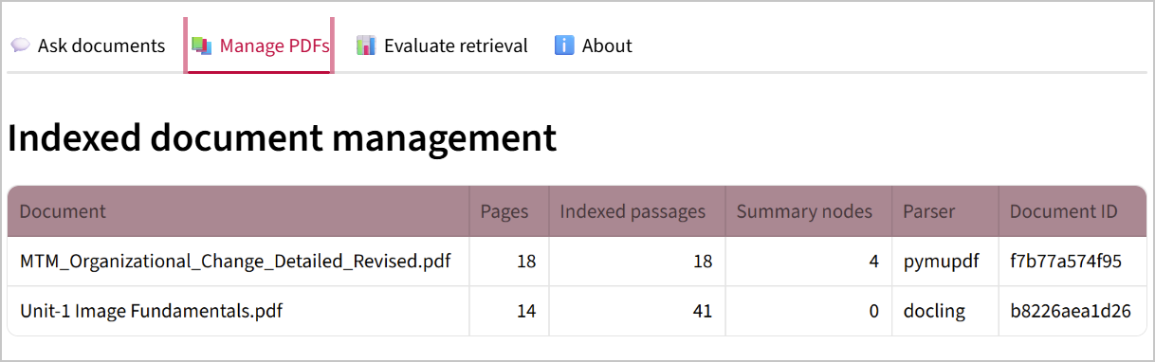
Figure 3. Image Fundamentals indexed through Docling: 14 pages and 41 source passages. [2]

5.1.1 Storage consistency and duplicate handling
Leaf IDs combine the document hash, page and chunk number. Pinecone upserts are batched; the local lexical index and manifest are saved after successful cloud writes. Re-uploading an already indexed document normally skips processing. Indexing switches therefore apply to new files, not retroactively to existing vectors. [1]
The 41-passage Docling result establishes successful conversion and indexing. It is not, by itself, evidence that Docling is more accurate than another parser: passage counts also depend on extracted layout and splitting behaviour. [2]

5.2 Semantic Chunking
GroundLens implements semantic_split() directly using the existing local sentence encoder; it does not call a LlamaIndex semantic splitter. Text is divided into sentence-like units and neighbouring units are compared through normalized embeddings. The splitter uses semantic discontinuity together with a word-budget constraint. [1]
δⱼ = 1 − (eⱼ · eⱼ₊₁), τ = percentile₈₀(δ)
A boundary is eligible when adjacent sentences are sufficiently dissimilar and the accumulated segment already contains approximately one-third of the 170-word target. The word budget can independently force a split. Very short sentence lists and oversized sentences fall back to bounded word splitting. This is an embedding-aware heuristic, not a learned optimal segmentation model. [1]
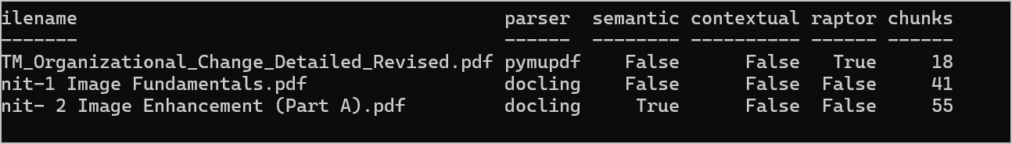
Figure 4. Saved manifest confirms semantic=True for Image Enhancement and records 55 chunks. [2]

5.2.1 Observed evidence and interpretation
The Image Enhancement document has 52 pages and 55 indexed passages with parser=docling and semantic=True. The subsequent gamma-transformation response addressed the principal question with displayed citations. The indexing record is stronger evidence of the selected configuration than a checkbox photographed after ingestion. [2]
Because Docling and semantic splitting were used together for this document, the recorded passage count cannot isolate the contribution of semantic splitting. No controlled segmentation benchmark is claimed. Local embeddings are pretrained; this stage does not fine-tune MiniLM. [1], [2]

5.3 Contextual Embedding Preparation
For eligible chunks, Gemini produces a short description using the filename, page, a brief document overview and the chunk itself. The description is prepended to the original passage before local embedding. At answer time, the stored original passage—not the generated description—is the factual evidence. This is a bounded adaptation of contextual retrieval rather than a full-document contextualization implementation. [1], [20]
vᵢ = E(“Context: ” + cᵢ + “ Passage: ” + xᵢ)
Here xᵢ is the original text, cᵢ is the generated context sentence, and E is the local MiniLM encoder. The lexical BM25 index continues to use original chunks, so this implementation does not contextualize both the dense and lexical indexes. [1]
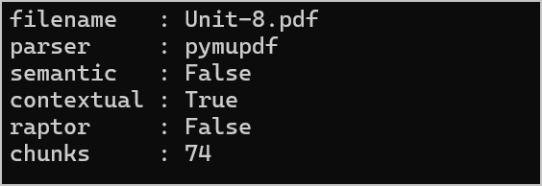
Figure 5. Unit-8 manifest: contextual=True, semantic=False, raptor=False and 74 source chunks. [2]
The supplied configuration limits contextualization to the first 30 chunks per document by default. For a 74-chunk file, the same document can therefore contain context-enriched and ordinary embeddings. A contextual=True flag records the selected mode, not 74 independently verified descriptions. The successful Unit-8 answer demonstrates usability of the indexed collection, not full coverage or superiority of contextual embeddings. [1], [2]
Context generation adds Gemini requests during indexing. The observed 429 quota errors are therefore relevant operational evidence. A completed manifest and successful retrieval should be distinguished from the success of each optional enrichment call. [1], [2]

5.4 RAPTOR-Inspired Hierarchical Indexing
RAPTOR motivates retrieval at several abstraction levels by recursively embedding, clustering and summarizing text. GroundLens adopts this hierarchy idea but implements a smaller, deterministic cosine K-means variant rather than the paper’s complete probabilistic-clustering pipeline. [1], [14]
The builder activates for documents with at least ten chunks. It groups local embeddings, asks Gemini for concise thematic summaries, embeds those summaries and repeats for at most two levels. The default bound is twenty summary nodes per document. Degenerate clusters use a deterministic balanced fallback. Each summary retains the IDs of its original leaf passages. [1]
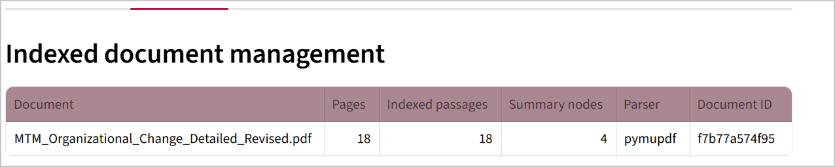
Figure 6. Organizational Change: 18 original passages and four hierarchical summary nodes. [2]

5.4.1 Navigation nodes are not source evidence
Summary records have record_type=summary and navigation metadata rather than an original page citation. A summary match leads back to leaf text in the local exact-ID cache. Only original PDF passages enter the answer evidence. This reduces the risk of presenting model-generated summaries as quotations from the source document. [1]
The final collection preserves four summary nodes for Organizational Change. The other three PDFs show zero summary nodes; hierarchical indexing was not enabled for every document. The displayed 188-source-passage count excludes these four navigation records. Thus the manifest describes 188 leaves plus four summaries, not 188 total records independently counted from Pinecone. [1], [2]

6. Retrieval and Evidence Refinement

6.1 Dense search, BM25 and reciprocal rank fusion
Questions and passages use the same 384-dimensional normalized encoder. Pinecone searches within the configured namespace and selected document IDs. Optional hybrid search adds a local SQLite FTS5 BM25 ranking and combines ranks, rather than adding incomparable cosine and BM25 scores. [1], [9], [12], [13]
similarity(q, xᵢ) = E(q) · E(xᵢ) distance = 1 − similarity
RRF(d) = Σₘ 1 / (60 + rankₘ(d))
The sum includes each retrieval list in which passage d occurs. Matching passages are deduplicated by document, page and chunk identity. This is client-side hybrid fusion over Pinecone dense retrieval and a local lexical index; it is not a native Pinecone sparse-vector implementation. [1]
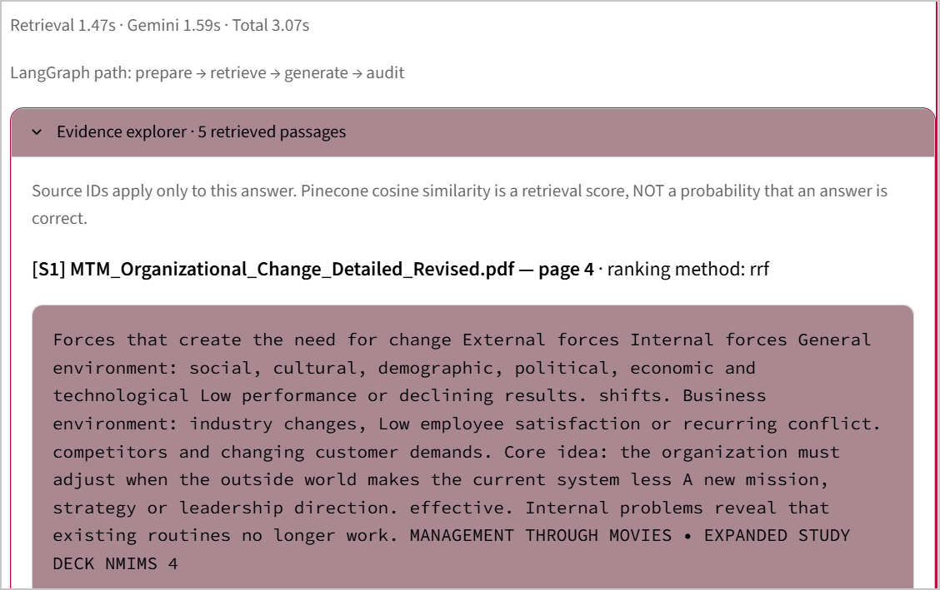
Figure 7. Hybrid test evidence: ranking method rrf, source page 4 and a completed answer route. [2]
The visible rrf label establishes use of the fusion pathway. It does not display each method’s contribution independently. Similarity and fusion scores rank evidence; neither is a calibrated probability that the answer is correct. [1], [2]

6.2 Hierarchical Retrieval and Topic Expansion
A matching summary is expanded to its leaf passages. Directly retrieved leaf scores are retained; missing children are embedded locally and individually compared with the query. The hierarchy score uses 90% leaf distance and 10% parent-summary distance, then filters uncompetitive children before rank fusion with direct results. This prevents one broad summary from promoting all its children equally. [1]
dʰ = 0.90 dleaf + 0.10 dparent
Separately, pattern-based decomposition identifies comparison or synthesis topics. The expand node searches each recognized topic, merges the results, removes duplicate passage IDs and limits final evidence to at most eight passages. No autonomous LLM planning agent is required for this branch. [1]
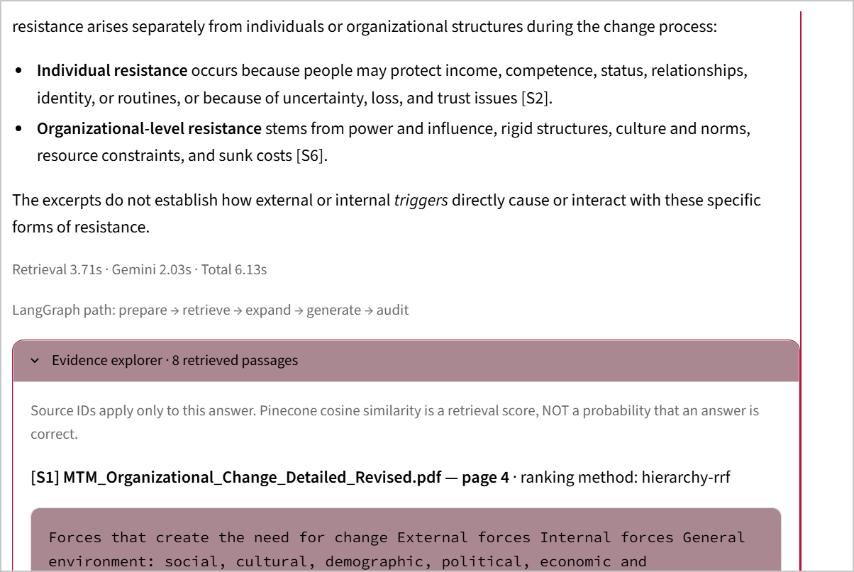
Figure 8. Three-topic synthesis records expand and hierarchy-rrf with original-page evidence. [2]
The completed question combines external forces, internal problems and resistance to change. The response covers supported concepts and qualifies a stronger causal connection that the excerpts do not establish. This is functional synthesis evidence, not a measured gain over all other retrieval configurations. [2], [4]

6.3 Cross-Encoder and Corrective Retrieval
The optional CPU Cross-Encoder jointly scores the question and selected candidate text, then reorders passages before generation. The model is cross-encoder/ms-marco-MiniLM-L-6-v2. In the compiled workflow, this operation occurs inside generate and appends rerank to the displayed path. [1], [21]
Figure 9. The hybrid-plus-reranking run records rerank in the displayed execution route. [2]
The corrective branch is a CRAG-inspired, in-document heuristic. It checks the maximum fraction of question keywords covered by a passage; a value below 0.25 triggers one additional search with filtered question terms. It neither uses a trained confidence classifier nor searches the web. [1], [15]
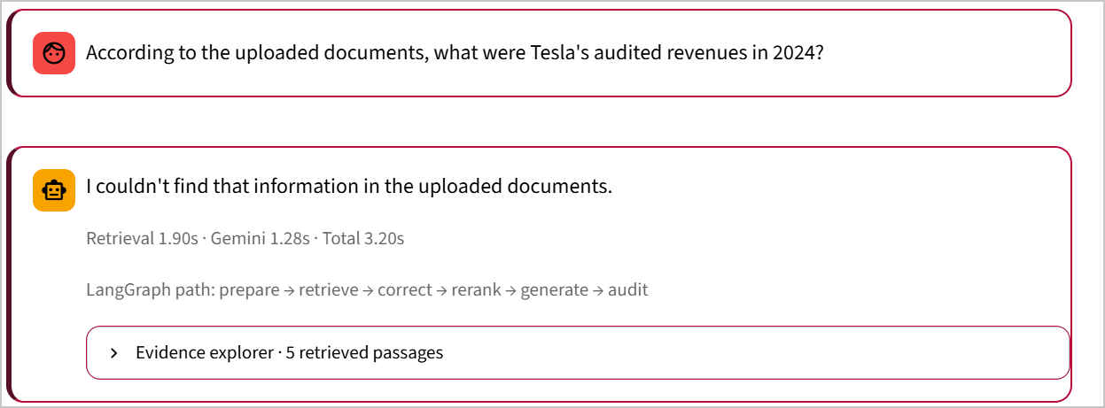
Figure 10. Unsupported Tesla question: correct executes and the response withholds an unsupported figure. [2]
This test verifies conditional correction and an insufficient-evidence response. It does not establish that correction recovered an answer or that a ranking score estimates factual confidence. The final answer remains limited to the selected document collection. [1], [2]

6.4 HyDE and Query Preparation
HyDE generates hypothetical source-like text and embeds it to retrieve real documents. GroundLens implements the same search-aid principle with Gemini and the local MiniLM encoder. The hypothetical paragraph is never passed to answer generation as original document evidence. [1], [16]
When enabled, the prepare node calls hyde_query(), records its use in state and passes the generated search text to retrieval. The original question remains the question answered by the generator. This explains why the visible route can remain prepare → retrieve → generate → audit rather than displaying a separate hyde node. [1]
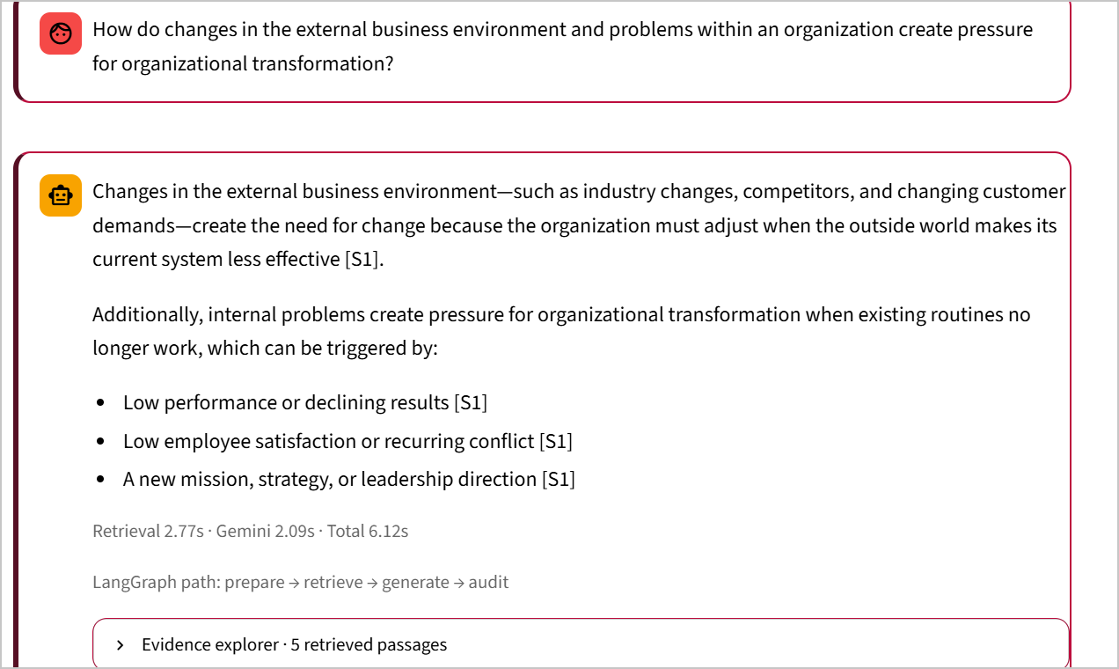
Figure 11. A paraphrased organizational-change question completes with HyDE and hybrid search selected. [2]
The supplied implementation executes the HyDE request when the option is enabled; the screenshot demonstrates the enabled answering workflow. A separate capture of the generated hypothetical text was not retained. Therefore the evidence is narrower than a full query-transformation trace or a controlled retrieval-quality comparison. [1], [2]
Short follow-ups can also reuse the previous question to resolve a reference. This bounded session-context mechanism is distinct from persistent conversational memory or checkpointed agent execution. [1]

7. Grounded Generation and Citation Handling
Each response receives its own source labels, [S1], [S2] and so on. The generation prompt contains original text with filenames and page numbers, the current question, and limited recent conversation. Previous answers are explicitly treated as conversational context rather than new document evidence. [1]

7.1 Supported synthesis and abstention
The prompt requires support for factual statements, permits clearly identified inference from supported facts, and asks for partial answers when only part of a compound question is supported. When no material support exists, the configured response is an insufficient-information statement. An empty retrieval result takes abstain without calling Gemini; irrelevant nonempty results can instead lead Gemini to decline an answer. [1]
The citation audit checks recognized standalone [S#] references against the supplied source count. It does not check every grouped-citation form, prove that the excerpt entails a claim or guarantee resistance to instructions embedded in source text. A visible audit step is therefore a reference-label check, not a factual certification. [1]

7.2 Generation configuration
The ordinary answer helper uses the Google Gen AI SDK, temperature 0.1, a 1,200-token output limit, a 60-second HTTP timeout and one configured SDK attempt. These settings describe the inspected code. They are separate from the RAGAS evaluator’s timeout and do not promise that every request will complete within the same wall-clock duration. [1]

7.3 DSPy as an alternative generation program
DSPy supplies a signature with question and evidence inputs and an answer output. A saved MIPROv2 program can replace ordinary generation while using the retrieved evidence and the same Gemini provider. DSPy optimizes instructions and examples; it does not fine-tune Gemini’s neural weights. The program is optional and requires an actual saved artifact. [1], [17]
The path dspy_generate → generate describes the DSPy operation inside the common generate node. It does not mean that an ordinary Gemini answer is always generated afterwards. This distinction is verified by the implementation’s mutually exclusive generation branches. [1]

7.4 DSPy Optimization Evidence
The optimization pack contains twelve development examples and four held-out questions. Each development row provides a question, source-labelled evidence and a reference answer. MIPROv2 runs in its light setting with one thread, using an overlap-based development metric. The exported program is saved as artifacts/dspy_program.json. [1]
development score = |tokens(reference) ∩ tokens(answer)| / |tokens(reference)|
This metric measures reference-token coverage. It is not semantic correctness, citation entailment, precision or a held-out accuracy percentage. The saved references require review; the existence of an optimization artifact is distinct from demonstrated generalization. [1]
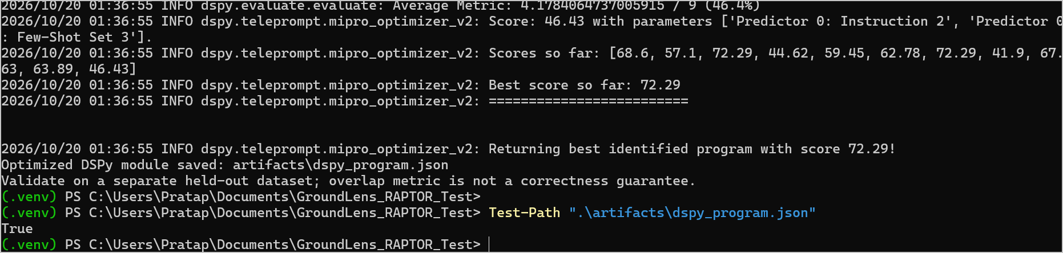
Figure 12. MIPROv2 completes, reports best score 72.29 and saves a program whose path exists. [2]
Some requests during optimization encountered Gemini quota errors. The captured run nevertheless returned its best identified program and saved it. The score 72.29 is therefore reported as the optimizer’s internal metric, not as 72.29% answer accuracy. [2]
The Moneyball question was held out of the twelve development examples. It was used for a live DSPy ON/OFF integration comparison. The remaining held-out questions are provided as evaluation material; this report does not claim that a complete four-question held-out benchmark was executed. [1], [2]

7.5 DSPy ON/OFF Observation
Table 5. One observed generation comparison, not a repeated benchmark.
Recorded measure | DSPy ON | DSPy OFF
Retrieval stage | 1.74 s | 1.58 s
Generation stage (UI: Gemini) | 3.43 s | 1.84 s
Total response | 26.81 s | 3.43 s
Visible generation path | dspy_generate → generate | generate
Question and retrieval mode | Moneyball; hierarchy; 8 passages | Same question and settings

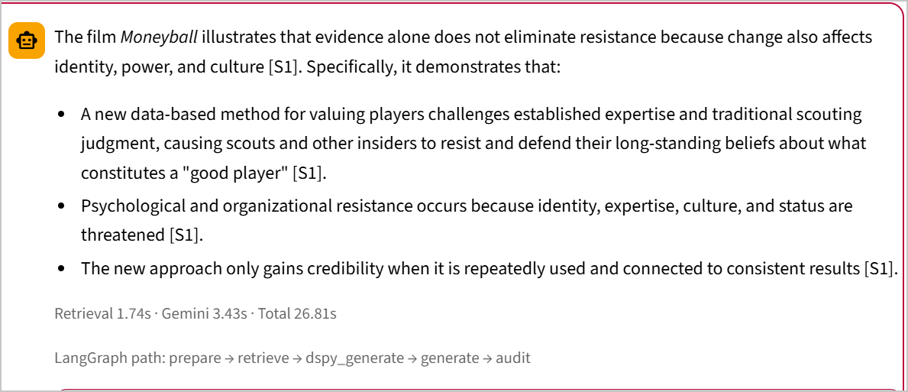
Figure 13. DSPy-enabled Moneyball answer with citations and the dspy_generate path. [2]
Both recorded answers address threatened expertise, culture, status and resistance to a data-based method. The ordinary response also gives more context about resource constraints and embedding the change. This example does not show a clear quality advantage for DSPy, and its total latency is higher. [2]
The comparison is one run per configuration. The displayed generation timer can include reranking or DSPy execution; it is not always an isolated network-call measurement. Additional time outside the two stage timers is not attributed to DSPy or service load without further profiling. [1], [2]

8. Application and Final Document Collection
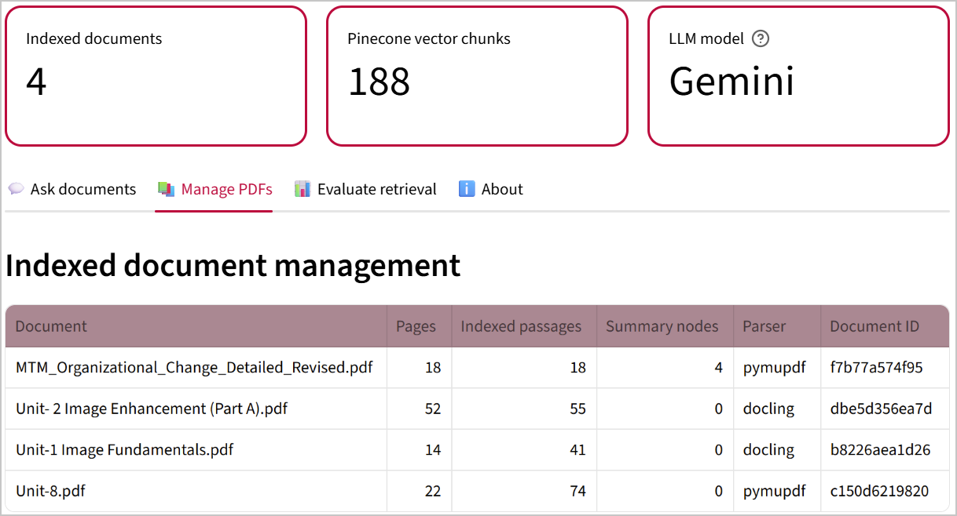
Figure 14. Final application recognizes all four documents and 188 source passages. [2]
Table 6. Final demonstration corpus and source counts.
Academic PDF | Pages | Passages | Summary nodes
Organizational Change | 18 | 18 | 4
Image Enhancement (Part A) | 52 | 55 | 0
Image Fundamentals | 14 | 41 | 0
Unit-8: Digital Video | 22 | 74 | 0
Total | 106 | 188 | 4

The interface exposes Ask documents, Manage PDFs, Evaluate retrieval and About. All four documents have local BM25 records. The count is manifest-backed; it is not a refreshed Pinecone cloud-statistics measurement. Unit-8.pdf contains a chapter headed “Unit 13 Digital Video”; the filename is retained as its document identity. [1], [2], [7]

8.1 Cross-Document Evidence Demonstration
The retained cross-document capture asks how sampling and quantization differ from intensity transformation. It selects Image Fundamentals and Image Enhancement, enables document coverage and records the expand route. The answer separates digitization of spatial coordinates/intensity from mapping already digital pixel values through s = T(r). [3], [5], [6]
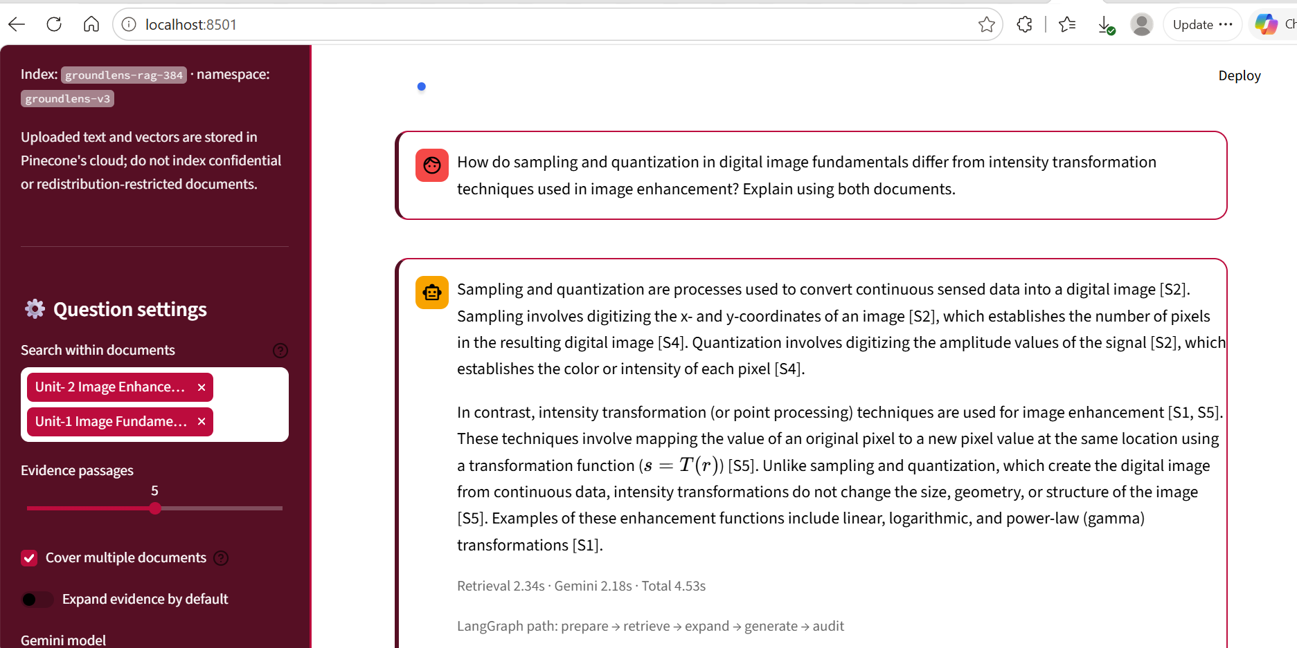
Figure 15. Cross-document response with page-linked citations and an expanded route; retained source capture dated 15 October 2026. [3]
Table 7. Source coverage for the two-document comparison.
Source | Original pages | Evidence used
Image Fundamentals | 6–7 | Spatial sampling and intensity quantization
Image Enhancement | 11–12 | Point processing and transformation families

This capture establishes the retained application’s cross-document capability. It predates the final four-document configuration and is not presented as a fresh combined-options benchmark. A title-only retrieved passage was not substantive support, illustrating why high retrieval similarity is not sufficient evidence. [3]

9. Experimental Methodology
Evidence is grouped into three levels: implementation inspection, functional execution and measured evaluation. A selected option is not treated as proof of execution; a successful route is not treated as proof of quality improvement. Figures retain genuine outputs and manifest values. [1], [2]
Table 8. Evidence matrix and bounded conclusions.
Component | Recorded evidence | Supported conclusion
Hybrid retrieval | rrf source label and answer | Fusion pathway used
Cross-Encoder | rerank route label | Reranking operation entered
Corrective retrieval | correct route; Tesla refusal | Conditional corrective branch executed
HyDE | Enabled response; inspected prepare code | HyDE-enabled workflow completed
Hierarchy | 4 nodes; hierarchy-rrf; expand | Index/navigation/synthesis demonstrated
Docling / semantic | Parser column; semantic manifest | Selected ingestion paths completed
Contextual indexing | contextual=True; Unit-8 answer | Configured collection supports Q&A
DSPy | Saved program; dspy_generate | Optimization and generation integration
RAGAS | 1 scored row; faithfulness=1.0000 | One completed live metric
Langfuse | Root/retrieval/generation rows | Cloud receipt of live observations

Live tests used selected academic questions rather than a random or exhaustive benchmark. Several settings, questions and source collections differ across captures. Performance observations are therefore reported individually, with no pooled accuracy estimate and no unsupported causal ranking of the techniques. [2]

9.1 Recorded Timing Results
Table 9. Individual completed runs from the execution captures.
Run / configuration | Retrieval (s) | Generation (s) | Total (s)
Hybrid: change drivers | 1.47 | 1.59 | 3.07
Hybrid + Cross-Encoder | 1.59 | 39.75 | 41.37
Corrective unsupported question | 1.90 | 1.28 | 3.20
Hybrid + HyDE paraphrase | 2.77 | 2.09 | 6.12
Hierarchy + three-topic expansion | 3.71 | 2.03 | 6.13
DSPy ON: Moneyball | 1.74 | 3.43 | 26.81
DSPy OFF: Moneyball | 1.58 | 1.84 | 3.43
Docling: image resolution | 2.71 | 15.28 | 20.86
Docling + semantic: gamma | 1.29 | 12.26 | 13.57
Contextual collection: streaming | 1.46 | 3.23 | 41.69
Final answer exported for RAGAS | 1.73 | 59.39 | 92.97
Final live traced streaming answer | 1.26 | 17.56 | 41.92

9.1.1 Timer interpretation
Retrieval time accumulates work inside retrieve, correct and expand. The generation-stage timer surrounds the generate node, including optional reranking or DSPy. The outer total also includes resource access, graph construction, preparation and other unmeasured work. Consequently the two stage values do not always sum to total latency. [1]
For example, 41.69 − 1.46 − 3.23 = 37.00 seconds are outside the displayed retrieval and generation timings in the contextual-collection run. The record does not identify a single cause. These single runs are not latency percentiles, a warm-cache benchmark or a throughput claim. [2]

9.2 Answer-Level Evidence and Content Checks
The final streaming question was restricted to Unit-8.pdf. GroundLens explains that playback starts after an initial portion has downloaded while the remaining file downloads progressively. The cited document describes this mechanism on PDF page 8; factors affecting playback appear on pages 7–8 and in the chapter’s review material. [2], [7]
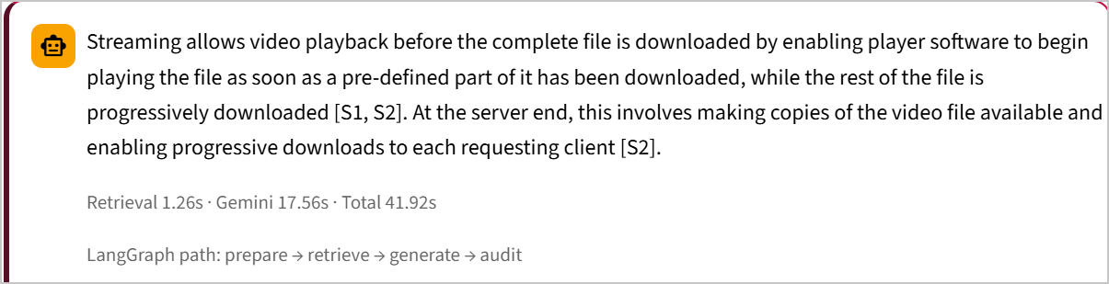
Figure 16. Final Unit-8 answer, source labels and recorded route from the live Langfuse-enabled session. [2]

9.2.1 Correct abstention versus missing knowledge
An RGB-to-CMY numerical question initially failed because the indexed Unit-8 file concerned digital video rather than the separate colour-transformation numerical PDF. That response is not used as evidence that contextual embeddings failed. Retrieval cannot supply a numerical example from an unindexed file. The subsequent video question matches the actual source and receives a supported answer. [2], [7]

9.2.2 Answer-quality limitations remain visible
The gamma response gives the standard direction of brightness change for normalized intensities: gamma below one brightens and gamma above one darkens. The resolution response also contains a questionable statement that intensity resolution is not used to generate a digital image. This case is retained as an answer-quality limitation rather than being silently classified as flawless. A correct ingestion path does not guarantee every generated sentence. [2], [5], [6]
Displayed citation labels alone do not prove support. Only the visible original passages or source-document checks justify a claim-level assessment. This report does not assign universal citation accuracy from a small number of inspected examples. [1], [2]

9.3 RAGAS Evaluation Procedure
RAGAS evaluates an exported GroundLens response together with its retrieved evidence. The export contains question, answer and contexts_json; preparation matches a reviewed reference into ground_truth. A dry run validates the completed row before any model requests. The selected live metric is faithfulness. [1], [2]
Faithfulness = supported answer claims / total extracted answer claims
The evaluator decomposes the answer into claims and judges whether the retrieved context supports them. Faithfulness measures support relative to those passages; it does not require the reference answer for its core calculation and does not establish completeness, retrieval recall or truth beyond the sources. The runner still requires ground_truth for its common evaluation schema. [1], [18]

9.3.1 Isolated evaluation environment
The successful installation uses RAGAS 0.3.9 in .venv-ragas. A separate environment avoids modifying the working LangGraph/DSPy application dependencies. The observed missing langchain_community.chat_models.vertexai import was resolved through compatible dependency pins. A later 90-second timeout was addressed by setting the evaluator’s RunConfig timeout to 240 seconds. [2]
python -m evaluation.prepare_ragas --input evaluation/groundlens_ragas_input.csv
python -m evaluation.ragas_runner --dry-run evaluation/ragas_ready.csv
python -m evaluation.ragas_runner --limit 1 --metrics faithfulness evaluation/ragas_ready.csv
The successful run uses one worker and one configured retry. The live generation and judging both use Gemini in the recorded setup, so the result is not an independent-model benchmark. API service time and quota availability remain external constraints. [1], [2]

9.4 Measured RAGAS Result
Figure 17. Completed RAGAS evaluation: faithfulness 1.0000, one scored row and results saved to CSV. [2]
Table 10. The completed live RAGAS evaluation.
Evaluation item | Observed value
Metric | RAGAS faithfulness
Evaluated answers | 1
Score | 1.0000
Evaluation progress | 1/1 completed
Displayed evaluation duration | 48.78 seconds
Saved output | evaluation/ragas_results.csv
Question topic | Internet video streaming and progressive playback

The score means that this evaluator judged the extracted answer claims to be supported by the supplied retrieved passages. It is not “100% GroundLens accuracy”, not a result for all four PDFs, and not a claim that every displayed citation has been independently checked. The screenshot does not expose the exact claim count or per-claim verdicts. [2], [18]
The execution output records the measured score and confirms that the result was saved as a CSV file. Context precision, context recall and answer relevancy are supported by the runner as optional metrics, but no measured values for those metrics are reported. [1], [2]
For reproduction, retain the tested evaluator setting timeout=240. The completed result follows that local timeout adjustment; it should not be confused with the ordinary answer helper’s separate HTTP timeout. [1], [2]

10. Langfuse Observability
Langfuse tracing is explicitly opt-in. The application opens a root observation for the question, and instrumented functions record retrieval and generation observations. The synthetic check verifies connectivity without user PDFs; a real application question separately verifies the deployed workflow. [1], [19]
Figure 18. Synthetic health-check observation received by Langfuse Cloud. [2]
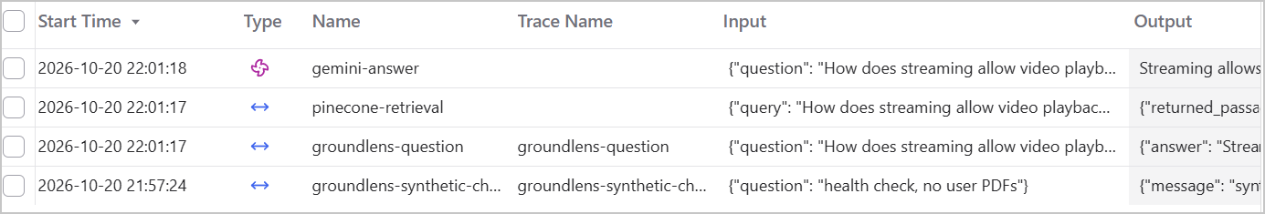
Figure 19. Live trace listing includes groundlens-question, pinecone-retrieval and gemini-answer. [2]

10.1 What the live trace establishes
The dashboard receives the actual video-streaming question and answer, with named observations for the root operation, Pinecone retrieval and Gemini generation. These records demonstrate trace delivery beyond a local “export attempted” message. The screenshot contains the synthetic check and real workflow observations, not four separate real questions. [2]
The implementation has optional spans for HyDE, correction, query expansion, reranking and DSPy. The final captured trace exercises the ordinary retrieval/generation route; it does not demonstrate every optional span. Code forwards available Gemini usage metadata, but the screenshot does not display audited token totals or monetary costs. Those measurements are not reported. [1], [2]
The RAGAS score is a separate CSV result. No evidence shows automatic attachment of that score to a Langfuse trace, so the report does not present RAGAS and Langfuse as a single already-validated scoring dashboard. [1], [2]

11. Reliability and Integration Findings
Table 11. Observed operational issues and bounded remedies.
Observed issue | Resolution or interpretation
Invisible advanced controls | Sidebar contrast corrected; settings became readable.
Gemini 503 responses | A different available model was selected; this is distinct from a local parsing fault.
Gemini 429 responses | Quota pressure occurred during optional calls; repeated retries were not treated as a data repair.
Weak hierarchy selection | Children were rescored individually rather than inheriting a parent summary’s relevance.
Multi-topic refusal | Search-hint expansion and supported-part synthesis were added.
Missing Optuna | DSPy optimizer’s optional dependency was installed.
RAGAS import failure | Separate evaluation environment and compatible LangChain dependencies.
RAGAS timeout | Evaluator timeout changed from 90 to 240 seconds; a later run completed.
Langfuse remained OFF | Exact opt-in variable GROUNDLENS_LANGFUSE_ENABLED=1 was used.

These are implementation and integration observations, not a guarantee that all failures have been eliminated. The main generation helper still has a single configured SDK attempt, and optional enrichment operations can consume additional API calls. No new rate-limiting service or fault-tolerant job queue is claimed. [1], [2]
Re-indexing is not the normal remedy for a Gemini service error. Deterministic IDs and namespace isolation protect the collection during controlled ingestion, while the JSON manifest and SQLite cache must remain aligned with the configured Pinecone namespace. [1]

11.1 Limitations and Responsible Interpretation

Evidence quality and retrieval completeness
Document extraction can lose layout, split equations or retain source errors. Title-only fragments can rank highly, and an eight-passage limit can omit material needed for a broad answer. Docling processing is demonstrated, but a comprehensive OCR, formula or table benchmark is not. A statement that information was not found refers to the selected evidence, not a proof of absence from the full collection. [1]–[3]

Conditional methods and resource limits
The corrective trigger is a keyword heuristic, semantic boundaries use a percentile rule, and hierarchical clustering is a bounded adaptation. Context enrichment is capped; not every chunk in a context-enabled file receives a generated description. All optional methods add complexity, and several add CPU work or hosted model calls. Their benefits depend on the question and source material. [1]

Evaluation validity
One RAGAS result cannot establish overall accuracy. The DSPy metric is token coverage and the ON/OFF comparison is a single pair of runs. Tests are manually selected and do not form a large held-out or adversarial benchmark. Automated unit checks validate code behaviour separately from live cloud generation. [1], [2]

Timing and observability
Several recorded totals exceed the displayed retrieval-plus-generation sum by a wide margin. The instrumented trace confirms cloud receipt, but full stage attribution, reliable token accounting and cost analysis are not demonstrated. Service contention, resource loading and orchestration remain possibilities, not verified explanations for the observed residual time. [1], [2]

Safety and privacy
Grounding prompts and a source-label audit do not guarantee immunity to hallucination or prompt injection. Uploaded text reaches Pinecone and selected context reaches Gemini. Enabling Langfuse adds a third external destination for configured telemetry. Only documents and trace content permitted for these services should be used. [1]

12. Reproducibility and Repository Preparation

12.1 Repository identity and installation
The project repository remains:
https://github.com/aryanpaode/groundlens-rag
The repository is the publication location for the application, this report and the permitted execution evidence. Matching source, configuration templates, dependency specifications and screenshots form the reproducibility package. Private runtime data and credentials remain outside the published repository. [1]–[3]
py -3.11 -m venv .venv
.\.venv\Scripts\python.exe -m pip install -r requirements.txt
Copy-Item .env.example .env
.\.venv\Scripts\python.exe -m pytest -q
.\.venv\Scripts\python.exe check_pinecone.py
.\.venv\Scripts\python.exe -m streamlit run app.py --server.port 8503
Configure GEMINI_API_KEY, GEMINI_MODEL, PINECONE_API_KEY, PINECONE_INDEX, PINECONE_NAMESPACE, PINECONE_CLOUD and PINECONE_REGION privately. Pinecone must accept external 384-dimensional dense vectors with cosine similarity. Optional dependencies should be installed only for the features being used. [1]

12.2 State migration versus a clean checkout
The completed local installation retains its matching .env, runtime/pinecone_manifest.json, runtime/groundlens_bm25.sqlite3 and artifacts/dspy_program.json. A migration copies this state into the consolidated application without recreating the cloud collection. A public clean checkout should instead use a fresh authorized workspace or restore its own private matching state. [1], [2]
Do not publish private .env files, keys, virtual environments, local runtime databases or unrestricted copies of teaching PDFs. A saved DSPy artifact can contain demonstration text and must be reviewed for redistribution permission before inclusion. The report and sanitized screenshots are suitable repository documentation. [1]

12.3 Evaluation and Tracing Reproduction
The live RAGAS check used a separate Python 3.11 environment to isolate the legacy evaluation API. The following dependency combination reflects the successful setup sequence; it is not a guarantee for every future package release. [2]
py -3.11 -m venv .venv-ragas
$rp = ".\.venv-ragas\Scripts\python.exe"
& $rp -m pip install "ragas==0.3.9" "langchain-community==0.3.31" `
"langchain==0.3.27" "langchain-google-genai>=2.1,<3" `
"datasets>=4,<5" "python-dotenv>=1,<2"
The evaluator setting used for the completed check is RunConfig(max_workers=1, max_retries=1, timeout=240). Export a real answer, review the matched reference, validate it with --dry-run and then evaluate one row initially. The result belongs in evaluation/ragas_results.csv; the reference and actual retrieved passages should be retained together. [1], [2]

12.3.1 Langfuse opt-in configuration
GROUNDLENS_LANGFUSE_ENABLED=1
LANGFUSE_PUBLIC_KEY=<private project public key>
LANGFUSE_SECRET_KEY=<private project secret key>
LANGFUSE_BASE_URL=https://cloud.langfuse.com
The recorded deployment uses the EU Langfuse endpoint. Use the endpoint for the actual project region. After saving private credentials, the main application environment runs scripts/check_langfuse.py --send. Restarting Streamlit loads the new configuration; a genuine question should then produce a visible groundlens-question observation. [1], [2]
The package’s broad optional dependency file should not be treated as the exact RAGAS compatibility lock. The isolated evaluator configuration and final timeout setting are part of the tested reproduction record. [1], [2]

12.4 Implementation Map and Local Checks
Table 12. Source-module responsibilities.
Module or area | Implemented responsibility
app.py | Streamlit controls, graph invocation, root trace and answer export
rag/document_ingestion.py | Docling conversion and custom semantic splitting
rag/pdf_processing.py | Page text extraction, normalization and fixed chunks
rag/pinecone_store.py | Index checks, ingestion, scoped search and hierarchy expansion
rag/lexical_store.py | SQLite FTS5 BM25, exact-ID leaf cache and RRF
rag/raptor.py | Bounded clustering, summaries and child-leaf links
rag/model_helpers.py | Chunk-context descriptions and HyDE queries
rag/corrective.py | Keyword-overlap weakness trigger and corrected query
rag/reranking.py | Cached CPU Cross-Encoder scoring
rag/workflow.py | StateGraph routes, decomposition and optional operations
rag/generation.py | Grounded prompt, Gemini call and source-label audit
rag/dspy_program.py | Saved DSPy program and alternative generation
rag/observability.py | Opt-in Langfuse spans and available token metadata
scripts/optimize_dspy.py | Offline MIPROv2 compilation
evaluation/prepare_ragas.py | Real-response/reference matching
evaluation/ragas_runner.py | Validated, opt-in metric execution and CSV output

A credential-free check of the inspected consolidated source completed with 43 tests passed and one skipped. The skipped module requires LangGraph, which was not installed in the report-preparation environment. This is not a new live cloud test or a claim that every optional dependency ran locally; the laptop screenshots provide separate execution evidence. [1]

13. Conclusion
GroundLens implements the complete multi-document question-answering workflow while exposing how answers are retrieved, generated and supported. The completed system integrates configurable document processing, local embeddings, Pinecone storage, lexical fusion and LangGraph control flow without changing the application’s central purpose. [1], [2]
The final recorded collection comprises four PDFs, 106 pages and 188 original-source passages, plus four summary-navigation nodes. Evidence demonstrates Docling processing, semantic indexing configuration, context-enabled document answering, hierarchical fusion, multi-topic expansion, corrective routing and optional DSPy generation. The RAGAS integration produced one measured faithfulness score of 1.0000, and Langfuse received genuine question, retrieval and generation observations. [2]
The main contribution is the traceable integration of document processing, retrieval and generation: source pages remain inspectable, optional methods can be selected independently, the graph exposes its route and evaluation is based on actual exported responses. Research-inspired components are described at the level implemented, including local BM25 fusion, bounded contextualization and the RAPTOR-inspired hierarchy. [1], [2]

13.1 Remaining research and engineering work
Further work should prioritize a larger reviewed held-out test set, controlled ablations with identical questions and sources, and repeated warm/cold latency measurements. These would establish when each optional feature is worth its additional cost. More detailed phase timing and verified token accounting would make performance conclusions stronger. [1], [2]
Other practical refinements include explicit enrichment-coverage records, careful dependency locking and better rate-aware scheduling of hosted-model requests. These are prospective improvements, not components claimed as complete in the present implementation. The report supports a reproducible academic prototype, not an unqualified production or accuracy guarantee.
Final outcome: an operational, evidence-visible advanced RAG application that combines multi-document question answering with configurable retrieval, measured faithfulness evaluation and live cloud observability.

References
[1] A. Paode, GroundLens, consolidated Python implementation, October 2026. Source archive inspected: GroundLens_Final_Advanced_RAG.zip; principal modules listed in Section 12.4. Repository: https://github.com/aryanpaode/groundlens-rag
[2] A. Paode, GroundLens execution evidence, October 19–20, 2026. Original application, manifest, DSPy, RAGAS and Langfuse screenshots; evidence identifiers and source filenames are listed in Appendix B.
[3] A. Paode, GroundLens: Evidence-Grounded Multi-Document Question Answering Using Pinecone and LangGraph, supplied report C033_GroundLens_Final_Report(2).docx, and retained October 15, 2026 cross-document captures.
[4] Management Through Movies, Organizational Change, supplied academic study deck MTM_Organizational_Change_Detailed_Revised.pdf, 18 pages.
[5] Unit 1: Image Fundamentals, supplied academic lecture PDF, 14 pages.
[6] Unit 2: Image Enhancement (Part A), supplied academic lecture PDF, 52 pages.
[7] Unit 13: Digital Video, supplied as Unit-8.pdf, 22 PDF pages, printed pages 51–72. Section 13.2.6 supports the streaming test.
[8] P. Lewis et al., “Retrieval-Augmented Generation for Knowledge-Intensive NLP Tasks,” NeurIPS, 2020, arXiv:2005.11401. https://arxiv.org/abs/2005.11401
[9] Pinecone, “Hybrid search overview,” official documentation. Accessed October 20, 2026. https://docs.pinecone.io/guides/search/hybrid-search
[10] LangChain, “LangGraph overview,” official documentation. Accessed October 20, 2026. https://docs.langchain.com/oss/python/langgraph/overview
[11] C. Auer et al., “Docling Technical Report,” arXiv:2408.09869, 2024; Docling project documentation. https://arxiv.org/abs/2408.09869

References (continued)
[12] Sentence Transformers, “all-MiniLM-L6-v2,” official model card. Accessed October 20, 2026. https://huggingface.co/sentence-transformers/all-MiniLM-L6-v2
[13] SQLite, “FTS5 Extension,” official documentation, including the BM25 auxiliary function. Accessed October 20, 2026. https://sqlite.org/fts5.html
[14] P. Sarthi et al., “RAPTOR: Recursive Abstractive Processing for Tree-Organized Retrieval,” ICLR, 2024, arXiv:2401.18059. https://arxiv.org/abs/2401.18059
[15] S.-Q. Yan, J.-C. Gu, Y. Zhu, and Z.-H. Ling, “Corrective Retrieval Augmented Generation,” arXiv:2401.15884, 2024. https://arxiv.org/abs/2401.15884
[16] L. Gao, X. Ma, J. Lin, and J. Callan, “Precise Zero-Shot Dense Retrieval without Relevance Labels,” arXiv:2212.10496, 2022. https://arxiv.org/abs/2212.10496
[17] DSPy, “MIPROv2,” official optimizer documentation. Accessed October 20, 2026. https://dspy.ai/current/api/optimizers/MIPROv2/
[18] RAGAS, “Faithfulness,” official metric documentation, versioned documentation path v0.3.9. Accessed October 20, 2026. https://docs.ragas.io/en/v0.3.9/concepts/metrics/available_metrics/faithfulness/
[19] Langfuse, “Observability & Application Tracing,” official documentation. Accessed October 20, 2026. https://langfuse.com/docs/observability/overview
[20] Anthropic, “Contextual Retrieval,” engineering article, 2024. Accessed October 20, 2026. https://www.anthropic.com/engineering/contextual-retrieval
[21] Sentence Transformers, “ms-marco-MiniLM-L6-v2,” Cross-Encoder model card. Accessed October 20, 2026. https://huggingface.co/cross-encoder/ms-marco-MiniLM-L6-v2

Appendix A. Recorded Test Questions
A1 — Hybrid and reranking
What are the external and internal forces that trigger organizational change?
A2 — Corrective / unsupported
According to the uploaded documents, what were Tesla’s audited revenues in 2024?
A3 — HyDE paraphrase
How do changes in the external business environment and problems within an organization create pressure for organizational transformation?
A4 — Hierarchy and expansion
Explain how external forces, internal organizational problems, and resistance to change are interconnected in organizational transformation.
A5 — DSPy held-out comparison
What does the film Moneyball illustrate about resistance to a data-driven change?
A6 — Docling collection
Explain the difference between spatial resolution and intensity resolution in digital images.
A7 — Semantic-indexed collection
How does gamma transformation affect the brightness of an image, and what is the significance of different gamma values?
A8 — Contextual collection / RAGAS export
According to Unit-8, what factors affect the smooth streaming of digital video over the internet, and how does streaming allow playback before the entire video file is downloaded?
A9 — Live Langfuse trace
How does streaming allow video playback before the complete file is downloaded?
The retained two-document comparison is documented in Section 8.1. The RGB-to-CMY question is treated as a source-selection mismatch, not an answerable Unit-8 test. [2], [3]

Appendix B. Evidence Register
Figures use genuine supplied captures. Crops remove interface margins or unrelated account information; answer text, scores, counts and execution routes are not reconstructed. Original filenames are retained here to permit comparison with the full capture. Diagram figures are explanatory drawings based on code, not application screenshots. [1], [2]
Fig. | Original capture identifier | Evidence role
1 | Authored from inspected source | Architecture / control flow
2 | Authored from inspected source | Architecture / control flow
3 | 20261019-203525 | Docling indexing
4 | 20261019-205239 | Semantic ingestion record
5 | 20261020-054319 | Contextual ingestion record
6 | 20261019-185005 | 4 summary nodes
7 | 20261019-182519 | RRF evidence
8 | 20261019-194356 | Expansion + hierarchical evidence
9 | 20261019-182747 | Rerank path
10 | 20261019-182944 | Corrective branch
11 | 20261019-183157 | HyDE-enabled answering
12 | 20261019-200846 | MIPROv2 output + artifact
13 | 20261019-201415 | DSPy answer + path
14 | 20261020-151931 | Final 4-PDF collection
15 | 11-cross-document-answer-and-route.png | Two-document answer
16 | 20261020-163203 | Final traced response
17 | 20261020-155521 | Faithfulness = 1.0000
18 | 20261020-162813 | Synthetic trace receipt
19 | 20261020-163250 | Live observations

Additional retained control evidence: image(20261019-201628).png (DSPy OFF); image(20261020-055252).png (contextual-collection streaming response); image(20261020-152522).png (answer exported for RAGAS); image(20261020-154747).png (RAGAS 0.3.9 environment). The data table in Section 9.1 also uses the corresponding original answer captures. [2]

