Pre-Lab Activity 1: Understanding useEffect Execution
import React, { useEffect } from "react";
function WelcomeComponent() {
useEffect(() => {
console.log("Component Loaded Successfully!");
}, []); // Empty dependency array
return <h2>Hello, Welcome to React useEffect Demo!</h2>;
}
export default WelcomeComponent;
Output:
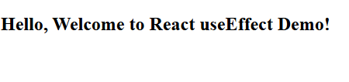
Pre-Lab Activity 2: Dependency Array Behavior
import React, { useState, useEffect } from "react";
function CounterComponent() {
const [count, setCount] = useState(0);
// Dependency with count
useEffect(() => {
console.log("Counter Updated");
}, [count]);
return (
<div>
<h2>Count: {count}</h2>
<button onClick={() => setCount(count + 1)}>Increment</button>
</div>
);
}
export default CounterComponent;
Output:
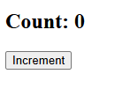 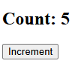
Pre-Lab Activity 3: Simulating API Call using setTimeout
import React, { useState, useEffect } from "react";
function FakeApiComponent() {
const [data, setData] = useState(null);
useEffect(() => {
setTimeout(() => {
setData("Sample Data Fetched Successfully!");
}, 2000);
}, []);
return (
<div>
{data ? <h3>{data}</h3> : <h3>Loading...</h3>}
</div>
);
}
export default FakeApiComponent;
Output:
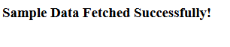 Pre-Lab Activity 4: Basic Fetch API (Without useEffect)
import React from "react";
function FetchOnClick() {
const fetchData = () => {
fetch("https://jsonplaceholder.typicode.com/users")
.then(response => response.json())
.then(data => console.log(data))
.catch(error => console.error("Error:", error));
};
return (
<div>
<button onClick={fetchData}>Fetch Data</button>
</div>
);
}
export default FetchOnClick;
Output:

Pre-Lab Activity 5: Async/Await Practice
import React from "react";
function AsyncAwaitExample() {
const fetchData = async () => {
try {
const response = await fetch("https://jsonplaceholder.typicode.com/users");
const data = await response.json();
console.log(data);
} catch (error) {
console.error("Error fetching data:", error);
}
};
return (
<div>
<button onClick={fetchData}>Fetch Data</button>
</div>
);
}
export default AsyncAwaitExample;
Output:
Pre-Lab Activity 6: Rendering Array Data Dynamically
import React, { useState } from "react";
function UserList() {
const [users] = useState([
{ id: 1, name: "Rahul Sharma", email: "rahul@gmail.com" },
{ id: 2, name: "Priya Mehta", email: "priya@gmail.com" },
{ id: 3, name: "Amit Verma", email: "amit@gmail.com" }
]);
return (
<div>
<h2>User List</h2>
<ul>
{users.map(user => (
<li key={user.id}>
<strong>{user.name}</strong> - {user.email}
</li>
))}
</ul>
</div>
);
}
export default UserList;
Output:
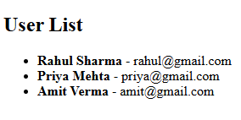
Pre-Lab Record Questions:
1.When does useEffect execute?
useEffect executes after the component renders (after the DOM updates).
- No dependency array → Runs after every render.
- Empty dependency array [] → Runs only once (when component mounts).
- With dependencies [value] → Runs whenever the specified dependency changes.
- It can also return a cleanup function, which runs before the component unmounts or before the next effect execution.

2. What is the difference between .then() and async/await?
.then() | async/await
Uses promise chaining | Uses synchronous-like syntax
Can become complex with multiple chains | Cleaner and easier to read
Errors handled using .catch() | Errors handled using try-catch
Less readable for complex logic | More readable and structured

3. Why is loading state important during API calls?
Loading state is important because:
- It improves user experience.
- It informs users that data is being fetched.
- It prevents showing empty or broken UI.
- It avoids confusion during network delay.

4. Why must fetched data be stored in state?
Fetched data must be stored in state because:
- React re-renders the component when state changes.
- If data is stored in a normal variable, React will not detect the change.
- Storing data in state ensures the UI updates automatically when new data arrives.

