
ARYAN PATIL 25070122051 CSE-A2

Subject: Programming with Java
ASSIGNMENT No :3
TITLE :Develop a Java application demonstrating method overloading and the use of static variables, methods in class design.

Problem Statement
Develop a Java application demonstrating method overloading and the use of static variables, methods in class design.

Learning Objectives
To implement method overloading and use static variables and methods in Java programs.

Theory
Method overloading allows multiple methods to have the same name with different parameter lists, enabling compile-time polymorphism. The static keyword is used for variables and methods that belong to the class instead of individual objects. Static members share common data among all objects and reduce memory usage. These concepts improve code flexibility, readability, and efficient resource management.

CONCLUSION- This assignment demonstrated the implementation of method overloading and the use of static variables and methods in Java. Method overloading provided flexibility by allowing multiple methods with the same name to perform similar operations using different parameter lists, while static members enabled data and methods to be shared across all objects of a class. The Calculator application showed how overloaded methods can handle different data types and how a static variable can track the number of calculations. Similarly, the Restaurant Billing Application demonstrated the use of overloaded methods for different order types and static variables to maintain the total number of orders. Overall, this assignment strengthened the understanding of compile-time polymorphism and efficient class design in Java.
EXCERCISES-
- Develop a Calculator program using overloaded methods for addition of integers and decimals. Use a static variable to count calculations.
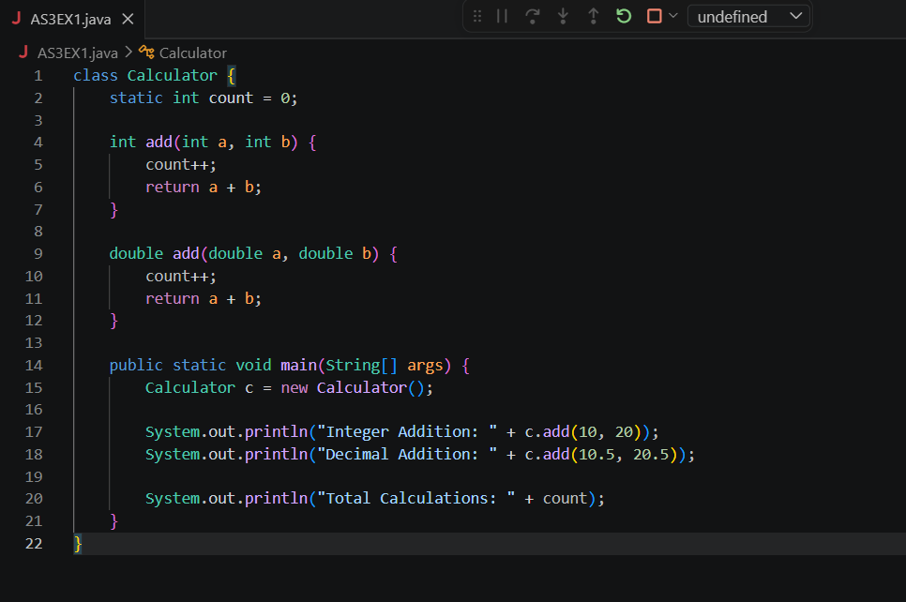

OUTCOME-
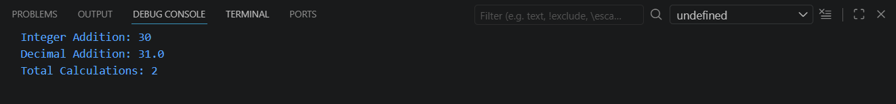

- Develop a Restaurant Billing Application where overloaded methods calculate bills for dine-in, takeaway, and delivery orders, while static variables track total orders.

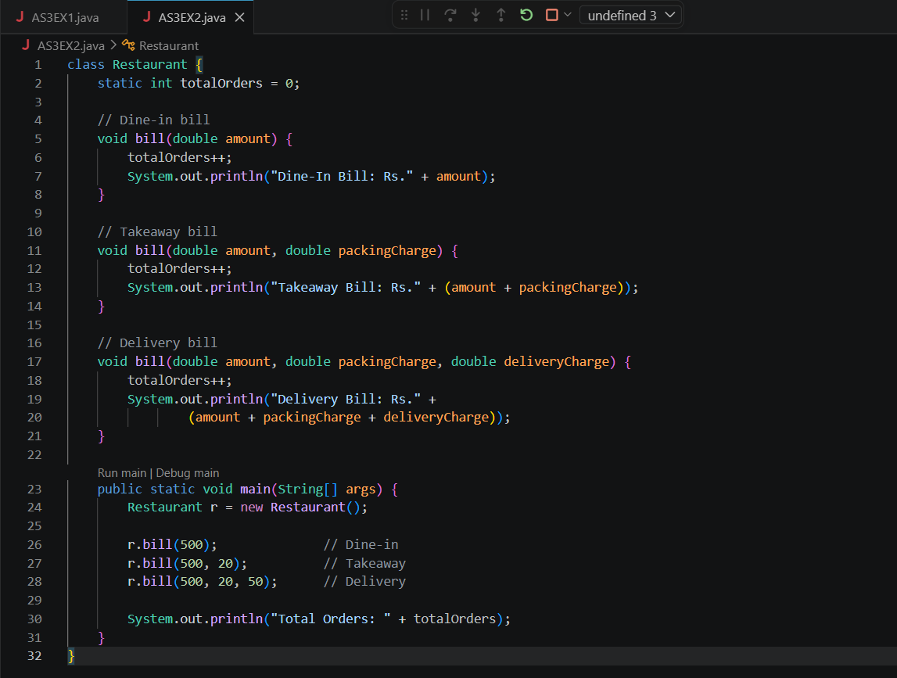

OUTCOME-
