
ARYAN PATIL 25070122051 CSE-A2

Subject: Programming with Java
ASSIGNMENT No : 4
TITLE :Develop a Java application demonstrating the use of wrapper classes for conversion between primitive data types and objects, and performing basic operations on wrapped values.

Problem Statement
Develop a Java application demonstrating the use of wrapper classes for conversion between primitive data types and objects, and performing basic operations on wrapped values.

Learning Objectives
To perform conversion between primitive data types and wrapper objects using Java wrapper classes.

Theory
Wrapper classes are predefined classes that encapsulate primitive data types into objects. Java provides wrapper classes such as Integer, Double, Character, and Boolean for every primitive type. They support autoboxing, unboxing, parsing, and conversion methods. Wrapper classes are widely used in Java Collections Framework and when object representation of primitive values is required
CONCLUSION-
This assignment demonstrated the use of Java wrapper classes for converting primitive data types to objects and vice versa. It provided practical experience with autoboxing, unboxing, and parsing methods to handle different types of data efficiently. The Student Marks program showed how string inputs can be converted into numeric values for calculations, while the Employee Payroll System illustrated the use of wrapper objects for input validation and salary computation. Overall, the assignment enhanced the understanding of wrapper classes and their importance in data conversion, validation, and real-world Java applications.

EXCERCISES-
- Create a program to convert student marks from String format to Integer and calculate total marks.

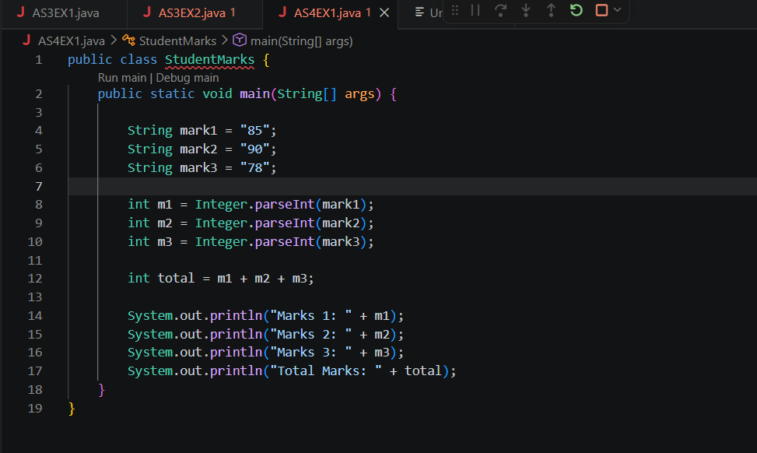

OUTCOME-
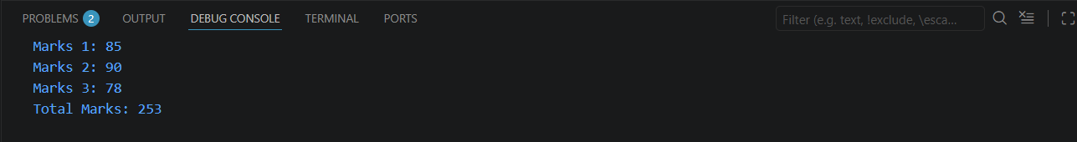
- Develop an Employee Payroll System that accepts employee IDs, basic salary, and bonus amounts from the user. Convert the entered values into wrapper objects and perform validation operations to ensure valid salary values before calculating the net salary.
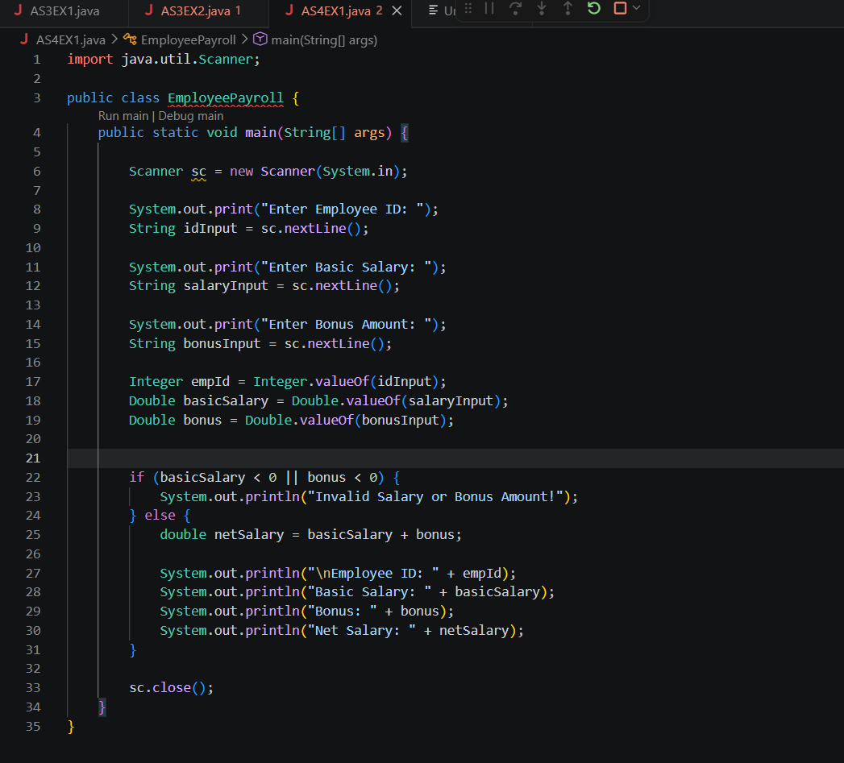

OUTCOME-
