
ARYAN PATIL 25070122051 CSEA2
Subject: Programming with Java
ASSIGNMENT No : 10
TITLE :Write a Java program to demonstrate the use of abstract classes and abstract methods
Problem Statement
Write a Java program to demonstrate the use of abstract classes and abstract methods
Learning Objectives
To implement abstraction using abstract classes and abstract methods.
Theory
Abstract classes provide partial implementation of a program and cannot be instantiated directly. They may contain both abstract and concrete methods. Abstract methods declare functionality that must be implemented by subclasses. Abstraction hides implementation details while exposing only essential functionality. This improves code flexibility and maintainability in object-oriented programming.
Outcome
Exercise
- Create an abstract Payment class and implement Credit Card and UPI payment classes.?
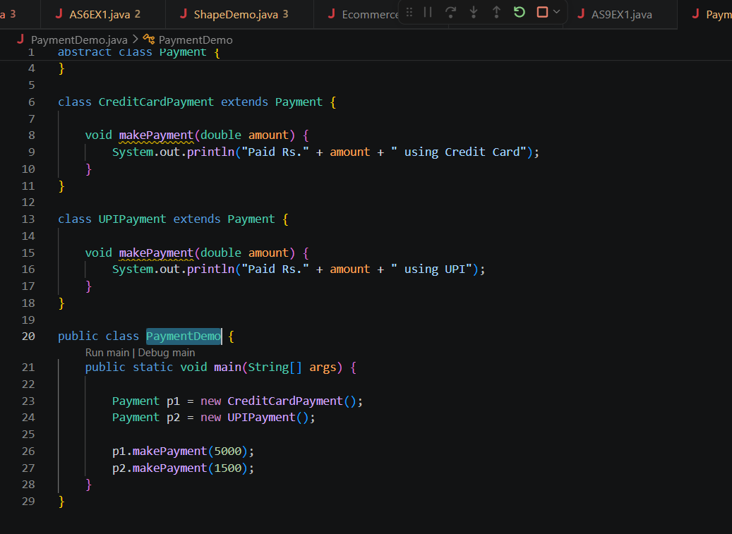

OUTPUT-

- Create an abstract FoodOrder class with an abstract method calculateBill(). Implement two subclasses, DineInOrder and TakeAwayOrder, to calculate and display the total bill based on the order type.
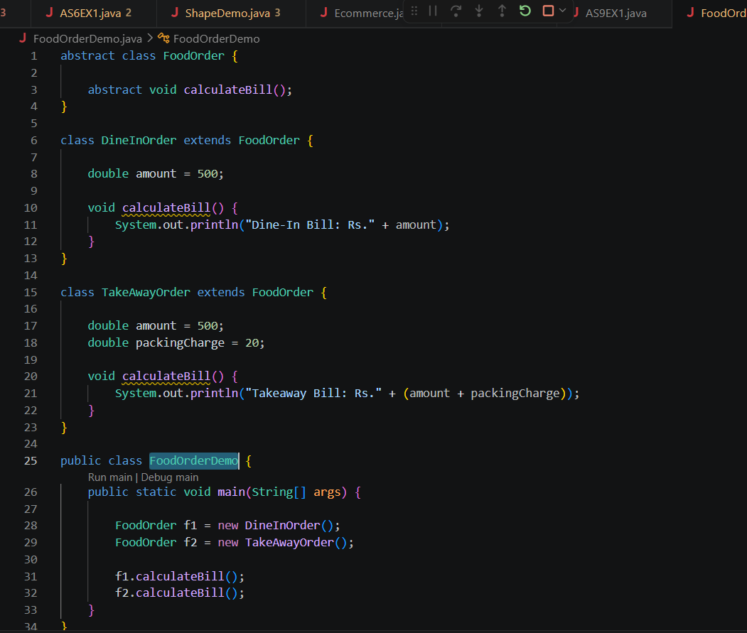

OUTPUT-

Conclusion
The program was successfully implemented to demonstrate the use of abstract classes and abstract methods in Java. It showed how abstraction hides implementation details while providing a common structure for subclasses. The practical helped in understanding how different classes can implement the same abstract methods in their own way, improving code flexibility, reusability, and maintainability in object-oriented programming.

