
ARYAN PATIL 25070122051 CSEA2
Subject: Programming with Java
ASSIGNMENT No : 11
TITLE :Write a Java program to demonstrate the implementation of interfaces.
Problem Statement
Write a Java program to demonstrate the implementation of interfaces.
Learning Objectives
To implement interfaces for achieving abstraction and multiple inheritance of type.
Theory
An interface specifies a set of abstract methods that implementing classes must define. It provides complete abstraction and supports multiple inheritance of type. Interfaces improve modularity, loose coupling, and software flexibility. They allow different classes to implement common behavior while maintaining independent implementations. Interfaces are widely used in enterprise application development.
Outcome
Exercise
- Create an interface Printable and implement it in Student and Employee classes.
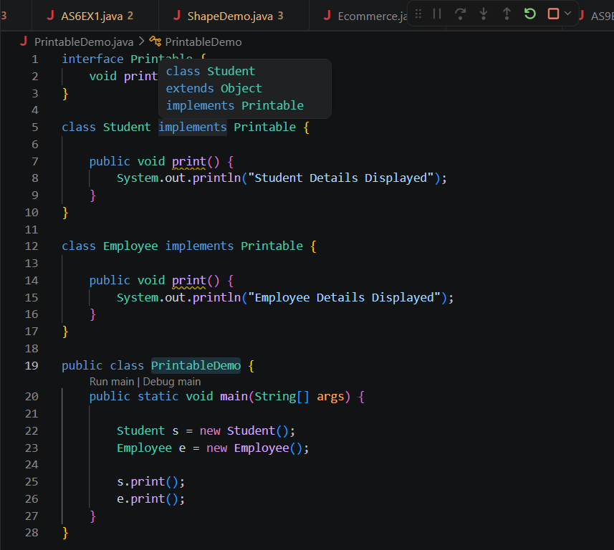

OUTPUT-

- Create an interface Switchable with a method turnOn(). Implement the interface in Light and Fan classes to display the device status.
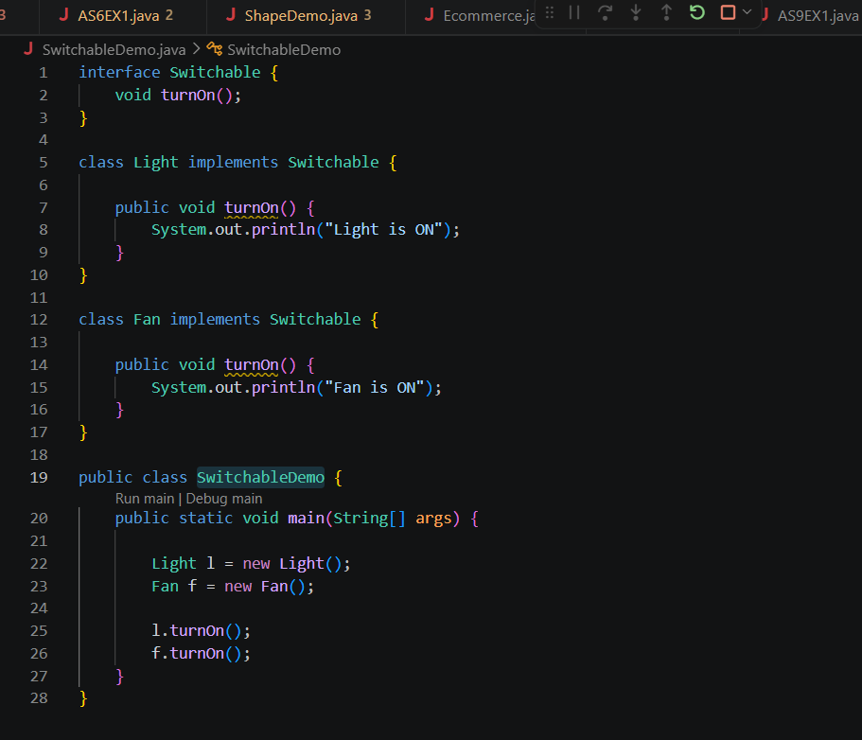

OUTPUT-

Conclusion
The program was successfully implemented to demonstrate the implementation of interfaces in Java. It showed how interfaces provide abstraction by defining a common set of methods that implementing classes must implement. This practical enhanced the understanding of abstraction, multiple inheritance of type, and code reusability, while promoting modular, flexible, and maintainable object-oriented applications.

